Workplace Culture and its Impact on Organisational Efficiency
BMSW 5105
How do Broder External Environmental Factors along with Covid-19 and Ethical Dilemmas Affect Organisational Culture and its Performance?
TM Sidhu 1920725
Lecture Md Kalam

Executive Summary
Employees choose to work for a firm for a variety of reasons, and organisational culture is a big part of why they stay for the long haul. More specifically, an organization's culture is what helps employees feel like they're a part of the team, which can affect satisfaction, motivation, and, eventually, performance.
The problem is that, as more people work from home, and many work part time, that make up corporate culture no longer within the control of businesses in the same way and to the same extent as they formerly were. As a result, it's critical for company leaders to consider how internal and external factors like COVID-19, Brexit, and other ethical dilemmas are affecting organisation, as well as what they can do to maintain a healthy organisational culture for their employees.
This exploratory report elaborates the impact of organizational culture on organizational performance by using different models, tools and techniques and give some recommendations before conclusion.

Table of Contents
Executive Summary………………………………………………………2
- Introduction……………………………………………………………4
- Asda and its Environment…………………………………………..5
    - PESTLE ANALYSIS……………………………………...5
    - SWOT ANALYSIS………………………………………...6
    - Porter’s Five Forces analysis………………………….7
- Asda Structure…………………………………………………………8
- Asda Culture……………………………………………………………8
- Ethical culture………………………………………………………….8
- Factors affecting the culture of an organisation………………...9
    - The McKinsey 7’S model………………………………..9
- The Cultural WEB of Asda………………………………………….11
- Changing the Organisational Culture…………………………….13
    - Kotter’s 8 Step Approach to bring change in Asda.13
- Organisational Performance Using BEER’s Model…………….14
- Impact of Global culture on Asda………………………………….15
  - Hofstede's Cultural Dimensions Theory…………….15
- Recommendations……………………………………………………17
- Conclusion……………………………………………………………..17
- Reflection……………………………………………………………….18
- References……………………………………………………………...19
- Appendices……………………………………………………………..20

1. Introduction
Workplace culture is an environment made up of values, interests, beliefs, habits, and Education that make people's behaviour. Culture can be communicated within the shape of the experiences of all sorts of employees and is impacted by the proprietors, administrators, and administration staff of the organization.
Workplace culture is set by making, organizing, and defining the culture of the company. Culture looks superior within the way businesses are seen and within the way workers dress, but it flourishes within the demeanour of employees by setting objectives and giving value to employees and customers. It impacts Strategy of the business and plays a critical part in gaining organizational productivity and culture.
External factors of the environment are beyond the control of the organization. These factors incorporate the social environment, the political situation, the technology environment, and government policies and controls. The external environment consists of all external factors that can affect the functioning of an organization. There are two parts of external environment, direct interaction, and indirect interaction,
A direct interaction sort of involvement quickly and straightforwardly impacts the organization by implication, the indirect interaction sort of environment contains an auxiliary and more affect on the organization. The categories of environmental forces that interact directly incorporate proprietors, customers, suppliers, competitors, workers, and unions.
On the other hand, the categories of indirectly interacting environmental forces incorporate social, cultural, political, legal, technical, economic, and global impacts. Indirectly interacting forces can have a greater impact on one organization than another due to the nature of a specific business.
The Proliferation of Covid19 and measures to control it have had a significant effect on the UK economy and globally as well. UK GDP is evaluated to have declined by 20% within the second quarter of 2020. That was by distant the biggest quarterly drop on record. The segments most influenced were those where a moderately high extent of shopper investing includes face-to-face contact or social action, these include food, accommodation, and recreational services and those that were most influenced by government confinements (transport).
This report includes a full account of Asda’s workplace culture and its impact on organizational viability. Critical evaluation of external environmental analysis (PESTLE), (SWOT) and critical evaluation of industry analysis (Porter’s Five Forces) also be discussed. The McKinsey 7’S model for internal factors and analyse the web culture of Asda will also be discussed. Kotter’s 8 Step Approach, Beer’s Model and Hofstede’s Model is also part of this report to understand organisation culture change.
This report also focuses on the impact of ethical practices on Asda’s stakeholders and how ethical dilemmas can affect Asda’s culture and its performance.
2. Asda and its Environment
Asda was established in Yorkshire in the 1960s. Annual sales for 2019 was £22,899.2m. Asda have more than 145,000 committed employees serving more than 18 million customers who shop in stores every week, and 98% of UK homes are serviced at www.asda.com. (Asda, 2021)
Last 20 years, Business environment at Asda has changed dramatically. Typically, ASDA conducts research to identify changes in the business environment and respond to the client demands identified by its research. Both its internal and external environments affect the operation of the organisation. Asda use PESTLE as one of the research models. This analysis of the macroenvironment will lead to the identification of a number of opportunities and threats (Griffiths & Wall, 2011).
2.1.1. PESTLE ANALYSIS
Political
Brexit has become a stumbling block. Asda should conduct a supplier chain audit. The ensuing declarations between the UK and the EU must be deemed to have helped both sides.
Economic
Asda must consider the factors from pay scale to fuel prices as they have notable affect on pricing. Many People lost their businesses during the 2020 lockdown and buying power has declined.
Social
Identifying social aspects can aid in the promotion of new products and services to the market as well as the progress of the company's departmental strategies. As a result of the growing demand for ethnic food, Asda provides a variety of foods to clients of various ethnic backgrounds.

Technological
After the covid-19 Pandemic customers prefer to use online services using technology. Asda learn this habit quickly and improving his online services using technology such as mobile app, click & collect and website.
Environmental
Asda focuses on shrinking the packaging with better quality. It will no longer produce non-detectable black plastic in its own-brand by the end of this year and will make all of its own-brand packaging 100% recyclable by 2025 (Asda, 2020)
Legal
Minimum wage and unfair dismissal of an employee can affect the image of Asda if this happens Asda can face heavy charges by employment tribunals. It should be mentioned that Asda shop floor workers have won the latest round of a legal battle with their employer over equal pay in a ruling has been hailed as a potential “game changer” for more than half a million retail workers (INDEPENDENT, 2019).
2.1.2. SWOT ANALYSIS
SWOT is used by Asda to identify its microenvironment. It can also be used for macro environmental factors.
Strengths
Asda is the 3rd leading superstore with 630 outlets in UK which provide low-cost products and service to its customers. Introducing own brands in different products increase its strength and control on prices. Large economy, advanced technology and loyalty programs are also the key strength of Asda.
Weaknesses
There is a perception that quality of products is not as good as its rival stores. On the other hand, Aldi and Lidle sell less expensive products. Asda does not have local stores as its rival have, this is its major weakness.
Opportunities.
There is an opportunity for Asda to collaborate with cross border retailers to acquire or merge to expand the business. For example, Asda can acquire small retails like it did in 2011 by acquiring focus DIY stores to open local stores. Online platform is another opportunity, online shoppers grow after covid-19, it is important to improve its online services along with delivery time.
Threats.
Asda’s mail rivals are Tesco and Sainsbury’s, but Lidle and Aldi are also giving tough time by introducing low price products. Also, online shopping is a new threat as more customers prefer to order online for example Amazon is also delivering grocery items.
2.1.3. Porter’s Five Forces
1.The Bargaining Power of Suppliers
Asda has less buyers but more suppliers, leading to weaker supplier bargaining power and weaker control over prices.
There is no competition between Suppliers. This means that there is no other option than the merchandise offered by the seller. This increased the suppliers bargaining power
2.The Bargaining Power of Buyers
Asda deals with more suppliers while buyers dealing with few retailers, buyers have no control on price and their bargaining power decreased.
buyer returns are down, they are pressured to buy at a lower price. This resulted in decreasing power of buyer.
3.The Threat of New Entrants
Asda has few rivals in the industry. Therefore, any steps by the enterprise will be less noticeable, current transactions within that department will be less competitive.
Because fixed costs are important in the industry, businesses must operate with a maximum capability. if demand declines, they will reduce the prices and traditional corporate competition will become a more established force in the industry.
4.The Threat of Substitute Products or Services
Due to less alternatives available for products produced within industries, The readily available alternatives are meaningless, and they are also being developed in minimal industries. This implies that there is no restrain to the maximum benefit an enterprise can make within the industry. Threat of alternative products weaken by these factors.
Asda is buying the products at low prices but high quality but other alternatives available are expensive for the same quality. Asda less likely to switch to other alternatives. Therefore, threat of alternatives is low in the industry
5.The Rivalry
There are few rivals of Asda which are equally large and operates in a similar area therefore it is not possible for them to make any unnoticed development, that make them a weaker force.
To become a market leader Asda, need to compete with rival superstores and this competition between rivals become stronger force in the industry.
3. Asda Structure
Because ASDA's organisational structure is hierarchical, there will be fewer senior executives of the corporation controlling the employees below them. Furthermore, the CEO is on the top of the structure with decision power. These are critical judgments that should be taken by senior executives who have the necessary experience and expertise in this field.
ASDA's structure is made up of seven tiers, each of which is connected by a six-tiers line of authority. As a result, some messages may be misconstrued. Stress is often caused by the hierarchical structure of the organisation or lack of delegation and empowerment (Mullins & McLean, 2019) The CEO has power over everyone and direct accountability for six subordinates.
4. Asda Culture
There are four primary components to Asda's organisational culture. These components affect the behaviour of employees and, in turn, the organization's ability to provide value when providing retail and related services to customers. Asda's principles are Customers' service, Individuality is respected, Pursue quality and Honesty in action.
Asda always welcomes commitments from each worker to the success of the enterprise. Additionally, Asda aspires to distinction in the work of individual employees, teams, and the entire organisation. In maintaining integrity, Asda emphasizes the standards of honesty, fairness, and transparency.
5. Ethical culture
ASDA's operations aim to answer the problems of its many customers. Through decreased prices, and seeks to provide consumers with more inexpensive, healthier options. Asda is dramatically decreasing the environmental impact of its operations by employing a variety of sustainable strategies also look after any inappropriate conduct recognised by their staff. Asda's ethics team will covertly identify, analyse, and resolve issues. In 2020, Asda ethics received a total of 1,968 contacts, this was an increase of 15 contacts compared with 2019. 1,283 of these contacts contained ethics concerns or requests for ethics guidance (Asda, 2020).
Business ethics is a discipline of practical philosophy that examines which norms can be established and brought to bear under the conditions of modern society (Lütge & Uhi, 2021). ASDA believes that it is doing its best to fulfil its social responsibilities with a wide range of stakeholders. When it comes to the Covid-19 safety measures audited by Shepper (Hawthorne, 2020) Asda headed with an average score of 82%. Asda was affected by the covid-19 outbreak and saw the need to develop a wellness portal early in the pandemic and make it accessible to all employees,
6. Factors affecting the culture of an organisation
Internal factors that influenced Asda’s culture, using McKinsey’s 7’s model.
6.1.1. The McKinsey 7’S model
Model is used to describes Asda's culture and values. It is positioned as the fundamental aspect that distinguishes Asda's culture. McKinsey’s 7’s framework to analyse the internal factors will be used, it consists of seven factors that define successful businesses: strategy, structure, systems, style, staff, skills, and shared values, this offers an important factor for business success. Model represents the relations between seven areas and splits them into "Soft Ss" and "Hard Ss," is shown below.
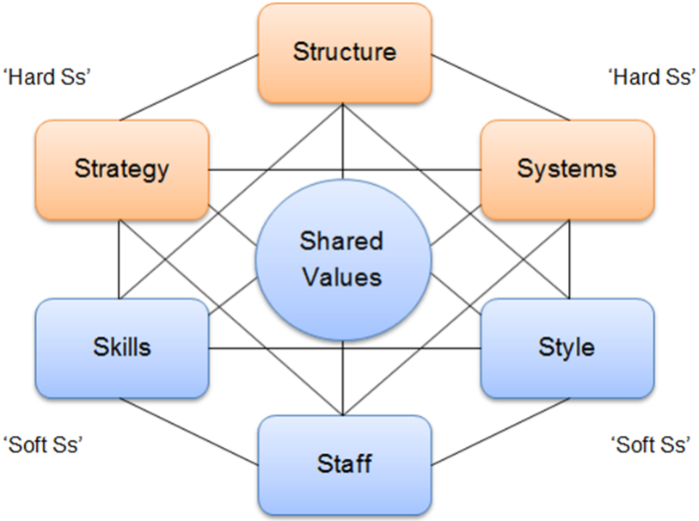
McKinsey 7’S Framework
Source from Class Lecture week 6

Strategy
Asda's cost-reduction corporate methodology is built on its trademark promise of "everyday low costs." The corporation has been able to maintain this policy due to economies of scale, the use of its enormous bargaining strength to achieve low pricing from suppliers, and the payment of low wages to staff. Asda has been chastised for paying its employees cheap wages, which has a negative influence on customer service quality.
Structure
Due to the vast size and scope of its operation, which includes almost 145,000 dedicated employees who serve almost18 million customers every week. Asda's organisational structure has traditionally been highly hierarchical. Asda has introduced steps to delayer the organization's structure to reduce bureaucracy. It provides front-line employees with more information about how they operate their Sections in the stores.
System
Asda depend on various technologies to maintain its operations. New management outlined initiatives to simplify organisational procedures in order to get the company back on track. Asda redesigned performance evaluation system, the new system consists of only 6 performance metrics, significantly streamline the process.
Skills
Asda's employees are impressive, having excellent skills and capabilities. Asda has defined duties, job roles and teaches staff based on their skill levels in those areas. It arranges frequent training and workshops, both internally and externally managed, to provide development opportunities for its employees.
Staff
Depending on the urgency and the level of skills required, employees of various types of jobs and positions will be hired. Asda's human resources department uses a systematic approach to identify potential job vacancies or skills gaps involving all other departments.
Style
Asda leads in a participative manner. It has Ability to involve employees in the decision-making process and management decisions through the use of a participatory leadership style. Asda can increase employee motivation and establish organizational commitment and ownership among employees and other stakeholders through participatory leadership

Shared Values
Asda specifies and reveals its core principles to develop a creative and supportive organizational structure that enables people to perform at their best while increasing their organizational commitment and motivation. Asda’s core values include Innovation - Sincerity - Clarity - Accountability - Trust and Value.
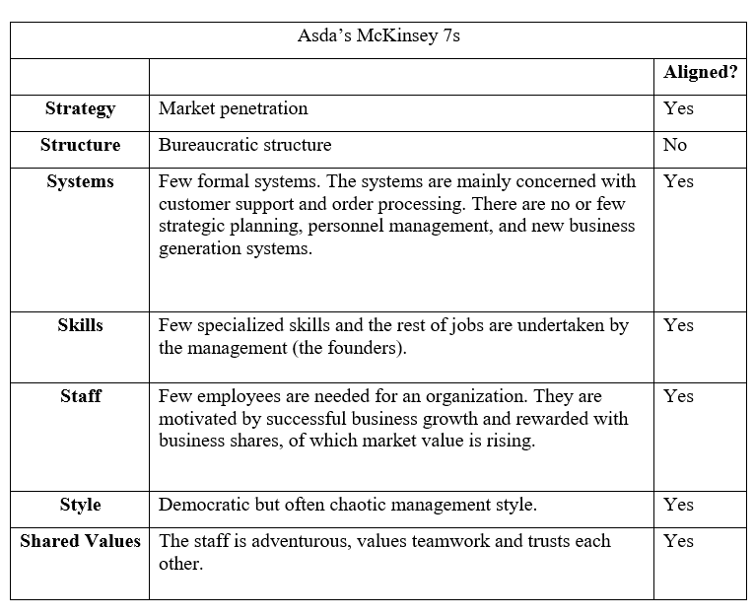
Strategy, system, skills, staff, style, and shared values are aligned with the rest of the organisation only organisation structure is misaligned. Asda's structure should be transformed from a well-organized bureaucracy to a departmental organization. Departmental structure was created to facilitate operations in new geographic areas. This did not happen, so the company will have difficulty operating successfully
7. The Cultural WEB of Asda
It is necessary to be able to analyse culture in order to comprehend existing culture and its impacts. This can be accomplished through the cultural web. Cultural web describe how cultural behaviour, physiology, and metaphorical expressions affect and are affected by assumptions made by organizations.
Asda is employing the approach to investigate various aspects of the business and then putting the findings into practise to shape its employees' working experiences.
The elements of the cultural web are
Stories
It was discovered that there was a mixture of facts about Asda's reputation among its staff. Negative remarks were discovered while conducting employee feedback. It revealed that management positions were abused, leaving staff angry and demoralized. Feedback also shows that most people are satisfied with the wages they receive for working long hours.
Symbols
Asda's brand image is well-known, popular among customers, and the logo is distinctive, standing out among competitors. Asda introduces children friendly shopping list that includes Makaton symbols for typical foods like fruit, vegetables, and biscuits. It helped to promote the business and achieve the marketing goals.
Power Structure
Asda has a hierarchical power structure, with management and Head Office making the majority of product and service choices. Management discusses the options before making a decision. Employees are given notice of decisions and are expected to comply.
Organisational Structure
Asda is the UK's third largest supermarket chain. For Asda to remain competitive in the marketplace, it must ensure that each product and service is made according to management's specifications. To meet organisational goals, Asda relies on staff to work in teams.
Control Systems
Asda operates in a carefully controlled environment, with management and corporate headquarters in charge of decision-making. Employees are trained in a variety of areas, some of them trained to deal with customers and suppliers. Employees are also given employment contracts that specify the length of their employment.
Rituals
Asda evaluated its training on a regular basis and devised a more comprehensive training programme. All personnel receive training in order to guarantee that they have the skills and information needed to execute their everyday jobs. Asda provides development opportunities for employees by allowing them to learn from management and the work itself. Employees are encouraged to work hard and strive for promotions as a result of these development possibilities. New staff receive induction training as well as safety training.
8. Changing the Organisational Culture
Organizational cultures are dynamic and ever-changing. They start with the mission and vision of the founders and then grow naturally through time.
John Kotter’s model used to establish comprehensive techniques to implement changes.
8.1.1. Kotter’s 8 Steps
1- Establish a sense of urgency
The most challenging difficulty is figuring out why firms do not seek change with a sense of urgency to meet corporate goals. To create the sense of urgency required for change, Asda must commit to strategically allocating resources for development plans and execution, resulting in a combination of short- and long-term growth initiatives.
Throughout the Pandemic Asda Management find the way to keep the organisation running, which means doing all the old work (Anon., 2002). and learn from the basic concept of mutual needs between enterprises and communities.
2-Create a guiding coalition
During this age of technology, Outside members of the Asda guiding coalition, including as consultants, associate professors, professors, and professional groups from distinct or allied businesses, should be considered. The coalition should also use social media to spread change among the supply chain, stakeholders, and employees.
3-develop a vision and strategy
Asda should think like a newly founded corporation again in order to develop a vision. The company's strategies and vision should be adjusted to match changing client needs and market conditions. The current model should be reviewed by the corporate management. The review will enable management to understand technology trends and the growing needs of customers.
4- Communicating the change vision
Organizational success is based on clearly expressed visions. Asda's corporate mission must be communicated frequently and clearly. A company's vision can be communicated effectively in a variety of methods. Asda vision for change should be simple in order to clearly benefit all stakeholders while avoiding inconsistencies.
5-Empower broad-based change
Employee empowerment entails holding them accountable for the enterprise successes, engaging and listening their suggestions. To encourage them to be more rationally involved, more authority needed from Asda for corporate reform. Employee empowerment should include managers who are supportive of the Company's changing methods.
6-Generate short-term wins
Asda will achieve short-term success if its management introduces creative items, embraces new cultures, and provides measurable financial impacts. Asda has to move away from its existing traditional hierarchy structure toward a more flexible framework that can offer fresh and personalised solutions to customers.
7-Consolidate gains produce more change
Collaboration between multiple departments is a major difficulty during the selection of change projects. Asda management should develop teamwork in order to speed up the desire for transformation following the short-term successes.
8-Anchor new approaches in the culture
Customer demands and new technologies create expectations for a dynamic and entertaining experience. If Asda implements core principles for sustaining profitable development through change, infrastructure will expand considerably, fostering a constant culture of change. This will be difficult to achieve until a shift in company culture is anchored.
9. Organisational Performance Using BEER’s Model
Leaders are frequently unaware of — and sometimes unwilling to learn about — hidden impediments that obstruct their institution's development. To survive the pandemic, leaders must face the realities of their competitive environment as well as the hidden impediments that render their organisation ineffective. Let's have a look at the six obstacles:
1. Unclear Strategy and Values, Too Many and Conflicting Priorities
On paper, Asda's strategy is sound, but it hasn't been turned into a straightforward, rational, and widely understood "narrative" about how the company will succeed and the principles that should guide its actions. Asda's organisational behaviour is guided by a lack of well-defined and stated values.
2. Senior team is ineffective and not really a team
Asda's leader meets with each team member individually to discuss their role and results. The entire team rarely gets together to discuss the business. Rather than confronting and resolving difficult strategic issues, the majority of the meeting was devoted to sharing information and providing updates on short-term operational issues.
3. Top Down or “Hands Off” Leadership
Asda executives are prone to becoming engrossed in operational issues and working "one step below their pay grade." Leaders are not visible; they spend little time conveying general strategy or direction and "forcing" productive dialogue to reconcile divergent points of view. To overcome festering problems, leaders do not face issues or people directly.
4. Poor coordination/teamwork across silos
Even with solid personal relationships, cross-functional, business, or regional initiatives are difficult to implement. Work on horizontal cross-boundary teams is viewed as secondary to achieving the goals of one's own unit (function, business, or area). Functions, business units, and/or regions have unclear roles, duties, and decision-making authority. There are conflicts between various activities that require coordination and collaboration.
5. Poor Leadership Skills and Development
Some senior managers are fit to lead cross-business projects or assuming an enterprise “general management” approach. When something significant needs to be done, managers return to the same "regular suspects." There are far too few possibilities for leadership and management growth.
6. Poor or closed Vertical Communication
Employees are afraid to speak up about issues with organisational and managerial effectiveness. There are few places for open and public contact with senior management where managers and associates can do so in a low-risk atmosphere. It is against the cultural norm to have open public discussions about challenging matters. Senior executives hardly ask lower-level employees to notify them regarding the issues that are impeding the organization's efficiency or how they might be improved.
10. Impact of Global culture on Asda.
10.1. Hofstede's Cultural Dimensions Theory
This is a way of understanding cultural differences between countries and distinguishing how companies operate in different cultures.
Theory identified the following categories
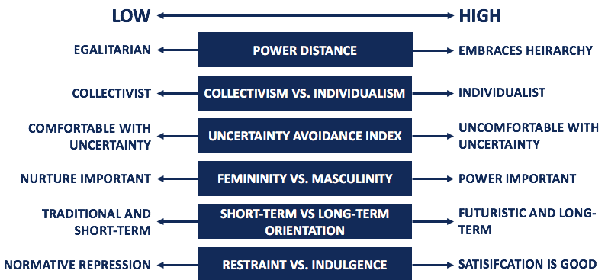

1. Power Distance
Senior management ignore the opinions of employees at Asda who share their feelings about different practices inside the organisation. So due to the larger power distance, Asda faces problems such as high employee turnover and low labour productivity.
2. Uncertainty Avoidance
uncertainty avoidance refers to how civilizations differ in their tolerance for unpredictability. The level of tension among workers is represented by the uncertainty evasion index in this measurement. A higher score means stronger problem-solving abilities. Lower uncertainty avoidance ratings indicate relaxed culture. ASDA's culture includes a combination of the two, prefer lower scores to avoid uncertainty.
3. Individualism
At Asda, a fundamental barrier limiting the workers' collectivism attitude is their ignorance of junior employees' feedback. The upper management's ignorance of the superiors' feedback makes it difficult for them to function as a team with their superiors, and it also prevents the organisation from improving, leaving employees demotivated.
4. Masculinity
The ASDA scores low on masculinity and femininity, indicating that the company's job responsibilities generally correspond between men and women, these job descriptions are not unfair or labelled.
5. Long Term Orientation
In terms of strategic focus and development, ASDA is long-term thinking, while implementation and associated operations are more focused by short-term thinking.
11. Recommendations
To promote productivity and effective working practises, Asda should adopt clear regulations and invest in technology and training at all levels of the corporate hierarchy. The COVID-19 pandemic's limits have quickly changed the goalposts for Asda, which takes its corporate culture seriously. Although ASDA's employees and managers are proud of the company's culture. Managers, on the other hand, must be more appreciative of their employees, treating each one equally and providing equal opportunities without discrimination.
Long after the immediate effects of COVID-19 have passed, Asda will need to embrace flexible working options and telecommuting to meet individual needs – with the potential to recruit and retain the best employees.
12. Conclusion
The examination of ASDA's organisational culture reveals that Profitable businesses do not have a rigid cultural preference, trying to hit the right balance to make a successful culture. ASDA has successfully established a strong corporate culture, which is deeply embedded in its diverse employees and is generally accepted.
The finding of this report show that all aspects of Asda culture have an impact on various aspects of Asda performance. According to this report, if employees' norms and values are aligned with those of the Asda, it is useful to attaining the firm's goals.
13. Reflection
This Module was absolutely unexpected; in my mind, I expected it to be another hectic class that I would not enjoy. MD Kalam, our lecturer, however, altered everything. He had a really unique and intriguing teaching style. Kalam continuously checked to see whether anyone had any questions about what he was teaching. Kalam kept it all quite easy for students, so that the tasks were straightforward for them. I completed my assignment by following instructions he gave in week 10. Everyone understand what exactly he is looking from us in the assignment. I learnt more than I did in any other Module since he always managed to hold everyone's attention in class, which is something that some instructors struggle with.
One important technique Kalam told us about the assignment is how to analyse, evaluate and conclude the matter. I always use this technique whenever he gave us a task to complete in short span of time. Overall, the class culture was great. Students from diverse background and beliefs were together, when working on a group task it was great experience to understand each other and respect each other culture and beliefs. I had confronted an ethical dilemma during one task given by another lecturer for a group work and one of our group members complete the whole task by himself without consulting us. he told the lecturer that he done the whole work by himself, and the group members were not interested. I was shocked by his statement and learn a lesson that how ethical behaviour of one can demoralise other.
Working together with my colleagues was an important element of group discussions for this module. Every member of the group was responsible for his part of the task. Members helped each other so that we can complete our task. Regrettably, I had a group member who did not turn up for a team meeting and did not offer any assistance. But we completed the task without her. Luckily other members were helpful and compassionate towards their studies. I tried to help by finding the right information online wrap up the whole information to present to our lecturer Mr Md. Kalam. Teamwork made easy to solve the given task as the task divided between the team members.
I learned many skills during this term but the key skill for me is teamwork, how you can work together in an environment where people are from different cultures, values, and attitudes. Second skill I learned is use of technology, social media, and online research these really change my life as I am spending most of my time online to search different books, articles and journals, university online library is very useful. Finally, Mr Kalam was one of the lecturers I have ever had; he is very passionate, has great knowledge and grip on his subject. His friendly attitude and behaviour attract me to focus on the subject.

14. References
Anon., 2002. Simple solutions. The Journal of Business Strategy, 23(5), p. 6.
Asda, 2020. Asda accelerates plastic reduction commitments to end of 2020. [Online]
Available at: https://corporate.asda.com/newsroom/2019/10/25/asda-accelerates-plastic-reduction-commitments-to-end-of-2020#:~:text=Asda%20has%20also%20set%20out%20the%20next%20stage,of%20its%20%E2%80%98test%20and%20learn%E2%80%99%20approach%20to%20innovation.
[Accessed 30 08 2021].
Asda, 2020. Ethics and Compliance Programme. [Online]
Available at: https://www.asda.com/creating-change-for-better/better-business/ethics-and-compliance
[Accessed 31 08 2021].
Asda, 2021. Company Facts. [Online]
Available at: https://corporate.asda.com/our-story/company-facts
[Accessed 18 08 2021].
Griffiths, A. & Wall, S., 2011. Economics for Business and Management PDF Ebook. 3rd ed. Harlow: Pearson Education Limited.
Hawthorne, E., 2020. the Grocer. [Online]
Available at: https://www.thegrocer.co.uk/supermarkets/coronavirus-in-store-safety-which-supermarkets-are-doing-it-best/645177.article
[Accessed 01 09 2021].
INDEPENDENT, 2019. Asda loses equal pay case against shop floor workers at Court of Appeal.. [Online]
Available at: https://www.independent.co.uk/news/business/news/asda-shopfloor-workers-win-equal-pay-case-court-appeal-gender-a8756221.html
[Accessed 20 08 2021].
Lütge , C. & Uhi, M., 2021. Business Ethics: An Economically Informed Perspective. 1st ed. Oxford: Oxford University Press.
Mullins, L. & McLean, J., 2019. Orhanisational Behaviour in the Workplace. Twelfth ed. Harlow: Pearson Education Limited.

15. Appendices
Appendix 1.


