

Module: BMHP5004
Children, Young People and Families
Student: Claudia-Ancuta Dragan
Student nr: 2021166
Lecturer: Laila Surani
Presentation support paper

Introduction
This report will discuss the case of a single mom with a son. The mom had been victim of a several domestic abuse for long time, this have impact in her mental health and affecting her capacity to take care of the sun and be a good parent. The mom is unemployed, and the son is not attending to school. During the assessment with the social services the son was placed to live with the grandparents because mom in unable to provide a basic care to her son. This report will contain the information and the process how the social services work together with the mom to ensure the child is take care of in a good environment and all the needs are fulfil. The Maslow hierarchy of needs is applicable with this study cases.

Case studies Wandsworth.
The case study Wandsworth is a report about a single mom with a sun. The mom suffers with mental health problems after she was in a domestic abuse relationship. The mom is unemployed unable to take care of the sun. the child is not attending to school, not take care of and living in a messy home. the social services are concerned about the child safety and mom mental health (Stanley, N. 2003)
Under the Children Act 1989 local authorities, other agency and the parents are reasonable to protect and ensure the children are safeguarded. (Children Act 1989)
Safeguard is the process of protecting members of family/ society from neglect abuse and danger (Hughes, L. and Owen, H. 2009)

The venerability the study case:
- The parent (mom) involved in domestic abuse
- Parent with mental health problem.
- Child neglect
- Economic, Environmental, Social
When the members for the family are involved any type of abuse, mental health problem and economic vulnerability, the child will be at risk and is required support and supervision from the government (Children Act 1989)

In the study case the factors are:
- Economic Factors, the mother is unemployed

- Environment factors, the mother and the child are living in toxic environment, they are abuse and expose to harm, and poverty (George, Wiegand 2019)

- The family background is a important factor, in many case the if the child is comping form a family with a background where to be physical and mental abuse is happened often, they will learn that is a normal to be abuse. (Mental health act, act 2007)

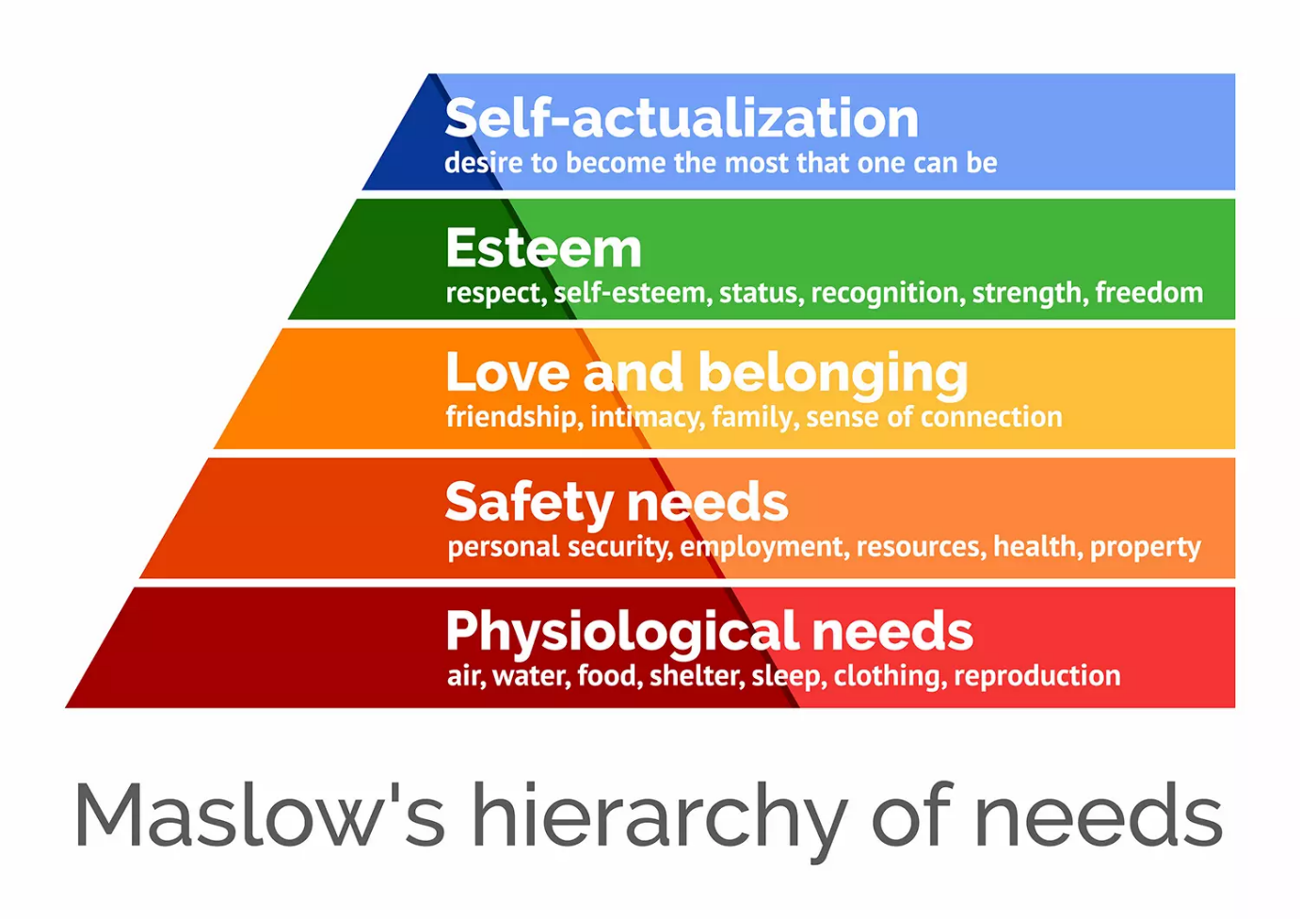

(McLeod, 2007)

Relevant theory to the topic
Maslow's theory is relevant theory to the given case and thus, the different needs described under the theory are as follows:
Physiological needs. In this case the physiological need is not fulfill. The mom and the sun they need help to completed housework, cooking, clothing, sleeping, mom having a job or financial support. (Noltemeyer, A. et al. 2021)
Safety needs
The safety needs related to the person suffering from mental health problems include emotional security, financial security, freedom from fear and social stability. (McLeod, 2007)
Love and belonging needs
The love and belonging ends refer to the emotional needs for social relationships like trust, friendship, acceptance and receiving and giving affection, (McLeod, 2007). The mom and the sun they need emotional support to feel loved my family and friend. The child needs to know his mom care and love him
Self-esteem needs
The need for self-esteem is only created when the person is respected by others and also includes self-respect, and confidence for the achievement of success. After the domestic abuse the mom suffer with mental health problems and make here to be diffident.
Self-actualization and self-fulfillment
These needs refer to the realization of self-fulfillment, one’s potential and the personal growth of an individual, the mom need to find a job to be financial independent and the child have to attend to school for a good future. (Rosenblum and Elimelech, 2021).

The impact of neglect and abuse on child and young people
- The impact of neglect and abuse on child and young people will affect the child health, the brain development, the child is at risk to don’t have access to education, care. The child is at risk to have mental and behavioural issues, they have smooching, drug, or alcohol addiction and even to run from home (Children act 1989)

- The future of the child and young people are affected too: Because they don’t have access to education, they won't have a good job, good future. Without access to health care will result with health problem or death. (NSPCC, 2020)

- Unhealthy lifestyle: The child or the mom trey don’t have enough food and resource as a result the mom is unemployed (NSPCC, 2020)

- The mom suffers of mental health problems and will affect her capacity to take care of the sun.

The process of intervention by relevant health and social care agencies
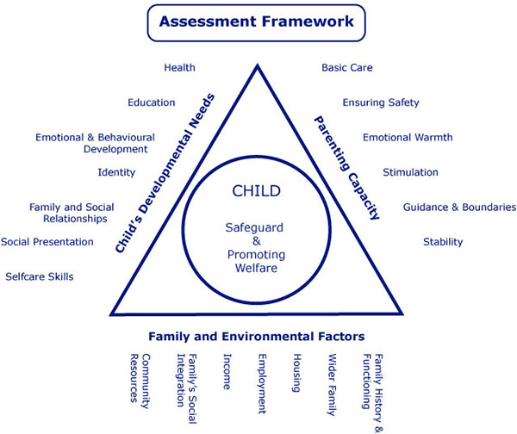

(www.londonsafeguardingchildrenprocedures.co.uk, n.d.)

Assessment Framework
The process of intervention of the health and social care agencies are:
Assessment is focused on safeguarding and promoting the welfare of the child, to reflect the child best interest. (Anon, 2015)
The assessment composed of:
1)Family and environment factors,
2)The parenting capacity,
3)Child developmental needs, (Anon, 2015)

Actions of social services with the family
During the assessment the social services, GP, Police, child protection services.

All these services work together with the family to ensure all the child need are fulfil and the mother received the necessary support. (Children act 2004)
- They create a routine together with the social worker for few weeks, teaching the mom how to take care of the son, explaining importance of child immunization, attending to university (Anon, 2015)
- Encourage the mom to try to find a job
- Separating the abusive ex- partner from family
- The mother gets mental health support and taking antidepressant.

The policy and legislation related to the case

- Children act 1989 and 2004
- Mental health act
- Children rights act
- Education act 1996
- Children and social act
- UNCRC United nations convention on the rights of child

Conclusion
In conclusion the study case it's a example off family problems and how the social services and agency/government, have to work together to help family or member of family if they are in danger or struggling. follow the legislation in policy will help the social worker 2 find out what are the needs in in this study case and how they can work together with the family to improve the situation. The result an outcome after the social worker makes a plan to work together with the mom and the child are:
- The child is taking care off, house clean.
- The mother improves her mental health
- The star covers all the missing vaccination and dental appointments
- The son attends back to school
- The mother is doing volunteering work and looking for a job
- The relationship with de family is improving
- EX-partner is away from mother and son

Reference list

Anon, (2015). Child and Family Assessment | Cambridgeshire and Peterborough Safeguarding Partnership Board. [online] Available at: https://www.safeguardingcambspeterborough.org.uk/children-board/professionals/procedures/child-and-family-assessment/.
‌Children Act 1989 , Legislation.gov.uk https://www.legislation.gov.uk/ukpga/1989/41/contents
Noltemeyer, A. et al. (2021) ‘The Relationship between Deficiency Needs and Growth Needs: The Continuing Investigation of Maslow’s Theory’, Child & youth services, 42(1), pp. 24–42. Available at: https://doi.org/10.1080/0145935X.2020.1818558.

McLeod, S. (2007). Maslow’s Hierarchy of Needs. (online) Simply Psychology. Available at: https://www.simplypsychology.org/maslow.html.

Hughes, L. and Owen, H. (2009) Good practice in safeguarding children working effectively in child protection. London;: Jessica Kingsley Publisher

Stanley, N. (2003) Child Protection and Mental Health Services: Interprofessional Responses to the Needs of Mothers, Child protection and mental health services: interprofessional responses to the needs of mothers. Bristol: Policy Press, pp. ix–ix. Available at: https://doi.org/10.46692/97818474257

Rosenblum, S. and Elimelech, O.C., 2021. Gender Differences in State Anxiety Related to Daily Function Among Older Adults During the COVID-19 Pandemic: Questionnaire Study. JMIR aging, 4(2), p.e25876.
NSPCC (2020). Neglect. [online] NSPCC. Available at: https://www.nspcc.org.uk/what-is-child-abuse/types-of-abuse/neglect/.

www.londonsafeguardingchildrenprocedures.co.uk. (n.d.). Appendix 4: Triangle chart for the Assessment of Children in Need and their Familiesv. [online] Available at: https://www.londonsafeguardingchildrenprocedures.co.uk/appendix_4.html.

Children Act 2004 https://www.legislation.gov.uk/ukpga/2004/31/content

‌

‌

