

Programme: CertHE Computing Skills Module: Analysing & Solving Problem
Component 2 Coursework 1


Student Name: Mohamad A Idris Student Number: 2440118
Tutor Name: Abida Perveen Module Code: ACCA4019
Table Of Content
Contents
Introduction 2
Task 3
Abstraction 4
Refferences 6

Introduction
Computational thinking helps us take a messy, unclear problem and break it down into a clear, step-by-step plan. It shows us what needs fixing, which info really matters, and how to come up with a solution that we can repeat and trust. For example, when dealing with route management in an online grocery delivery service, using computational thinking means breaking the problem apart, spotting patterns, focusing on key details, and thinking in terms of algorithms.

Task
Problem summary: An online grocery delivery service is struggling with poor route planning, leading to wasted fuel and late deliveries. The goal is to cut fuel use and distance, assign orders smartly, and make sure no delivery arrives more than 30 minutes late. The MoSCoW method will guide solving these issues.

Must Have (M):
- No delivery should be over 30 minutes late. Reliability is critical.
- Cut down total distance and fuel consumption — that’s the main efficiency target.
- Match orders to vehicles effectively, considering routes, timing, and capacity, so scheduling is realistic and workload is balanced.
- Respect delivery time windows, driver shift limits, and vehicle capacity to keep operations feasible.
- If needed, reroute in real time but keep an eye on performance to stay efficient.
Should Have (S):
- Update routes using real-time traffic info to reduce delays and improve accuracy.
- Group nearby orders together (“batching”) to save time and cut trip distances.
- Prioritize urgent or high-value deliveries to boost service quality.
- Predict when vehicles will need maintenance or refuelling to avoid interruptions.
- Estimate daily demand to optimize fleet size, preventing overuse or waste.
(C): Could Have
- Consider adding low-emission or “green” vehicles to improve sustainability.
- Use consolidation practices to further enhance efficiency and reduce environmental impact.
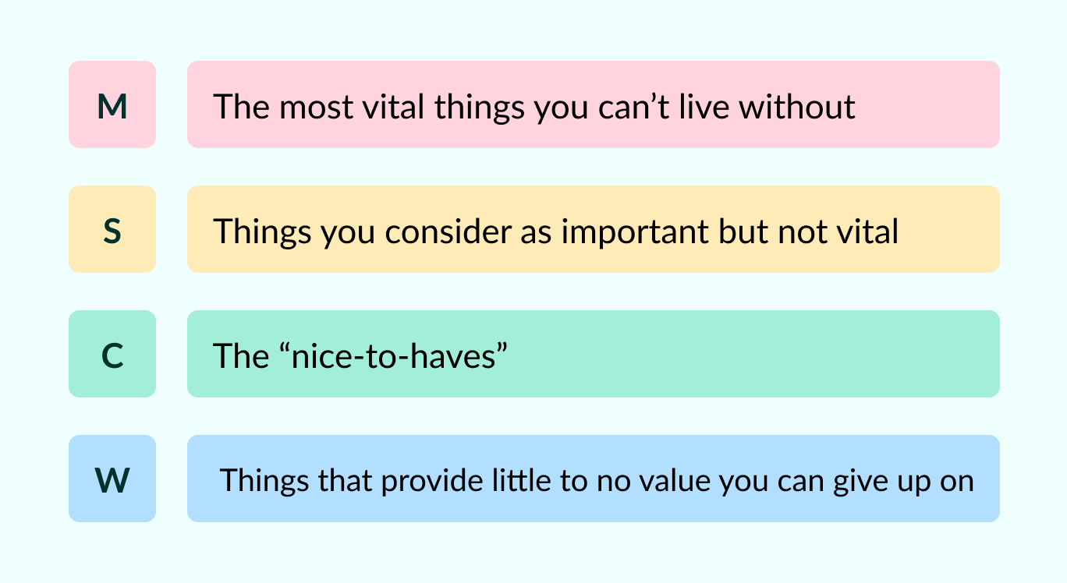

Abstraction
Simplifying the map: We can think of the city as a geography, a set of districts, or a network.
Key spots: warehouses, customer addresses, and major intersections.
Every road has a travel time assigned to it, which changes dynamically—not just based on distance.
Abstracting the Problem
The heart of the challenge is a Vehicle Routing Problem.
A list of delivery locations, or nodes.
A matrix showing travel times between all points, with edges weighted by time.
Delivery time windows, like the promise to arrive within 30 minutes.
Constraints like how much a vehicle can carry and any special-order requirements.
A set of routes sequences of deliveries for each van that aim to minimize total travel time and fuel, while respecting all those constraints.
Solution Development
We build a solution step by step based on this abstraction.
The solution: a Route Optimization System.
Core optimization steps:
First, group nearby orders together (clustering), then plan the routes.
Start with random routes and improve them over many cycles by mixing good parts of different routes, always keeping the fastest ones for the next round.
This system takes in the abstracted map, order list, and constraints.
Real-Time Data Integration Layer
Connects with traffic APIs like Google Maps and Waze.
Continuously updates travel times to reflect current conditions.
Taps into weather APIs to adjust travel time predictions when weather turns bad.
Interfaces with the Order Management System.
Handles new orders and cancellations as they come in.
Driver App & Feedback Loop
Drivers follow the plan and send back data to help improve the system.
Provides turn-by-turn navigation based on the optimized route.
Let’s drivers report urgent issues like a customer not being home or a road closure.
Tracks real progress versus the plan, feeding this info back to improve future time estimates.
Validation & Improvement
This is where the system checks if everything’s working as it should. If something’s or rules are broken or things aren’t running perfectly it tweaks itself. It might adjust settings or dive deeper into the data to fix issues.

Execution & Adaptation
Once things are rolling, the system stays flexible. If something unexpected pops up, it can quickly change course but keeps that promise of delivering within 30 minutes.
Learning & Improvement
After deliveries are done, the system looks back and learns from what happened. It updates its models, so each new route gets smarter and smoother. This ongoing learning helps make fuel savings and on-time deliveries more reliable over time.
Constraint Handler
This part keeps everything realistic. It makes sure the van isn’t overloaded with too much weight or volume. It also plans the loading order, so items go in the van in reverse of their delivery stops, cutting down on time spent searching for packages. Plus, it keeps an eye on temperature-sensitive goods to deliver them just when they need to

References
[1] “MoSCoW prioritisation tool,” Connected Places Catapult, 2024. https://cp.catapult.org.uk/playbook-tool/moscow-prioritisation-tool (accessed Oct. 31, 2025).
[2] “MoSCow Method,” Open Practice Library, 2023. https://openpracticelibrary.com/practice/moscow-method (accessed Oct. 31, 2025).
[3] “BiteSize Learning,” BiteSize Learning, Sep. 25, 2024. https://www.bitesizelearning.co.uk/resources/moscow-prioritisation-model. [1]
[4] Atlassian, “Understanding the MoSCoW prioritization | How to implement it into your project,” Atlassian Community, Aug. 30, 2023. https://community.atlassian.com/forums/App-Central-articles/Understanding-the-MoSCoW-prioritization-How-to-implement-it-into/ba-p/2463999.

‌

‌

