Cyber assignment 1 supporting documents

Josh Lloyd (2205191)

Contents
Intro to packet tracer certificate: 2
Network security fundamentals certificate: 3
Cybersecurity foundation certificate: 3

Intro to packet tracer certificate:

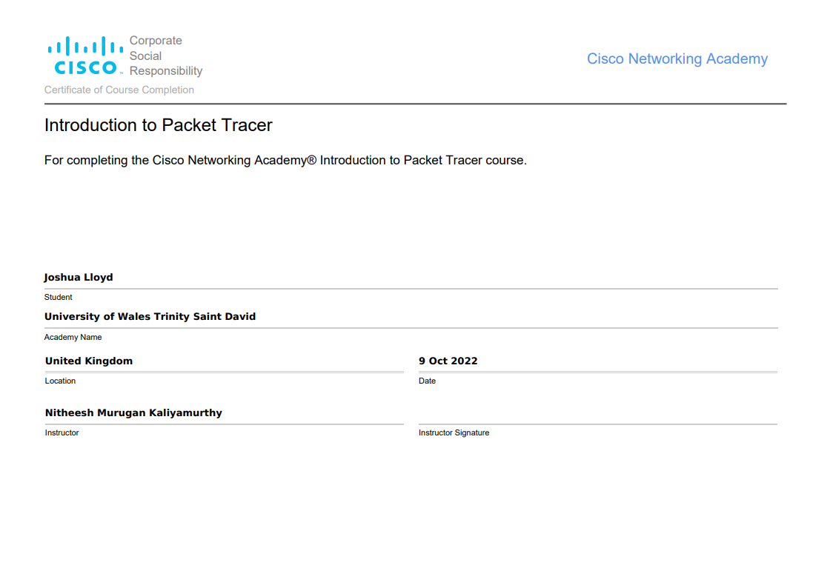

Network security fundamentals certificate:

Cybersecurity foundation certificate:


