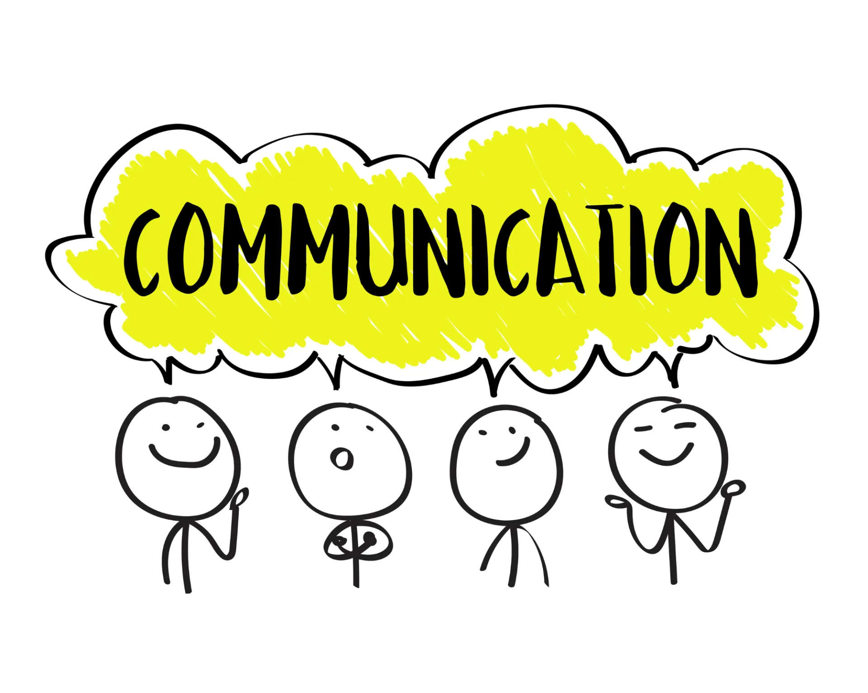Effective Team Working and Communication

Communication is the exchange of information between individuals or groups (Merriam-Webster, n.d.). Effective communication is vital in all aspects of life, including personal and professional settings. Over the years, communication has evolved drastically and consequently, different models of communication have been developed to help people understand how communication works. In this report, I will be discussing three models of communication: Shannon Weaver Model, Schramm's Model, and Berlo's Model. Additionally, I will explore communication skills and provide examples of poor communication in the workplace.
  - Module Code: BSMW4002
Jennifer Nofisat Ajiboye | Student Number: 2022550 | Lecture: Olusoyi Ashaye

Importance Of Communication

Being able to communicate effectively is one of the most crucial life skills to have. It is one of the many things which allows us to pass information accurately to one another, and also to understand what is passed on to us. The ability to be able to communicate information accurately, clearly and as wanted is a necessary life skill and it definitely should never be overlooked. (SkillsYouNeed, 2011)
Communication is only effective if the receiver can entirely comprehend the message. We use communication every day, we are surrounded by multiple different forms of communication, such as the radio, telephones, letters, newspapers, social media, text messages etc. We use all of these different forms of communication knowingly and sometimes even unknowingly. For example, the radio, when you are on the way to work you listen to the radio and will be informed on things such as the weather or traffic.
Communication is a great thing which has its benefits and its flaws, but that goes the same for anything of substance. In our daily life communication assists in building great relationships enabling us to share our experiences, interests, needs, wants and give us the opportunity to connect with one another properly. In a way it is the essence of life, providing a platform to showcase our feelings, relay information and share our thoughts. Communication is inevitable and we all need it. (Stuart Hall, 2022)

Different Forms Of Communication

There are multiple types of communication, every type of communication can be effective, whether that is in your personal life or your place of work. To solve most problems in an organization effectively you must be able to communicate. Communication can consist of the following:
- Verbal Communication
- Non – verbal Communication
- Active Listening

Verbal Communication:
Verbal communication is a type of communication where we use words to share information with others, either by speaking or writing. Whenever we use language to express our ideas, emotions, or thoughts, we are engaging in verbal communication (Pavlovic, 2023). Verbal communication is a very common method of communication which use to create understanding and avoid problems and misunderstanding.
Non-Verbal Communication:
Nonverbal communication is the way we convey messages or signals without using words. This includes things like making eye contact, using facial expressions, using gestures, having good posture, using objects, and using body language. (Wikipedia Contributors, 2019)
Body language is an important aspect of communication that can convey emotions or feelings to others. The way you speak and behave can put people at ease, make them trust you, or even create a bad impression. Body language is crucial not only in personal relationships but also in the workplace. Knowing how to use nonverbal communication can help you express your ideas, connect with others, build stronger relationships, increase trust, and improve clarity. This is especially useful in a leadership role where you work with a team and multiple stakeholders. (Team, C. 2023)
Active Listening:
Active listening is the act of paying close attention to what someone is saying, without interrupting or assuming what they mean. It involves using body language cues and other forms of communication to fully understand the speaker's message. Being an active listener can improve communication in both personal and professional settings and can be especially beneficial in job interviews to build a positive connection with your interviewer. (Doyle, 2022)

Models Of Communication
Shannon and Weaver Model:
The Shannon and Weaver Model of communication was developed in 1948 by Claude Shannon and Warren Weaver. (Dickinson, 2022)
This linear model identifies the six key components of communication, they are: The sender, the encoder, the channel, the decoder, the receiver and noise.
Littlejohn and Foss (2017) highlighted how feedback, noise, and sender/receiver can influence message transmission. These constituents essentially form the basis of communication models. Shannon and Weaver (1949) proposed that communication involves a sender, who encodes the message, which is then sent through a channel and received by a receiver who decodes it. The model puts emphasis on making sure that the message is sent correctly- any noise during transmission could affect how the receiver takes in the information. This makes accuracy important for effective communication.(Littlejohn & Foss, 2017). Furthermore, some have suggested that the model is too basic and doesn't provide enough detail to account for human interaction, it continues to be a popular method for understanding how communication works.(Miller, 2019). The Shannon and Weaver Model has been employed in numerous disciplines, such as mass communication, interpersonal communication and organizational communication research to understand how people communicate. (Littlejohn & Foss, 2017).
Shannon and Weaver Model of communication
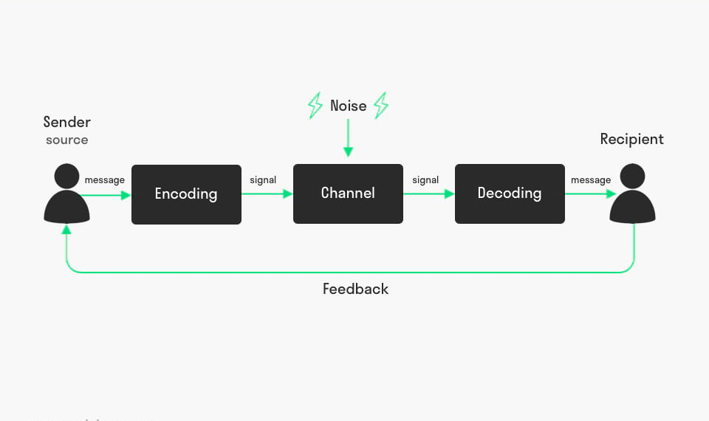 Figure 1: Shannon and Weaver Model of communication (Mulder, 2022)
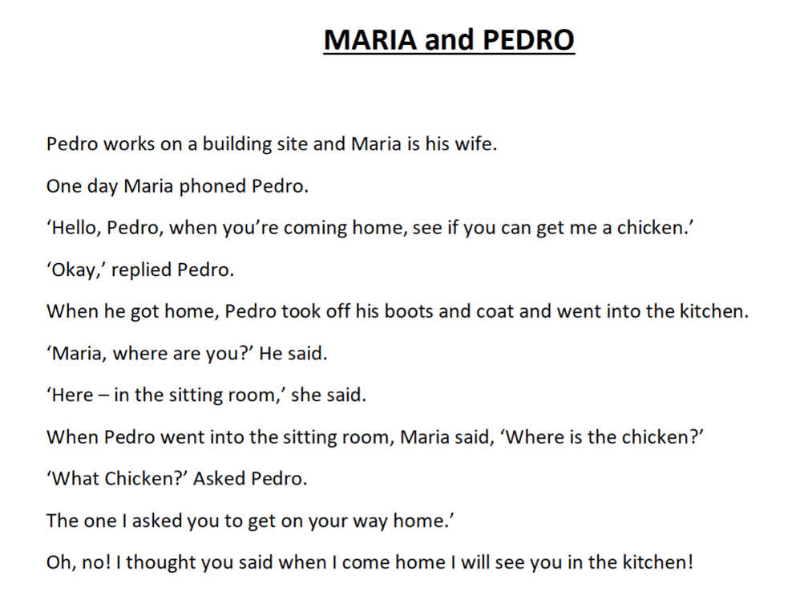 Figure 2: Mario and Pedro Case Study
In Maria and Pedro's case study, the Shannon Weaver Model of communication was not properly utilized. When Maria said "get me a chicken" Pedro interpreted it differently due to noise and interference, understanding it as "when you come home, you will see me in the kitchen." This caused confusion which would have been avoided if the message was communicated using the model more effectively. For better communication, Pedro and Maria could've formed their message in a more understandable manner, by decreasing noise interference and moving to a quieter location also asking for feedback to ensure they were both on the same page. Miscommunication can lead to a complete misunderstanding of the intended message, especially when it is unclear, ambiguous or incomplete. When there are missing pieces left out of the conversation, receivers often fill in the gaps with their own assumptions and expectations which can be detrimental (Lloyd, 2017).

Berlo’s SMCR Model:
The Berlo Model, referred to as the SMCR model, was developed by David Berlo in 1960 and is still used today in order to assess communication efficiency. It outlines four essential parts: the source of communication, the message content, the channel chosen and finally the receiver. According to the model, successfully communicating involves understanding the four components involved: the source, message, channel and receiver. Having clarity on these elements is essential for effective communication.
The Berlo model of communication has been studied in depth to analyse its effectiveness under different conditions. Numerous research projects have been conducted to see the results. Researchers investigated nurses' communication styles and found that the Berlo model was a useful way for them to better understand communication processes, leading to improved patient outcomes. (Zolnierek & DiMatteo, 2009). David Berlo began to create this linear model to expand the Shannon Weaver Model in a more simplistic way to ensure it was comprehendible for anyone and everyone. David Berlo identified three factors hindering the effectiveness of communication, depending on multiple factors related to the sender, message, and receiver. For example, the sender's communication skills, attitude, knowledge, and socio-cultural system influence how well the message is understood by the receiver. The message's content, treatment, and code also affect how well it is received. The channel used to communicate, such as radio, TV, or the internet, can also impact how well the message is received. (Cuofano, 2021)
In summary, communication is influenced by a wide range of factors that can impact how well the message is understood by the receiver.
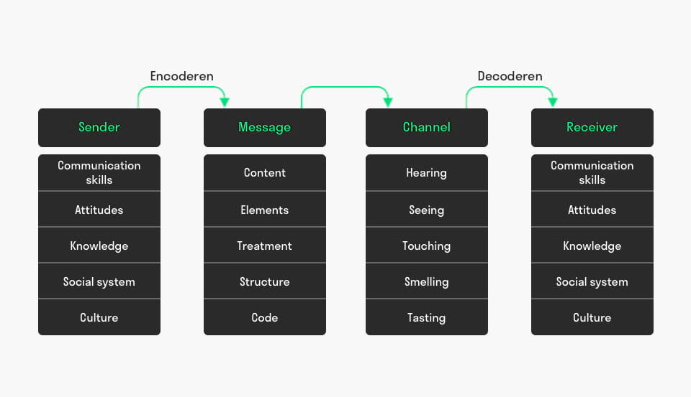
Figure 3: Berlo’s SMCR Model of Communication (Toolshero, 2022)
Schramms Model of Communication
Wilbur Schramm developed the Schramm model of communication in the 1950s, and it has since become one of the most popular models amongst communicators. This model views communication as a circular process that involves encoding, decoding, feedback and noise. Additionally, it emphasises the importance of having an engaging dialogue.
Numerous studies have demonstrated the efficacy of the Schramm model in different communication scenarios. Lin and Lein (2015) conducted a study which concluded that the Schramm model has a positive effect on the communication skills of nursing students. According to a study, the Schramm model can be used as an effective teaching tool which helps students gain a better understanding of the communication process and enhances their communication abilities. Additionally, another research conducted by Li and Liang (2016) looked into the efficiency of the Schramm model in crisis communication. Research discovered that the Schramm model was useful to promote clarity and understanding in crisis communication, thereby leading to an improvement in its quality and efficiency.
To communicate effectively, we need to turn our thoughts into words, which is called encoding. Then, the person receiving the information needs to understand or decode it to make the communication successful. Without encoding and decoding, communication can't happen. Schramm's model agrees with the idea and says that effective communication needs both encoding and decoding. Additionally, communication is incomplete if there is no feedback from the recipient. It's like talking to a friend who doesn't respond; the communication is not complete. Schramm's model states that communication is a two-way process between the sender and the recipient. (moodle.uwtsd.ac.uk, n.d.) Schramm's communication model states that a person's knowledge, experience, and culture affect how they understand and interpret messages. People from different backgrounds may have different interpretations of the same message. In this model, effective communication requires the receiver to understand the message in the way the sender intended and provide feedback to the sender. If there is no feedback, the communication is incomplete and ineffective. (moodle.uwtsd.ac.uk, n.d.)

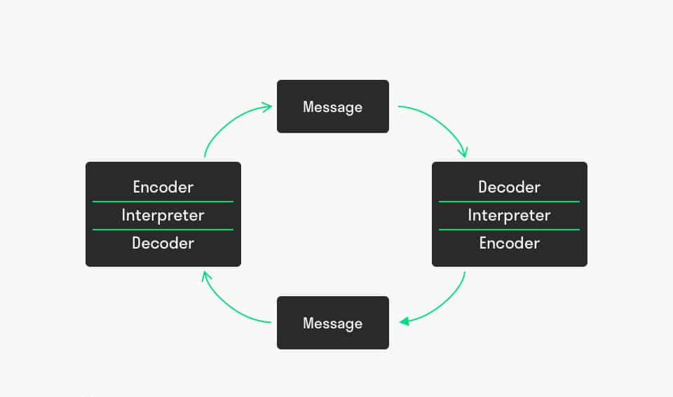
Figure 4: Schramm’s Model of Communication (Toolshero, 2022)

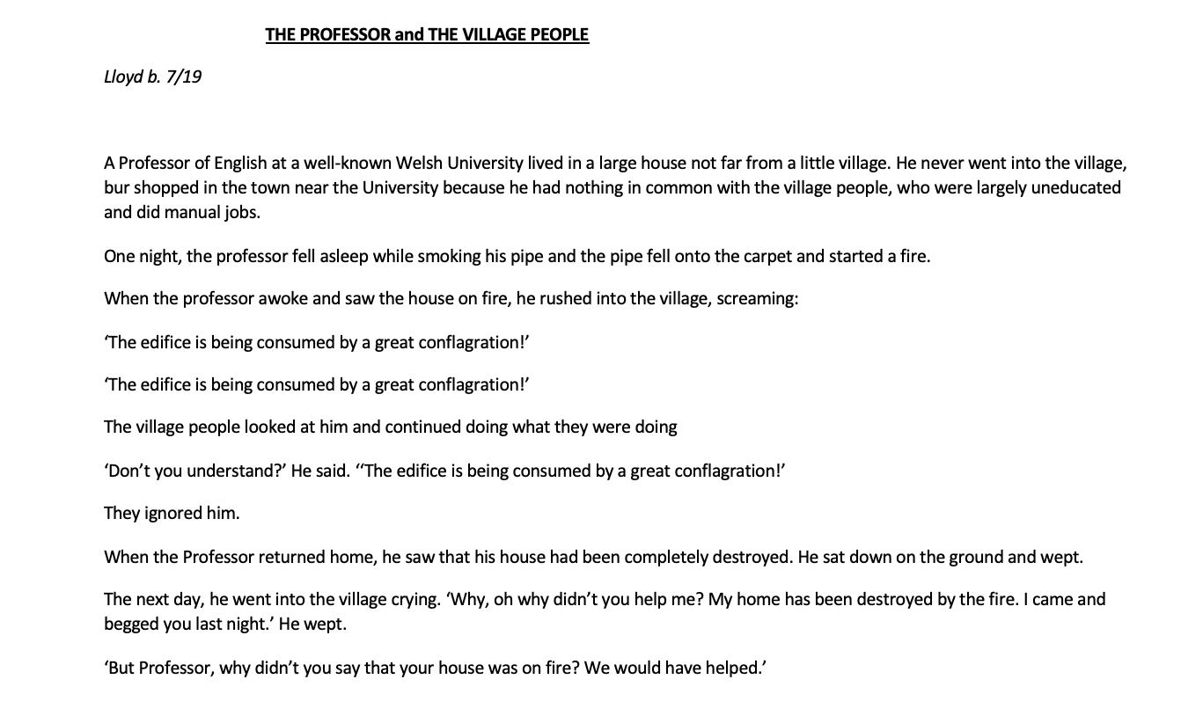Figure 5: The Professor and The Village People Case Study
In this case study of the Professor and the Village People, the Schramm's Model of communication was not effectively used. The Professor failed to encode the message clearly and used jargon such as “edifice” and “conflagration”, which the Village People did not understand. Additionally, he did not allow feedback from the Village People, which resulted in miscommunication. To improve communication, the Professor should have used clear and simple language and allowed feedback from the Village People.

Workplace Communication
Poor communication in the workplace can lead to misunderstandings, conflict, and reduced productivity. In the case studies provided, both examples illustrate poor communication. In the first case study, Pedro misunderstood Maria's message due to noise or interference. In the second case study, the Professor used jargon and did not allow for feedback, resulting in miscommunication.
To improve communication in the workplace, it is essential to consider the communication models and skills discussed above. Using clear and simple language, allowing for feedback, and being mindful of cultural differences can improve communication. Additionally, using nonverbal communication, clarifying messages, and asking questions can reduce noise and ensure effective communication.

Conclusion:
In conclusion, it is clear that communication is vital in our personal and professional lives. This report has provided us with a clear understanding of what effective communication is and how important it is. Each of the models above demonstrate this perfectly. They do this by utilising various forms to achieve identical results if not better, which effectively is leaving the receiver with a clear precise message essentially allowing effective communication to progress.

Reference List
Cuofano, G. (2021). What is Berlo’s SMCR model? Berlo’s SMCR Model In A Nutshell. [online] FourWeekMBA. Available at: https://fourweekmba.com/berlos-smcr-model/ [Accessed 13 Apr. 2023].
Cuofano, G. (2022). Schramm Communication Model. [online] FourWeekMBA. Available at: https://fourweekmba.com/schramm-communication-model/ [Accessed 20 Apr. 2023].
Dickinson, G. (2022). Shannon-Weaver Model of Communication. [online] Study.com. Available at: https://study.com/learn/lesson/shannon-weaver-model-communication-theory-parts-transmission-model.html [Accessed 16 Apr. 2023].
Doyle, A. (2022). Active Listening Definition, Skills, and Examples. [online] The Balance. Available at: https://www.thebalancemoney.com/active-listening-skills-with-examples-2059684 [Accessed 18 Apr. 2023].
Lin, Y. T., & Lein, H. C. (2015). Enhancing nursing students' communication skills through instruction in the Schramm model of communication. Journal of Nursing Education and Practice, 5(10), 79-85.
Littlejohn, S. W., & Foss, K. A. (2017). Theories of human communication (11th ed.). Waveland Press.
Li, X., & Liang, B. (2016). Application of Schramm model in crisis communication. Journal of Convergence Information Technology, 11(6), 301-306.
Lloyd, S. (2017). Communication breakdown: Causes and cures. Nursing Management, 23(6), 20-24.
Miller, K. (2019). Communication theories: Perspectives, processes, and contexts (3rd ed.). Routledge.
moodle.uwtsd.ac.uk. (n.d.). UWTSD Moodle 2022/23: Log in to the site. [online] Available at: https://moodle.uwtsd.ac.uk/course/view.php?id=7030&section=0 [Accessed 3 May 2023]. Schramms Model lecture notes.
Mulder, P. (2022). Communication Cycle model by Shannon and Weaver. [online] toolshero. Available at: https://www.toolshero.com/communication-methods/communication-cycle-shannon-weaver/ [Accessed 25 Mar. 2023].
Pavlovic, J. (2023). Verbal communication explained - Pumble. [online] Pumble Blog. Available at: https://pumble.com/blog/verbal-communication/.
Shannon, C. E., & Weaver, W. (1949). The mathematical theory of communication. University of Illinois Press.
SkillsYouNeed (2011). Communication Skills | SkillsYouNeed. [online] Skillsyouneed.com. Available at: https://www.skillsyouneed.com/ips/communication-skills.html.
Stuart Hall (2022). The importance of communication. [online] www.cipp.org.uk. Available at: https://www.cipp.org.uk/resources/news/the-importance-of-communication.html#:~:text=In%20our%20daily%20life%2C%20communication.
team, C. (2023). 10 Types of Nonverbal Communication with Examples. [online] Chanty. Available at: https://www.chanty.com/blog/non-verbal-communication/#:~:text=Nonverbal%20communication%20or%20body%20language [Accessed 20 Apr. 2023].
toolshero. (2022). Berlo’s SMCR Model of Communication. [online] Available at: https://www.toolshero.com/communication-methods/berlos-smcr-model-of-communication/ [Accessed 20 Apr. 2023].
Wikipedia Contributors (2019). Nonverbal communication. [online] Wikipedia. Available at: https://en.wikipedia.org/wiki/Nonverbal_communication [Accessed 26 Mar. 2023].
www.merriam-webster.com. (n.d.). Definition of COMMUNICATION. [online] Available at: https://www.merriam-webster.com/dictionary/communication#:~:text=%3A%20a%20process%20by%20which%20information [Accessed 23 Apr. 2023].
Zolnierek, C. D., & DiMatteo, M. R. (2009). Physician communication and patient adherence to treatment: A meta-analysis. Medical Care, 47(8), 826-834. doi: 10.1097/MLR.0b013e31819a5acc
‌

