To what extent can it be claimed that sacred space was produced at Maiden Castle, Dorset.

Nicholas R. Jones
(1602109)

2020


Master’s Degrees by Examination and Dissertation
Declaration Form
1. This work has not previously been accepted in substance for any degree and is not being concurrently submitted in candidature for any degree.
Name: Nicholas R. Jones
Date: 5th August 2020

2. This dissertation is being submitted in partial fulfilment of the requirements for the
degree of Master of Arts (Ancient Religions)
Name: Nicholas R. Jones
Date: 5th August 2020

3. This dissertation is the result of my own independent work/investigation, except where otherwise stated.
Other sources are acknowledged by footnotes giving explicit references.
A bibliography is appended.
Name: Nicholas R. Jones
Date: 5th August 2020

4. I hereby give consent for my dissertation, if accepted, to be available for photocopying, inter- library loan, and for deposit in the University’s digital repository
Name: Nicholas R. Jones
Date: 5th August 2020
Supervisor’s Declaration.
I am satisfied that this work is the result of the student’s own efforts.
Signed: …………………………………………………………………………...
Date: …………………………………………………………………………..

Contents
Page
Title 1
Declaration 2
Contents 3
List of figures 5
Abstract 6
1.0 Introduction 7
1.1 Technologies of belief 7
1.2 Geographical and historical context 8
1.3 Structure of the investigation 9
1.4 Research aims and objectives 9
1.4.1 Aims 9
1.4.2 Objectives 10

2.0 Literature review (sacred space) 11
2.1 What constitutes sacred space and how is it produced? 11
2.2 Phenomenological philosophy and practice 13
2.3 Critique of the application of phenomenological practice to
interpreting landscape 16

3.0 Literature review (sacred objects) 19
3.1 Which interpretive approaches should be applied to sacred
objects used at Maiden Castle 19
3.1.1 Agency 20
3.1.2 Materiality 21
3.1.3 Biography 23
3.1.4 Memory 24
3.2 How do these objects connect to sacred space? 25
Page
4.0 Literature review (archaeological evidence from excavations) 27
4.1 Neolithic causewayed enclosure 27
4.2 Neolithic bank barrow 29
4.3 Bronze Age bowl barrow 31
4.4 Hut shrine 31
4.5 Romano-Celtic temple 32
4.6 Selected sacred space and object 33

5.0 Methods of interpretation and findings 34
5.1 Structure of chapter 34
5.2 Sacred space analysis 35
5.3 Sacred object analysis 38
5.3.1 Interpretations of characteristics and attributes of
Tavros Trigaranus figurine 42

6.0 Discussion 49
6.1 Early Celtic and Graeco-Roman mythological connections
to Tavros Trigaranus 49
6.2 Connecting the Tavros Trigaranus figurine to the
Romano-Celtic temple. 50
6.3 The end of historical ritual performance at Maiden Castle 52
6.4 The episodic production and reproduction of sacred space 52
6.5 Trialectics and new technologies of belief 53
6.6 Landscapes of sacred power 54

7.0 Conclusion 56

8.0 Bibliography 59

List of figures
Page

Figure 1: Remains of Romano-Celtic temple 35
Figure 2: Remains of priest house 36
Figure 3: Sketch map of Romano-Celtic temple 37
Figure 4: Tavros Trigaranus figurine (Maiden Castle, Dorset) 39
Figure 5: Pillar of the Boatmen 40
Figure 6: Bull with three cranes 41
Figure 7: Treveran Stone 44
Figure 8: Tavros Trigaranus figurine (Waddon Hill, Dorset) 46
Figure 9: Tavros Trigaranus figurine (Holbrook, Suffolk) 47

Abstract:
Maiden Castle, Dorset, is a site where different ancient religions have been practised from the fourth millennia to the end of the fourth century A.D. This study has explored the relationships between excavated ritual objects found within Maiden Castle and the sacred constructions built there during the Neolithic, Bronze and Iron Ages as well as the Roman period.
All the sacred constructions at Maiden Castle were found to be spatially connected and to understand the significance of those relationships the central inquiry of this research was concerned with how sacred space was produced and remade at the site. Understanding the process of sacred space production at Maiden Castle then permitted engagement with a debate raised by Woodward (1992) as to why Roman religious buildings were constructed over, or adjacent to, the sites of prehistoric barrows.
Using phenomenological methods and object interpretation it was found that although the production of sacred space is a social act that privileges specific terrain and objects used within its boundaries, this process occurs because of a belief in preternatural forces. Due to the recurrence of this process across millennia it suggests that the landscape induces and accommodates sacred power. This power is symbolically represented and indexed by the sacred constructions that were previously created and the geological/topographical uniqueness of the site.
Through placing specific emphasis on the study of the Romano-Celtic temple and the Tavros Trigaranus figurine excavated at the temple’s boundary, it was established that these examples of ancient religious expression brought to the site had travelled from mainland Europe producing a node in a meshwork of heterodox myth and ritual that found syncretic accommodation within the interior of Maiden Castle.
It was concluded that the process of sacred space production may continue into the future using new technologies of belief.

1.0: Introduction:
Ann Woodward asserts in Shrines and Sacrifice that an “aspect of temple location that has never been fully discussed is the occurrence of Roman religious buildings over, or adjacent to, the sites of prehistoric barrows.” (Woodward, 1992, p. 26). It is postulated here that in order to significantly contribute to Woodward’s discussion that a more fundamental inquiry into the production of sacred space and how it is remade be undertaken at a site possessing that combination of sacred constructions.
Christopher Hawkes’ “ladder of Inference” holds that “unaided inference from material remains to spiritual life is the hardest inference of all” (Hawkes, 1954, p162) and this view best explains why there has been a lack of scholarly inquisitiveness towards the discussion that Woodward (1992) seeks.
To address this neglect it is necessary to select a site that has been repeatedly used for ritual action across thousands of years culminating in Roman religious buildings and where archaeological excavations have yielded sufficient material to provide a rich spatial and temporal profile for examination.
There are numerous sites that could have been considered for this investigation (e.g. Mutlow Hill, Haddenham, Harlow, Hayling Island, Henley Wood, Slonk Hill, Uley, etc) but Maiden Castle, located in Dorset was selected due to the abundance of excavation research that is available for this site.
1.1. Technologies of belief
To challenge Hawkes (1954) ladder of inference and yield meaningful inference from the material found at Maiden Castle, this research will utilise technologies of belief to produce significant contributions to the discussion proposed by Woodward (1992).
Technologies of belief provide “that the spiritual is actualised in material form” (Pearson, 2001, p204). Sacred objects as well as the production and spatial arrangements of religious monuments found at Maiden Castle will constitute technologies of belief because these material forms reveal the sacred character of the place and its entangled relationships with the religious world beyond its physical boundaries.
It is the contention of this research that technologies of belief receive sacred status due to the enactment of ritual performance. The enactment of ritual means “the physical expression of symbolic relationships and spiritual beliefs through formal behavioural routines” (Muir and Driver, 2004, p128).
Through ritual the Sacred inhabits matter and space enabling the production of sacred objects and territory. Through understanding how these technologies of belief have changed through time it becomes possible to establish how sacred space is produced and then remade out of previous sacred terrain.
1.2: Geographical and historical context
English Heritage (2019) informs that “Maiden Castle is the largest and most complex Iron Age hillfort in Britain.” It is an earthwork (0.18km²) that has developed from a natural landform through episodes of human construction into a built environment that has over time functioned in varied ways. Situated 3km southwest of Dorchester, Dorset, this site has been a place of intermittent occupation for five millennia spanning the Early Neolithic period (4250 BC) to the Early Medieval period (550 AD).
The site is located upon the geology of central Dorset that is dominated by white beds of cretaceous chalk. This geology has produced the topography, soils and vegetation that have characterised this landscape for millennia. The soils produced are thin and light, thus easily removed to reveal white rock that perhaps best explains why there is an abundance of prehistoric monuments found in central Dorset.
Sharples (1991) states that Maiden Castle is of particular archaeological interest due to “the presence of a unique sequence of occupation which is unparalleled in its length and complexity” to any other archaeological monument found in the British Isles (Sharples, 1991, pp. 13-17).
The sequence of occupation and development at Maiden Castle is as follows:
i) undisturbed hilltop (<4000 BC); ii) causewayed enclosure (4000 BC); iii) bank barrow and Late Neolithic occupation (3500 BC); iv) Bronze Age activity on the hilltop (2000-700 BC); v) Early Iron Age hillfort (700-470 BC); v) expanded Middle Iron Age hillfort (470-100 BC); vi) Late Iron Age activity (100 BC–43 AD); vii) Early Roman activity (43-367 AD); viii) Late Roman activity (367-400 AD).
Maiden Castle has received most attention due its development as a hillfort and a site of military conflict but excavations have revealed that it was used for much more which includes religious purposes too. This is particularly evident with the construction of the causewayed enclosure (stage ii); bank barrow (stage iii); bowl barrow (stage iv); Late Iron Age shrine (stage vi); Romano-Celtic temple (stage vii) and the Roman shrine (stage viii).
The temporal sequencing of religious activity at Maiden Castle is not continuous but episodic suggesting that the production and remaking of sacred space followed a cyclic pattern. This pattern necessitated that sacred space was produced and remade at different times by religious actors with different beliefs. This religious heterodoxy is materially entangled and bound to the site. Therefore, it follows that ritual objects and constructions from the latter period of Maiden Castle’s religious use will be constituted and constitutive of the site’s complex mythic and ritualistic composition.
1.3: Structure of investigation
This research will seek to fulfil the aims and objectives set out below (section 1.4). To accomplish those requirements the literature reviewed will consider sacred space, sacred objects and the religious archaeology of Maiden Castle. Having considered scholarly sources it will be possible to develop a methodological approach that can support useful interpretation and discussion enabling the production of valid conclusions.
1.4: Research aims and objectives
1.4.1: Aims
- To investigation the extent to which Maiden Castle can be considered to be a sacred place and how that sacred space was produced and remade.
- To significantly contribute to the discussion proposed by Woodward (1992) as to the reasons for specific sites, such as Maiden Castle, accommodating Roman religious buildings over, or adjacent to, the sites of prehistoric barrows.
- To show how understanding the production of sacred space is essential to augment the discussion proposed by Woodward (1992).
1.4.2: Objectives
- To have fully assessed the extent to which it can be claimed that sacred space was produced at Maiden Castle, Dorset.
- To have critically evaluated the extent to which the findings of this research significantly contribute to the discussion proposed by Woodward (1992).
- To have convincingly demonstrated how understanding the production of sacred space is essential to augment the discussion proposed by Woodward (1992).

2.0: Literature review (sacred space)
Critical arguments and scholarly contributions that attend to the problem of what is sacred space and how is it produced in the landscape is the primary concern of this chapter. Once those critical arguments and scholarly contributions have been reviewed, it will be necessary to further address how sacred space can be researched in the field as well as evaluating the usefulness of phenomenological methodology both in terms of philosophical integrity and application to the study of sacred space.
2.1: What constitutes sacred space and how is it produced?
Essentialism and social constructionism provide juxtaposing frames of reference that attend to the questions: what constitutes sacred space and how is it produced? The essentialist frame of reference is evinced in Mircea Eliade’s The Sacred and the Profane: The Nature of Religion, originally translated into English in 1959 (Jones, 2019).
Eliade (1987) posits that sacred space can occur where the profane has been transcended through hierophany; a term Eliade applies to demarcate the manifestation of the Sacred from the ordinary (Ibid.).
Eliade further posits:
The manifestation of the Sacred ontologically founds the world. In the homogeneous and infinite expanse, in which no point of reference is possible and hence no orientation can be established, the hierophany reveals an absolute fixed point, a centre.
(Eliade, 1987, p.21)
Homo religiosus (religious human) reproduces this hierophany through building a home on Earth for the Sacred which too has a fixed locus. This act of building separates sacred from profane space with thresholds between those two ontological states. Sacred space has its locus which Eliade (1987) designates as an axis mundi (centre of the world). It will be shown how Eliade’s ideas resonate with the later philosophy of Martin Heidegger (Jones, 2019).
Emile Durkheim (2001) coined the title phrase “sacred and profane” that Eliade used for the title of his book but unlike Eliade, Durkheim contended that the production of sacred space would be an entirely social process. Durkheim was a functionalist, who contested the transcendentalist case for receiving the Sacred into objects arguing instead that sacred objects are set apart and privileged by society for social reasons. It follows that the space where the sacred objects are emplaced and utilised is also sacred due to it being privileged. Thus sacred space contrasts with other spaces for reasons of social convention. It will be shown how this frame of reference resonates with the philosophy of Maurice Merleau-Ponty (Jones, 2019).
These two contrasting frames of reference can in part be reconciled through acknowledging that spaces designated as sacred are made through the performance of ritual. Those spaces should supply evidence of ritual performance through the art, symbolism and ritual objects found within its boundaries (Ibid.). This expectation appears to hold true for Maiden Castle because sacred objects have been excavated, reported and mapped.
Despite the scholarly contributions of Eliade (1987) and Durkheim (2001), there remains an unresolved problem concerning the extent to which ritual performance should be understood as a method of spiritual transcendence, or a pragmatic mode of cultural reproduction serving social ends (Ibid.). To reconcile these divergent arguments it is necessary to contemplate the possibility that both arguments may be valid despite appearing to be contradictory.
Ritual performance could be viewed as multivalent, operating simultaneously at the social and transcendental level. However, the multivalent explanation must be carefully applied because it will not always be the case that a performed ritual will attend to transcendental experience and cultural (re)production simultaneously. Ritual action could be exclusively transcendental, or social, and will be uniquely framed by the landscape in which it is performed, thus analysis must avoid generalised claims but instead seek to reveal meaning through interpreting the uniqueness and particularity of the site.
It could be further argued that each sacred space will express some unique characteristics that set it apart from profane spaces that situates both the purpose and expression of ritual action. Space and the mode (or modes) of ritual action performed within its boundaries are relational and mediated through material objects as well as the human body. The phenomenon that arises from that mediation is considered in the scholarly works of phenomenology.
2.2: Phenomenological philosophy and practice
The usefulness of applied phenomenology to archaeological inquiry has been most clearly expressed in the scholarly work of Christopher Tilley in the 1990s. The potential for phenomenology to be utilised as a methodology for encountering and then interpreting landscape was initially recognised in the discipline of geography with archaeology following two decades later. During the middle of the 1970s, a group of geographers who had become frustrated by the constraints of the ‘quantitative turn’ that privileged quantifiable and statistically testable research over qualitative and interpretive research created the sub-discipline of Humanistic Geography.
Foundational scholarship emerged from Yi-Fu Tuan with the publication of Topophilia: A study of Environmental Perception, Attitudes and Values in 1974. This text was followed by Space and Place: The Perspective of Experience published in 1977. Edward Relph published Place and Placelessness in 1976 with further scholarship emerging towards the end of the decade from luminaries such as David Seamon’s Geography of the Lifeworld: Movement, Rest and Encounter published in 1979.
British scholarship’s interest in Humanistic Geography declined throughout the 1980s and its survival as a niche sub-discipline of geography was arguably due to those pioneering British scholars relocating to North America and finding a more receptive community of scholars sympathetic to the sub-discipline’s research aims. However, during the 1990s, British scholarship reengaged with the ideas from Humanistic Geography but this time in response to debates in archaeology concerning the limitations of quantifiable and statistically testable inquiry.

Writing in 1994, Tilley states in A Phenomenology of Landscape: Places, Paths and Monuments:
There is no space, only spaces. These spaces, as social productions, are always centred in relation to human agency and are amenable to reproduction or change because their constitution takes place as part of the day-to-day praxis or practical activity of individuals and groups in the world.
(Tilley, 1994, p. 10)
Tilley (1994) suggests, citing the scholarship of Tuan (1974, 1977), Relph (1976) and Seamon (1979) that space can be created by individuals or groups. This claim inherently eschews the everyday notion of Cartesian space and instead anchors itself upon intricate arguments that derive from the philosophy of phenomenology. To examine the legitimacy of Tilley’s claim that space is made through human interaction, it is necessary to briefly review how the philosophy of phenomenology supports Tilley’s proposition.
The origin of the philosophy of phenomenology resides with the mathematician-philosopher Edmund Husserl. Husserl’s thesis expressed in Ideas: Introduction to Pure Phenomenology published in 1913 acted as a philosophical stimulus that engaged future scholars, who in turn extended Husserl’s thesis along two new and distinct philosophical paths.
The more transcendental path is articulated in the works of Martin Heidegger and those works could arguably be further segmented into early and late periods (e.g. Being and Time vis-a-vis Building, Dwelling, Thinking), whereas the more somatic path is expounded in the work of Maurice Merleau-Ponty. Merleau-Ponty’s most noteworthy work concerning phenomenology is to be found in the Phenomenology of Perception.
Heidegger augmented Husserl’s foundational arguments and drew upon the Kantian apparatus of noumenal and phenomenal categories to yield a philosophical discourse which contended that space was more than a measurable and thus quantifiable area but a qualitative region with a slumbering essence that could be experienced as a phenomenon by receptive individuals open to the four-fold: Earth, sky, mortals and divinities.
In terms of phenomenological practice, it follows from Heidegger’s latter ideas that when encountering space, provided that the researcher is receptive then their phenomenal experience is proximal to the noumenal. Husserl coined the term ‘epoche’ or bracketing to express the need for presuppositions to be discarded in phenomenological inquiry and for Heidegger (1972) this remains an implicit assumption. Merleau-Ponty explored the usefulness of this pre-condition towards phenomenological practice more rigorously than Heidegger but nonetheless Heidegger’s call to receive the four-fold of Earth, sky, mortals and divinities needs epoche.
In common with Heidegger, Merleau-Ponty avoids emphasis on the subject as a privileged external observer but instead as a mere entity situated in the world. Thus, Being-in-the-World is mediated through the body which is entangled in a dynamic phenomenon that can be encountered and understood through phenomenological practice. To draw upon Eliade’s terminology, Heidegger’s four-fold is a hierophany received by Homo religiosus, who in the state of Being There (Dasein) brackets out distractions and receives the Sacred through its four-fold expression of Earth, sky, mortals and divinities.
Social participation is spatially structured and the body negotiates those social and spatial arrangements through ritual action. Heidegger gives minimal attention to the body which is in contrast to Merleau-Ponty who contends that phenomenological practice must situate the body at the centre of engagement with the world. Durkheim’s collective effervescence arises from ritualised movement of bodies, so it is the body that binds the scholarship of Durkheim to Merleau-Ponty’s phenomenological practice.
In applying phenomenological practice to archaeological inquiry, Tilley (1994) draws upon the philosophy of both Heidegger and Merleau-Ponty, thus defining phenomenology as “the understanding and description of things as they are experienced by a subject. It is about the relationship between Being and Being-in the-World.” (Tilley, 1994, p.12).
Being-in-the-World is where individual human consciousness distinguishes itself from the environment it inhabits, thus producing a subjective mind and objective world separation. This separation requires a bridge made of perceptions, movements and experiences to create a state of there-ness (Jones, 2017).
The work of de Certeau (1984) is applied by Tilley to make the case for the importance of body kinetics in relation to landscape to help better comprehend landscape on its own terms (Jones, 2017). Historical meanings can be successfully recovered by understanding landscape as a “process rather than a product.” (Tilley, 1994, p73).
Should landscape be recognised as process and human consciousness as well as bodily kinetics understood as constitutive of that process, it could be argued that “social space, rather than being uniform and forever the same, is constituted by differential densities of human experience, attachment and involvement.” (Tilley, 1994, p.10).
The meanings that are recovered from social space change with time as do the pathways along which kinetic bodies move and consciousness interact with it (Jones, 2017). These pathways are the relic social “bones” of landscape that yield some advancement for improved understanding of historic populations and their engagement with landscape. (Tilley, 1994, p.73).
The meanings of spaces change and stratify across time (sedimentation of landscape). Tilley (1994) has applied phenomenological practice drawn from the philosophy of Heidegger and Merleau-Ponty to recover some of those stratified meanings from ritual landscapes such as the Dorset Cursus and the South Dorset Ridgeway but this approach has not been met with universal scholarly approval.
2.3: Critique of the application of phenomenological practice to interpreting landscape
Fleming (1999, 2005, 2006) as well as Barrett and Ko (2009) have expressed concern towards Tilley’s approach to phenomenological practice as a credible archaeological methodology. Fleming (1999) disputes Tilley (1994) claim that phenomenological practise had revealed an intentional relationship between the placing of Welsh megalithic tombs and natural features of the landscape. Fleming (1999) raises methodological concerns about sampling and observational rigour but then goes further and criticises Tilley (1994) for not considering alternative hypotheses to explain the formation of the archaeological landscape.
Fleming (2005) extends the original critique upon Tilley (1994) six years later due to the publication of Places of Special Virtue (2004) written by Vicki Cummings and Alasdair Whittle. Cummings & Whittle (2004) applied Tilley (1994) phenomenological practice to their fieldwork and Fleming (2005) expressed concern:
Archaeological fieldwork has been well served over the years by a combination of empirical, logical positivism and critical scepticism, supported by careful observation and recording. It comes as something of a shock to encounter a version of ‘landscape archaeology’ which is much more dependent on rhetoric, speculation, argument by assertion, and observation not always replicable when checked.
(Fleming, 2005, p. 930)
The following year, Fleming raises yet more theoretical and practical concern with phenomenology stating these as “seriously problematic” and further laments the direction of post-processual landscape archaeology (Fleming, 2006, p. 271). Fleming (2006) identifies Cosgrove (1984) Social Formation and Symbolic Landscape as the source and point of departure for post-processual landscape archaeology which resulted in the work of Tilley (1994) and those that have used Tilley as a source for interpreting landscape.
Cosgrove (1984) was a geographer whose work contributed to the canon of Humanistic Geography. Arguments concerning what should be the correct disciplinary direction for archaeology expressed by Fleming (1999, 2005, 2006) mirror those in geography during the 1970s and 1980s.
Methodological concerns with Tilley (1994) phenomenological practice have been further adduced by Barrett and Ko (2009). To a great extent these concerns echo those of Fleming (1999, 2005, 2006) but Tilley is further criticised for philosophical inconsistency.
The case is made that the phenomenology of Husserl and Heidegger are very different but Tilley (1994) does not sufficiently delineate between whose phenomenological tradition is being adhered to “and we would suggest that this lack of precision in the chosen approach shields the entire phenomenological programme in archaeology from any scrutiny of its theoretical basis” (Barrett and Ko, 2009, p.279).
Fleming (1999, 2005, 2006) as well as Barrett and Ko (2009) articulate mostly justifiable concerns but each academic discipline needs to extend its reach to address what may at first appear to be intractable problems but with the formation of new paradigms and methods those problems can yield new ground.
Where Fleming (1999, 2005, 2006) expresses traditional positivistic archaeological concerns, Barrett and Ko (2009) overreach in their critique of Tilley (1994). It is unreasonable to discredit Tilley on the grounds of philosophical imprecision and then ignore methodological utility.
Tilley (1994) has produced new methodological instruments for archaeological fieldwork through selecting philosophical contributions from Husserl, Heidegger and Merleau-Ponty. In so doing, Tilley has established a theoretical basis to support new phenomenological methods. Concerns about the reproducibility and validity of results are legitimate but the challenge then is to adapt, modify and improve methodology rather than dismiss the whole project as mythopoesis or post-modern nonsense.
Having considered the critical literature pertaining to phenomenological inquiry as a method for researching the production of sacred space, it is legitimate to apply phenomenological practice to elicit the uniqueness and particularity of Maiden Castle as a place where sacred space was made due to ritual action across thousands of years.
Approaches to interpreting sacred objects will now be reviewed in the following chapter.

3.0: Literature review (sacred objects)
There are two additional questions that need to be addressed before a methodological approach can be designed which attends to this research: which interpretive approaches should be applied to the sacred objects found at Maiden Castle and how do these objects connect with sacred space?
The previous chapter identified how the production of sacred space can be understood through the perspectives of Eliade (1987) and Durkheim (2001). It further showed how phenomenological practice pioneered by Tilley (1994) can be usefully applied to interpret sacred terrain that framed and influenced the enactment of ritual performance at specific locations, such as is found inside Maiden Castle.
Those same theoretical arguments hold for the production of sacred objects too; that is to contend that sacred objects are differentiated from others because those objects have either received the Sacred (Eliade) or have been set aside as special for social reasons (Durkheim). It is further posited that as is the case with sacred space, objects too can become sacred through the enactment of ritual performance. The prestige that ritual enactment bestows upon objects could be interpreted as being due to preternatural power, social power or both.
3.1 Which interpretive approaches should be applied to sacred objects used at Maiden Castle?
Leach (1983) contends:
…all societies, complex as well as primitive, externalise the ideas they hold about the physical and metaphysical universes, and about social relations within their own societies, by making and manipulating artefacts.
(Leach, 1983, p243)
Objects can be made and used to render complex ideas tangible. Leach (1983) confirms that irrespective of the stage of a society’s development there is a universal need to create and use objects that embody the problems of physical and metaphysical uncertainty as well as the power to restore order. Although Leach (1983) applies analysis at the scale of society, it is also the case that individuals too can produce and use objects for private reasons that possess unique specificity to that individual but nonetheless may hold attributes in common with ritual objects used in collective ritual performances.
To understand the sacred characteristics of objects, it is necessary to establish the belief systems of the sponsors, producers and users, as well as how those objects would have been used during the enactment of ritual performance. It is further necessary to establish the agency, materiality, biography and memory of those objects to comprehend why specific objects were found within the boundaries of a sacred space and not elsewhere.
3.1.1: Agency
Alfred Gell’s publication of Art and Agency: An Anthropological Theory in 1998 sets out that objects as well as humans can affect and influence others. That is not to state that objects are conscious decision-making things but instead to suggest that objects guide human decisions and behaviour due to the indexing of human ascriptions upon the object. Miller (2005) summarises Gell (1998) thesis as a “theory of natural anthropomorphism, where our primary reference point is to people and their intentionality behind the world of artefacts.” (Miller, 2005, p. 13).
Gell’s conceptualisation of agency is situated within humanism, whereas Bruno Latour moves debate towards post-humanism wherein the concept of agency arises from dynamic nodes in a network. Actor Network Theory (ANT) sets out a contrasting ontological framework to Gell’s because humans and objects hybridise into actants which perform as nodes with the potential to produce transformative effects upon the network.
The concept of agency has received criticism from Tim Ingold:
Suffocated by the dead hand of materiality, this world can only be brought back to life in the dreams of theorists by conjuring a magical mind-dust that, sprinkled among its constituents, is supposed to set them physically in motion. It has come to be known in the literature as agency, and great expectations have been pinned upon it.
(Ingold, 2007, p. 11)
Nine years earlier, Peter Pels had raised concerns about agency that in turn influenced Ingold’s view. For Pels (1998), agency acts as a substitute term for animism. The concerns raised by Ingold (2007) and Pels (1998) are valuable but perhaps the framework in which their concerns are formulated adheres too strongly to positivistic scholarship. Gell’s and Latours formulation of agency are not attempts to re-enchant the material world as Ingold and Pel fear but instead, albeit from heterodox vantage points, reveal that objects are constituted and constitutive of a dynamic cosmos bound to human consciousness.
Tilley (2007) rebuts Ingold’s concerns thus:
Ingold strangely objects to the concept that things have agency in relation to people. If, as I do, we translate the term ‘agency’ as meaning providing affordances and constraints for thought and action, then I cannot understand why the term should trouble Ingold or anyone else.
(Tilley, 2007, p. 19)
Tilley (2007) provides a helpful definition and defence of agency. In view of the arguments presented, it is Tilley’s definition that will be used in this study because it captures how objects participate in ritual performance where affordances and constraints as well as thought and action are negotiated.
3.1.2: Materiality
As with agency, Tilley (2007) and Ingold (2007) provide useful points of debate to aid definition of the term materiality. Their debate pivots around stone as an object of inquiry for archaeologists but the value of the debate is to the general class of material objects and not exclusive to stone.
Ingold (2007) holds that social readings of artefacts have come to replace investigation into the physical properties of materials: “What academic perversion leads us to speak not of materials and their properties but of materiality of objects?” (Ingold, 2007, p. 3). For Ingold (2007), the post-processual turn has produced an impoverished path of inquiry which eschews positivistic approaches that hitherto grounded archaeology in fact, not interpretative mystique.
Tilley (2007) is not persuaded to abandon materiality as presented by Ingold (2007) but instead sets out the usefulness of the concept to archaeological inquiry thus:
The concept of materiality is required because it tries to consider and embrace subject-object relations going beyond brute materiality of stones and considering why certain kinds of stone and their properties become important to people…..The concept of materiality is one that needfully addresses the ‘social lives’ of stones in relation to the social lives of persons.
(Tilley, 2007, p. 17)
Tilley (2007) attempts to advance archaeological inquiry through seeking to find how objects relate to other objects, people, behaviours and landscape. Materiality then, should Tilley’s arguments hold, provide a further constituted and constitutive element of an interpretive framework to explain connections between artefacts and place.
Ingold (2007) is too dismissive of the usefulness of materiality and Tilley (2007) puts the case for its value to archaeology succinctly but it must be recognised whereas statistical tests seek to remove bias and quantify the likelihood of false claims, there is no such comfort in interpretation. So, how can the benefits of materiality be applied without bias skewing results?
Colin Renfrew is an advocate of cognitive archaeology and has proffered a theory of material engagement that may not solve the concerns outlined by Ingold (2007) but perhaps provides more anchorage to Tilley (2007) arguments through providing a biological bridge between the physical and social fabric of reality.
Material engagement theory reasons that humans engage with the world through their bodies and this affords both limitations and capacities. The human condition is one of embodiment but that state changes with experience, knowledge, encounters with objects, animals and people. Materialisation, Renfrew (2005) argues accompanies material engagement because material culture acts in the production of social structures and therefore religious activity.
Artefacts can be both physical objects and stores of cognitive information. The cognitive element of an artefact reveals patterns of learned behaviour that have been culturally shaped. Across time and space, patterns of development emerge and that cultural development should be accessible through engagement with those artefacts by archaeologists because the physiological and neurological hardware has not changed in humans for forty thousand years.
Although Renfrew’s theory can present a biological case for why humans produce and later interpret information-rich material culture, it cannot account for the niche, individualistic productivity of artefacts and assumes homogeneous lumps of culture enwrapped by time and space progressing along a pathway of development.
The arguments presented in the works of all three scholars have legitimate claims but for the purposes of this research it is important to seek as much interpretive detail as possible and so Tilley’s advocacy of materiality will be heeded. The use of materiality within the methodological design will need to reduce the prospect of researcher bias and the ideas postulated by Ingold as well as Renfrew should be valuable to that end.
3.1.3: Biography
Igor Kopytoff recommends in The Cultural Biography of Things: Commoditisation as Process, that objects should be studied like people to ascertain biographical knowledge: “one would ask questions similar to those one asks about people (Kopytoff, 1986, p.65). Objects are social, that is to argue that an object can confer social status (e.g. crown) and have social status conferred upon it through human production and action (e.g. defixio). Objects are culturally, spatially and temporally bound that go through a life-cycle: it is created, has culturally distinct periods of use and finally an end.
Usefully, Kopytoff (1986) sets out why the biographical approach is helpful to understanding the study of objects:
Biographies of things can make salient what might otherwise remain obscure. For example, in situations of cultural contact, they can show what anthropologists have so often stressed: that what is significant about the adoption of alien objects -as of alien ideas- is not the fact that they are adopted, but the way they are culturally redefined and put to use.
(Ibid. p.67)
There are multiple pathways through an object’s biography and for the purposes of this study it is necessary to clearly define a specific pathway that shows how those objects were used in the enactment of ritual performance. It will be necessary to compare ritual objects excavated from Maiden Castle to similar artefacts found at other locations near and far, to reveal biographical facts and in so doing clarify the sacred character of the objects and the site. To that end, Kopytoff’s theoretical approach can contribute to an understanding of which groups invested power into ritual objects and why those objects were bound to place. Therefore, biography of objects will inform the methodological design of this investigation.
3.1.4: Memory
Rowlands (1993) usefully expands upon the earlier work of Connerton (1989) and Whitehouse (1992) to show that the role of social memory in relation to objects can be categorised into two types: inscribed and incorporated. Inscribed and incorporated forms of memory are mediated by human action (practice) and are defined thus:
Inscribing practices refers to how frequent repetition and the extensive logical integration of verbalized ritual discourse facilitates the dissemination of religious knowledge as transportable ideology……By contrast, the persuasiveness and enduring impact of incorporating practices depends upon iconic symbolism, the avoidance of exegetical commentary and the rigorous observance of secrecy and exclusion.
(Rowlands, 1993, pp.142)
Rowlands (1993) categorisation asserts that there is a structural demarcation concerning the reading of memory between public/portable and private/place bounded contexts. This insight is crucially important for understanding the sacred character and relationship between object and place in ritual contexts.
Seeking to recover inscribed or incorporated memory from objects must utilise other methodological approaches already reviewed, such as, agency, materiality and biography. Moreover, it is reasonable to confer the same methodological approach towards objects of the built environment (e.g. causewayed enclosure, long barrow, bowl barrow, shrines and Romano-Celtic temple) found within the interior of Maiden Castle to better understand the production and use of sacred space at the site.
The value of recovering memory is beyond dispute when attempting to identify and understand the role of sacred objects and their relationship to place but there are difficulties that need to be considered within a methodological design. Memories that are recovered will be selective, fluid, diverse, gendered and to some extent assertions of power.
Any reading of memory through analysing objects or sacred constructions must recognise that the loudest echoes from the memories embodied within the archaeological finds will be the most easily accessible and that this constitutes only one path of interpretation. There are likely to be a diversity of memories and pathways in potentia that remain unrecovered until further evidence or analytical techniques become available to be applied by researchers with sensitivity to that plurality.
Despite those limitations, memory in conjunction with agency, materiality and biography will be used within the methodological design of this research because it recognises the interdependence of objects and place thus affording the opportunity to access a ‘thick’ sense of place (Tuan, 1977).
3.2: How do these objects connect with sacred space?
Scholarly contributions from Ian Hodder, Tim Ingold and Edward Soja will be considered in relation to the connection between objects, people and place. Hodder (2016) has developed material entanglement theory from excavations at Catalhoyuk (Turkey) but the theory may be usefully applied elsewhere.
Hodder (2016) presents his theory of material entanglement thus:
The sum of four types of relationships between humans and things: humans depend on things (HT), things depend on other things (TT), things depend on humans (TH), humans depend on humans (HH). Thus Entanglement = (HT) + (TT) + (TH) + (HH).
(Hodder, 2016, pp.13-14)
Hodder (2016) contends that these four categories of relationship generate dependencies due to human reliance on things, such as tools. Such reliance in turn creates constraints, imposing new limits within an evolving nexus of human action with material objects (Jones, 2019).
This web of human-thing arrangements producing dependencies and constraints resonate with Tilley’s definition of agency producing “affordances and constraints for thought and action” (Tilley, 2007, p. 19). The distinction between dependencies and affordances is a matter of vantage point and what becomes apparent is that Hodder’s theory of material entanglement is a complex multi-valent theory of agency bounded by space and time.
Systems thinking is deeply embedded within Hodder (2016) material entanglement theory. Ingold (2016) shows theoretical alignment with Hodder (2016) using the term meshwork to capture the plurality of human paths that intersect and constitute “the trails along which life is lived” (Ingold 2016, p. 83). Ingold (2016) uses the term meshwork to distinguish the concept of flowing and intersecting lines or paths from that of a network (e.g. ANT) where there are points of connection that close down pathways as routes of flow.
Ingold (2016) use of the concept of meshwork derives from the French philosopher Henri Lefebvre. Lefebvre’s ideas further stimulated the postmodern geographer Edward Soja to create the concept of trialectics. Soja (1996) theory of trialectics expounded in Thirdspace: Journeys to Los Angeles and Other Real-and-Imagined Places reformulates Marxist dialectics (i.e. ideological v material) to explore a third mode of production where the dialectics of ideological and material space can be disrupted as well synthesised.
The opening up of both Hodder (2016) and Ingold (2016) theories to Soja (1996) trialectics may be helpful to the analysis of objects found within bounded space because the relationships between human pathways and an object’s agency can get disrupted or blocked as well as flow and that cessation of connection may constitute an important detail for that object’s biography in relation to place.
Hodder (2016) concept of material entanglement is well defined and will usefully contribute to the interpretation of this research. Ingold (2016) and Soja (1996) ideas will assist that endeavour and reveal how the sacred objects found at Maiden Castle connect with its sacred space.
Archaeological evidence from excavations held at Maiden Castle will now be reviewed in the following chapter.

4.0: Literature review (Archaeological evidence from excavations)
Having considered the literature concerning sacred space and sacred objects it is necessary to consider the archaeological literature for Maiden Castle to select which built structures and artefacts should be methodologically examined to best serve the research aims and objectives of this investigation.
Scholarship concerning Maiden Castle has emerged from three archaeological excavations with each temporally separated by approximately fifty years: Edward Cunnington (1884), Sir Mortimer Wheeler (1934-37) and Niall Sharples (1985-86). This temporal separation between excavations has permitted the site’s investigation to benefit from developments in archaeological excavation techniques across that one hundred year period.
This chapter will consider evidence of religious activity at the site found from excavations that potentially reveal the greatest insight into how ritual performance was enacted at Maiden Castle across time and thereby discover the development of religious life at the site.
4.1: Neolithic causewayed enclosure
Causewayed enclosures can be defined as a group of monuments that share many constructional elements but may not all share the same purpose. These monuments “consist primarily of one or more circuits of bank and ditch, where the ditches (and sometimes the banks) are discontinuous” (Gale, 2010, p. 25). Oswald, Dyer & Barber (2001) have noted 66 examples of causewayed enclosures in the British Isles with three examples in Dorset (Maiden Castle, Stepleton and Hambledon Hill) each having been constructed between 4000 – 3500 BC.
During that period, Dorset would have been mostly forest consisting of deciduous trees, such as oak (Quercus robur). This location presented topographical advantage due to the view of the surrounding lands from its summit. The production of the causewayed enclosure at Maiden Castle necessitated clearance of a natural hill exposing the limestone bedrock. The site would have appeared brightly white and contrasted with the surrounding forest. It would have been visible from afar.
The causewayed enclosure’s interior is 0.04km² and the inner and outer ditches approximately 15m apart with the inner ditch measuring a slightly larger volume compared to the outer ditch. The ditches would have been constructed in sections then joined. The depth of each ditch varied between 1.2m-1.6m. Both ditches exhibited a round-bottomed profile with straight sides. The width of each ditch varied between 3-4m measuring the top of the profile.
The monument is proximal to the South Winterborne Valley with the southern ditches close to a stream at the bottom of the valley. The stream may have been much larger 6 000 years ago and as such may have been a significant factor in the selection of the site.
Sharples (1991) concludes:
….by analysing the siting of the enclosure we can, therefore, obtain an idea of its function….It was probably closely tied to the agricultural community …and was intended to draw people from the surrounding agricultural settlements to the north and east.
(Sharples, 1991, pp.34-35).
The causewayed enclosure is no longer visible due to later Iron Age construction of hillfort banks and ditches. Wheeler (1943) discovered the two ditches during excavations and Sharples (1991) comments that there is little evidence to suggest that this monument was built for domestic use. Instead, it had a “different and more specialised role” of a religious nature (Sharples, 1991, p. 37).
At the centre of the causewayed enclosure, Wheeler (1943) found two children buried (six or seven years of age) placed in a crouched position with knees next to chest. The head of each child faced the legs of the other and a pygmy vessel (Neolithic A form) was placed at the shoulder of one child. Sharples (1991) found an additional child burial making three within the interior of the monument.
Furthermore, Wheeler (1943) discovered a pit containing broken pottery, fragments of animal bones and limpet shells. The coast is 8km from Maiden Castle, so limpets would have been available but were not usually a desirable food source. Sharples contends that during the Neolithic limpets were only ever “eaten during times of famine” (Sharples, 1991, p. 37).
The pit may have received depositional offerings, perhaps connected to the buried children. Sharples (1991) concludes that when the causewayed enclosure at Maiden Castle is compared to other contemporary sites then a pattern of special deposits, burials and limited evidence of occupation are recurrent themes.
This may suggest that during the early Neolithic colonisation of southern Britain that causewayed enclosures acted as places of religious ritual binding dispersed families together into a community. The example found at Maiden Castle could be interpreted as evidence for that claim.
There is undoubtedly clear evidence of ritual activity from 6 000 years ago that indicates the site had been used as a sacred space but 500 years after its construction the causewayed enclosure fell out of use. It is important to examine further archaeological evidence from later in the Neolithic to find out how religious activity developed on the site after the decline of the causewayed enclosure.
4.2: Neolithic bank barrow
Built approximately 500 years after the causewayed enclosure, this monument has a length of 546m and a 17m width. It is located between two parallel ditches, each 5.5m wide and 1.5m deep. The monument consists of three segments each with separate alignments. It would have been initially constructed as a long barrow of which sixty examples have been found in Dorset. Bank barrows are a type of monument unique to Dorset where there are three examples: Maiden Castle, Broadmayne and Martin’s Down. Only the bank barrow at Maiden Castle has been excavated, so detailed comparisons with other examples is not possible, therefore, comparisons to long barrows will yield the most useful details.
The dominant orientation of long barrows in southern England is east-west due to the movement of the sun. Typically, “long barrows have one structurally dominant end, that is to say the focus of activity both functional and ritual, is usually confined to one of the ends” (Gale, 2010, p. 36-37). This appears to be the case for Maiden Castle because Wheeler (1943) found at the eastern end of the bank barrow many bones and horn-cores from oxen or urus (Bos primigenius). Wheeler (1943) dated these artefacts from the Neolithic A and provided sufficient evidence to suggest ceremonial use.
The bank barrow at the eastern end cuts through the causewayed enclosure. The artefacts and child graves previously discussed reside under this more recent monument too. Moreover, Wheeler (1943) found an additional Neolithic burial which showed “extensive trephination and mutilation immediately after death” (Wheeler, 1943, p. 88).
Wheeler further postulates:
It is at least tempting to suspect an element of cannibalism in the curious ritual of the Maiden Castle burial, but it must be admitted that the proof is not forthcoming and that the real interpretation may be very different.
(Ibid. p. 21)
Sharples (1991) is not tempted to follow Wheeler’s suspicion but instead suggests that the monument may have been constructed as a symbolic barrier rather than for burial. As the numbers of burials found within the bank barrow were few, those could be viewed as token representations of the ancestors of the community rather than as a space for the dead.
For Sharples, the bank barrow “acted as a marker which symbolized ownership or the right to exploit a certain area of land” but acknowledges that the “spirits of the ancestors would have played a very important role in the rituals which punctuated the everyday business of subsistence for these early agriculturists” (Sharples, 1991, p. 57).
The hypothesis that the bank barrow served as a boundary marker has merit but nonetheless, as Wheeler (1943) discovered, there is evidence of ritual activity at the eastern end. To some extent that evidence arises due to the intersection of the underlying causewayed enclosure but it will be valuable to consider the location of a Romano-Celtic temple constructed in the 4th century AD with respect to the eastern end of the bank barrow.
Tilley (1999) proposes that the causewayed enclosure and bank barrow represent the Isle of Portland and Chesil Beach. Chesil Beach is a tombolo that connects the Isle of Portland to the mainland. Maiden Castle is located 13km north of the Isle of Portland and Tilley (1999) suggests that there is a religious connection between the monuments present at Maiden Castle to the morphology of these nearby coastal landforms:

I want to make a suggestion here that the causewayed enclosure, situated on its distinctive island hill, represented in physical form the Isle of Portland during the earlier Neolithic, and that Portland itself, probably only visited seasonally, represented an ancestral home, a place of origins and cosmic powers.
(Tilley, 1999, p. 197).
Chesil Beach acts as an umbilical cord to the Isle of Portland and the bank barrow performs the same metaphoric function to the causewayed enclosure. Tilley (1999) reasons that the production of the bank barrow indicates a shift in ritual practice. These monuments could be interpreted as repositories of sacred imagery and mythological structure that contributed to the life-world of the local Neoliothic population.
Should Tilley (1999) be correct then changes to ritual performance indicates a restructuring of myth. The process of objectifying mythological change necessitates the production of new monuments.
4.3: Bronze Age bowl barrow
To the western end of the bank barrow is situated a Bronze Age bowl barrow constructed approximately 1500-2800 years later. It is located at one of the highest points on the site (135.3m OD) with a diameter of 20m and a height of 0.7m. It shows a central depression that suggests some crude excavation for which no records survive. Wheeler (1943) suspects Cunnington of excavation but this cannot be established beyond doubt.
Gale (2010) notes Dorset contains 2233 round barrows of which 94% are bowl barrows. This suggests that the bowl barrow at Maiden Castle can neither be described as rare or unique but its relative isolation near the western end of the bank barrow sets it apart from earlier and later monuments that are clustered towards the eastern end.
4.4: Hut shrine
Wheeler’s excavation found on the northern side of the bank barrow, towards the eastern end some evidence of an oval building. It is located on the crest of a hill (131.7m OD) and measures internally 7m by 6.4m. Wheeler (1943) dated the building remains as Late Iron Age (100 BC – 43 AD).
Wheeler (1943) found inter alia 171 fourth century Roman coins (latest, Honorius 393-423 AD), a bronze pedestal for a statue and the base of a statuette made from Italian marble that may have depicted the Roman goddess Diana and her hound.
The hut’s use can only be suggested through the artefacts unearthed during Wheeler’s excavation and so it appears that if it were originally an Iron Age shrine then the Romans repurposed it to serve their own religious needs after the nearby Romano-Celtic temple (11m south-west) went out of use..
Woodward (1992) agrees with the historical sequencing and concludes that each incarnation of the hut served the purpose of ritual. The Roman practice of territorialising sacred space with its own shrines to Roman deities is well attested and can be convincingly argued to have occurred at Maiden Castle.
4.5: Romano-Celtic temple
Edward Cunnington produced notes from excavations carried out at Maiden Castle between 1865-1884 wherein, so Wheeler (1943) reports, Cunnington claims to have discovered a Roman villa building with a small quantity of black and white tessellated pavement and large amounts of masonry. Additionally, Cunnington found a votive bronze plaque depicting Minerva and fragments of a bronze statue.
Using Cunnington’s notes, Wheeler (1943) performed a thorough excavation of the location and discovered that there were two buildings:
1. Romano-Celtic temple with portico and cella
2. Priest dwelling house containing two rooms
The Romano-Celtic temple was positioned nearby and south of the dwelling house. Wheeler (1943) discovered Roman coins (Valens and then Gratian depicted on the latest examples) and from these deduced that the temple was not constructed earlier than 367 AD. Pottery found further supplied supportive evidence for that date.
Wheeler (1943) contends that, “no good evidence was forthcoming for the dedication of the temple” (Wheeler, 1943, p. 133). Further to the religious artefacts (feather-shaped bronze plaque depicting Minerva and bronze fragment of life-size statue) found by Cunnington, Wheeler (1943) excavated outside of the south-eastern corner of the temple and discovered a tinned bronze figurine. The figurine is of a bull that represents the three-horned bull (Tavros Trigaranus) surmounted by three female busts with one bust missing.
4.6: Selected sacred space and object
It is necessary to select where and what will be examined in detail to fulfil the aims and objectives of this research. Such choices must yield the best evidence to support rigorous conclusions. In view of those requirements, the following will be studied in detail:
1. The Romano-Celtic temple because it is located within or adjacent to all but one of the sacred constructions reviewed: causewayed enclosure, bank barrow, Iron Age and then Roman hut. The evidence is clear that this specific location has been used periodically for ritual activity. Although these episodes of religious activity were approximately 6000, 5500 and 1650 years ago and this implicitly suggests extensive periods of non-activity, nonetheless, it is this location at the site that will yield specific answers concerning the production and use of sacred space.
The temple, to some extent, embodies that which came before it because it is situated within or adjacent to earlier monuments. Phenomenological inquiry will be applied to explore this space further.
2. The Tavros Trigaranus figurine is selected because its provenance is reliable. Wheeler (1943) excavated this artefact and records exactly where it was found and those records place it within the locus of space that will be investigated. As an object from the fourth century A.D., it represents one of the last ritual objects used at Maiden Castle.
It is argued that this object, to some extent embodies the sacred character of the space it inhabited. The episodic impulse for ritual performance that has entangled both sacred space and sacred objects at the site should in part be recoverable from the figurine.
The following chapter will set out the methodological approach and interpretation of findings to support discussion.

5.0: Methods of interpretation and findings
The methods and interpretation used to study how sacred space has been produced at Maiden Castle consisted of studying one sacred structure (Romano-Celtic temple) located at the locus of all but one previous sacred constructions (Bronze Age bowl barrow) and one sacred object (Tavros Trigaranus).
Dorset County Museum was not accessible for the duration of this research. Initially this was due to refurbishment which was then further delayed because of restrictions in movement and visitation imposed by the UK Government in response to the Covid-19/SARS-CoV-2 pandemic in the spring of 2020.
Due to this prolonged closure it was not possible to handle the Tavros Trigaranus figurine or other sacred objects from the site that are housed in Dorset County Museum. Nor was it possible to review Cunnington’s note books.
Prior to the restrictions due to the Covid-19/SARS-CoV-2 pandemic, a further example of a Tavros Trigaranus figurine found at a nearby hillfort and now housed in Bridport Museum was handled and studied. This additional study was undertaken to use for comparison with the Maiden Castle example.
The fieldwork component of the investigation was carried out at Maiden Castle before the pandemic. It is anticipated that the primary research from the fieldwork will supplement the secondary research used to study the Tavros Trigaranus figurine. In sum, despite impediment due to the pandemic the resulting interpretations of the data will be sufficient in terms of quantity and quality to serve the needs of this inquiry.
5.1: Structure of this chapter
In this chapter, the presentation of interpretations will be blended with the methodology that produced those interpretations. This approach has been selected in preference to separate chapters because it will permit the reader greater comprehension of how those interpretations arise out the methodological process. This is critically important in the case of phenomenological inquiry and utilisation of excavation reports.

5.2: Sacred space analysis
Drawing upon Tilley (1994) phenomenological approach to landscape, the author visited Maiden Castle in February 2020 and walked the entire site to gain a full appreciation of its size and complexity. Before walking this vast monument, the author trialled and therefore engaged with reflexivity and in so doing attempted, as much as possible, to recognise the prejudices brought about through age, gender and biography that could introduce unwanted bias to the research process. This preliminary exercise was necessary to enable the production of records from experiential encounter received through the senses of the body to be valid. Those records made in note form were then used for site interpretation.
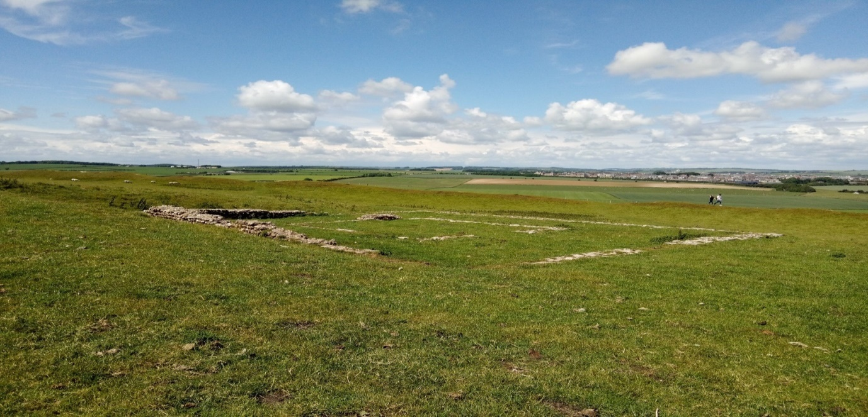
Figure 1: Remains of Romano-Celtic temple of unknown dedication viewed from a north facing vantage point.
The most time was spent at the locus of all but one sacred construction because it is contended that this space is where ritual activity is most likely to have occurred. This specific location of interest is to be found near the far eastern end of the bank barrow where the remains of a Romano-Celtic temple and priest house can be observed. The shrine hut is not visible.
Fig. 1 shows the outline of the Romano-Celtic temple to be clearly visible. The cella and portico are immediately identifiable as is the entrance that can be seen on the right side. Poundbury can be recognised in the background and the inclined slope of the northern flank of the bank barrow is situated behind the vantage point of the photograph.
The priest house is clearly identifiable in the next image (fig. 2). Again, Poundbury is visible in the background and the perimeter of north-east facing section of the Romano-Celtic temple is identifiable in the bottom left hand corner of the image.
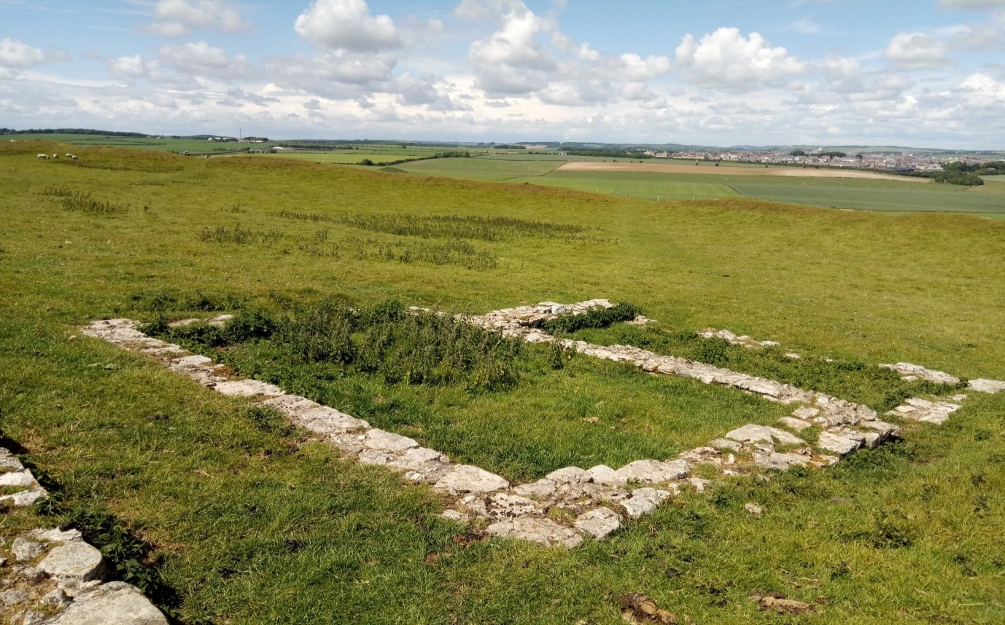
Figure 2: Remains of the priest house adjacent to the Romano-Celtic temple.
The Romano-Celtic temple was built after 367 AD and this is known due to coins found buried under the floor. The statue of a deity would have been situated in the cella and only accessible to the priest alone. Visitors would have glimpsed the statue of the deity from the portico. Importantly, those visitors would bring “small offerings which they hoped would encourage the gods to intervene on their behalf. Offerings were buried around the site and excavation of these temples often result in large quantities of artefacts, coins and votive tablets” (Sharples ,1991, p. 130).
A sketch map depicting both visible structures and the shrine hut was produced by Wheeler (1943) and is shown below (fig. 3):
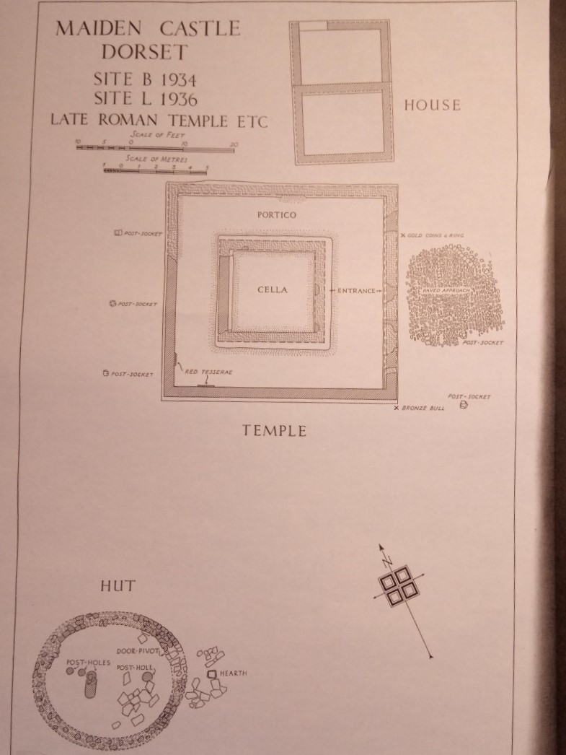
Figure 3: Sketch map of Romano-Celtic temple (Wheeler, 1943, plate XXII)
Usefully, Wheeler (1943) identifies where the bronze bull figurine (Tavros Trigaranus) was discovered and this will be referred to more fully in section 5.3. It seems probable that this artefact was ritually buried.
Standing in the centre of the cella and facing the entrance, the view of the surrounding landscape is extensive. Rotating in an anti-clockwise direction, the view remains panoramic until reaching the bottom left-hand corner shown on Wheeler’s sketch map. Continuing to rotate anti-clockwise from the bottom left-hand corner back to the entrance, the view is obscured due to the inclined plane of the bank barrow’s northern slope.
The wind was noticeably strong around the Romano-Celtic temple relative to other areas of the site. The relatively high altitude and surrounding local topography are conducive to this effect. The vibrancy and sense of elemental force is evident in this place and given the details described, it is understandable that this specific zone has been of religious interest, albeit intermittently from the early Neolithic to the end of the Roman period.
The Romano-Celtic temple is not located at the highest point and thus is not visible from all approaches. A degree of shelter is afforded by the northern slope of the bank barrow and this suggests that the temple was placed with discretion in mind. The impression was that the temple would have been a place of solitude and quiet reflection rather than collective ritual. It is therefore understandable that a singular sacred object be buried at the temple’s threshold perhaps by one Roman auxiliary from Gaul seeking preternatural favour.
5.3: Sacred object analysis
As previously stated, it was not possible to visit and handle the Tavros Trigaranus figurine excavated from Maiden Castle, so secondary sources of data were used to establish its attributes and characteristics in relation to agency, materiality, biography and memory.
The figurine measures 9.5cm in height and is described as “silver coloured” made from “tinned bronze” (Wheeler, 1943, p. 113). Wheeler (1943) identified on the sketch map (fig. 3) the location where the figurine was excavated outside of the south-eastern corner of the temple. One of the three busts is missing from the figurine but otherwise the artefact is in good condition.
An enlarged reproduction of the photograph found in Wheeler’s report is presented to further develop an understanding of the figurine’s attributes and characteristics.
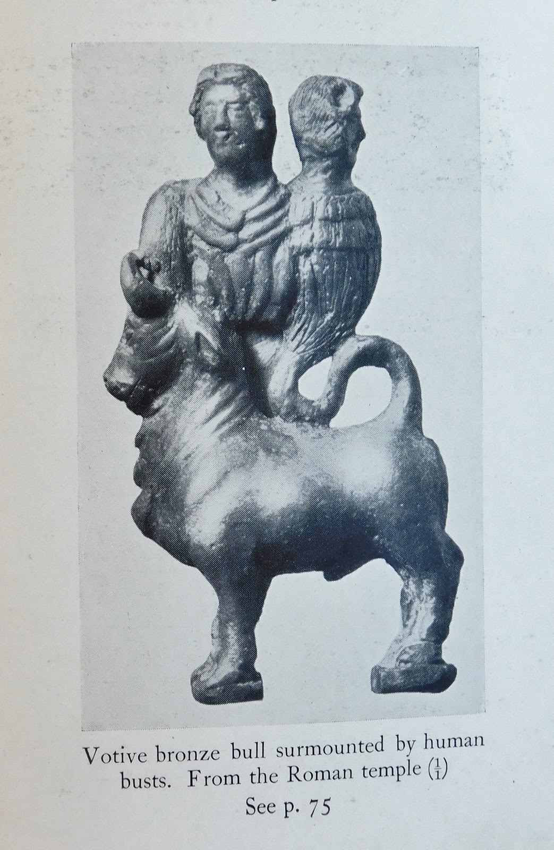
Figure 4: The Tavros Trigaranus figurine found at Maiden Castle (Wheeler, 1943, plate XXXI).
Henig (1984) describes the figurine as a “rich offering” and refers to it as representing “Tarvos trigaranos” which is a variant spelling from Wheeler’s (Henig, 1984, p. 49). Whatever variant of the spelling, the meaning is undisputed as the “bull with three cranes” (ibid). The common point of reference for artefacts depicting the bull with three cranes is the Pillar of the Boatmen of Lutetia found under Notre-Dame cathedral in 1710. It was dedicated to Jupiter and importantly the Roman emperor Tiberius (reigned: 14 – 37 AD), thus the Pillar of the Boatmen would have been produced during Tiberius’ reign. It stands 5.24m high and can be viewed at the Musee de Cluny in Paris:
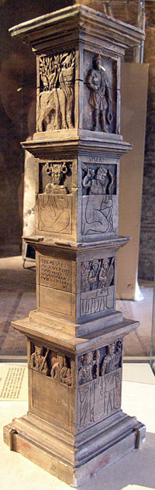
Figure 5: Pillar of the Boatmen of Lutetia (Wikipedia, 2020)
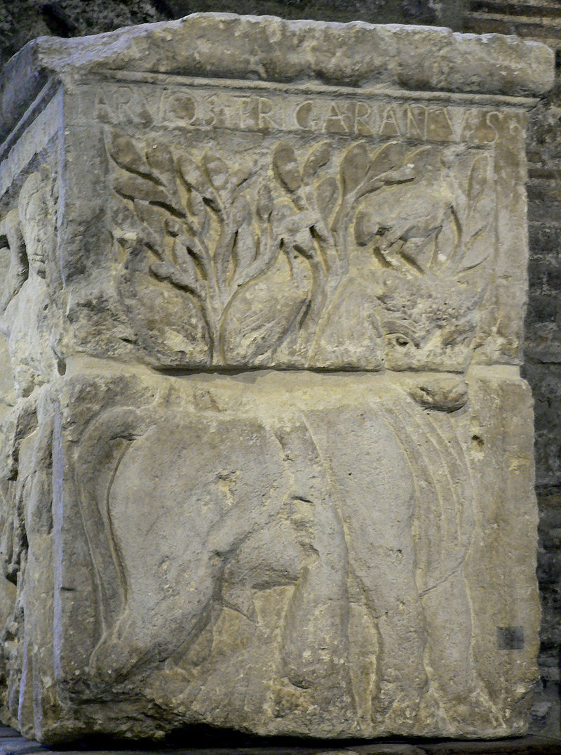
Figure 6: Close up depiction of the Bull with Three Cranes (Wikipedia, 2020)
The bas-relief depicting Tavros Trigaranus identified on the Pillar of the Boatmen (fig. 5) is shown in greater detail (fig. 6). Two cranes can be identified upon the bull’s back with the third on top of its head. The bull stands next to a willow tree (Salix alba) with the name of the deity written above the image. An array of Celtic and Roman deities are shown upon the Pillar of the Boatmen and this indicates the strong syncretism of religious iconography and practice in first century Gaul living under Roman rule.
By contrast, the Maiden Castle figurine is likely to date from the last quarter of the fourth century but given that it was found so close to a Romano-Celtic temple, the object too suggests a continuation of the syncretism embodied within the Pillar of the Boatmen. This raises questions as to who the object belonged, their religious beliefs and the object’s purpose. Those questions can only be addressed once the artefact’s characteristics and attributes have been fully established.
5.3.1: Interpretations of characteristics and attributes of Tavros Trigaranus figurine
Henig (1984) argues that the three human busts upon the bull from Maiden Castle represent harpies from Greek mythology. Harpies (Harpyiai) were wind spirits (diamones) that acted upon the commands of Zeus and were associated with the sudden removal of people and objects. If Henig (1984) is correct, then substituting three cranes for harpies suggests further syncretism embodied in this sacred object. The figurine thus presents itself as a composite of Celtic, Greek and Roman religious ideas and beliefs. Given the location of the object’s burial, it suggests that the figurine was an object of great significance and through it an understanding of the importance of the temple as a space of preternatural power may be inferred.
Green (2004) contends that there are parallels between the Maiden Castle figurine and the bull with three cranes depicted on the Pillar of the Boatmen because the cranes in the Maiden Castle figurine have transmogrified into human form. This flux of states between bird and human depicted on the figurine affirms the sacral importance of the object and preternatural motion. Both Henig (1984) and Green (2004) hold broadly compatible interpretations of the figurine but it is important to further unpack its Celtic symbolism to fully comprehend the cultural memory and materiality that the object holds.
The significance of three horns, cranes, or busts indicates the importance of triplism to the sacred form of Celtic objects. Green (2004) explains the importance of three as a sacred number for Celts and in the context of the bull acts to intensify its sacred potency. Horns were fertility symbols for the Celts and three would signify “a multiplication of the essence of a creature, its power, vigour and virility…. a natural way of increasing the symbolism” (Green, 2004, p. 180).
Similar to the Pillar of the Boatman, fig. 7 depicts a further example of a pillar (Treveran Stone) depicting the bull with three cranes that was found in Trier, Germany, located near the French border. The example from Trier shows the bull with three cranes discretely peering out from the foliage of a willow tree and this is compatible with the symbolism shown on the Pillar of the Boatmen but with one important difference. The Trier carving depicts a woodcutter in the foreground.
The woodcutter is the Celtic god Esus and can be identified because Esus also appears on the Pillar of the Boatmen with a separate bas-relief and name. Esus became associated with Mercury under the guidance of the interpretatio Romana and this deity is mentioned by the 1st century Roman poet Lucan in the Pharsalia as one of three merciless gods (Esus, Taranis and Teutates) worshipped by the Gauls.
Webster (1960) speculates that the three busts on the Maiden Castle figurine were the three Celtic deities: Esus, Taranis and Teutates. As interesting as this proposition is, Lucan is likely to have been writing for a Roman audience where the Gauls and their beliefs would be ‘other’ and subject to exaggeration. Given the classical features and style of the busts it becomes most problematic to identify these as a trio of Celtic deities.
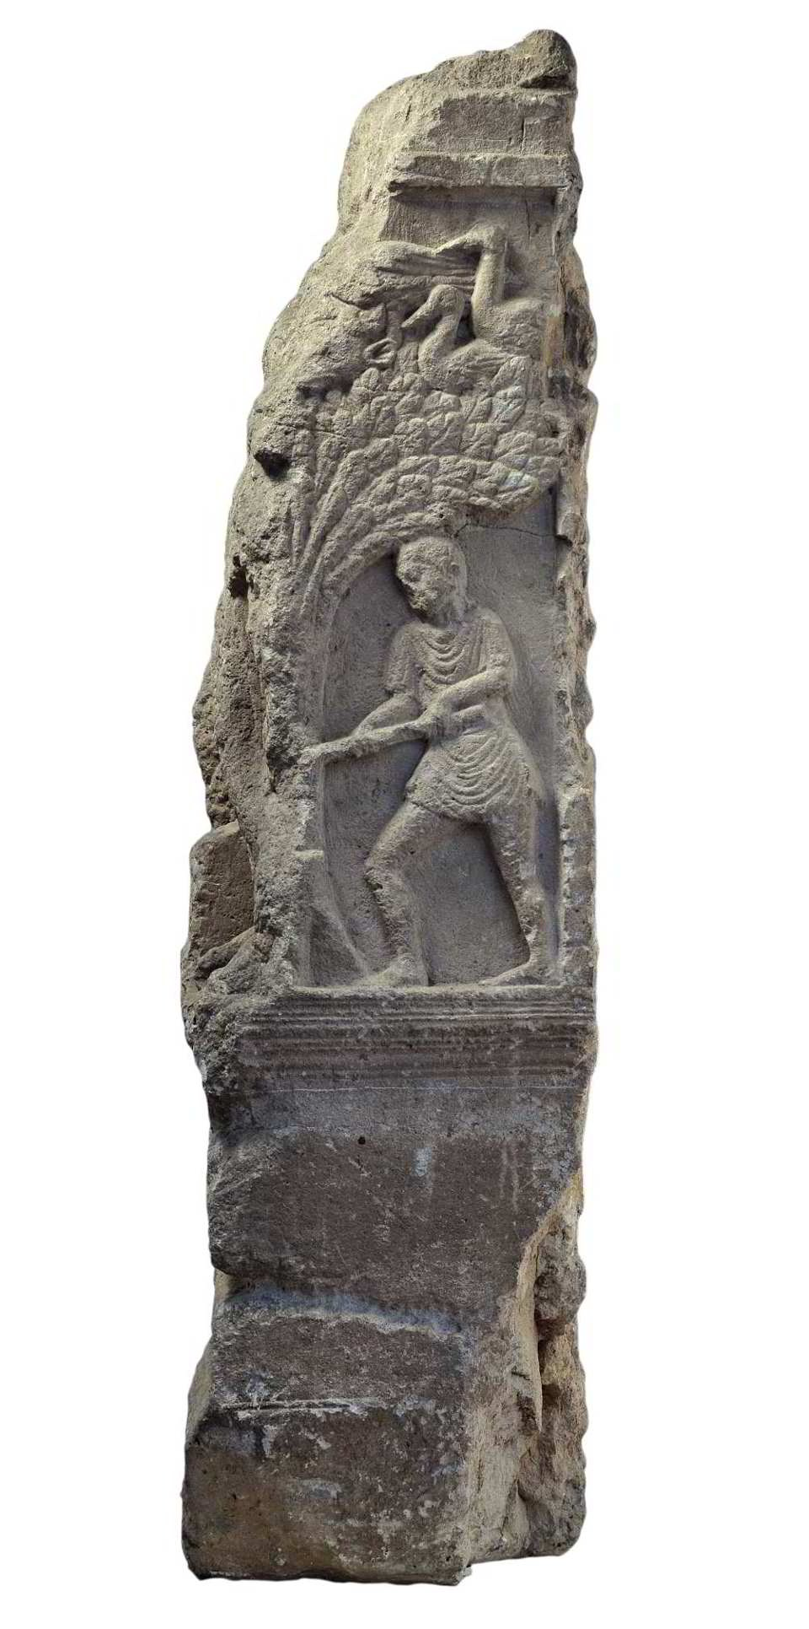
Figure 7: Treveran Stone showing a woodcutter (Esus) cutting a willow with a bull’s head peering out of the foliage with three marsh birds (Rhineland-Palatinate Museum, 2020).
Returning to the Pillar of the Boatmen, it is clear that Tavros Trigaranus and Esus are Celtic deities that have separate profiles and identities but why are these two deities depicted together at Trier? Esus symbolises strength, destruction and growth but it is unclear what preternatural part Tavros Trigaranus plays in the scene. It could be argued that marsh birds nest in willows and have a symbiotic relationship with cattle by removing and eating parasites found on the body. The role of Tavros Trigaranus as a water deity becomes possible in view of the bird and willow symbolism but this claim reveals no connection with Esus or the Maiden Castle figurine.
An alternative explanation that brings these disparate elements together is through examining the connection between Esus and Mercury. As a woodcutter, Esus fells trees that could be equated to human spirit/souls. The willow grows well near rivers and occupies a liminal boundary between static land and flowing water. The classical association of Mercury with boundaries and guide to the underworld can partially fit with Esus and the willow trees.
Mercury functioned as a psychopomp operating between the boundaries of life and death so could it be that in the Trier example, the birds collect the spirits of felled people depicted as trees and place those spirits, three at a time because that number is sacred, on the back of Tavros Trigaranus who awaits in the foliage to carry those three spirits into a sacred realm.
Should the three busts on the Maiden Castle figurine be harpies then these creatures too remove life from this world, so albeit speculative, a mythology that sees Tavros Trigaranus as a psychopomp transporting three spirits/souls from life to the otherworld is credible. At Trier, Tavros Trigaranus discretely awaits in the foliage for the felled to be collected by the birds and placed on its back to journey beyond the threshold of life (temporal boundary), then it is possible that buried outside the Romano-Celtic temple at Maiden Castle, the figurine too was placed at a threshold of sacred terrain (spatial boundary).
It should be noted that many other examples of the Tavros Trigaranus have been found across Western Europe with the greatest density located in France. There have been further examples of Tavros Trigaranus found in the UK but none with the three human busts. Neither, have examples with the three human busts been found in continental Europe. This suggests the uniqueness of the Maiden Castle figurine and its potential to shed light on the mythology that attends to Tavros Trigaranus.
To understand why the Maiden Castle figurine should be found in Dorset, it was reasoned that should there be other examples of the bull found locally then it would be valuable to examine how those examples compare. A further example of a Tavros Trigaranus figurine from Dorset now housed at Bridport Museum, Dorset, was identified, visited and examined. The artefact was handled under the supervision of the curator and photographed (see fig. 8):
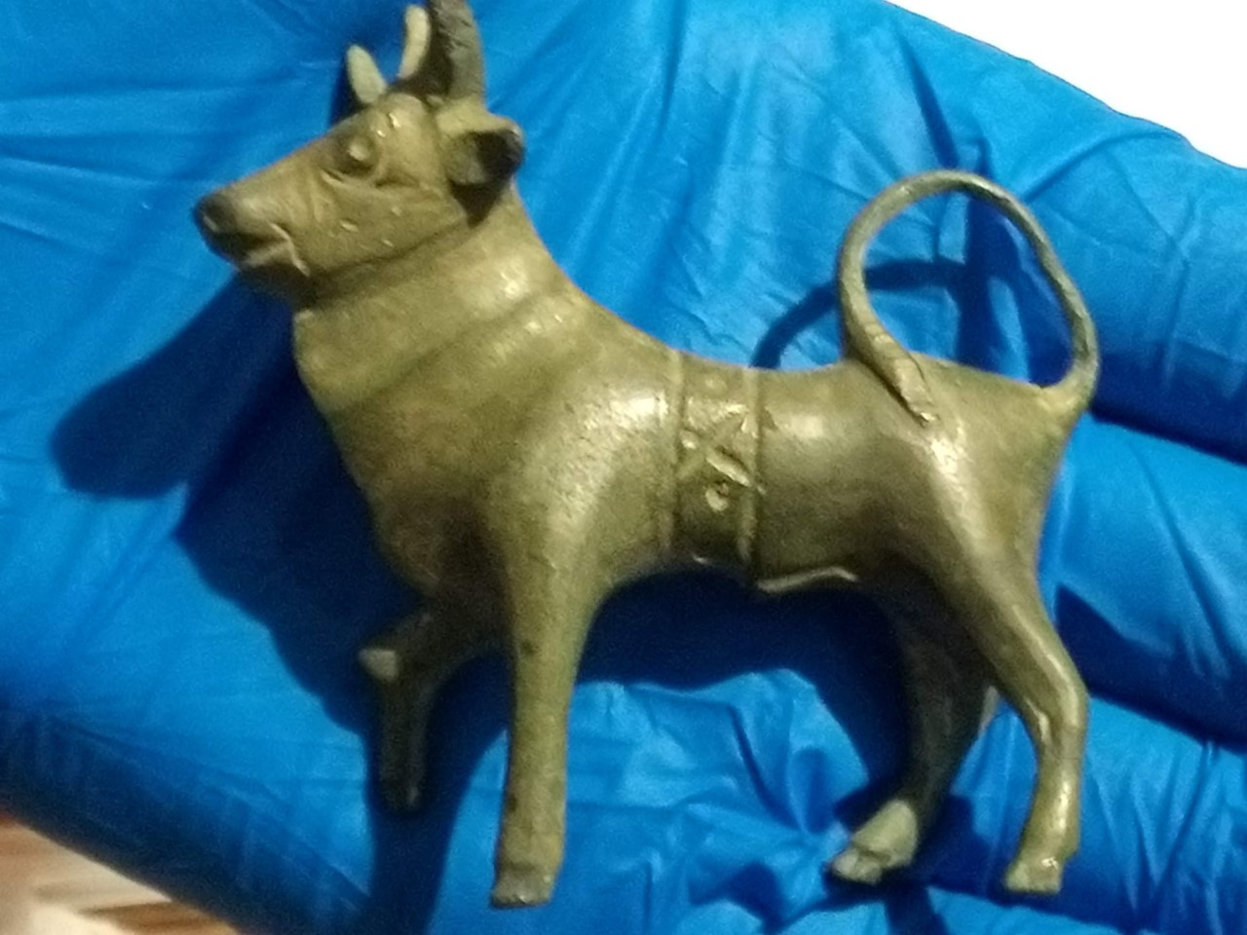
Figure 8: Three-horned bull excavated from the Roman fort at Waddon Hill, Stoke Abbott, Dorset, in 1959.
Waddon Hill and Maiden Castle are located 24km apart with both artefacts made out of bronze which is common for the three-horned bull (Green 2004). In the Waddon Hill example, the right fore-leg is elevated suggestive of movement, whereas with the Maiden Castle figurine movement is suggested by the human-bird creatures riding upon it. The tail and dewlaps show commonality for both examples. There are no hints of an avian connection with the Waddon Hill figurine other than it has three horns.
The Waddon Hill figurine exhibits a band (dorsuale) across the bull’s body which is not the case for the Maiden Castle example. Webster (1960) contends that the dorsuale is indicative of cult and sacrifice concluding that it was a religious object brought to Waddon Hill by Gallic auxiliaries noting that “not far off at Maiden Castle, was the temple where the god was venerated in the company of other deities” (Webster, 1960, p. 108).
There are further examples of three-horned bulls exhibiting a similar dorsuale that have been discovered. One example, a three-horned bull exhibiting a dorsuale was found in 2005 at Holbrook, Suffolk.
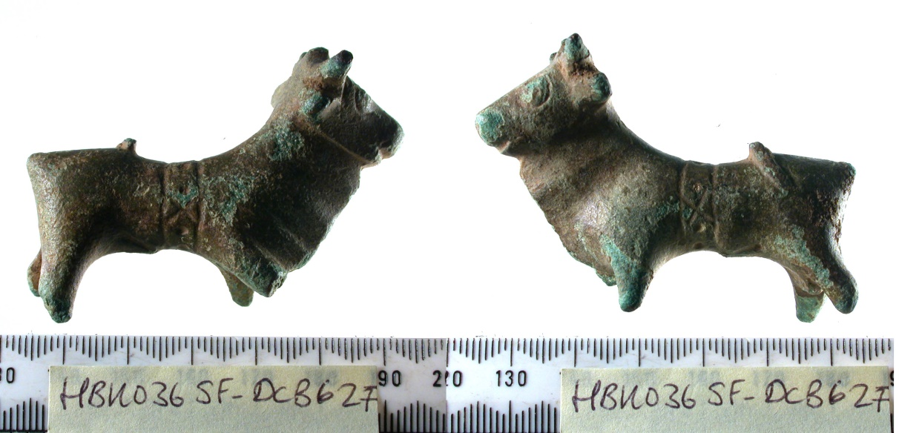
Figure 9: Three-horned bull found at Holbrook, Suffolk exhibiting a dorsuale (Minter, 2005).
It could be interpreted that the three-horned bull with dorsuale might represent a ritual substitute for the deity (Tavros Trigaranus). To deliberately bury the bull ex voto suggests that despite an expectation to worship the gods of the Roman state (e.g. Jupiter, Minerva, etc.) at the same time Gallic auxiliaries imported and worshiped their more personal tribal gods to the Iron Age hillforts of Dorset too.
The tombstone of Vellaunus Biturix, a horseman of a cavalry division (Ala Longiniana) in the reign of Claudius (10 BC - 54 AD) located in Bonn depicts the Gaul carrying a standard with the image of the three-horned bull. Haynes (2013) contends “that it is an interesting testimony to the manipulation of symbols in the Roman world that this regiment adopted a Celtic religious icon as a sign of its identity under Rome” (Haynes, 2013, p. 219). This suggests that the bulls from Waddon Hill and Holbrook were symbols of tribal, military and religious identity for those auxiliaries from Gaul who brought them. Perhaps those bulls were assertions of difference despite serving in Britain under Roman rule. Cult and the military are well attested in the Roman world (e.g. Mithraism).
The unique iconography of the Maiden Castle figurine remains distinct and unparalleled. It is now necessary to consider this figurine within broader mythological schemes to establish its function in the production of sacred space.
Discussion concerning that function will be drawn in conjunction with field interpretation to reveal more insight into the production of sacred space at Maiden Castle. This will follow in the next chapter.

6.0: Discussion
6.1: Early Celtic and Graeco-Roman mythological connections to Tavros Trigaranus
The mythology of Tavros Trigaranus has been interpreted from the Maiden Castle figurine and comparative figurines as well as bas-reliefs depicting the deity. The Maiden Castle figurine remains unparalleled to any other example and so it is necessary to extend further back to the figurine’s Celtic and Graeco-Roman mythological foundations to further establish its meaning.
Campbell (1964) associates Tavros Trigaranus with the Celtic myth of Cuchullin and the cattle raid of Cuailagne in which the goddess Morrigan steals cattle belonging to Cuchullin to breed with the brown bull of Cuailagne. One year after the first calf is born, the hero Cuchullin will die:
The goddess Morrigan, as an apparition of fate from the Fairy Forts of the Tuatha De Danann, is known as Badb, the crow or crane of battle, and, like the other goddesses of the Celtic, Germanic, Greek and Roman worlds she appears in triplicate.
(Campbell, 1964, p. 305)
Although the Celtic myth of Cuchullin and the cattle raid of Cuailagne is in no way a direct explanation for the figurine, it does link a bull with a goddess that can transmogrify into a bird. The likelihood is that these basic elements of the myth would have been in circulation across the Celtic world and retold with each new generation but can those basic elements be traced back further?
Burkert (1979) connects the Greek hero Heracles with possessing three horns. In the Cacus myth, Heracles on his return to Greece from taking the cattle of Geryon from Erytheia, slays the fire-breathing monster (Cacus) that dwells in a cave on the Aventine Hill. This is an old myth that predates Virgil’s telling of it and this is known because Heracles is depicted on a Daunian stela dating from the 7th century B.C. with three horns killing a monster (Ibid., p. 87). Moreover, a precursor to the Daunian stela can be identified in a Neolithic painting found near Porto Badisco, Italy, depicting a three-horned figure (Ibid., p. 92).
It is not proposed that the Maiden Castle figurine is a direct representation of Heracles or the figure from the cave painting but nonetheless it is a sacred object with a multi-layered cultural composition made from Celtic, Roman and Greek mythological elements that in turn were extracted from Bronze Age and Neolithic sources of myth. The Maiden Castle figurine is not merely a sacred object but a complex product of multiple cultures materially entangled across both space and time.
It is probable that the Maiden Castle figurine belonged to a prestigious Gallic auxiliary who despite being governed by Roman rule privately identified with their tribal Celtic roots. The figurine is elaborate and distinct compared to all other Tavros Trigaranus figurine examples. It is portable and made well suggesting that it was commissioned by someone of wealth and prestige. The Graeco-Roman style of the busts further suggests that the producer of the figurine had received classical instruction.
6.2: Connecting the Tavros Trigaranus figurine to the Romano-Celtic temple
Dorchester (Durnovaria) was a wealthy Roman town in the 4th century A.D. Many mosaic floors have survived which attests to the prestige of the arts as well as the calibre of the craftsmen visiting or residing there.
As to the figurine’s role with regards to the Romano-Celtic temple, it is worthwhile to consider the political and religious context in which the temple was built and its impact at the local level. Richmond (1963) contends that towns in the south of England, such as Dorchester were predominately Christian by 367 A.D. which pushed out cult worship from the town into the countryside.
The Roman-Celtic temple at Maiden Castle was constructed in that space due to the push factor of Christianity in Dorchester and the pull factor of prior ritual activity occurring in that space. Dorothy Watts reasons that old shrines, such as the Iron Age hut shrine at Maiden Castle “would usually suffice sometimes for one, two or even three centuries before a cella-and-ambulatory structure appeared” (Watts, 1998, p. 8).
It was these local push and pull forces that were responsible for the construction of the temple on adjacent land to replace the Iron Age shrine hut for ritual activity. Rahtz & Watts (1979) support the view that the Roman shrine hut replaced the abandoned Iron Age shrine hut but that the Roman shrine hut was constructed and used as a place of worship only after patronage of the temple had ceased.
The broader religious and political forces that produced the construction of the Romano-Celtic temple and ritual action were generated due to Emperor Julian (360-363 A.D) reviving the veneration of the old gods of Roman State religion. This challenge to Christianity officially ceased when Emperor Theodosius decreed that all temples should be shut and cults banned in 391A.D. The withdrawal from Britain of official Roman governance had occurred by 410 A.D., so the temple’s use may have been only two or three decades.
In sum, the biography of the Roman-Celtic temple at Maiden Castle was relatively brief. Ritual was administered by a priest but what those rituals were remains unknown. The syncretism embodied in the design of the temple and the Tavros Trigaranus figurine deposited at its boundary suggests heterodoxy of belief and identity drawn from varied mythological elements that potentially extended as far back as the Neolithic.
There are clear themes that persisted through different forms of mythological expression, such as the bull and three cranes. This small inventory of symbols was of enduring importance for centuries across the Celtic world. Those symbols became accommodated to Roman power but were not appropriated by it leaving room for tribal identity to be maintained.
This heterodoxy of symbols depicting Roman and tribal religious identities perhaps found further accommodation through shared ritual practices that were bound to Maiden Castle’s sacred space identifiable from earlier earthworks.
The Romano-Celtic temple stood in opposition to the rapid growth of Christian faith that had colonised the minds of powerful people in Rome as well as peripheral urban centres across the Roman Empire, such as, Dorchester. The rural location of Maiden Castle in the 4th century A.D. was a natural place for Roman and Celtic cult worship; it could only be construed as a sacred place within a landscape of power.
The religious uncertainty facing Dorchester made the depopulated Maiden Castle a fitting space to fulfil Emperor Julian’s demands without compromising the urban Christians of Dorchester. The popularity of Christianity in Dorchester at that time is attested by the nearby cemeteries found outside Poundbury that reveal graves with an east-west alignment.
6.3: The end of historical ritual performance at Maiden Castle
There is some piecemeal evidence of religious continuity after the decline of the temple and Roman shrine hut. Sharples (1991) points to the finding of four Christian graves to the west of the temple. These graves date from the late-Roman or post-Roman period. To the south-east of the temple was found a Saxon grave that was accompanied with a scramasax and knife. There is no further evidence of ritual practice after the Saxon burial. The Saxon burial signifies the closure of Maiden Castle as a sacred space from an archaeological perspective.
6.4: The episodic production and reproduction of sacred space
The evidence that Maiden Castle has been a site where sacred space has been produced and remade is considerable. Each episode of production through ritual performance has provided art, symbols and objects that bespeak of an attempt to connect with the Sacred.
The nature of the rituals enacted may have been seasonal and processional during the Neolithic exhibiting a character of public performance. Four millennia later, a Gallic auxiliary may have sought private ritual performance to assert identity in a foreign land under the command of an empire with an ex voto offering.
The space where the causewayed enclosure is situated at the eastern end of the bank barrow has acted as a centre for ritual performance. New technologies of belief were constructed in close proximity to this terrain episodically by people separated through time, technology, mythology and language but each materially entangled to each other through the sacred space made and remade within the same geographical terrain.
It could be argued that each historical episode of sacred space production exclusively served social ends, or that this geographical terrain served as an axis mundi through which the Sacred punctured profane space to form a renewed bond with homo religiosus. Whether through hierophany or social process, or both, the sacred space repeatedly made at Maiden Castle is a node in a meshwork of connections.
The gods housed and worshipped during each episode of sacred space production can only be guessed until the Roman occupation. The gods of the Iron Age remain unknown from the excavations and Watts (1998) contends that worship would not have gone much beyond genius loci. The spirit of place as a point of reference is most useful because it is sufficiently vague to permit countless forms of religious expression but at the same time ties those expressions to place. Roman, Greek, Celtic and Christian expressions were unambiguously imports but nonetheless sought to connect with the fixity of spirit of place.
English Heritage (2020) have utilised mobile phone technology to commission and make available for download an audio file that can be listened to while at the site (or elsewhere). The public can experience an immersive audio experience that is narrated by the genius loci of Maiden Castle. It could be argued that through audio augmentation, Maiden Castle again takes on a renewed religious dimension because individuals can encounter the space and listen to disembodied voices that purport to be from the past.
Space becomes storied which can be received by individuals as they move within and through the site. This action for some will be leisure but for others a private ritual to affirm their connection to the landscape and the historical spread of people that produced the site. Should it be contended that Maiden Castle possesses agency, then it must be multi-vocal and through its complex and changing history offer consolation or hope to those who seek it but with audio augmentation there is a danger that certain stories are retold and others discarded.
6.5: Trialectics and new technologies of belief
The audio augmentation commissioned by English Heritage (2020) has reawakened the site’s potential for religious fulfilment. The landscape suggests permanence but the phenomenon of space as process for those seeking the Sacred does change.
New space, not entirely physical or ideological is produced where the poetics of time, space and the individual culminate to form a personal encounter with place. It is argued that new sacred space is made through this process. There will not be physical monumental expressions of faith created for cultural, social and political reasons such as occurred in the past because the new constructions will be audio files and other forms of augmented reality.
Nonetheless, the production of sacred space within the framework of trialectics is only possible because of sacred constructions visible and recorded within the site. These different technologies of belief show how the physical apparatus of ritual changed through time but the purpose, to connect with the Sacred, remained constant. New technologies of belief will be portable, pocket-sized and downloadable. Considering the Tavros Trigaranus figurine, portable and pocket-sized has been a historically successful blueprint for personal technologies of belief.
6.6: Landscapes of sacred power
It has been shown that Maiden Castle is a complex site that hosted many episodes of religious activity. The temporal sequencing of the technologies of belief that have been produced or brought to Maiden Castle have been studied to show how the site has been subject to the push and pull of changeable human and material forces.
The sacred power of the landscape to shape human and material change is squeezed out of material entanglement theory to its detriment and merits discussion in terms of the findings for this site. The technologies of belief found at Maiden Castle were activated through ritual performance and together codified myth into praxis. In response to paradigmatic shifts of belief, those prior technologies of belief created a landscape of sacred power to which authority and legitimacy for the introduction of new myth and ritual could be accommodated.
There are practical considerations as to why the Roman Shrine hut was situated where the Iron Age Shrine hut once stood and the Romano-Celtic temple was built in an adjacent space. To visit the site the reason becomes obvious because the Romano-Celtic temple was too big to have been built where the Iron Age Shrine hut stood, so the temple was constructed upon the flattest nearby land. The Roman Shrine hut built after the Romano-Celtic temple fell into disuse also used the nearest flat space to the temple which happened to be where an Iron Age Shrine hut had been prior to the construction of the temple.
The Iron Age Shrine hut was built at the eastern end of the Neolithic bank barrow because the space was perceived to be imbued with preternatural power. In turn, the Neolithic bank barrow was constructed in that space because of the previous Neolithic causewayed enclosure.
Maiden Castle is a landscape of sacred power constituted of multiple technologies of belief and constitutive of changeable human and material forces. Its space is a process of remaking from the made. It is a thirdspace where myth and ritual; material and ideological; constraints and affordances are negotiated and find spatial expression as a landscape of sacred power.
Conclusions from this study will be presented in the following chapter.

.

7.0: Conclusion
It has been shown that Maiden Castle is a site where sacred space has been produced and remade by different ritual actors separated by place of origin, inventory of symbols, mythological knowledge, technologies of belief and time. Despite the absence of epigraphic evidence this research has demonstrated the dynamic sacred character of the site and how that has transitioned through episodes of decay and renewal punctuated by periods of ritual inactivity.
In response to Woodward (1992), this research has applied phenomenological methods and detailed object analysis directly to the Romano-Celtic temple and the Tavros Trigaranus figurine found at its boundary. This space and object together express the assertion of political, tribal and individual identities at the periphery of an Empire confronted by religious change.
Christianity was in the ascendant and despite Emperor Julian’s brief attempt to reassert the old State gods to accomplish political order this was soon extinguished. The habit to default to old myths and technologies of belief when confronted by the new is understandable because it suggests ancient authority and control but does not deliver it in the long-term. Hybridisation through religious accommodation is a more profitable political discourse and that is to some extent the religious signature of Maiden Castle.
The Roman hut may have been the final sacred structure on the site but it is the Romano-Celtic temple that expresses the fullness of the site’s preternatural potency that in part is derived from those earlier Neolithic and Iron Age technologies of belief that asserted sacred status upon the terrain. The Bronze Age bowl barrow at the western end of the bank barrow sits apart from the other sacred structures but its proximity to the bank barrow makes it a constituent of the site’s nested set of technologies of belief.
Each new technology of belief at Maiden Castle had been constructed in relation to the previous sacred constructions. A new iteration sits in relation to the iteration that came before it. Ritual can follow the same patterning thus seeking to restore cosmological order through acts of renewal. Myth has fluidity that can be solidified through ritual and technologies of belief to assert power to restore the cosmos. After many iterations of this process what remains is a complex of sacred power symbolically indexed within its landscape.
Eliade (1987) and Durkheim (2001) explanations for the production of sacred space are both valid and mutually supportive. Without the possibility of preternatural agency then myth is redundant and ritual meaningless. The social production of sacred space can only arise if ritual participants invest meaning in the movements, symbols, utterances and myth that support the social act. Both perspectives are necessary to explain how the landscape is invested with sacred power.
Given that the production of sacred space is iterative, there is no reason to conclude that the process has ended. New technologies of belief, such as smartphones and audio files could produce new iterations of sacred space production but privately and internalised. Individuals could embark on a personal pilgrimage; experience natural/preternatural forces, hear myths and stories of the past as they encounter the space. This research did not seek to discover how sacred space could be produced in the future but some consideration of that possibility and process would be a credible path for future research to follow and a useful augmentation to Woodward (1992) discussion.
This research has shown that through selecting a site rich in archaeological evidence that the process of sacred space production can be usefully studied using an array of theoretical perspectives. To understand the ancient religious character of a landscape and its sacred constructions, it is necessary to examine archaeological evidence as expressions of sacred power. The producers of sacred objects and sacred space did so for an array of social, psychological, political and economic reasons but what organised those human forces was belief in the Sacred and the need to express that belief.
It is the varying expression of belief inscribed upon space that explains why invading Romans decided to construct religious building over, or adjacent to, Neolithic religious structures. Hawkes (1954) pessimism is unfounded because expression of belief is a phenomenon that can be recovered from objects and spatial arrangements. This research has shown how new technologies of belief are spatially constrained by the old even though the actors, myths and rituals attending to those new technologies of belief are separated by hundreds or thousands of years.
Maiden Castle functioned many times from the Neolithic to the Roman period as a node in a meshwork of social power that sought stability from preternatural sources. It was this perceived capacity that set particular space apart from the rest of Maiden Castle. The production and use of that privileged space went through episodes of growth and decline but each episode has left evidence that in totality confirms the enduring capacity of this landscape to accomodate heterodox religious expression and frame how and where new sacred space could be produced within its interior.
This research has been an initial step into understanding the role of ancient religion at Maiden Castle and the importance of sacred space production to understanding that role. Future research could extend study and interpretation of other excavated objects from the site to further understand how myth and ritual changed between different episodes of religious use.
It would be valuable to consider other comparable sites to establish whether the archaeological evidence found from those sites could be used to support or contest the conclusions drawn from this study of Maiden Castle. Woodward (1992) discussion does not end with this research but becomes invigorated from it because Maiden Castle could now be regarded as a point of reference within this important archaeological discussion.

Bibliography:
Barrett, C. and Ko, I. (2009) ‘A Phenomenology of Landscape: A Crisis in British Landscape Archaeology?’ Journal of Social Archaeology 9(3), pp. 275-294.
Burkert, W. (1979) Structure and History in Greek Mythology and Religion. London: University of California Press.
Campbell J. (1964) Occidental Mythology. New York: Viking Press.
Connerton, P. (1989) How Societies Remember. Cambridge: Cambridge University Press.
Cosgrove, D. (1984) Social Formation and Symbolic Landscape. London: Croom Helm.
Cummings, V. and Whittle, A. (2004) Places of Special Virtue: Megaliths in the Neolithic Landscapes of Wales. Oxford: Oxbow Books.
de Certeau, M. (1984) The Practice of Everyday Life. Berkeley: University of California Press.
Durkheim, E. (2001) The Elementary Forms of Religious Life. Oxford: Oxford University Press
Eliade, M. (1987) The Sacred and the Profane: The Nature of Religion. Orlando: Harcourt
English Heritage (2019) History of Maiden Castle. Available at: http://www.english­heritage.org.uk/visit/places/maiden-castle/history/ [Accessed 12/10/19].
English Heritage (2020) Echoscape: Sounds and Memories of Maiden Castle. Available at: https://www.english-heritage.org.uk/visit/places/maiden-castle/echoscape/ [Accessed 24/06/20].
Fleming, A (1999) ‘Phenomenology and Megaliths of Wales: A Dreaming Too Far?’, Oxford Journal of Archaeology 18, pp. 119-25.
Fleming, A (2005) ‘Megaliths and Post-modernism: The Case of Wales’, Antiquity 79, pp. 921-932.
Fleming, A (2006) ‘Post-processual Landscape Archaeology: A Critique’, Cambridge Archaeological Journal 16, pp. 267-80.
Gale, J (2010). Prehistoric Dorset. Stroud: The History Press.
Gell, A. (1998) Art and Agency: An Anthropological Theory. Oxford: Oxford University Press.
Green, M. (2004) The Gods of the Celts. Stroud: Sutton Publishing.
Hawkes, C. (1954) ‘Archaeological Theory and Method: Some Suggestions from the Old World’, American Anthropology, 56, pp.153-68.
Haynes, I. (2013) Blood of the Provinces: The Roman Auxilia and the Making of Provincial Society from Augustus to the Severans. Oxford: Oxford University Press.
Heidegger, M. (1962) Being and Time. London: Blackwell
Heidegger, M. (1971) Poetry, Language, Thought. London: Harper.
Heidegger, M. (1972) ‘Building dwelling thinking’ in D. Krell (ed.), Basic Writings. London: Routledge.
Henig, M. (1984) Religion in Roman Britain. London: Batsford.
Hodder, I (2012) Entangled: An Archaeology of the Relationships between Human and Things. Chichester: Wiley-Blackwell.
Hodder, I (2016) Studies in Human-Thing Entanglement. Online: Creative Commons.
Husserl, E. (2012) Ideas: Introduction to Pure Phenomenology. London: Routledge.
Ingold, T (2007) ‘Materials against materiality’, Archaeological Dialogues, 14(1), pp 1-16.
Ingold, T (2016) Lines: A Brief History. Oxford: Routledge.
Jones, N (2017) Is Barbara Bender’s theory of contested space complemented by Christopher Tilley’s phenomenological perspective?, unpublished paper. UWTSD.
Jones, N (2019) To what extent can it be claimed that sacred space was produced at Catalhoyuk?, unpublished paper. UWTSD.
Kopytoff, I. (1986) The Cultural Biography of Things: Commoditization as Process. In A. Appadurai (Ed.), The Social Life of Things: Commodities in Cultural Perspective (pp.64-91). Cambridge: Cambridge University Press.

Leach, E.R (1983) The Harvey Lecture Series. The Gatekeepers of Heaven: Anthropological Aspects of Grandiose Architecture. Journal of Anthropological Research 39(3), pp. 243-264.

Lucan, The Civil War (Pharsalia), Books I-X.(trans.). Duff, J.D. 1962. Cambridge, Mass.: Harvard University Press.

Merleau-Ponty, M (2014) Phenomenology of Perception. Oxford: Routledge.

Miller, D. (2005) ‘Materiality: an Introduction’, in D. Miller, (ed.) Materiality. Durham & London: Duke University Press, 1-50.

Minter, F (2005) SF-DCB627: A ROMAN FIGURINE. Available at: https://finds.org.uk/database/artefacts/record/id/113949 [Accessed: 19/05/20].

Muir, R.J. and Driver, J.C. (2004) ‘Identifying ritual use of animals in the North American Southwest’, in S.J. O’Day, W. Van Neer and A. Ervynck (eds.), Behaviour Behind Bones: The Zooarchaeology of Ritual, Religion, Status and Identity, pp. 128-143. Oxford: Oxbow Books.

Oswald, A., Dyer, C. and Barber, M., 2001. The Creation of Monuments: Neolithic Causewayed Enclosures in the British Isles. Swindon: English Heritage Press.
Pearson, M.P. (2001) ‘The historical context of world religions’, in T.Insoll, (ed.) Archaeology and World Religion. New York and London: Routledge.
Pels, P. (1998) ‘The Spirit of Matter: On Fetish, Rarity, Fact and Fancy’ in Spyer, P. (ed.) Border Fetishisms: Material Objects in Unstable Places. New York and London: Routledge.

Rahtz, P. and Waats, L. (1979) ‘The end of Roman temples in the west of Britain’, in P. J. Casey (ed.) ‘The end of Roman Britain’, British Archaeological Reports, 71, Oxford.

Relph, E. (1976) Place and Placelessness. London: Pion Publishing.
Renfrew, C. (2005) ‘Material Engagement and Materialisation’, in C. Renfrew and P. Bahn, (ed.) Archaeology: The Key Concepts. Oxford: Routledge.

Rhineland-Palatinate Museum (2020) Holy Stone for Mercury and Esus. Available at: https://rlp.museum-digital.de/index.php?t=objekt&oges=5763 (Accessed: 19/05/20).

Richmond, I.A. (1963) Roman Britain, 2nd edn, Penguin: Harmondsworth.
Rowlands, M. (1993) ‘The Role of Memory in the Transmission of Culture’, World Archaeology, 25(2), pp. 141-151.
Seamon, D. (1979) Geography of the Lifeworld: Movement, Rest and Encounter. London: Croom Helm Publishing.
Sharples, N.M. (1991) Maiden Castle, London: Batsford.

Soja, E. (1996). Thirdspace: Journeys to Los Angeles and Other Real-and-Imagined Places. Oxford: Blackwell.
Tilley, C. (1994) A Phenomenology of Landscape: Places, Paths and Monuments. Oxford: Berg.
Tilley, C. (1999) Metaphor and Material Culture. Oxford: Blackwell.
Tilley, C. (2007) ‘Materiality in materials’, Archaeological Dialogues, 14(1), pp 16-20.
Tuan, Y.-F. (1974) Topophilia: A study of Environmental Perception, Attitudes and Values. New Jersey: Prentice-Hall Publishing.
Tuan, Y.-F. (1977) Space and Place: The Perspectives of Experience. London: Arnold.
Watts, D. (1998) Religion in Late Roman Britain: Forces of Change, London: Routledge.
Webster, G. (1960) ‘The Discovery of A Roman Fort at Waddon Hill, Stoke Abbott, 1959’, Dorset Natural History and Archaeological Proceedings, 82, pp 88-108.
Wheeler, R.E.M. (1943) ‘Maiden Castle’, Report of the Research Committee of the Society of Antiquaries XII, Oxford.
Whitehouse, H. (1992) Memorable Religions: Transmission, Codification and Change in Divergent Melanesian Contexts. Man (N.S) 27(4), pp.777-799.
Wikipedia (2020) Pillar of the Boamen. Available at: https://en.wikipedia.org/wiki/Pillar_of_the_Boatmen (Accessed: 04/05/20).
Woodward, A., (1992), Shrines and Sacrifice, London: Batsford Publishing.

This spelling was favoured by Wheeler (1943) and is retained in this submission.
Luc. : Pharsalia 1.445

