

Data Analytics and Visualisation
Cody John,
Applied Computing HND
Lecturer: Cat Wilkes

Statistical Analysis of Retail Performance Report

Table of Contents
1.Introduction 2
2. Descriptive Statistics 3
2.1 Question 1: 3
2.2 Question 2: 5
3. Inferential Statistics 7
3.1 Question 3: 7
3.2 Question 4: 9
3.3 Question 5: 10
4.References 11
5.Appendacies 12

1.Introduction

I have been introduced to a retail company that operates multiple stores across different cities. They require me to provide statistical analysis of their sales data to gain insight into their stores' performance and to reevaluate their business decisions. The company wants me to provide a statistical report on their sales data and insight with correct documentation and evidence of each store and conclude the differences and what they represent. Creating visual insights will also help understand the statistics. Appendices are at the bottom of this report.

2. Descriptive Statistics

2.1 Question 1:
I have investigated the data and have carefully constructed a report of the store data and have provided excel documentation to discuss further data analysis. The data shown will provide a significant insight into what is going on in each store.

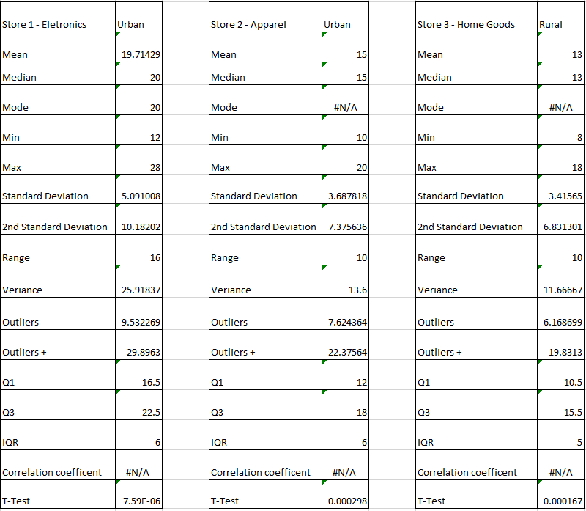

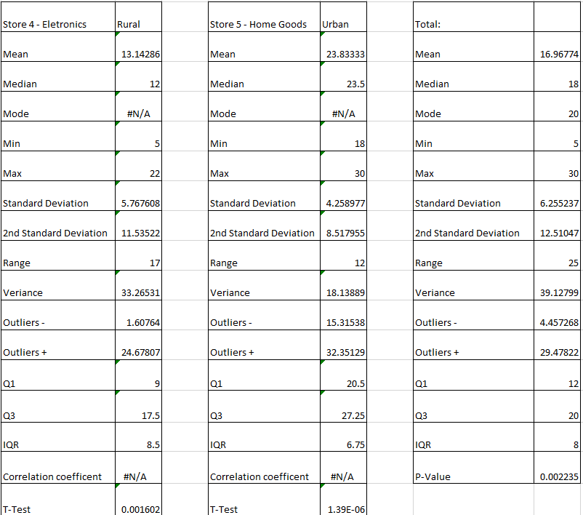
Diagram 1 – Statistics of each store's performance and total

The example above explains that store five brings a higher average income than store three, this can be a multiple of conditions such as the type of product, ratings, and location. As seen in the statistics above the store with the lest average sales is store three, the reasoning for its low number may be because of the location, as store three is based in a rural area which shows that there is an insufficient number of sales being distributed, which explains the low statistic. However, looking at both store five and three they both distribute the same product, and store five is performing significantly better as sales distributors can quickly and efficiently access the store's facilities.

Taking consideration of the sales between store three and five shows that there is a substantial separation between the minimum and maximum number of sales. For both stores they are close to the mean, indicating they have a small variance. Finding out the range and variance can help understand and compare different types of data. We can also calculate the standard deviation which can prove that its either close or far from the mean.

As observed in Diagram 1, we can see the overall given outlier shows that there may be potential outliers in the data set, this could mean that it can have a disproportionate effect on the statistical results, which can mislead predictions when analysing data. Outliers are normally considered to be abnormal data as it outlies the lower and upper quartile range.

2.2 Question 2:
To ensure the performance of each store I need to calculate the 75th percentile of each store to measure the sales performance. Calculating the IQR can prove how consistent your data is, for example in store four the IQR is the highest out of all of them, this means that the data is less consistent and is skewed, which proves that the store isn’t performing well.

Calculating the 75th percentile can provide a robust measure in capturing the performance of stores in the upper range of the sales distribution. Higher values at the 75th percentile indicate a stronger sales performance highlighting stores that perform well, such as store one in electronics, as it has a higher Q3 than store four indicating that the first electronic store is preforming better than store four. For beneficial sale strategies it would be useful to identify the stores that are high-performing and that gaining insight into strategic decisions, such as promotional activities, product offerings and staff allocation.

Analysing the location of the store can also be a leverage into how you approach these strategies. As there is a significant difference between rural and urban locations. I have looked at a recent research study surrounding links between sales promotions, benefits and consumer perceptions between rural and urban consumers. It says that both urban and rural can attract sales promotions whether it is hedonic or utilitarian. Which satisfies both obtainability and support for people who are urban and rural. They also conducted a questionnaire to verify what creates more comfort and obtainability to consumers, they found out that customers in rural areas prefer a utilitarian approach as stores that are long distanced may be subjected to availability issues, and urban customers are more attracted to the benefits of hedonic sales promotions, and logically individuals will have a higher income living in more populated areas [1].

3. Inferential Statistics
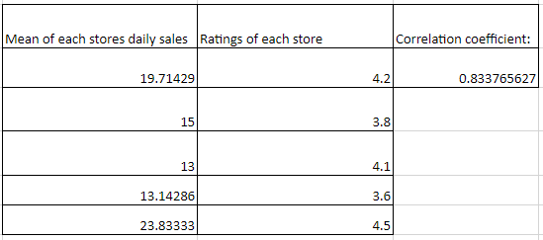
Diagram 2 – Relationship between the average daily sales and each store’s rating

3.1 Question 3:
The company what’s to assess the relation between the customer rating and the average sales performance. There are multiple ways to find this out such as calculating the average daily sales to the customer ratings. This can prove some problems in this scenario as for each store there is only one rating, so to get around this I used the CORREL function for all of the average means of the stores, and each of the store ratings which prove the figure given in Diagram 2.

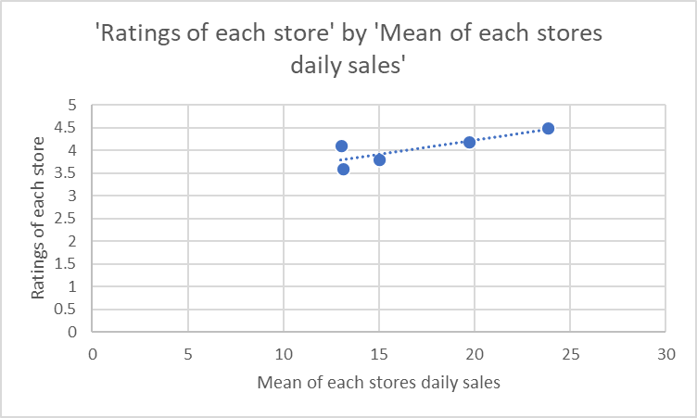
Diagram 3 – Plotted graph of the correlation between mean of daily sales and ratings

The relationship between the average store’s daily sales and has given a number of 0.833765627, which indicates an almost perfect positive correlation, which can mean that when one variable change, the other variables change in the same direction. What we can take from Diagram 3 is that it does appear to be following the trendline, however it can be argued that the plot with a 4.1 rating and 13 mean (which is store three) can be seen to slightly deviate from the trendline, which could indicate false or abnormal data. In this circumstance the correlation is close to the relationship between both criteria.

Looking at the data there can be a room for improvement, recommendations to improve customer ratings, and sales performance. Recommendations such as enhancing customer engagement, which can provide personalised promotions and targeted communications based on customer preferences and requirements. Data-Driven decisions can establish an insight from sales data and customer ratings to guide decision making, and to adapt strategies based on customer trends and preferences. Prioritising a holistic and utilitarian approach that considers both customer satisfaction and sales performance is a blueprint of success.

3.2 Question 4:
To test whether there is a significant difference in the sales performance between two groups of stores and verify the analytics between urban and rural areas. Firstly, we have to develop a null and alternative hypothesis to determine whether the evidence gathered supports or rejects it. In this circumstance there is no difference between how rural and urban stores preform in daily sales. If this statement is false and there is a difference, this is the alternative hypothesis. To prove that there is a difference I will need to perform t-tests to evaluate the significance. I am 95% confident that the statistics lie in this range, and that anything outside of it should be rejected. The t-tests have shown a p-value of 0.02235. This proves that the p-value is less than the significance level (0.05). With this conclusion we reject the null hypothesis as there is a significant difference between how rural and urban stores preform in daily sales.

With these findings it proves that the alternative hypothesis was correct. The clear difference in daily sales performance between both locations was initially and statistically proven by the t-statistic, and that there was significant difference in all product categories. Possible action for the company would anticipate the reasoning of the difference in sales, as doing this can provide insight into what business should and should not be doing based on their utilitarian locations. I have looked into a journal article that discusses business decision-making based on their location. They point out that sophisticated software has enabled smart decision-making for business, and can sort through a list of effecting conditions, such as property costs, transportation, specialised services, tax structures/subsidies, personalised engagements, and social norms. All these points can hinder store owners’ placements and decisions. Their main key findings were that businesses that are in urban areas are more likely to target people who are more positioned on the cost spectrum, and that businesses that try to settle or relocate continuously fight against the global market [2]

3.3 Question 5:
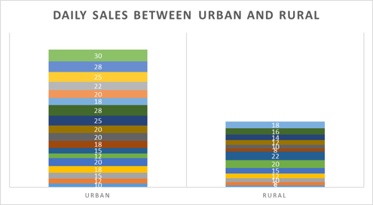
Diagram 4 – Visual representation of stores performance for urban and rural locations

I have created a stacked bar chart to visualize the distribution of product categories across both urban and rural areas. Looking at Diagram 4 it can present that there are more daily sales being made in urban store locations than rural. This can be due to an array of reasons, such as availability, product importance, and customer useability. However, this is what was provided to analyse and evaluate.

To provide a visual display of the daily sales and ratings I have already generated a scatter plot above in Diagram 3. This shows us that the more the average mean is the higher the rating is as with any business the higher the ratings the more income they will receive. Each plot represents each store that is dictated by the average daily sales of each store, and the overall ratings. The store with the most noticeable difference in these categories is home goods store five and three.

4.References

[1] | P. V. Somesh Kumar Sinha, “The Link Between Sales Promotion's Benafits and Consumers Perception: A Comparative Study Between Rural and Urban Consumers,” vol. 1, no. 5, p. 17, 2019.
[2] | Natalie Cohen, “Busines Location Decision-Making and the Cities: Bringing Companies Back,” vol. 1, no. 1, p. 29, 2000.

5.Appendacies

Diagram 1 – Statistics of each store's performance and total

Diagram 2 – Relationship between the average daily sales and each store’s rating

Diagram 3 – Plotted graph of the correlation between mean of daily sales and ratings

Diagram 4 – Visual representation of stores performance for urban and rural locations

