

ACFA7004 – Postgraduate Research Methodology

Research Proposal

Continuous Improvement, using
Microsoft Teams, and Remote Working in NHS Wales


Submission Date: 15th April 2021
Tutor: Chris House
Student ID: 2012817
Table of Contents

1.0 Introduction 3
2.0 Literature Review 7
2.1 Remote Working and Continuous Improvement 7
2.2 Microsoft Teams Platform 9
2.3 Continuous Improvement and Microsoft Teams Function 12
3.0 Methodology 20
3.1 Questionnaires 22
3.2 Interviews and Observations 24
3.3 Work Schedule 25
4.0 Results 26
5.0 Evaluation 27
6.0 References 28
7.0 Appendices 41
Appendix 1 41
Appendix 2 45
Appendix 3 47

Figure 1- Microsoft Project integrated with MS-Teams (Spataro, 2019) 10
Figure 2- Microsoft Visio accessed through MS-Teams (Goyal, 2020) 11
Figure 3- OneNote example of Ink to Text (Stratvert, 2020) 11
Figure 4- Deming's PDSA - The Deming Institute (2021) 13
Figure 5- Basic statistical methodology for quality - Evans and Lindsey, 2008 14
Figure 6- Fishbone Cause and Effect Diagram - NHS Improvements 2020b 15
Figure 7- Pareto chart showing kinds of surgery - NHS Improvement, 2018b 16
Figure 8- Five Whys worksheet - Serrat, 2017 17
Figure 9- Swim lane activity diagram of a simplified patient discharge process - Jun et al. 2009 18
Figure 10- The Research Onion - Saunders, Lewis and Thornhill, 2018 20
Figure 11- The action research process - Saunders, Lewis and Thornhill, 2019 21

1.0 Introduction

On the 19th September 2019 the Welsh Government (2019a) announced the need to make the NHS Wales Informatics Service (NWIS) a Special Health Authority in its own right, enabling it to more effectively deliver the digital technology to support A Healthier Wales (2019b). NWIS become Digital Health and Care Wales (DHCW) on the 1st April 2021 (DHCW, 2021), suggesting the importance of the digital work in healthcare and also determining the need for this proposal to use both NWIS and DHCW documentation as supporting evidence.
What was once NWIS, and is now DHCW, designs, builds and implements digital services for health and care in wales. These services or systems most often require forms of continuous improvement (CI) practices for completing tasks like benchmarking, process analysis, process re-design, change management and staff training pre, during and post new system deployments (NWIS, 2021 and Withers et al. 2020).
Each service or system is structured and controlled as individual projects, which are categorised into one of 4 workstreams and reported to Welsh Government on an Integrated Medium Term Plan (IMTP). Welsh Government expects IMTP’s to comply with the duties and spirit of the following legislations (Welsh Government, 2020a):
- The NHS Finance (Wales) Act 2014.
- The Well-being of Future Generations (Wales) Act 2015.
- The Social Services and Well-being (Wales) Act 2014.
- The Public Health (Wales) Act 2017.
- The Nurse Staffing Levels (Wales) Act 2016.
- The Regulation and Inspection of Social Care (Wales) Act 2016.
- The Welsh Language Measure 2011.
- The Equality Act 2010.
The DHCW IMTP, before the Coronavirus pandemic, for the period 2019 to 2022 documented 50 main digital projects spread across 4 workstreams (NWIS, 2019).
On the 12th March 2020, the Welsh Government (2020b) issued a statement to inform the public that the World Health Organisation (WHO) had declared coronavirus a pandemic, specifying its abbreviation COVID-19. The following day, Welsh Government (2020c) publicly announces emergency restructuring measures of NHS Wales to cope with the oncoming pandemic; and appropriate NHS staff were instructed to work from home.
The IMTP following these imposed working restrictions, for the term 2020 to 2023, seen digital projects reduced to 26, and later reduced further (NWIS, 2020). Not all these project reductions resulted from remote working, some were to release resources to work on new COVID-19 related projects and some to redesign the infrastructure to cope with homeworking. More research will be required to establish which projects paused because of reduced CI practices. Further evidence by Stride (2021) indicates Improvement Cymru, the all Wales improvement service for NHS Wales, has also reduced its CI activities and re-deployed its staff to support COVID 19 tasks through Public Health Wales (PHW).

The importance of this topic and its relevance to current ways of working is still emerging. The DHCW COVID-19 homeworking restrictions are still in place and there is still world uncertainty about the pandemic and organisational strategic planning (WHO, 2021; Conerly, 2021).
The Welsh Government (2020d) announced it is aiming for thirty percent of the Welsh workforce to work remotely long term, while emerging evidence from DHCW investigations suggest more than fifty percent of their workforce will work remotely long term (Stone, 2021). This suggests remote working is establishing itself as a credible long-term way of working.
Clochet (2020) interviewing Shell’s Continuous Improvement Manager, Gerard Poolman, highlighted the global organisations rection to COVID-19 by pausing CI to manage the crisis. However, Poolman quickly realised remote working increases the need for CI, and its ways of working must be adapted to suit.
There is little academic research currently available for CI practices conducted and managed while working remotely, and McKinsey (Bick et al. 2020) is suggesting businesses need to quickly invest in long-term remote working practices to compete in this rapidly emerging ‘Next Normal’.

Microsoft Teams (MS-Teams) is extensively been used to keep organisations working from home, accelerated by the COVID-19 pandemic, seeing two years transformation in two months with 115 million daily active users. The platform has evolved to include multiple facilitative functions, enabling virtual meetings, collaborative design, virtual school classrooms, collaborative file sharing and wellbeing experiences to address employee stress and burnout, recognising the negative effects on emotional health and wellbeing (Hamilton, 2021; Spataro, 2020).
More specifically to the NHS, clinicians such as Dr Sarah Blackstock (2021) suggests MS-Teams has had a significant role in secure clinical communication, sharing clinical information, aiding multi-disciplinary team meetings, patient consultations and virtual medical education. In a non-clinical context, Teams is used as the main tool for communication, collaborative file sharing and editing, e-learning and point of access to a wider range of Microsoft applications (DHCW, 2021).

While it is assumed access will continue to the relevant NHS subject matter experts and that existing equipment will be available for the research, there are some limitations to consider before discussing what the research sets out to achieve.
Should the pandemic resurge during this research, the NHS employee workloads may prohibit their participation in interviews or experiments.
Organisation culture will probably be a contributing factor to remote working CI. Consequently, culture would be recognised and discussed but not researched in depth, adhering to realistic timescales.

This research will investigate if there is a way CI can continue, by staff working remotely, by completing the following three objectives in order to answer the research question “To what extent can remote working, using Microsoft Teams, support continuous improvement in NHS Wales”:
- As a result of the COVID-19 pandemic, how and to what extent has remote working affected NHS Wales continuous improvement?
- Determine if the current Microsoft Teams infrastructure in NHS Wales is capable of supporting its Continuous Improvement techniques.
- Develop recommendations as to how continuous improvement practices, and Microsoft Teams function, can be adapted to support continuous improvement remotely.
Rather than taking a post-Positivist approach (O’Leary, 2017), the following hypothesis is included in conjunction with objectives because this is what this research will strive to prove, disprove, or lay foundations for future research.
NHS Wales personnel can support and progress continuous improvement activities remotely, using Microsoft Teams, when used within an organisationally accepted procedural framework.
Supporting this investigation, contemporary literature and source materials will be reviewed to contribute existing knowledge to this research (Hart, 2018), providing conclusions, recommendations and limitations, contributing to existing knowledge.

2.0 Literature Review

Reviewing the literature representing established ideas and contemporary thought is an essential exercise of research (Hart, 2018, pp.1-29). It allows the researcher to understand others work already conducted on the topic (Bryman and Bell, 2019), and provides a broader context, helping form significant questions and fresh ideas (O’Leary, 2017). While Blaxter, Hughes and Tight (2010) warns the review should be a very selective process to avoid overload, consideration must be given to wider scanning to establish where relevant boundaries lay (Saunders, Lewis and Thornhill, 2018).
Using a mainly systematic, deductive approach (Saunders, Lewis and Thornhill, 2018) the research will be tested with available data, accounting for concern on using reliable, relevant information (Blaxter, Hughes and Tight, 2010). Relevant literature to this proposed research has been categorised into the following three subheadings.

2.1 Remote Working and Continuous Improvement

McKinsey & Company are advising organisations to adopt a more agile approach to strategic workforce planning, because “remote working, where possible, is here to stay” (Bick et al, 2020, p.3). Research by Robinson (2020, p.1) supports this, suggesting remote working is reshaping a “new future world of work”, breaking down emotional barriers with conference calls in family settings and imposing leadership from afar.
The ability to perform CI practices while working remotely will be wider than just DHCW. For instance, many of the DHCW projects link with initiatives like A Healthier Wales, jointly launched by Health Education and Improvement Wales (HEIW) and Social Care Wales, and will require new and additional ways of working across organisations (Welsh Government, 2019b; Welsh Government, 2019c; NWIS, 2020).
The Welsh Government (2019b, pp.15-16) plan for A Healthier Wales is ambitious, aiming to future proof the health and care of the nation. Making up the National Transformation Programme, there are four key interlocking aims, or “Quadruple Aim”, to steer the changes needed:
- Population Health and Wellbeing
- Health and Social Care Services
- Health and Social Care Workforce
- Higher Value Health and Social Care
One expected outcome from this programme, while adhering to Value Based Health Care (Withers, 2020; European Commission, 2019; Welsh Government, 2020a), would be to make assistive technology available in the home to link with NHS systems to monitor the health of individuals by 2028. The ambition of this programme alone suggests the pace at which improvements are required, so reducing ongoing projects in DHCW could have implications for generations of the population. Further investigation will be conducted to determine what implications the COVID-19 delays may have had to this programme and its contributing work from DHCW.
Literature has started to emerge relating to remote working and CI. However, much of this literature is in the form of blogs or corporate sites, attempting to offer insight like setting clear expectations, aligning goals, safeguarding culture and being mindful of wellbeing (Millard, 2020; Prior, 2021). Although culture is a significant aspect of change (McCalman, Paton and Siebert, 2016), and reflected in an organisations Cultural Web (Johnson, Scholes and Whittington, 2008), these blogs are not addressing real issues like getting a virtual team to produce a value stream map. While this literature is pertinent, it isn’t sufficiently insightful to the new dynamics of remote working. Another emerging factor for closer examination is the perceived prevalence of remote working being detrimental to mental health and wellbeing (Health and Safety Executive, 2021).
McCalman, Paton and Siebert (2016) previously acknowledged the web, global connection, and galvanising crisis events could play a part in the future of CI practices, it is not specific to remote working. Hayes (2014) suggests initial face to face participation is a key factor to teams accepting change and forming trust, perhaps building on Tuckman’s (1965) forming, storming, norming and performing. Further research is required to determine to what extent initial face to face meetings are required for remote working CI.

2.2 Microsoft Teams Platform

MS-Teams is a proprietary chat based workspace built on the Office 365 secure cloud based platform. It has secure videoconferencing and file storage and collaboration functions, it is also integrated with other applications like OneNote, Planner, Power BI and Outlook (Microsoft, 2016; Microsoft, 2021; DHCW, 2021). This research will investigate appropriate applications connected to the MS-Teams platform; however, it should be recognised that many other connected applications exist.
MS-Teams integrates seamlessly with Microsoft Outlook and contacts, allowing quick access to all meetings, contacts, tasks, allowing intelligent communication through work group channels (Woods et al. 2019). Communication is a key element of CI along with the common understanding of the information contained within it (Thompson, 2018). While Mengella (2019) agrees with some of the benefits being discussed, he also stresses MS-Teams can appear to have a confusing structure, because it is different to what users are accustomed to, and transitional set up can be complicated.
Lee and Chan (2020) suggests MS-Teams’ Live Event function provides a stable platform that provides live presenters the ability to present e-learning and open communication to an audience of thousands. These events can also be recorded for later consumption, via Microsoft Stream, by a wider audience (Ozer, 2019). This could be the means of instantaneously reaching teams in several locations, pre, during and post system go-live events to monitor the CI practices or communicate issues, so deeper research is required.
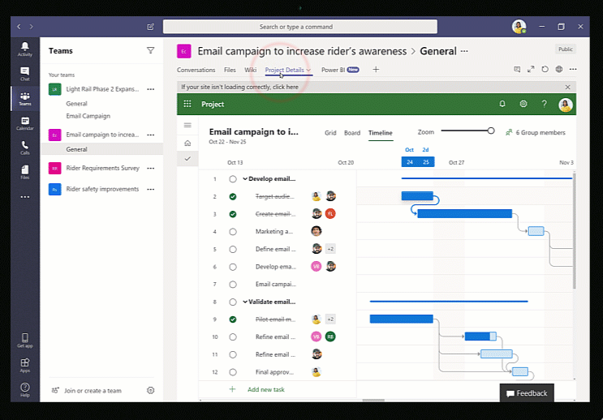
Spataro (2019) informs of the latest release of Microsoft Project and its integration with MS-Teams, suggesting team members in multiple locations can collaboratively work on the same tasks simultaneously (Figure 1).
Figure 1- Microsoft Project integrated with MS-Teams (Spataro, 2019)

A published update by Goyal (2020) informs of integrating Microsoft Visio with MS-Teams, allowing multi-location stakeholders to co-author process maps, flow charts and diagrams (Figure 2). This will be an important application to consider, since it has many useful tools associated with CI and change management (Barang, 2016; Microsoft, 2019). However, attention should be drawn to Wali and Othman’s research (2019) indicating the complexity of Microsoft project and the need for user training. Microsoft Project and Visio are commonly used tools by CI and Business Analyst teams currently and further research would be required to determine the extent of their use in the wider NHS.

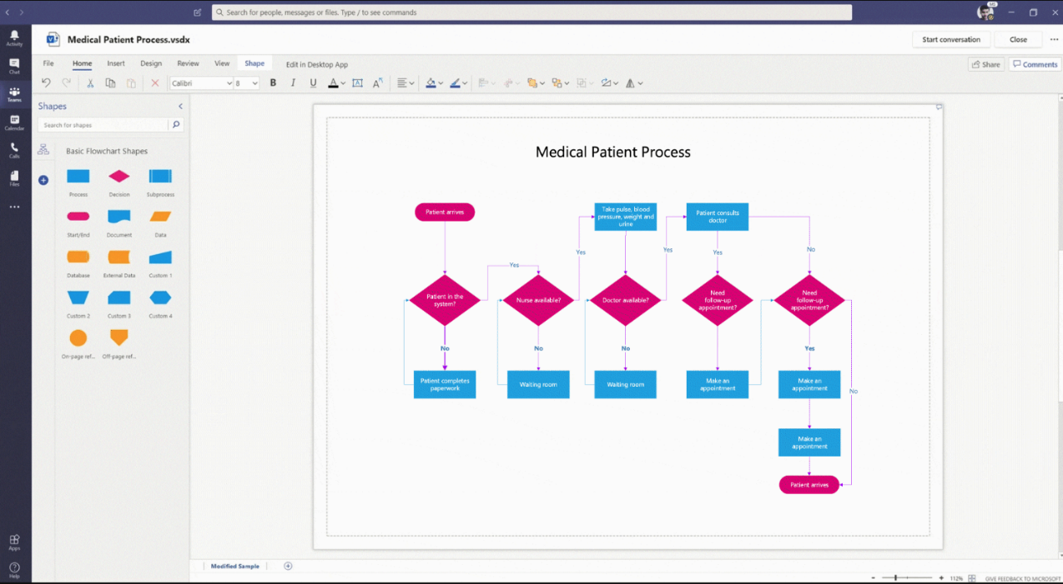
Figure 2- Microsoft Visio accessed through MS-Teams (Goyal, 2020)
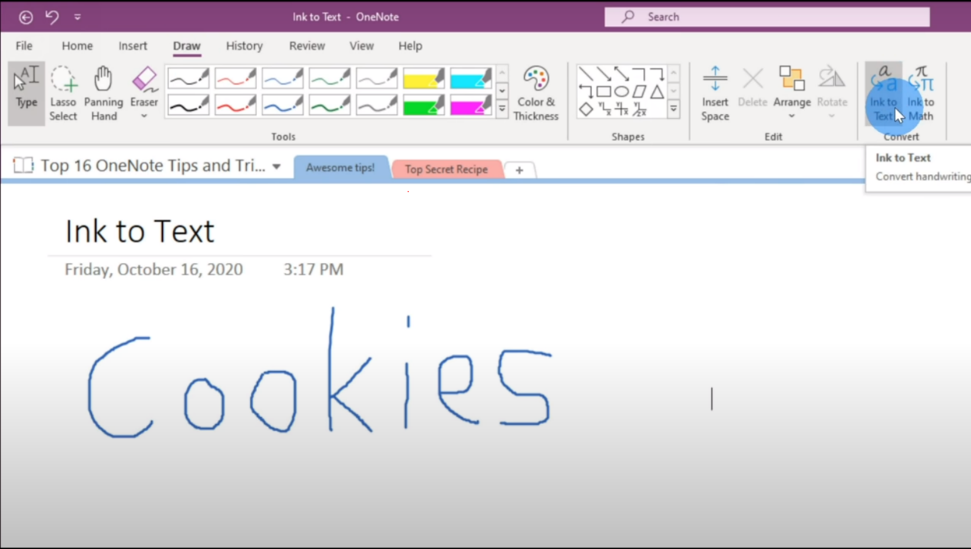
Microsoft OneNote shows good potential for use with CI activities, and this is enhanced when used through MS-Teams. It could be a way to immerse stakeholders and facilitate progressive participation. Capturing meeting details, participants and dynamically taking notes which can then link to tasks is just the beginning. Web based material can be manipulated, and the immersive reader can add focus or even read material itself to an audience.
Figure 3- OneNote example of Ink to Text (Stratvert, 2020)

It’s drawing function can be used as a virtual whiteboard that can make use of the dictate function, convert handwritten notes to text and if required, translate them to another language. It also offers the ability to solve math equations, useful for statistical process control. When linked to MS-Teams and SharePoint, it becomes the gateway to all shared and collaborative documents and files, providing specific password protection to sections and having full audit and recovery on page versions (Stratvert, 2020; Microsoft, 2013; Barber, Haque and Gardner, 2009; Patchigalla, 2019). Further investigation is required to build on research by Dieck-Assad (2018) and Grijalva-Borja et al. (2020) suggesting OneNote can be slower than some alternatives and user filing structure needs forethought.
Research will be conducted into the use of the MS-Teams integrated applications, capturing initial opinions to their relevancy for use with CI tasks as described in section 2.3. Additionally, Active Research experimentation will test their use in the field, as and when appropriate (O’Leary, 2017).

2.3 Continuous Improvement and Microsoft Teams Function

While CI is the stepped, gradual, incremental version of change (Voehl, et al. 2020), change management focuses on the people side of change to introduce bigger, more impactful projects (Hayes, 2014). Both focus on achieving quality improvement (Dale, Bamford and Wiele 2016; The Health Foundation, 2016) however, this research will focus on CI as the change isn’t expected to be large enough for change management. This could alter during the research if resistance emerges higher than expected (NHS Improvement, 2011).
CI is striving to improve the efficiency in the way we work by constructively challenging system and process inefficiencies. It also aims to reduce waste while promoting a healthy workplace and sustainable environmental practices (Liker, 2020; George, 2002; Russell and Taylor, 2011). Stelson et al (2016) suggests CI is more important than ever to the NHS organisations as they strive to make changes and improvements with limited resources to meet outcome based assessments, all while meeting the challenges of the recent pandemic (Graham and Woodhead, 2021). Additionally, DHCW has had the pressure of addressing service failings published by the National Assembly for Wales Public Accounts Committee (2018).
NHS Improvement (2017) demonstrates an extensive collection of over 150 CI tools available for approaches such as Lean, Six Sigma, project management and more, however, this research will focus on the following smaller sample of these frequently used tools (Kaplan, Lopez, and McGinnis, 2015; Improvement Cymru, 2020).

PDCA cycle
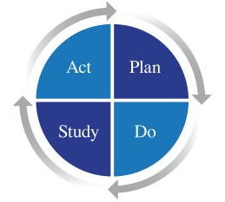
Deming’s (2013) Plan, Do, Check, Act cycle, or more recently the Plan, Do, Study, Act (The Deming Institute, 2021) is a long established framework for developing, testing and implementing improvement changes, and is extensively used through the NHS (NHS Improvement, 2020a; Kaplan, Lopez and McGinnis, 2015).
Figure 4- Deming's PDSA
- The Deming Institute (2021)

Statistical Process Control
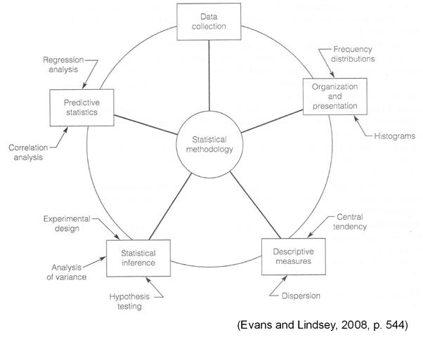
This is a way of capturing data and comparing it to a benchmark, testing if a product is within scope, without having to reply on manual process interpretations (Oakland, 2012). The following diagram demonstrates how this method is applied.
Figure 5- Basic statistical methodology for quality - Evans and Lindsey, 2008

Cause and Effect Diagrams
A visual tool, such as the Fishbone diagram, used to develop investigations into possible causes to a specific problem, and suggests causal relationships between theories. This is another popular CI tool in the NHS (Ishikawa, 1968; McCalman, Paton and Siebert, 2016).
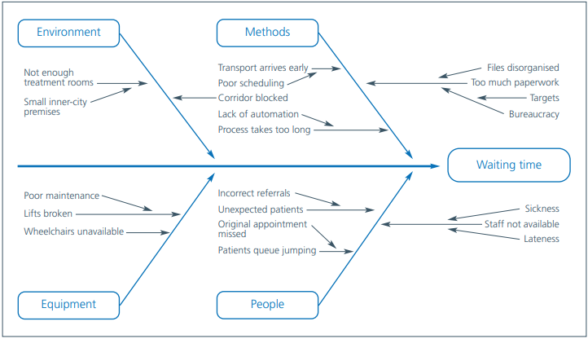
Figure 6- Fishbone Cause and Effect Diagram - NHS Improvements 2020b
Brainstorming
Osborn’s (1963) popular tool for creative problem solving as a group activity and is extensively and systematically used in the NHS and healthcare, among specialist groups, for tackling known issues (Jiju et al, 2017; NHS Improvement 2018a).

Pareto Analysis
Another extensively used, globally established CI tool is the Pareto Analysis (Juran, 2010), based on Vilfredo Pareto’s 80/20 Rule (1896). This is a decision making method, based on the principle that 80% of problems occur from 20% of causes, and can be applied to most situations (Orzes and Dal Bo, 2019; NHS Digital, 2020).
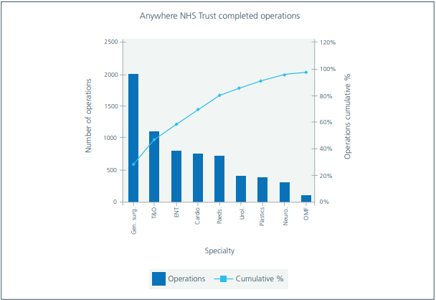
Figure 7- Pareto chart showing kinds of surgery - NHS Improvement, 2018b

Root Cause Analysis - 5 Whys
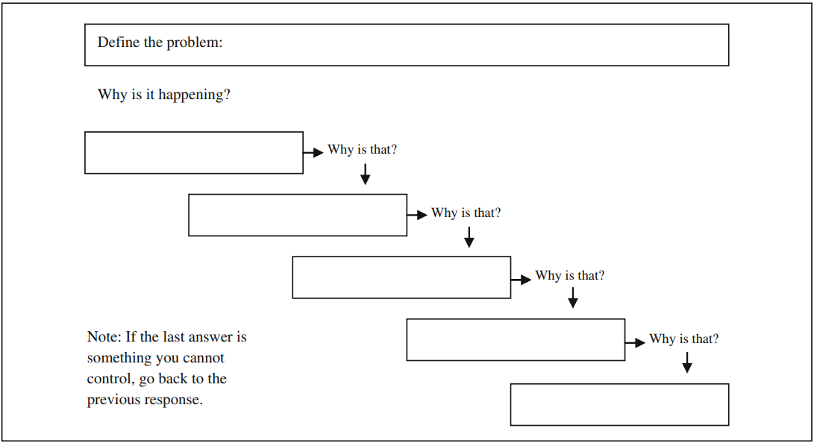
The 5 Whys is an iterative, interrogative technique for exploring the cause and effect relationships underlying identified problems. Each time you ask why, you are digging deeper into the cause of the main problem by finding the underlying issue behind each level (Institute for Healthcare Improvement, 2018; Keller, 2011; Kohfeldt and Langhout, 2012).
Figure 8- Five Whys worksheet - Serrat, 2017

Process Mapping / Modelling
DHCW adheres to the British Computer Society’s (BCS) standard of Modelling Business Processes (BCS, 2017; DHCW, 2020). Acknowledging Evans and Lindsey’s (2008) suggestion of using a traditional process map for easier reading, DHCW has more complex process that needs Cross Functional modelling flowcharts (Cadle, Paul and Turner, 2014), and these will be the focus of this research.
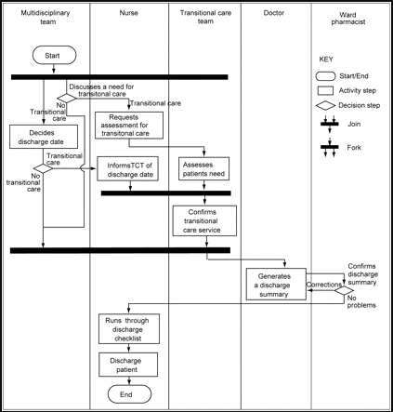
Figure 9- Swim lane activity diagram of a simplified patient discharge process - Jun et al. 2009

This research will investigate how successfully these tools can be used with dispersed, remote working team members through the MS-Teams platform and applications detailed in section 2.2. It must be noted, as this research progresses through the following methodology, opportunities may arise to test other CI tools being used at the time, which will add to or alter the list of tools presented above.

3.0 Methodology

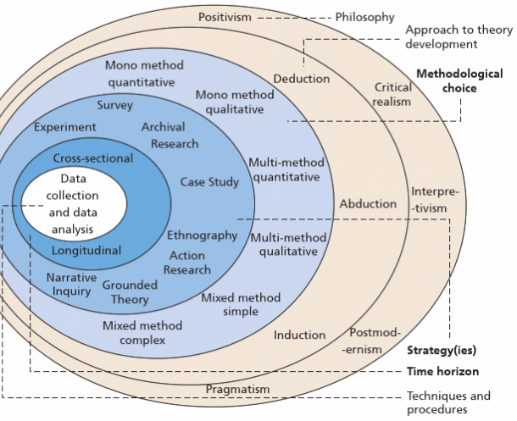
Considering Saunders, Lewis and Thornhill’s research ‘onion’ (2018, p.130), this research will use the pragmatism philosophy, rather than positivism or post positivism and straddling both worlds of ontology and epistemology (O’Leary, 2017). This will free the research to focus on the research question.
Figure 10- The Research Onion
- Saunders, Lewis and Thornhill, 2018

It will also better suit a mixed method of quantitative and qualitative research to blend and understand any causal effects (Saunders, Lewis and Thornhill, 2018; O’Leary, 2017). However, Feilzer (2010) cautions pragmatism tends to lead the researcher to not accept truth as permanent. Whether this is true or not, it could be dangerous for society.
Deduction will continue to be the predominant approach as further primary research is conducted, using established existing theories and methods to help shape the hypothesis for testing. However, this could blend with Induction later in the research, should any trials not go to plan and CI staff need to be interviewed (Saunders, Lewis and Thornhill, 2018; O’Leary, 2017; Wilson, 2014).
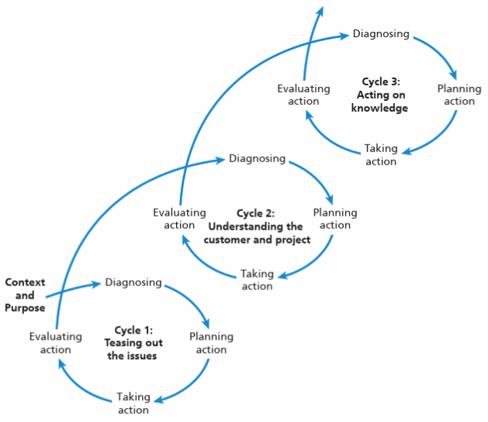
The main strategy will take the form of action research, allowing real life experiments, observations, and theory testing (Leedy and Ormrod, 2021; O’Leary, 2017), and will be blended with Case Study to examine any pioneering work in this area already completed (Yin, 2018; Wilson, 2014). Figure 11 demonstrates the iterative nature of the action research process that will be followed.
Figure 11- The action research process - Saunders, Lewis and Thornhill, 2019

Fellows and Liu (2008) warns of possible delays with this strategy, arising from the dual role of the researcher, however, Bell, Bryman and Harley (2019) suggests this method produces more readable, relevant and interesting outputs.
As mentioned in the literature review, further secondary research will be conducted in the same manner to build on the knowledge acquired from predecessors work, however, to help address the research question, primary research must be undertaken to address the objectives and providing some insight into the following questions:
- How many of the project reductions since the pandemic are resulting from remote working.
- Could the project delays affect the delivery of parts of Welsh Governments National Transformation Program.
- Are there genuine concerns over mental health and wellbeing from working remotely.
- Determine if some aspects of CI remote working, need an initial face to face meeting before switching to remote.
- Investigate the listed MS-Teams applications, determine what CI tools could be used with them and comment on their performance.
- Assess the performance of the CT tools before and after use with MS-Teams applications.
- Comment on the possible impact of the above, on the continuation of the projects stopped because of remote working.

3.1 Questionnaires

Blaxter, Hughes and Tight (2010) suggest questionnaires are an efficient means of capturing reality at a specific point in time. Although Charter (2008) insists sampling is paramount to producing reliable data, this research will not use it; questionnaires will be specifically targeted to a limited pool of NHS employees and Microsoft representatives that have the skills, knowledge, and experience to provide insightful information (Oppenheim, 2009).
Questionnaires (Appendix A) will be conducted remotely via MS-Teams using interviewer administered questionnaires (Saunders, Lewis and Thornhill, 2019) applied via Microsoft Forms. More research is needed before the interview questions can be finalised, however, they will contain specific questions to address the research aim and objectives. Each question is assured to be unbiased and correct completion is assured (Bell, Bryman and Harley, 2019; Yin, 2018). Some sections of the questionnaires will adopt Likert scaling to assess degrees of competence as well as judging improvement advantage or neutrality (Likert, 1932; Oppenheim, 2009).
There will be several different questionnaire styles to address the following required insights:
- Assess current CI staff knowledge of MS-Teams applications and their functions, so do they know it and how well.
- Seeking approval to participate in some of their CI activities to make observations.
- Assess the performance of the CT tools before and after use with MS-Teams applications.

3.2 Interviews and Observations

The primary research pragmatism approach for interviews and observations (Saunders, Lewis and Thornhill, 2019) will use a mixed method of quantitative and qualitative data (Bak, 2011), addressing concerns that quantitative research lacks depth of detail (Flick, 2018).
Interviews will be conducted using carefully selected questions designed to direct the flow of the interview (Appendix B). As with the questionnaires, more research is needed before the questions can be finalised, however, sets of sub questions are anticipated on the questions where further probing would be needed. This allows the interviewee enough space to ensure their insights are expressed (Saunders, Lewis and Thornhill, 2019; Bell, Bryman and Harley, 2019; Oppenheim, 2009).
There will be several different interview styles to address the following required insights:
- Interview the HR lead to determine if work related wellbeing has deteriorated since working remotely.
- Interview CI department leads and staff to gain insight into the performance of the CT tools before and after use with MS-Teams applications. Seek permission to begin observations on their work. Seek permission to test CI functions on live projects using MS-Teams
- Interview the programme leads to determine the impact of project delivery as a result of remote working because of the pandemic.
- Seek insight from relevant IT personnel, to the impact on infrastructure if CI were to be used through MS-Teams.
The next section will outline the work schedule to complete this proposed research.

3.3 Work Schedule

Appendix 3 displays the project timeline for this part-time research. The planned start date is the beginning of May 2022 with the collection and review of secondary information and estimated to take around 2 months. Work on primary information will begin with the Questionnaire Design, after the secondary information work, and from design to data synthesis completion, it’s anticipated to take 66 days. To compress the timeline, work on interviews will commence 5 days after the questionnaires begin and run parallel to make use of questionnaire waiting time.
Work on testing theories and equipment with identified Subject Matter Experts will start directly after completing the work on the primary data and expected to take 70 days, anticipated difficulty in contacting Subject Matter Experts and arranging work.
Before work begins on writing the dissertation, new literature will be scanned to check for relevant updates, taking around 5 days. Writing the dissertation will begin around mid-February and expected to take 77 days.

All data will be gathered in an ethical manner, acting with integrity and ensuring autonomy is respected so participants are treated fairly (Oppenheim, 2009; O’Leary, 2017). The information will be analysed and presented objectively (Charter, 2008; Spence, 2014). All participants in interviews, questionnaires and observations will provide their consent before they can participate (Oppenheim, 2009). The next section will touch on the anticipated results expected from this research.

4.0 Results

This work sets out to answer the research aim by systematically addressing the incremental objectives set out in the introduction. The literature reviewed to date has supported the need for this research, nonetheless, further secondary research is required to form deeper understanding around some of the proposed research questions.
The methodology proposed in section 3 supports the primary investigations intended to conclude this research. The proposed interviews, questionnaires and observations will produce a mixture of qualitative and quantitative data. The qualitative data will be put through the drilling in / abstracting out iterative cycle (O’Leary, 2017) to determine common themes, experiences and patterns. The quantitative data will have already been subjected to measurement scales to isolate the variables of the different applications (O’Leary, 2017) before analysis by frequency distributions (Kranzler. 2011). Results are expected to address:
- The number of projects stopped because of remote working.
- The impact these projects will have on the National Transformation Program.
- The general level of concern over wellness because of remote working.
- The requirement of face to face meetings as part of CI while remote working.
- List the MS-Teams applications that can support CI tools.
- List the performance of CI tools used before and after use with MS-Teams.
- Propose new working models for using MS-Teams for CI.
This data will be sequentially synthesised to produce primary evidence to either support or refute the hypothesis.

5.0 Evaluation

The COVID-19 pandemic highlighted gaps in global established procedures for CI teams to introduce system and process changes while working remotely. It is sincerely believed this research will clarify what these gaps are, test proposed remote working methods and recommend new procedure models while laying the foundations for future research on the subject.
It is intended for the methods used during this research to follow existing, established protocol, supported by evidence, to ensure all aspects of the research is robust and could be replicated when required. The COVID-19 pandemic is ongoing, and the effects to CI are affecting many organisations globally, so it is believed this topic will have many ongoing investigations and much research conducted in the coming months or years. Therefore, horizons will be monitored for emerging theories that could support this research.
Although the research will focus on NHS Wales, continuous improvement practices are conducted by most organisations worldwide and the emergent recommendations of this research will have effect on this wider community. This is magnified by suggestions of home working becoming the new norm for much of the workforce.
There are significant limitations to this work. The NHS can be known to be bureaucratic, which could slow progress. While we are in the grips of this pandemic, it is plausible that we are subjected to another wave that could severely restrict access to NHS staff. There is no finalised detail on the questionnaires, interviews or observations because a fast changing research landscape may have significant impact on these before they are used. Microsoft have made significant changes to Microsoft Teams at a pace that has been unseen before, more of this could alter the approach to some elements of this research.
To summarise the intent behind this research, it is to find out if it is possible to use the MS-Teams platform, while working remotely, to perpetuate CI; then recommend tested models to conduct it.

6.0 References

Barber, C., Haque, N. and Gardner, B. (2009) ‘‘OnePoint’ – combining OneNote and SharePoint to facilitate knowledge transfer’, Drug discovery today, 14(17), pp.845–850. Elsevier ScienceDirect. Available at: https://www-sciencedirect-com.ezproxy.uwtsd.ac.uk/science/article/pii/S1359644609002268 (Accessed: 13 April 2021).

Barang, N. (2016) ‘BusinessPundit: Visio: The Best Flowchart Software for Small Businesses in 2016.', Newstex Global Business Blogs, pp. Newstex Global Business Blogs, 2016–09-29. ProQuest. Available at: https://search-proquest-com.ezproxy.uwtsd.ac.uk/docview/1824373238/citation/4C2C85A7B8B94F39PQ/1?accountid=130472 (Accessed: 14 April 2021).

Bak, O. (2011) ‘The role of qualitative research in a mixed method study’, Qualitative Research Journal, 11(2), pp. 76-84. Emerald Insight. Available at: http://www.emeraldinsight.com.ergo.southwales.ac.uk/doi/pdfplus/10.3316/QRJ1102076 (Accessed 18 April 2021).

BCS (2017) Practitioner Certificate in Modelling Business Processes. Available at: https://www2.bcs.org/certifications/ba/modelling-business-processes (Accessed: 11 April 2021).

Bell, E., Bryman, A. and Harley, B. (2019) Business research methods. 5th edn. Oxford: Oxford University Press.

Bick, R. et al. (2020) ‘The future of work: Reskilling and remote working to recover in the ‘next normal’’, McKinsey Digital, 7th July. Available at: https://www.mckinsey.com/business-functions/mckinsey-digital/our-insights/the-future-of-work-reskilling-and-remote-working-to-recover-in-the-next-normal (Accessed: 28 March 2021).

Blackstock, S. (2021) How Microsoft Teams can support your clinical practice during the pandemic. Available at: https://www.nhsx.nhs.uk/blogs/how-microsoft-teams-can-support-your-clinical-practice-during-pandemic/ (Accessed: 11 April 2021).

Blaxter, L., Hughes, C. and Tight, M. (2010) How to research. 4th edn. Berkshire: Open University Press.

Cadle, J., Paul, D. and Turner, P. (2014) Business analysis techniques: 99 essential tools for success. Swindon: BCS.

Charter, R. (2008) ‘Statistical approaches to achieving sufficiently high test score reliabilities for research purposes’, The Journal of General Psychology, 135(3), pp. 241-251. Available at: http://www.tandfonline.com/doi/abs/10.3200/GENP.135.3.241-251 (accessed 18 April 2021).

Clochet, A. (2020) ‘Remote working will only increase the need for Continuous Improvement,” says Gerard Poolman, Shell’, Process Excellence Network, 20th August. Available at: https://www.processexcellencenetwork.com/lean-six-sigma-business-performance/interviews/remote-working-will-only-increase-the-need-for-continuous-improvement-says-gerard-poolman-shell (Accessed: 27 February 2021).

Conerly, B. (2021) ‘Strategic planning with uncertainty about pandemic’s end’, Forbes, 13th February. Available at: https://www.forbes.com/sites/billconerly/2021/02/13/strategic-planning-with-uncertainty-about-pandemics-end/?sh=2c4c8e9c400d (Accessed: 28 March 2021).

Dale, B., Bamford, D. and Wiele, T. (2016) Managing quality: an essential guide and resource gateway. 6th edn. Chichester: Wiley.

Deming, W. (2013) The Essential Deming: Leadership Principles from the Father of Quality. London: McGraw Hill.

DHCW (2020) NWIS shortlisted for three BCS IT industry Awards. Available at: https://dhcw.nhs.wales/news/archived-news/nwis-shortlisted-for-three-bcs-it-industry-awards/ (Accessed: 11 April 2021).

DHCW (2021) Microsoft Teams. Available at: https://nwis.nhs.wales/coronavirus/information-and-guidance-for-nwis-staff/microsoft-teams/ (Accessed: 12 April 2021).

Dieck-Assad, F. (2018) ‘Digital Teaching: In Search Of An Effective Paperless Platform For Classroom Activities', Journal of International Education Research, 14(2), 1. ProQuest. Available at: https://search-proquest-com.ezproxy.uwtsd.ac.uk/docview/2210395716/fulltextPDF/66CF97E538184A03PQ/1?accountid=130472 (Accessed: 14 April 2021).

European Commission (2019) Defining value in “value-based
healthcare”: Report of the Expert Panel on effective ways of
investing in Health (EXPH). Available at: https://ec.europa.eu/health/sites/health/files/expert_panel/docs/024_defining-value-vbhc_en.pdf (Accessed: 10 April 2021).

Evans, J. and Lindsay, W. (2008) The management and control of Quality. Mason: Thomson South Western.

Feilzer, Y. (2010) ‘Doing Mixed Methods Research Pragmatically: Implications for the Rediscovery of Pragmatism as a Research Paradigm', Journal of Mixed Methods Research, 4(1), pp.6-16. Saga Journals. Available at: https://journals-sagepub-com.ezproxy.uwtsd.ac.uk/doi/pdf/10.1177/1558689809349691 (Accessed: 18 April 2021).

Fellows, R. and Liu, A. (2008) Research methods for construction. 3rd edn. Chichester: Wiley-Blackwell.

Flick, U. (2018) Managing Quality in Qualitative Research. 2nd edn. London: SAGE Publications.

George, M. (2002) Lean six sigma: combining six sigma quality with lean speed. New York: McGraw Hill.

Goyal, S. (2020) Visio as a tab in Microsoft Teams is generally available. Available at: https://techcommunity.microsoft.com/t5/visio-blog/visio-as-a-tab-in-microsoft-teams-is-generally-available/ba-p/1474787#:~:text=Visio%20tabs%20in%20Teams%20allow,of%20that%20channel%20or%20chat. (Accessed: 13 April 2021).

Graham, R. and Woodhead, T. (2021) ‘Leadership for continuous improvement in healthcare during the time of COVID-19', Clinical Radiology, 76(1), pp.67–72. Elsevier ScienceDirect. Available at: https://www.emerald.com/insight/content/doi/10.1108/IJHCQA-03-2016-0035/full/html (Accessed: 14 March 2021).

Grijalva-Borja, N. et al. (2020) ‘Analysis of the Perception of University Students About the Use of Microsoft OneNote as an Electronic Laboratory Notebook in Response to Non-Face-to-Face Education in Pandemic Times', Communications in Computer and Information Science, vol 1307, pp.150-162. Springer. Available at: https://link.springer.com/chapter/10.1007/978-3-030-62833-8_13 (Accessed: 14 April 2021).

Hamilton, J. (2021) How Microsoft Teams is evolving. Available at: https://www.bcs.org/content-hub/how-microsoft-teams-is-evolving/ (Accessed: 12 April 2021).

Hart, C. (2018) Doing a literature review: releasing the research imagination. London: Sage Publications.

Hayes, J. (2014) The theory and practice of change management. 4th edn. New York: Palgrave Macmillan.

Health and Safety Executive (2021) Protect home workers. Available at: https://www.hse.gov.uk/toolbox/workers/home.htm (Accessed: 12 April 2021).

Improvement Cymru (2020) What is Improvement? Available at: https://phw.nhs.wales/services-and-teams/improvement-cymru/improvement/ (Accessed: 13 April 2021).

Institute for Healthcare Improvement (2018) 5 Whys: Finding the Root Cause Available at: http://www.ihi.org/resources/Pages/Tools/5-Whys-Finding-the-Root-Cause.aspx (Accessed: 17 April 2021).

Ishikawa, K. (1982) Guide to Quality Control. Tokyo: Asian Productivity Organization.

Jiju, A. et al. (2017) ‘Six Sigma in healthcare: a systematic review of the literature', The International Journal of Quality & Reliability Management, 35(5), pp.1075-1092. ProQuest. Available at: https://www-proquest-com.ezproxy.uwtsd.ac.uk/docview/2025300200?OpenUrlRefId=info:xri/sid:primo&accountid=130472 (Accessed: 19 March 2021).

Johnson, Scholes and Whittington, (2008) Exploring corporate strategy. 8th edn. Harlow: Prentice Hall.

Jun, G. et al. (2009) ‘Health care process modelling: which method when?', International Journal for Quality in Health Care, 21(3), pp.214-224. Oxford Academic Available at: https://academic.oup.com/intqhc/article/21/3/214/1797244 (Accessed: 17 April 2021).

Juran, J. and Juran, D. (2010) Juran's quality handbook: the complete guide to performance excellence. 6th edn. New York: McGraw‐Hill.

Kaplan, G., Lopez, M. and McGinnis, J. (2015) Transforming health care scheduling and access: getting to now. Washington: The National Academies Press.

Keller, P. (2011) Six Sigma demystified. 2nd ed. London: McGraw Hill.

Kohfeldt, D. and Langhout, R. (2012) ‘The Five Whys Method: A Tool for Developing Problem Definitions in Collaboration with Children', Journal of Community & Applied Social Psychology, 22(4), pp. 316-329. EBSCOhost. Available at: https://web-a-ebscohost-com.ezproxy.uwtsd.ac.uk/ehost/detail/detail?vid=0&sid=9492d2f6-337f-4691-b4b3-de02120f2f6e%40sessionmgr4006&bdata=JnNpdGU9ZWhvc3QtbGl2ZQ%3d%3d#AN=75176356&db=aph (Accessed: 17 April 2021).

Kranzler, J. (2011) Statistics for the terrified. 5th edn. London: Prentice Hall.

Lee, L. and Chan, H. (2020) ‘Challenged by the masses: Using Microsoft Teams Live Event to moderate large‐scale meetings', Journal of dental education, pp. Journal of dental education, 2020–06-27. Wiley Online. Available at: https://onlinelibrary-wiley-com.ezproxy.uwtsd.ac.uk/doi/pdfdirect/10.1002/jdd.12256 (Accessed: 14 April 2021).

Leedy, P. Ormrod, J. (2021) Practical research: planning and design. 12th edn. New Jersey: Pearson.

Liker, J. (2020) The Toyota way: 14 management principles from the world’s greatest manufacturer. 2nd edn. New York: McGraw Hill.

Likert, R. (1932) A technique for the measurement of attitudes. New York: Columbia University Press.

McCalman, J., Paton, R. and Siebert, S. (2016) Change management: a guide to effective implementation. London: Sage Publications.

Mengella, S. (2019) ‘Microsoft Teams for Business: Advantages and Disadvantages’, Tech-Mag, 24th June. Available at: https://www.tech-mag.co.uk/microsoft-teams-for-business-advantages-and-disadvantages/ (Accessed: 14 April 2021).

Microsoft (2013) Top 10 things you didn’t know about OneNote. Available at: https://www.microsoft.com/en-us/microsoft-365/blog/2013/11/12/top-10-things-you-didnt-know-about-onenote/ (Accessed: 13 April 2021).

Microsoft (2016) Introducing Microsoft Teams: The new chat-based workspace in Office 365. Available at: https://news.microsoft.com/november-2016-event/ (Accessed: 12 April 2021).

Microsoft (2019) How process mapping will help your business succeed. Available at: https://www.microsoft.com/en-gb/microsoft-365/business-insights-ideas/resources/succeed-with-process-mapping (Accessed: 14 April 2021).

Microsoft (2021) Microsoft 365 roadmap. Available at: https://www.microsoft.com/en-gb/microsoft-365/roadmap?filters= (Accessed: 12 April 2021).

Millard, M. (2020) ‘How to Keep a Remote Workforce Engaged in Improvement’, KaiNexus [blog]. 6 April. Available at: https://blog.kainexus.com/employee-engagement/how-to-keep-a-remote-workforce-engaged-in-improvement (Accessed: 12 April 2021).

National Assembly for Wales Public Accounts Committee (2018) Informatics systems in NHS Wales. Available at: https://senedd.wales/laid%20documents/cr-ld11822/cr-ld11822-e.pdf (Accessed: 14 April 2021).

NHS Digital (2020) Hospital Activity Pareto Analysis with Peer Benchmarking Report. Available at: https://digital.nhs.uk/data-and-information/data-tools-and-services/data-services/innovative-uses-of-data/demand-on-healthcare/hospital-activity-pareto-analysis-with-peer-benchmarking-report (Accessed: 17 April 2021).

NHS Improvement (2011) Overview – Change Management – the Systems and Tools for Managing Change. Available at: https://www.england.nhs.uk/improvement-hub/wp-content/uploads/sites/44/2017/11/Overview-Change-management.pdf (Accessed: 16 April 2021).

NHS Improvement (2017) Quality, service improvement and redesign (QSIR) tools by type of approach. Available at: https://improvement.nhs.uk/resources/quality-service-improvement-and-redesign-qsir-tools-type-approach/ (Accessed: 16 April 2021).

NHS Improvement (2018a) Brainstorming. Available at: https://improvement.nhs.uk/documents/2091/brainstorming.pdf (Accessed: 16 April 2021).

NHS Improvement (2018b) Pareto. Available at: https://improvement.nhs.uk/documents/2137/pareto.pdf (Accessed: 17 April 2021).

NHS Improvement (2020a) Plan, Do, Study, Act (PDSA) cycles and the
model for improvement. Available at: https://improvement.nhs.uk/documents/2142/plan-do-study-act.pdf (Accessed: 17 April 2021).

NHS Improvement (2020b) Cause and
effect (fishbone). Available at: https://improvement.nhs.uk/documents/2093/cause-effect-fishbone.pdf (Accessed: 17 April 2021).

NWIS (2020) Integrated Medium Term Plan 2020-2023. Internal NWIS report. Unpublished.

NWIS (2021) Our Governance. Available at: https://nwis.nhs.wales/about-us/our-governance/ (Accessed: 28 March 2021).

NWIS (2019) Integrated Medium Term Plan 2019-2022. Internal NWIS report. Unpublished.

NWIS (2020) Integrated Medium Term Plan 2020-2023. Internal NWIS report. Unpublished.

NWIS (2021) Home Page. Available at: https://nwis.nhs.wales/ (Accessed: 27 March 2021).

O’Leary, Z. (2017) The essential guide to doing your research project. 2nd edn. London: Sage Publications.

Oakland, J. (2012) Statistical process control. 7th edn. Chichester: Wiley.

Oppenheim, A. (2009) Questionnaire design, interviewing and attitude measurement. London: Continuum.

Orzes, G. and Dal Bo, A. (2019) 'Statistical tools for quality management', in Sartor, M. and Orzes, G. (ed.) Quality management: tools, methods and standards. Bingley: Emerald Publishing.

Osborn, A. (1963). Applied imagination; principles and procedures of creative problem-solving. New York, Scribner.

Ozer, J. (2019) ‘Microsoft Stream’. Streaming media magazine, 16(4), pp.69–74. ProQuest. Available at: https://search-proquest-com.ezproxy.uwtsd.ac.uk/docview/2250998764?accountid=130472&pq-origsite=primo (Accessed: 14 April 2021).

Pareto, V. (1896) ‘Cours d’Economie Politique’. The Economic Journal, 6(22), pp.249–253. Oxford Academic. Available at: https://academic.oup.com/ej/article-abstract/6/22/249/5302596 (Accessed: 16 April 2021).

Patchigalla, R. (2019) ‘A Critical Evaluation of the Implementation of Microsoft OneNote Class Notebook at One New Zealand Secondary School’, Available at: http://orapp.aut.ac.nz/bitstream/handle/10292/12616/PatchigallaRP.pdf?sequence=3&isAllowed=y (Accessed: 13 April 2021).

Robinson, B. (2020) ‘How remote working is reshaping a future new world of work’, Forbes, 4th May. Available at: https://www.forbes.com/sites/bryanrobinson/2020/05/04/how-remote-working-is-reshaping-a-future-new-world-of-work/?sh=26bf0370627b (Accessed: 24 March 2021).

Russell, R. and Taylor, B. (2011) Operations management: creating value along the supply chain. 7th edn. New Jersey: Wiley.

Saunders, M., Lewis, P. and Thornhill, A. (2018) Research methods for business students. 8th edn. Harlow: Pearson Education

Serrat, O. (2017) Knowledge solutions: tools, methods, and approaches to drive organizational performance. Singapore: Springer.

Spataro, J. (2019) The new Microsoft Project rolls out to customers worldwide. Available at: https://www.microsoft.com/en-us/microsoft-365/blog/2019/10/29/new-microsoft-project-rolls-out-worldwide/ (Accessed: 12 April 2021).

Spataro, J. (2020) A pulse on employees’ wellbeing, six months into the pandemic. Available at: https://www.microsoft.com/en-us/microsoft-365/blog/2020/09/22/pulse-employees-wellbeing-six-months-pandemic/ (Accessed: 11 April 2021).

Spence, R. (2014) Information visualisation. 3rd edn. London: Springer.

Stelson, P. et al. (1965) ‘What drives continuous improvement project success in healthcare?', International journal of health care quality assurance, 30(1), pp. 43-57. ProQuest. Available at: https://search-proquest-com.ezproxy.uwtsd.ac.uk/docview/1860081559/fulltextPDF/B03D15323622476BPQ/1?accountid=130472 (Accessed: 16 April 2021).

Stone, H. (2021) Microsoft Teams to Mark Williams, 29 January.

Stratvert, K. (2020) ‘Top 16 Microsoft OneNote Tips & Tricks’, YouTube [vlog]. 19 October. Available at: https://www.youtube.com/watch?v=DD6Ts7L85tQ (Accessed: 13 April 2021).

The Deming Institute (2021) PDSA Cycle. Available at: https://deming.org/explore/pdsa/ (Accessed: 17 April 2021).

The Health Foundation (2016) Quality improvement made simple: What everyone should know about health care quality improvement. Available at: https://www.health.org.uk/sites/default/files/QualityImprovementMadeSimple.pdf (Accessed: 16 April 2021).

Thompson, N. (2018) Effective communication: a guide for the people professions. 3rd edn. London: Palgrave Macmillan.

Tuckman, B. (1965) ‘Developmental sequence in small groups', Psychological bulletin, 63(6), pp.384–399. EBSCOhost. Available at: https://web-a-ebscohost-com.ezproxy.uwtsd.ac.uk/ehost/detail/detail?vid=0&sid=cfcf4339-8969-4869-83e5-8ec1d8347904%40sdc-v-sessmgr03&bdata=JnNpdGU9ZWhvc3QtbGl2ZQ%3d%3d#AN=1965-12187-001&db=pdh (Accessed: 21 March 2021).

Voehl, F. et al. (2020) The lean six sigma black belt handbook: tools and methods for process acceleration. Boca Raton: Productivity Press.

Wali, K. and Othman, S. (2019) ‘Comparison and Assessment of Using Primavera and Microsoft Project in Construction Projects in Erbil City', Zanco Journal of Pure and Applied Sciences, 31(s3), 285–291. DOAJ. Available at: https://zancojournals.su.edu.krd/index.php/JPAS/article/view/3123/1932 (Accessed: 14 April 2021).

Welsh Government (2019a) Written Statement: Update on Digital Health and Care. Available at: https://gov.wales/written-statement-update-digital-health-and-care (Accessed: 26 February 2021).

Welsh Government (2019b) A Healthier Wales: Our Plan for Health and Social Care. Available at: https://gov.wales/sites/default/files/publications/2019-10/a-healthier-wales-action-plan.pdf (Accessed: 28 March 2021).

Welsh Government (2019c) NHS Wales National Integrated Medium Term Plan. Available at: https://gov.wales/sites/default/files/publications/2019-09/nhs-wales-national-integrated-medium-term-plan-2019-22.pdf (Accessed: 24 March 2021).

Welsh Government (2020a) NHS Wales Planning Framework 2020/23. Available at: https://gov.wales/sites/default/files/publications/2019-09/nhs-wales-planning-framework-2020-to-2023.pdf (Accessed: 28 February 2021).

Welsh Government (2020b) Written Statement: coronavirus (COVID-19). Available at: https://gov.wales/written-statement-coronavirus-covid-19-1 (Accessed: 28 February 2021).

Welsh Government (2020c) Written Statement: Coronavirus (COVID-19). Available at: https://gov.wales/written-statement-coronavirus-covid-19-2 (Accessed: 28 February 2021).

Welsh Government (2020d) Aim for 30% of the Welsh Workforce to Work Remotely. Available at: https://gov.wales/aim-30-welsh-workforce-work-remotely (Accessed: 28 February 2021).

WHO (2021) Slow vaccine roll-out prolonging pandemic. Available at: https://www.euro.who.int/en/media-centre/sections/press-releases/2021/slow-vaccine-roll-out-prolonging-pandemic (Accessed: 12 April 2021).

Wilson, J. (2014) Essentials of business research: a guide to doing your research project. London: SAGE Publications.

Withers, K. et al. (2020) ‘First steps in PROMs and PREMs collection in Wales as part of the prudent and value-based healthcare agenda', Quality of life research, pp. Quality of life research, 2020–11-29. Springer Journals. Available at: https://link-springer-com.ezproxy.uwtsd.ac.uk/article/10.1007/s11136-020-02711-2#article-info (Accessed: 21 January 2021).

Woods, P. et al. (2019) Adopt & embrace Microsoft Teams: a manager's guide to communication, collaboration, and coordination with Microsoft Teams. London: Change Empire Books.

Yin, K. (2018) Case study research and applications: design and methods. London: Sage Publications Ltd.

7.0 Appendices

Appendix 1
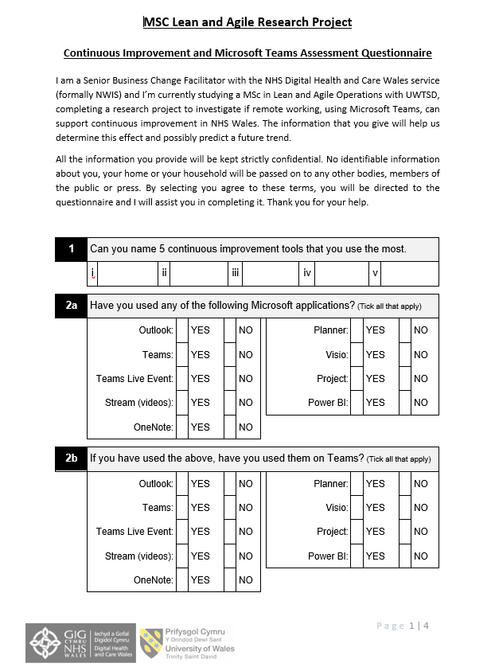
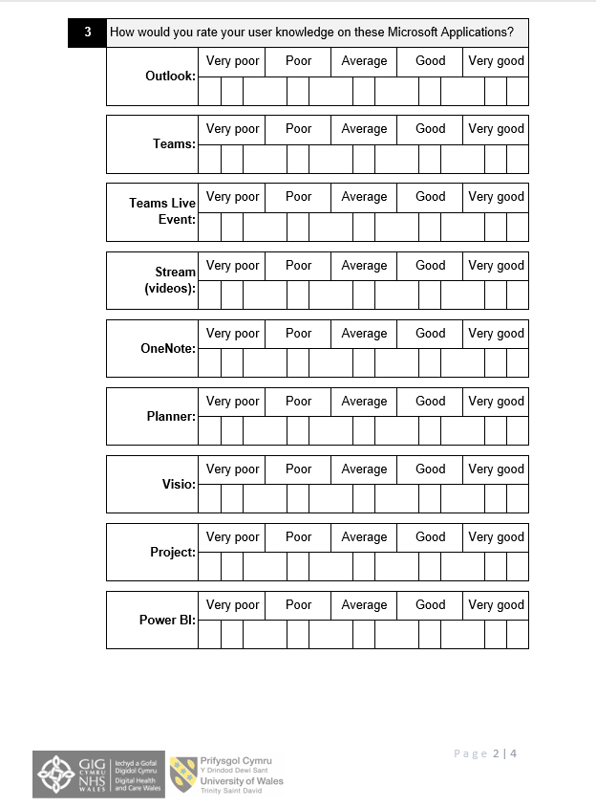
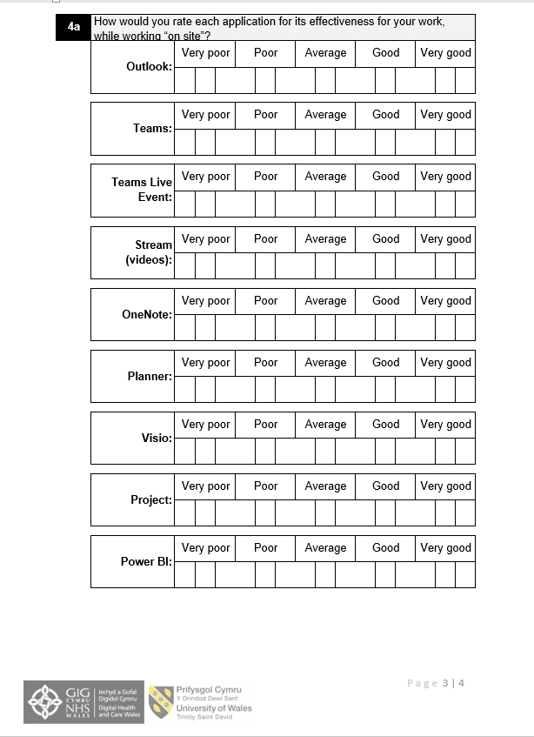
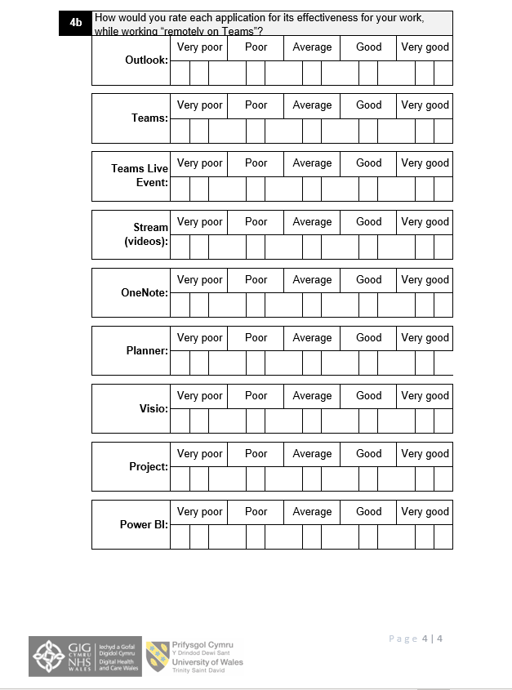

Appendix 2
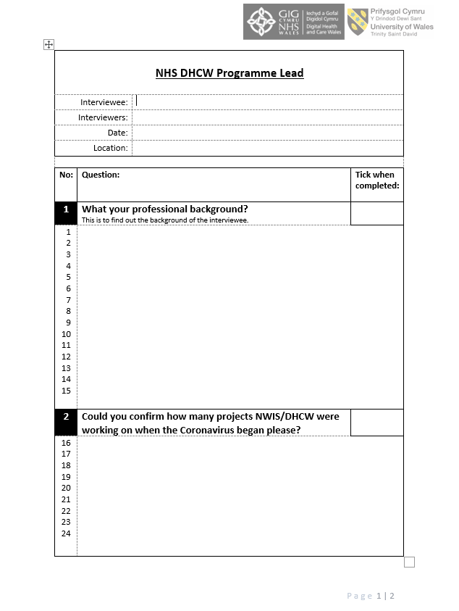

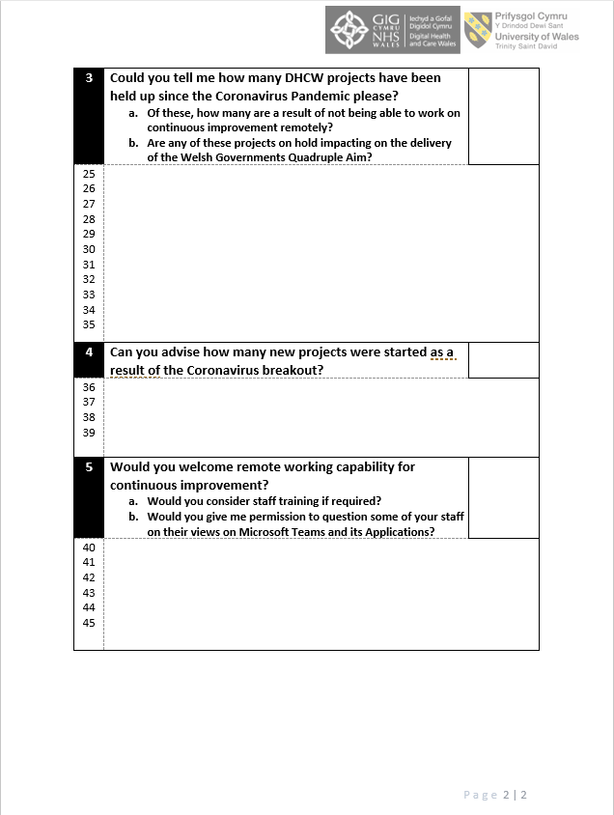

Appendix 3


