UNIVERSITY OF WALES TRINITY SAINT DAVID
LONDON CAMPUS
Assignment 2
Learning in the Digital Era
Video Link:
https://uowtsd-my.sharepoint.com/:v:/g/personal/2509557_student_uwtsd_ac_uk/IQA84ptUs9oqRq6YNiq23_D_AXfJup-sJxZGj5pSNOaO5oE?e=xwejUa

Module Name: Learning in the Digital Era
Module Code: ACCA 4025

Student Name: Hora Big
Student ID: 2509557
Group: 4

Lecturer’s Name: Dipo Dunsin

Table of Contents
Introduction 2
Main Body 2
Task 1: 4
Self Evaluation: 4
Gibbs Reflective Model: 5
Traits Gained from Self Reflection: 6
Task 2: PDP: 7
Task 3: Unit 4 Topic: 8
Conclusion: 8
References: 9
Task 4: Vide Presentation: 9
Conclusion 10
References 10

Introduction
This report supports the video presentation for the module Learning in the Digital Era. It presents my self-evaluation, professional development plan (PDP), and reflective practice using an appropriate reflective model. The report also includes a summary of a Unit 4 topic related to becoming a lifelong learner. The purpose of this report is to demonstrate awareness of my strengths, weaknesses, and future development needs within a computing and IT context.

Main Body
This section briefly explains the content presented in each slide of the video presentation and links theory to practice using appropriate academic references.
Video Link:
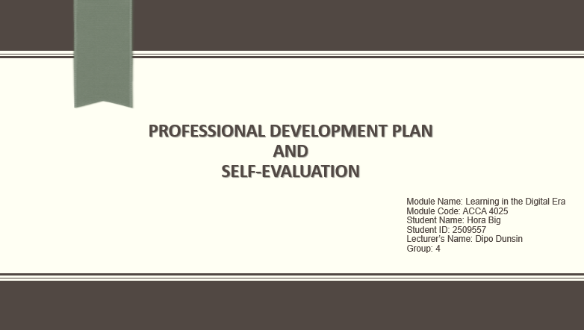
Figure 1 : Slide 1

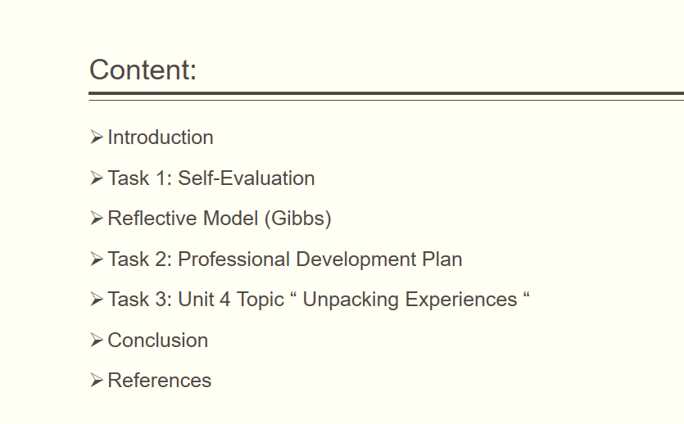
Figure 2: Slide 2

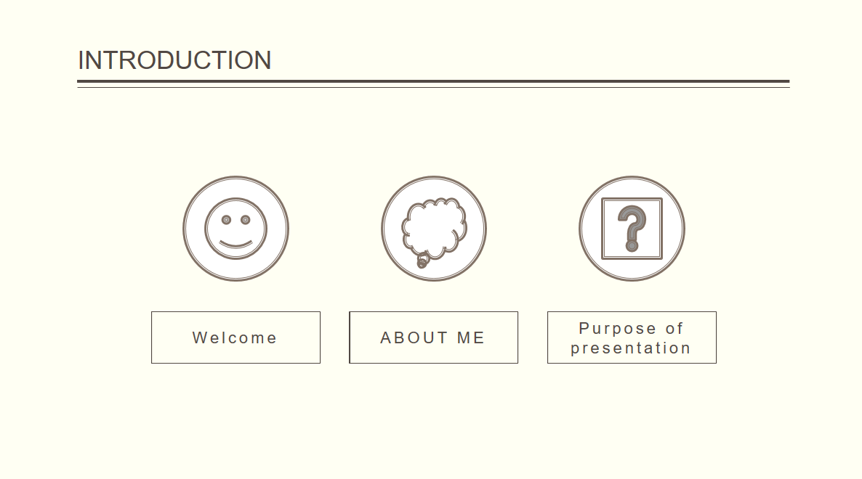
Figure 3: Slide 3
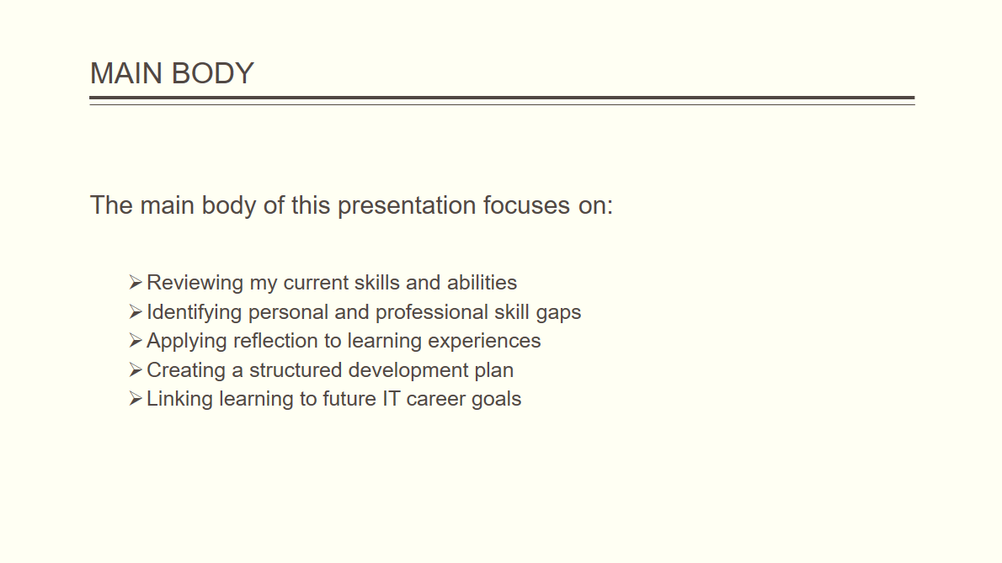
Figure 4: Slide 4

Task 1:

Self Evaluation:
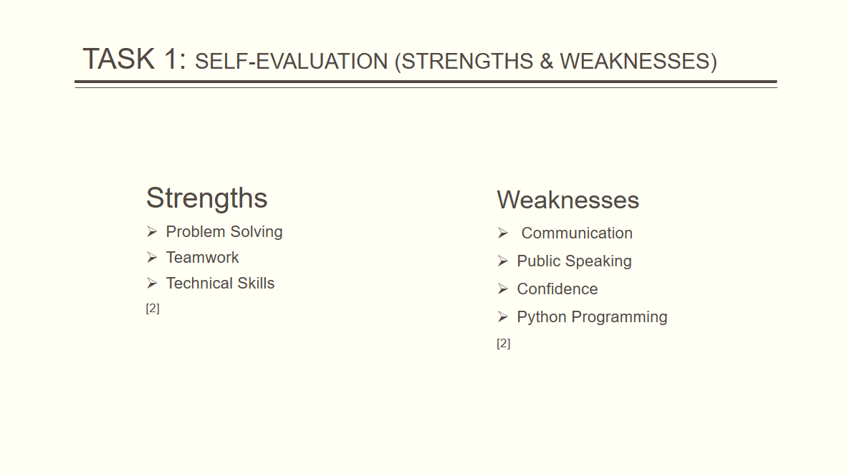
Figure 5: Slide 5
This self evaluation is based on my individual SWOT analysis, which helps identify my strengths and weaknesses. One of my main strengths is problem solving skills, which I have developed through practical experience, teaching computing, and self learning. This strength allows me to approach challenges logically and find effective solutions in academic and work related situations. One of my key weaknesses is English communication, as it is not my first language. This sometimes affects my confidence and public speaking.
Recognising this weakness has helped me identify areas for improvement, which are addressed in my professional development plan. [2]

Gibbs Reflective Model:
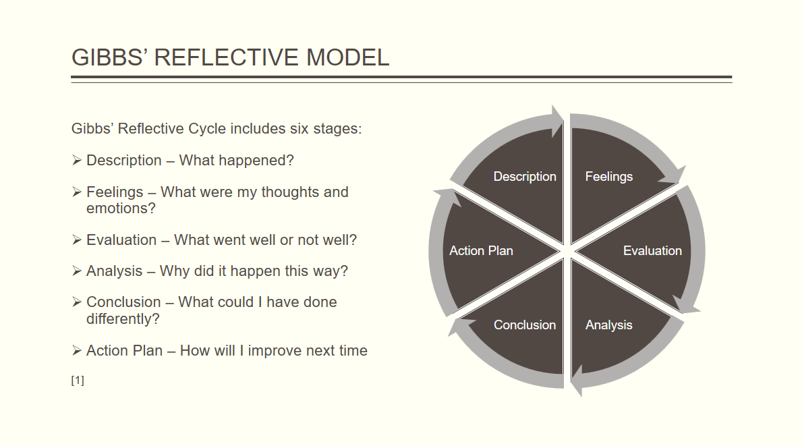
Figure 6: Slide 6
Gibbs reflective model is a structured framework that supports learning from experience through six stages: description, feelings, evaluation, analysis, conclusion, and action plan [1].
In Assignment 2, this model is applied to reflect on my academic and professional experiences, particularly my self evaluation and skill development. By using this model, I am able to identify what went well, recognise challenges such as communication and confidence, and create an action plan within my professional development plan to improve these areas. Reflective practice using Gibbs’ model supports continuous learning and personal development .

Traits Gained from Self Reflection:
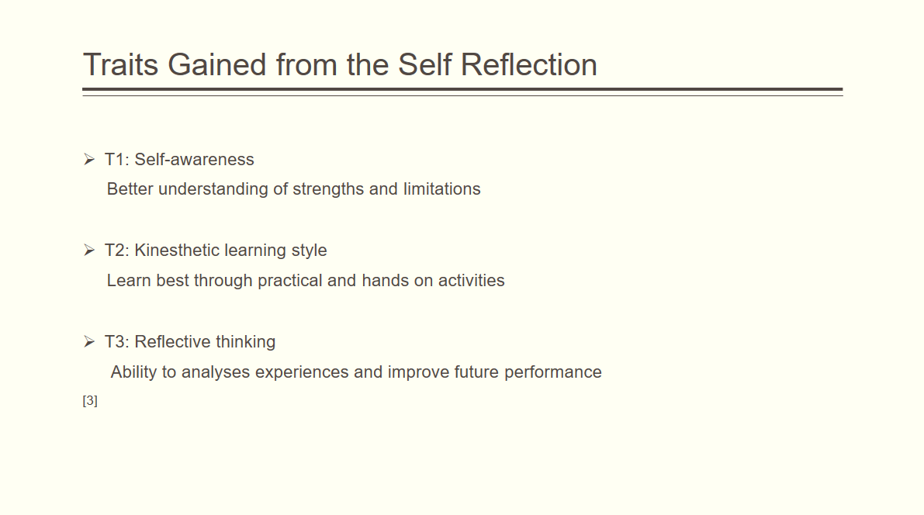
Figure 7: Slide 7

Through self reflection, I developed several important traits. These include self awareness, understanding my kinesthetic learning style which means that I learn best by doing practical work, and improved reflective thinking. Reflexive practice helps learners understand how their beliefs and experiences influence learning and decision making [3].

Task 2: PDP:
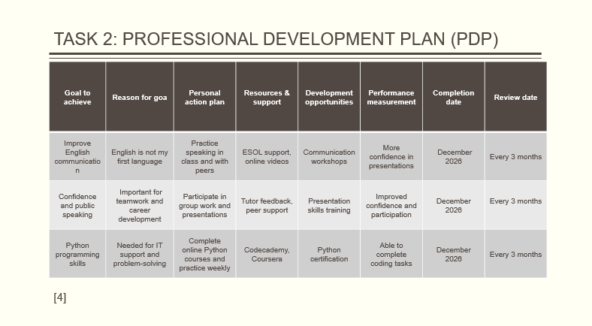
Figure 8: Slide 8
My professional development plan focuses on improving communication skills, confidence, and Python programming. SMART goals are used to ensure that objectives are specific, measurable, achievable, relevant, and time bound. The plan includes actions such as online courses, regular practice, and engagement with peers and tutors. Progress will be reviewed regularly, with a target completion date of December 2026 [4].

Task 3: Unit 4 Topic:
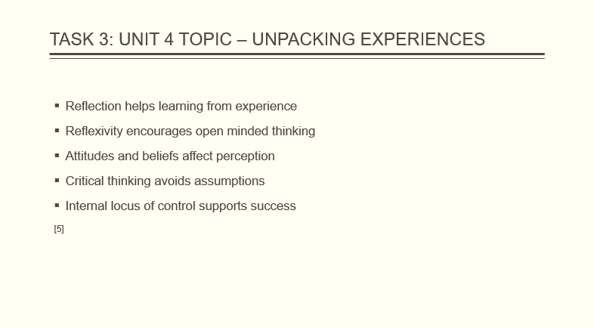
Figure9: Slide 9

The Unit 4 topic Unpacking Experiences focuses on reflection, reflexivity, and critical thinking. It explains how attitudes, beliefs, and past experiences influence perception and understanding. Developing an internal locus of control encourages learners to take responsibility for their learning and persist when facing challenges. This topic supports lifelong learning and personal resilience [5].

Conclusion:
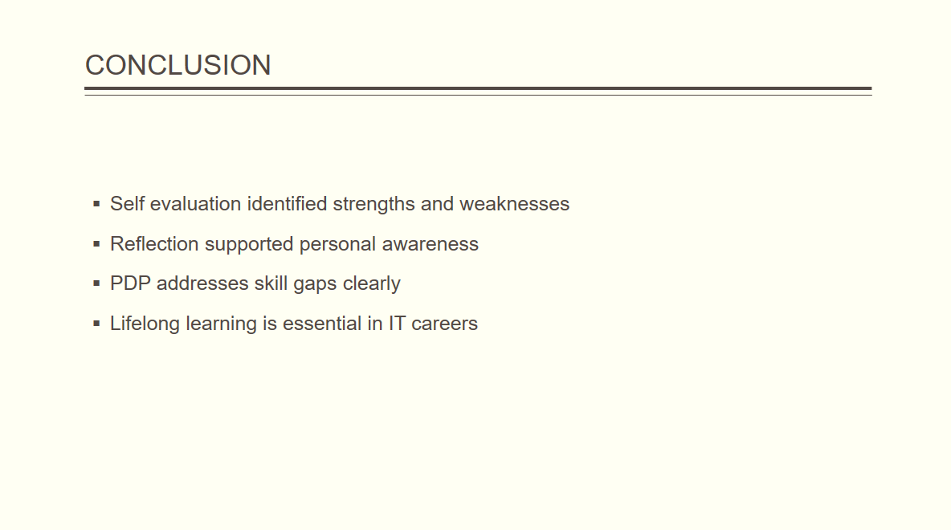
Figure 10: Slide 10

The conclusion slide summarises the key points of the presentation. It highlights how self-evaluation and reflection helped identify strengths and weaknesses. The professional development plan provides a clear pathway to address skill gaps. Overall, reflective practice and lifelong learning are essential for success in academic study and future IT careers.

References:

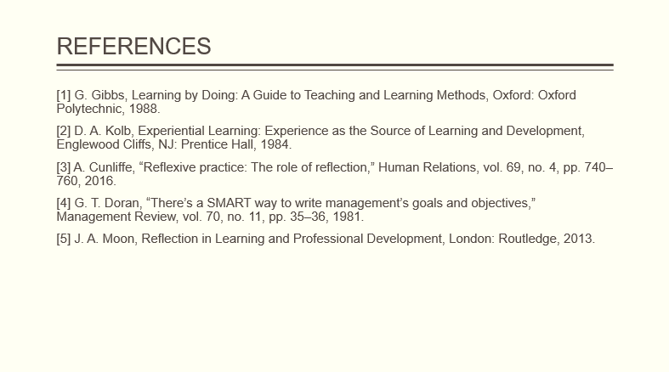
Figure 11: Slide 11

Task 4: Vide Presentation:
https://uowtsd-my.sharepoint.com/:v:/g/personal/2509557_student_uwtsd_ac_uk/IQA84ptUs9oqRq6YNiq23_D_AXfJup-sJxZGj5pSNOaO5oE?e=xwejUa
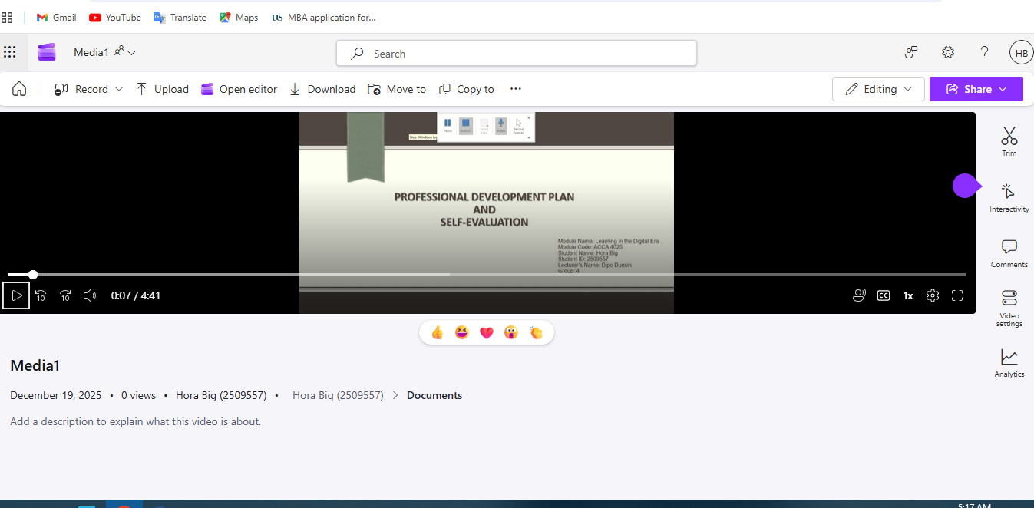
Figure 12: Video Presentation on One Drive

Conclusion
In conclusion, this report and video presentation demonstrate my ability to reflect on my learning, evaluate my skills, and plan for professional development. By applying Gibbs’ reflective model and SMART goal setting, I have identified clear steps to improve my communication, confidence, and technical skills. The Unit 4 topic on unpacking experiences further reinforces the importance of reflection and responsibility in lifelong learning.

References

[1] | G. Gibbs, Learning by Doing: A Guide to Teaching and Learning Methods, Oxford: Oxford Polytechnic, 1988.
[2] | D. A. Kolb, Experiential Learning: Experience as the Source of Learning and Development, Englewood Cliffs, NJ: Prentice Hall, 1984.
[3] | A. L. Cunliffe, ““Reflexive practice: The role of reflection,” Human Relations,” Jornal of Management Education, vol. 69, no. 4, pp. 740-760, 2016.
[4] | G. T. Doran, “There’s a SMART way to write management’s goals and objectives,” Management Review, vol. 70, no. 11, pp. 35-36, 1981.
[5] | J. A. Moon, Reflection in Learning and Professional Developmen, London: Routledge, 2013.

