MediLink Pharmacy Database System

Name :kaled mensur
Student ID: 2514975
Module: ACCA4023 Introduction to Web and Database Concepts
Date: 24th March, 2026

Table of contents
1. Introduction | Page: 3
2. Scenario Analysis | Page:3-6
3. ERD | Page:7-9
4. Data Structure Development & Normalization | Page:9-13
5. Sample Data Population | Page: 14-16
6. Query Development | Page: 17-23
7. Validation and Testing | Page: 24
8. Design Decisions and Critical Evaluation | Page:25
9. Conclusion | Page:25
10. References | Page:26

1.Introduction
MediLink Pharmacy currently manages stock control, prescriptions, customer records and sales transactions manually. Manual systems increase the risk of data redundancy, inconsistency, and human error, particularly when handling inventory levels and prescription records. To address these issues, a relational database system was designed and implemented using Microsoft Access.
Relational databases organize data into structured tables linked by relationships to ensure consistency and integrity. The Entity-Relationship (ER) model, introduced by Chen [1], provides a conceptual framework for modelling real-world entities and their relationships. This project applies ER modelling principles and normalization techniques to develop a database system that ensures data accuracy, reduces redundancy, and supports efficient pharmacy management.
The system was normalized up to Third Normal Form (3NF) and includes referential integrity enforcement, structured queries, and validation mechanisms to support operational decision-making.

2. Scenario Analysis
The pharmacy operations involve the following core activities:
- Suppliers provide medicines.
- Customers receive prescriptions.
- Medicines are dispensed through prescriptions.
- Sales transactions record medicine purchases.
From the pharmacy scenario, several core entities and their attributes were identified to support the database structure.

Suppliers
- SupplierID (Primary Key)
- SupplierName
- PhoneNumber
- Address

Medicines
- MedicineID (Primary Key)
- MedicineName
- Category
- Price
- StockQuantity
- SupplierID (Foreign Key)

Customers
- CustomerID (Primary Key)
- CustomerName
- PhoneNumber
- Address

Prescriptions
- PrescriptionID (Primary Key)
- CustomerID (Foreign Key)
- PrescriptionDate
- Status

PrescriptionDetails
- PrescriptionDetailID (Primary Key)
- PrescriptionID (Foreign Key)
- MedicineID (Foreign Key)
- Quantity
Sales
- SaleID (Primary Key)
- SaleDate
- CustomerID (Foreign Key)

SaleDetails
- SaleDetailID (Primary Key)
- SaleID (Foreign Key)
- MedicineID (Foreign Key)
- Quantity
- TotalPrice
Relationship Analysis
- One Supplier supplies many Medicines (1:M).
- One Customer can have many Prescriptions (1:M).
- One Prescription can contain many Medicines.
- One Medicine can appear in many Prescriptions.
The last relationship represents a Many-to-Many (M:N) relationship. According to relational database theory [2], M:N relationships must be resolved using a junction table. Therefore, PrescriptionDetails and SaleDetails were created to decompose these relationships into two 1:M relationships.
This structure ensures referential integrity and prevents data anomalies.
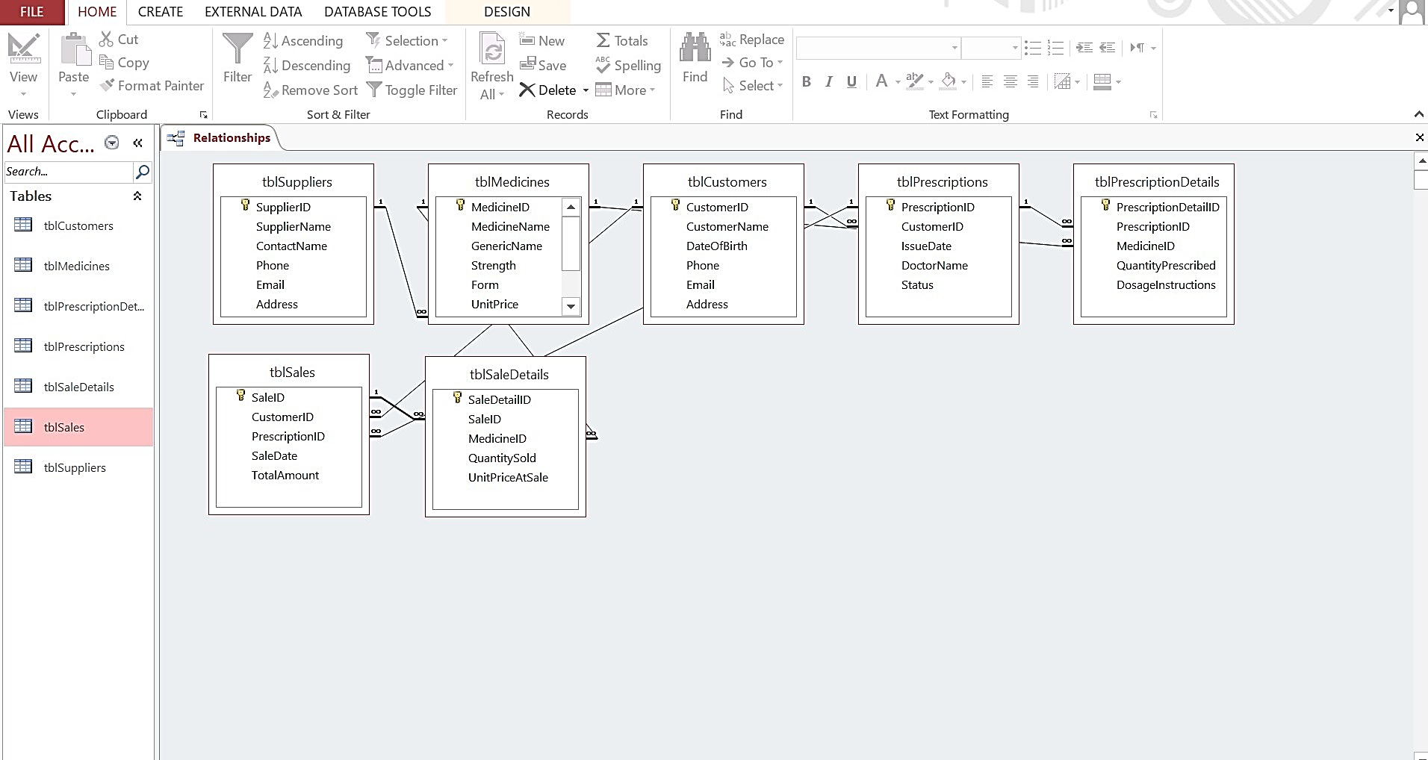

Figure 1: Complete Relationship Diagram Showing Cardinality and Referential Integrity

3. Entity-Relationship Diagram (ERD)

The ERD visually represents entities, attributes, primary keys (PK), foreign keys (FK), and cardinality in a relational database model [3].

3.1 Conceptual ERD
The conceptual ERD represents the high-level structure of the pharmacy system. It identifies the main entities and the relationships between them without including detailed attributes or implementation details.

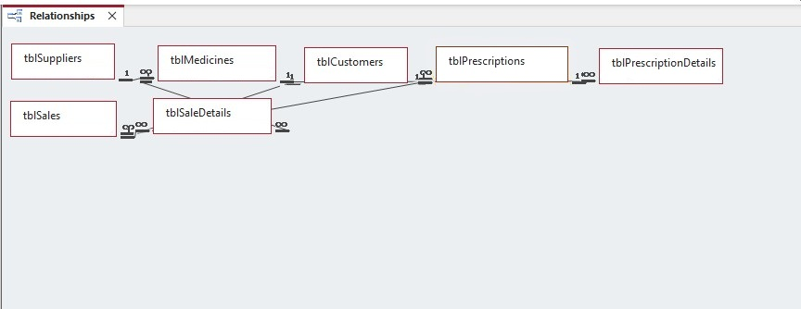
The key entities identified are Suppliers, Medicines, Customers, Prescriptions, and Sales. These entities interact through defined relationships such as suppliers providing medicines and customers receiving prescriptions.

Figure 2: Conceptual ERD Showing Entities and Relationships

3.2 Logical ERD
The logical ERD expands the conceptual model by including entity attributes, primary keys, and foreign keys. It defines the structure of the data model while remaining independent of a specific database system.
Each entity includes attributes that describe its properties, while relationships between entities are implemented using foreign keys.
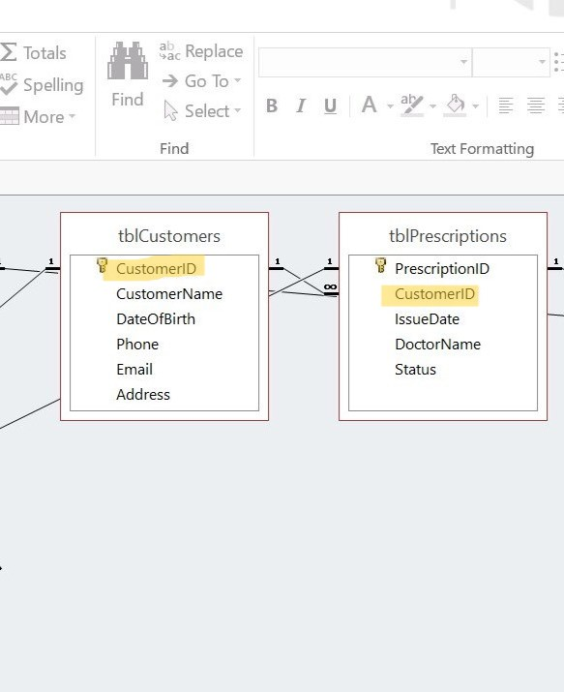
Figure 3: Logical ERD Showing Attributes, Primary Keys and Relationships

3.3 Physical ERD
The physical ERD represents the actual implementation of the database in Microsoft Access. It includes tables, data types, primary keys, foreign keys, and enforced referential integrity rules.

This diagram reflects how the logical model is translated into a working relational database structure.
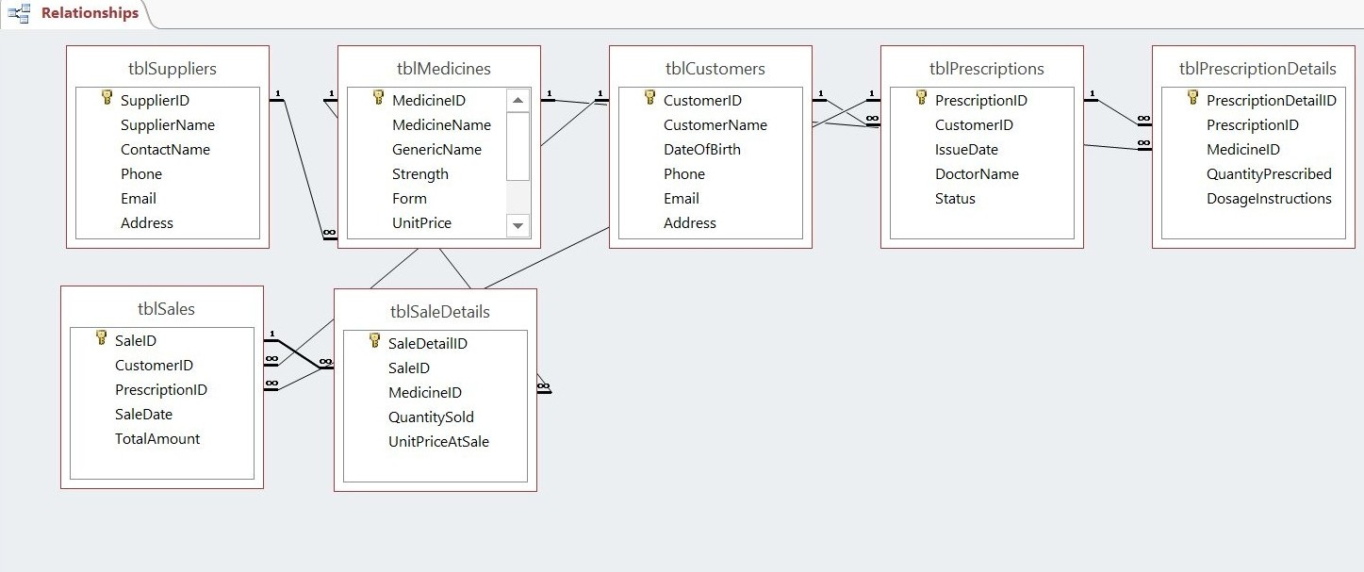
Figure 4: Physical ERD Showing Referential Integrity in Microsoft Access

4. Data Structure Development & Normalization

4.1 First Normal Form (1NF)
A table satisfies 1NF when:
- All attributes contain atomic values
- No repeating groups exist
All tables were designed with atomic attributes (e.g., MedicineName, Price, Quantity) ensuring no multi-valued fields.

4.2 Second Normal Form (2NF)
2NF removes partial dependencies. Since all tables use single-attribute primary keys (AutoNumber), no partial dependency exists.
Junction tables (PrescriptionDetails, SaleDetails) ensure composite relationships are properly structured.

4.3 Third Normal Form (3NF)
3NF eliminates transitive dependencies and ensures that non-key attributes depend only on the primary key [4]. For example:
- Supplier details are stored only in Suppliers.
- Customer information exists only in Customers.
No non-key attribute depends on another non-key attribute. Therefore, the database satisfies 3NF.
Normalization reduces redundancy and improves update consistency [2] [4].
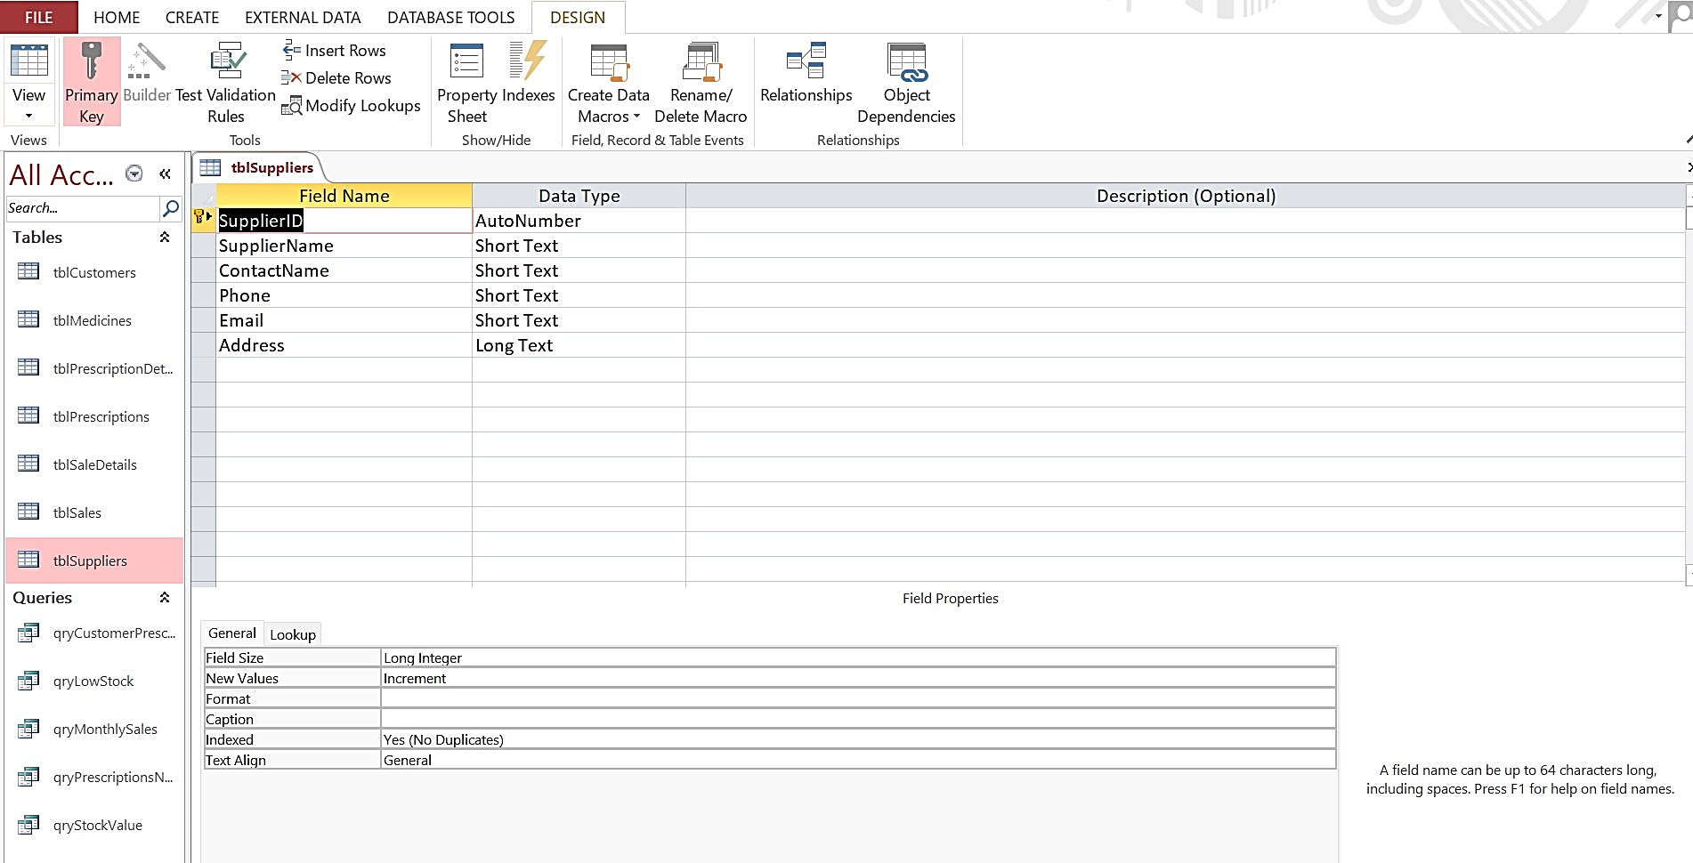

Figure 5: Suppliers Design View

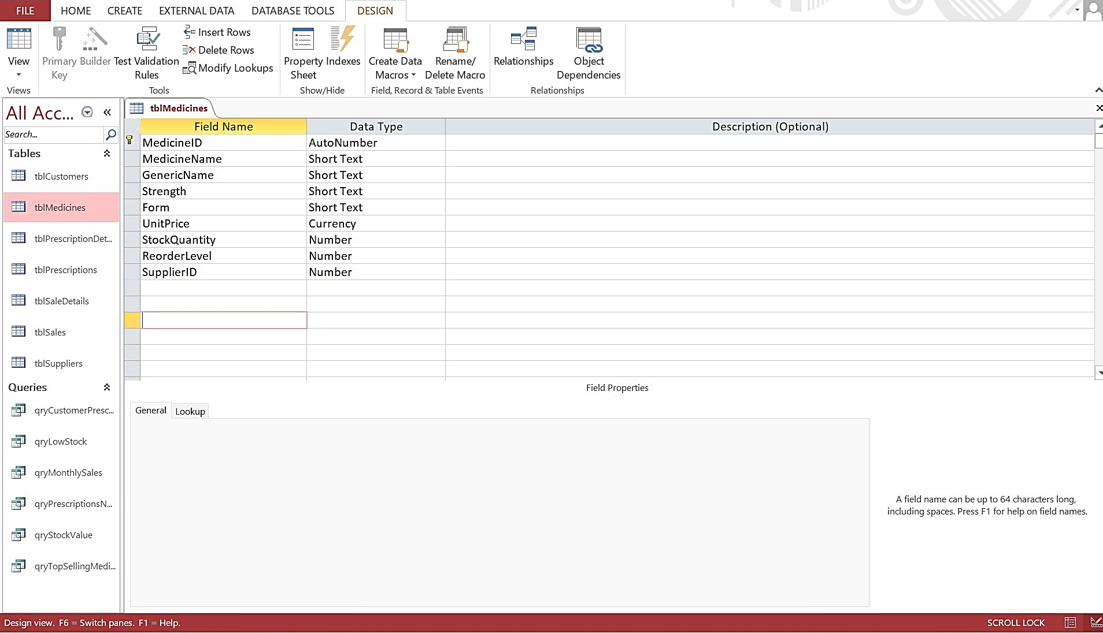

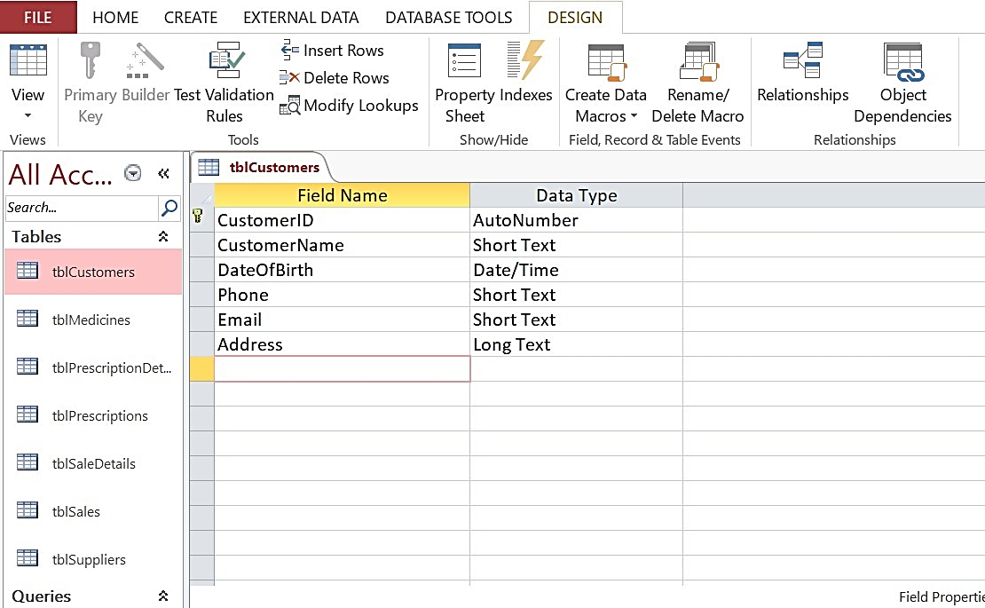
Figure 6: Medicines Design View

Figure 7: Customers Design View

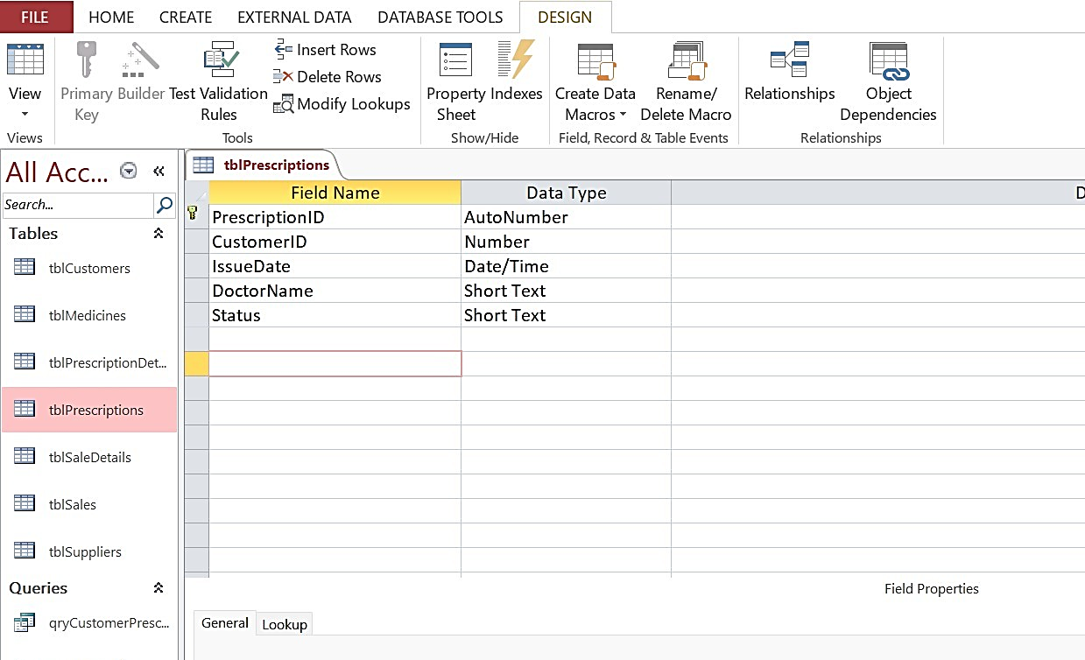

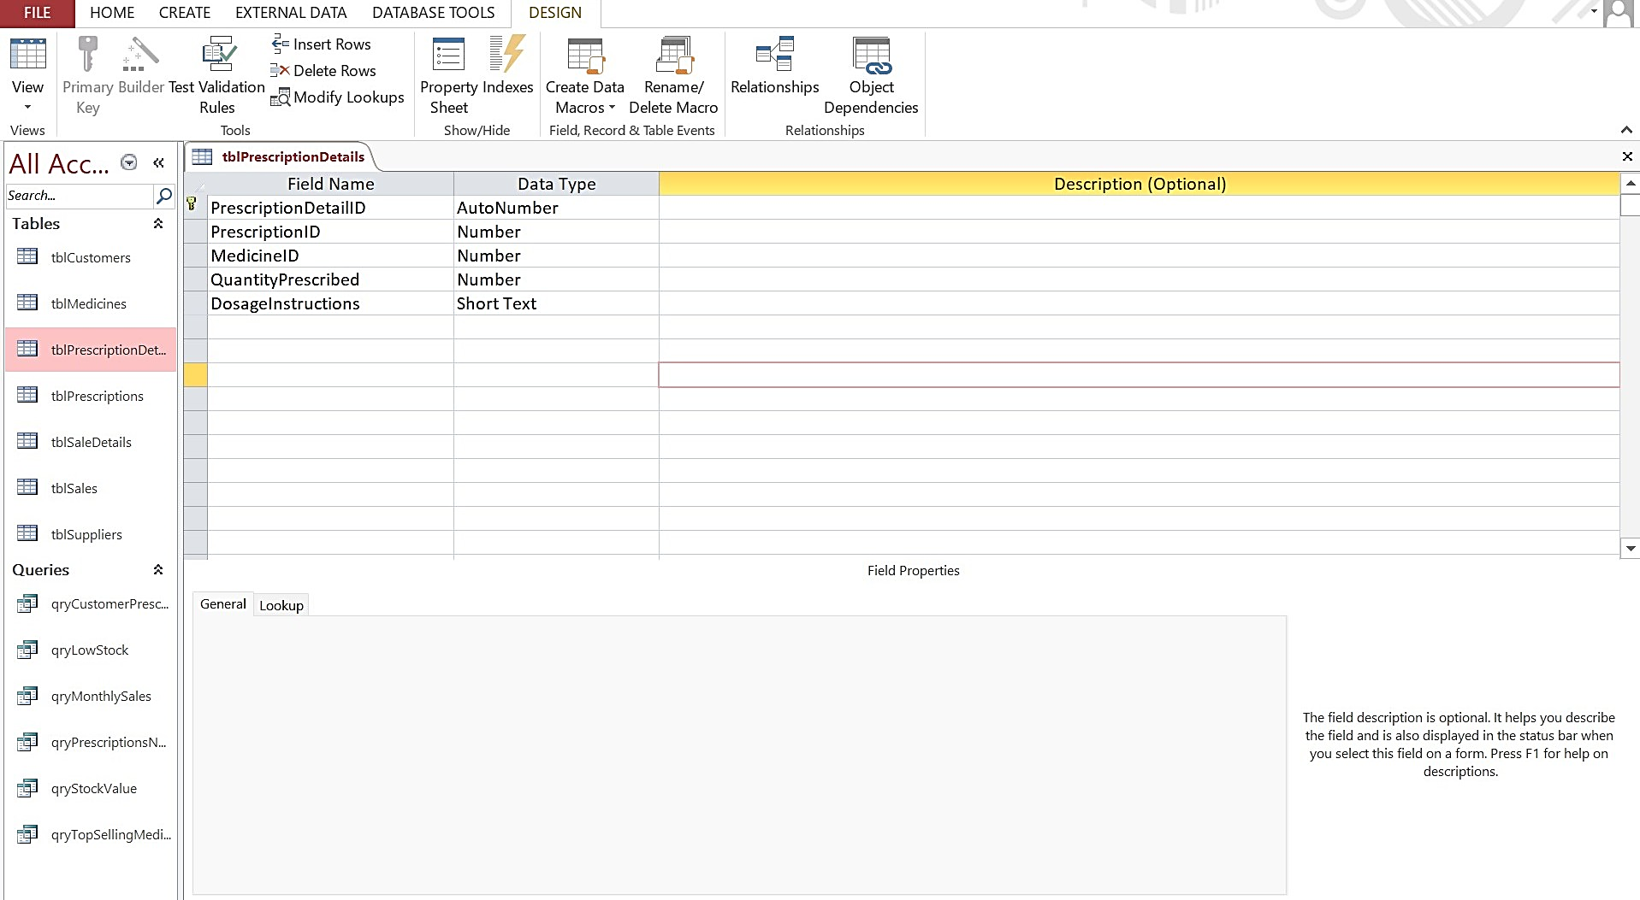
Figure 8: Prescription Design View

Figure 9: Prescription Details Design View
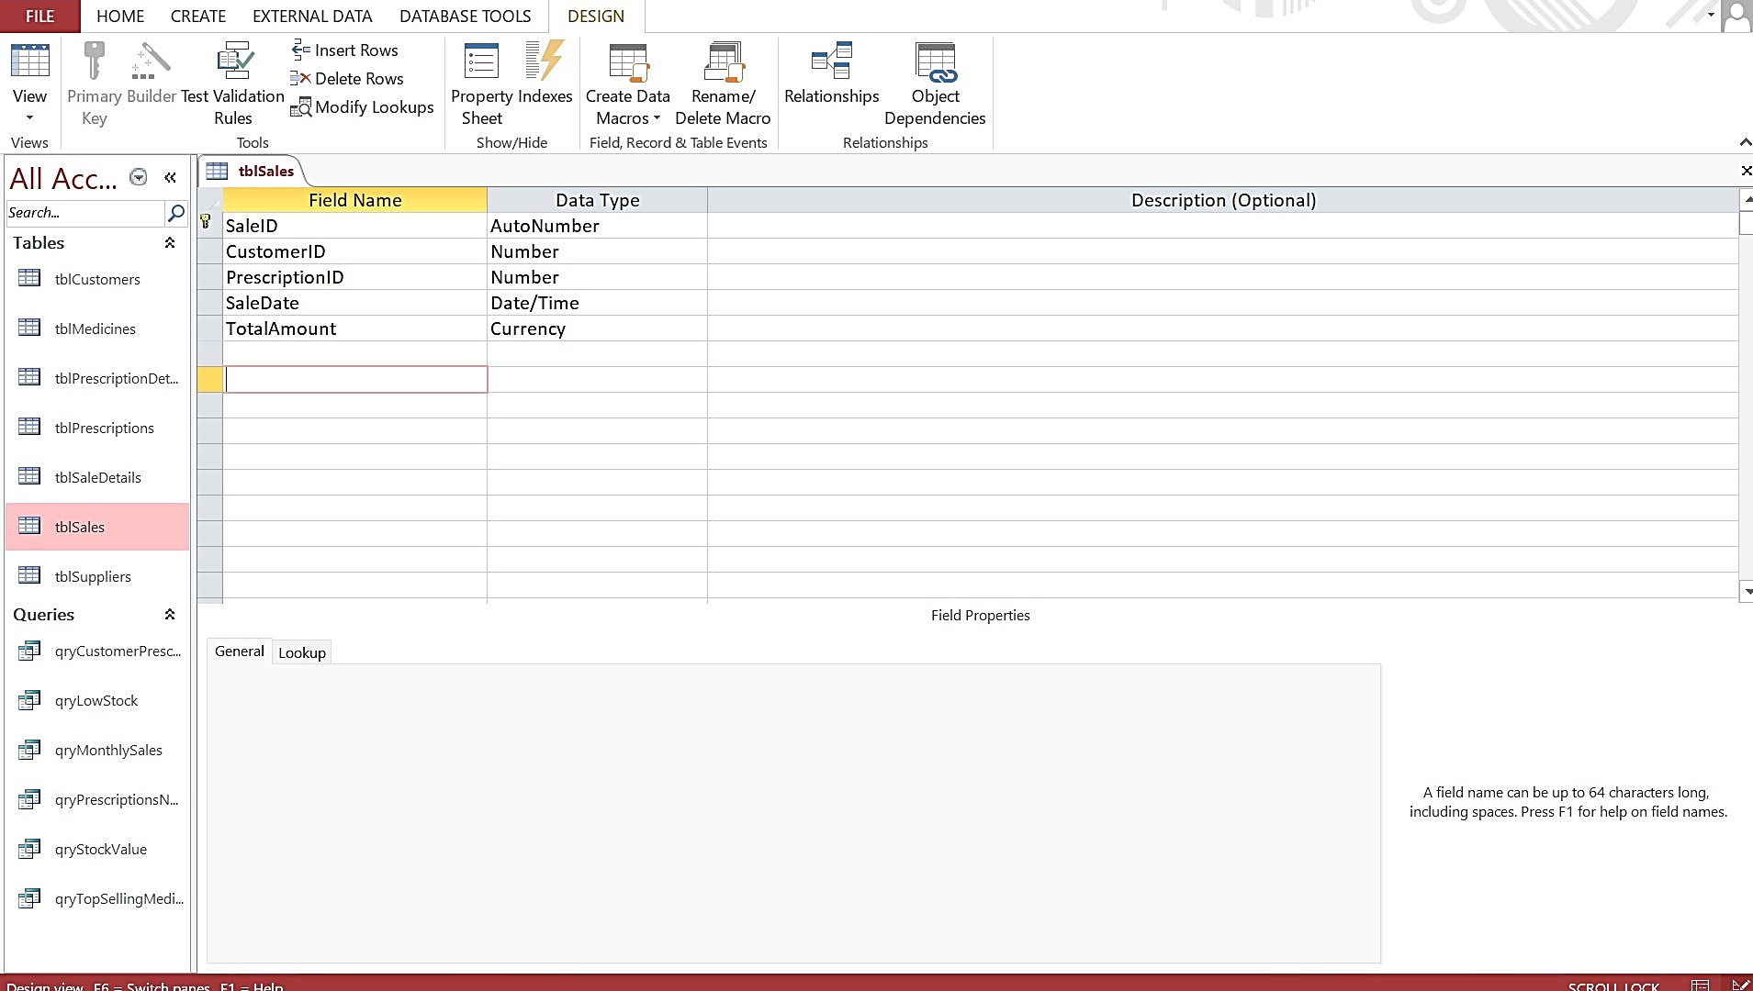
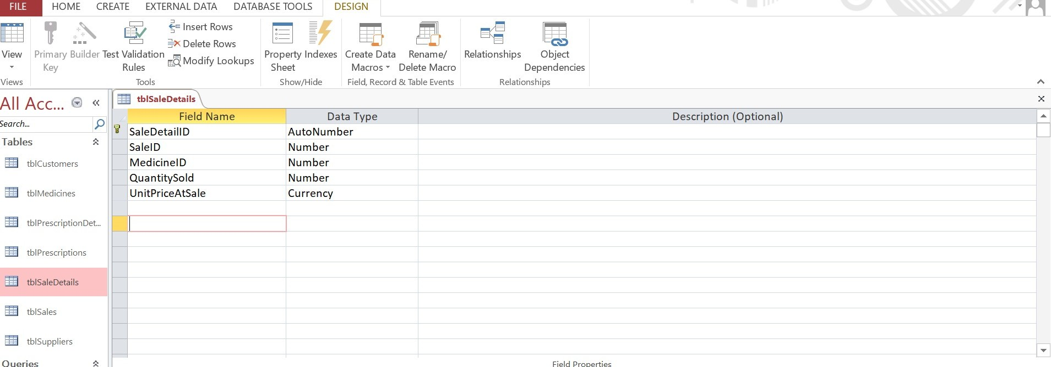
Figure 10: Sales Design View

Figure 11: Sale Details Design View
5. Sample Data Population
To simulate realistic operations, at least six records were inserted into each table. Sample data reflects typical pharmacy activity, including supplier names, customer records, prescription transactions, and medicine sales.
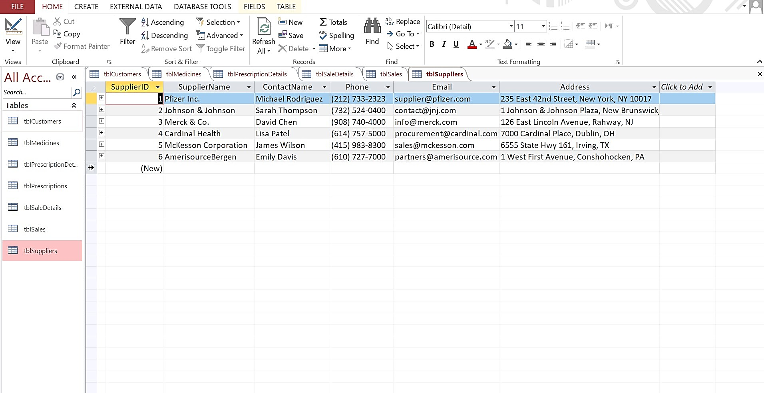
The sample data enables meaningful testing of queries and validation rules.

Figure 12: Suppliers Datasheet
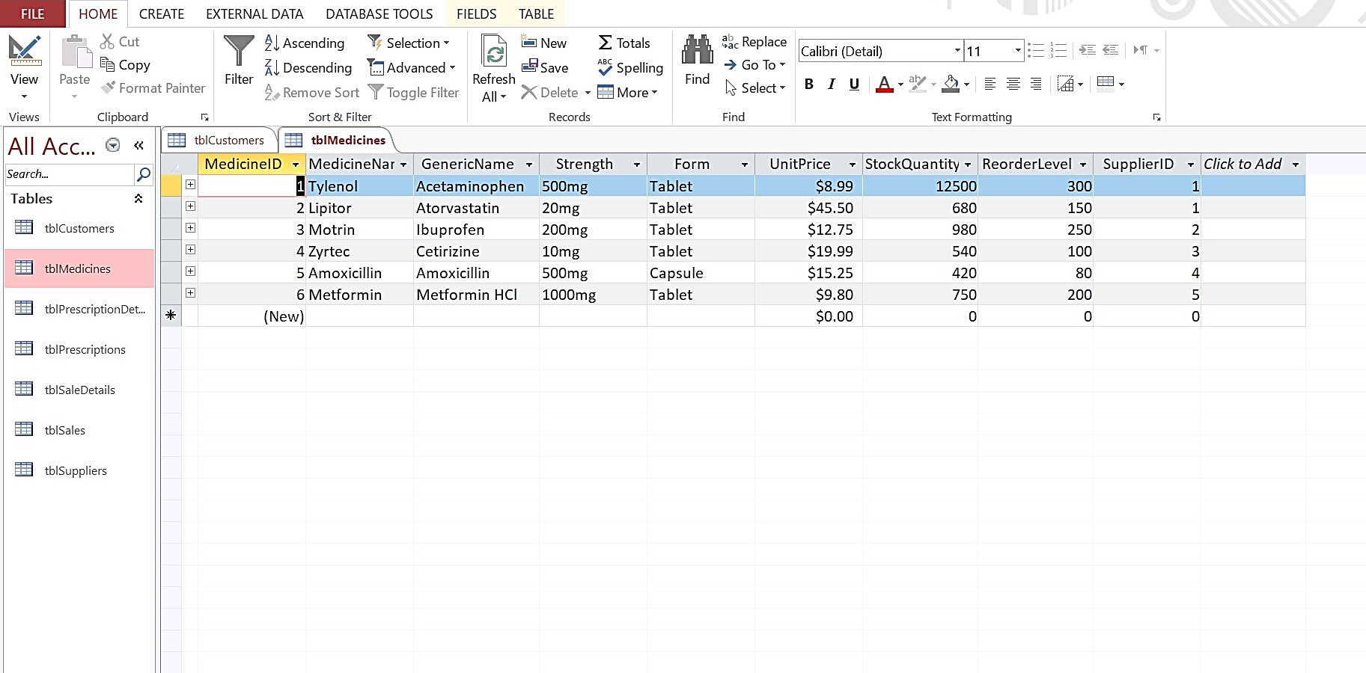
Figure 13: Medicines Datasheet
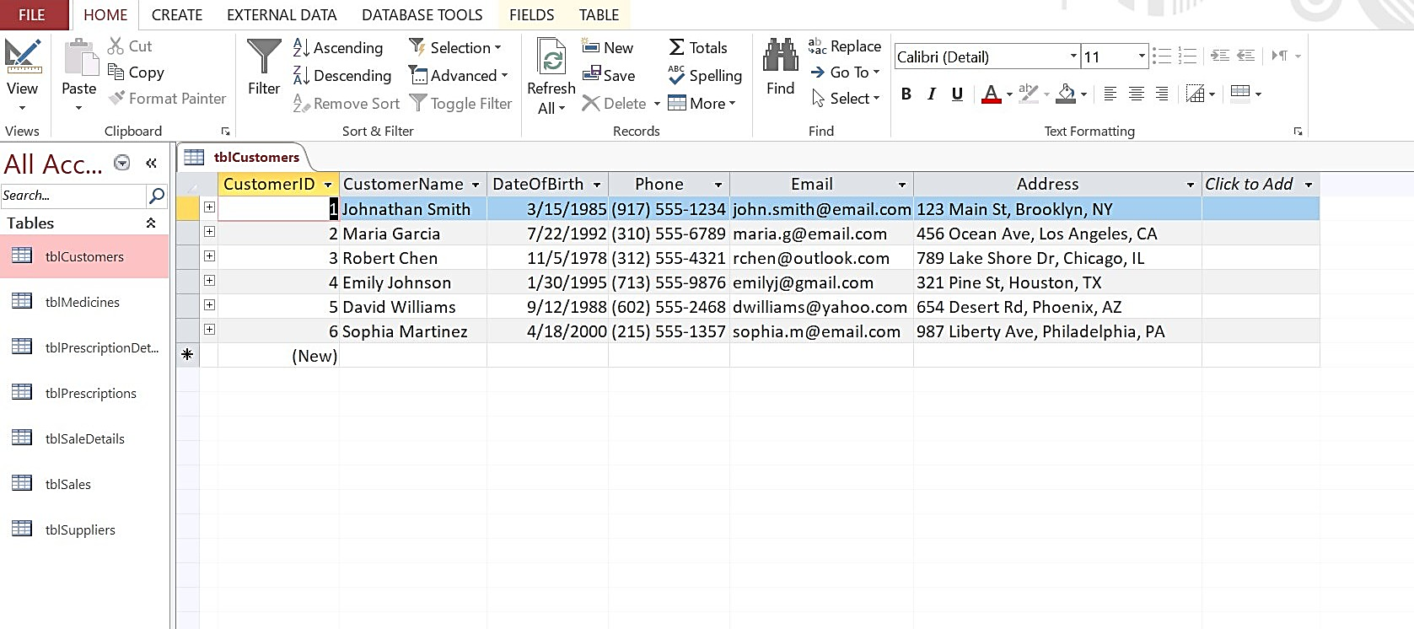

Figure 14: Customers Datasheet
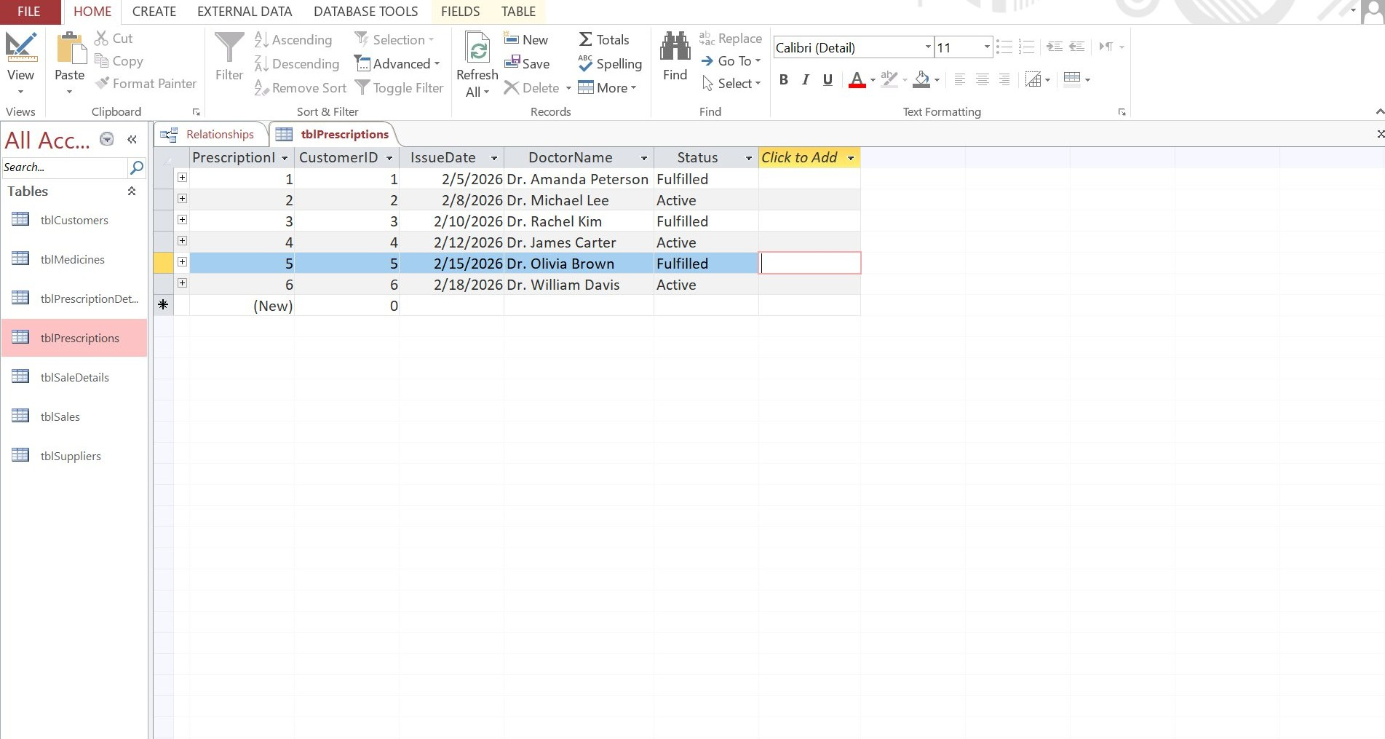
Figure 15: Prescriptions Datasheet
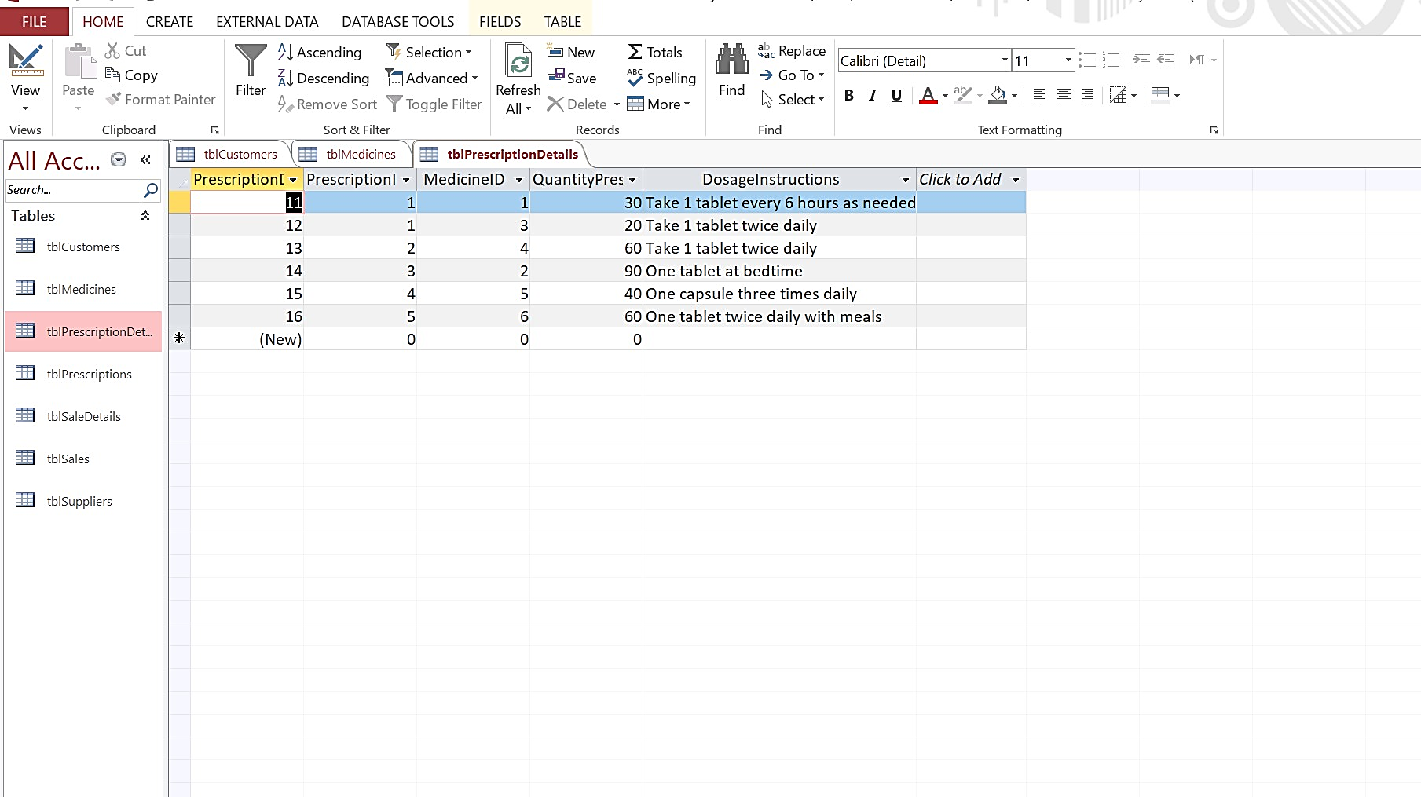
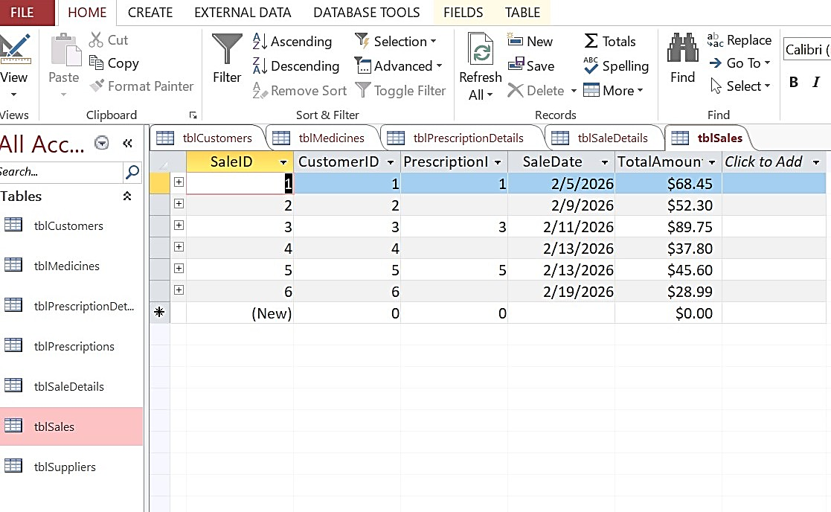
Figure 16: Prescription Details Datasheet

Figure 17: Sales Datasheet
6. Query Development
Six operational queries were created to support managerial decisions:
- Low Stock Medicines
Identifies medicines below reorder threshold.
- Top Selling Medicines
Uses aggregate SUM function.
- Customer Prescription History
Parameter query filtering by CustomerName.
- Active Prescriptions
Filters based on Status field.
- Monthly Sales
Uses date criteria and grouping.
- Total Stock Value
Calculates inventory value (Price × Quantity).
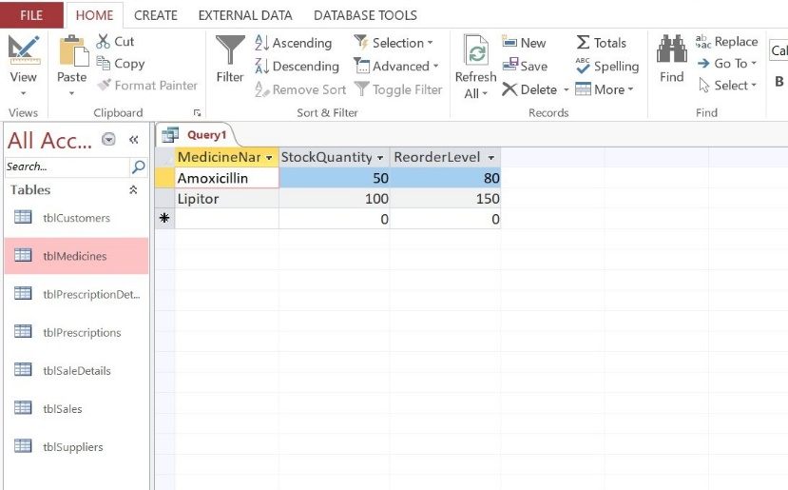
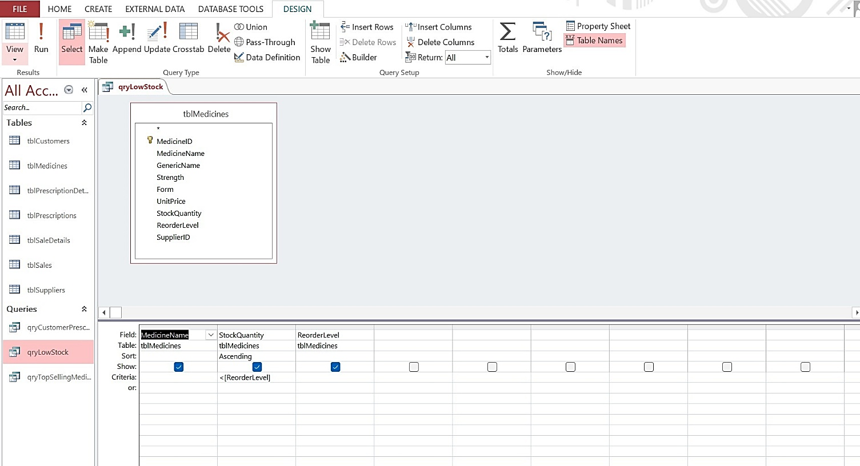


Figure 18: Query and Result of Low Stock Medicines
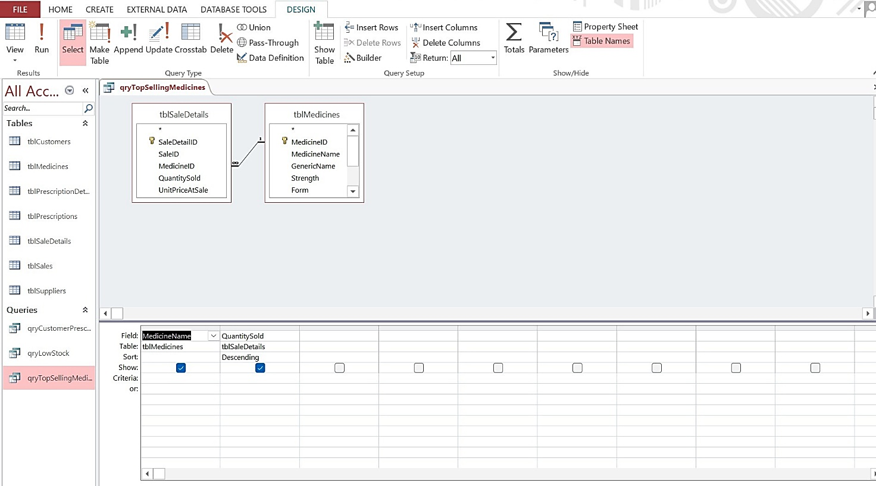

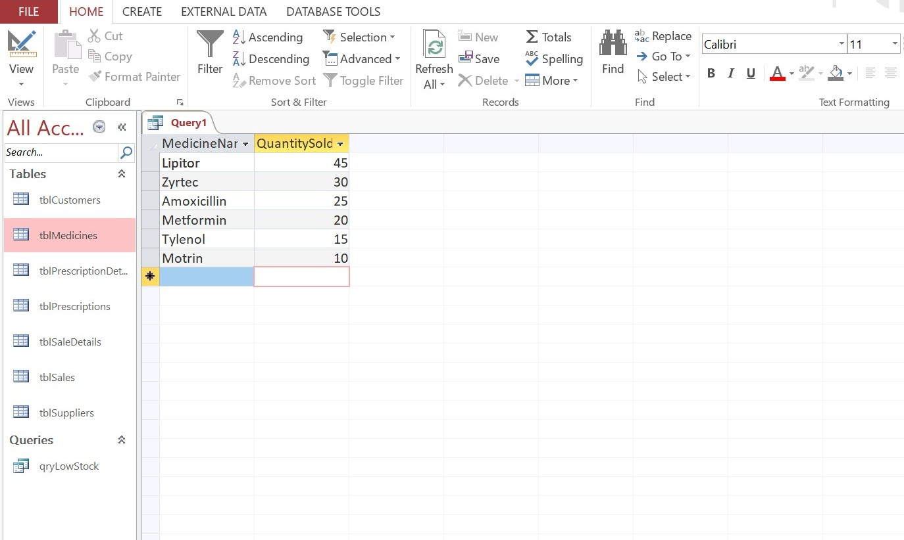

Figure 19: Query and Result of Top Selling Medicines

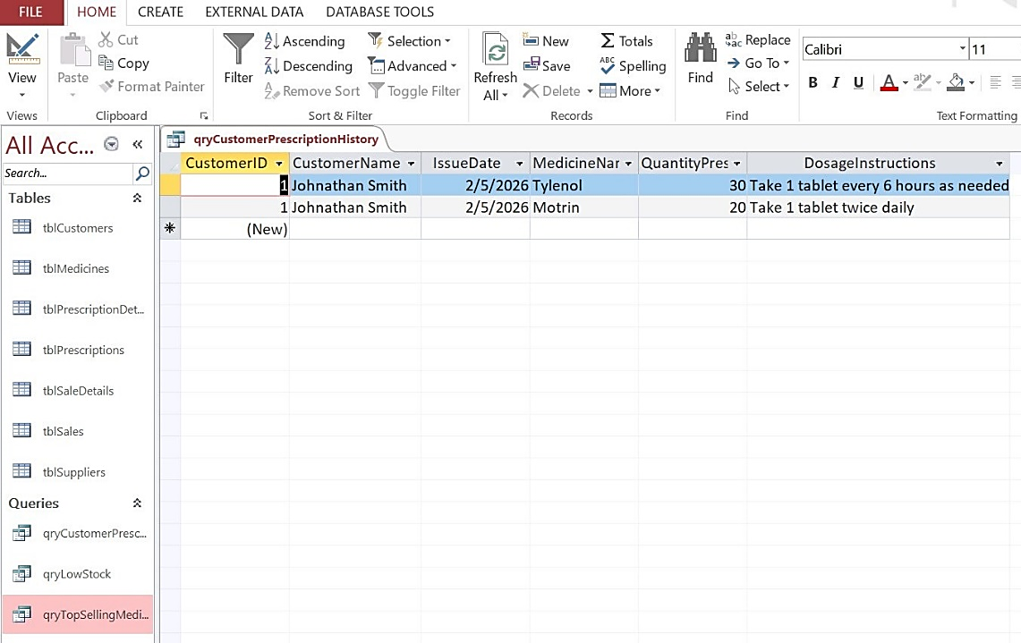
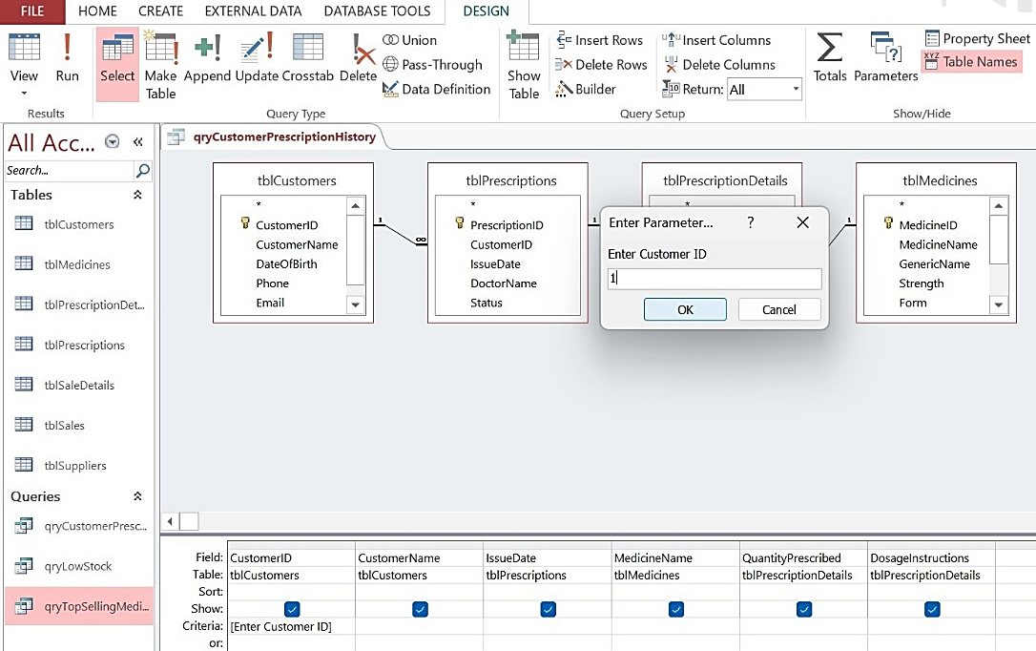


Figure 20: Query and Result of Customer Prescription History
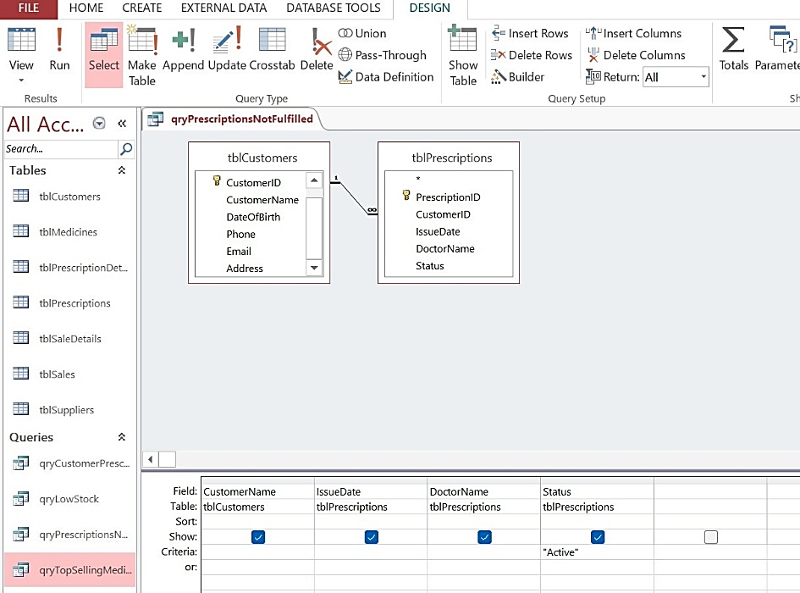
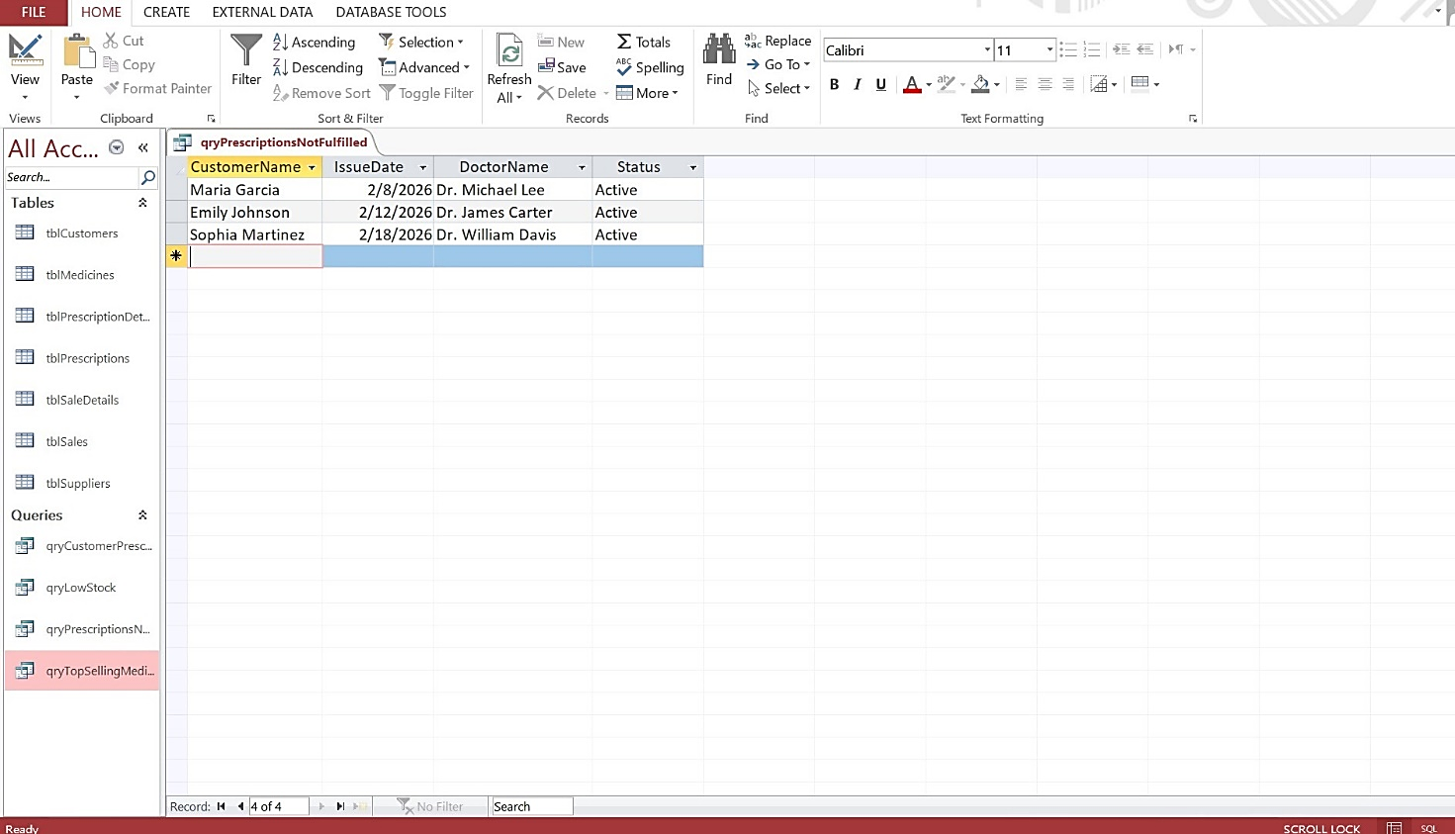
Figure 21: Query and Result of Active Prescriptions

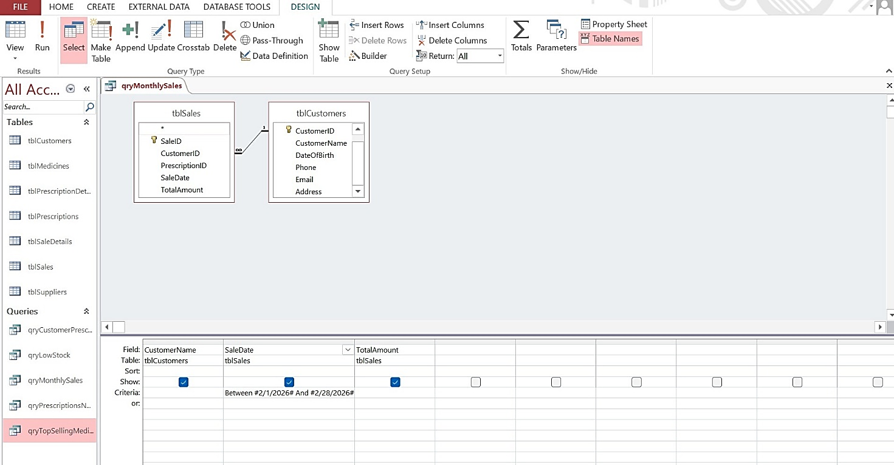


Figure 22: Query and Result of Monthly Sales

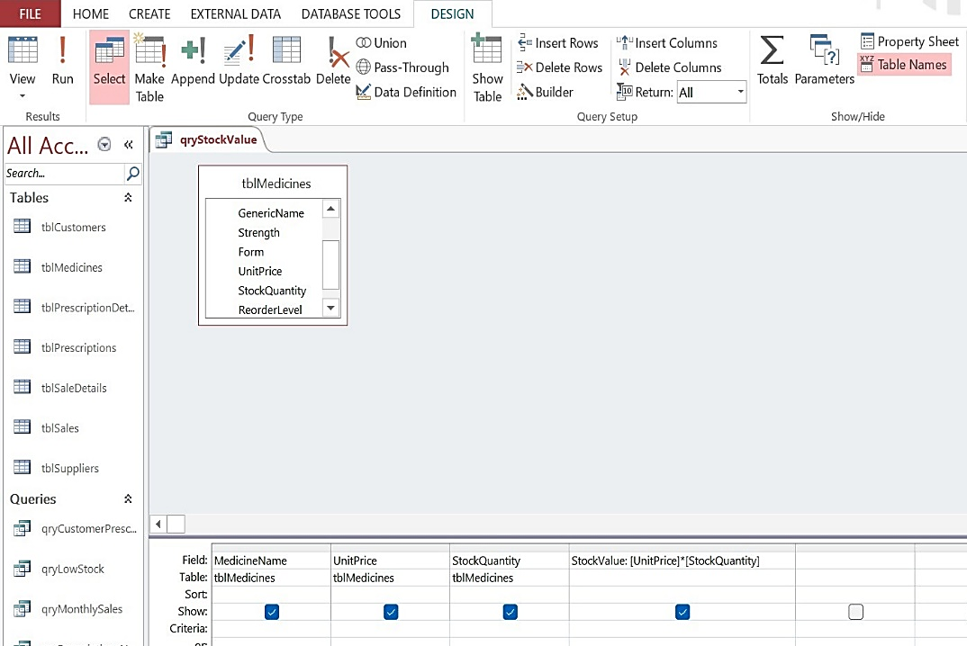
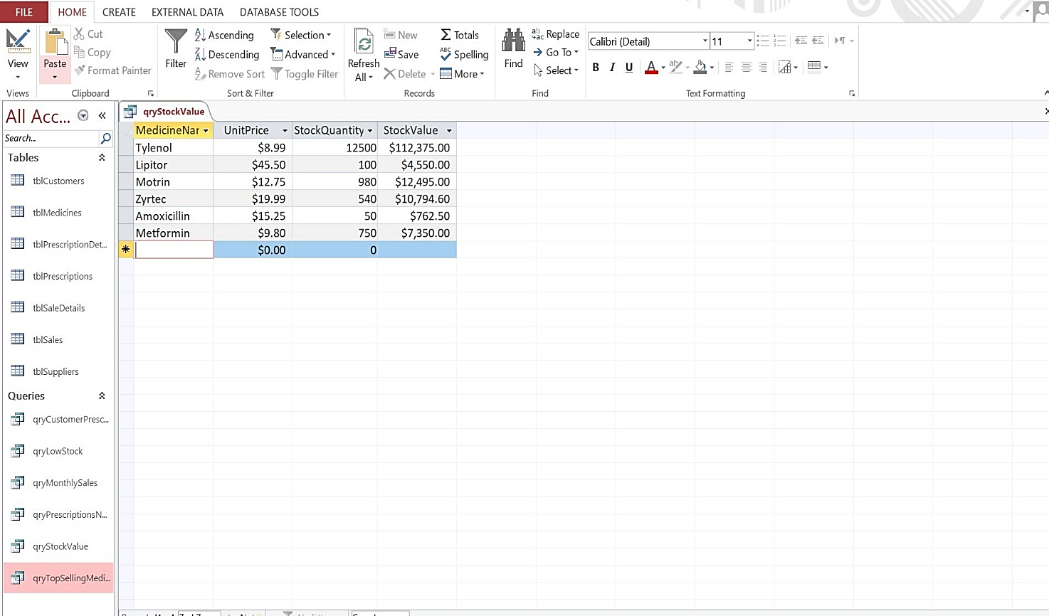

Figure 23: Query and Result of Stock Value

7. Validation and Testing
The database was tested to ensure integrity and reliability.
Referential Integrity Test
Attempting to enter an invalid SupplierID generated an error message, confirming referential enforcement.
Data Validation
- Required fields prevent null entries.
- Status field restricted to predefined values.
- Numeric fields validated for correct data types.
Query Verification
All queries returned results consistent with inserted sample data.
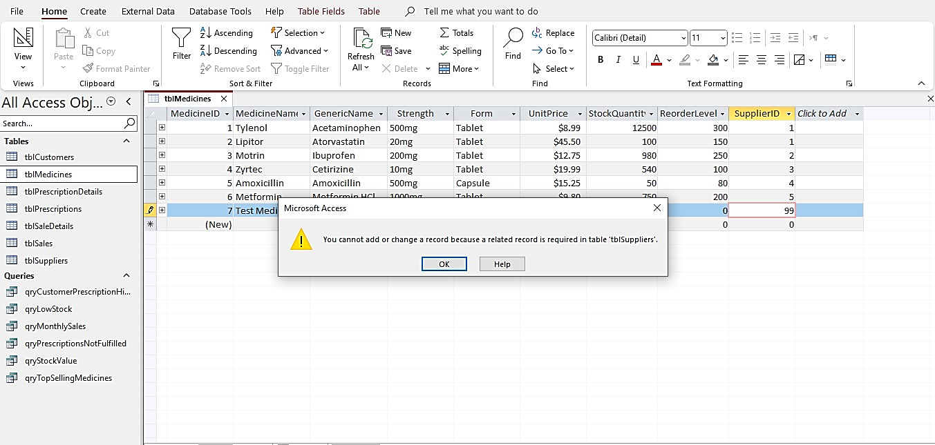
These tests confirm compliance with entity integrity and referential integrity rules [2].

Figure 24: Referential Integrity Error Message

8. Design Decisions and Critical Evaluation
Junction tables were implemented to resolve M:N relationships because relational databases cannot directly represent many-to-many relationships [1][4].
AutoNumber primary keys were selected to ensure uniqueness and simplify relationship creation.
Referential integrity was enforced to prevent orphan records and maintain consistency.
Limitations
- System designed for single-branch use.
- No user authentication implemented.
- Not optimized for multi-user cloud deployment.
Future Improvements
- Expiry date alerts
- Barcode scanning integration
- User role-based access control
- Cloud-based backend migration

9. Conclusion
The MediLink Pharmacy database system successfully transforms a manual record-keeping process into a structured relational database. By applying ER modelling principles and normalization up to 3NF, the system eliminates redundancy and ensures data consistency.
Functional queries provide operational insight, and validation mechanisms guarantee integrity. While the system meets current requirements, scalability and security enhancements could further improve performance in future implementations.
The project demonstrates the practical application of relational database theory in solving real-world business problems.

References
[1] P. P. Chen, “The Entity-Relationship Model—Toward a Unified View of Data,” ACM Transactions on Database Systems, vol. 1, no. 1, pp. 9–36, Mar. 1976.
DOI: https://doi.org/10.1145/320434.320440
[2] C. J. Date, An Introduction to Database Systems, 8th ed. Boston, MA, USA: Addison-Wesley, 2004.
Publisher link: https://www.pearson.com/en-us/subject-catalog/p/introduction-to-database-systems/P200000003481
[3] “Data Modeling Using the Entity-Relationship (ER) Model” (PDF), DocsLib — based on R. Elmasri & S. B. Navathe, Chapter on ER modeling. [Online]. Available: https://docslib.org/doc/11870137/data-modeling-using-the-entity-relationship-er-model (click to view/download)
[4] M. Demba, “Algorithm for Relational Database Normalization Up to Third Normal Form,”
International Journal of Database Management Systems (IJDMS), vol. 5, no. 3, pp. 39–51, 2013.
DOI: https://doi.org/10.5121/ijdms.2013.5303
Available: https://www.researchgate.net/publication/269674039_Algorithm_for_Relational_Database_Normalization_Up_to_3NF

