

Name | Samir Zaky Ibrahim Morsy
Student ID | 2518295
Course | CertHE Computing Skills and Workplace
Module | Introduction to Web and Database Concepts
Group | 3

Table of Contents
1. Introduction 3
2. Scenario Description 3
3. Database Design 4
3.1. Identification of Entities 4
3.2. Entity Relationship Diagram (ERD) 5
4. Database Implementation 5
4.1. Table Creation 5
4.2. Relationships and Referential Integrity 6
5. Sample Data Population 7
6. Query Implementation 8
7. Design Decisions and Discussion 8
8. Challenges and Future Improvements 9
9. Conclusion 9
10. References 10

Introduction
The database system plays an important role in the management of the current healthcare and pharmaceutical industries^{[1]}. Pharmacies deal with huge amounts of information related to medicine, patients, prescriptions, etc. If the database system is not appropriately designed, the management of information cannot be effectively achieved.
The report presents the design and implementation of a relational database system for MediLink Pharmacy, an assumed pharmacy based in the United Kingdom. The database system was developed using the Microsoft Access application.
The main aim of the assignment is to create an organized relational database system that ensures the integrity of the information, maximizes the storage capacity, and allows for the efficient retrieval of information through the definition of appropriate queries^{[2]}.

Scenario Description
MediLink Pharmacy needs the implementation of a database system to effectively control its varied facets of operations, including inventory management, medicine prescriptions, supplier information, and retail transaction management. The system must store information on the medicines provided by the pharmacy’s various suppliers, the patients, the prescribers, the prescriptions issued, and the prescriptions that have been dispensed.
Furthermore, the pharmacy must monitor the medicine batch numbers and their respective expiration dates to ensure the safety of the medicine users^{[4]}. In addition, the pharmacy must maintain the stock levels of the medicine to ensure that the medicine does not run out of stock. The database system also records the retail transaction management, which enables the pharmacy to monitor the over-the-counter medicine sales. Using the relational database approach, the pharmacy can effectively store the information, establish relationships between the entities, and execute queries to obtain useful information.

Database Design

Identification of Entities
Based on the stipulated system requirements, several entities were identified to accommodate the operational needs of the pharmacy. These entities are analogous to tables in a relational database management system^{[2]}.
The main entities include:
- Suppliers: This entity holds information relating to suppliers of medicines to the pharmacy.
- Medicines: This entity holds information relating to medicines available in the pharmacy.
- Patients: This entity holds information relating to patients who visit the pharmacy.
- Prescribers: This entity holds information relating to medical practitioners who prescribe medicines.
- Batches: This entity holds information relating to particular batches of medicines, including batch numbers and expiry dates.
- StockMovements: This entity holds information relating to movements of medicines in the pharmacy, including sales, receipts, and dispensing.
- Prescriptions: This entity holds information relating to prescriptions issued to patients.
- DispenseItems: This entity holds information relating to medicines dispensed to patients as part of prescriptions.
- TillSales: This entity holds information relating to sales transactions recorded in the pharmacy.
- TillSaleItems: This entity holds information relating to medicines sold to customers as part of sales transactions.

Entity Relationship Diagram (ERD)
The Entity Relationship Diagram shows how the tables relate to each other using primary keys and foreign keys. The entities in the ERD represent real-world objects in the pharmaceutical system, while the relationships show how data flows from one object to another.
The relationships ensure that the data has referential integrity.
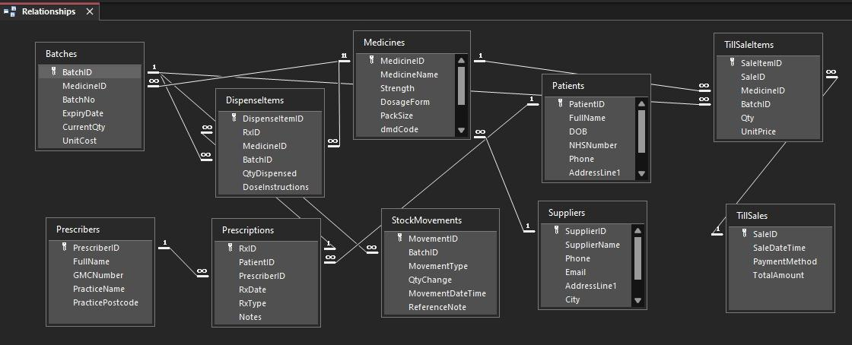
Figure 1: Entity Relationship Diagram of MediLink Pharmacy Database

Database Implementation

Table Creation
The database tables have been developed using the Microsoft Access Design View^{[3]}. Each table is defined based on appropriate fields that have been given the right type. Keys have been established to uniquely identify each record in the tables.
For example, the Patients table contains fields such as PatientID, FullName, Date of Birth, NHSNumber, etc. The NHS number ensures that each patient is uniquely identified.
In the same way, the Medicines table contains information relating to medicines, including dosage form, pack size, etc. These details are used for inventory control.

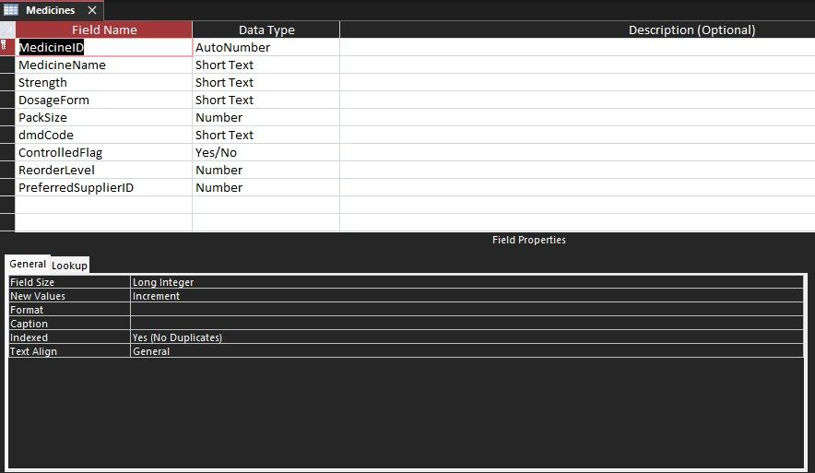
Figure 2: Table Design for Medicines Table

Relationships and Referential Integrity
The relationships that exist among the tables were established using foreign keys to ensure consistency in the records throughout the database. This is achieved by the use of referential integrity constraints.
For example:
- The batch of medicines must exist in the database.
- The prescription must belong to a real patient and prescriber.
- The medicines that are to be dispensed must belong to a real prescription.
- The items that are to be sold must belong to a real retail transaction.
The relational constraints ensure that the database contains reliable information.

Figure 3: Relationships Between Tables with Referential Integrity

Sample Data Population
After the creation of the database schema, sample data that represented the operations of pharmacies in the UK was entered into the tables. For instance, the patient information contains valid NHS numbers, as well as UK addresses. On the other hand, the medicine information contains batch numbers, expiry dates, etc. The data entered into the tables was meant for queries that would return useful results.

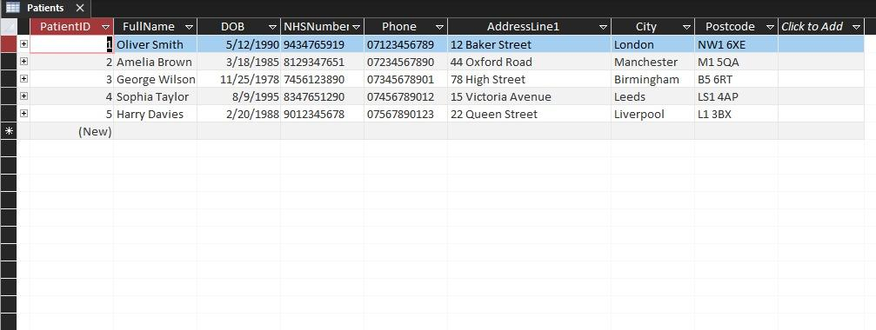
Figure 4: Sample Data Inserted into Patients Table

Query Implementation
To retrieve necessary information from the database, inquiries were created. These inquiries demonstrate how the system can be used to make decisions or carry out day-to-day activities within the pharmacy.
The key inquiries that were implemented are:
- Batches Expiring Soon Query: This query retrieves medicine batches whose expiry dates are approaching.
- Low Stock Alert Query: This query retrieves medicine whose stock level is below a certain threshold.
- Prescription History Query: This query retrieves information about a prescription belonging to a particular patient.
- Daily Sales Summary Query: This query calculates the number of sales made on a particular day, along with the amount of money generated.
- Itemised Sales Report Query: This query provides detailed information regarding the medicine sold within a particular sale transaction.

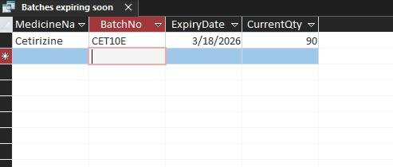
Figure 5: Query Result Showing Medicines Expiring Soon

Design Decisions and Discussion
Several design decisions were made to ensure that the database design is efficient and scalable.
The database design was normalized to ensure that there is no redundancy and data integrity is maintained. Separate tables were used to store various entities, e.g., medicine, patient, prescription, and supplier, ensuring that the data is represented only once and relationships between the data are defined.
Batch tracking was also considered to ensure that the pharmacy is able to track the expiry dates of the medicine and ensure the safety of the medicine in circulation. This is a critical aspect of the database design, especially when dealing with medicine expiry dates, where expired medicine needs to be recalled from circulation.
The relationships between the tables were also carefully defined to ensure that there is no entry of invalid data into the database. For instance, a prescription needs to be made for a patient and written by a prescriber before it is recorded in the database.

Challenges and Future Improvements
During the implementation of the database, several challenges arose. First, the definition of the inter-table relationships in the database while avoiding circular dependencies was a challenge. This meant that proper configuration of the foreign keys had to be planned with careful thought put into the design of the tables.
The other challenge that arose was the generation of queries that could produce useful output based on the sample data provided. This meant that changes to the data or the queries had to be made to ensure that the reports generated, such as the low stock level reports or the batch expiration reports, produced valid output.
In the near future, the database could be expanded to add more features to the system. This could include staff management systems, automated stock level calculations using triggers, or even graphical displays for the pharmacy managers. This could be achieved by connecting the system to other healthcare systems to enable the transfer of prescriptions electronically.

Conclusion
This assignment demonstrates the process of designing and developing a relational database system in the context of the pharmacy environment. The database was successfully designed and developed using Microsoft Access, which included tables, relationships, sample data, and queries for the database system.
The database system allows the pharmacy to manage medication, monitor inventory, track prescriptions, and process retail sales transactions in an efficient manner. The database system uses tables and relationships to ensure the accuracy and consistency of the data.
In conclusion, the database system was successfully designed and developed to provide the pharmacy with a reliable platform for managing data and producing informative reports for decision-making.

References
[1] T. Connolly and C. Begg, Database Systems: A Practical Approach to Design, Implementation, and Management, 6th ed. Harlow, UK: Pearson, 2015.
[2] R. Elmasri and S. Navathe, Fundamentals of Database Systems, 7th ed. Boston, MA: Pearson, 2016.
[3] Microsoft, “Introduction to Microsoft Access.” Available: https://learn.microsoft.com/en-us/office/troubleshoot/access/intro-to-access
[4] NHS Digital, “The NHS Number.” Available: https://digital.nhs.uk/services/nhs-number

