

Student Name: Vilma Dias Rodrigues
Student ID: 2336478
Module Code and Name: Changemakers: Building your Personal Brand for Sustainable Employment BMHP5015

Table of Contents
Introduction 3
Reflection on Professional Networking in Health and Social Care 4
Reflection on Self-Determination in Career Development 7
Reflection on the Concept of Boundaryless Career 9
Reflection on Professional Collaboration and Interdisciplinary Work 11
Conclusion 12
References 13

Introduction
Today, contemporary professional settings are influenced by factors like globalisation, technological development, and rising cooperation between companies and professionals. Connecting this to health and social care, the changes are very crucial due to mandatory collaborations between professionals and colleagues from different disciplines, organisations, and cultures. In this way, they should give efficient care for service users. The idea of global professional interaction focuses on the importance of cultural awareness, networking, and career development.
Networking helps professionals to exchange knowledge, access resources, and create new skilled opportunities. In addition, professional networks also improve cooperation between companies and support the quality of services provided to different communities (Spann, 2025). In healthcare environments, cooperation between professionals is important. Also, patient care usually needs interdisciplinary cooperation between doctors, nurses, therapists, and social workers (Corbaz-Kurth, 2025). Another important idea in modern career development is the boundaryless career. The concept describes careers that pass the limits of one company and include mobility between different jobs, industries, and locations (De Vos, Van der Heijden, and Akkermans, 2020). So, professionals often change organisations and roles to improve different skills and gain more experience.
Also, career development theories focus on the importance of self-concept and personal growth. The Super’s Life-Span Career Theory states that career development is a long-term process affected by personal identity, experiences, and social roles (Savickas, 2019).
This task represents various learning activities that defined career development, networking, and professional collaboration. The analysis also inspects how these activities refined understanding of professional networking, boundaryless careers, and self-determination in career planning.

Reflection on Professional Networking in Health and Social Care
Screenshot 1. Professional networking discussion activity on Moodle
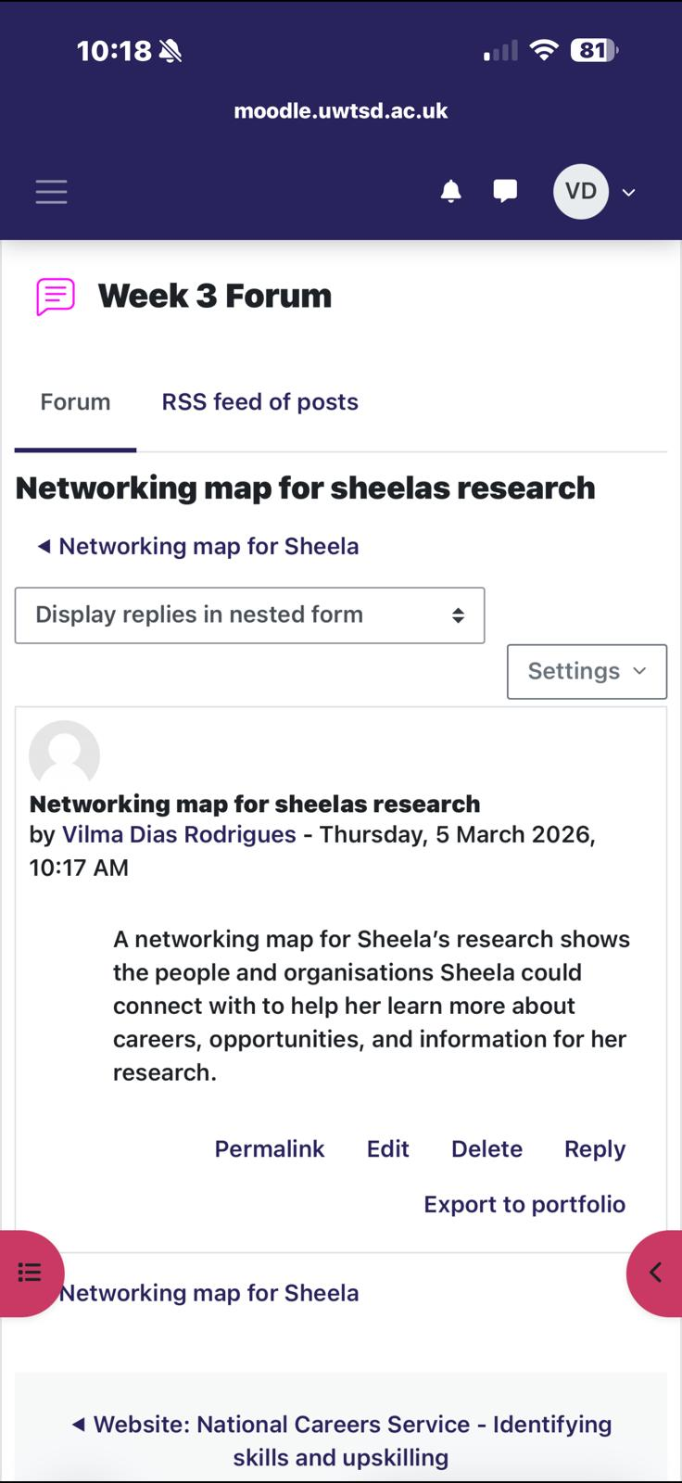
Professional networking was one of the most crucial topics analysed in the learning activities. In addition, networking can be described as the process of creating relationships with other professionals to exchange knowledge, share experiences, and develop new professional opportunities. Networking improves cooperation and professional development in many roles. However, in health and social care environments it is very important, as professionals do not work alone. Healthcare services demand collaboration between various companies, experts, and professionals. Consequently, these parties must work together in order to create efficient care for service users.
During the module, I realised that networking is more than communication. It is also about creating professional relationships that can improve learning and career growth. Wani (2024) states that professional networks support back collaboration between people and help professionals to share knowledge and experiences, refining professional abilities. In healthcare environments, this sharing of knowledge is crucial. In addition, medical and social care workers should update their abilities all the time to be more reactive to changing healthcare necessities.
Networking also creates opportunities for professionals to apply new resources and data. With professional networks, people can learn about training options, conferences, and professional training seminars. In addition, these networks are also available to people that want specific knowledge. On the other hand, these professionals cannot have access to this information in their own company (Spann, 2025). For instance, healthcare professionals can cooperate with experts from other hospitals or institutions to solve problems for complex medical situations.
Another essential idea of networking in health and social care environments is cooperation between companies. Healthcare services are mostly provided by partnerships between hospitals, community health services, social care companies, and government parties. So, cooperative partnerships between firms can refine healthcare results and improve the efficiency of services provided to societies. Therefore, efficient collaboration needs clear communication between all the stakeholders, trust between professionals, and clearly defined roles in the healthcare teams (Arabi, 2025).
Community collaboration is also a major driver for improving public health. In addition, healthcare professionals work together with community firms to identify broader social factors of health. Also, these include housing, employment, education, and access to healthcare services. So, cooperation between healthcare companies and community organisations helps professionals create more comprehensive solutions that refine the wellbeing of individuals and communities (Santa, 2025).
Also, another essential improvement in professional networking is the use of digital platforms and online communication technologies. In modern healthcare societies usually apply online platforms and social media to better communicate with co-workers and exchange professional knowledge. In addition, these platforms provide new opportunities for networking. So, they help professionals from different countries and companies to cooperate without boundaries. Pianese and Belfiore (2021) state that digital networking platforms help professionals exchange data, discuss professional problems, and generate international professional communities.
Based on the learning activities during the module. I understood that networking is closely related to the growth of a personal brand. In addition, a personal brand is how a professional presents skills, values, and identity to other parties. So, professional networking helps people to show their skills and improve professional credibility in their field. Labrecque, Markos and Milne (2011) state that personal branding helps individuals show their professional identity and present a positive reputation in professional networks.
So, this activity helped me realise that networking is important for companies and individual career development. Creating professional relationships helps individuals find new opportunities for learning, mentorship programs, and career development. So, networking is a major ability for professionals who want to achieve a successful career in health and social care environments.

Reflection on Self-Determination in Career Development
Screenshot 2. Self-determination forum activity on Moodle
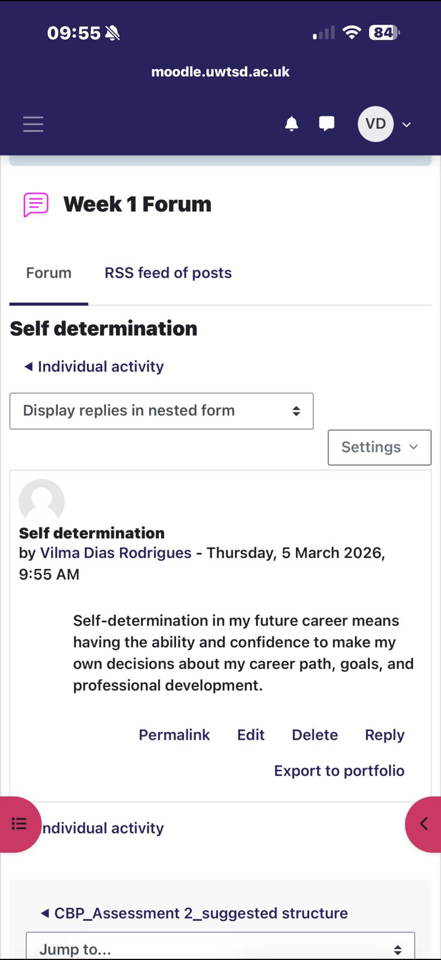
Self-determination in career development is another essential concept analysed deeply during the learning activities. In addition, it is related to the ability of people to make independent decisions about their career goals, professional growth, and further opportunities in their lives. It included higher responsibility for personal development and actively working towards reaching professional objectives.
In addition, self-determination is a crucial component of career development. This is because professionals should improve their knowledge and skills constantly. People who show self-determination easily identify learning opportunities, are involved in professional training, and refine new competencies. These practices aid people in improving employability and professional work.
Career development theories say that career choices are affected by an individual’s self-concept and professional character. Savickas (2019) states that career development is a continuous process where individuals create their professional identity by using experiences, learning, and social interactions. When they gain new experiences and knowledge, the understanding of their professional role and career goals can be different (Akkermans, Richardson and Kraimer, 2020).
Self-determination is also closely related to health and social care jobs. For example, healthcare professionals should constantly improve their knowledge and abilities to react to new healthcare problems, technological improvements, and changes in healthcare guidelines. So, lifelong learning is a major element of professional activity.
Moreover, the improvement of self-determination can also be refined by mentoring and peer programs. For example, mentoring programs help experienced staff to give advice and guidance to new hires that initially grow their careers. Allen, Eby and Lentz (2020) say that mentoring relationships improve career development by refining professional confidence and assisting individuals in seeing their career opportunities.
Also, professional networks maintain self-determination. This is because they give opportunities for cooperation and knowledge transfer. By networking, individuals can gain experience and knowledge from other professionals in order to support their career growth. In addition, these interactions can also help professionals to improve their professional identity and improve their personal brand.
During this activity, I realised that career development includes active participation and personal responsibility. On the other hand, professionals cannot depend only on their companies to help them in their career development. Instead, they should look for new opportunities to learn, improve new skills, and create professional relationships that help their career growth.

Reflection on the Concept of Boundaryless Career
Screenshot 3. Boundaryless career forum activity on Moodle
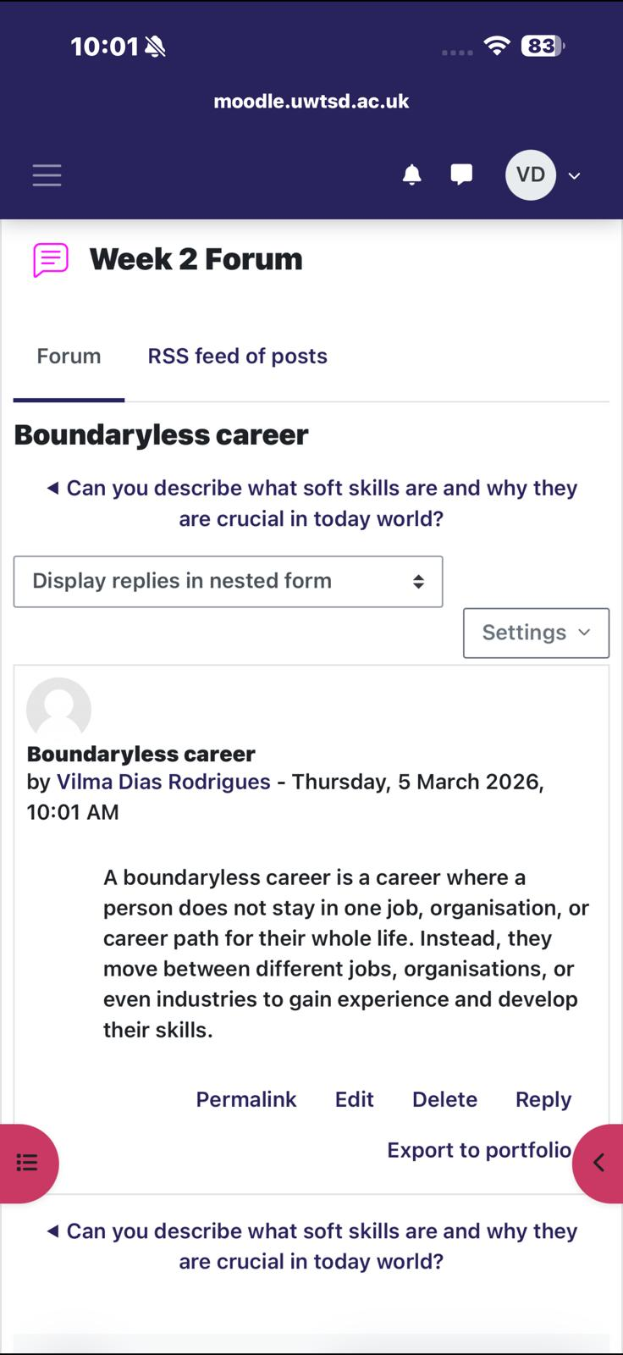
The main idea behind the boundaryless career is related to a career choice in which people often change companies, roles, and industries to achieve success and improve new skills. Compared to traditional career paths, often demanding long-term employment in one company, modern careers are very flexible and dynamic (Baruch, 2021).
According to De Vos, Van der Heijden and Akkermans (2020), modern labour markets want professionals who adapt easily and wish to improve new competencies. So, many people change their companies or job roles all the time during their careers. These changes help professionals develop new skills and gain different experiences that can be used in various professional ideas.
Also, research shows that emotional and social skills are important factors in boundaryless careers. So, people that have strong communication, teamwork, and interpersonal competencies easily get used to new professional settings (Gerli et al., 2015). These skills help professionals to cooperate easily with co-workers and improve professional relationships in various organisational environments.
Boundaryless careers also force people to improve transferable skills. In addition, these skills can be used in different companies and professional contexts. Such skills include communication, problem-solving, teamwork, leadership, and cultural competence. These aid professionals to become accustomed to fast-changing professional settings and improve sustainable careers.
The healthcare industry represents the features of boundaryless careers. In such settings healthcare professionals often change companies, like hospitals, community healthcare centres, social care organisations, and private clinics. This change helps them acquire different experiences and gain specialised knowledge in different areas of healthcare.
In addition, globalisation has provided opportunities for international career mobility in healthcare jobs. Professionals can be involved in international healthcare projects or cooperate with co-workers from other countries. This experience helps professionals to transfer knowledge and provide innovative healthcare solutions.
Based on the boundaryless careers concept, I realise that career development requires flexibility and adaptability. So, professionals must be ready to learn and improve their skills constantly to be more competitive in the labour market. Creating a strong personal brand is also crucial, as it helps people to clearly present their competencies when changing companies and job roles.

Reflection on Professional Collaboration and Interdisciplinary Work
Professional cooperation is a major component of modern healthcare systems. Different healthcare problems are heavy and demand collaboration between different professionals and companies. So, interdisciplinary teamwork helps professionals include their knowledge and skills to offer efficient care for patients. Health systems science defines communication, teamwork, and leadership to be essential skills required for healthcare professionals (Skochelak et al., 2021).
Cooperative care approaches focus on teamwork between healthcare providers, community companies, and policy makers. These collaborations identify health problems that cannot be fixed by only one company. Shimbre (2024) states that collaborative healthcare systems refine health results by helping companies provide balanced care. In addition, trust between professionals helps communication and decision-making in healthcare teams (Corbaz-Kurth, 2025).
Networking improves collaboration by gathering professionals from different companies and disciplines. So, these networks motivate knowledge exchange, mentoring, and innovation in healthcare systems (Spann, 2025). In addition, cooperation refines healthcare quality and maintains better results for patients. This activity improved my understanding of strong collaboration and communication skills. These abilities are crucial for creating a professional image and personal brand in modern healthcare settings.

Conclusion
This project focused on the importance of networking, career development, and professional collaboration in modern healthcare settings. The learning activities in the module show that professional networking is an important driver in knowledge exchange, career development, and interdisciplinary cooperation. Networking also aids employees in creating better relationships that maintain professional learning, access resources, and create new career growth. In healthcare environments, cooperation between professionals from various activities refines the service excellence and provides efficient care.
The idea of self-determination focuses on the position of personal responsibility in career development. So, professionals should actively be involved in their learning and career planning to achieve better professional success. Therefore, the boundaryless career idea shows how modern careers are very flexible and dynamic. This forces professionals to change companies and roles to gain more experience and improve their skills.
To conclude, interdisciplinary collaboration and professional networks are important elements of efficient healthcare systems. With cooperation and exchanging knowledge, healthcare professionals can reach better health outcomes and react more efficiently to difficult healthcare problems. Overall, the analysis focuses on the importance of networking, lifelong learning activities, and collaboration in modern professional settings. So, these skills are considered important for healthcare professionals who want to provide better quality care and follow successful careers.

References
Allen, T.D., Eby, L.T. and Lentz, E. (2020) Mentorship behaviors and mentorship quality associated with formal mentoring programs. Journal of Applied Psychology.
Akkermans, J., Richardson, J. and Kraimer, M. (2020) Career shocks and career development: A conceptual model. Journal of Vocational Behavior, 119.
Arabi, M. (2025) Collaboration and partnerships in healthcare systems. International Journal of Healthcare Management.
Baruch, Y. (2021) Careers in the 21st century: From linear to boundaryless careers. Human Resource Management Review, 31(4).
Corbaz-Kurth, S. (2025) Trust and collaboration in interprofessional healthcare teams. Journal of Interprofessional Care.
De Vos, A., Van der Heijden, B. and Akkermans, J. (2020) Sustainable careers: Towards a conceptual model. Journal of Vocational Behavior, 117.
Gerli, F., Bonesso, S., Pizzi, C. and Cortellazzo, L. (2015) Boundaryless career attitudes and emotional competence. Career Development International, 20(6).
Labrecque, L.I., Markos, E. and Milne, G.R. (2011) Online personal branding: Processes, challenges and implications. Journal of Interactive Marketing, 25(1), pp.37–50.
Pianese, T. and Belfiore, P. (2021) Social networking and knowledge sharing in healthcare communities. Technological Forecasting and Social Change, 162.
Savickas, M.L. (2019) Career construction theory and life design. In: Brown, S.D. and Lent, R.W. (eds.) Career Development and Counseling. 3rd ed. Hoboken: Wiley.
Shimbre, M. (2024) Collaborative healthcare systems and integrated care. Health Policy and Planning.
Skochelak, S.E., Hawkins, R.E., Lawson, L.E., Starr, S.R., Borkan, J. and Gonzalo, J.D. (2021) Health Systems Science. 2nd ed. Philadelphia: Elsevier.
Spann, M. (2025) Professional networking and knowledge exchange in healthcare organisations. Health Services Management Research.
Santa, K. (2025) Community partnerships and public health improvement. Public Health Review.
Wani, S. (2024) Professional networking and knowledge sharing in healthcare education. Medical Education Review.

