Professional caeer development

Lisa Thomas 1812477
BK500J

Contents

Page 1 Introduction
Page 2 Kolb’s learning cycle /learning cycle diagram
Page 3 Go mad/ diagram
Page 4-5 Swot analysis
Page 6 S.M.A.R.T
Page 7 Vark learning styles/ questionnaire
Page 8 Honey and Mumford
Page 9 Honey and Mumford questionnaire
Page 10-11 Personal development plan
Page 12 Conclusion
Page 13 Reference

Introduction
Professional career development skills are very important in all industries, it helps develop yourself and helps you demonstrate your employability skills
I would produce a report demonstrating upstanding of skills and knowledge which contribute towards Woking effectively.an understanding of personal strengths and areas for further development, as well as establishing my employment goals and develop a personal action plan/development plan.

Reflective review of journey
In this assignment, I will be reviewing and then reflecting on the learning journey, in which I have made. Moreover, looking into depth at my strengths and weaknesses, then being able to turn them in to opportunities, which will then neutralise my threats. I will be researching different theories, in order to make a bigger and better picture for myself. To do this I will personally aim to set goals, by using a smart objective technique, also using swot analysis-go mad. Too add to this, a feature I will include which has helped me on my journey is Kolb’s learning cycle. Which talks about experience, reflection, conceptualisation and experimentation. Overall, this will be a review of the progress I have made.

Kolb’s experimental learning cycle (1984)
David Kolb published his learning styles model in 1984 from which he developed his learning styles, Kolb’s experiential learning style theory is typically represented by a four-stage leaning cycle in which the learner touches all the bases. (Mcleod, S. 7.3.19)

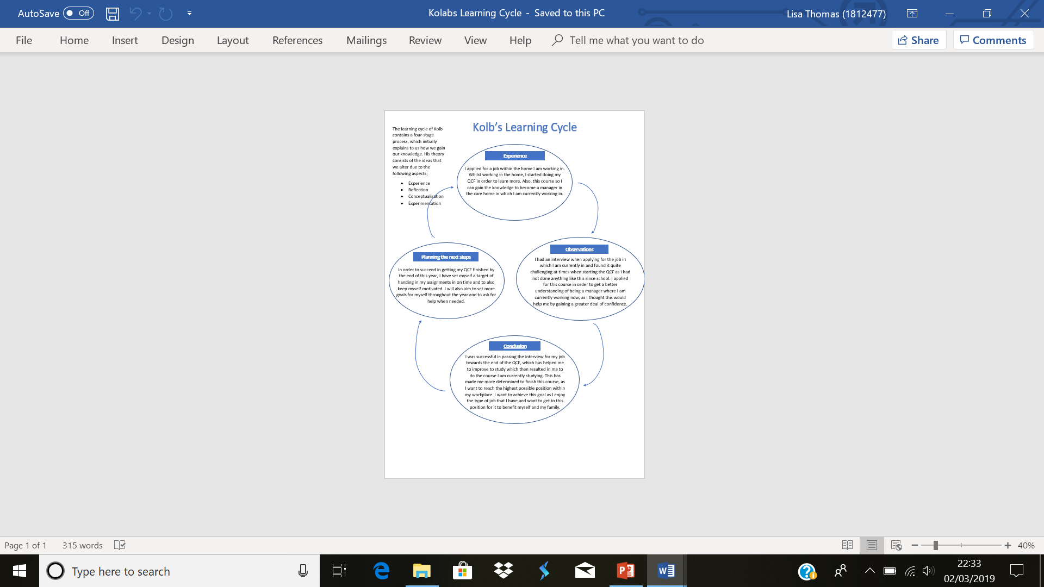

GO MAD

I believe that go mad is a very helpful way of helping me set up my goals forth Future. As it will help me believe in myself and I could gain more confidence from it. It would help me develop in various ways as it could potentially help me see a clearer picture of my future and how to set targets for myself. Also, when I get to the targets I make, I will be sure I reward myself and be proud of what I have achieved.
Go mad can save time and improve performances as well as help me develop as a leader.
Andy gilbert is the developer of the acclaimed go mad results frame work and thinking system. Which is used worldwide and nearly 2 million people use it since it was created in 1997. When the leading research team to studying how people think in a solution, he focused a way when they make a difference. He has gained over 20 years’ experience in studying peak performance.
(Gomadthinking.com. 3.3.19)
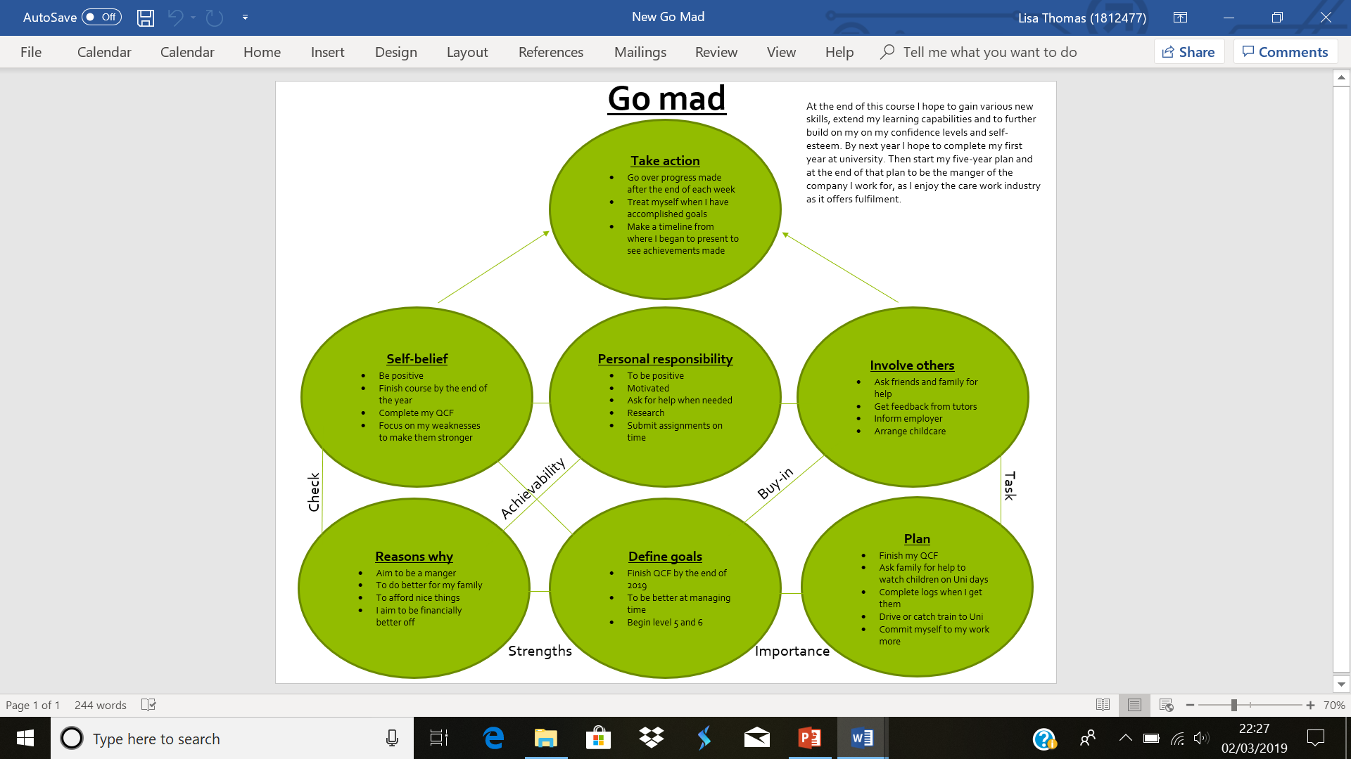
Swot analysis

Swot analysis is a frame work which is helpful for business, it is used to evaluate a company’s competitive position and develop strategic planning. SWOT stands for strengths, weaknesses, opportunities and treats. SWOT analysis assesses internal and external factors, as well as current and future potential.
(Project Smart 4.3.19)
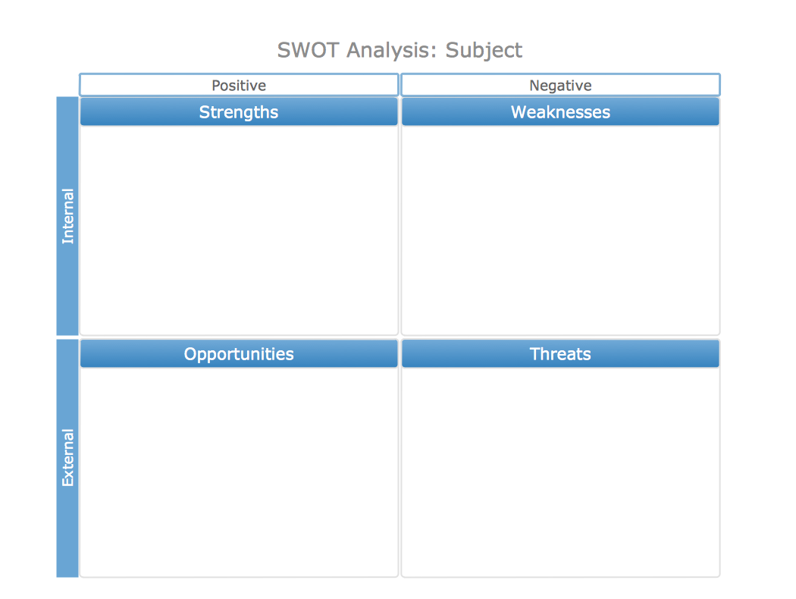

punctuality
negative
writing skills
confidence
talking in front of others
talking in groups
Flexibility
Listen to people
Learning from my mistakes
Organisation and planning
Passion for working with people

Childcare
Stress working in mental health and challenging issues
Excessive workload
Not meeting deadlines with my course work
Conflicting demands and lack of role clarity

Starting university
Gaining a certificate in BA
Building on my confidence
Learning new skills
Increase mental care homes

Turning my strengths into opportunities
While attending university, I aim to work on my communication, gaining confidence, making myself more organised, putting my coursework first. I am passionate about my role, which encourages me to succeed, also being flexible, gives me more hours to leaning more skills.

Converting my weakness to strengths
I will aim to use my written skills, already gained, to help with my coursework. Moreover, also asking my tutors for help when I need it. This would help with my confidence, as I will be asking for assistance from others which I usually do not tend to do. Furthermore, whilst in my lessons I aim to be more involved with the convocation, as opposed to sitting quiet. By engaging in more convocations with others, hopefully it will increase my number of friends, leading me to a better and more active social life.

Neutralising my threats
Using a plan, would help me to limit my threats. This would be because I will write down everything that will be happening in to days of the week. Also, setting them into priority order, for example
Monday- University
Tuesday- Working
- Do University coursework
Wednesday- University
Thursday- Working
- Do coursework
Being a manger would involve me having to create a staff rota which can suit everyone whom I employ. Working as an effective team would be key to make the care home a working success. As a result of this we as a team would get jobs done correctly without any mishaps.

SMART OBJECTIVES

SMART goals are crucial to your success,
Smart stands for specific, measurable, achievable, relevant and time-bond objectives you wish to achieve,
it is easily remembered by using the acronym S-M-A-R-T,
Goals are part of everyday life and provide a sense of direction, motivation, and a clear focus,
By setting these goals up u can aim at targets as inside of rushing to get where you want to be and failing. Goals are a part of life, you are constantly setting them to make your life or a thing better. They help us to have clear objectives of what we want to achieve in our heads. When setting goals, we must aim to make them as realistic and as achievable as possible. For them to be achieved. (Project Smart. 4.3.19)

Be specific
I would like to gain a manger position in work to further my career goals and attend skills in the work place 2019 which will be a Monday and Wednesday then fit my shifts in where I curranty work now to gain more experience.
Measurable
I will make sure I have set shifts in my workplace enabling me to attend university which is Mondays and Wednesdays every week for the next 12 months to finishes this course by the end of this year I will have more confidence to apply for a higher role to be employed as management of the care home taking on bigger tasks widening my skills and experience next stage up in my workplace before being promoted management.
Achievable
I would work hard make my self-dedicated to achieving my goal I have applied for a course which will help me learn the knowledge I need to know to build on my future, gain more confidence.
Realistic
Meeting these goals are realistic to me as I work in care now and doing my QCF to improve my knowledge, attending university to learn new skills, to become management at the job am in now leaning different skills to suit the job role. Leaning new employability skills.
Time
To achieve a certificate in my QCF in a few mouths and a certificate in my skills in the work place by the end of this year. (Project Smart. 4.3.19)

Vark learning styles

The vark guide to learning styles is one of the best learning techniques use today around the world to discover their greatest way of learning it comes in four different categories which are these,
V-Visual learners
These learn best by visual techniques, are not good with written text however easily understand and make since from highlight, symbols, diagrams, gestures and mind-maps are also a very helpful way.
A-Aural learners
Learn best by taken information from what they hear. The best way for them is face to face discussions, they might slower at reading or taken notes they also like recording lectures as they can go over and listen to them when ever they like to take the information in it will help them gain the knowledge, they also like face to face training.
R-Read/ write learners
Are comfortable with information from a booklet, leaflets or enjoy libraries to get information and gather things from the internet also, they like making notes so they can over them it enables them to recall the content quickly.
K-Kinaesthetic
Is the type of person who likes being hands on as they benefit from assessing the material for them self’s also working in labs, field trips, exhibits, applications and taken notes and writing bullet points, where possible they will get involved and then will stay engaged.
There is also a multimodal learner which means a person could be a combination of more than two leaning techniques they are the people who like a high quality of learning as if you use a mixture of them you would gain better knowledge of knowing what you have learn.
(Verywell Mind. 4.3.19) (Myotc.net 5.3.19 )

Vark questionnaire
Total numbers of v’s circled =1
Total numbers of a’s circled =7
Total numbers of r’s circled =2
Total numbers of k’s circled=3

Result of questionnaire
I feel that this result best fits me because I am poor at writing and reading things, however my learning ability is best when I am listening to someone speak. I think that this is because my brain processes the information first hand. Also, when reading and writing it is always in black
and white, but the brain takes in more and remembers things when they are in colour and different. So, when I talk or listen to people, they are always different people, this explains why I am strongest at listening and taking in the most information through being an auditory learner.

Honey and Mumford learning styles

Honey and Mumford learning styles were developed by peter honey and Alan Mumford in 1986 their work is inspired from and built upon Kolb’s learning styles, however, they produced their own learning questionnaire.
As that they found out by given people a questionnaire it was easier than asking people directly how they learned.
Learning styles helps individuals to make a smarter decision in adjusting the learning opportunities and your preference of best learning, increases the range and variety of experiences.

There are four learning styles

Activists
Activists are individuals who learn by getting their hands dirty, they can be brainstorming, problem solving, group discussion, puzzles, competitions and role-play.
Theorists
These learners get a kick out of the chances to comprehend the hypothesis be hide the activities. their choice of learning activities includes models, statistics, stories, quotes, background information, applying concepts theoretically.
Pragmatists
These individuals have the capacity to perceive how to put leaning into practice in their present reality. Experimenting with new ideas, they learn better through talking time to think about how to apply learning, case studies, problem solving and discussion.
Reflectors
These individuals learn by watching and contemplating what happened. They may abstain from jumping in and prefer to watch from side-lines. They like paired discussions, self-analysis questionnaires, personality questionnaires, time out, observing activities, feedback from others. coaching, interviews. (ELN Resources .6.3.19)

Honey and Mumford questionnaire
Total numbers of a’s 15
Total number of r’s 19
Total number of t’s 15
Total number of p’s 16

Result of questionnaire
When I did the questionnaire on myself, I came out as the reflectors I think this is a good result for myself as out of them all I think I am a reflector I find I am like that because I learn by watching what happened instead of jumping in, I like to analyse things first. I like to stand back and watch from many different angle’s reflectors like to consider all possible angles before making a move and prefer to take a back seat in meetings and discussions. Enjoy observing others in action.

Summary of strengths being a reflector:
- Careful
- Thorough
- Thoughtful
- Good at listening
- Rarely jump to conclusions

Summary of weaknesses:
- Hold on from taken part
- Slow to make up my mind up and reaching a decision
- Tendency to be cautious and not take risks
- Not assertive not one to make conversation first.

.
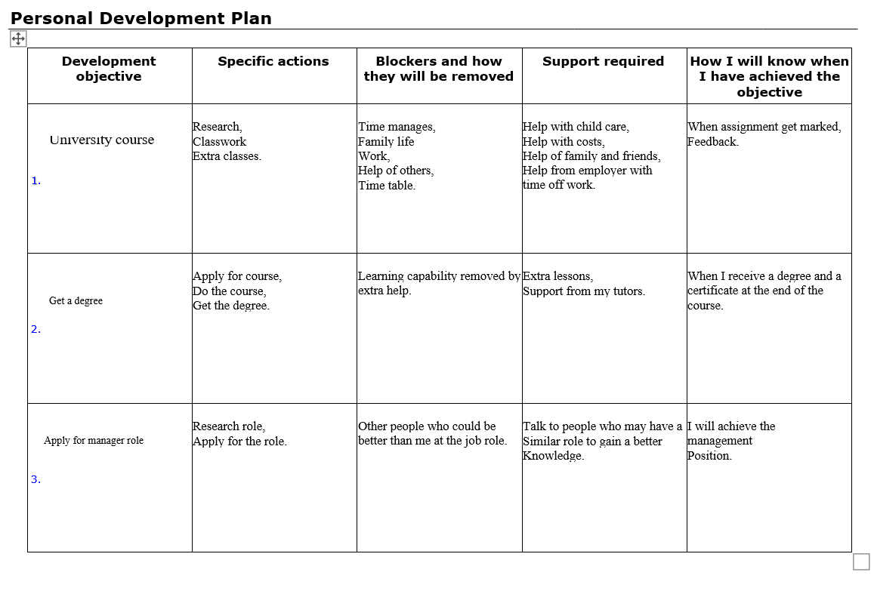
Personal development plan

PDP can be an enormously powerful tool, they can help people feel more fulfilled in their jobs, when becoming wider in their job role. PDP is more focus on their individual aspirations. A good PDP will also have a clear structure, whilst you focus on long-team goals these would be broken down in to achievable short-term objectives in terms of months and years. [jon.seymour,6.03.19]

Conclusion

To conclude, I leant that by using these different styles of leaning techniques they can help you set up plans and goals. Once you have those you can achieve anything. If you put hard work and time into it, then it makes it easier to do them step by step. As a result of this, you will achieve better things as opposed to rushing into them. After learning about these various learning techniques, I have been setting myself achievable goals in life, this is because it makes it much easier to achieve them with a clear plan to follow.
Due to wanting to be a manger for the care company I am currently employed with, I have gathered the information on what I need to achieve this ambition. Also, by using my plan I have worked out how many years it will take me to get to this goal. In particular, the God Mad learning technique has taught me the most as it teaches you to say positive as opposed to being negative. As it makes it more accomplishable for you to get where you want to be, it will just take time and effort. By turning my strengths into opportunities and converting my weakness into strengths and neutralising my threats. It has made me come to the realisation that my dreams are reachable. I turned all these things to make them SMART. I enjoyed carrying out the questionnaires, as you can find out what type of person you are as well as gaining further knowledge on which way of learning is best for myself.

Reference

- Verywell Mind. (2019). Are You a Visual, Auditory, Reading/Writing, or Tactile Learner?. [online] Available at: https://www.verywellmind.com/vark-learning-styles-2795156 [Accessed 6 Mar. 2019].

- Boltlearning.com. (2019). Bolt Learning - Online Training and Learning Technology. [online] Available at: https://www.boltlearning.com/ [Accessed 6 Mar. 2019].

- Gomadthinking.com. (2019). Go MAD Thinking. [online] Available at: https://www.gomadthinking.com/ [Accessed 6 Mar. 2019].

- ELN Resources. (2019). Honey and Mumford four Learning Styles. [online] Available at: http://resources.eln.io/honey-and-mumford-learning-styles/ [Accessed 6 Mar. 2019].

- Mcleod, S. (2019). Simply Psychology. [online] Simply Psychology. Available at: https://www.simplypsychology.org/ [Accessed 7 Mar. 2019].

- Mueller, S. and Mueller, S. (2019). How to Write a Personal Development Plan. [online] Planet of Success. Available at: http://www.planetofsuccess.com/blog/2015/how-to-write-a-personal-development-plan/ [Accessed 6 Mar. 2019].

- Project Smart. (2019). SMART Goals. [online] Available at: https://www.projectsmart.co.uk/smart-goals.php [Accessed 6 Mar. 2019].

- Project Smart. (2019). SWOT Analysis Definition. [online] Available at: https://www.investopedia.com/terms/s/swot.asp [Accessed 6 Mar. 2019].

- team, T. (2019). A Guide to Personal Development Plans for Business |. [online] Business advice from is4profit. Available at: http://is4profit.com/personal-development-plans/ [Accessed 6 Mar. 2019].

- Briantracy.com. (2019). Three Principles for Great Success. [online] Available at: https://www.briantracy.com/blog/leadership-success/three-principles-for-great-success/ [Accessed 6 Mar. 2019].

- Myotc.net. (2019). What Is VARK?: What Is VARK?. [online] Available at: https://myotc.net/mod/page/view.php?id=8019 [Accessed 6 Mar. 2019].

