

LOCATION: Swansea | LLEOLIAD: abertawe
LEVEL 4 | LEFEL 4
EXAMINATION PERIOD | CYFNOD ARHOLIADAU
may 2021 | mai 2021

MODULE CODE: ACDB4002 / ACDA4006
Electrical & Electronic Principles

TIME: 2 HOURS
answer all questions

Equipment or materials required – Calculator
Adnoddau neu ddefnyddiau sydd eu hangen - Dim

ANSWER ALL QUESTIONS
Name the specific circuit element represented by the following symbols:

Switch
[1 Mark]

Diode
[1 Mark]

Cell (Battery)
[1 Mark]

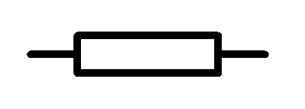Resistor
[1 Mark]

Inductor
[1 Mark]

Capacitor
[1 Mark]

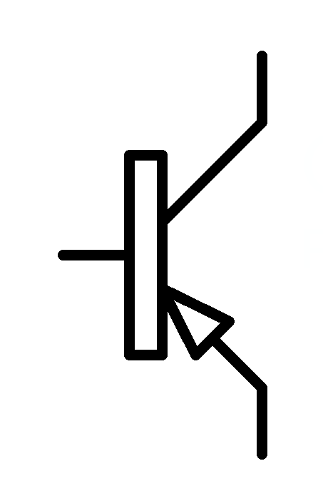PNP Transistor
[1 Mark]

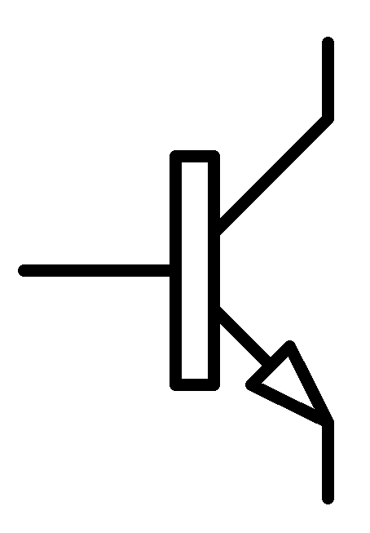 NPN Transistor
[1 Mark]

Ground
[1 Mark]

Bulb [1 Mark]
- Sketch the voltage – current relationship of a standard rectifier diode. Label the forward conduction voltage, the reverse breakdown voltage and the reverse leakage current.
[10 Marks]

- For the circuit shown in fig Q3. Calculate the following:
  - Total circuit resistance
See Photo at end of paper
[4 Marks]
  - Total circuit current

See Photo at end of paper
[2 Marks]
  - Current flowing through R2
See Photo at end of paper
[4 Marks]
  - Total power delivered by the battery
See Photo at end of paper

[2 Marks]
  - Power dissipated by R4
See Photo at end of paper

[4 Marks]
  - R4 is replaced by a wire link. What is the new circuit current?
$$I=\frac{v}{R_{1}+\left(\frac{R2×\left(R3+R5\right)}{R2+\left(R3+R5\right)}\right)}$$

$$I=\frac{15}{1000+\left(\frac{5600×\left(220+3300\right)}{5600+\left(220+3300\right)}\right)}$$

I=4.75 mA
[4 Marks]

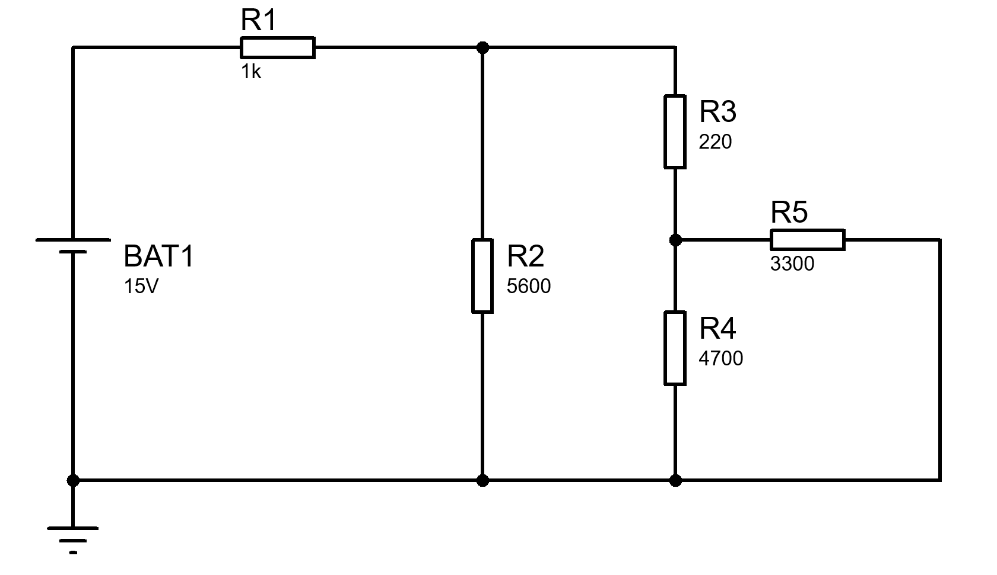
Fig Q3

- An oscilloscope display shows the above voltage waveform. The oscilloscope settings are shown in the box next to the waveform.

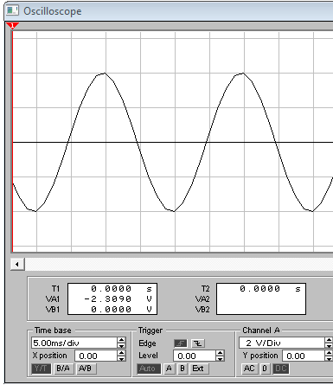
Oscilloscope settings:
50 mV/div
100 µs/div

Fig Q4

- Estimate the period of the waveform
4 div x 100 us/div = 400 us
[1 Mark]
- From the estimated period, determine its frequency
f = 1/t = 1/400us = 2500 Hz
[1 Mark]
- Determine its peak to peak amplitude
Vpk-pk = 4 div x 50 mV = 200 mV

[1 Mark]
- Sketch the diagram shown in fig Q4 and indicate on it any two points between which the PERIOD (T) could be measured
[1 Mark]

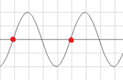

- For a series RLC circuit where R=120Ω, L= 470mH, and C=1µF supplied from a 48V 400Hz supply,
  - calculate the voltage across:

    - The resistor
[2 Marks]
    - The capacitor
[2 Marks]
    - The inductor
[2 Marks]
  - Calculate the resonant frequency of the circuit
[2 Marks]
  - At the resonant frequency, calculate the circuit current
[2 Marks]

- A 12 V battery has an internal resistance of 3 Ω,
  - Calculate the power dissipated by various load resistances and complete the table below.

Load resistance (Ω) | Load power (W)
1 | 9
2 | 11.52
3 | 12
4 | 11.775
5 | 11.25
[10 Marks]
  - Plot a graph of the load power against load resistance
[6 Marks]

Diwedd/End

Question 2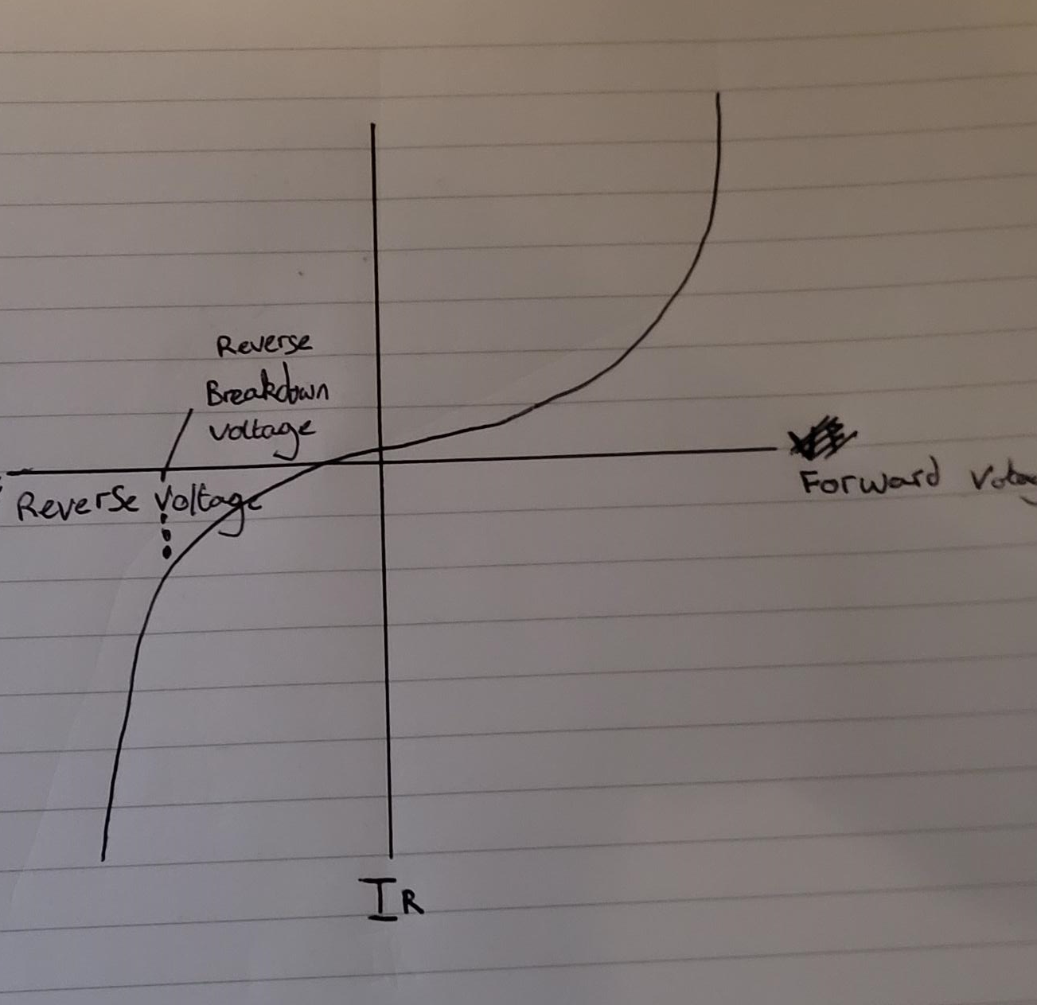

Q1

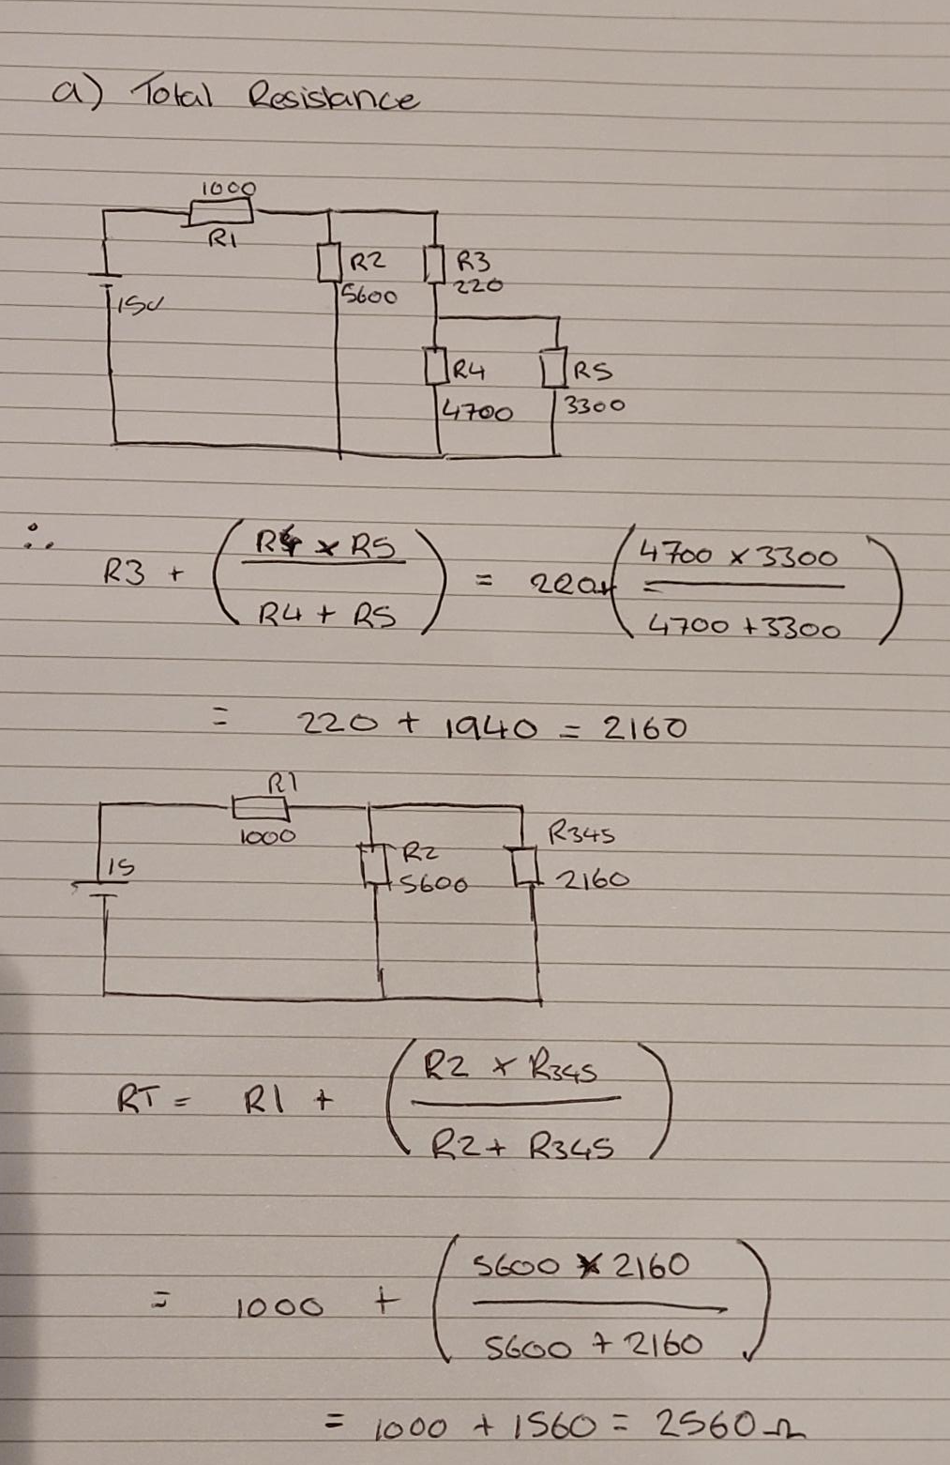
Question 1

