
Module: Data Handling and Business Intelligence
Module code: LCBB5000
Lecturer: Gasso Mwaluseke – Weekend
STUDENT NAME: mIROSLAVA gEORGIEVA
sTUDENT nUMBER: 2112588
Data Analysis and Visualization

2023

Contents
1. Introduction 2
2. Data Description 3
3. Methodology 4
4. Analysis and Findings 5
5. Conclusion 11
6. Introduction 12
7. Data Description 12
8. Methodology 13
9. Analysis and Findings 14
10. Conclusion 23
11. References 24

Introduction
This report aims to describe the results of investigating the Hotel Reservation dataset. The dataset contains data on hotel reservations, including details on the number of adults and children, the kind of accommodation, the dates of arrival, the meal schedules, special requests, and the average reservation cost. The investigation sought to ascertain whether hotel moderate prices had decreased or increased between 20y. Data preprocessing steps were carried out before the analysis began. This entailed preparing the dataset for analysis, dealing with missing values, and altering some variables. To simplify the data, Extra columns that weren't relevant to the study were eliminated from some data and were analysed to find links between various variables and the average price. This made it easier to comprehend the variables that could affect how much a hotel room might cost. A secondary sheet's VLOOKUP function was used to map values using label encoding, improving the data's ability to be understood and analysed.
Additionally, pivot tables combined and summarised the data, giving meaningful insights into historical trends in average prices. These pivot tables helped visualises the patterns and changes in room reservation pricing and enabled a thorough investigation of the
Moderate fluctuations.
The report contains extensive analyses, results, and conclusions from the dataset. Additionally, recommendations are included to tackle the identified issues. It is important to note that the study relied on available references, which will be comprehensively discussed in the report.

Data Description
The Hotel Reservation dataset is essential for analysing hotel reservations. To gain a thorough understanding of the data, it's crucial to examine significant variables and their corresponding labels, including Market Type, Room Type, Booking Status, and Meal Plan are covered.

- Market Type
  - Labels: Offline, Online, Complementary, Corporate, Aviation
  - Values: 0, 1, 2, 3, 4
The market type, represented by a number between 0 and 4, is the one through which hotel reservations were made.

- Room Type
  - Labels: Room Type 1, Room Type 2, Room Type 3, Room Type 4, Room Type 5, Room Type 6, Room Type 7
  - Values: 1, 2, 3, 4, 5, 6, 7
Room Type refers to the room category guests reserve, with seven categories given numerical numbers for analysis.

- Booking Status
  - Labels: Not Canceled, Canceled
  - Values: 0, 1
Two labels, Not_Canceled and Cancelled, with corresponding numerical values of 0 and 1, represent the booking status.

- Meal Plan
  - Labels: Meal Plan 0, Meal Plan 1, Meal Plan 2, Meal Plan 3
  - Values: 0, 1, 2, 3
The sort of meal plan contained in a reservation is called Meal Plan, and it has four labels with numerical values between 0 and 3.
Understanding these variables, associated labels, and values will be crucial for deciphering the analysis results and getting a valuable dataset.
Before conducting the analysis, several data preprocessing and cleaning steps were undertaken to ensure the accuracy and reliability of the results. The following steps were performed on the Hotel Reservation dataset:

- Missing values Handling
- Data Transformation
- Removal of unnecessary values
- Data Correlation Analysis
- Label Encoding
Our data analysis is based on thoroughly cleansed and high-quality information, resulting in valuable and advanced insights.

Methodology
The Hotel Reservation dataset underwent a systematic analysis to determine whether the average cost of booking a room increased or decreased between 2017 and 2. The research topic was answered using the following methodology:
- Data Preprocessing
The data preprocessing included handling missing values, transformation, eliminating superfluous variables, and label encode assure sensuality and usefulness for analysis.

- Exploratory Data Analysis
Exploratory data analysis was conducted to obtain a preliminary understanding of the dataset using statistical techniques to visualise the distribution, central tendency, and correlations between variables.
- analysing Tables
Pivot tables were used to group data by year and calculate the average price of room reservations.

- Statistical Analysis
Statistical analysis techniques were used to analyse average price trends, including year-wise mean and standard deviation.

- Visualization
Pie charts, line graphs and bar graphs were used as visualisations to show how the average price changed over time.

- Interpretation and Reporting
The results were presented clearly and succinctly using graphs, statistical values, and insights. They were also interpreted and discussed in relataboutdy issues.
This methodology allowed for a thorough dataset study and identifidentifiederage pricing trends for hotel reservations throughout the given time frame.

Analysis and Findings
The analysis of the Hotel Reservation dataset sought to ascertain whether the average cost of booking a room decreased or increased between 2017 and 2. Following are the following of the analysis:
- Correlation Table:
 | Adults No | Children No | Weekend Nights | Weekday nights | Meal_Plan | Required_car_parking_space | Room_type_reserved | Lead_time (minutes) | Arrival_year | Arrival_month | Arrival_date | Market_Type | Repeated_guest | Previous Cancellation | Previous bookings | Average price | Special requests | Booking_Status
Adults No | 1
Children No | -0.020801193 | 1
Weekend Nights | 0.104236438 | 0.02995376 | 1
Weekday nights | 0.107042964 | 0.026429015 | 0.181993924 | 1
Meal_Plan | -0.003557157 | 0.042132262 | -0.018996533 | 0.02902744 | 1
Required_car_parking_space | 0.010711884 | 0.033045629 | -0.030222691 | -0.049095697 | -0.013629109 | 1
Room_type_reserved | 0.269635284 | 0.365403803 | 0.057493691 | 0.095296219 | 0.093803637 | 0.039596214 | 1
Lead_time (minutes) | 0.097970926 | -0.046259808 | 0.04965048 | 0.151034716 | 0.225906163 | -0.066845405 | -0.107544851 | 1
Arrival_year | 0.06672625 | 0.032336106 | 0.045421592 | 0.027104741 | -0.145923514 | 0.011879014 | 0.078087325 | 0.11321113 | 1
Arrival_month | 0.022326647 | -0.002534519 | -0.009418522 | 0.037079626 | 0.017829816 | -0.014967424 | -0.005398164 | 0.136365924 | -0.266584432 | 1
Arrival_date | 0.025213173 | 0.024470207 | 0.027403359 | -0.008139862 | 0.016890019 | 0.001048228 | 0.032060241 | 0.007425038 | 0.010058102 | -0.04213057 | 1
Market_Type | -0.163108671 | 0.045475827 | -0.033715951 | -0.075621062 | -0.19808306 | 0.124032578 | 0.112948885 | -0.318009539 | 0.060331313 | -0.031831087 | 0.008985947 | 1
Repeated_guest | -0.192672777 | -0.036255368 | -0.067259515 | -0.101164568 | 0.009764341 | 0.112392055 | -0.027117856 | -0.136261196 | -0.015871174 | 0.003021418 | -0.016010125 | 0.346252272 | 1
Previous Cancellation | -0.047788769 | -0.016480094 | -0.020657013 | -0.030970905 | -0.007334168 | 0.028133773 | -0.008581968 | -0.04562501 | 0.00352283 | -0.039082655 | -0.012405424 | 0.081897212 | 0.391848513 | 1
Previous bookings | -0.119317064 | -0.021260754 | -0.027341379 | -0.052063506 | 0.006273392 | 0.064599673 | -0.009630007 | -0.078542835 | 0.018789803 | -0.010407948 | -0.001060955 | 0.221007026 | 0.540544459 | 0.467822423 | 1
Average price | 0.296449954 | 0.338356159 | -0.00490456 | 0.023290969 | 0.13496305 | 0.060167445 | 0.471018946 | -0.062910296 | 0.137969127 | 0.054168538 | 0.017839107 | 0.001370476 | -0.174228056 | -0.063516676 | -0.113781923 | 1
Special requests | 0.189314888 | 0.12579483 | 0.060174845 | 0.044737921 | -0.088656273 | 0.085767519 | 0.146174391 | -0.102606734 | 0.044758904 | 0.110557182 | 0.018010679 | 0.130544076 | -0.010722775 | -0.002247576 | 0.028754881 | 0.186229623 | 1
Booking_Status | 0.08710398 | 0.033546404 | 0.063604468 | 0.093130754 | 0.04816704 | -0.084845435 | 0.02280722 | 0.440790987 | 0.138360055 | -0.009693218 | 0.009938007 | -0.065368783 | -0.107449302 | -0.033578305 | -0.060523688 | 0.141916958 | -0.253478914 | 1
Quickly identify the target variable as the Average Price, highlighted in yellow. Our goal is to establish its fundamental correlation with other variables. In case of a negative relationship or a low value indicating a weak correlation, we will promptly exclude such features from the dataset.
- Pivot Tables
The sum of the Average price
Arrival_year | Total
2017 | $549,304.11
2018 | $2,984,721.57
2019 | $18,015.29
2020 | $20,857.30
2021 | $19,436.80
Grand Total | $3,592,335.07

Based on this pivot table, we can observe the total revenue generated from room reservations each year. It provides an overview of the financial performance regarding average prices from ovefrom17 to 2021.

 | 2017 - 2021
Arrival_year | The sum of Adults No | The sum of the Average price
2017 | 10727 | $549,304.11
2018 | 52216 | $2,984,721.57
2019 | 320 | $18,015.29
2020 | 382 | $20,857.30
2021 | 364 | $19,436.80
Grand Total | 64009 | $3,592,335.07

The provided pivot table shows the sum of the "Adults No" and "Average price" columns, grouped by the "Arrival_year" column. Overall, the pivot table indicates that 2018 had the highest number of adults and generated the highest revenue in terms of average prices for room reservations.
- Visualization

- Variation in Average Price: The average price for room reservations varied across the years.
- Highest Average Price: 2018 had the highest average price sum, with a value of $2,984,721.57.
- Lowest Average Price: Among 2017-2021, the lowest average price sum was observed in 2019, with an $18,01.
- Fluctuations in Average Price: The average price sums for 2020 and 2021 were relatively similar, with values of $20,857.30 and $19,436.80, respectively.
- Overall Trend: The average price sums were relatively higher in 2018, 2020, and 2021 compared to 2017 and 2019.

In summary, it indicates the total number of adults and the sum of average prices for each year in the range of 2017-2021

- Year Wise Mean
Year Wise Mean
 | Data
Arrival_year | Average of Average price | StdDev of Average price | The sum of the Average price
2017 | $ 90.05 | $ 33.03 | $ 549,304.11
2018 | $ 106.45 | $ 34.90 | $ 2,984,721.57
2019 | $ 101.78 | $ 35.60 | $ 18,015.29
2020 | $ 105.34 | $ 33.61 | $ 20,857.30
2021 | $ 101.23 | $ 34.49 | $ 19,436.80
Grand Total | $ 103.51 | $ 35.13 | $ 3,592,335.07

The pivot table provides insights into the average prices, price variability, and annual revenue generated from 2017 to 2021. The analysis suggests that the average prices remained relatively stable with a moderate variation, and the total revincomen be observed for each year.
From the following visualisation, we can observe more clearly the results specified above.

Conclusion
In conclusion, examining the hotel reservation dataset, which covers 2017 to 2021, offers essentials about average costs and clientele patterns. The dataset was made ready for analysis by using various processing each, including data cleaning, transformation, and addressing missing values.
The data showed that, with a small amount of volatility, the average cost of hotel reservations remained broadly stable. The year-wise mean costs increased moderately from $90.05 in 2017 to $106.45 in 2018, showing a range. However, the variations in average prices over the years were comparatively minor, pointing to a generally stable pricing trend. The data revealed a relationship between the average cost and the number of adults, showing that larger groups typically pay more for hotel reservations.
Examining the overall revenue from reservations of rooms gave information about the hotel's financial health. The revenue increased steadily over time, peaking in 2018 at $2,984,721.57. The revenue remained sizable in the following years despite a little reduction, demonstrating the hotel's general success.

Introduction
This study examines the connections between students’ student’s test scores, gender, and reduced or free lunch eligibility. Based on the pupils' lunch status, the school seeks to ascertain whether there are any appreciable disparities in these characteristics. In addition, regardless of whether a student qualifies for lunch, the school wants to investigate any connections between gender and pre-an-and results.
For data analysis, the institution has historically used Microsoft Excel. However, SPSS will be used as the analytical tool in this report. Using SPSS, which offers strong causalities, solid causalities, descriptive statistics, and advanced statistical analysis, is appropriate for investigating the relationships between variables and getting significant insights.
The descriptive statistics for the variables of relevance in this study, including counts, means, medians, and other pertinent metrics, will be examined first. Next, we will analyse the connections between students' pre-test and post-test scores, gender, and whether or not they qualify for lunch. Cross tabulations will be done, means and medians calculated, and any notable discrepancies that show up will
The analysis's findings will help the school better understand the relationships between academic achievement, gender, and lunch eligibility. These perceptions can help in decision-making procedures involving the distribution of resources, intervention techniques, and student assistance programs.

Data Description
The dataset used in this analysis contains information on students from various schools. It includes the following variables:
- School: This variable represents the name or code of the school where the student belongs.
- School_setting: This categorical variable describes the school’s setting, such as urban, suburban, or rural.
- School_type: This categorical variable indicates the type of school, whether public or non-public.
- Classroom: This variable represents the specific classroom or section the student is assigned.
- Teaching_method: This categorical variable indicates the teaching method used in the classroom, such as standard or experimental.
- Student_No: This variable represents the student number or identification code.
- Student_ID: This variable contains a unique identifier for each student.
- Gender: This categorical variable denotes the gender of the student, either male or female.
- Lunch: This categorical variable indicates whether the student qualifies for reduced/free lunch or does not qualify.
- Pretest: This numeric variable represents the score or performance of the student on a pre-test assessment.
- Posttest: This numeric variable represents the score or performance of the student on a post-test assessment.

The variable "meal" is crucial in determining students' eligibility for free or reduced lunch, revealing their socioeconomic status. Gender is another important demographic factor that provides insights into potential gender disparities. Pre- and post-test variables are essential in monitoring students' academic progress before and after a specific intervention or instructional phase, offering valuable insights into their academicintellectualment.

Methodology
This section describes the methodology used to analyse the dataset and look at the correlations between students' pre-test and post-test results, lunch eligibility, and gender. SPSS (Statistical Package for the Social Sciences) was used for the analysis.
- Data Preparation
Data was loaded into SPSS, including variables such as school setting, school type, classroom, teaching method, student number, ID, gender, lunch qualification, pre-test scores, and post-test scores.

- Descriptive Statistics
To comprehend the distribution and central tendencies of the variables, descriptive statistics such as frequencies, percentages, means, and medians were utilised to acquire an overview of the dataset.

- Cross Tabulation Analysis
To investigate the connection between lunch qualification and gender, a cross tab cross-tabulations were employed. This analysis established the frequency distribution and looked for any patterns or relationships.

- Mean and Median Differences
By deducting pre-test scores from post-test scores, the mean and median differences between scores from the pre-and post-tests were calculated, iindicatinghange in performance.

- Interpretation of results
Insights regarding potential implications for educational interventions were gained through analyses that demonstrated connections with lunch qualification, gender, and pre-test and post-test scores.
It is crucial to remember that the technique outlined above is merely a broad framework. The precise stages and statistical analyses may change depending on the research goals and the dataset's characteristics.

Analysis and Findings
- Male and Female Students Frequency
The gender distribution study reveals roughly equal numbers of male and female students in the sample, with females making up 49.5% and men making up 50%. These numbers indicate that the dataset's gender representation is fair.

An essential demographic element, the gender variable, can be further investigated through other factors like lunch eligibility and pre- and pre-and scores. InvestigaStudyingl gender inequalities in academic achievement and eligibility for the lunch period might provide light on educational equity and drive targeted support or intervention initiatives.
Gender
 |  | Frequency | Per cent | Valid Percent | Cumulative Percent
Valid | Female | 1056 | 49.5 | 49.5 | 49.5
Valid | Male | 1077 | 50.5 | 50.5 | 100.0
Valid | Total | 2133 | 100.0 | 100.0

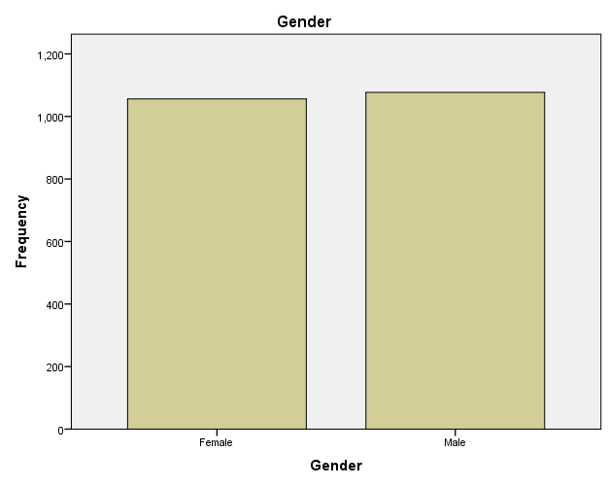

- No of Students Qualifying and not Qualifying for Lunch
The analysis of lunch eligibility shows that 43.0% of the students in the dataset are eligible for reduced or free lunch, while 57.0% are not. These statistics shed light on how the pupils' eligibility for lunch is distributed.

The lunch qualifying variable significantly predicts socioeconomic level and impacts academic achievement and extracurricular support requirements. Identifying potential discrepancies and directing efforts to guarantee educational equity can be accomplished by examining the relationship between lunch eligibility and other factors, such as gender and pre-test/post-test scores.
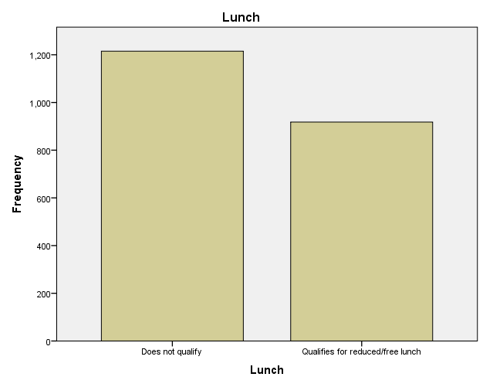

Lunch
 |  | Frequency | Per cent | Valid Percent | Cumulative Percent
Valid | Does not qualify | 1215 | 57.0 | 57.0 | 57.0
Valid | Qualifies for reduced/free lunch | 918 | 43.0 | 43.0 | 100.0
Valid | Total | 2133 | 100.0 | 100.0

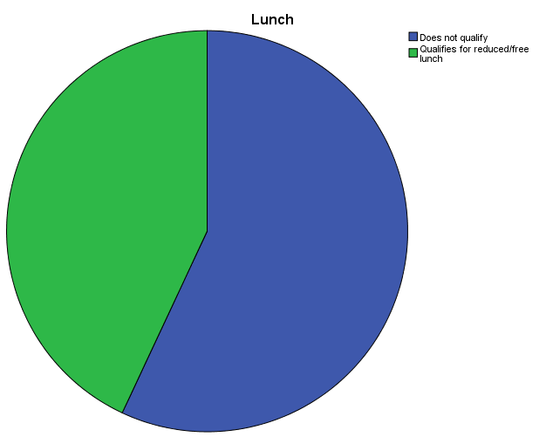

- Mean and median of students who qualify and do not qualify for reduced/free lunch?
The mean values reveal the average lunch qualifying status for students in the dataset. The lower mean value among students for free or reduced lunches suggests a higher incidence of meal eligibility among them. Students who do n On the other hand, students who do not qualify for free or reduced-price meals value ndicatinindicating the prevalence of lunch eligibility within this group.

It is significant to note that the mean values do not provide information about the exact deals of individual students; instead, they represent the average lunch qualifying status for each group. The mean values are also computed using the specified frequency data.

- Mean for students who qualify
= 918/2133 = 0.430
- Mean for students who do not qualify
= 1215/2133 = 0.5696
- Mean and median differences
Comparing these results reveals trends in their performance and growth over time. The mean and median values respect the data's average scores and central tendency. The standard deviation also reveals information about the spread or dispersion of scores.
Statistics
 |  | Pretest | Posttest
N | Valid | 2133 | 2133
N | Missing | 0 | 0
Mean |  | 54.96 | 67.10
Median |  | 56.00 | 68.00
Std. Deviation |  | 13.563 | 13.987
Skewness |  | .042 | .073
Std. Error of Skewness |  | .053 | .053
Kurtosis |  | -.624 | -.720
Std. Error of Kurtosis |  | .106 | .106

- Clustering (K-Means)
Based on the students’smance on the pretest and posttest, we ran a K-means clustering analysis to look for trends and groupings. The goal was to locate unique groups of pupils and learn more about their performance in assigned examinations.

The pretest and posttest results for a sample of students made up the dataset. The K-means clustering technique is used to pretest and Posttest scores as features divide data into K groupings based on similarity.

Based on the results of the students' tests, the analysis identified the following:
Initial Cluster Centers
 | Cluster
 | 1 | 2 | 3 | 4
Pretest | 23 | 93 | 50 | 59
Posttest | 35 | 100 | 53 | 85

Iteration Logª
Iteration | Change in Cluster
Iteration | 1 | 2 | 3 | 4
1 | 11.678 | 12.811 | 6.007 | 9.261
2 | 4.059 | 4.351 | 1.513 | 2.421
3 | 1.711 | 1.888 | .817 | 1.185
4 | .797 | 1.338 | .598 | .582
5 | .573 | .679 | .448 | .305
6 | .162 | .381 | .126 | .174
7 | .115 | .063 | .094 | .030
8 | .000 | .000 | .000 | .000
Because of little or no change in the cluster centres, convergence was achieved. Any centre can move its absolute coordinates up to a maximum of.000. Eight is the current edition. A minimum of 32.450 metres must separate the initial centres.

Final Cluster Centers
 | Cluster
 | 1 | 2 | 3 | 4
Pretest | 37 | 75 | 49 | 62
Posttest | 48 | 88 | 61 | 74

Number of Cases in Each Cluster
Cluster | 1 | 459.000
Cluster | 2 | 340.000
Cluster | 3 | 577.000
Cluster | 4 | 757.000
Valid |  | 2133.000
Missing |  | .000

These findings demonstrate the importance of cluster sizes in comprehending the composition and traits of the student groups based on pretest and posttest results.

- Data Mining and Text Mining Techniques
Let's take the example of a large e-commerce platform that wants to improve customer experience and increase sales by analysing customer reviews and feedback.

Data Mining:
- Association Rule Mining
Examining client purchase information and feedback to spot patterns of related products. For instance, they find that smartphone buyers are also inclined to buy phone cases and screen protectors.

- Clustering
Customer groups such as "satisfied," "unsatisfied," and "brand loyal" are formed based on review opinions and purchasing patterns.

- Decision Tree
We are constructing decision trees to forecast consumer happiness based on product qualities, delivery time, and pricing.

- Regression Analysis
We estimate revenues based on past review data and outside variables like promotions and consumer feedback.

- Neural Networks
We use patterns and anomalies in review data to create predictive models to find potential fraudulent reviews or fake product ratings.

Text Mining:
- Sentiment Analysis
They analyse customer reviews to determine sentiment towards products and e-commerce platforms.

- Named Entity Recognition
We are removing specified entities from customer testimonials.

- Topic Modelling
Identifying common topics or themes in customer reviews, such as product performance, packaging quality, or return/refund process.

- Text Classification
You are assigning predetermined categories or product categories to customer reviews.

- Information Extraction
They glean specific details from reviews, such as complaints, recommendations, or product qualities that buyers value.

- Advantages and Disadvantages of using SPSS and Excel
Here's a table comparing Excel and SPSS based on a relevant practical example of conducting a t-test:

Aspect | Excel | SPSS
Data Analysis | Can perform a t-test using the | Offers a wide range of
 | built-in T.TEST function, but | statistical procedures,
 | limited to basic t-tests | including t-tests, ANOVA,
 |  | regression, and more
Data Preparation | Limited data cleaning and | Provides extensive data
 | transformation capabilities | management capabilities,
 |  | including data cleaning,
 |  | recoding, and merging
Data Visualization | Basic charting options with | Advanced charting and
 | limited customisation | graphing options for creating
 |  | visually appealing plots
Automation and | Supports automation through | Supports automation through
Reproducibility | macros and VBA programming, | syntax or scripts, enabling
 | allowing repetitive tasks | reproducibility and consistency across analyses
Collaboration | Limited collaboration features, | Allows for collaborative
and File Sharing | version control can be | work within the software,
 | challenging | tracking changes and
 |  | managing shared datasets
Statistical | Limited advanced statistical | Extensive library of advanced
Capabilities | capabilities | statistical procedures and tests
Scalability | Suitable for small to medium-sized datasets | Can handle large datasets and complex analyses

Conclusion
To investigate the association between students' gender, pre-test and post-test scores, and their eligibility for reduced or free lunch, we analysed student data. The statistical programme SPSS was used to perform the analysis.
First, we looked at how students were distributed according to whether they were eligible for free or reduced lunch. This information makes understanding the study's participants' socioeconomic background possible.
The mean and median differences between the students' pre-and post-test results were examined. The typical test score going into the exam was 54.96, and the specific test score coming out was 67.10. The median score before the test was 56, while the median score after the test was 68. These results show an overall increase in student performance between the pre-and post-test.
Overall, this analysis highlights the relationship between students' qualification for reduced/free lunch, their gender, and their academic performance. The findings suggest that students' socio-economic background, as indicated by their qualification for reduced/free lunch, can influence their academic performance. Additionally, the improvement in scores from comparing the pre-test and post-test shows how well the implemented educational interventions or programs worked.

References
- Connolly, T., & Beg, C. E. (2015). Database systems: A practical approach to design, implementation, and management (6th ed.). Boston: Pearson.
- Azevedo, A., & Santos, M. F. (2015). Integration of data mining in business intelligence systems. Hershey: Business Science Reference.
- Veli, C. (2021). Integration challenges for analytics, business intelligence, and data mining. Hershey, PA: IGI Global.
- Vercellis, C. (2009). Business intelligence: Data mining and optimisation for decision making. Chichester, U.K.: Wiley.
- Maheshwari, A. K. (2015). Business intelligence and data mining. New York: Business Expert Press.
- Witten, I. H., Frank, E., & Hall, M. A. (2011). Data mining: Practical machine learning tools and techniques (3rd ed.). Amsterdam: Elsevier/Morgan Kaufmann.

