

Module Name: Marketing Management

Module Code: LCMB7024

Student Name:

Student ID:

Lecturer’s Name:

Work Count: 2648

Term 1

Table of Contents
1. Introduction 3
2. Task 1: Critical Analysis of the Macro Marketing Environment 4
2.1 Overview of the Macro Marketing Environment 4
2.2 Selection of Two External Macro Marketing Actors 5
2.3 Critical Analysis of Each Actor 6
2.3.1 Technological Forces 6
2.3.2 Environmental and Sustainability Pressures 7
3. Task 2: Strategic Response of Pioneering and Follower Organisations 9
3.1 Pioneering Organisations’ Strategic Responses 9
3.2 Follower Organisations’ Strategic Responses 11
4. Conclusion 14
5. References 15

1. Introduction
Strategic marketing management compels organisations to keep analysing the external forces that impact their level of competitiveness, ability to innovate, as well as long-term sustainability in the market (Hooley et al., 2020). This report is particularly on the topic of the macro marketing environment analysis with regard to the development of strategic decisions in both pioneering and follower organisations. Evaluation of the external forces to create opportunities and threats will enable firms to fit well into a highly dynamic and technology-driven industry like fast fashion. The report underscores the need to conduct macro-environmental scanning since forces that determine the consumer behaviour, pressure on the environment and technological capability are mostly beyond control but have a huge effect on organisational performance. The analysis is based on the PESTEL framework as a guiding tool, which analyses two key external forces: technological forces and environmental sustainability pressures and looks at how they affect Zara and Shein in their product launch of the Zara Flexwear Suit and the Shein InstaFit Set. The report is discussed in two major tasks: a critical examination of the various macro-environmental actors of choice and an analysis of strategic responses that have been adopted by the pioneering and follower organisations. A combination of these tasks gives a holistic picture of how companies can manage change in the external environment in order to remain competitive.

2. Task 1: Critical Analysis of the Macro Marketing Environment

2.1 Overview of the Macro Marketing Environment
Macro marketing environment comprises the broad external forces that shape the manner in which organisations formulate their strategies, react to risks and the ways in which organisations recognise opportunities in the long run (Kotler et al., 2020). These are forces that are not under direct control of the firm, but they influence consumer expectations, the structure of the supply chain and the competitive behaviours. Strategic marketing management mandates companies to consider such external conditions in order to predict change and make decisions by keeping up with the emerging trends.
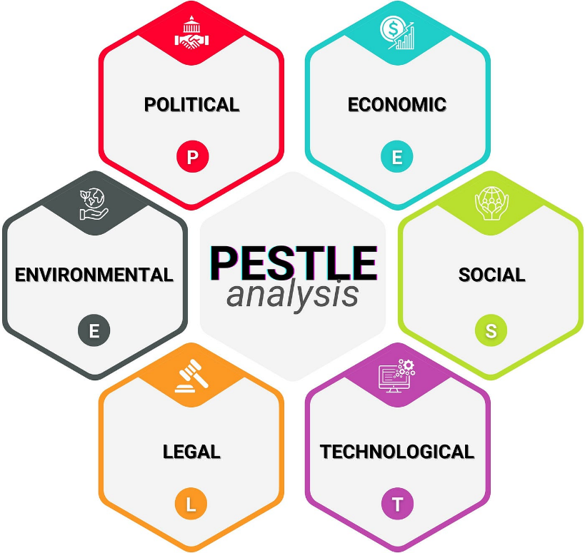
Figure 1: Pestle Analysis
Source: (Iqbal, 2025)
This analysis is commonly structured using the PESTEL framework, which divides the external environment into Political, Economic, Social, Technological, Environmental, and Legal dimensions(Iqbal, 2025). The impacts of each dimension on markets vary based on the dynamics of change and the industry. In the case of organisations like Zara, when launching the Zara Flexwear Suit, and Shein, when launching the Shein InstaFit Set, there is a great influence of the competitive advantage by changes in digital manufacturing, sustainability expectations, and regulatory demands.

2.2 Selection of Two External Macro Marketing Actors
Technological Forces
The technological forces are chosen because the fast-fashion industry depends on digital retailing, automated production, and AI trend forecasting. In 2024, global online sales reached USD 7,391 billion, and automation in the apparel manufacturing sector grew by 34 per cent between 2020 and 2024 as a trend toward fast production technologies (Ayushi Nagalia, 2024). In the case of Zara and Shein, technology defines the pace of product development, inventory optimisation and direct-to-consumer distribution.
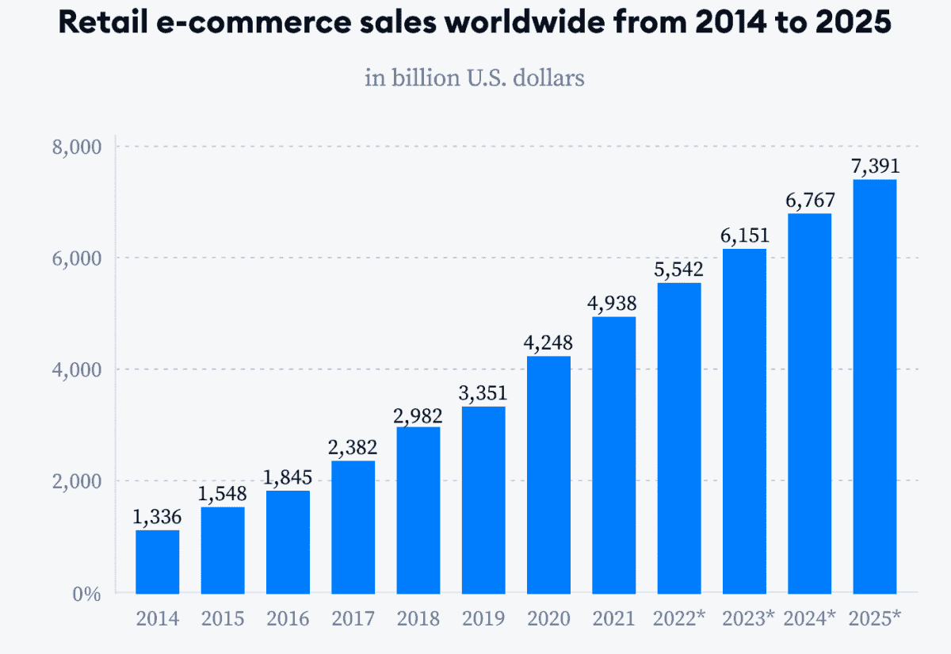
Figure 2: Global Online Sales 2014-2025
Source: (Ayushi Nagalia, 2024)
Environmental and Sustainability Pressures
The environmental forces are chosen since there is a global increase in sustainability demands and regulatory needs. The fashion industry contributes around 8-10 per cent to the overall carbon footprint in the world, and over 60 per cent of consumers all over the world in 2024 said they would consider environmentally responsible brands first (Maiti, 2024). As the EU and various Asian markets enforce more stringent waste, recycling and circular production regulations, fashion brands are incurring increased compliance expenses. In the case of items such as the Zara Flexwear Suit and the Shein InstaFit Set, sustainability demands are influencing material selection, marketing communications and future competitive standing.

2.3 Critical Analysis of Each Actor

2.3.1 Technological Forces
Impact on the Fast-Fashion Industry
Global fast-fashion has experienced a significant digital shift in which more than 70 per cent of fashion purchases in 2024 will be driven by digital content, algorithms, or online platforms and the market size of the industry was 136.19 billion dollars in the same year (Cardona, 2025). Furthermore, the fabric innovation market, such as stretch-performance fabrics used in items such as Zara Flexwear Suit and Shein InstaFit Set, has increased at an average pace of 9 per cent per year since 2022.
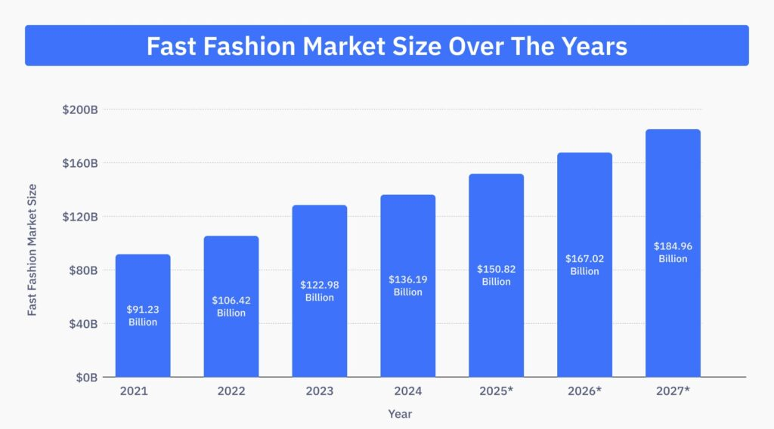
Figure 3: Global Fast Fashion Market Size
Source: (Cardona, 2025)
Pioneer (Zara)
- Opportunities: Its real-time data analytics across 2,000+ stores worldwide make it more design responsive and enable it to create advanced-performance apparel such as the Zara Flexwear Suit within a short time. Robotics and automated cutting technologies have led Zara to lead times of as short as two weeks, providing a good first-mover advantage (Zara, 2025).
- Threats: The expenses associated with proprietary supply-chain technologies are increasing, and digital investments in retail are more than 20 per cent per year with the major brands (Kotler et al., 2020). Competitors or disruptive AI-driven design websites might be able to eat into the traditional advantage of Zara in terms of speed-to-market.
Follower (Shein)
- Opportunities: Its design model is an algorithm-based analyser of behaviour based on over 500 million app downloads and allows for the quick production of trend-responsive products like the Shein InstaFit Set (SHEIN, 2025). Followers can imitate technological advances at a lower cost and, as a result, Shein can still benefit by adopting existing innovations without the resource intensity as found in the innovator.
- Threats: The excessive dependence on third-party production diminishes the level of control over the quality of products and their technological complexity. The mean production cycle time by Shein is still 30-40% longer than the automated production cycles by Zara (Hooley et al., 2020). Also, the intensity of digital data practices scrutinised by consumers of Shein is growing, and over 40 per cent of customers are worried about privacy and algorithms, posing reputational and regulatory risks.
Strategic Implications
To sustain the first-mover advantage, Zara has to keep on spending a lot on proprietary technology, automation and hi-tech materials. To improve the quality of products and minimise the instability of production, Shein will need to consolidate digital infrastructure control and seek strategic alliances with technologies. AI-enhanced customer personalisation should also be incorporated into both brands in order to ensure growth in the long term.

2.3.2 Environmental and Sustainability Pressures
Impact on the Fast-Fashion Industry
The industry is currently being redefined by environmental regulations in the production systems. Over 35 countries embraced extended producer responsibility (EPR) schemes on textile waste in 2024, which raised the cost of operation to apparel brands (Abrahamsson, 2025). The European markets strive to cut landfill textile waste by half by 2030, and 18% more fabrics have been recycled during the previous two years. Clothes resembling the Zara Flexwear Suit and the Shein InstaFit Set fall under further criticism of the environmental impact of synthetic fibres.
Pioneer (Zara)
- Opportunities: The company has resolved to utilise 100% sustainable fabrics by 2030 and 35 per cent higher recycled materials by 2024 (Zara, 2025). These features aid in the promotion of green products like the Zara Flexwear Suit, which improves brand image in controlled markets.
- Threats: The evolution of sustainability demands the use of compliance, which raises the cost of production as sustainable materials are 20-40 per cent more expensive than conventional fabrics (Johnson et al., 2017). Tougher environmental reporting regulations also put an extra burden on the vertically integrated model of Zara, where extensive monitoring of emissions and chemical consumption is needed.
Follower (Shein)
- Opportunities: Since it is a follower, Shein has the opportunity to implement sustainability innovations once they become affordable (SHEIN, 2025). An increase in demand for eco-performance wear globally offers a chance to position the Shein InstaFit Set with recycled fibre or less harmful production.
- Threats: The brand has been attacked on environmental consequences, and rapidly increasing international regulations pose a risk of limited market access (Kotler et al., 2020). As the EU shifts to obligatory eco-design standards, Shein can encounter greater compliance than vertically integrated giants such as Zara.
Strategic Implications
To cope with the rising regulations, Zara should further invest in circular production and low-impact fabric technologies. To reduce exposure to regulatory risk, Hein needs to improve supply-chain transparency, embrace certified sustainable materials and diversify manufacturing sites.

3. Task 2: Strategic Response of Pioneering and Follower Organisations

3.1 Pioneering Organisations’ Strategic Responses
Zara, being an innovative organisation, works at the leading edge in the fast-fashion industry by integrating both rapid-response manufacturing and vertically integrated supply chains (Zara, 2025). Technological acceleration and environmental pressures force Zara to strengthen its first-mover advantage in launching products like the Zara Flexwear Suit. Ansoff Growth Matrix can be used to analyse strategic responses.
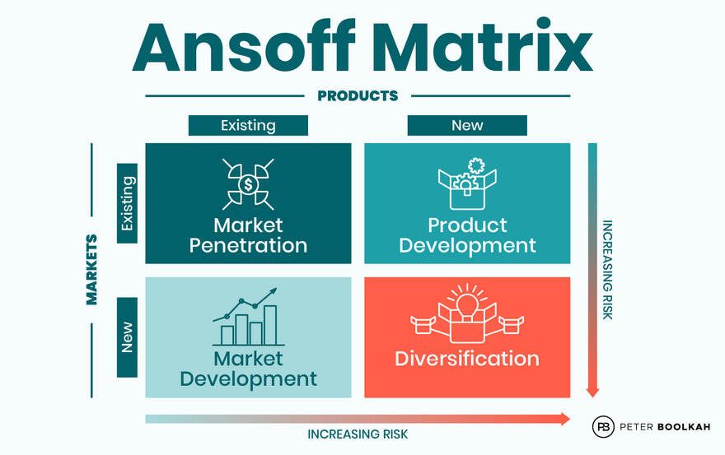
Figure 4: Ansoff Growth Matrix
Source: (Boolkah, 2024)
Market Penetration – Strengthening Speed Leadership and Enhancing Customer Value
Zara amplifies market penetration by taking advantage of its developed digital supply-chain network and internal production strength (Zara, 2025). As the worldwide consumer interaction moved to online platforms, Zara expanded its online investment by more than 25% in 2024, which allowed it to see products faster and replenish them instantly. In the case of the Zara Flexwear Suit, Zara operates on the list of penetration through performance-based marketing, demand-based forecasting, and real-time store feeds, which reduces the design-to-shelf time to less than two weeks.
Product Development – Introducing Advanced Materials and Functional Apparel
The fundamental pioneering response of Zara is product development. The Zara Flexwear Suit introduction is in line with the growth in the global demand for performance textiles, which increased by 9 per cent per year between 2022 and 2024. Zara makes heavy investments in fabric development, which incorporates stretch-based fabrics, moisture control features and recycled fibres because of the environmental regulations (Maiti, 2024). The vertically integrated nature of Zara also speeds up product testing, prototyping and testing in small batches, allowing several versions of the Flexwear to be launched in the global market.
Market Development – Entering Sustainability-Driven and Digitally Mature Markets
Zara's market development strategy is influenced by environmental pressures and the adoption of digital. Markets that are highly regulated in terms of sustainability, like the EU and South Korea, are the ones that demand low-impact performance gear. To react, Zara has created green-labelled formal collection lines, such as the Zara Flexwear Suit, backed by transparent sustainability propositions (Ayushi Nagalia, 2024). In 2024, Zara added over 20 new cities in Europe to the list of its eco-ready products, in reaction to a local growing demand of 30% in recycled-textile-based clothing. Fashion purchasing via smartphones is more than 75 per cent, and Zara also aims at digitally developed markets, including the UAE and Singapore.
Diversification – Expanding into Circular Manufacturing and Digital Apparel Services
To overcome environmental demands, Zara is enhancing its pioneering advantage through diversification. The company has increased its circular economy efforts, such as a textile take-back programme and low-impact dyeing centres, which will help in long-term competitiveness with increasing global regulations (Zara, 2025). Also, Zara is considering digital twin and virtual tailoring solutions, which allow customers to tailor-fit products such as the Zara Flexwear Suit.
Evaluation of Zara’s Strategic Effectiveness
The strategies have made Zara stronger in its role as an innovation leader, especially in terms of the quick responsiveness of the supply chain and making the products based on sustainability. Nevertheless, material cost increases, technological imitation by digital-first entrants, and tougher regulatory reporting requirements are problematic. Competitiveness will only be maintained by continuing to invest in advanced textiles, circular systems and digital innovation in retail.

3.2 Follower Organisations’ Strategic Responses
As a follower organisation, Shein utilises the agile approach, online trend tracking and cheap production to quickly imitate innovations on the market. With the same external forces, including technology and the environment, Shein modifies the Shein InstaFit Set by focusing on costs, quick copying and algorithm growth. The Ansoff Growth Matrix model can be used to analyse the strategic responses.
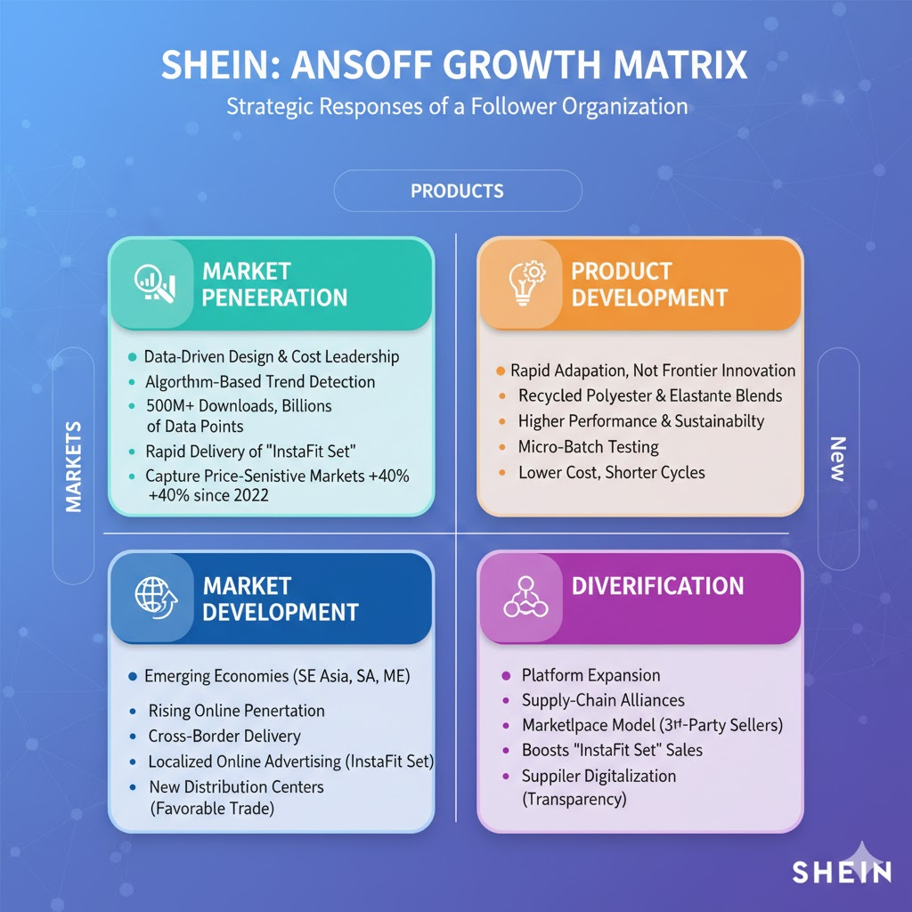
Figure 5: Ansoff Growth Matrix for Shein
Source: (Self-Made)
Market Penetration – Leveraging Data-Driven Design and Cost Leadership
Shein uses a penetration strategy in the market by maximising the use of algorithm-based trend detection (Daxue Consulting, 2025). Shein, with more than 500 million downloads, analyses billions of bits of data to understand the growing interest in performance and athleisure categories. This allows quick delivery of products like the Shein InstaFit Set at much cheaper rates compared to the traditional competition. This will enable Shein to capture price-sensitive markets, which have increased by almost 40% since 2022, particularly in areas where economic pressures have changed consumer behaviour to low-price items.
Product Development – Adapting Innovations at Lower Cost and Shorter Cycles
Shein, as a follower, is more concerned with rapid adaptation and not frontier innovation. Shein has started using recycled polyester and elastane blends in products like the Shein InstaFit Set to meet customer demands of higher performance fabrics and sustainability demands (SHEIN, 2025). This is consistent with the trends worldwide, which show that the use of recycled synthetic fibre grew by 18 per cent between 2022 and 2024. There is also micro-batch testing with Shein, developing small quantities of new products and scaling up those with high digital opinion. The method allows constant product innovation without the expensive R&D costs incurred by innovators.
Market Development – Expanding into Emerging Economies and Regulatory-Light Regions
The market development by Shein focuses on areas where online penetration is on the rise and sustainability barriers are minimised. E-commerce in Southeast Asia, South America and the Middle East has grown over 20% per annum and prefers low-cost fashion segments (Fan, 2025). Shein applies cross-border delivery and localised online advertising to increase the visibility of the Shein InstaFit Set in these rapidly developing regions. Moreover, Shein has started to open distribution centres in countries where trade policies are favourable to minimise delivery times.
Diversification – Expanding Marketplace Services and Supplier Ecosystems
The diversification that is practised by Shein is through the expansion of platforms and supply-chain alliances. In 2023, the company launched the marketplace model, which enables third-party sellers to sell products with its own brand, offering a variety of products and limiting operational risks (Chan Kim, Hwang and Burgers, 2023). This approach helps to boost the selling ability of products like the Shein InstaFit Set. Shein is likewise investing in supplier digitalisation programmes to enhance transparency and comply with the new environmental standards.
Evaluation of Shein’s Strategic Effectiveness
The cost leadership-based follower strategies, digital agility, and global expansion that are practised by Shein have resulted in the company experiencing tremendous growth and competitive placement in the mass markets. Nevertheless, the sustainability demands, growing regulatory influence and reputation issues put long-term stability at risk. To remain competitive, Shein should strengthen supply-chain traceability, invest in proven eco-materials, and diversify into markets that have compliance requirements in line with new global norms.

4. Conclusion
The analysis illustrates that both pioneering and follower companies in the fast-fashion industry are highly influenced by technological forces and environmental sustainability pressures in the nature of competition. Task 1 noted the opportunities presented by developments in the field of automation and artificial intelligence in the design and digital retailing, as well as the competition and regulation that are increasing. Equally, an increase in sustainability expectations and changes in international policy pose strategic benefits to the environmentally proactive brands and pose challenges to those that rely on the resource-intensive production model. Task 2 revealed that Zara, being a pioneering organisation, uses technological leadership, vertical integration, and innovation that is sustainability oriented to retain first-mover advantage, whereas Shein uses agile, cost-driven and digitally enabled approaches to rapidly mimic and grow market trends. Generally, the results support the idea that constant environmental scanning is vital in predicting change, minimising risk, and maximising opportunity. Organisations that actively adjust themselves using strategic innovation, sustainability promise and digital capability-building will have higher chances of remaining competitive in the dynamic fashion world in the long term.

5. References
Abrahamsson, E. (2025). The Extended Producer Responsibility for textiles. [online] Available at: https://www.utupub.fi/bitstream/handle/10024/182236/Abrahamsson_Elli_opinnayte.pdf?sequence=1 [Accessed 20 Nov. 2025].
Ayushi Nagalia (2024). Latest Online Shopping Trends and Statistics (2025). [online] EngageBay - All-in-one marketing, sales, and service software for growing businesses. Available at: https://www.engagebay.com/blog/online-shopping-trends-statistics/ [Accessed 20 Nov. 2025].
Boolkah, P. (2024). Ansoff Matrix: What Is It And How To Use It? [online] Peter Boolkah. Available at: https://boolkah.com/ansoff-matrix/ [Accessed 20 Nov. 2025].
Cardona, N. (2025). Environmental Impact of Fast Fashion Statistics. [online] UniformMarket. Available at: https://www.uniformmarket.com/statistics/fast-fashion-statistics [Accessed 18 Nov. 2025].
Chan Kim, W., Hwang, P. and Burgers, W.P. (2023). Global diversification strategy and corporate profit performance. Strategic Management Journal, 10(1), pp.45–57. doi:https://doi.org/10.1002/smj.4250100105.
Daxue Consulting (2025). Shein’s market strategy: How the Chinese fashion brand is conquering the West - Daxue Consulting - Market Research China. [online] daxueconsulting.com. Available at: https://daxueconsulting.com/shein-market-strategy/ [Accessed 20 Nov. 2025].
Fan, J. (2025). Global Trends and Regional Dynamics in International E-commerce. Handbook of E-commerce in China, 9(3), pp.1235–1258. doi:https://doi.org/10.1007/978-981-96-7629-3_57.
Hooley, G. J., Nicoulaud, B., Rudd, J. M., & Lee, N. (2020). Marketing strategy and competitive positioning. Seventh edition. Harlow, England ; Pearson.
Iqbal, A. (2025). PESTLE Analysis: The CEO’s Guide to Future-Proofing a Business. [online] Medium. Available at: https://medium.com/techno-preneurship/pestle-analysis-the-ceos-guide-to-future-proofing-a-business-877e6c4e20ea [Accessed 20 Nov. 2025].
Johnson, G., Whittington, R., Scholes, K., Angwin, D., & Regnér, P. (2017). Exploring strategy : text and cases. Eleventh edition. Harlow: Pearson Education Limited.
Kotler, P., Armstrong, G., Harris, L. and Piercy, N. (2020). Principles of marketing. 8th European edn. Harlow: Pearson.
Maiti, R. (2024). The Environmental Impact of Fast Fashion, Explained. [online] Earth.org. Available at: https://earth.org/fast-fashions-detrimental-effect-on-the-environment/ [Accessed 19 Nov. 2025].
SHEIN (2025). Women’s & Men’s Clothes, Shop Online Fashion | SHEIN UK. [online] Shein.co.uk. Available at: https://www.shein.co.uk/ [Accessed 18 Nov. 2025].
Zara (2025). Company-+ Info | ZARA International. [online] www.zara.com. Available at: https://www.zara.com/ww/en/z-company-corp1391.html?v1=11112 [Accessed 20 Nov. 2025].

