In this report I will be researching and analysing the business Next. I will be focusing on the business structures used, including the organisation of management, their approach to motivation and work satisfaction and the general functions of the business. I have chosen to report on Next because they are a hugely successful business with an ever expanding range of products and have had major success transitioning to online sales, with most of their investments now going towards improving online sales and marketing. Next is also very transparent about their business in the aforementioned areas I will be researching, encouraging students to learn more about their framework; they even have a student help Q and A page on their website.

Nature and context of NEXTplc

Next has come a long way since its beginnings. In 1864 J Hepworth and Son opened ‘Gentlemen's Tailors’ in Leeds England. In 1981 Hepworth bought a chain of Kendals rainwear shops to develop a womenswear group of stores which was then renamed Next. The first of these to open was in 1982, with 70 open by the end of July of the same year. Skipping ahead a few years in 2000 Next began to offer “next day delivery standard on orders before 5pm”. In 2013 Next was trading online “in over 70 countries worldwide”. In 2020, Next launched Total Platform which is a new initiative put forward by Next CEO “to leverage Next’s Online infrastructure and provide partners with a comprehensive solution to trading online.” In the current year (2021) Next has “acquired 25% of Reiss”, and from early 2022 all of Reiss’s websites and online operations, including overseas, “will be contracted to Next through Total Platform”. Next has also agreed a “joint venture to operate Gap’s E-commerce business across Total Platform, host shop-in-shops and offer click and collect options for online shoppers.” (Next plc)

“Total Platform pay-as-you-go service..” which “...offers third-party brands access to the retailer's online logistics and back-end systems, is starting to gather momentum.” (Fish, I. 2021, 18 August) Essentially this means that 3rd party businesses can benefit on a commission basis from the Next online platform and customer base, while still remaining in control of their business. Next simply offers a larger platform with a charge on commissions which is how they make their money. Having more businesses on their platform helps Next to draw in more customers to the website which allows these consumers to be exposed to other products or similar items sold by next, which can lead to more sales on the website. Next hosts well known brands such as Hugo Boss, Lipsy, Nike, Adidas, Calvin Klein and many many more in an ever growing collection. (Next plc)

NEXT Organisational Structure and Management

There are 4 main theories of management that still influence many businesses and structures today. These are Classical, Human Relations, Systems, and Contingency.
The Classical approach, which includes scientific (F.w. Taylor, 1856-1917), holds emphasis on purpose and productivity, having a formal hierarchical structure with clear management positions, allocating tasks to specific fixed individuals to do in a specific simplified structured way. Everyone has a job and a place and a specific structured way of working. Classical approach became “..mainstream in the early 1900s with an emphasis on increasing worker productivity... the classical theory of management advocated a scientific study of tasks and the workers responsible for them.” ( Terry,L. 2011) Fayol also contributed to this theory, suggesting a need for planning, organisation, command, coordination and control as the 5 managerial activities. Taylor believed money is the main motivator for work and so a fair wage would boost productivity which is why he developed the concept of “fair day’s wages for a fair day’s work” (corporate finance institute)

The Human relations approach (HR)- (Mayo, E. 1880- 1949) offers more attention to the social and cultural side of the work environment, considering groups, the methods of leadership and the informal social relationships and interactions within the organisation. This allows more flexibility and job satisfaction as workers aren't so detached from managers. Rather than adopting a purely rational organisation which assumes everyone will always be on their best performance as is the case with some classical approaches, the HR approach focuses on human psychology and social needs. Considering the social environment of the workplace as having an impact on worker productivity.

Systems approach combines aspects of classical and HR approach and is “based on the generalization that everything is inter-related and interdependent.” (Chand, S) This approach considers the total organization and relationships between organisational structure and resulting behaviour.

Contingency approach accepts that there is no single best design that will apply to all organisations and the approach used must be relevant to the aims and cultures of the business. This theory “..identifies three variables that are likely to influence an organization’s structure: the size of an organization, technology being employed, and style of leadership.” (corporate finance institute)

Next operates as a formal organisation. This is defined by Schein as:
“the planned coordination of the activities of a number of people for the achievement of some common, explicit purpose or goal, through division of labor and function, and through a hierarchy of authority and responsibility.” For Next that goal is outlined in their mission statement : “Our commitment is to offer beautifully designed, excellent quality clothing and homeware products that are well made, functional and safe, sourced responsibly and provide outstanding value to meet or exceed our customers’ expectations.” (Next plc)
Next appears to operate with a systems approach to management, with intersectional areas of the business all collectively working to the shared goal of delivering high quality goods and service to their customers. Next has a board of 10 with their Chairman, Chief Executive, 3 directors from different sections of the business ( finance, merchandise and operations, sales and marketing) and 5 independent non-executive directors, one of which senior. Of the 10 members of the board, 4 are Women, making a more accessible and diverse panel in decision making, with different perspectives.These members act as representatives of their areas within the company in board meetings where decisions are often made on majority votes. Annual meetings occur although additional meetings can be called at any time should such need arise.
Due to the enormous scale of the business, a systems approach seems the most appropriate method. A classical approach for the entire business would stifle creativity and innovation as everything would have a fixed structure and method of working. Even in the production line it is important to understand the social networking of the groups and organise them in accordance to where they best perform. Having a strong organisational structure with clear levels of authority, integrated with consideration for the nature of the workplace, allows Next to be resilient and adaptable, as they can communicate relevant information to the appropriate people in each circumstance.

Work and Motivation

Maslow is famously known for his theory on motivation - the Hierarchy of needs. Maslow theorised that all humans have foundational basic needs and then a pyramid of needs that must be met to achieve growth and reach full potential. “From the bottom of the hierarchy upwards, the needs are: physiological (food and clothing), safety (job security), love and belonging needs (friendship), esteem, and self-actualization.” (Dr. Saul McLeod)

Under Biological and Physiological needs comes, sustenance, warmth, intimacy and sleep (Dr. Saul McLeod)

Safety needs include shelter, security, law and order, freedom and safety from harm.
(Dr. Saul McLeod)

Love and belongingness covers the human need for friendship and social connections, this includes intimacy, trust, love and acceptance into a group (friends, family, work) (Dr. Saul McLeod)
Esteem needs “which Maslow classified into two categories: (i) esteem for oneself (dignity, achievement, mastery, independence) and (ii) the need to be accepted and valued by others (e.g., status, prestige).” (Dr. Saul McLeod)

Cognitive needs are the knowledge, understanding of the work, curiosity, creativity and the need for purpose and in some cases routine and predictability. (Dr. Saul McLeod)

Self actualisation is the chance to achieve true potential and feel the satisfaction from doing so, not confined by surroundings, but pushed and inspired to be more. This is where transcendence comes into play, when an individual is top of their game and maximising their potential and growth as an individual.

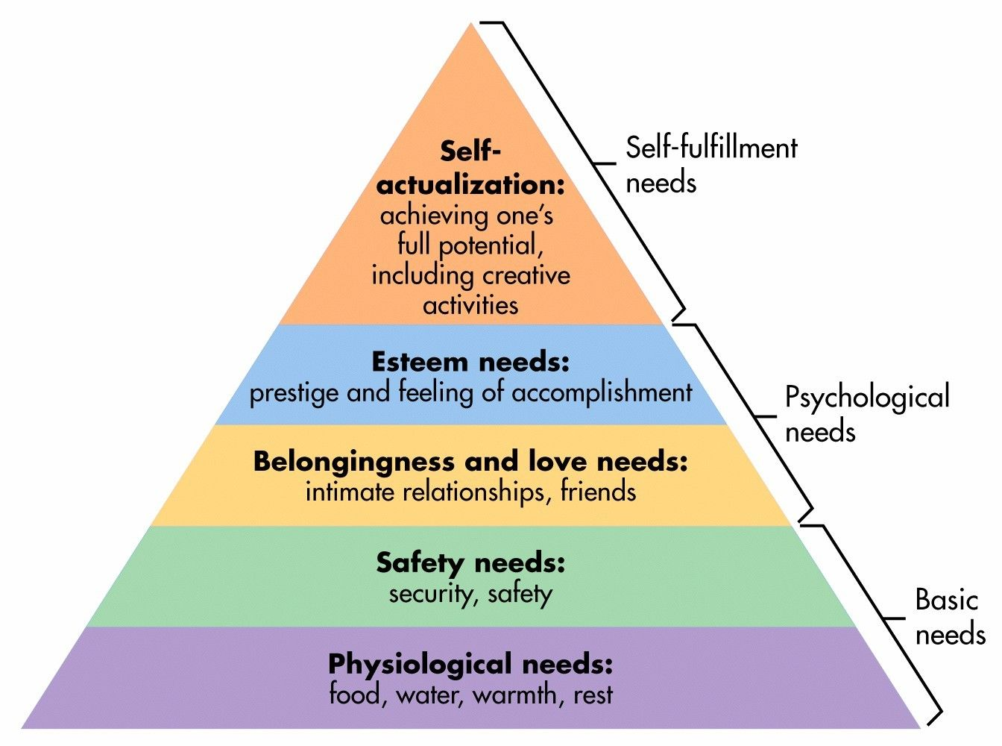
(Dr. Saul McLeod)

Next places high importance on maintaining that “..safe, healthy and secure working conditions are provided, which are free from discrimination”(Next plc) This is a very basic but important expectation for all workplaces. You must respect staff if you are to expect the best performance from them. Next also promises a fair wage for everyone within Next supply chain and any area within Next, with strict policies to prevent “..any form of modern slavery, human trafficking, forced labour or child labour against any individual working for NEXT’s suppliers or NEXT’s business partners or within the NEXT group..” (Next plc)

Over Lockdown Next “invested heavily in making workplaces COVIDsafe '' (Next plc) as well as improving staff motivation and supporting mental health by developing a “wellbeing website focusing on support for employees working from home and in isolation”. This no doubt made staff feel valued and more supported at such a difficult time of enormous change. Next also supported staff by launching a “free digital GP service and hosted a Mental Health Awareness Week event” to allow discussions amongst employees about their personal challenges with the adaptation to online working and “how the business was responding to wellbeing needs.” (Next plc, 30 April 2021)

Perception and Communication

Next has a very in depth ‘articles of association’ pdf that details how the votes are cast, who is allowed to vote in different meetings and the number of votes allocated according to authority of the voter. The Board makes the decisions on a majority vote when a poll is demanded by the board. The results of the poll are conclusive to the meeting, if the poll is granted and the request is not withdrawn. The following is an extract from this Pdf, from the section on voting.

“40. How poll is to be taken

(a) If a poll is demanded (and the demand is not withdrawn), it shall be taken at such time (either at the meeting at which the poll is demanded or within 30 days after the meeting), at such place and in such manner (including electronically) as the chairman of the meeting shall direct and he may appoint scrutineers (who need not be members).

(b) A poll demanded on a question of adjournment shall be taken at the meeting without adjournment.

(c) It shall not be necessary (unless the chairman of the meeting otherwise directs) for notice to be given of a poll whether taken at or after the meeting at which it was demanded.
(d) On a poll, votes may be given either personally or by proxy and a member entitled to more than one vote need not use all his votes or cast all the votes he uses in the same way.

(e) The result of the poll shall be deemed to be a resolution of the meeting at which the poll was demanded” ( Next Plc)

Any meeting must also come at advanced warning so those who are able can attend and make arrangements allowing them to be present. This is an example of democratic, collaborative management by Next. Communication is encouraged amongst the board during these meetings and the majority vote is an accepted way to reach an agreement if the group does not unanimously agree with the decision of the chairperson. This is an effective way of gaining a wider more diverse panel to make company decisions. Each director will be familiar and experienced within different sectors of the business, and so can contribute from the perspective of how any decision made will impact them and their area within the company. For example its implications on marketing and how that could affect finances. If all the decisions were decided by the CEO alone, they would likely be a lot more out of touch with the real time impact it'll have on different levels, as it would be difficult to be aware of everything happening in all areas.

Next also have very open communication on their website showing pdf files outlining meetings procedures, covid compliance and procedures, Background information on all members of the board including when they joined and their contribution. Information for customers and enquiries about orders are all easily located on their page which is very clearly set out, and in addition to this they have a student information page with links to relevant pages, answering commonly asked questions about their business structure and methods.

On the website, Next outlines their CSR commitments with a page containing links to annual reports to show progress and developments. In the 2021 January CSR report, Next state:
“The principles underpinning our aim to do business responsibly are unchanged; we seek always to: • Act in an ethical manner • Recognise, respect and protect human rights • Develop positive relationships with our suppliers and business partners • Recruit and retain responsible employees • Take responsibility for our impact on the environment • Deliver value to our customers • Provide support through donations to charities and community organisations” (Next plc)

To Achieve these Next ensures a fair wage, using sustainable materials wherever possible in their production lines aiming to minimise their negative impact on the environment. By abiding by human rights laws and regulations, Next protects workers rights and maintains ethical practice within its means. Since the development of the Total platform in 2000, Next has improved and strengthened its relationships with suppliers and business partners, expanding their product range. This expansion has brought in new markets and customers, thus being able to deliver more value to consumers, who are provided more options and value for money. With more sales, Next is in a better position to donate to charities and charitable organisations, benefiting the local, and wider community.

To conclude, although Next has room to improve on environmental impacts and its global CSP, they have identified these areas and have an action plan laid out to meet their new targets. Next has already successfully diverted 97% of waste from landfill and has a “new total value chain target set to reduce emissions by 40% by 2030 per £1m sales”. Next has accessible progress reports publicly and freely available on their website to show how they are working towards their goals and putting their words into action. ( Next Plc) Next has been very successful in its ventures so far seeing large gains following their extension of Total Platform with suppliers. Next has a strong business model with a relatively diverse panel of decision makers and a lot of collaboration across the business to gain the best understanding of their company goals and targets. Overall, Next is very open with communication on their goals and their actions that follow, and so although there is room for improvement, the path to improvement has been mostly identified and put into action.

References:

Chand, S. System Approach to Management: Definition, Features and Evaluation. URL:
https://www.yourarticlelibrary.com/management/system-approach-to-management-definition-features-and-evaluation/27897

Corporate finance institute. Management Theories - Concepts surrounding recommended management strategies. URL:
https://corporatefinanceinstitute.com/resources/careers/soft-skills/management-theories/

Dr. McLeod,S. (2020, December 29).Maslow's Hierarchy of Needs. URL:
https://www.simplypsychology.org/maslow.html

Fish, I. (2021, August 18). Next’s Total Platform: ‘genius at so many levels’. URL:
https://www.drapersonline.com/insight/nexts-total-platform-genius-at-so-many-levels

Mind Tools. Frederick Taylor and Scientific Management - Understanding Taylorism and Early Management Theory. URL: https://www.mindtools.com/pages/article/newTMM_Taylor.htm

Next plc.(2020). Articles-of-association-may20 [pdf]. How a poll is to be taken Pp 19. URL:
https://www.nextplc.co.uk/~/media/Files/N/Next-PLC-V2/documents/about-us/articles-of-association-may20.pdf

Next plc. (2021). Audit Committee Terms of Reference 2021 [pdf]. URL:
https://www.nextplc.co.uk/~/media/Files/N/Next-PLC-V2/documents/2022/Audit%20Committee%20Terms%20of%20Reference%202021.pdf

Next plc.(2021). Corporate Responsibility - Environment. URL:
https://www.nextplc.co.uk/corporate-responsibility/environment

Next plc. (2017, March ). Human-rights-and-modern-slavery-policy-march-2017 [pdf].URL:
https://www.nextplc.co.uk/~/media/Files/N/Next-PLC-V2/human-rights-and-modern-slavery-policy-march-2017.pdf

Next plc.(2021, January).next-cr-report-2021[pdf]. URL:
https://www.nextplc.co.uk/~/media/Files/N/Next-PLC-V2/documents/cr-reports/next-cr-report-2021.pdf

Next plc.(2021). Our Board. URL:
https://www.nextplc.co.uk/about-next/our-board

Next plc. Our History.URL:
https://www.nextplc.co.uk/about-next/our-history

Simple Psychology.(2021). Maslow - Pyramid.[Digital diagram].URL:
https://www.simplypsychology.org/maslow-pyramid.jpg

Terry,L .(2011, October 17).Classical and Scientific Management Theory - Enlist classical management theories to boost efficiency and worker productivity. URL:
https://www.business.com/articles/classical-and-scientific-management-theory/#:~:text=Scientific%20management%20theory%2C%20also%20called,the%20workers%20responsible%20for%20them.

Wall,N. ( 2014, March 11). Next launches new standalone fashion website, Label. Cosmopolitan. URL: https://www.cosmopolitan.com/uk/fashion/news/a25682/next-standalone-fashion-website-label/

