Innovative Strategic Marketing in F&B at Best Western York House Hotel, Eastbourne: A Path to Market Expansion

Modul name: BMIH 6008 – Hotel Placement Research Project
Student name: Corina Elena Slujitoru (2111320)
Supervisor name: Ben Chong
Submission date: 1st June 2024

University of Wales Trinity Saint David

Executive Summary
This research project investigates innovative strategic marketing initiatives in the food and beverage (F&B) sector at Best Western York House Hotel, Eastbourne, and explores their potential for market expansion. The study focuses on effective market segmentation, digital marketing, experiential dining, sustainability practices, and technology-driven personalisation. Through a comprehensive analysis of the hotel's current practices and application of various marketing theories, the project identifies significant opportunities for enhancing customer engagement, satisfaction, and loyalty.
Digital marketing and social media engagement are highlighted as practical tools for increasing visibility and fostering a sense of community among guests. The study emphasises the need for a robust content strategy, collaboration with local influencers, and targeted campaigns to maximise the impact of these efforts. Experiential dining, focusing on local produce, is recognised for creating unique and memorable experiences, with recommendations for expanding themed events to attract more food enthusiasts.
The research also underscores the importance of sustainability practices in today's hospitality industry. While the hotel has made progress in sourcing local and organic ingredients, improvements in waste management and energy use practices are critical. Implementing comprehensive waste reduction programs and investing in alternative energy sources can enhance the hotel's appeal to eco-conscious travellers.
Effective market segmentation and understanding consumer behaviour are vital for tailoring marketing efforts to specific customer groups. Developing targeted marketing messages and personalised services for different segments can increase customer satisfaction and loyalty. Additionally, leveraging technology for personalised guest experiences, such as through a mobile app and digital menus, can significantly enhance satisfaction and operational efficiency.
The project concludes with several recommendations to help Best Western York House Hotel capitalise on these findings, including enhancing digital marketing, expanding experiential dining initiatives, strengthening sustainability practices, improving market segmentation strategies, and leveraging technology for personalisation. The hotel can enhance its market position, improve customer satisfaction, and achieve sustainable growth by implementing these recommendations.
The insights gained from this research provide a roadmap for leveraging innovative strategic marketing initiatives to drive the hotel's success in the dynamic and competitive hospitality market.

Table of Contents

1. Introduction 6
1.1 Aims and Objectives 6
1.2 Research Questions 6
1.3 Background Information 6
1.4 Scope and Organisation 7
2. Literature Review 7
2.1 Consumer Behavior and Market Segmentation 8
2.2 Technological Advancements and Digital Marketing 8
2.3 Sustainability Trends and Ethical Marketing 9
2.4 Cultural Preferences and Experiential Dining 10
2.5 Gaps in the Literature 10
3. Methodology 11
4. Case Study Discussions 13
4.1 Location 13
4.2 Geographical and Cultural Context 13
4.3 Hotel Overview 14
4.4 Brand and Turnover 15
4.5 Staffing and Management 15
4.6 Analysis Tools 15
4.7 SWOT Analysis 16
4.7.1 Impact on Strategic Marketing Initiatives 17
4.8 PESTLE Analysis 17
4.8.1 Political Factors 18
4.8.2 Economic Factors 18
4.8.3 Social Factors 18
4.8.4 Technological Factors 19
4.8.5 Legal Factors 19
4.8.6 Environmental Factors 20
4.8.7 Impact on Strategic Marketing Initiatives 20
4.9 Competitor Analysis (Price vs Quality) 20
4.10 Netnography 21
5 Theme/Findings 23
5.1 Consumer Behaviour and Market Segmentation 24
5.2 Digital Marketing and Social Media Engagement 24
5.3 Experiential Dining and Culinary Innovation 25
5.4 Sustainability and Ethical Marketing 25
5.5 Technology-Driven Personalisation 26
6. Contributions 27
7. Conclusions and Recommendations 27
8. Reflective Writing on Placement Experience at Best Western York House Hotel 30
8.1 Experience 30
8.2 Reflection 32
8.3 Action 33
References: 34

- Introduction

1.1 Aims and Objectives
The primary aim of this research project is to critically evaluate and enhance the Best Western York House Hotel's food and beverage (F&B) marketing efforts. Objectives include analysing current marketing methods, identifying opportunities for innovation, and proposing strategic initiatives to expand the hotel's market, increase occupancy rates, and boost revenue. Additionally, the project seeks to elevate the guest experience, positioning the hotel as a top destination for leisure and business travellers.

1.2 Research Questions
This research addresses the following questions: What are the current marketing strategies in the hotel's F&B sector? How can innovative marketing strategies improve market reach and financial performance? How can insights into market segmentation and consumer behaviour enhance F&B marketing efforts? How do personalised dining experiences and sustainability practices impact customer satisfaction and loyalty?

1.3 Background Information
Leveraging its strategic advantages, the Best Western York House Hotel aims to boost its market through targeted marketing initiatives. Its prime location, minutes from both nature and urban amenities, is a significant asset.
Nestled just 20 yards from the shimmering waters of the English Channel, the Best Western York House Hotel in Eastbourne blends Victorian elegance with contemporary hospitality (York House Hotel, 2024). This 3-star establishment on the seafront offers immediate access to a scenic promenade, the vibrant Eastbourne pier, and the charming town centre. The Verandah Bar & Restaurant, featuring modern British cuisine, provides a memorable dining experience with breathtaking sea views. As one of Eastbourne's top-rated hotels on TripAdvisor, it boasts an indoor heated pool, open-air balcony, and versatile lounges (The Argus, 2021). These facilities cater to leisure and business travellers, ensuring a satisfying stay.

1.4 Scope and Organisation
This report begins with a literature review of innovative marketing strategies in the F&B sector, including digital marketing, experiential dining, sustainability, technology-driven personalisation, consumer behaviour, and market segmentation. It identifies trends and gaps, setting the stage for the case study. The methodology section outlines the case study approach, relying on secondary data from existing literature and databases. The case study analyses the hotel's brand, location, and marketing practices, highlighting its unique advantages. Findings focus on enhancing market reach through innovative strategies. The report concludes with practical recommendations for improving the hotel's F&B marketing to expand its market and enhance guest experience.
- Literature Review

According to Kotler's definition of marketing, it is the methodical and inventive process of identifying, developing, and delivering value to satisfy the requirements of market segments while achieving profitability (Kotler and Keller, 2016). Marketing seeks to satisfy unfulfilled needs, evaluating and projecting the market's extent and potential for profit. In these challenging times, the hotel industry, particularly the food and beverage (F&B) sector, faces fierce competition and constant pressure to innovate marketing strategies to attract and retain customers (Bayona-Saez et al., 2017). Innovative marketing strategies in the F&B sector involve utilising modern and creative approaches to market F&B services and products effectively, including digital marketing, social media engagement (Ahamat et al., 2022), sustainability practices, and experiential dining (Hussain et al., 2020). This review explores these strategies and their implications for enhancing competitiveness and customer satisfaction to expand the market.

According to Solomon (2017) and Han et al. (2010), factors influencing the F&B sector include consumer behaviour, technological advancements, sustainability trends, and cultural preferences. Implementing innovative marketing strategies can expand the market and increase customer satisfaction by targeting specific consumer needs, improving engagement through technology (Alalwan et al., 2017), and adopting sustainable practices (Martindale, 2014). The F&B sector significantly impacts the hotel industry by generating revenue, enhancing guest experiences, and differentiating hotels in a competitive market (Kanaan et al., 2023).

2.1 Consumer Behaviour and Market Segmentation

Understanding consumer behaviour and effectively segmenting the market is crucial for implementing successful marketing strategies in the F&B sector of the hotel industry (Melia, 2011). Consumer behaviour studies reveal that dining preferences, purchasing decisions, and loyalty are influenced by various factors, including cultural background, social influences, and personal preferences (Solomon, 2017). Market segmentation divides a large target market into smaller groups with similar characteristics (Wedel and Kamakura, 2000). This approach enables hotels to customise their marketing strategies to meet the specific needs of different consumer segments. Kotler and Keller (2016) highlight the significance of segmentation in creating focused marketing initiatives that appeal to particular consumer groups. For example, psychographic segmentation, which considers lifestyle, values, and personality traits, can help hotels create marketing messages that appeal to specific consumer segments.

Research by Dolnicar (2007) underscores the significance of segmentation in the hospitality industry. It notes that well-segmented markets enable hotels to design customised services and marketing plans that cater to the distinct requirements of various customer segments. This method has the potential to enhance customer satisfaction and foster loyalty.

2.2 Technological Advancements and Digital Marketing

Digital marketing, mainly through social media, has become a cornerstone of modern marketing strategies in the F&B sector of the hotel industry. Studies highlight the effectiveness of social media platforms in enhancing customer engagement, brand awareness, and customer loyalty. For instance, Leung et al. (2013) found that hotels utilising social media platforms such as Facebook, Instagram, and Twitter experienced increased customer interaction and loyalty. These platforms allow hotels to share visually appealing content, promote special offers, and interact directly with customers, fostering a sense of community and engagement. Similarly, Alalwan et al. (2017) underscore the significance of social media in influencing customer attitudes and decision-making processes. They contend that utilising social media for marketing allows hotels to expand their reach to a larger demographic, interact with customers in real time, and collect valuable feedback. However, the challenge lies in maintaining consistent and authentic engagement, which requires dedicated resources and a clear strategy.

Recent studies support the role of digital marketing in improving hotel performance. For example, digital marketing strategies significantly enhance customer engagement and loyalty, contributing to revenue growth in the hotel restaurant sector (Kanaan et al., 2023). Additionally, technological advancements have enabled hotels to offer personalised dining experiences tailored to individual preferences and dietary requirements. Research by Buhalis and Amarangana (2015) suggests that leveraging technology for personalisation, such as using data analytics to understand customer preferences and offering customised menus, can enhance customer satisfaction and loyalty. Technology can streamline operations, improve service quality, and offer personalised recommendations. For example, mobile apps allowing customers to customise their orders, receive real-time updates, and provide feedback can enhance the dining experience. A study by Ahamat et al. (2022) highlights the challenges and opportunities associated with leveraging cutting-edge marketing technologies to launch new products and improve the company's image in the F&B sector.

2.3 Sustainability Trends and Ethical Marketing

Sustainability has become a critical consumer consideration, influencing purchasing decisions and brand loyalty. Research indicates that hotels adopting sustainable practices in their F&B operations can appeal to environmentally conscious consumers and enhance their brand image. According to Han, Hsu, and Sheu (2010), adopting sustainable methods like utilising local and organic ingredients, minimising food wastage, and incorporating eco-friendly packaging are well-received by consumers and lead to heightened customer satisfaction and loyalty. Moreover, Martindale (2014) argues that ethical marketing, emphasising transparency and social responsibility, can significantly impact consumer behaviour. Hotels that communicate their commitment to sustainability through their marketing efforts can attract a niche market of eco-conscious travellers.

Studies by Hussain et al. (2020) indicate that market performance within the hospitality sector is greatly influenced by sustainable brand equity and marketing innovation, with this relationship being mediated by sustainable competitive advantage. Implementing innovative marketing strategies focusing on sustainability can expand the market and enhance customer satisfaction by meeting the growing demand for eco-friendly practices.

2.4 Cultural Preferences and Experiential Dining

Experiential dining is another innovative marketing strategy that has gained traction in the hotel industry. This approach focuses on creating memorable dining experiences beyond traditional food service. Research by Pine and Gilmore (1999) introduced the concept of the "experience economy," where businesses create value by offering one-of-a-kind and unforgettable experiences. In the context of F&B, this can include themed dining events, interactive cooking classes, and immersive culinary experiences. Culinary innovation is crucial in attracting tourists and enhancing their overall experience. Hotels that offer unique and locally inspired dishes, interactive dining experiences, and personalised services are more likely to attract repeat customers and positive word-of-mouth referrals (Hjalager and Richards, 2003). A study by Sykimte (2023) found that culinary trends, such as distinct cuisines, dietary preferences, sustainable ingredients, and innovative presentation methods, benefit hotel restaurant revenue and customer satisfaction.

2.5 Gaps in the Literature
While existing research provides valuable insights into innovative marketing strategies in the F&B sector of the hotel industry, several gaps still need to be addressed. Firstly, more research is needed on the specific challenges independent hotels, such as the Best Western York House Hotel, face in implementing these strategies. Most studies focus on large hotel chains (Richard, 2017) with substantial resources, overlooking the unique constraints and opportunities for smaller, independent establishments (Calisto et al., 2021). Independent hotels often need more budgets, marketing resources, and brand recognition than their larger counterparts. Understanding these unique challenges is crucial for developing tailored strategies to help these hotels compete effectively.
Secondly, more empirical studies are needed to measure the effectiveness of these marketing strategies in terms of customer satisfaction, loyalty, and financial performance (Ribaudo et al., 2020). While theoretical frameworks and case studies provide valuable insights, quantitative data on the impact of innovative marketing strategies is still needed (Morgan et al., 2019). Empirical studies can help quantify the benefits of various marketing initiatives, providing concrete evidence that can be used to justify investments in these areas. For example, measuring the impact of social media engagement on booking rates or the return on investment from sustainability initiatives can provide valuable insights for hotel managers (Michopoulou and Moisa, 2019).
To summarise, innovative marketing strategies in the F&B sector of the hotel industry, such as digital marketing, experiential dining, sustainability, technology-driven personalisation, and effective market segmentation, offer significant potential for enhancing customer engagement and loyalty. However, more research on the challenges and opportunities for independent hotels and empirical studies measuring the effectiveness of these strategies are needed.
- Methodology
A case study is a research technique involving a detailed investigation of a specific case or cases within a real-world setting (Coombs, 2022). Yin (2018) defines it as an investigative approach that focuses on a current event in its real-life context, especially when it is problematic to discern the phenomenon from its context. This approach is beneficial for exploring complex issues where context is integral to understanding the phenomenon.
The primary advantage of the case study methodology is its ability to provide rich, qualitative insights into a specific subject. It captures the complexity and nuances of real-life situations, offering a comprehensive understanding that other methods might not (Stake, 1995). This flexibility allows researchers to use various data sources, such as documents, archival records, interviews, direct observations, and physical artefacts, facilitating a holistic view of the case.
Case studies are also practical for generating hypotheses and theories. By thoroughly examining a single case or a few cases, researchers can uncover patterns and insights that may not be evident through quantitative methods alone (Eisenhardt, 1989). This approach is especially advantageous in exploratory research aimed at comprehending underlying processes and mechanisms.
Several techniques ensure comprehensive data collection and analysis in case studies. Yin (2018) classifies case studies into three distinct types: exploratory, descriptive, and explanatory. Exploratory case studies are designed to identify research questions and hypotheses for further investigation. Descriptive case studies comprehensively portray a phenomenon within its specific context. Explanatory case studies explore causation and uncover underlying principles.
Case studies often involve multiple sources of evidence, enhancing the validity of the findings. This research project uses secondary data collection, relying heavily on existing literature, databases, and previously collected data. This approach saves time and resources while still providing valuable insights.
Despite its strengths, the case study methodology has several limitations. One significant limitation is the potential for researcher bias. Since case studies involve subjective interpretation, researchers may inadvertently introduce biases into data collection and analysis (Flyvbjerg, 2006). To mitigate this, researchers should maintain a clear and transparent methodology, including triangulation of data sources to validate findings.
Another area for improvement is generalisability. Case studies typically focus on one or a few cases, which may not represent the broader population. As a result, findings may not be readily generalisable to other contexts or settings (Stake, 1995). However, Yin (2018) argues that case studies can contribute to theory building by providing in-depth insights that inform broader theoretical frameworks.
Lastly, conducting case studies can demand a substantial investment of time and resources. The detailed nature of the methodology requires significant effort in data collection and analysis, which can be a constraint for researchers with limited time and resources.
The case study methodology is valuable for conducting in-depth, contextual analyses of complex phenomena. It offers numerous benefits, including generating rich, qualitative insights and contributing to theory building. However, researchers must be aware of its limitations, such as potential biases and issues with generalizability. By employing rigorous and transparent techniques, researchers can effectively leverage case studies to explore and understand intricate real-world issues.
- Case Study Discussions

4.1 Location
The Best Western York House Hotel in Eastbourne is a distinguished three-star hotel known for its excellent service and prime seafront location (Best Western, 2024).
Eastbourne, known for its scenic coastal beauty and cultural heritage, attracts both leisure and business travellers, providing a diverse market for the hotel (tripadvisor.co.uk, 2024). The hotel is ideally near key attractions like the Eastbourne Pier and the South Downs National Park, making it an excellent base for leisure and business travellers (Best Western, 2024).

4.2 Geographical and Cultural Context
According to Encyclopedia Britannica (2024), Eastbourne is a district and borough in East Sussex, part of historic Sussex in southeastern England on the English Channel coast. It lies at the eastern end of the South Downs, with cliffs at Beachy Head (163 meters). The modern resort town emerged in the early 19th century with the arrival of the railway, developing on estates owned by the Duke of Devonshire and others in a planned, spacious layout (britannica.com, 2024).
Eastbourne is famous for its Victorian architecture, beautiful beaches, and vibrant cultural scene (Great Days Out UK, 2024). The town hosts numerous events annually, including the Eastbourne Airshow, which draws significant tourist crowds (visiteastbourne.com, 2024).
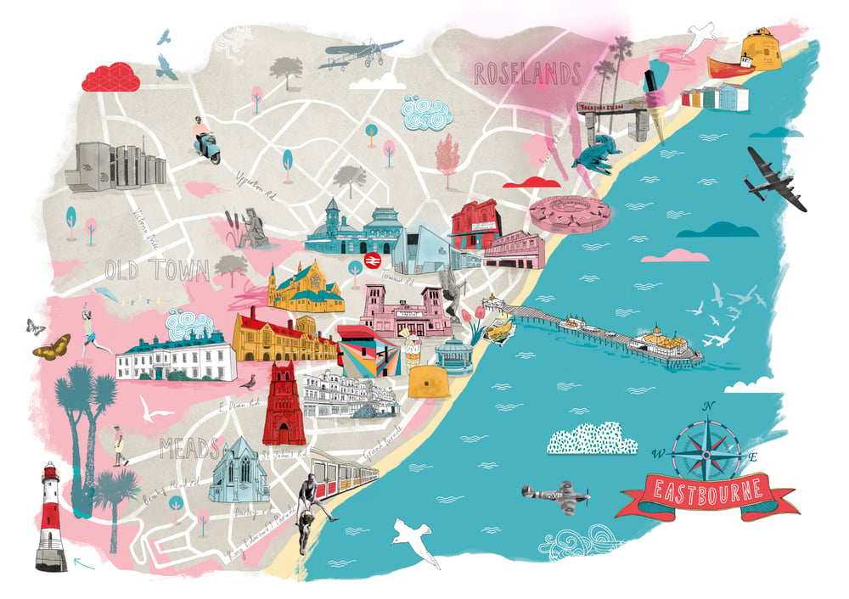(Source: tonwenjoneslikestodraw.bigcartel.com, 2024)

4.3 Hotel Overview
The Best Western York House Hotel, established in 1896, is a Victorian-era establishment boasting a stunning seafront location just 20 meters from Eastbourne Beach and a short walk from the town's pier and main attractions (York House Hotel, 2024). It offers 85-room accommodations, including deluxe rooms and family suites, all with modern amenities. The hotel features an indoor heated swimming pool, a sea-view terrace, and the Verandah Restaurant & Bar serving modern British cuisine.
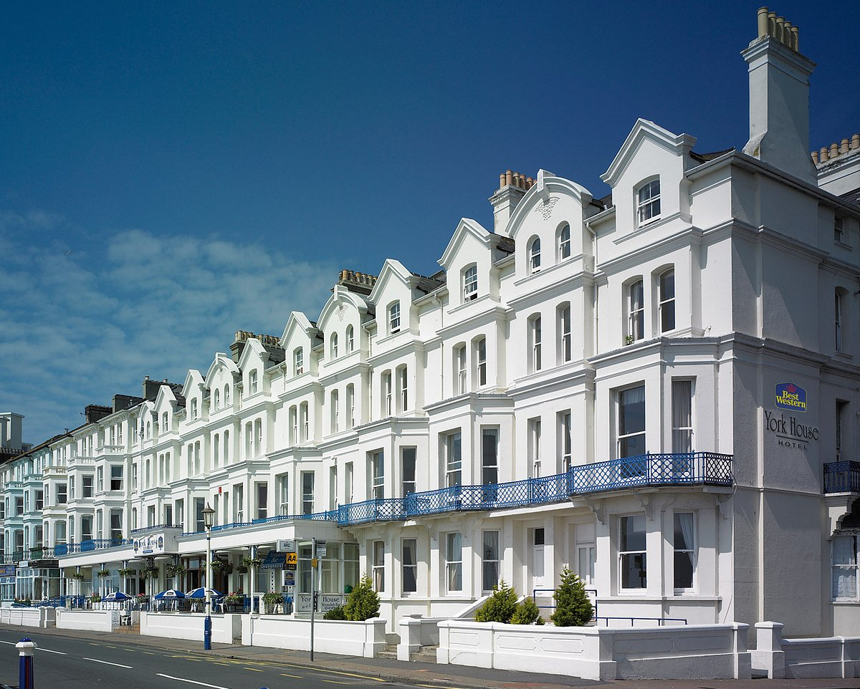(Source: TripAdvisor, 2024)
Under Vine Hotels' new management, the hotel aims to maintain its tradition of excellence in hospitality (Best Western, 2024).

4.4 Brand and Turnover
Best Western Hotels & Resorts is a well-known hotel brand, founded in 1946 by M.K. Guertin, that operates over 4,700 hotels and motels worldwide (Best Western, 2024). Today, Best Western is known for its diverse portfolio of hotel brands catering to many travellers, including economy, midscale, and upscale properties. The brand is recognised for its commitment to quality, value, and excellent customer service. The annual turnover of the York House Hotel is not publicly disclosed, but as part of the Best Western chain, it benefits from a significant global presence and strong brand recognition.

4.5 Staffing and Management
The hotel employs a dedicated team of 11-50 staff members (uk.linkedin.com, 2024) who cater to various aspects of hotel operations, including front desk, housekeeping, F&B services, and event management.
In 2023, the management of the Best Western York House Hotel in Eastbourne was taken over by Vine Hotels (Wentworth, 2022). Vine Hotels is a hospitality management company that manages a diverse portfolio of hotels and venues across the UK (Event Planner News, 2022). The company focuses on delivering high-quality guest experiences by combining strategic management with personalised service. Vine Hotels is renowned for revitalising properties and implementing sustainable practices to improve operational efficiency and customer satisfaction. This acquisition was part of Vine Hotels' strategic expansion following a competitive tender process and was one of the thirteen hotels in the company portfolio (Wentworth, 2022). The new management aims to enhance service quality and guest experience through innovative and customer-centric practices.

4.6 Analysis Tools
PESTLE and SWOT analyses are essential for assessing an organisation's environment and capabilities. The PESTLE analysis examines macro-environmental factors impacting an organisation, focusing on Political, Economic, Social, Technological, Environmental, and Legal factors (Reznowski, 2023). This analysis helps organisations understand external influences and prepare for potential opportunities and threats (Helms and Nixon, 2010). Alternatively, a SWOT analysis examines an entity's internal strengths and weaknesses, along with external opportunities and threats, highlighting areas for improvement (Siddiqui, 2021). By focusing on internal and external factors, organisations can develop strategies that leverage strengths and opportunities, address weaknesses, and mitigate threats (Ghazinoory, Abdi and Azadegan-Mehr, 2011). These analyses provide a comprehensive view of the factors affecting an organisation, facilitating informed decision-making and strategic planning.
  - SWOT Analysis
For Best Western York House Hotel, the SWOT analysis aligns to evaluate its market expansion strategies in the F&B sector.
Strengths: | Weaknesses:
Prime seafront location.  Strong brand affiliation with Best Western.  High customer satisfaction and positive reviews. | Limited parking availability.  Seasonal fluctuations in occupancy rates.  Some rooms require modern updates to meet contemporary guest expectations.
Opportunities: | Threats:
Expansion of F&B services to attract local clientele.  Leveraging digital marketing to enhance online presence.  Hosting events and partnerships with local businesses. | Competition from other local hotels and Airbnbs.  Economic recessions affecting travel and tourism.  Changing consumer preferences and expectations.
The prime seafront location of the hotel, which offers scenic views and proximity to Eastbourne's attractions (York House Hotel, 2024), and its strong brand affiliation with Best Western provide a solid foundation for attracting a diverse clientele. These strengths are critical in enhancing the hotel's market appeal and ensuring consistent guest experiences, which are vital for successful marketing campaigns (Helms and Nixon, 2010), so the opportunity to expand F&B services to attract local customers and increase revenue streams is significant. Additionally, leveraging digital marketing can enhance the hotel's online visibility, driving direct bookings and improving occupancy rates (Bathia, 2021).
Despite these strengths, the hotel faces challenges such as limited parking facilities and the need for modern updates in some rooms, which could detract from the overall guest experience (Alrawadieh and Law, 2019). Furthermore, the competitive landscape poses a threat, with numerous local hotels and alternative accommodations like Airbnb offering varied pricing and unique experiences that can attract potential guests. Economic downturns and changing travel trends also pose significant threats, potentially reducing tourism inflows and affecting the hotel's revenue (Khan et al., 2020).

4.7.1 Impact on Strategic Marketing Initiatives

Combining the hotel's strengths and opportunities can significantly impact its strategic marketing initiatives. For instance, the prime location and strong brand can be highlighted in marketing campaigns to attract domestic and international travellers. The expansion of F&B services can be marketed to Eastbourne's residents, creating a new revenue stream and enhancing community engagement. However, addressing weaknesses such as limited parking and room updates is crucial to maintaining these strengths. Additionally, strategic initiatives must consider competitive threats and economic fluctuations (Olsen, 2004) to develop resilient marketing strategies that adapt to changing market conditions (Chepkwei, 2021).

4.8 PESTLE Analysis

PESTLE analysis is essential for understanding the external environment in which Best Western York House Hotel operates and aligns with the aim of strategising market expansion.

4.8.1 Political Factors
The political environment in the UK is relatively stable (Lelii, 2022), which positively influences the hospitality industry by providing a secure operating environment (GOV.UK, 2021). Government policies promoting tourism and regulations ensuring health and safety standards (Hse.gov.uk, 2019) are crucial in sustaining high service quality and operational consistency. These factors enable the Best Western York House Hotel to maintain a reliable and attractive tourist destination.

4.8.2 Economic Factors
Fluctuations in disposable income significantly affect demand for F&B products (Aguiar and Hurst, 2005). As incomes rise, consumers spend more on dining out, boosting revenues for restaurants and hotels, including Best Western York House Hotel, which can attract more customers. Rising labour costs, driven by higher minimum wages and increased worker demand (Draca, Machin and Van Reenen, 2011), squeeze profit margins due to higher operating costs, necessitating price adjustments or efficiency improvements. Inflation raises costs for ingredients and utilities (PricewaterhouseCoopers, 2024), increasing operational expenses and requiring strategic pricing to maintain competitiveness and profitability (Thompson, 1984). Understanding these economic factors is crucial for developing effective strategic marketing initiatives. The York House Hotel can leverage increased consumer spending power by offering premium dining experiences and promoting these through targeted marketing campaigns. Addressing the challenge of rising labour costs might involve investing in staff training to improve service efficiency (CIPD, 2019) and justify higher menu prices. Lastly, staying agile in pricing strategies to account for inflation and its impact on costs and consumer spending will be essential for maintaining profitability (Thompson, 1984).

4.8.3 Social Factors
Cultural trends, demographic shifts, lifestyle changes, and social attitudes are social factors that affect consumer behaviour (Braveman, Egerter and Williams, 2011) and corporate operations. These factors determine consumer tastes and needs, affecting how food and beverage companies must change to meet changing expectations and stay competitive. Consumers, particularly younger generations, are adopting vegetarian, vegan, and pescetarian diets as lifestyle choices, driven by greater awareness of the relationship between diet and health (Hargreaves et al., 2021). The increasing demand for organic, natural, and healthier food options requires the Best Western York House Hotel to adapt its menu to include such choices to stay competitive.
Busy lifestyles increase demand for convenience foods and delivery services (Shinde, 2023). The Best Western York House Hotel can expand the market with takeout and delivery options to accommodate time-constrained customers.

4.8.4 Technological Factors
Recent shifts from traditional to digital marketing have redefined marketing (Vitsentzatou, Tsoulfas and Mihiotis, 2022). Many companies, regardless of industry, have employed social media marketing, digital advertising, and e-word of mouth to compete. Since experience is the value proposition, the intangible and ephemeral F&B business needs to identify itself during this unprecedented conversion from traditional to digital marketing to meet customer demands in a multichannel environment.
Social media significantly impacts food trends, with viral products and influencer recommendations shaping consumer preferences (Rini et al., 2023). The Best Western York House Hotel should utilise social media to market its offerings and engage with a broader audience.

4.8.5 Legal Factors
Consumer safety and high-quality service depend on food and beverage (F&B) health and safety standards. Food enterprises in the UK must follow strict food hygiene and safety requirements set by the Food Standards Agency (FSA). Companies must use HACCP (Hazard Analysis and Critical Control Points)-based food safety management systems to identify and control food production hazards (Food Standards Agency, 2020). Local authorities examine premises, food processing, and storage to ensure legal compliance and public health. These standards safeguard customers from foodborne illnesses and ensure food is safe, appropriately labelled, and of expected quality (GOV.UK, 2012). Compliance with these regulations is essential to avoid legal issues and maintain a trustworthy reputation. For Best Western York House Hotel, adhering to legal standards ensures operational stability and protects the brand's integrity.

4.8.6 Environmental Factors
Climate change significantly impacts food production costs at the York House Hotel (Sovacool et al., 2021). Adhering to strict regulations and practices to minimise waste and emissions is essential (Chung et al., 2022). Organic farming and renewable energy sources can reduce the hotel's environmental footprint (Dalin and Rodríguez-Iturbe, 2016). Implementing strategies to reduce food waste and use eco-friendly packaging can support the hotel's green initiatives and appeal to environmentally conscious consumers (Alsaffar, 2015). Additionally, offering locally sourced and sustainable menu options can capitalise on the growing consumer trend towards ethical and sustainable food (Smith and Barling, 2014).

4.8.7 Impact on Strategic Marketing Initiatives
The macroenvironmental factors identified through PEST analysis significantly influence the strategic marketing initiatives at Best Western York House Hotel. Political stability and supportive tourism policies enable the hotel to plan long-term marketing strategies confidently (Aguinis et al., 2023). Economic conditions require adaptive marketing approaches to attract guests during economic highs and lows. Social trends offer opportunities to align marketing campaigns with current consumer preferences, such as promoting eco-friendly stays (Reddy, 2023). Technological advancements enhance digital marketing capabilities and guest engagement, leading to more personalised and efficient services (Vitsentzatou, Tsoulfas and Mihiotis, 2022). Lastly, compliance with legal standards ensures that the hotel's operations are sound and its reputation remains intact.

4.9 Competitor Analysis (Price vs Quality)

The local hotel market in Eastbourne includes competitors such as The View Hotel, The Cavendish Hotel, and Premier Inn. The Best Western York House Hotel offers good value for money, with competitive pricing and a strong emphasis on customer service and amenities.
Price vs. Quality Matrix:
- Best Western York House Hotel: offers a balance between moderate pricing (£60 - £110 per night) and quality. It features amenities like a seafront location, an indoor pool, and a restaurant. It is known for its historical charm and excellent customer service (Best Western, 2024).
- Premier Inn Eastbourne: typically priced between £50 - £90 per night, Premier Inn offers reliable and consistent quality, emphasising comfort and affordability. It is known for budget-conscious travellers looking for clean, no-frills accommodation (Premier Inn, 2024).
- The View Hotel: positioned in the higher price range (£100 - £150 per night), The View Hotel offers superior amenities, including modern rooms with sea views, a gym, and a high-quality restaurant. It targets customers seeking a premium experience with enhanced comfort and services (The View Hotel Eastbourne, 2024).
- The Cavendish Hotel: priced lower, between £40 - £70 per night, The Cavendish offers basic amenities with a focus on affordability. While it may lack some of the upscale features of its competitors, it remains a viable option for budget travellers (britanniahotels.com, 2024).
In terms of quality, The View Hotel offers superior amenities and services, followed by the Best Western York House Hotel, which balances historic charm with modern comforts. Premier Inn offers consistent, reliable quality, while The Cavendish provides the most basic amenities.
Regarding the price, The Cavendish Hotel is the most affordable, followed by Premier Inn. Best Western York House Hotel offers mid-range pricing, and The View Hotel is the most expensive, catering to those seeking a premium experience.
Overall, Best Western York House Hotel effectively differentiates itself between budget-friendly options like The Cavendish and Premier Inn and the premium offering of The View Hotel, appealing to a broad range of guests looking for both quality and value.

4.10 Netnography

Netnography, or online ethnography, involves analysing customer reviews and social media interactions to gain insights into consumer behaviour and preferences (Bartl, Kannan and Stockinger, 2016). Netnography is used in marketing and consumer research to analyse online behaviour and its effects on corporate strategies (Kaur et al., 2021).
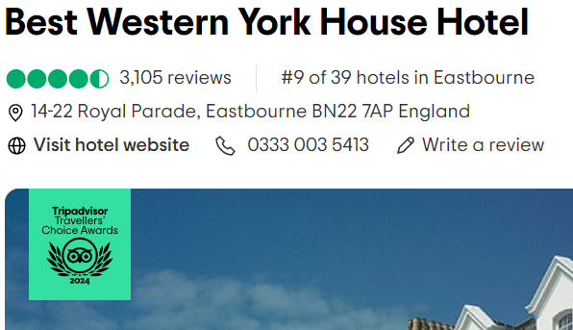 | 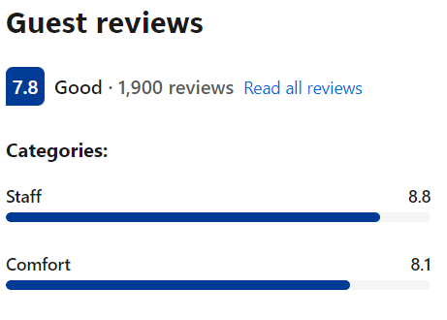
(Source: Tripadvisor, 2024) | (Source: Booking.com, 2024)

Best Western York House Hotel, Eastbourne, appears on the Tripadvisor platform as "Travellers' Choice Awards 2024". The hotel has 3105 reviews and is rated 4.5 out of 5 with the qualification "Excellent". Upon a brief analysis of the reviews, out of 3105 comments, 423 recommend the hotel as average, poor or terrible, meaning that 13.6% of the customers are not fully satisfied. Other 1900 reviews give Best Western York House Hotel on the BOOking.com online platform a rating of 7.8 out of 10, with the qualification "Good".
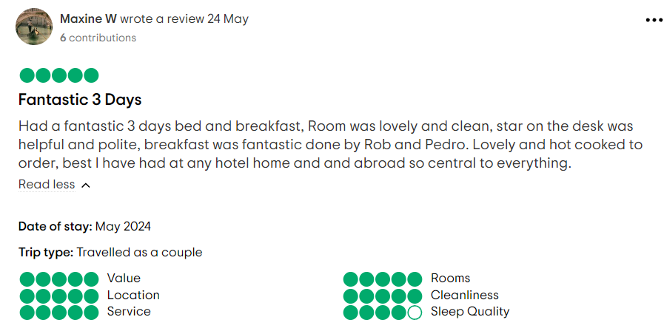 | 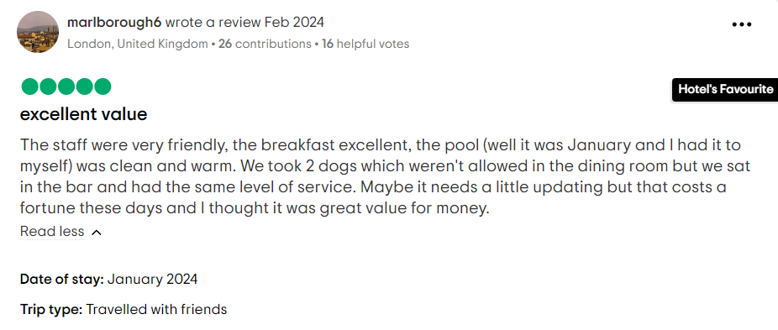
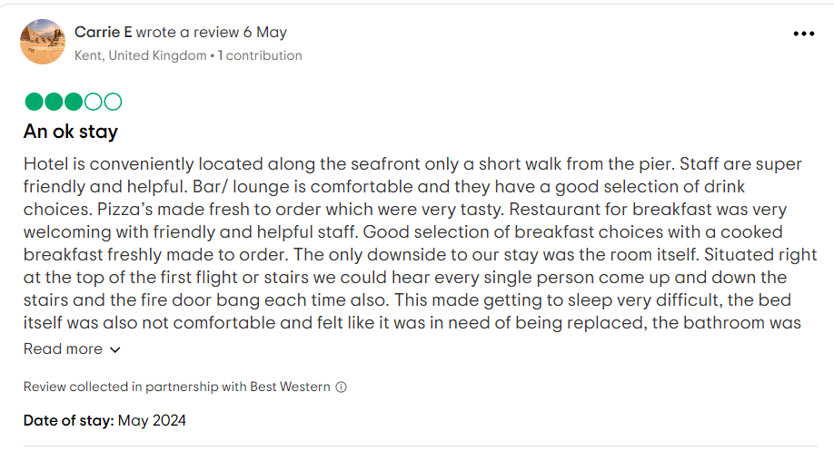 | 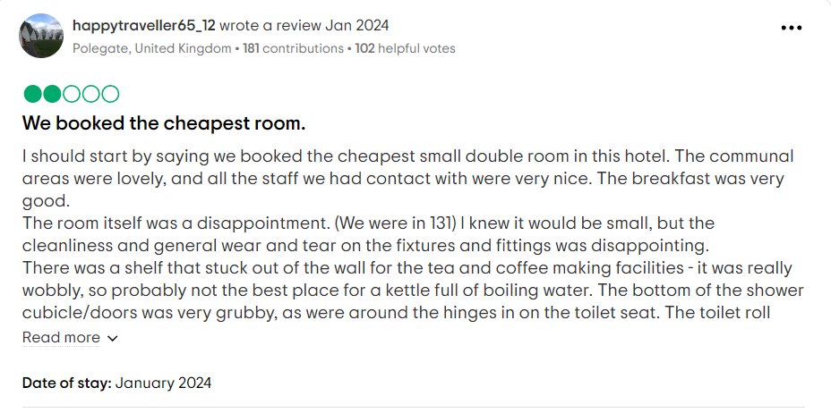
(Source: Tripadvisor, 2024)
Reviews on platforms like TripAdvisor reveal that guests appreciate the hotel's friendly staff, excellent breakfast, and prime location. However, there are occasional mentions of the need for room updates, noise at night, and other issues (TripAdvisor, 2024).

Key Features from Netnography:
·High ratings for staff friendliness and service quality.
·Positive feedback on breakfast and dining options.
·Noted areas for improvement include room maintenance and quality below expectations.

Theme/Findings

The hospitality industry continuously evolves, requiring businesses to adopt innovative strategies to remain competitive (Aladag et al., 2020). The Best Western York House Hotel in Eastbourne seeks to enhance its market position through strategic marketing initiatives in its food and beverage (F&B) sector.

5.1 Consumer Behaviour and Market Segmentation

Understanding consumer behaviour and effective market segmentation is crucial for tailoring marketing efforts and F&B offerings to meet the needs of specific customer segments (Okumus et al., 2017).
The hotel can enhance customer satisfaction and loyalty by identifying and targeting specific customer segments, such as families, business travellers, or food enthusiasts.

Suggested Improvements:

- Segmented Marketing: Develop targeted marketing campaigns for different customer segments, highlighting relevant F&B offerings.
- Customer Feedback: Use customer feedback to refine market segmentation and tailor F&B services accordingly.

5.2 Digital Marketing and Social Media Engagement

Digital marketing and social media engagement are critical in today's hospitality industry, as they significantly impact visibility and customer loyalty (Montero, Rubio and Álvarez, 2023). Effective digital marketing strategies involve creating engaging content, utilising social media platforms, and fostering online communities to attract and retain customers.
The hotel's primary target customers include families and seniors. Leveraging social media can enhance visibility to attract a younger, tech-savvy demographic. The hotel can create a robust online presence by regularly posting engaging content, such as behind-the-scenes looks at the kitchen, chef interviews, and user-generated content. This strategy can foster customer loyalty and increase bookings.

Suggested Improvements:

- Content Strategy: Develop a content calendar featuring diverse and engaging posts, including recipes, cooking tips, and guest testimonials.
- Influencer Collaborations: Partner with local influencers to reach a broader audience and enhance credibility.
- Social Media Campaigns: Create specific social media promotions to advertise special occasions, seasonal menus, and dining deals.

5.3 Experiential Dining and Culinary Innovation

Experiential dining involves creating unique and memorable dining experiences beyond just food (Kustos et al., 2021). This approach can differentiate a hotel from competitors and attract food enthusiasts (Williams, Yuan and Williams, 2018). Local produce and themed dining events enhance the dining experience (Xu et al., 2022). The hotel's Victorian atmosphere provides a unique backdrop for experiential dining. Hosting themed dining nights, featuring local produce, and offering cooking workshops can attract food enthusiasts and create a unique selling proposition.

Suggested Improvements:

- Themed Nights: Introduce Victorian-themed dinners or local cuisine nights to highlight the hotel's heritage.
- Cooking Workshops: Offer workshops led by the hotel's chefs, focusing on local ingredients and traditional recipes.
- Farm-to-Table: Emphasise farm-to-table dining experiences by sourcing ingredients from local farms and highlighting these partnerships on the menu.

5.4 Sustainability and Ethical Marketing

Sustainable practices in hospitality are increasingly important as consumers become more environmentally conscious. Sustainable strategies and adopting and marketing sustainable practices can benefit the hotel (Bux and Amicarelli, 2022). Highlighting commitments to sourcing locally, reducing waste, aligning with green rating systems (Awadh, 2017) and supporting local farmers can enhance the hotel's reputation and attract eco-conscious travellers.

Suggested Improvements:

- Sustainable Energy Sourcing: Adopt advanced technologies to tap into alternative energy sources like solar or wind power, thereby reducing the hotel's carbon footprint.
- Waste Reduction: Implement comprehensive waste reduction programs, including recycling and composting initiatives.
- Green Certifications: Pursue green certifications to validate the hotel's commitment to sustainability and use them in marketing efforts.

5.5 Technology-Driven Personalisation

Technology-driven personalisation enhances customer satisfaction by offering tailored experiences. Implementing mobile apps and digital tools can improve service efficiency and customer engagement (Munjal and Singh, 2021). Implementing a mobile app that allows guests to customise their dining experience, make reservations, and provide feedback can improve personalised dining experiences.

Suggested Improvements:

- Mobile App: Develop an app with features like customisable dining options, reservation management, and real-time feedback.
- Digital Menus: Introduce digital menus that allow guests to customise their orders based on dietary preferences and allergies.
- Guest Profiles: Create guest profiles to store preferences and personalise future dining experiences.

Overall, innovative strategic marketing initiatives in the F&B sector at Best Western York House Hotel can significantly enhance its market position and attract a diverse customer base. The hotel can improve customer satisfaction and loyalty by leveraging digital marketing, experiential dining, sustainability practices, technology-driven personalisation, and effective market segmentation. Implementing these strategies will require ongoing evaluation and adaptation to meet evolving consumer preferences and market trends.

  - Contributions

This project contributes to the academic and practical understanding of how strategic marketing initiatives can be implemented effectively in the hospitality industry's food and beverage (F&B) sector. It provides a detailed analysis of innovative marketing strategies supported by current academic research.
The project offers valuable insights into how the hotel can customise its marketing strategies and food and beverage options to cater to the distinct requirements of various customer segments by examining consumer behaviour and market segmentation.
The project offers a comprehensive framework for leveraging digital marketing and social media to enhance visibility and attract a broader demographic.
By emphasising experiential dining and culinary innovation, the project highlights how themed dining events, local produce, and cooking workshops can create unique selling propositions and attract food enthusiasts. Moreover, this project explores the applications of the technology and how to offer personalised dining experiences. It suggests implementing mobile apps, digital menus, and guest profiles to enhance customer satisfaction and differentiate the hotel from competitors.
The project underscores the importance of sustainability and ethical marketing practices in the F&B sector. It provides practical recommendations for sustainable sourcing, waste reduction, and green certifications, which can enhance the hotel's reputation and appeal to environmentally conscious guests.

Conclusions and Recommendations
The research project on innovative strategic marketing in the food and beverage (F&B) sector at Best Western York House Hotel, Eastbourne, has provided a comprehensive analysis of current practices and potential strategies for market expansion. Based on specialised literature, the study highlights the importance of various marketing initiatives, including digital marketing, experiential dining, sustainability practices, technology-driven personalisation, and effective market segmentation. These strategies have significant potential to enhance customer engagement, satisfaction, and loyalty, thereby driving the hotel's growth and competitive edge in the hospitality industry.
Digital marketing and social media engagement have proven practical tools for increasing visibility and fostering a sense of community among guests. The hotel's active presence on platforms like Facebook and Instagram and regular engaging content have helped attract and retain customers. However, there is room for further enhancement through collaboration with local influencers and targeted campaigns.
Experiential dining, focusing on local produce, has created unique and memorable guest experiences. This approach aligns with the "experience economy" concept and can potentially differentiate the hotel from its competitors. Expanding these themed events to include a broader range of culinary experiences could attract more food enthusiasts.
Sustainability practices are crucial in today's hospitality industry. While the hotel has made strides in sourcing local and organic ingredients, there is significant room for improvement in waste management and energy use practices. Implementing comprehensive waste reduction programs and investing in alternative energy sources can enhance the hotel's appeal to eco-conscious travellers.
Effective market segmentation and understanding consumer behaviour are vital for tailoring marketing efforts to specific customer groups. Developing more tailored marketing messages and personalised services for different segments can lead to higher customer satisfaction and loyalty.
Leveraging technology for personalised guest experiences can significantly enhance satisfaction and operational efficiency. Implementing a mobile app with customisable dining options, reservation management, and real-time feedback, along with using data analytics to understand guest preferences, can further differentiate the hotel from its competitors.
The following recommendations are proposed for Best Western York House Hotel to capitalise on the findings of this research:
- Improving Market Segmentation Strategies:
  - Develop targeted marketing campaigns for customers such as families, business travellers, and food enthusiasts.
  - Use customer feedback to refine market segmentation and tailor F&B services accordingly.
  - Implement loyalty programs that reward repeat customers and encourage more extended stays.
- Enhancing Digital Marketing and Social Media Engagement:
  - Develop a comprehensive content strategy with a content calendar featuring diverse posts, such as behind-the-scenes looks, guest testimonials, and interactive Q&A sessions with chefs.
  - Collaborate with local influencers to broaden reach and enhance credibility.
  - Run targeted social media campaigns to promote special events, seasonal menus, and dining offers.
- Expanding Experiential Dining Initiatives:
  - Introduce more frequent themed dining nights, such as Victorian-themed dinners or international cuisine nights, to highlight the hotel's heritage and culinary diversity.
  - Offer interactive cooking workshops led by the hotel's chefs, focusing on local ingredients and traditional recipes.
  - Emphasise farm-to-table dining experiences by sourcing ingredients from local farms and highlighting these partnerships on the menu.
- Strengthening Sustainability Practices:
  - Implement comprehensive waste reduction programs, including recycling and composting initiatives.
  - Invest in modern technologies to utilise alternative energy sources, such as solar or wind power, to reduce the hotel's carbon footprint.
  - Communicate sustainability initiatives clearly through marketing materials and social media to attract eco-conscious travellers.
- Leveraging Technology for Personalisation:
  - Develop a mobile app with features like customisable dining options, reservation management, and real-time feedback.
  - Introduce digital menus that allow guests to customise their orders based on dietary preferences and allergies.
  - Create guest profiles to store preferences and personalise future dining experiences.
- Continuous Innovation and Adaptation:
  - Regularly evaluate and adapt marketing strategies to stay ahead in the highly competitive hospitality industry.
  - Embrace new technologies and trends to improve guest experiences and operational efficiency continuously.
  - Foster a culture of innovation within the hotel staff, encouraging them to contribute ideas for enhancing services and marketing efforts.

By implementing these recommendations, Best Western York House Hotel can enhance its market position, improve customer satisfaction, and achieve sustainable growth. The insights gained from this research project provide a roadmap for leveraging innovative strategic marketing initiatives to drive the hotel's success in the dynamic and competitive hospitality market.

Reflective Writing on Placement Experience at Best Western York House Hotel

The ERA framework, encompassing Experience, Reflection, and Action, provides a structured approach to reflective writing. It helps individuals systematically analyse their experiences, reflect on their significance, and plan future actions based on these insights (Regmi and Naidoo, 2013).

8.1 Experience

During my placement at Best Western York House Hotel in Eastbourne, I observed and engaged in various aspects of hotel management, focusing mainly on the food and beverage (F&B) sector. This hands-on experience provided valuable insights into the day-to-day operations and strategic decision-making processes that underpin a successful hospitality business. One of the standout observations was the hotel's commitment to customer engagement and satisfaction. The staff consistently emphasised creating a welcoming and hospitable environment, tailoring their services to meet the specific needs of their guests, thus ensuring a personalised experience. This attention to detail is crucial in fostering customer loyalty and enhancing the hotel's reputation (Kotler and Keller, 2016).
Another significant observation was the hotel's digital marketing and social media engagement. The hotel actively utilised platforms such as Facebook and Instagram to promote their services and interact with guests, increasing their visibility and creating a sense of community among their customers (Leung et al., 2013). Additionally, I witnessed the impact of experiential dining on customer satisfaction. The hotel organised themed dining nights focusing on local produce, which was highly popular among guests. These events provided distinctive dining experiences, showcasing the region's culinary skills, thus differentiating the hotel from its competitors (Pine and Gilmore, 1999).
However, I noticed that the hotel's sustainability practices needed significant improvement. Although they sourced local and organic ingredients, there needed to be more in their waste management and energy use practices. The hotel had basic waste segregation but lacked comprehensive programs for reducing waste and investing in modern technologies for alternative energy sources. Han et al. (2010) emphasises that sustainable practices in F&B operations can appeal to environmentally conscious consumers and enhance a hotel's brand image. This gap presented a critical area for development to attract eco-conscious travellers and improve the hotel's sustainability credentials.
One of the challenges I observed during my placement was the need for effective market segmentation to target specific consumer groups. The hotel caters to guests, including families, seniors, and business travellers. Kotler and Keller (2016) highlight the importance of market segmentation in developing targeted marketing campaigns that resonate with distinct consumer groups. The hotel had implemented some segmentation strategies, such as offering family-friendly amenities and business services, but there was still room for improvement. For example, developing more tailored marketing messages and personalised services for each segment could enhance customer satisfaction and loyalty.
Technology-driven personalisation was another area where the hotel could improve. While the hotel had implemented technological advancements, such as online booking and digital menus, there were opportunities to leverage technology further to enhance the guest experience. Buhalis and Amarangana (2015) suggest that using data analytics to understand customer preferences and offer customised services can significantly enhance customer satisfaction. Implementing a mobile app that allows guests to customise their dining experience, make reservations, and provide feedback could further differentiate the hotel from its competitors and improve operational efficiency.

8.2 Reflection

Reflecting on my placement experience, I realised the critical role of customer engagement and satisfaction in the hospitality industry. Observing the staff's dedication to providing personalised services reinforced my understanding of how essential it is to exceed guest expectations to build loyalty and enhance reputation (Kotler and Keller, 2016). The hotel's strategic use of digital marketing and social media platforms illustrated the power of these tools in modern marketing. Engaging content and direct interaction with guests increased visibility and fostered a sense of community, which is vital for customer retention (Leung et al., 2013; Alalwan et al., 2017).
Although limited to local produce, the themed dining nights were particularly eye-opening. They demonstrated how experiential dining can create unique and memorable experiences that attract and retain customers. This approach aligns with the "experience economy" concept, where businesses generate value through distinctive experiences (Pine and Gilmore, 1999). However, expanding these themes to include a broader range of dining experiences could further enhance guest satisfaction and differentiation.
The observation of inadequate sustainability practices highlighted the need for improvement in this critical area. While the hotel sourced local and organic ingredients, it lacked comprehensive waste management programs and investments in alternative energy sources. Han et al. (2010) emphasise that effective sustainability practices attract eco-conscious travellers and enhance the overall brand image. This gap reinforced the importance of adopting more robust sustainability measures to meet modern consumer expectations.

8.3 Action

Based on my reflections, I propose several actions to enhance the hotel's marketing strategies and overall guest experience. Firstly, developing a more comprehensive content strategy for social media is crucial. This strategy should include a content calendar featuring diverse and engaging posts, such as behind-the-scenes looks, guest testimonials, and interactive Q&A sessions with chefs. Collaborating with local influencers can further broaden the hotel's reach and enhance credibility (Alalwan et al., 2017).
Secondly, enhancing experiential dining through more frequent themed nights and expanding the themes beyond local produce can attract food enthusiasts and create a unique selling proposition. Emphasising farm-to-table dining experiences by sourcing ingredients from local farms and highlighting these partnerships on the menu can further differentiate the hotel (Pine and Gilmore, 1999).
Thirdly, improving sustainability practices is essential. The hotel should implement comprehensive waste reduction programs, including recycling and composting initiatives. Investing in modern technologies to utilise alternative energy sources, such as solar or wind power, can significantly reduce the hotel's carbon footprint and appeal to eco-conscious travellers (Han et al., 2010).
Finally, leveraging technology for personalised guest experiences is crucial. Developing a mobile app with features like customisable dining options, reservation management, and real-time feedback can significantly enhance customer satisfaction. Using data analytics to understand customer preferences and offering personalised services can further differentiate the hotel and improve operational efficiency (Buhalis and Amarangana, 2015).
In conclusion, my placement at Best Western York House Hotel provided invaluable insights into the complexities of hotel management and the importance of innovative marketing strategies. The hotel can enhance its market position and achieve sustainable growth by focusing on customer engagement, digital marketing, experiential dining, sustainability, and personalisation. The knowledge and skills I gained during this placement will undoubtedly inform my future career in hospitality management, enabling me to contribute effectively to the success of any organisation I join.
Word count: 7347

References:
Awadh, O. (2017). Sustainability and green building rating systems: LEED, BREEAM, GSAS and Estidama critical analysis. Journal of Building Engineering, 11, pp.25–29. doi: https://doi.org/10.1016/j.jobe.2017.03.010 [Accessed 3 May 2024];
Aguiar, M. and Hurst, E. (2005). Consumption versus Expenditure. Journal of Political Economy, 113(5), pp.919–948. doi: https://doi.org/10.1086/491590 [Accessed 20 May 2024];

AHAMAT, A., SHAHKAT ALI, M.S., AZAMI, M.A. and Prasad, N.V. (2022). Innovation Marketing from the Perspective of New Technologies in the Food and Beverage Industry. Journal of Marketing Research and Case Studies, pp.1–14. doi: https://doi.org/10.5171/2022.492387 [Accessed 6 May 2024];

Aladag, O.F., Köseoglu, M.A., King, B. and Mehraliyev, F. (2020). Strategy implementation research in hospitality and tourism: Current status and future potential. International Journal of Hospitality Management, 88(3), p.102556. doi: https://doi.org/10.1016/j.ijhm.2020.102556 [Accessed 24 May 2024];

Alalwan, A.A., Rana, N.P., Dwivedi, Y.K. and Algharabat, R. (2017). Social Media in marketing: a Review and Analysis of the Existing Literature. Telematics and Informatics, [online] 34(7), pp.1177–1190. doi: https://doi.org/10.1016/j.tele.2017.05.008 [Accessed 5 May 2024];

Alrawadieh, Z. and Law, R. (2019). Determinants of hotel guests’ satisfaction from the perspective of online hotel reviewers. International Journal of Culture, Tourism and Hospitality Research, 13(1), pp.84–97. doi: https://doi.org/10.1108/ijcthr-08-2018-0104 [Accessed 18 May 2024];

Anne-Mette Hjalager, and Richards, G. (2003). Tourism and Gastronomy. Routledge;

Aguinis, H., Kraus, S., Poček, J., Meyer, N. and Jensen, S.H. (2023). The why, how, and what of public policy implications of tourism and hospitality research. Tourism Management, 97, p.104720. doi: https://doi.org/10.1016/j.tourman.2023.104720 [Accessed 22 May 2024];

Bartl, M., Kannan, V.K. and Stockinger, H. (2016). A review and analysis of literature on netnography research. International Journal of Technology Marketing, 11(2), p.165. doi: https://doi.org/10.1504/ijtmkt.2016.075687 [Accessed 23 May 2024];

Bathia, S. (2021). Social media marketing and web marketing in food and beverage industry. In J. Singla & K. Chaudhary (Eds.), Marketing 5.0: Putting up blocks together (pp. 51–55). National Press Associates;

Bayona-Saez, C., Cruz-Cázares, C., García-Marco, T. and Sánchez García, M. (2017). Open innovation in the food and beverage industry. Management Decision, 55(3), pp.526–546. doi: https://doi.org/10.1108/md-04-2016-0213 [Accessed 6 May 2024];

Braveman, P., Egerter, S. and Williams, D.R. (2011). The Social Determinants of Health: Coming of Age. Annual Review of Public Health, [online] 32(1), pp.381–398. doi: https://doi.org/10.1146/annurev-publhealth-031210-101218 [Accessed 21 May 2024];

Buhalis, D. and Amaranggana, A. (2015). Smart Tourism Destinations Enhancing Tourism Experience Through Personalisation of Services. Information and Communication Technologies in Tourism 2015, pp.377–389. doi: https://doi.org/10.1007/978-3-319-14343-9_28 [Accessed 6 May 2024];

Bux, C. and Amicarelli, V. (2022). Circular economy and sustainable strategies in the hospitality industry: Current trends and empirical implications. Tourism and Hospitality Research, p.146735842211195. doi: https://doi.org/10.1177/14673584221119581 [Accessed 25 May 2024];

Calisto, M. de L., Umbelino, J., Gonçalves, A. and Viegas, C. (2021). Environmental Sustainability Strategies for Smaller Companies in the Hotel Industry: Doing the Right Thing or Doing Things Right? Sustainability, [online] 13(18), p.10380. doi: https://doi.org/10.3390/su131810380 [Accessed 26 May 2024];

CIPD (2019). The Case for a Broader Training Levy ADDRESSING EMPLOYER UNDERINVESTMENT IN TRAINING. [online] Available at: https://www.cipd.org/globalassets/media/comms/news/addressing-employer-underinvestment-in-training_tcm18-61265.pdf [Accessed 20 May 2024];

Chepkwei, A. (2021). STRATEGY IMPLEMENTATION IN HOSPITALITY INDUSTRY: GLOBAL PERSPECTIVE. Journal of Strategic Management, [online] 6(1), pp.33–45. doi: https://doi.org/10.47672/jsm.687 [Accessed 19 May 2024];

Chung, M.M.S., Bao, Y., Zhang, B.Y., Le, T.M. and Huang, J.-Y. (2022). Life Cycle Assessment on Environmental Sustainability of Food Processing. Annual Review of Food Science and Technology, 13(1), pp.217–237. doi: https://doi.org/10.1146/annurev-food-062420-014630 [Accessed 22 May 2024];

Coombs, H.V. (2022). Case Study Research Defined. [online] Utah Journal of Communication. Available at: https://ujoc.org/case-study-research-defined [Accessed 7 May 2024];

Dalin, C. and Rodríguez-Iturbe, I. (2016). Environmental impacts of food trade via resource use and greenhouse gas emissions. Environmental Research Letters, [online] 11(3), p.035012. doi: https://doi.org/10.1088/1748-9326/11/3/035012 [Accessed 22 May 2024];

Dimitrios Buhalis (2003). ETourism : information technology for strategic tourism management. Harlow, England: Financial Times Prentice Hall;

Dolnicar, S. (2007). (PDF) Market Segmentation in Tourism. [online] ResearchGate. Available at: https://www.researchgate.net/publication/30387969_Market_Segmentation_in_Tourism [Accessed 6 May 2024];

Draca, M., Machin, S. and Van Reenen, J. (2011). Minimum Wages and Firm Profitability. American Economic Journal: Applied Economics, 3(1), pp.129–151. doi: https://doi.org/10.1257/app.3.1.129 [Accessed 20 May 2024];‌

draw, T.J. likes to (2024). Map of Eastbourne. [online] Tonwen Jones likes to draw. Available at: https://tonwenjoneslikestodraw.bigcartel.com/product/illustrated-map-of-eastbourne [Accessed 23 May 2024];

Eisenhardt, K.M. (1989). Building Theories from Case Study Research. The Academy of Management Review, [online] 14(4), pp.532–550. doi: https://doi.org/10.2307/258557 [Accessed 8 May 2024];

Flyvbjerg, B. (2006). Five Misunderstandings about case-study Research. Qualitative Inquiry, [online] 12(2), pp.219–245. doi: https://doi.org/10.1177/1077800405284363 [Accessed 8 May 2024];

Food Standards Agency (2020). Managing Food Safety. [online] Food Standards Agency. Available at: https://www.food.gov.uk/business-guidance/managing-food-safety [Accessed 22 May 2024];

Ghazinoory, S., Abdi, M. and Azadegan-Mehr, M. (2011). SWOT Methodology: a state-of-the-art Review for the past, a Framework for the Future. Journal of Business Economics and Management, 12(1), pp.24–48;

GOV.UK (2012). Food Safety - Your Responsibilities. [online] GOV.UK. Available at: https://www.gov.uk/food-safety-your-responsibilities [Accessed 22 May 2024];

GOV.UK (2021). The Tourism Recovery Plan. [online] Available at: https://assets.publishing.service.gov.uk/media/60c239a8e90e074397d8c8b0/Tourism_Recovery_Plan__Web_Accessible_.pdf [Accessed 20 May 2024];

Great Days Out UK. (2024). Days Out in Eastbourne. [online] Available at: https://www.great-days-out.co.uk/south-east-england/east-sussex/eastbourne/ [Accessed 23 April 2024];

Han, H., Hsu, L.-T. and Sheu, C. (2010). Application of the Theory of Planned Behavior to green hotel choice: Testing the effect of environmental friendly activities. Tourism Management, 31(3), pp.325–334. doi: https://doi.org/10.1016/j.tourman.2009.03.013 [Accessed 5 May 2024];

Hargreaves, S.M., Raposo, A., Saraiva, A. and Zandonadi, R.P. (2021). Vegetarian Diet: An Overview through the Perspective of Quality of Life Domains. International Journal of Environmental Research and Public Health, [online] 18(8), p.4067. doi: https://doi.org/10.3390/ijerph18084067 [Accessed 21 May 2024];

Helms, M.M. and Nixon, J. (2010). Exploring SWOT analysis – where are we now? Journal of Strategy and Management, 3(3), pp.215–251. doi: https://doi.org/10.1108/17554251011064837 [Accessed 6 May 2024];

Hse.gov.uk. (2019). Health and safety in catering and hospitality. [online] Available at: https://www.hse.gov.uk/catering/index.htm [Accessed 20 May 2024];

Hussain, I., Mu, S., Mohiuddin, M., Danish, R.Q. and Sair, S.A. (2020). Effects of Sustainable Brand Equity and Marketing Innovation on Market Performance in Hospitality Industry: Mediating Effects of Sustainable Competitive Advantage. Sustainability, [online] 12(7), p.2939. doi: https://doi.org/10.3390/su12072939 [Accessed 6 May 2024];

KANAAN, K., Abuhjeeleh, M., Darabseh, F.M., Taha, O. and Nader Mohammad Aljawarneh (2023). How digital marketing and innovative performance contribute to hotel restaurant revenue growth: The mediating role of knowledge sharing. Cogent Social Sciences, 9(1). doi: https://doi.org/10.1080/23311886.2023.2209985 [Accessed 6 May 2024];

Kaur, I., Gaur, D., Kumar, A. and Alatawi, F.M.H. (2021). Netnography. International Journal of Electronic Government Research, 17(4), pp.63–83. doi: https://doi.org/10.4018/ijegr.2021100104 [Accessed 23 May 2024];

Khan, K., Su, C.-W., Xiao, Y.-D., Zhu, H. and Zhang, X. (2020). Trends in tourism under economic uncertainty. Tourism Economics, 27(4), pp.841–858. doi: https://doi.org/10.1177/1354816620909608 [Accessed 18 May 2024];

Kotler, P. and Keller, K.L. (2016). Marketing management. 15th ed. Pearson;

Kustos, M., Goodman, S., Jeffery, D.W. and Bastian, S.E.P. (2021). Appropriate food and wine pairings and wine provenance information: potential tools for developing memorable dining experiences. Food Quality and Preference, p.104297. doi: https://doi.org/10.1016/j.foodqual.2021.104297 [Accessed 24 May 2024];

Lelii, M. (2022). Trust in government, UK - Office for National Statistics. [online] www.ons.gov.uk. Available at: https://www.ons.gov.uk/peoplepopulationandcommunity/wellbeing/bulletins/trustingovernmentuk/2022 [Accessed 19 May 2024];

Leung, D., Law, R., van Hoof, H. and Buhalis, D. (2013). Social Media in Tourism and Hospitality: a Literature Review. Journal of Travel & Tourism Marketing, [online] 30(1-2), pp.3–22. doi: https://doi.org/10.1080/10548408.2013.750919 [Accessed 5 May 2024];‌

Martindale, W. (2014). Using consumer surveys to determine food sustainability. British Food Journal, 116(7), pp.1194–1204. doi: https://doi.org/10.1108/bfj-09-2013-0242 [Accessed 5 May 2024];

Melia, D. (2011). Trends in the Food and Beverage Sector of the Hospitality Industry. Conference papers. [online] doi: https://doi.org/10.21427/D7445Q [Accessed 26 May 2024];

Michopoulou, E. and Moisa, D.G. (2019). Hotel social media metrics: The ROI dilemma. International Journal of Hospitality Management, 76, pp.308–315. doi: https://doi.org/10.1016/j.ijhm.2018.05.019 [Accessed 27 May 2024];
Montero, R.A., Sellers Rubio, R. and Cely Álvarez, A. (2023). Inbound marketing in the hospitality industry: A systematic review of the last 12 years. rua.ua.es. [online] doi: https://doi.org/10.33776/et.v13i1.7291 [Accessed 24 May 2024];

Morgan, N.A., Whitler, K.A., Feng, H. and Chari, S. (2019). Research in marketing strategy. Journal of the Academy of Marketing Science, 47(1), pp.4–29. doi: https://doi.org/10.1007/s11747-018-0598-1 [Accessed 27 May 2024];

Mun, S.G., Park, E.O. and Woo, L. (2022). Strategic target customers of food and beverage offerings in full-service hotels: Outside-hotel customers. International Journal of Hospitality Management, 102, p.103159. doi: https://doi.org/10.1016/j.ijhm.2022.103159 [Accessed 20 May 2024];

Munjal, S. and Singh, A. (2021). Going digital is the only way forward for the Indian hospitality and tourism industry. Worldwide Hospitality and Tourism Themes, ahead-of-print(ahead-of-print). doi: https://doi.org/10.1108/whatt-09-2020-0119 [Accessed 26 May 2024];

None Claudine Sykimte (2023). Feasting on Profit: Exploring the Interplay of Culinary Trends and Hotel Restaurant Revenue. International Journal of Advanced Research in Science, Communication and Technology, pp.666–671. doi: https://doi.org/10.48175/ijarsct-12352 [Accessed 7 May 2024];

Okumus, F., Köseoglu, M.A., Morvillo, A. and Altin, M. (2017). Scientific progress on strategic management in hospitality and tourism: a state-of-the-art. Tourism Review, 72(3), pp.261–273. doi: https://doi.org/10.1108/tr-03-2017-004 [Accessed 24 May 2024];

Olsen, M.D. (2004). Literature in strategic management in the hospitality industry. International Journal of Hospitality Management, [online] 23(5), pp.411–424. doi: https://doi.org/10.1016/j.ijhm.2004.10.003 [Accessed 17 May 2024];

Pine, B.J. and Gilmore, J.H. (1999). The Experience Economy : Work Is Theatre & Every Business a Stage. Boston: Harvard Business School Press;‌

Premier Inn. (2024). Eastbourne Town Centre Hotel | Premier Inn. [online] Available at: https://www.premierinn.com/gb/en/hotels/england/east-sussex/eastbourne/eastbourne-town-centre.html?cid=KNC_Brn [Accessed 23 May 2024];

PricewaterhouseCoopers (2024). Sharp rise in labour costs and slowing demand put spotlight on cost control and profitability margins for UK hotels in 2024. [online] PwC. Available at: https://www.pwc.co.uk/industries/hospitality-leisure/insights/labour-costs-sharp-rise-slowing-demand-spotlight-cost-control-profitability-margins-hotels-2024.html [Accessed 20 May 2024];

Reddy, K.Pradeep. (2023). Consumers perception on green marketing towards eco-friendly fast moving consumer goods. International journal of engineering business management, 15(15). doi: https://doi.org/10.1177/18479790231170962 [Accessed 22 May 2024];

Regmi, K. and Naidoo, J. (2013). Understanding the processes of writing papers reflectively. Nurse Researcher, 20(6), pp.33–39. doi: https://doi.org/10.7748/nr2013.07.20.6.33.e320 [Accessed 27 May 2024];

Reznowski, G. (2023). LibGuides: Industry Research: PESTEL Analysis. [online] libguides.libraries.wsu.edu. Available at: https://libguides.libraries.wsu.edu/c.php?g=294263&p=4358409#:~:text=It%20examines%20the%20Political%2C%20Economic [Accessed 6 May 2024];

Ribaudo, G., Moccia, S., Orero-Blat, M. and Palacios-Marqués, D. (2020). Comparing chains versus independent hotels based on international sales: an exploratory study. Economic Research-Ekonomska Istraživanja, 33(1), pp.2286–2304. doi: https://doi.org/10.1080/1331677x.2019.1710719 [Accessed 27 May 2024];

Richard, B. (2017). Hotel chains: survival strategies for a dynamic future. Journal of Tourism Futures, 3(1), pp.56–65. doi: https://doi.org/10.1108/jtf-06-2016-0018 [Accessed 26 May 2024];

Rini, L., Schouteten, J.J., Faber, I., Bom Frøst, M., J A Perez-Cueto, F. and De Steur, H. (2023). Social media and food consumer behavior: A systematic review. Trends in Food Science & Technology, [online] 143, p.104290. doi: https://doi.org/10.1016/j.tifs.2023.104290 [Accessed 22 May 2024];

Shinde, S. (2023). Ready-to-Eat Food Market Surges as Convenience and Busy Lifestyles Drive Demand. [online] www.linkedin.com. Available at: https://www.linkedin.com/pulse/ready-to-eat-food-market-surges-convenience-busy-drive-suyog-shinde-/ [Accessed 21 May 2024];

Siddiqui, A. (2021). ‘SWOT Analysis (or SWOT Matrix) Tool as a Strategic Planning and Management Technique in the Health Care Industry and Its Advantages’. Biomedical Journal of Scientific & Technical Research, 40(2). doi: https://doi.org/10.26717/bjstr.2021.40.006419 [Accessed 8 May 2024];

Smith, J. and Barling, D. (2014). Social impacts and life cycle assessment: proposals for methodological development for SMEs in the European food and drink sector. The International Journal of Life Cycle Assessment, 19(4), pp.944–949. doi: https://doi.org/10.1007/s11367-013-0691-0 [Accessed 22 May 2024];

Solomon, M.R. (2017). Consumer behavior: buying, having, and being. 12th ed. Harlow, England: Pearson;

Sovacool, B.K., Bazilian, M., Griffiths, S., Kim, J., Foley, A. and Rooney, D. (2021). Decarbonizing the food and beverages industry: A critical and systematic review of developments, sociotechnical systems and policy options. Renewable and Sustainable Energy Reviews, [online] 143(143), p.110856. doi: https://doi.org/10.1016/j.rser.2021.110856 [Accessed 22 May 2024];

Stake, R.E. (1995). The art of case study research. London: Sage Publications;

The Argus. (2021). Seafront hotel with swimming pool up for sale (it could be yours for £5 million). [online] Available at: https://www.theargus.co.uk/news/19309546.best-western-york-house-hotel-eastbourne-sale/ [Accessed 25 April 2024];

The View Hotel Eastbourne. (2024). Seaside Hotel in Eastbourne | The View Hotel | Book Direct & Save. [online] Available at: https://www.theviewhoteleastbourne.com/ [Accessed 23 May 2024];

Thompson, A. (1984). Strategies for Staying Cost Competitive. [online] Harvard Business Review. Available at: https://hbr.org/1984/01/strategies-for-staying-cost-competitive [Accessed 20 May 2024];

Tripadvisor. (2024). BEST WESTERN YORK HOUSE HOTEL - Updated 2024 Reviews, Photos & Prices. [online] Available at: https://www.tripadvisor.co.uk/Hotel_Review-g190722-d193467-Reviews-Best_Western_York_House_Hotel-Eastbourne_East_Sussex_England.html [Accessed 23 May 2024];

uk.linkedin.com. (2024). BW York House Hotel - Eastbourne | LinkedIn. [online] Available at: https://www.linkedin.com/company/bwyorkhousehotel?originalSubdomain=uk [Accessed 15 May 2024];

Vitsentzatou, E., Tsoulfas, G.T. and Mihiotis, A.N. (2022). The Digital Transformation of the Marketing Mix in the Food and Beverage Service Supply Chain: A Grey DEMATEL Approach. Sustainability, [online] 14(22), p.15228. doi: https://doi.org/10.3390/su142215228 [Accessed 22 may 2024];

Wedel, M. and Wagner Antonio Kamakura (2000). Market segmentation : conceptual and methodological foundations. Boston, Mass. Kluwer Acad. Publ;

Wentworth, I., 2022. Eastbourne hotel management changes following 'multi-stage competitive tender'. Sussex Express, 21 September. Available at: https://www.sussexexpress.co.uk/business/eastbourne-hotel-management-changes-following-multi-stage-competitive-tender-3851592 [Accessed 16 May 2024];

Williams, H.A., Yuan, J. (Jessica) and Williams, R.L. (2018). Attributes of Memorable Gastro-Tourists’ Experiences. Journal of Hospitality & Tourism Research, 43(3), pp.327–348. doi: https://doi.org/10.1177/1096348018804621 [Accessed 24 May 2024];

www.booking.com. (2024). Best Western York House Hotel, Eastbourne. [online] Available at: https://www.booking.com/hotel/gb/yorkhousehoteleastbourne.en-gb.html?label=gen173nr-1FCAEoggI46AdIM1gEaFCIAQGYAQm4ARfIAQzYAQHoAQH4AQuIAgGoAgO4At_vurIGwAIB0gIkNTI4YjhiNTAtNDIyYS00ZDU0LWEwNmEtZjZlZmYxMTUzOTVk2AIG4AIB&sid=694d5a1f759138ffd92e969dedad971f&aid=304142&ucfs=1&dest_id=-2595114&dest_type=city&group_adults=2&no_rooms=1&group_children=0&atlas_src=sr_iw_title [Accessed 15 May 2024];

www.britanniahotels.com. (2024). The Cavendish Hotel Eastbourne | Britannia Hotels. [online] Available at: https://www.britanniahotels.com/hotels/the-cavendish-hotel [Accessed 23 May 2024];

www.britannica.com. (2024). Eastbourne | district, England, United Kingdom | Britannica. [online] Available at: https://www.britannica.com/place/Eastbourne-district-England [Accessed 25 April 2024];

www.expedia.co.uk. (2024). Best Western York House Hotel. [online] Available at: https://www.expedia.co.uk/Eastbourne-Hotels-Best-Western-York-House-Hotel.h17401.Hotel-Information?chkin=2024-05-23&chkout=2024-05-27&x_pwa=1&rfrr=HSR&pwa_ts=1716434157917&referrerUrl=aHR0cHM6Ly93d3cuZXhwZWRpYS5jby51ay9Ib3RlbC1TZWFyY2g%3D&useRewards=false&rm1=a2&regionId=4629&destination=Eastbourne%2C+England%2C+United+Kingdom&destType=MARKET&neighborhoodId=553248635939578821&selected=17401&latLong=50.767693%2C0.28924&sort=RECOMMENDED&top_dp=708&top_cur=GBP&userIntent=&selectedRoomType=314116344&selectedRatePlan=382416646&searchId=6486487f-83f3-4ff1-8788-bdf5cf264088&propertyName=Best+Western+York+House+Hotel [Accessed 13 May 2024];

www.tripadvisor.co.uk. (2024). Tourism Eastbourne East Sussex England Vacations. [online] Available at: https://www.tripadvisor.co.uk/Tourism-g190722-Eastbourne_East_Sussex_England-Vacations.html [Accessed 3 May 2024];

www.tripadvisor.co.uk. (2024). Best Western York House Hotel. [online] Available at: https://www.tripadvisor.co.uk/Hotel_Review-g190722-d193467-Reviews-Best_Western_York_House_Hotel-Eastbourne_East_Sussex_England.html [Accessed 3 May 2024];
www.visiteastbourne.com. (2024). Airbourne - Airshow. [online] Available at: https://www.visiteastbourne.com/airshow [Accessed 13 May 2024];
XU, Y.H., NG, Y.N.C., TAN, X. and WU, C.D. (2022). Likable or Authentic? Perspectives of Locals and Tourists in Food Event Experience. Event Management. doi: https://doi.org/10.3727/152599522x16419948391104 [Accessed 24 May 2024];

Yin, R.K. (2018). Case Study Research and Applications: Design and Methods. 6th ed. Thousand Oaks, California: Sage Publications;

York House Hotel. (2024). York House Hotel Eastbourne. [online] Available at: https://www.yorkhousehotel.co.uk/ [Accessed 25 April 2024];

