BMIH6007
International Meetings Management for the Hotel Industry
Event Strategic Planning and Delivery Considerations for an International Meeting
[Word Count: 2500]
Lecture name: Chris Wilkin
Student Name: Ioana Mirela Bumbu
Student ID: 2227453
Topic: Protest on Breaking Barriers: Empowering Women Leaders in the Hospitality Industry

Acknowledgement
I certify that the work I sent in for this assignment is entirely original. Credit has been given when my work has been supported by the efforts of others. Every source I utilised for this work has been found, recognised, and cited using the Harvard referencing style. I have reviewed the assignment brief's parts on plagiarism, collusion, and artificial intelligence, and I am aware of the negative effects of plagiarism.
Table of Contents
1 Introduction 5
2 The Event Cycle 7
2.1 Planning the Protest 7
2.2 Organising the Protest 8
2.3 Measuring Protest Success 8
2.4 Analysing the Outcomes 8
2.5 Sharing the Impact 9
3 Protest Concept 9
4 Key Stages of EMBOK Model 11
4.1 Initiation 11
4.2 Planning 11
4.3 Implementation 12
4.4 The Event 12
4.5 Closure 12
5 Aim and Objectives of the Event 12
6 Event Management 13
6.1 Operational & Planning Activities 13
6.2 Organising Team 13
6.3 Communication Materials 13
6.4 Volunteer Workforce 13
6.5 Legal Support 14
6.6 Race model 14
7 Protest Budget 15
8 Industry Trends 18
8.1 Digital Activism & Social Media Influence 18
8.2 Gender Inequality in the Workforce 19
8.3 Public Safety & Security Challenges 20
8.4 Stakeholder Collaboration & Economic Pressure 20
8.5 SOSTAC model 21
9 Situational and Cultural Considerations 23
9.1 PESTLE Analysis 23
9.2 SWOT Analysis 25
9.3 SOAR Analysis 26
10 Conclusion 27
11 References 28

List of Tables
Table 1: Estimated Costs for Protest 14
Table 2: Revenue Sources for Protest 15
Table 3: Sponsorship Contributions for Protest 16
Table 4: Total Revenue & Profit for Protest 17
Table 5: PESTLE Analysis 20
Table 6: SWOT Analysis 22
Table 7: SOAR Analysis 23

List of Figures
Figure 1: Protest “Breaking Barriers: Empowering Women Leaders in the Hotel Industry” 5
Figure 2: Galle Face Green, Colombo 6
Figure 3: Event Cycle 7
Figure 4: EMBOK Model 11
Figure 5: Internet penetration rate in Sri Lanka from 2011 to 2020 18
Figure 6: Sri Lanka: proportion of seats held by women in national parliament 2011-2021 19
Figure 7: Sri Lanka: Inflation rate from 1987 to 2022 20

Introduction
The protest “Breaking Barriers: Empowering Women Leaders in the Hotel Industry” seeks to address gender discrimination within Sri Lanka's hotel sector. The tourism workforce consists mainly of men due to discrimination which leads to dangerous work environments and fewer opportunities for development in careers (Perera et al., 2024).
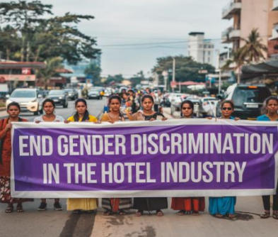
Figure 1: Protest “Breaking Barriers: Empowering Women Leaders in the Hotel Industry”
(Source: Author, 2025)
The protest site is located in Colombo, Sri Lanka because it stands as the leading hub of hospitality in the country. Galle Face Green serves as the venue for this protest because of its location near central hotels and government buildings which ensures great visibility and engagement between protesters and viewers (Trip Advisor, 2025).
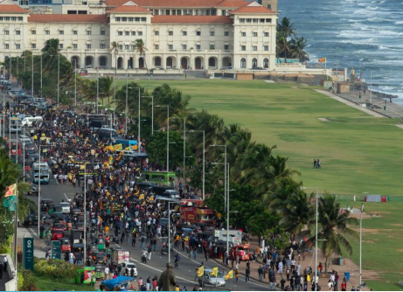
Figure 2: Galle Face Green, Colombo
(Source: Trip Advisor, 2025)
Through this protest, the participants want to spread knowledge while advocating for equal access alongside policy changes. This protest will combine hospitality employees with activists and organisations to obtain fair working conditions and safer work areas. The protest serves a crucial role in advancing industrial reforms and creating an inclusive hotel environment for the future of Sri Lanka’s hotel industry despite growing industry demands for gender equality. The protest aims to address the major areas, such as the event cycle, planning tactics, stakeholder management, budget, and trends in the industry. This report also utilises the SOSTAC and RACE models for determining strategic planning, digital promotion, engagement, and long-term effects. Additionally in this report, Situational analysis includes PESTLE, SWOT, and SOAR also analyses whether the protest is effective and sustainable.

The Event Cycle
Organisations use the Event Cycle framework to schedule and conduct event operations and assessment processes (O’Toole, 2010; Getz and Page, 2019).
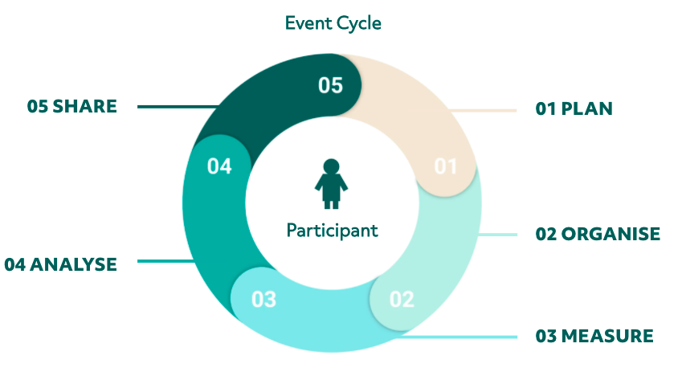
Figure 3: Event Cycle
(Source: O’Toole, 2010)

Planning the Protest
The initial step requires defining the protest objectives while determining who matters in the protest and what its purpose will be. The protest intends to solve gender-based inequalities in Sri Lanka's hotel industry alongside its campaign for gender equality rights. The necessary base decisions including the selection of Galle Face Green in Colombo and the identification of dates along with appropriate legal permissions reach completion. The funds raised through sponsorships and donations undergo financial planning steps to secure organisational resources (Dolores et al., 2021). Risk assessment establishes awareness about potential security threats and stakeholder opposition which could become obstacles.

Organising the Protest
The organising stage of the protest consists of bringing together resources followed by participant recruitment before carrying out strategic operational arrangements. A dedicated organizing team functions to organise roles related to volunteer management together with media engagement and on-site operations responsibilities (Muench and Winnen, 2023). Security arrangements along with permits receive approval through legal advisor collaboration and partnership with local authorities. Moreover, the participation rates increase when organisations build alliances with non-governmental associations and feminist groups together with labour unions (Muench and Winnen, 2023).

Measuring Protest Success
Success measurement requires monitoring three aspects including the levels of participation combined with media attention along with audience engagement (Trunfio and Rossi, 2021). Guests at the event are counted using on-site registration which also tracks social media check-ins. The evaluation of social media influence evaluates patterns of hashtag discussions combined with the number of shares and identification of popular hashtags.

Analysing the Outcomes
The evaluation process focuses on acknowledging strengths along with solving challenges and identifying sections that should be improved. The organisation achieves participant feedback through survey interviews which measure public emotions. A review examines both protest message effectiveness and speech effectiveness to determine stakeholder impacts (Chaudhuri et al., 2024). Future advocacy designs require security issues together with operational problems as essential components for design improvement efforts.

Sharing the Impact
The disclosure of results strengthens both advocacy movements and keeps supporters active. The team creates a complete report about the protest which includes statistics regarding turnout together with significant accomplishments and media attention received. The team sends information about the research to the public through media outlets that include online channels such as social media and blogs (Khanom, 2023).

Protest Concept
Activities | Description
Registration & Gathering | - Participants arrive and sign in at registration booths.  - Volunteers distribute protest kits, banners, and flyers.
Opening Address | - The organising committee leader delivers a welcome speech.  - Overview of protest objectives and expected outcomes.
Keynote Speeches | - Women’s rights activists and hospitality industry experts discuss systemic barriers and gender inequality.
Midway Rally & Awareness Session | - Short break with speeches from female hospitality workers sharing personal experiences.  - Social media engagement is encouraged.
Community Engagement & Petition Signing | - Protesters sign petitions demanding policy changes in the hotel industry.  - QR codes are provided for online petitions.
Lunch Break & Networking | - Attendees have refreshments at designated areas.  - Informal discussions with activists and legal experts.
Panel Discussion & Q&A | - Industry leaders, labour union representatives, and policymakers discuss solutions.  - Audience engagement with Q&A.
Media Interaction & Press Conference | - Protest representatives address the media.  - Journalists and news agencies report on key demands.
Call to Action & Future Plans | - Organizers summarise key takeaways and next steps.  - Attendees commit to ongoing advocacy through digital and legal means.
Closing Speech | - Final remarks from event leaders.  - Gratitude extended to participants and supporters.

Key Stages of the EMBOK Model

Initiation
The protest aims to discuss gender discrimination in Sri Lanka’s hotel industry. The key stakeholders include; hospitality workers, activists, NGOs and corporate sponsors Public demonstration legal requirements are reviewed, and permissions are obtained (Rogers and Wynn-Moylan, 2022).

Planning
The protest chooses Galle Face Green in Colombo for its high visibility near major hotels and government offices. Banners, slogans, and digital materials are created to optimize outreach and effect.
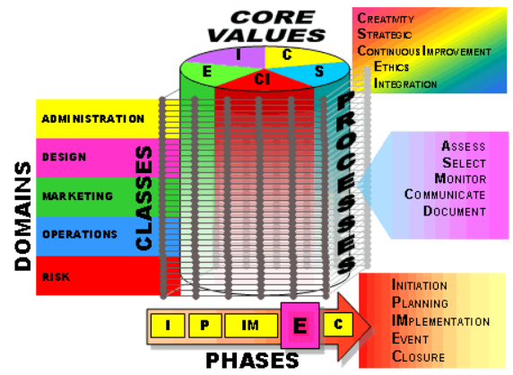
Figure 4: EMBOK Model
(Source: Rogers and Wynn-Moylan, 2022)

Implementation
Efforts are made to assign volunteers and organizers for the protest. To protect participants, safety and medical support, as well as legal support ensure the proper treatment (Khanom, 2023). Event materials are handed out to strengthen the protest’s main messages.

The Event
Speeches by industry leaders, activists and hospitality workers draw attention to workplace inequality (Rogers and Wynn-Moylan, 2022). Gender equality education materials are distributed. Participants network and form alliances to demand systemic changes in the industry.

Closure
Participants, stakeholders, and media representatives provide feedback on how impactful the protest is. Key outcomes and recommendations are documented in a report. After the event, campaigns help keep the movement relevant and tangible ensuring that real changes in workplaces occur.

Aim and Objectives of the Event
The key aim of the protest is to raise awareness throughout the Sri Lankan hotel industry by advocating for gender equality, fair treatment, and leadership opportunities for women.
The objectives of the protest are as follows;
- To gain media coverage from at least five national outlets within one month.
- To collect 10,000 petition signatures in three months for workplace reforms.
- To mobilise 500 participants, ensuring 30% are hotel industry workers.

Event Management

Operational & Planning Activities
An effective protest depends on complex plan development and effective coordination and execution steps (Getz and Page, 2019). The timeline will organise the main operational steps to promote efficient implementation. The complete acquisition of permits and legal approvals according to regulatory standards will take place for the protest. There will need an established contingency plan for managing emergencies and disruptions during the event.

Organising Team
A team that exists for organisational purposes will handle all aspects of the protest activity (Getz and Page, 2019). The event coordinators will lead the work of scheduling, and logistics management as well as overseeing the complete execution. Press coverage management and publicity functions will be handled by specialist media professionals to maximise public exposure. The volunteer coordinators will distribute work assignments together with relevant training to their team.

Communication Materials
Appropriate communicative measures serve to educate people while involving them in the process (Schellewald, 2021). Important demands and essential messages will be displayed on protest banners together with posters. The hotel industry's gender inequality issue will be taught to the public through both flyers and pamphlets. Electronic materials such as digital infographics social media content and video demonstrations will intensify the message on the internet. The dedicated hashtag will serve to unite discussions which will expand outreach for our cause.

Volunteer Workforce
The achievement of the protest depends heavily on having an effective volunteer base (O’Toole, 2010). The advocates who will speak to the audience will present field observations coupled with expert professional understanding. The social media team at the event will deliver instant news through real-time updates as well as maintain live streams to reach virtual observers. The protest event will have staff offering medical assistance for emergencies.

Legal Support
The safety of a protest depends on strict compliance with legal requirements (Ortiz et al., 2022). Lawful guidance will ensure the team obtains necessary permits and follows local authority requirements during the operational process. They work to maintain contact with authorities who ensure both the smooth execution of the protest as well as its peaceful nature. The legal monitoring team operates to document any events so incorrect accusations or misrepresentations can be disproven.

Race model
The RACE model comprises four components namely, reach, act, convert and engage which highly support this protest.
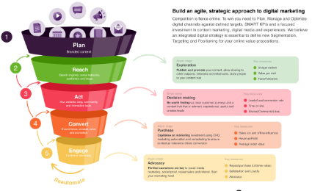
Figure 5: RACE model
(Source: Chaffey and Smith, 2022)

Reach
Reach is about achieving the best visibility through digital and conventional media. Social media advertising, influencer associations, and search engine optimization content will make the protest go viral on social media (Chaffey and Smith, 2022). Press releases and media outreach efforts will establish credibility, and this will familiarize influential stakeholders within the hospitality community with the movement as professionals, policymakers, and activists.
Act
The act enables interaction by offering accessible platforms for communication (Flew et al., 2019). A specific website or landing page will be used to host event information, petitions, and educational content. Moreover, Live Q&A sessions with industry experts and social media activists will enable meaningful conversation, enabling potential supporters to engage with the cause and become educated on the issues women in hospitality are facing (Flew et al., 2019).
Convert
Converts awareness into action. Strong calls-to-action (CTAs) will encourage people to sign petitions, volunteer, and physically take part in the protest (Lokot, 2021). Online support will translate into in-person engagement, mobilizing hospitality workers, gender equality activists, and citizens.
Engage
Engage achieves long-term influence following the event. Media coverage of post-protest activity, personal testimonies from protest participants, and ongoing email and social media lobbying will keep the movement going (Lokot, 2021). Ongoing activism will maintain pressure on industry bosses and politicians to implement workplace reform and gender equality policies.

Protest Budget
Table 1: Estimated Costs for Protest
Category | Estimated Costs (LKR)
Venue Fees | 150,000
Marketing & Advertising | 100,000
Legal & Compliance Fees | 200,000
Volunteer Expenses | 50,000
Equipment & Supplies | 75,000
Security & Crowd Control | 250,000
Contingency Fund | 75,000
(Source: Author, 2025)

Table 2: Revenue Sources for Protest
Revenue Source | Estimated Amount (LKR)
Donations (Public & NGOs) | 400,000
Sponsorship (Oxfam Sri Lanka) | 300,000
Sponsorship (Women in Hospitality Sri Lanka) | 250,000
Merchandise Sales | 100,000
Media Partnerships | 50,000
(Source: Author, 2025)

Table 3: Sponsorship Contributions for Protest
Sponsor Name | Contribution (LKR)
Women’s Rights Organisation (Sri Lanka) | 400,000
Hospitality Workers’ Union | 300,000 – 700,000 LKR
(Source: Author, 2025)
Table 4: Total Revenue & Profit for Protest
Category | Amount (LKR)
Total Revenues | 1,100,000
Total Costs | 900,000
Profit | 200,000
(Source: Author, 2025)
The protest requires LKR 900,000 to cover venue costs (LKR 150,000), promotional expenses (LKR 100,000) and compliance expenses (LKR 200,000). The protest gathers its primary funds from the Women's Rights Organisation of Sri Lanka (LKR 400,000) as well as the Hospitality Workers' Union (LKR 300,000–700,000). The LKR 1,100,000 in total revenue generates a LKR 200,000 profit that will fund more gender equality campaigns as well as ongoing support for women in Sri Lanka's hospitality industry.

Industry Trends

Digital Activism & Social Media Influence
Social media functions as a central tool for both recruiting people to protest and making their messages louder to the public. The internet has penetrated 35% of the Sri Lankan population in 2020 (Statista, 2025). Through X (Twitter) and Instagram users become able to learn about protests while receiving help with coordination and enforcement of pressure on representatives. Through hashtags and streaming activities, the protest obtains more publicity which reaches people beyond those who show up physically (Earl et al., 2022).
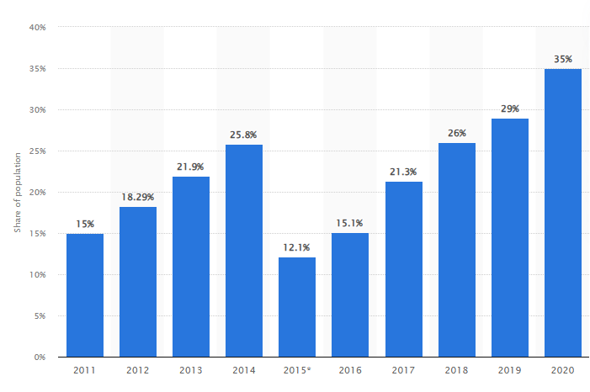
Figure 6: Internet penetration rate in Sri Lanka from 2011 to 2020
(Source: Statista, 2025)

Gender Inequality in the Workforce
Multiple institutional organisational elements prevent Sri Lankan females from achieving job advancement. Among the total workforce of 47.34% women earn only 5.33% of parliamentary seats and maintain inferior positions in management than their male counterparts (Statista, 2025a). The hotel industry shows an equal distribution of female workers because women are mostly assigned to limited-wage positions (Statista, 2025a).
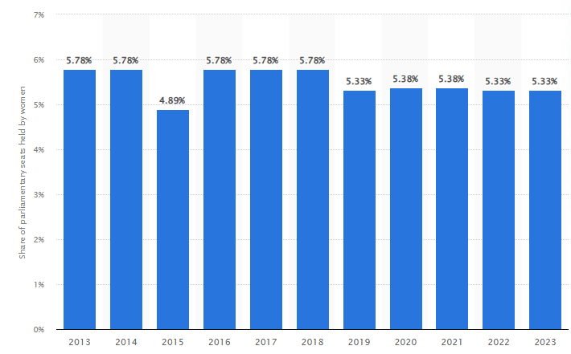
Figure 7: Sri Lanka: proportion of seats held by women in national parliament 2011-2021
(Source: Statista, 2025a)

Public Safety & Security Challenges
Large events must strengthen security measures because political risk areas have increased public safety needs (Jayasinghe et al., 2022). The protests in Sri Lanka triggered governmental reactions (Gunawardena and Kadirgamar, 2022). To ensure compliance with the law the protest needs to obtain permits while working with law enforcement for crowd management and danger prevention measures.

Stakeholder Collaboration & Economic Pressure
Event organisation costs continue to escalate into a major problem. The expenses for events in Sri Lanka have increased during past years because of rising inflation rates along with logistical expenses (Statista, 2025b). The protest depends on funding from NGOs as well as unions and corporate sponsorships to operate yet it continues its goal of maintaining advocacy integrity.
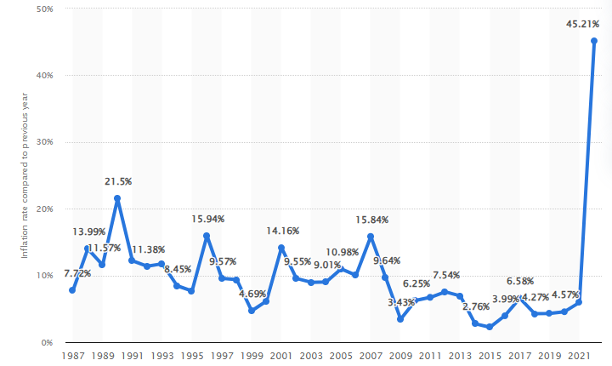
Figure 8: Sri Lanka: Inflation rate from 1987 to 2022
(Source: Statista, 2025b)

SOSTAC model
The SOSTAC model, developed by PR Smith, is an appropriate strategic planning framework for organizing international events such as protests (Björnfot and Dehlin, 2023).
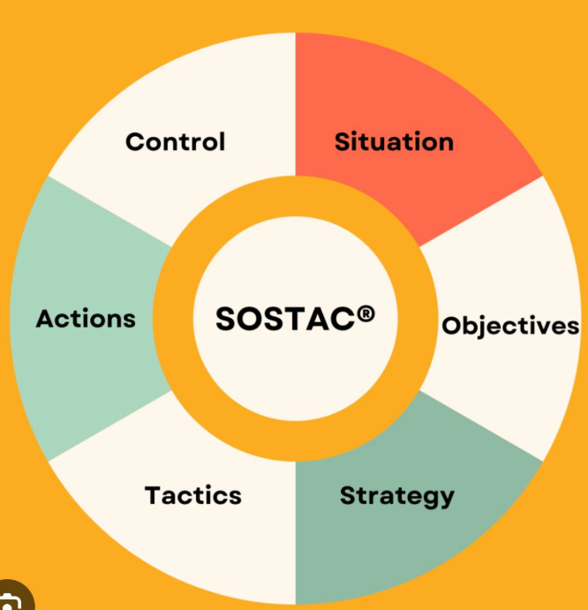
Figure 9: SOCTAC
(Source: Björnfot and Dehlin, 2023)
Situation Analysis
This phase examines the current situation, such as gender discrimination in Sri Lanka's hospitality industry (Björnfot and Dehlin, 2023). It examines the composition of the workforce, the law, and the stakeholders' interests to determine limitations to women's leadership in hospitality.
Objectives
The primary objective of the event is to mobilize voices for policy changes and gender equality. Prime objectives are coverage by a minimum of five national media, 10,000 signatures within three months, and mobilizing 500 participants, including hotel employees (Bowdin et al., 2023).
Strategy
The strategy revolves around online activism, partnerships with NGOs, and stakeholder engagement (Hall et al., 2020). The protest will take over Colombo's Galle Face Green for maximum visibility and will be addressed by hospitality staff, activists, and legal experts (Björnfot and Dehlin, 2023).
Tactics
Tactics involve securing permits, organizing speeches, and promotion the protest through social media. A unique hashtag, media partnership, and interactive Q&A sessions will complement engagement (Bowdin et al., 2023).
Action
Execution comprises coordination of volunteers, registration tables, keynote addresses, signing the petition, and panel discussions (Allen et al., 2022). Logistics, security measures, and compliance with laws guarantee event operations.
Control
Measurement of success entails tracking attendance, social media, media coverage, and stakeholders' feedback (Bowdin et al., 2023).

Situational and Cultural Considerations

PESTLE Analysis
Table 5: PESTLE Analysis
Factors | Analysis
Political | - Frequent policy changes create uncertainty for businesses and investors.  - Government regulations on public demonstrations may impact the protest’s reach.  - Political instability can influence industry reforms.
Economic | - High inflation (45.21% in 2022) affects business operations and tourism costs (Statista, 2024).  - The decline in GDP ($74.59 billion) reduces corporate spending on MICE events (Statista, 2024a).  - Financial instability may limit industry support for workplace reforms.
Social | - Gender discrimination remains a major issue in Sri Lanka’s hospitality sector (Kodagoda and Jayawardhana, 2022).  - Public awareness of workplace inequality is growing, strengthening the protest’s cause.  - Cultural shifts among younger generations favour inclusivity and fair employment.
Technological | - Digital campaigns and social media enhance protest visibility and engagement.  - Sri Lanka’s digital transformation in tourism can support awareness initiatives (Handaragama and Kusakabe, 2021).  - Technology-driven platforms can increase advocacy efforts.
Legal | - Labour laws need reform to support gender equality in the MICE and hospitality industries.  - Government restrictions on protests may pose legal challenges.  - Corporate policies often lack enforcement of inclusive workplace regulations (Kodagoda and Jayawardhana, 2022).
Environmental | - The tourism and MICE sectors rely on sustainability, creating opportunities for ethical business practices.  - Large protests may raise concerns about environmental impact, requiring responsible planning.  - Climate-related risks could affect event-based tourism.
(Source: Author, 2025)

SWOT Analysis
Table 6: SWOT Analysis
Factors | Analysis
Strengths | - The protest aligns with cultural and situational factors (Studies, 2022).  - Growing public awareness of gender bias strengthens support (Kodagoda and Jayawardhana, 2022).  - Financial and logistical aid from NGOs, unions, and corporate sponsors enhances reach.
Weaknesses | - Legal restrictions and corporate control limit public demonstrations.  - The hospitality sector offers weak support due to a lack of female executives (Handaragama and Kusakabe, 2021).  - Security risks require thorough safety planning.
Opportunities | - International support for gender equality aligns with the protest’s goals.  - Policy discussions on labour laws and corporate accountability can drive reforms (Henderson, 2020).  - Changing cultural attitudes encourages inclusive hiring and promotion.
Threats | - Political and corporate opposition slows progress. Some leaders resist gender reforms.  - Misinformation and propaganda may distort the movement’s purpose.  - Economic conditions affect companies’ willingness to implement policy changes (Surangi, 2022).
(Source: Author, 2025)

SOAR Analysis
Table 7: SOAR Analysis
Factors | Analysis
Strengths | - The protest directly addresses gender discrimination in Sri Lanka’s hotel industry (Perera et al., 2024).  - The location in Colombo, specifically at Galle Face Green, ensures high visibility near major hotels and government buildings (Trip Advisor, 2025).
Opportunities | - The protest aligns with global efforts to promote gender equality in the workplace.  - Collaboration with NGOs and international organizations can expand its impact (Henderson, 2020).
Aspirations | - The movement aims to create a fair and inclusive hotel industry where women have equal opportunities for leadership roles.  - The protest seeks beneficial long-term policy changes that benefit future generations.
Results | - The protest can lead to stronger legal protections for women in hospitality (Henderson, 2020).  - Increased awareness and corporate responsibility may result in more leadership opportunities for women.
(Source: Author, 2025)

Conclusion
Conclusively, The "Breaking Barriers" protest successfully promoted gender discrimination consciousness in Sri Lanka's hospitality industry, engaged high-level stakeholders, and forced policymakers towards change. Through strategic engagement, media, and ongoing lobbying, it deepened demands for equal opportunities, just treatment, and structural change in the long term within the sector.

References
Allen, J., Harris, R., and Jago, L. (2022). Festival and special event management. John Wiley and Sons.
Björnfot, Q., and Dehlin, M. (2023). Comparing the Return on Investment of Search Engine Optimization and Pay-Per-Click marketing: Developing a model to forecast the ROI of SEO based on the SOSTAC Planning System.
Bowdin, G. A., Allen, J., Harris, R., Jago, L., O'Toole, W., and McDonnell, I. (2023). Events management. Routledge.
Chaffey, D., and Smith, P. R. (2022). Digital marketing excellence: planning, optimizing and integrating online marketing. Routledge
Chaudhuri, N., Gupta, G., Mehdi Bagherzadeh, Tugrul Daim and Yalcin, H. (2024). Misinformation on social platforms: A review and research agenda. Technology in society, 78, pp.102654–102654. doi:https://doi.org/10.1016/j.techsoc.2024.102654.
Dolores, L., Macchiaroli, M. and De Mare, G. (2021). Sponsorship’s Financial Sustainability for Cultural Conservation and Enhancement Strategies: An Innovative Model for Sponsees and Sponsors. Sustainability, 13(16), p.9070. doi:https://doi.org/10.3390/su13169070.
Earl, J., Maher, T.V. and Pan, J. (2022). The digital repression of social movements, protest, and activism: A synthetic review. Science Advances, [online] 8(10). doi:https://doi.org/10.1126/sciadv.abl8198.
Flew, T., Martin, F., and Suzor, N. (2019). Internet regulation as media policy: Rethinking the question of digital communication platform governance. Journal of Digital Media and Policy, 10(1), 33-50.
Getz, D. and Page, S.J. (2019). Event Studies: Theory, Research and Policy for Planned Events. Fourth Edition. | New York: Routledge, 2020. | Series: Events management series | 'First edition published by Butterworth-Heinemann 2007. Third edition published by Routledge 2016'—T.p. verso. Routledge. Doi:https://doi.org/10.4324/9780429023002.
Gunawardena, D. and Kadirgamar, A. (2022). Sri Lankan Peoples’ Protests of 2022: The Present from the Past. [Online] Available at: https://www.theindiaforum.in/sites/default/files/article_pdf/2022/05/20/1153-1653027160.pdf.
Hall, N., Schmitz, H. P., and Dedmon, J. M. (2020). Transnational advocacy and NGOs in the digital era: New forms of networked power. International Studies Quarterly, 64(1), 159-167.
Handaragama, S. and Kusakabe, K. (2021). Participation of women in business associations: A case of small-scale tourism enterprises in Sri Lanka. Heliyon, 7(11), p.e08303. Doi:https://doi.org/10.1016/j.heliyon.2021.e08303.
Henderson, S. (2020). The legal protection of women migrant domestic workers from the Philippines and Sri Lanka: an intersectional rights-based approach. International Journal of Care and Caring. Doi:https://doi.org/10.1332/239788220x15976836167721.
Jayasinghe, N., Fernando, S., Haigh, R., Amaratunga, D., Fernando, N., Vithanage, C., Ratnayake, J. and Ranawana, C. (2022). Economic resilience in an era of ‘systemic risk’: Insights from four key economic sectors in Sri Lanka. Progress in Disaster Science, 14, p.100231. doi:https://doi.org/10.1016/j.pdisas.2022.100231.
Khanom, M.T. (2023). Using Social Media Marketing in the Digital Era: a Necessity or a Choice. International Journal of Research in Business and Social Science (2147- 4478), 12(3), pp.88–98.
Kodagoda, T. and Jayawardhana, S. (2022). Forced or voluntary reluctance or voluntary preference to work? Women in the hotel industry: evidence from Sri Lanka. Gender in Management: An International Journal. Doi:https://doi.org/10.1108/gm-01-2021-0011.
Lokot, T. (2021). Beyond the protest square: Digital media and augmented dissent. Rowman and Littlefield.
Muench, L. and Winnen, L. (2023). Requirements for the integration of volunteers into major events: An analysis from the perspective of human resource management and project management. Doi.org. [online] doi:https://publikationsserver.thm.de/xmlui/handle/123456789/283.
O’Toole, W. (2010). Events Feasibility and Development. Routledge. Doi:https://doi.org/10.4324/9780080940595.
Ortiz, I., Burke, S., Berrada, M. and Saenz Cortés, H. (2022). World Protests: A Study of Key Protest Issues in the 21st Century. [Online] library.oapen.org. Springer Nature. Available at: https://library.oapen.org/handle/20.500.12657/51476.
Perera, N.P.K.U., None H.L.N Wasantha, None P.L.K Lakshan and None W.M.A.H Bandara (2024). Barriers to Female Participation in Sri Lanka’s Hotel Industry: A Qualitative Exploration of Cultural, Social, and Organizational Challenges. International Journal on Recent Trends in Business and Tourism, 08(04), pp.12–23. doi:https://doi.org/10.31674/ijrtbt.2024.v08i04.002.
Rogers, T. and Wynn-Moylan, P. (2022). Conferences and Conventions. Routledge.
Schellewald, A. (2021). Communicative Forms on TikTok: Perspectives From Digital Ethnography. International Journal of Communication, [online] 15(0), p.21. Available at: https://ijoc.org/index.php/ijoc/article/view/16414.
Statista (2024). Sri Lanka - inflation rate 1984-2024 | Statista. [Online] Statista. Available at: https://www.statista.com/statistics/728516/inflation-rate-in-sri-lanka/ [Accessed 12 Feb. 2025].
Statista (2024a). Sri Lanka - Gross domestic product (GDP) 1985-2025. [Online] Statista. Available at: https://www.statista.com/statistics/728510/gross-domestic-product-gdp-in-sri-lanka/ [Accessed 12 Feb. 2025].
Statista (2025). Sri Lanka: internet penetration rate 2017 | Statista. [Online] Statista. Available at: https://www.statista.com/statistics/765516/internet-penetration-rate-sri-lanka/.
Statista (2025a). Sri Lanka: proportion of seats held by women in national parliament 2011-2021. [Online] Statista. Available at: https://www.statista.com/statistics/730591/sri-lanka-proportion-of-seats-held-by-women-in-national-parliament/.
Statista (2025b). Sri Lanka - inflation rate 1984-2024 | Statista. [Online] Statista. Available at: https://www.statista.com/statistics/728516/inflation-rate-in-sri-lanka/.
Studies, I.J. (2022). The Relationship between Conflict and Social Change in the Perspective of Expert Theory: A Literature Review | International Journal of Arts and Humanities Studies. Al-kindipublisher.com, [online] 2(1). Available at: https://al-kindipublisher.com/index.php/ijahs/article/view/2721.
Surangi, H.A.K.N.S. (2022). A critical analysis of the networking experiences of female entrepreneurs: a study based on the small business tourism sector in Sri Lanka. Journal of Innovation and Entrepreneurship, 11(1). doi:https://doi.org/10.1186/s13731-022-00255-y.
Trip Advisor (2025). Tripadvisor. [Online] Tripadvisor. Available at: https://www.tripadvisor.com/Attraction_Review-g293962-d3195710-Reviews-Galle_Face_Green-Colombo_Western_Province.html [Accessed 7 Feb. 2025].
Trunfio, M. and Rossi, S. (2021). Conceptualising and Measuring Social Media engagement: a Systematic Literature Review. Italian Journal of Marketing, 2021(3), pp.267–292. doi:https://doi.org/10.1007/s43039-021-00035-8.

