

Developing Innovation and Creativity for Business Advantage
Task 1
Student Name: Iuliana Mare
Student Number: 2113595

Executive summary
The innovative product is going to launch manufacturing bags with torn clothes. The name of the products will be Easy Store. The bag will be very easy to handle, and various people will buy these bags for shopping purposes. The uniqueness of this bag is that it is foldable and customized. Easy Store will use SaaS software to establish an online website for the new company. The name of the website will be www. Easystore.com and they will use SaaS software to manufacture it. The social media marketing that will be used by Easy Store and the security purpose that is Easy Store provide security to its e-commerce store by providing secure access to all the options for its e-commerce platform and limited access to the platforms.

Table of Content

Introduction 3
A) The innovative product OR unique service proposition: 3
B) eCommerce (propose to set up an online website) 4
C) Marketing 5
D) Privacy and Data Protection 7
Conclusion 9
References 10
Appendix 11

Introduction
The report aims to develop an innovative business plan by maintaining all economic challenges in the global market. Here considering the brick-and-mortar model, any small enterprise can establish the physical as well as online presence in building the operations. Here business will be developed based on the developing reusable Bags with wheels. This model is going to help before entering business, all product or service descriptions are going to be established. Market analysis, financial outlook, and e-commerce services will be provided. An effective marketing plan is going to be established to reach the target audiences. In this report, an effective business plan along with privacy and data protection is going to be established for maintaining long-term sustainability in the businesses. To establish the business, a detailed description of the business and competitive market is going to be analyzed, and to how to develop the business and sell in particular in the right way.

A) The innovative product OR unique service proposition:
The innovative product is going to launch manufacturing bags with torn clothes. The name of the products will be Easy Store. The bag will be very easy to handle and various people will buy these bags for shopping purposes. The uniqueness of this bag is foldable and customised. This bag can be carried by hand, shoulder, or wheel and can be added when customers need to carry heavy products. The company will gather all torn cloth and reuse those by giving bag shapes with machinery usage.
The targeting of the people is another important area. In this aspect, Easy stores will target all males and females who love shops and face difficulties carrying products. The target customers will be 25-45 years old and they will buy this product. Target marketing helps to enable business operations to access various people and offer customers the best products that can meet their needs. The bags of the easy store will be sold all over the UK. The main headquarters of the brand will be established in London and these products will be available on their official websites. Initially, a physical store will be established in London City, and after a few months, this brand will establish more stores in the UK Markets. Additionally, this product will be sold through the physical store of the Easy store and additionally, it will be sold in the E-commerce platform to reach their potential audiences. As they have an effective name, Easy Store, the maximum number of people easily go to buy these products. Having the name of business ventures, Entrepreneurs can create a variety of products as the customer’s demand.
To create Business sustainability, entrepreneurs will focus on creating powerful branding by focusing on the customers. This brand will develop a partnership with the fashion brand and effective collaboration with them helps to create an effective supply of the raw products for developing the business correctly. Additionally, the entrepreneur will focus on promoting their products and offering customised products as per the customer's demands. Giving higher satisfaction and retaining the customer will encourage them to develop business sustainability for a longer period. Furthermore, this company will focus on various bags like handbags, Hobo bags, Tote bags, duffle bags, Messenger bags, backpack bags, satchels, laptop bags and many more. The customer will decide that the wheel will be fired or removed from the bags. The versatile, eco-friendly, and functional structure of the products will develop durability and style. all of these will carry out their belonging for longer periods. The main competitors are Alexander McQueen, Aspinal of London, Hettie, Burberry, Carpet Bags of England, Danse Lente, GWeniss, DeMillier, Glencroft and many more (Painter, 2023). But Easy Store can deal with these competitors by manufacturing unique products with wheel facilities and eco-friendly raw materials. The versatility and functional values of the product make them different then other brands in the London market.
The products of the Easy Store will be delivered offline as well as online services. If the customers place an order through their application as well as the e-Commerce Platform, it will be delivered within 24-48 hours.

B) eCommerce (propose to set up an online website)
Easy Store will use SaaS software to establish an online website for the new company. The name of the website will be www. Easystore.com and they will use SaaS software to manufacture it. The Sass platform will be beneficial for creating web-based applications to attract millions of customers at a time. This software acts as a service tool which will be beneficial for Easy Store business organisation and develop customer over the Internet (gojilabs, 2023).
Shopify is one of the user-friendly platforms which will help build a business in the online store. Easy Store will focus on the using Shopify e-commerce platform for the creation of the online store as well as selling products online through the Streamline dashboard (Main, 2023). Modern technology helps Easy Store to be a Shopify merchant and develop sales rates through social media sites, other blog creation, and official website establishment. Furthermore, this will be beneficial to sell on automatic email, chat, and text delivery. Easy Store will be focusing on hiring potential employees with digital knowledge and creating the ability of online websites.
Easy Store will develop a collaboration with eBay to reach marketplaces for developing connections with customers. Easy Store will focus on developing collaboration with eBay and As eBay is the easy offers fixed rates and high punctuality in the delivery of the products it will create trust among individual clients in the right way. Based on the business's goals, Easy Store will focus on creating value content for the business. They used to focus on writing blogs and articles. They also focus on the creation of the video clip to make it more understandable to the user. They also include an image of the bags on their official sites and e-commerce platform for describing the products. The Easy Store will accept online transactions, PayPal services and card payments to improve the business patterns of the Easy Store. While customers will use credit cards, they must focus on PCL DSS Compliance to avoid critical business transaction issues. The number of card transactions will be focused on establishing online transactions in the right way. It will help to ensure data security, operational efficiency, and cost of compliance, and meet all complex requirements in an effective way (LinkedIn, 2023). To tie up business with an e-commerce platform, content creation, and website creation will develop confidence in the Easy store and the company can reach one step forward in establishing a business. Online selling and online money transactions will create opportunities in the development of business in global platform.

C) Marketing
Social media marketing: Social media marketing refers to a marketing technique through the internet that uses social media applications as a marketing tool. With the help of social media, new brands can connect with their customers to increase sales and drive traffic to the website brand building (Evans et al. 2021). Easy Store will use popular social media platforms such as Facebook, Instagram, and YouTube to promote its shopping bag. It will advertise on these different platforms by showing the advantages such as the main purpose is to recycle torn clothes. Along with this, Easy store will promote its e-commerce store by collaborating with social media influencers who will promote these bags and their uniqueness, therefore customer engagement in the Easy store will be increased accordingly.
Public relations: Public relations play an important role in promoting a new product of a brand. Public relations are normally used in the marketing purpose of the products which mostly maintains better media relations and public images, the building of brand awareness, and engagement with the potential brand promoters that is from sponsors to influencers (Youth Justice, 2023). Easy Store will maintain public relations through its social media by taking surveys, and by solving the issues they will face, and Easy Store will also connect to the people. Therefore, the trust will be built up and sales will be increased.
• Target customers
From the perspective of demographics, Easy Store will target both males and females as their potential customers between the 25-45 age group. The business will launch its shopping bag with torn clothes mainly with mid and low-income groups of people in mind. From the aspect of geography, they will first open their initial outlet in London and operate their operation across the whole country through online mode. Easy stores will also focus on the lifestyle and social status of their customers, male and female to target their customers geographically. The new business plans to raech with its potential customers by creating a strong network and feedback channel that will assist them in being updated with the changing customer behavior.
• Consideration of social media
Nowadays social media is an essential factor to reach the targeted customers. Easy Store has decided to promote its shopping bag through Facebook and Instagram which help them to stay connected with all the possible customers and emphasize social media marketing.
• Consideration of paid search engine
As the paid search engine, Easy Store will choose Google which will allow the business to foster their digital marketing strategy and gain all the competitive advantages. With the Google ads, the campaign manager of Easy Store will research the most possible terms people use to find their products to place a bid on those terms.
• Understand the role of customer journeys
Through the marketing activities, the products of the business will gain the attention of its targeted customers in an effective manner. This will enhance brand awareness of Easy Store. As they will get the visuals of the products and the entire journey of making them from torn clothes, it will be more appealing to them. The journey of the customers from knowing or purchasing the products will be full of knowledge which will help them understand the value of the products towards sustainability as well.
• Consider the use of email marketing
Email is one of the most effective ways of connecting and communicating virtually with customers so that products and services can be promoted (Mailchimp, 2023). Before launching the products made of torn clothes, Easy Store will have pre-launch promotional programs. This will be significantly effective for the brand to interact with its targeted and potential customers. In this process, the email addresses of those customers will be collected with their consent. Thus, the process of email marketing will be enabled.
Through the use of email marketing strategy, Easy Store will focus on making people aware of its unique products, manufacturing process, materials, and various offers and discounts as well. Thus, the products will be able to attract more customers and foster sales.

D) Privacy and Data Protection
GDPR/Data Protection Act 2018: According to the Data Protection Act, this act was applied by the UK to personal data, that is the information related to individuals. This act provides the right to the individuals, therefore then can access their data through the subject access requests and contains rules that must be followed while the personal data is processed (Legislation, 2023). Easy Store will have a lawful basis for processing personal data which includes getting explicit consent for, the data or demonstration that will be processed by this store. Easy Store will provide the notification to the relevant supervisory authority of a data breach within 48 hours of becoming aware of it so that action will be taken quickly. The easy store will conduct DPIA processing activities that will result in a higher risk to the rights and freedoms of data subjects. The easy store will provide two-step verification to the users to log in and email authentication will be there also (Service, 2023)
Privacy and Electronic Communication Regulations (PECR): Privacy and Electronic Communication Regulations is a law in the UK that made it unlawful to, amongst other things, transmit an automated recorded message or direct marketing purposes via a telephone without the prior consent of the subscriber (ICO, 2023).
It must be ensured that the organisations have the customer's consent to electronically market to them by phone, fax, or email. Even the identification of the organisation must be carried out at the time of marketing (FDIC, 2023). Easy store will ask for email or message consent while a customer will register herself or himself to the website using the phone number or email ID. Therefore, Easy Store will not send any kind of marking email regarding the discounts, or offers, through email to any people. Opt-out is a term in which each individual can choose not to receive marketing communications through email, phone numbers, and channels (Dataprotection, 2023). Easy Store will also provide this facility to the consumers rs that they can unsubscribe the emails from their IDs and there will be an option on the website to stop receiving marketing communications. Individual consumers have the right to erase their data without undue delay. Easy Store will provide the support rights that the user can erase personal data at any time whenever he or she wants. Therefore, erased personal data are no longer necessary concerning the Easy Store website.
Security and the importance
Security is an important term for an e-commerce platform to protect it from malfunction, phishing, cyber smores, or cyber-attacks to avoid data loss for the company (trade, 2023). Easy Store will also provide security to its e-commerce store by providing secure access to the cloud provider, sensitivity about default access, and frequent changes, and encrypting traffic in transit. Easy Store will provide secure access to the cloud providers that will be limited therefore, the cloud providers will have no access to the whole e-commerce store. The cloud providers only have storage access, the storage management, and they will have no access to the data that will be stored (Cloud, 2023). Easy Store will also provide all the options for its e-commerce platform by using which the users can choose the default settings, where they will be aware of the permissions which they allow such as notifications, location access, contacts access, managing phone calls and other factors. Encryption in transit defenses the data after establishing a connection and authentication against potential attacks by erasing the need to trust the lower layers of the network. (Development, 2023) Easy Store will provide encryption while transit so that the receiver will have no access to the information of sender data and similarly, the senders will not access any personal information of the receiver.

Conclusion
This report seeks to create an innovative business plan that can withstand the economic difficulties of the global market. Taking into account the brick-and-mortar model, small businesses can establish both a physical and an online presence to build their operations. This report will focus on the development of reusable bags with wheels, which will help in the early stages of business development. All product or service descriptions will be outlined, as well as market analysis, financial outlooks, and online services. Additionally, an effective marketing plan will be developed to reach the desired target audiences. Finally, an efficient business plan will be established, as well as privacy and data protection measures to ensure long-term sustainability. To create a successful business, a comprehensive analysis of the business and the competitive market will be conducted, as well as strategies for developing the business and selling in a particular way.

References
Cloud (2023) Encryption in transit | documentation | google cloud, Google. Available at: https://cloud.google.com/docs/security/encryption-in-transit#:~:text=Encryption%20in%20transit%20defends%20your,commonly%20provided%20by%20third%20parties (Accessed: 04 December 2023).
Dataprotection (2023) The right to erasure (articles 17 & 19 of the GDPR): Data Protection Commission, The right to erasure (Articles 17 & 19 of the GDPR) | Data Protection Commission. Available at: https://www.dataprotection.ie/en/individuals/know-your-rights/right-erasure-articles-17-19-gdpr#:~:text=This%20is%20also%20known%20as,it%20was%20collected%20or%20processed. (Accessed: 04 December 2023).
Development, S. (2023) What are the best practices for testing and auditing your data encryption in transit and at rest?, How to Encrypt Data in Transit and at Rest. Available at: https://www.linkedin.com/advice/0/what-best-practices-testing-auditing-your (Accessed: 04 December 2023).
Evans, D., Bratton, S. and McKee, J., (2021). Social media marketing. AG Printing & Publishing.
FDIC (2023) Consumer Compliance Examination manual, FDIC. Available at: https://www.fdic.gov/resources/supervision-and-examinations/consumer-compliance-examination-manual/index.html (Accessed: 04 December 2023).
ICO (2023) What are Pecr?, ICO. Available at: https://ico.org.uk/for-organisations/direct-marketing-and-privacy-and-electronic-communications/guide-to-pecr/what-are-pecr/ (Accessed: 04 December 2023).
Legislation (2023) Data protection act 2018, Legislation.gov.uk. Available at: https://www.legislation.gov.uk/ukpga/2018/12/contents/enacted (Accessed: 04 December 2023).
Linkedin, (2023). CyberArrow Understanding the 5 benefits and challenges of PCI DSS compliance, LinkedIn. Available at: https://www.linkedin.com/pulse/understanding-5-benefits-challenges-pci-dss-compliance-cyberarrow (Accessed: 04 December 2023).
Mailchimp, (2023). What is email marketing? definition and advantages. Mailchimp. Available at: https://mailchimp.com/marketing-glossary/email-marketing/ (Accessed: 04 December 2023).
Painter, S. (2023) 20 British handbag brands worth buying, LoveToKnow. Available at: https://www.lovetoknow.com/life/style/20-british-handbag-brands-worth-buying (Accessed: 04 December 2023).
Service, G.D. (2015) Data protection, GOV.UK. Available at: https://www.gov.uk/data-protection#:~:text=The%20Data%20Protection%20Act%202018%20is%20the%20UK’s%20implementation%20of,used%20fairly%2C%20lawfully%20and%20transparently (Accessed: 04 December 2023).
trade (2023) United Kingdom - Ecommerce, International Trade Administration | Trade.gov. Available at: https://www.trade.gov/country-commercial-guides/united-kingdom-ecommerce (Accessed: 04 December 2023).
Youth Justice, E. (2023) Managing public relations and the Media, Business Queensland. Available at: https://www.business.qld.gov.au/running-business/marketing-sales/marketing/activities/public-relations (Accessed: 04 December 2023).

Appendix
Slide 1:
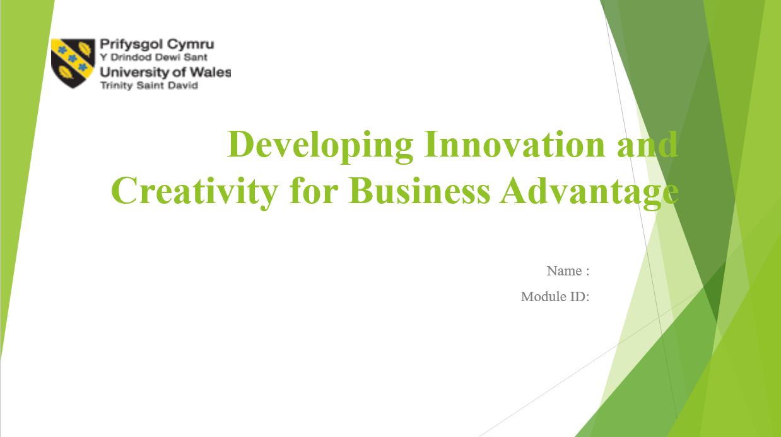
Slide 2:
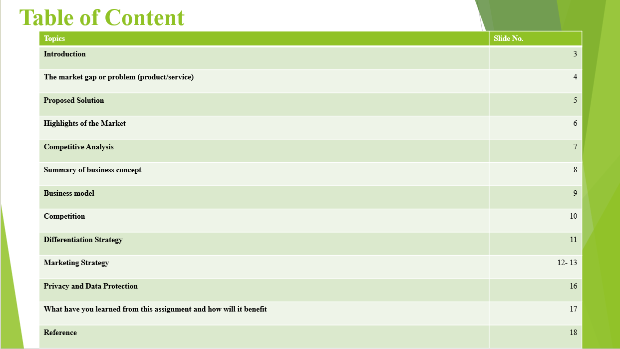
Slide 3:
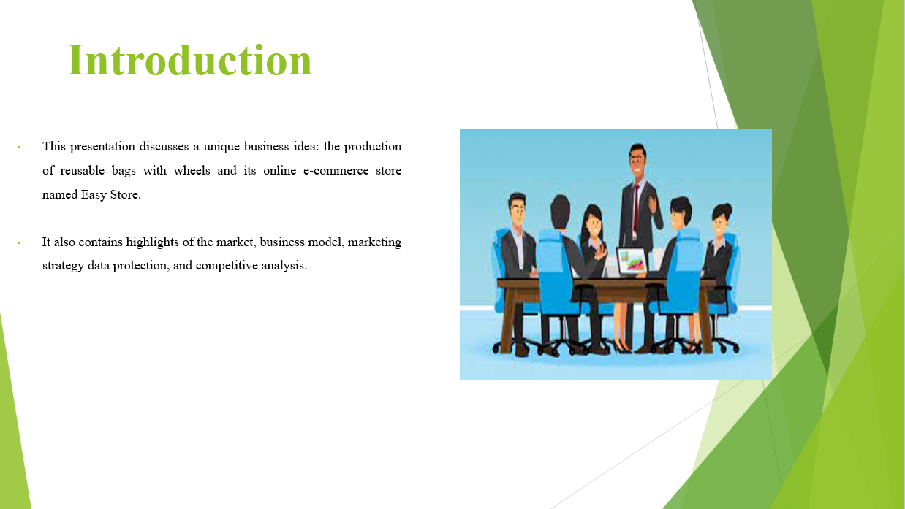
Slide 4:
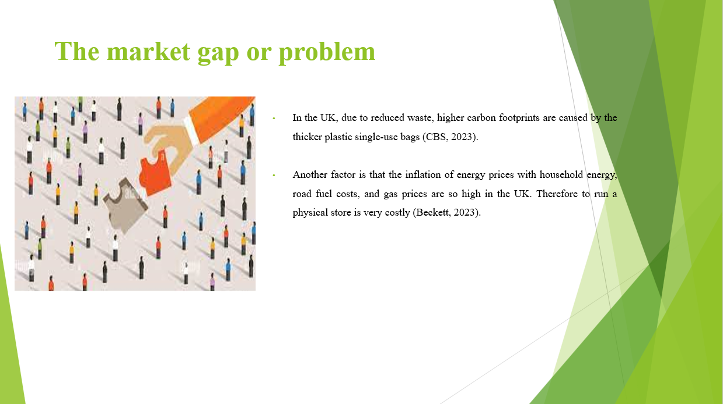
Slide 5:
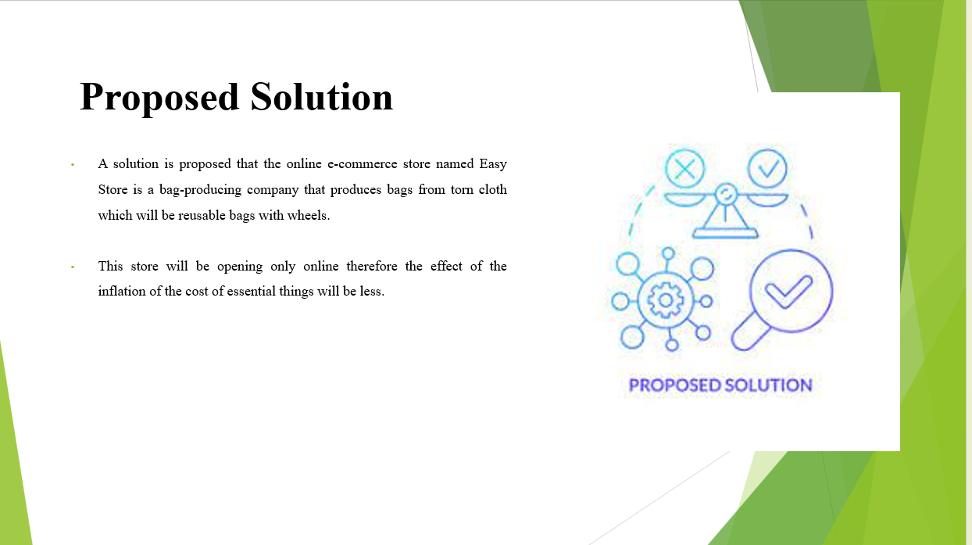
Slide 6:

Slide 7:
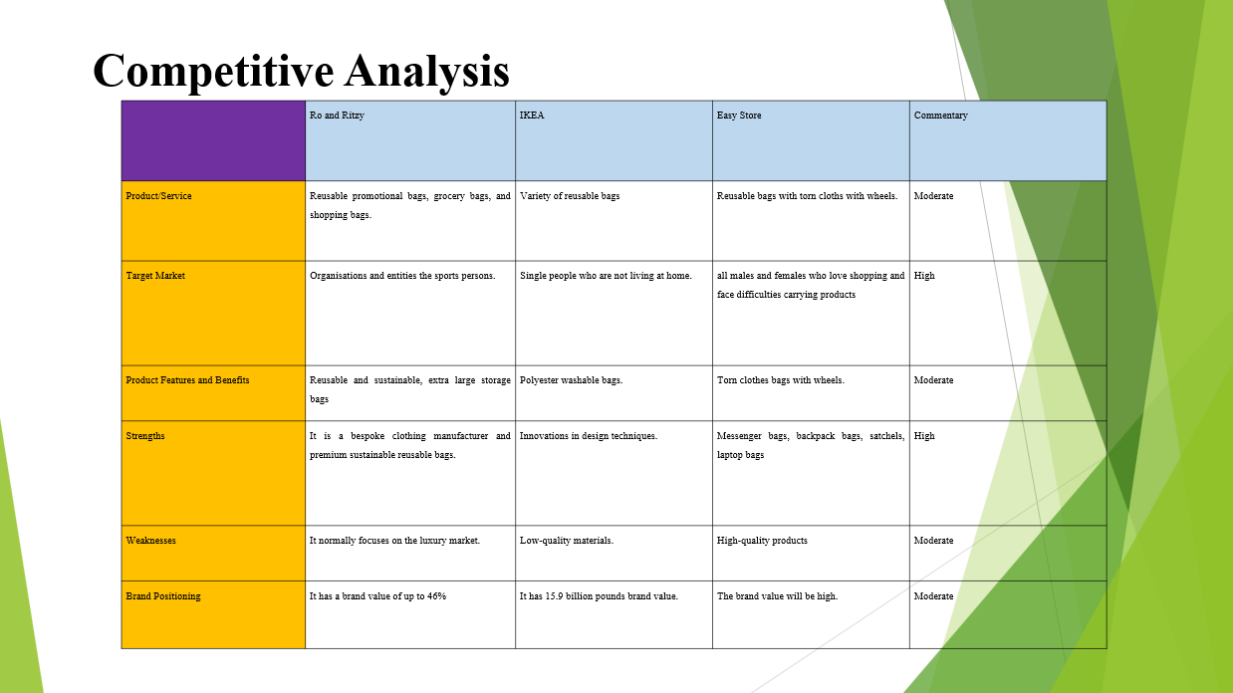
Slide 8:
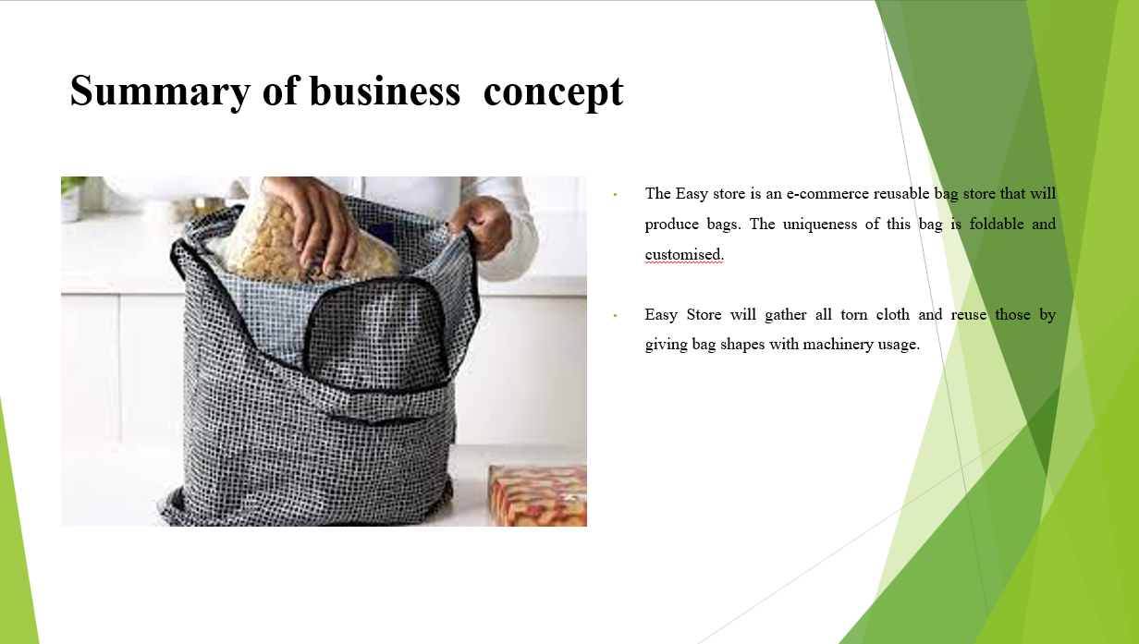
Slide 9:
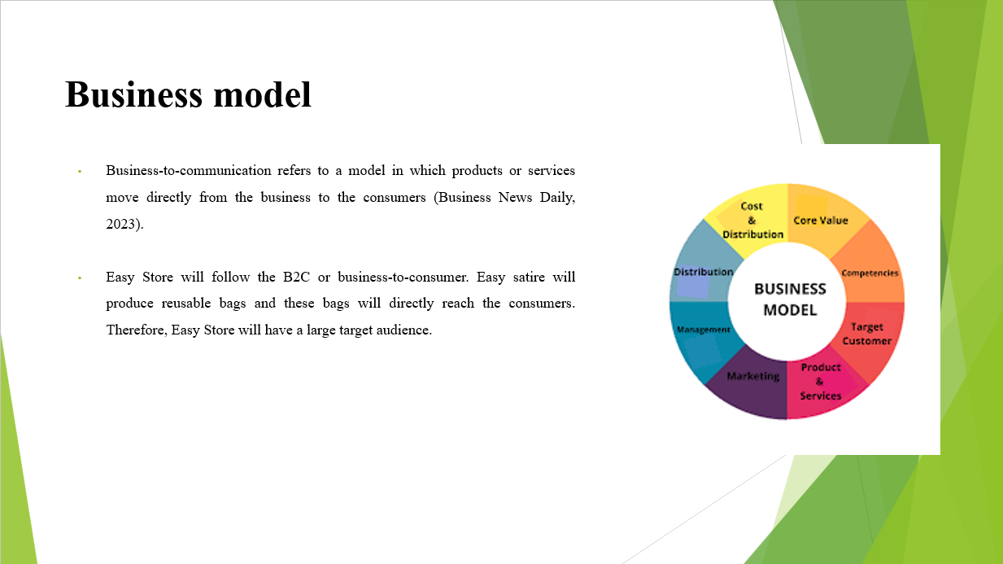
Slide 10:
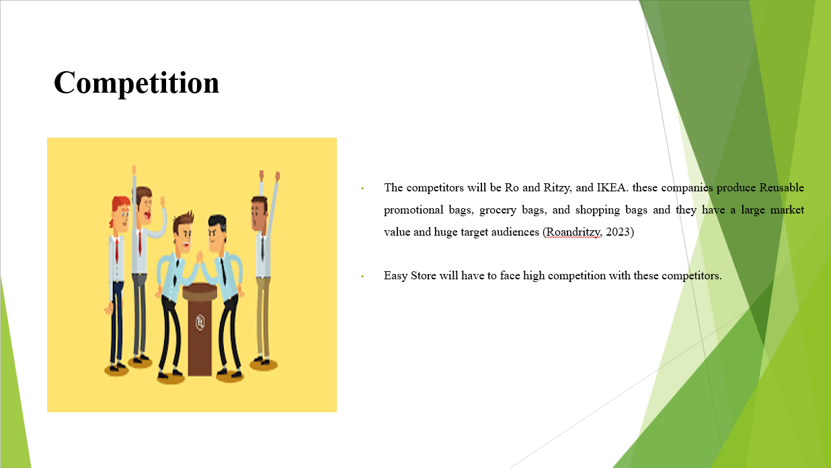
Slide 11:
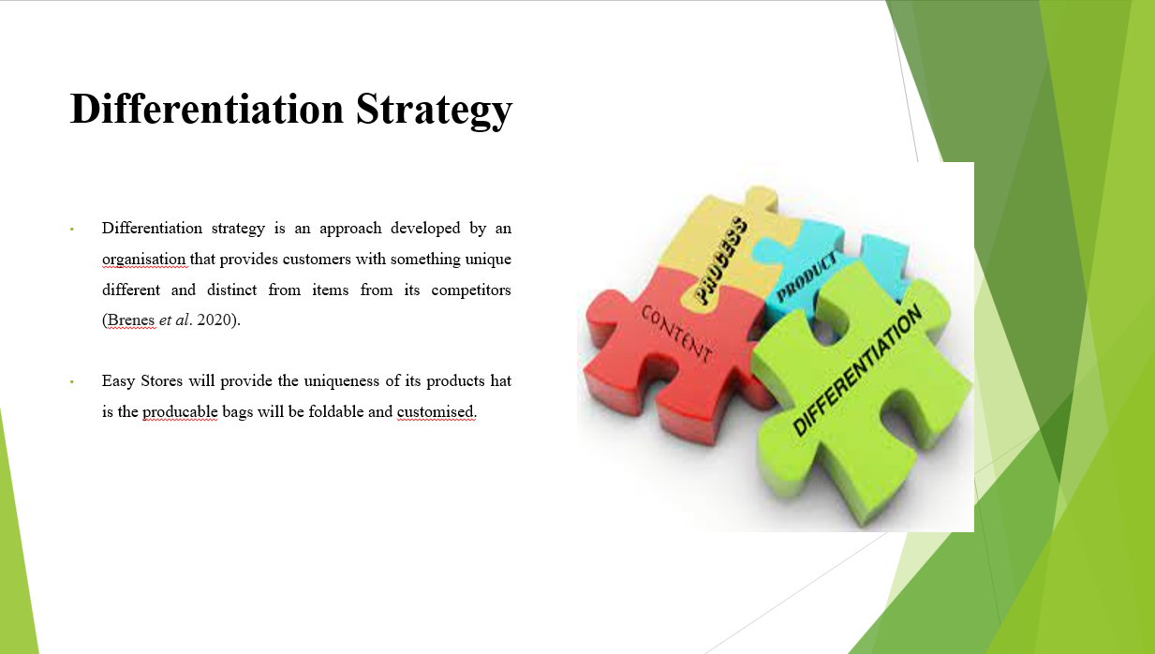
Slide 12: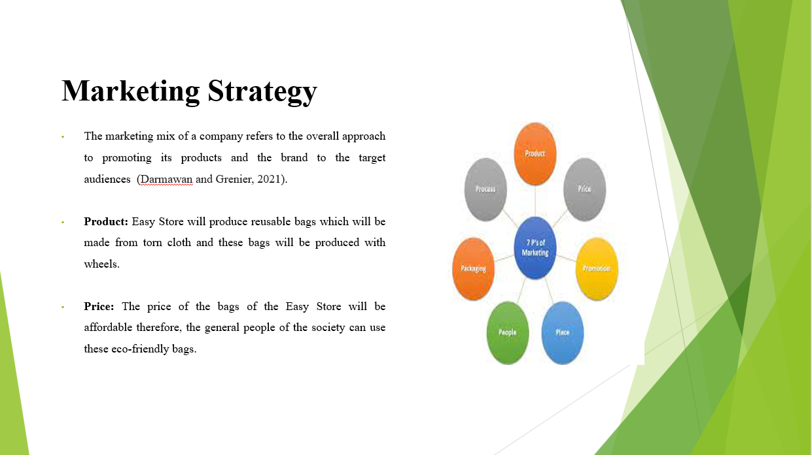
Slide 13:
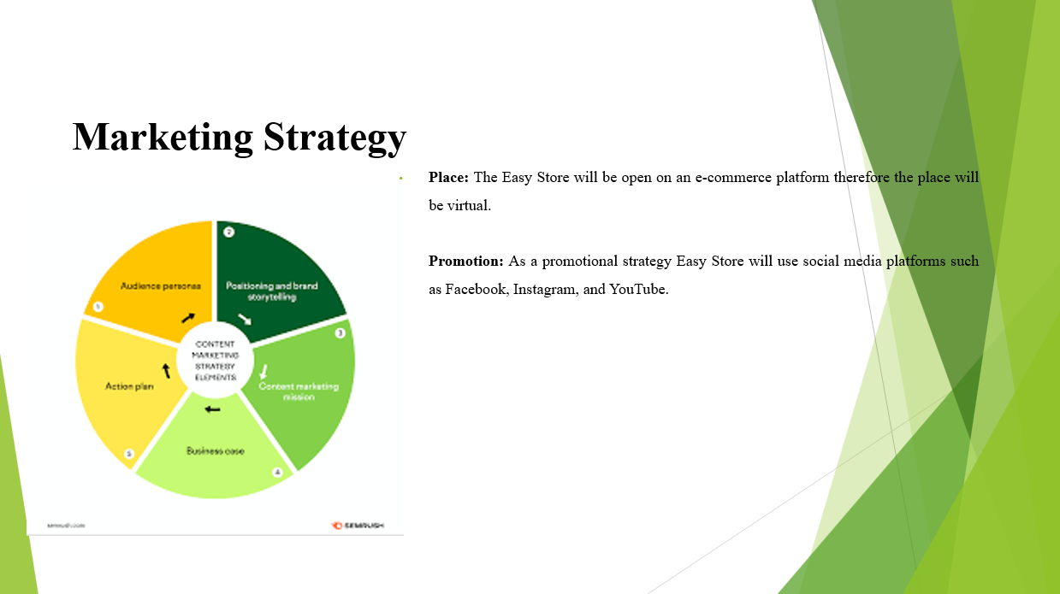
Slide 14:
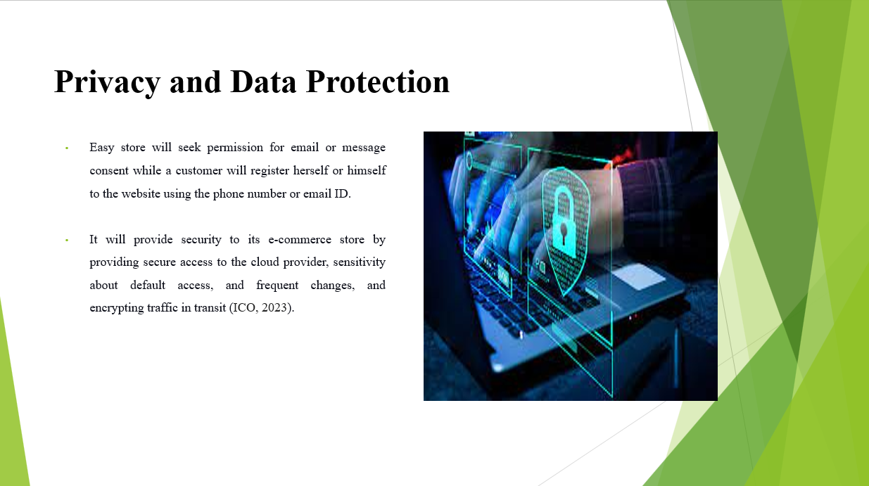
Slide 15:
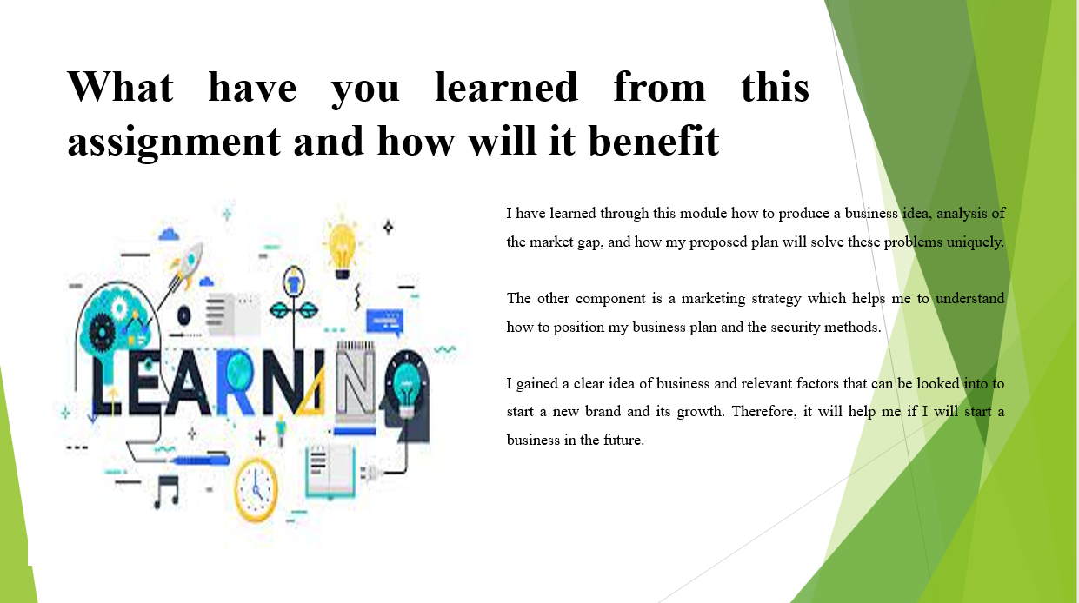
Slide 16:
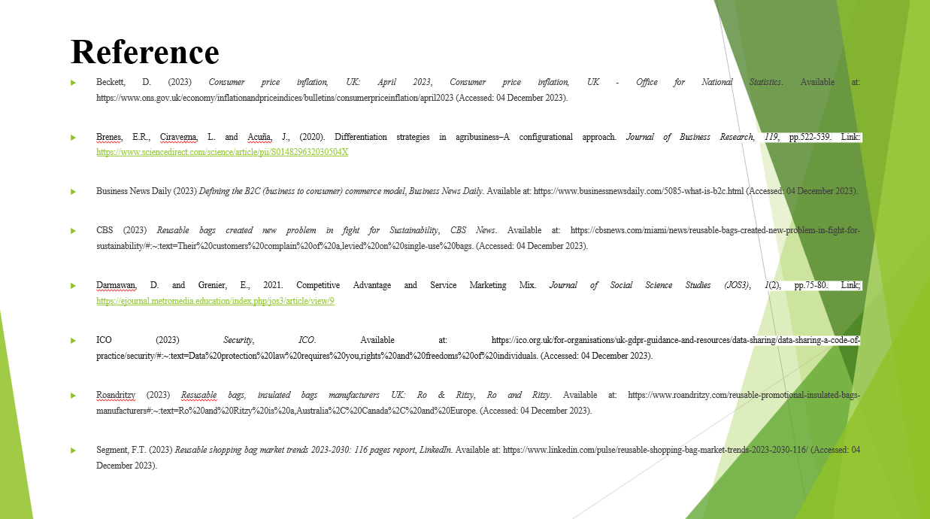
Slide 17:


