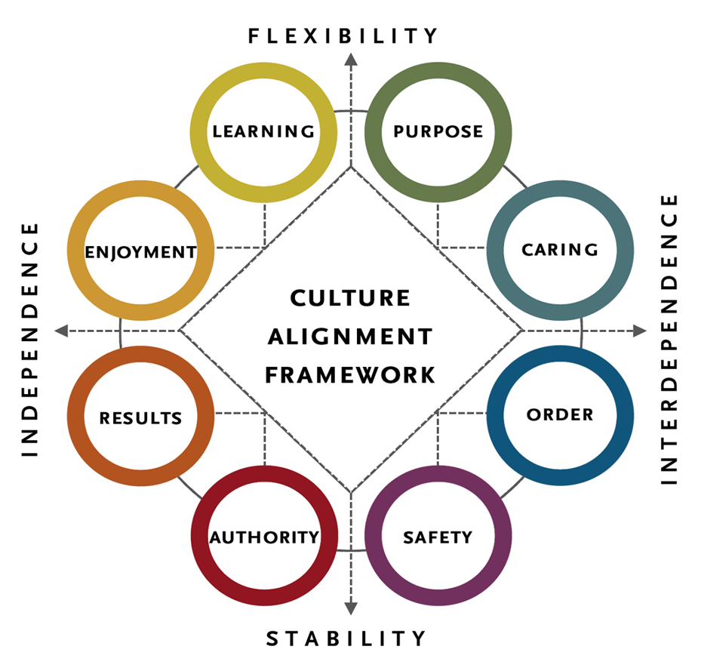
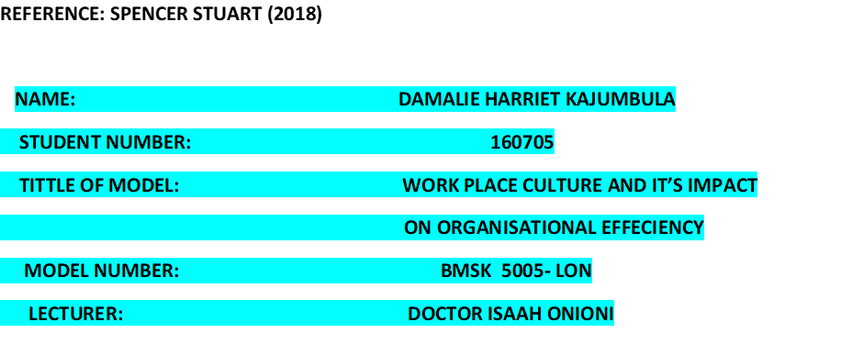

Contents
Discuss what culture is, dimensions of culture, why is it important to understand 4
Culture: 4
LIDL 5
. 6
Case study 6
Culture: 7
Personal values 8
Moral values: 8
Aesthetic values: 8
Belief: 8
Assessment: 9
Basic and induction training with “Leon” 9
9
Training units with theory and practice for everyone: 10
Structured further training: 10
Maslow’s Hierarchy of Need 11
Herzberg's Two-Factor Theory: 11
Scientific Management theories: 11
Management Theories of Motivation: 11
Taylor’s Scientific Management Theory: 11
McGregor’s X and Y Theory: 11
Organisational Virtual Structure: 12
Combating the Competitive Threat from Global Retailers: FMCG Initiatives: 12
Conclusion: 15
References: 17
http://uk.businessinsider.com/strategy 17
Mistakes that can make a company fail Reporter: Melia Robinson ©2004-2018 Joe Lau & Jonathan Chan 17
http://urn.kb.se/resolve?urn=urn:nbn:se:hig:diva-26456 10th08 2018 17
http://franklludwig.com/lidl.html 18
https://misebogland.wordpress.com/2013/03/20/extracts-from-a-diary-of-a-lidl-supermarket-worker/comment-page-1/https://stores.org/2017/07/03/poised-to-disrupt/ 18
https://philosophy.hku.hk/think/value/values.php http://www.pseudology.org/Psyhology/CultureCriticalReview1952a.pdf 18
https://www.washingtonpost.com/news/business/wp/2017/06/15/what-is-lidl-5-things-the-german-grocer-is-bringing-to-america/?noredirt=on&utm_term=.a9b102f343faec 18

Discuss what culture is, dimensions of culture, why is it important to understand

1 -INTRODUCTION:
The assignment talks about the Lidl and it is presented in a report form. It starts with an introduction which includes; the history of Lidl, its culture, operations, management structure, locations, controversies, and the quality of its customer service. This is followed by an assessment of the Culture at Lidl in detail and the role culture plays in achievement of its objectives. Also, included in the report is an evaluation of Lidl with its broader environment using the PESTEL and SWOT analysis techniques, followed by an appraisal of its cultural and ethical behaviour. The report ends with a conclusion and recommendations based on the contents if the report.

Discuss what culture is, dimensions of culture, why is it important to understand organisation culture, how culture influence performance…………….:
The assignment is going to talk about the history of Lidl how it started, its controversies, Management theories, culture, the number of stores and how it approaches is customer. Lidl Stiftung & Co. KG , previously known as Schwarz Unternehmenstreuhand KG based in Neckarsulm German .Lidl was stared in 19330 by Josef schwarz who was a fruit wholesaler and became partner with Südfrüchte Großhandel Lidl & Co In 1944 the company was destroyed by the second world war which took place between 1942-1945. After 10 years, Lidl was reconstructed and continued to develop and became a general food whole sale.

Lidl opened its first discount store in 1973. Lidl’s kept its store outlet as much as it could and copied Aldi’s ideal of removing products that were not sold from the shelve and sale them at a reduced price. In 1977 Schwarz’ son Dieter Schwaz started to focus on discount markets, larger supermarkets and wholesale market such as cash and carry and beaten up to 33 stores in Germany which made it to become a house hold name in Germany. Lidl kept their stores small as much as they can until the 1990’s that is when Lidl had 300 stores in Germany and had only 7 employees during that time. In1994, Lidl opened its first store in the UK and as they sustained with their stratagem of reduction, Lidl is recognised as the foremost discount retailers in the UK with 700 stores in the UK. With Dieter Schwarz’s Ideal of focusing on discount markets, Lidl has got about 1000 stores within Europe and United States. Lidl is the fifth largest retail in the world and it is one of the Schwarz group. The Lidl is the main provider of ice-covered foods in the United Kingdom market which make it have a big rivalry with Farm food. The last year income made by the Lidl was the 70 billion USD.

Culture:
According to Groysberg, B. (2018) Defined culture as “Culture is the tacit social order of an organization” In wide and tough way, the attitude and behaviours of their employees is shaped by culture. However, what is rejected or accepted is defined by the organisation as culture and whatever will be rejected or accepted will be defined by the organisation cultural norms. Groysberg,B. (2018).
According to Tylor, (1871): Culture, or civilization, and any other capabilities and habits acquired by man as a member of society, is that complex whole which includes knowledge, belief, art, law, morals, custom, Klineberg, (1952).

Boas, (1930): defined Culture as: the reactions of the individual as affected by the habits of the group, embraces all the manifestations of social habits of a community in which he lives, and the products of human activities as determined L\ these habits. The Mind of Primitive Man (19 11)

Culture includes a collection of communal genii which is not just the regular of separate physiognomies and cannot solely exist within a single parson. Culture is most usually knowledgeable through standards and prospects of a group which it exists in in communal actions, value and moulds which are the un written rules hours. In an organisation, culture approximately approve and smears manifold heights and it at times fights with the group itself (Groysberg etal.,2018)
.

LIDL
Global presence
Lidl is part retail group of the Schwarz which operation in 30 countries with 10,000 stores globally and 150 distribution centres around the world with225,000 employees globally.

First UK stores
Lidl entered the UK in 1994, opening the following 10 stores in November of that year.
Feltham
Winslow
Burton on Trent
Corby
Hinckley
Neath
Durham
Gipson
Shirley Southampton
Great Yarmouth
Number of UK stores
700 across England, Scotland and Wales
Number of UK Regional Distribution Centres
12
Number of UK employees
22,000
Size
Lidl is one of the fastest growing supermarkets, with a market share of 5.1% in the UK.
UK sales
£5.3 billion (FY16)
Expansion
Between 2017-18 Lidl is said to have £1.45 billion expansion investment
British Sourcing
Lidl UK works with suppliers across the British Isles wherever possible and is passionate about working with British producers and sources around two thirds of its products from the UK,

.

Case study
The key person (CEO) for Lidl is known as Jesper Hojer. Their products are Discount stores which as made Lidl as a discount store Globally. Lidl is owned by stakeholders known as: Schwarz Gruppe Dienter, Schwarz Stiftung and Gemeinnutziga.
Lidl is one of the multinational businesses which operates in the following countries Austria, Belgium, Bulgaria, Croatia, Cyprus, Czech Republic, Denmark, Finland, France, Germany, Greece, Hungary, Ireland, Italy, Lithuania, Luxembourg, Malta, Netherlands, Poland, Portugal, Romania, Serbia, Slovakia, Slovenia, Spain, Sweden, Switzerland, United Kingdom and the United States
Likewise, other multinational businesses, Lidl would want to know which models of information that could be applied in their own business from the international business strategy which means their managers must have a healthful knowledge that improves and make their firm function. According to Alain Verbeke, most of their managers must have pursued an MBA or executive MBA degrees. Nevertheless, they use their critical thinking of how to make their business succeed. Like other managers, they read, publications such as financial times, the wall street journal, the economics Business week and Fortune, they may even watch TV. But there is a publication known as Harvard Business review (HBR), which is normally used by multinational business managers for practical advice on how to improve multinational operations. In the early 1980’s, that is when the first article on globalization and its impact appeared on Multinational Enterprise (MNE) strategy. There have been always two key useful Journal publisher Standardized Mortality Ratio (SMR) and customer managed relationship (CMR) which are self-satisfaction proportions on the international business which are subject to senior managers as they are well written, perceptive and practical. Managers Strategies which are most effective suggests how to improve (MNE) presentation in two areas such as: Value creation across limits and to content stakeholders’ goal.
According to (Load,1977) there is a large and growing body of information about leader and leadership which have been made by detectives who have tried to subrogate the achievement of the organisation with particularised skill trains and leaders’ personal qualities by studying leadership in terms of absentees, possibility factors and style. The action of the leader transforms techniques to develop and improve the environment of the organisation (Burns 2003) was a struggle which was made to link the leader’s quality and personality. This view of leadership has built Ideals of rivalry and power based on personal attributes. (Thornton 2005) The impact of leadership on finest efficiency or main outputs of the organisation, were later tried to be underlined by both academics and business detectives. (Gordon& Yukl 204)
The organisation goals do not depend exclusively on the leader’s behaviour because, leadership is not an exceptional action invested separately. (Yukl1999) the organisation to achieve its goals, it requires input from the employees. (Gordon & Yukl 2004) Employees are considered as assets of the organisation as their performance is part of the success of the organisation. (Hurduzeu 2015) Hence, the association between leaders and employees are extended and explored by detectives to focus in achieving the organisational goals. Apart from effective leadership (Uzonna 2013)) sustainability, growth and progress of the any business is likely dependant on the inspired employees. However, the leader to succeed, must rely on the performance of every single the employee. (Zac car Rittman &Marks) (2002)
Finally, to be able to encourage followers towards the organisational goals, a leader must utilize motivational and managerial skills. (Hurduzeu) However, if there is no consistency between them, (Dubrin 2001) it is the manager’s responsibility to align. all managerial functions. However, managers may require an individual who can act as a leader if they find themselves struggling to implement the managerial activities to be able to take a corrective measure (Tsoukas1994)

Culture:
culture is essentially a construct that describes the total body of belief, behaviour, knowledge, sanctions, values, and goals that mark the way of life of any people. That is, though a culture may be treated by the student as capable of objective description, in the final analysis it comprises the things that people have, the things they do, and what they think. Herskovits, (1948)
The Culture of Lidl
According to Mali sales operator of Lidl (2017), they promote a culture of respect which inspires employees to be themselves. Their culture consists of four things such as: Value, support, Health and wellbeing and fun. Despite their discount prices, Lidl has a long-term forecast and steady nature in which to grow and develop.
Values:
Values are standards or ideals with which we evaluate actions, people, things, or situations. Beauty, honesty, justice, peace, generosity are all examples of values that many people endorse. In thinking about values, it is useful to distinguish them into three kinds:
Personal values:
values endorsed by an individual. For example, some people regard family as their most important values, and structure their lives so that they can spend more time with their family. Other people might value success instead and give less time to their families to achieve their goals.
Moral values:
values that help determine what is morally right or wrong, e.g. freedom, fairness, equality, etc, well-being. Those which are used to evaluate social institutions are sometimes also known as political values.
Aesthetic values:
values associated with the evaluation of artwork or beauty.
However, according to Henderson, M. Harper business (2003), Value at work is” The Invisible Threads Between People, Performance and Profit”
For all the publicity, classifying business Values is valuable only if organisation can classify the business values, then refer to these values in all business -choices and be able to inspire staffs to do the same. Values at Work includes conferences with business bosses, previously smearing values-based organisations methods and provides a feasible guide for managers wishing to comprehend values and their effect on intimate’s presentation, and profit. However, according to Mali (2017) stated that Lidl’s aim is always to deliver unresolved value for money and to gratify their customers. They believe in simple performs in making well-organized choices to unite the business which helps them to grow. Also, they take their financial, communal and ecological accountability considerately with admiration by following all laws where appropriate. Lidl believe in trust and through respect and support they potential to respect and be dedicated and fair to everyone who works for them. Last but not list, they uphold and concept censure in a working setting filled with praise and recognition. Mali (2017) sales operation.

Belief:
According to Lidl’s report (2016/17), they believe that discounter replica obviously helps to drive sustainability to their consolidated supply chain with capability and wiriness which brings greater control to well-organised energy use of resources.
Also, they have a strong track record in altering the resources of their customers. According to the Sunday Times (14/72016) They love to create work that is contentious, work that gets people talking. And we love to create work that engages on a deep emotional level, or simply makes you laugh. But above all, we love work that works. And we love to be where our client’s consumers are. To that end, our most powerful creative ideas have two facets in common: they clearly match marketing intent with consumer need, and they come from insights based on a thorough understanding of the context the idea needs to operate in. So, although we prize creativity, we never regard it as an end. Its true purpose is to realise our clients’ marketing objectives. This was our belief when we established Chemistry as a fully integrated communications agency in 1999, and it remains our belief today.

Assessment:
Based on the case study stated above in this report, its values and beliefs, Lidl promotes a culture that encourages colleagues to support one another, that aims at the environment that respects human rights and provides good working conditions which are safe and comply with the rules and regulations of health and safety. Furthermore the organisation not only forbids conditions that violate fundamental human rights at the work place but also ensure that workers are briefed on health and safety and adhere to the relevant standards at workplace In addition Lidlalso promotes values that meets needs of all its stakeholders, and this is manifested in the values of respect, recognition, responsibility and trust. However, it not very clear how successfully these values are being applied to achieve the set objectives. The goal should be set for the values and measures identified for each goal to ensure the purposes for each value are being achieved

For example: “As is the case in all large companies, Lidl is also asking itself the question: when, and in what form, does it make sense to migrate from a Lidl-specific on-premise solution to a cloud-based solution?”
Success required qualified workers Personnel development at Lidl is supported by the three pillars of basic training, further training and development, for each of which to develops exact learning solution. Each of the three areas is facilitated by its own system solutions. Lidl relies on the intermeshing of IT-supported and practical learning within the framework of basic and induction training. The challenge in this sub-domain consists of achieving the blended learning approach, since most employees do not have their own access via a PC. The on-premise SAP Learning Solution (SAP LSO) forms the technological platform for system support. All systemic personnel development processes are managed via a global personnel system, accessed by the individual countries.

Basic and induction training with “Leon”

Lidl like any other organisation in retail uses a relatively large number of casual employment and therefore faces a high level of labour turnover. The processes used involves using new machines for example the introduction of auto banking machines the store requires training of employees on how effectively to use the machine. Typically, many employees are involved in the induction, from new colleagues to the store manager, the sales manager and the personnel department. In the past, a blended learning approach in which theory and practice were closely combined was a success. The aim for the framework was to introduce an IT supported solution whereby the induction of new workers can be completed within four weeks. In the Leon basic training system, Lidl opted for a Kiosk- solution in the form of an employee terminal that is easy to use, like large iPad and which is made available in the store’s staffrooms.

As is the case everywhere in retail, Lidl has a relatively large number of casual employees and the accompanying high level of turnover. Moreover, the operational procedures in store branches, for example the introduction of automatic baking machines, are often affected by changes. Typically, many people are involved when new workers are inducted: the (already trained) colleagues, the store manager, the sales manager and the personnel department. In the past, a blended learning approach, in which theory and practice were closely combined, proved itself effective. The aim, within the framework of this project, was to introduce an IT-supported solution whereby the induction of new workers can be completed within four weeks. In the Leon basic training system Lidl opted for a kiosk-solution in the form of an employee terminal that is easy to use, like a large iPad, and which is made available in the stores’ staff rooms.

Training units with theory and practice for everyone:
An exercise unit allied to a exact part inside Leon contains of a diversity of units and continuously twitches with the theoretic stage, in which the fundamentals are connected via e-learning. Each theoretic stage accomplishes with a communicating test. In the applied stage that shadows, the employee excavates the information learnt at the fatal in day-to-day work in the store. This stage is watered-down by a coach, who is, as a rule, a knowledgeable salesclerk or treasurer. The applied stage ends with a response unit. This makes it likely to ensure that the worker has grasped all the gratified erudite in the theoretic and applied stages. 10,000 staffs consume previously rummage-sale Leon since June 2015 and the rollout is deliberate to twitch for the entire of Europe in October. By the end of 2017 worker stations for introductions will be connected in all of Lidl’s 10,000 store branches.
Structured further training:
Alongside a systematic induction, Lidl also sees further training exercise to established employees as a further success factor for effective personnel development. In this sub-domain of personnel development, Lidl makes a distinction between formal and informal learning. Even at the time of the migration of the ERP systems to SAP the question arose; how can we make the necessary knowledge available to employees at their precise moment of need (informal learning)? The answer: tt knowledge force. Small e-learning sequences built in-house using tt knowledge force which the employee can call up via a web portal at any time while at their place of work to knowledge force, which the employees can call up via a web portal at any time while at their place of work. businesses and logistics centres achieve the exercise management, invitation (or, where training is not required, disinvite) staffs to exercise and oversee them.
Alongside this relaxed knowledge, Lidl also delivers official knowledge in the procedure of traditional meetings or additional multifaceted e-learning units, which are managed via a web portal based on the SAP Knowledge Answer. The key users in the management of the numerous separate republic

Management theories:

Maslow’s Hierarchy of Need
Maslow (1957) stated that human needs form a hierarchy, ranging from lower order needs (physiological needs) to higher order needs (the need for self-actualization). He used a pyramid to illustrate the levels of motivation and states that once a need is accomplished; the individual moves towards the next level and strive to fulfil that. He categorized individual needs into physical needs (food, water, sex, etc.), security needs (personal security, health security, economic security, organization's security, work place security, etc.), love and belonging needs (love, intimacy, affection, friendship, etc.), esteem needs (self-respect, dominance, self-esteem, etc.) and self-actualization needs (realizing personal potential, seeking self-fulfilment, personal growth, etc.)

Herzberg's Two-Factor Theory:
According to Herzberg’s (1968) two-factor theory there are certain factors, related to the job, which create job satisfaction, and others, which create dissatisfaction. According to Herzberg (1968), hygiene factors (satisfiers) deal with the factors involved in doing the job (e.g. salary, work conditions, policy, relation with supervisor, security, etc.), whereas job motivators (dissatisfiers) deal with the factors that define the job context (e.g. achievement, recognition, work itself, responsibility, and advancement). According to Herzberg (1968), hygiene factors cannot be used as motivators, because satisfaction from hygiene factors is temporary. Employees' strive to achieve hygiene needs because they are unhappy without them, but once satisfied the effect wears off. Employees' motivation to work can only be enhanced by real motivators, such as achievement, advancement, development, etc.

Scientific Management theories:

Management Theories of Motivation:
The following are two important management theories related to employees’ motivation toward work.

Taylor’s Scientific Management Theory:
Taylor (1911) proposed the theory of scientific management to improve the performance (productivity) of employees, by optimizing and simplifying the job. According to the managers and workers need to cooperate with one another. He suggested breaking down the 13-work process into the smallest possible units, to determine the most efficient method to accomplishment the task. Furthermore, he asserted that the organization should identify the best way to do a job, train workers to handle each element in a predetermined manner and set up an equitable system of reward for improved productivity.

McGregor’s X and Y Theory:
According to McGregor (1960), management is responsible for organizing the elements of productive enterprise, including the human resources. He stated that without active intervention of management, employees would be passive. Therefore, they must be persuaded and rewarded. Based on these assumptions, he proposed two theories, theory X and theory Y. Theory X states that the average human being has an inherent dislike to work and will avoid it if he can. Therefore, employees must be forced to work, because they prefer to be directed and avoid responsibility. Whereas, theory Y states that the effort in work is as natural as play. Employees apply self-control and self-direction in the pursuit of organizational objectives, without external control or the threat of punishment. Their commitment to work is associated with the reward they achieve.
According to McGregor (1960), potential for development, assuming responsibility, and the readiness to direct behaviour toward organizational goals are absent among the employees. And it is a responsibility of management to arrange organizational conditions and methods of operation so that employees can best achieve their own goals, by directing their own efforts toward work.

Organisational Virtual Structure:

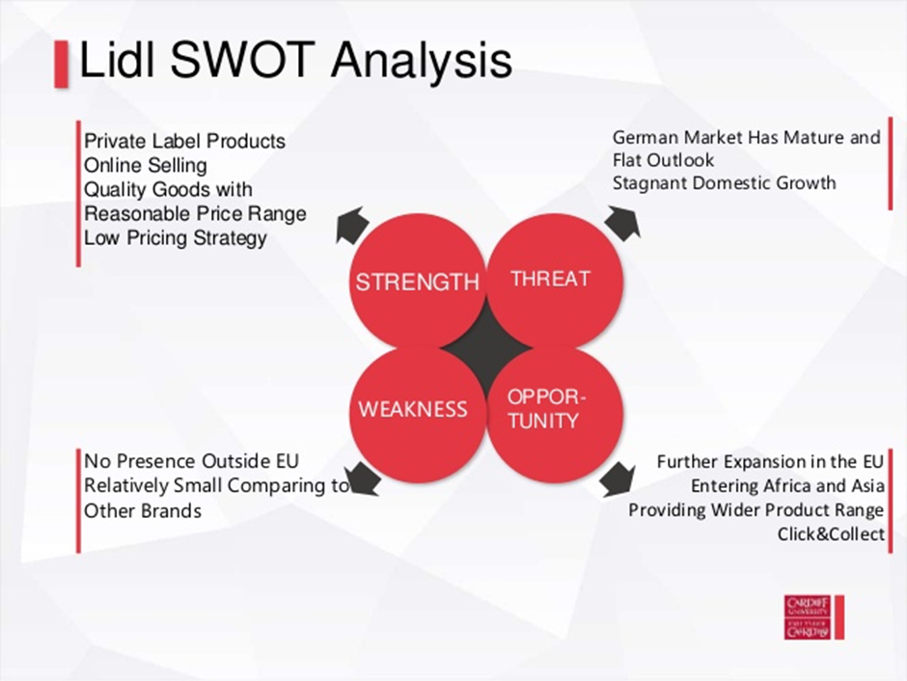

The purpose of the SWOT analysis is to analyse present situation in the market place it involves the internal environment which includes the strength and weakness and the external environment which includes threats and opportunities with reference to the diagram stated above Lidl’s brand is not competent enough outside the EU though it has opportunities of expansions in the EU ,Africa, and Asia with a potential to provide a wider product range in all its stores, also, Lidl uses its critical success factors such as online selling quality goods with low pricing strategy and the brand of private label products as its differentiating strategy.

Combating the Competitive Threat from Global Retailers: FMCG Initiatives:

There are a range of responses that FMCG companies can consider as mechanisms to combat the growing competitive threat from increasingly powerful global retailers:
Revolutionise – over-all retailers’ own tag is result copies of manufacturer makes for that reason, retailers have no past meaning-full speculation in NPD dirctly and/or via their own brand providers. FMCG firms have the reserves to capitalise in a high equal of R&D expenses to acquire results which have branded skills at 1.2 per cent of sales, R&D outflow in the global food business is at very moderate heights relations to the 10-12 per cent intensities of the pharmacological and health care businesses. However, FMCG firms must deliver a food result range with clear revolution to persist with different needed identification from their own offer from the retailers’. Firms should not only seek revolution that are produce related but in everything that they do such as: - supply chain organisation, IT, customer organisation, required management and, even in free enterprise, to persuade workers that innovations that disappoints, is a truth of life. But, disappointment to revolution is unforgiveable and it is equivalent to a demise wish! Fearne (2001).
Cost Leadership – according to McGoldrick (1990) “economise” or “cause” was a required world-wide for the firms to cut costs and remain viable. Notwithstanding the plausibility of Michael According to Porter’s (2006) article states that; generic business strategies, cost awareness and management is a required state for market management. In additional Porter notion - value chain analysis - is appropriate. It is” counterproductive” to reduce expenditure and, from side to side of performing, it reduced customers value by an equal better amount. The challenge is to identify customers value and what they are willing to pay for. Nevertheless, to emphasise on the key drivers of cost benefit namely, frugalities of scale, and of knowledge, manufacturing methods, product project, cost contributions, use of volume, and decision-making/structural efficacy - and their minimisation, keeping customer necessities resolutely noticed.
the supermarket segment drew the lion’s share of courtesy for FMCG businesses, to expand segments in the Exiting physical Market place - to-date, as this was the segment with the utmost capacity and value. Though, its comparative position was failing but there are other ways to the customer; for example, there is sustained development in the food facility subdivision. In past, food facility has remained well-serviced by itself. Foodstuffs absorbed at this subdivision inclined to be the comprehensive carton and/or superior size forms of foodstuffs that are sold at grocery trade. In additional, what was once a disjointed subdivision, problematic to facility, is flattering progressively focussed and qualities the care to buyers’ necessities that was typical of the grocery retail segment.

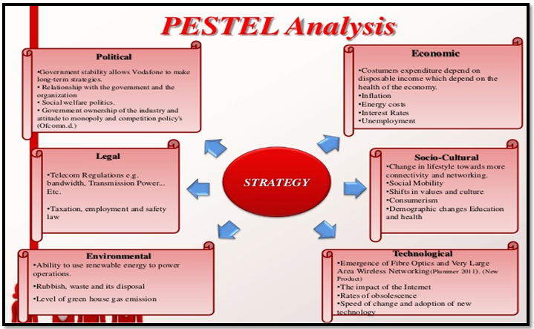

Likewise, Lidl also, uses the PEST model to scan the atmosphere in which Lidl functions. With reference to the diagram stated above, Lidl faces contests from both the macro atmosphere and the viable setting. The socio influence includes people’s life, connectivity and most particularly the equal of one-use revenue which scripts their buying power. The level of assessment also marks not solitary the one-use pay of the customers but also the net income of Lidl. The atmosphere which is characterised hooked on; exterior, presentation and interior is repeatedly altering therefore Lidl should unceasingly it to classify the services in contradiction of its business and take counteractive act in order to uphold its advantage differently..

Conclusion:
Findings from the report shows that Lidl is an international retail business which is growing rapidly due to its organisational culture and beliefs that values customers. It is also found out that Lidl has a culture and value that are manifested in its management structure, Leadership styles, social responsibility and ethical values of respect, recognition, responsibility and trust which have shaped the culture of Lidl McLaughlin (2008).
However, even though the organisational culture of Lidl encourages ethical behaviour regarding all its stake holders as well as focusing on the method used by the organisation to ensure the achievement of the set goals, many workers are overworked due to the small numbers of employees as well as affecting their performance but is also unethical in that Lidl is not complying with its code of conduct.
The result also show how Lidl had a continuous growth due it’s” no-frills approach and the “low cost business model” with an aim of offering products of high quality at very low prices to its customers. In addition, the external environment due to hard economic conditions is also making consumers to r=turn to low coast stores which as an advantage to retailers using the discount strategy like Aldi. However, the organisation should focus on its critical success factors as well as making sure that it has the core competencies required to support the critical success factors to enable them to have a sustainable competitive advantage.
Furthermore, it is identified that Lidl uses the strategy of differentiation through its high-quality products at low prices and the brand image. Moody’s senior analyst Sven Reinke spoke of a significant risk of an intensifying war developing especially in the united Kingdom market However, Lidl should consider the fact that differentiation can be eroded if the strategies being used to differentiate are imitated and also reduce the customer loyalty For example: Moody identified that Azda supermarket has the ability to reduce its prices as a way of mitigating the effect of the retail discounter.
One of the values of Lidl is to satisfy its customers through the provision of value for money, which includes economy, efficiency and effectiveness. However, all these strategies must be seen in terms of how they have been performed I recommend Lidl to have in place a performance measurement system that can be used to evaluate how well it is performing in the achievement pf the goals set regarding value for money. Regarding the SWOT analysis, Lidl should use its strength and opportunities to combat the threat and weaknesses. For instance, it is stated as its weakness that the market in German is at the maturity stage of the product life cycle. The opportunities that are in Africa, Asia and other European countries should be considered. In addition, the current critical success factors should be continually reviewed to make sure that they are still appropriate.
Also, the findings show that the management of Lidl uses minimum social standards both from within the organisation and its relations and the external stakeholders. I recommend that it focuses on the human resources to ensure they are motivated and retained because human capital is the key to the achievement of the objectives of retail company like Lidl. The system in use of having a small number of employees at the stores does not only demotivate them but also it affects their performance. I suggest Lidl to review its current System and to make sure they have in place a system with a structure, policies, procedures and benefits which reflect its organisational cultural and ethical values

References:
Ballabio, G., 2018. Cultural change to survive. Case study of Softplan.

https://careersportal.ie/pdfs/Lidl_release.pdf

Zeira, Y., Harari, E. and Nundi, D.I., 1975. Some structural and cultural factors in ethnocentric multinational corporations and employee morale. Journal of Management Studies, 12(1‐2), pp.66-82.
Porter, M.E. and Kramer, M.R., 2006. The link between competitive advantage and corporate social responsibility. Harvard business review, 84(12), pp.78-92.

Frondizi, R., 1971. What is value?

(Ellis and Kelley, 1992; McGoldrick, 1990, p. 98; Davies and Brooks,
1989, p. 193; Hoch, 1994). Aldi, Lidl or Wal-Mart could be mentioned a

Morschett, D., Swoboda, B. and Schramm-Klein, H., 2006. Competitive strategies in retailing—an investigation of the applicability of Porter's framework for food retailers. Journal of Retailing and Consumer Services, 13(4), pp.275-287.

Fearne, A., Duffy, R. and Hughes, D., 2001. Concepts of collaboration: supply chain management in a global food industry.

Klineberg uses it in his Social Psychology (1940, p. 62). Another important recent textbook in psychology (Gardner Murphy’s Personality, 1948)

Kroeber, A.L. and Kluckhohn, C., 1952. Culture: A critical review of concepts and definitions. Papers. Peabody Museum of Archaeology & Ethnology, Harvard University.
The Mind of Primitive Man (19 11)

Groysberg, B., Lee, J., Price, J. and Cheng, J., 2018. The leader’s guide to corporate culture. Harvard Business Review, 96(1), pp.44-52.

Lidl UK is an equal opportunities employer. ... Lidl UK expects all its employees and prospective employees to be treated with respect. Our policy is to provide a working environment in which all employees can realise their potential free of harassment and discrimination.

http://uk.businessinsider.com/strategy

Mistakes that can make a company fail Reporter:
Melia Robinson ©2004-2018 Joe Lau & Jonathan Chan
Arimoto, S., Kawamura, S. and Miyazaki, F., 1984. Bettering operation of robots by learning. Journal of Robotic systems, 1(2), pp.123-140.
https://www.birminghammail.co.uk/news/lidl-store-aims-more-double-1296712

http://urn.kb.se/resolve?urn=urn:nbn:se:hig:diva-26456 10th08 2018
https://www.change.org/p/lidl-make-lidl-respect-employer-s-rights-and-working-condition-s-laws
https://careers.lidl.co.uk/en/2406.htm
http://www.diva-portal.org/smash/record.jsf?pid=diva2:1198554 10th082018
https://www.dunnhumby.com/resources/blog/myths-lidl

http://franklludwig.com/lidl.html

https://www.iapi.ie/files/awards/1474279037_1473375164_rf_lidl_live_a_little.pdf 13/08/18
https://www.lidl.co.uk/en/sustainability.htm

https://misebogland.wordpress.com/2013/03/20/extracts-from-a-diary-of-a-lidl-supermarket-worker/comment-page-1/https://stores.org/2017/07/03/poised-to-disrupt/
https://www.tt-s.com/en/media-library/media/show/learning-pays-off-it-support-for-training-and-operational-education-at-lidl/

https://philosophy.hku.hk/think/value/values.php http://www.pseudology.org/Psyhology/CultureCriticalReview1952a.pdf

https://www.washingtonpost.com/news/business/wp/2017/06/15/what-is-lidl-5-things-the-german-grocer-is-bringing-to-america/?noredirt=on&utm_term=.a9b102f343faec

APPENDIX:1



