Centralised Alignment of Local Medication and Emergency Resources (C.A.L.M.E.R) Project Initiation Document (PID)

Name: Matthew John Stokes

Student Number: 1707417

Course: Software Engineering (BSc)

Module: L5 - Project Management and Research Methods (Sue) (ACDA5004)

Date: Wednesday 14th December

Declaration

I declare that this report is the product of my own / group work and is not being submitted for any other degree or certification.

Table of Contents
Declaration 1
The Project 3
Project Aim 3
Objectives 3
Scope 4
In Scope 4
Constraints / Assumptions 4
Authority / Responsibility 5
Resources 5
Project Benefits 5
Optional Features 5
Cost and Timescale 6
Cost/Benefit analysis 6
Appendices 7
1 – Organisation Structure 7
2 - Stakeholders 9
3 – Project Team Roles 9

The Project
In the event of a disaster such as a terrorist attack or natural disaster the healthcare system is very often over run and is unable to scale to deal with the volume of injuries that can occur within minutes. This not only means that the newly injured patients cannot get the care required, but also existing patients in hospitals get neglected and cannot get the required medicine due to shortages.

There are currently no systems that can direct patients to locations where the medicine and care required is available which results in over use of nearby hospitals and patients being unaware of what departments or services are available and how to use them.

Project Aim
In the event of a disaster both medical staff and patients need access to a centralised database system that provides easy to use information on the best location to get the treatment they require. The system will allocate resources and staff and display the information in an easy to use system.

Objectives
- Create a database that will provide directions for patients to get the medical attention they require.
- Provide direction to suitable care settings for patients that need to continue attending existing appointments for things such as dialysis.
- The system will keep count of the amount of patients that use each of the facilities.
- Provide directions to basic amenities such as clean drinking water.
- Provide suitable transport routes to the required treatment centre.
- Stop medication being stock-piled in the wrong areas and being unused. The centralisation of treatment centres will ensure that medicine is distributed as required.
- Distribute health care staff to locations required according to demand.

Scope
The system will utilise a Tableau database and will include an on-screen map that will be make directing patients to relevant establishments easily.

In Scope

- Acute medical conditions/injuries
- Distribution of medication to avoid stock-piling
- Use of devices that require power such as ventilators.
- Existing conditions such as Dialysis, Asthma, Diabetes, Oxygen tanks.
- Locations of suitable care centres
- Suitable transport routes to the care centres
- The type/amount of staff assigned to each care centre
- Directions to centres with basic amenities.

Constraints / Assumptions
- Computer system updates
- Power availability
- Internet Availability
- Purchasing and delivery of the Halo device
- The scale / amount of damage caused by the disaster
- Transport of patients to one of the care centres
- Transport routes are in tact
- Delivery of medication
- That the care centres aren’t damaged in the disaster
- Staff quantities / skillsets

Authority / Responsibility
- Project Organisation: See appendix 1
- Project Sponsor: Local Authorities/Government: Heads of Local Authority
- Project Manager: Christine Woods, the project managers responsibilities will include keeping the project on track and making sure the project segments get completed in time.
- Stakeholders: See appendix 2
- Project Team: See appendix 3

Resources
- Tableu database software
- All team Members
- Hardware Requirements
- Software Requirements
- Power and Network Infrastructure
- Information of local area
- Care centres

Project Benefits

- Better organisation of A&E centres resulting in smoother operation
- Patients will get directions to the most suitable care centre resulting in less overcrowding and restricting the amount of people using the wrong centre
- Better management of medicine and resources, allowing them to be delivered strategically to the most suitable care centres
- Better management of staff and will make sure that the correct amount of staff are at each centre, as well as making sure the correctly skilled staff are matched to the best suited centre for their skillset

Optional Features

- A digital, interactive map showing major damage to the surrounding areas
- Details on medicine and equipment suppliers, as well as instructions on how to order more supplies
- Web application allowing the system to be viewed on patients’ devices, removing the restriction of having to install HALO devices
- Missing persons database

Cost and Timescale
- Initial set up cost would be the hours that the database implement
- Costs ensuring 100% uptime access to Tableau/Server
- On-going management of the Tableau system
- Tableau Software and Hardware updates

Cost/Benefit analysis
- Freeing up unnecessary patient visits to the emergency areas
- Delivering supplies to all areas rather than a main central drop off
- Dedicated specialist areas allowing for equipment to be utilised fully

Appendices

1 – Organisation Structure

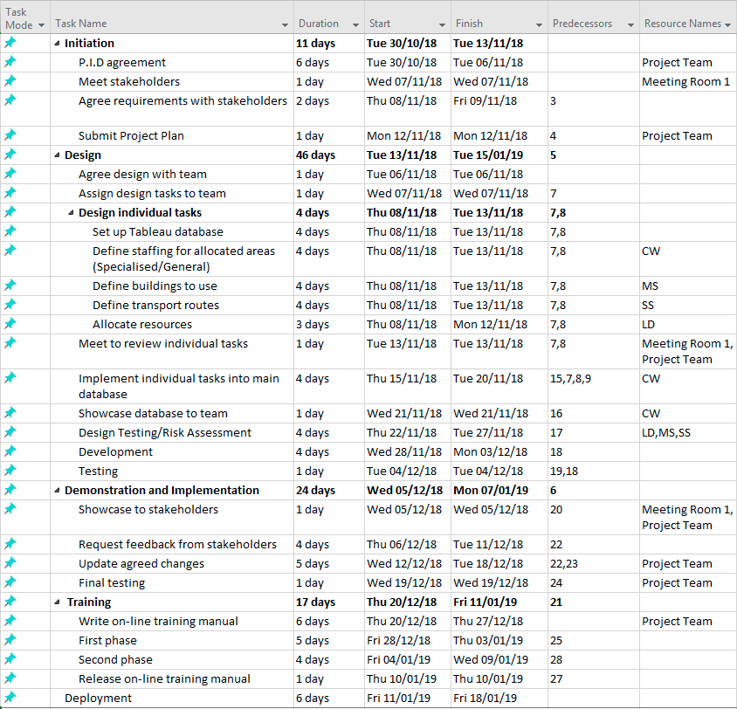

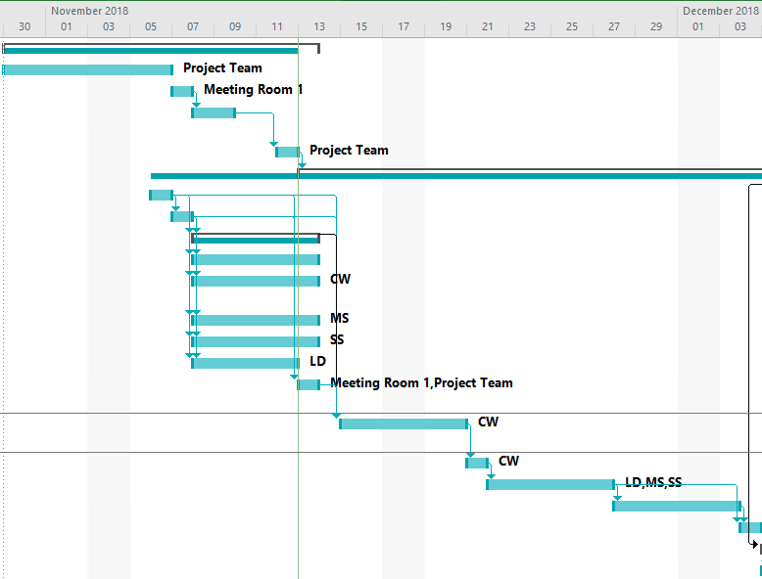

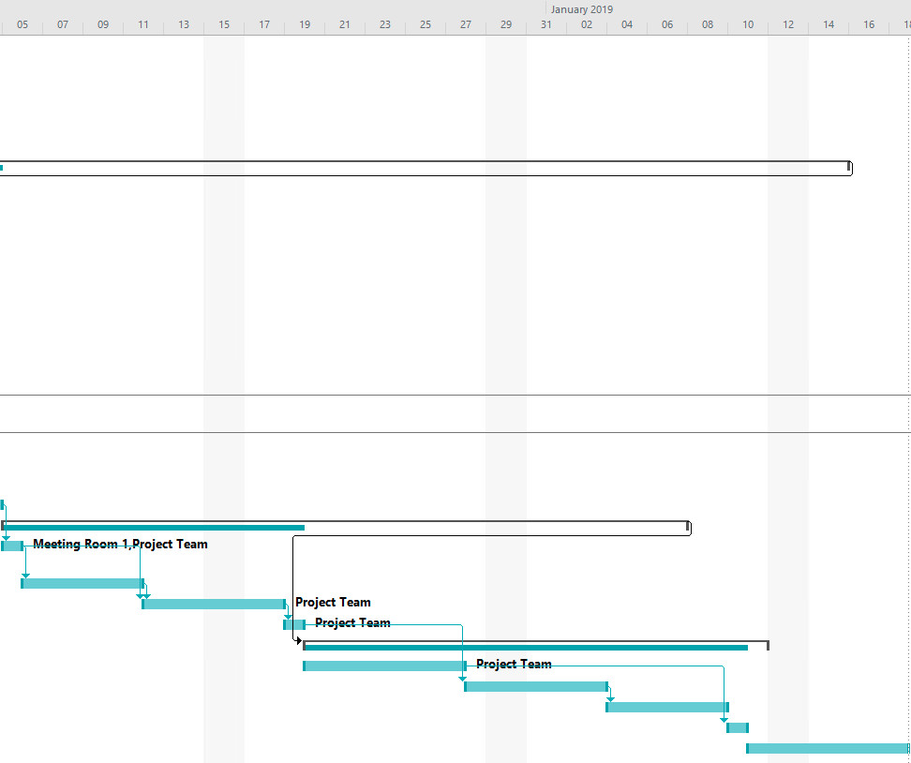

2 - Stakeholders

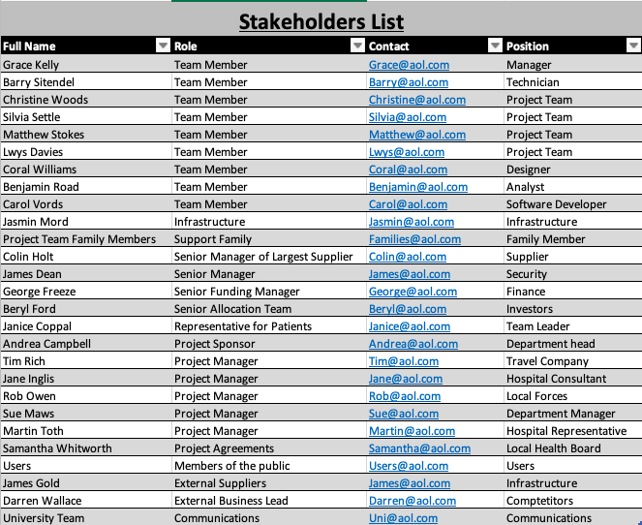

3 – Project Team Roles



