Learning in the Digital Era
Assignment 1: E-Portfolio
Jonathan Wilcox (2206641)
Data & information systems
2022
Table of Contents

E-Portfolio 2
Task 1 – Academic & Employment Skills 3
Task 2 – Academic Poster 5
Task 3 – Automatic Referencing Tool 6
Task 4 – e-Portfolio Creation & Review 8

E-Portfolio
ePortfolio - Jonathan Wilcox (2206641)
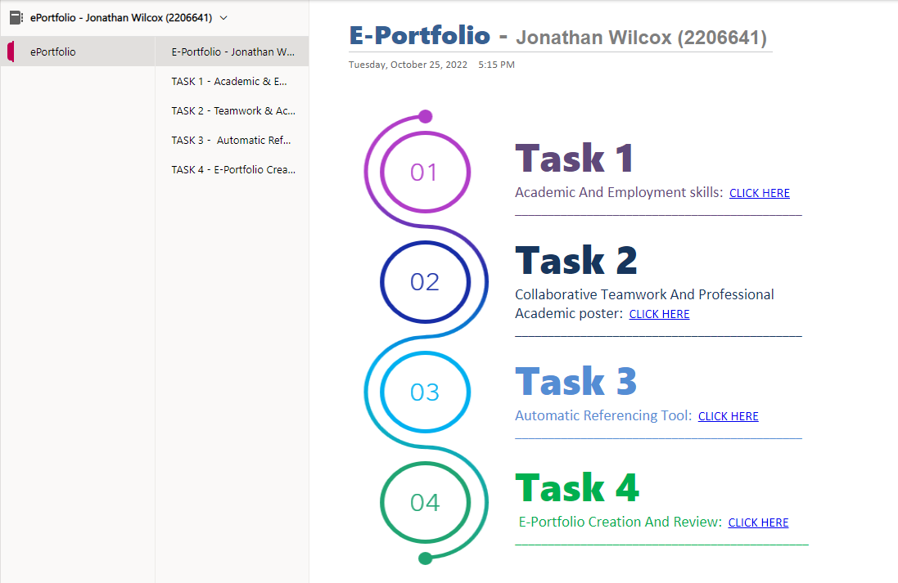

Task 1 – Academic & Employment Skills
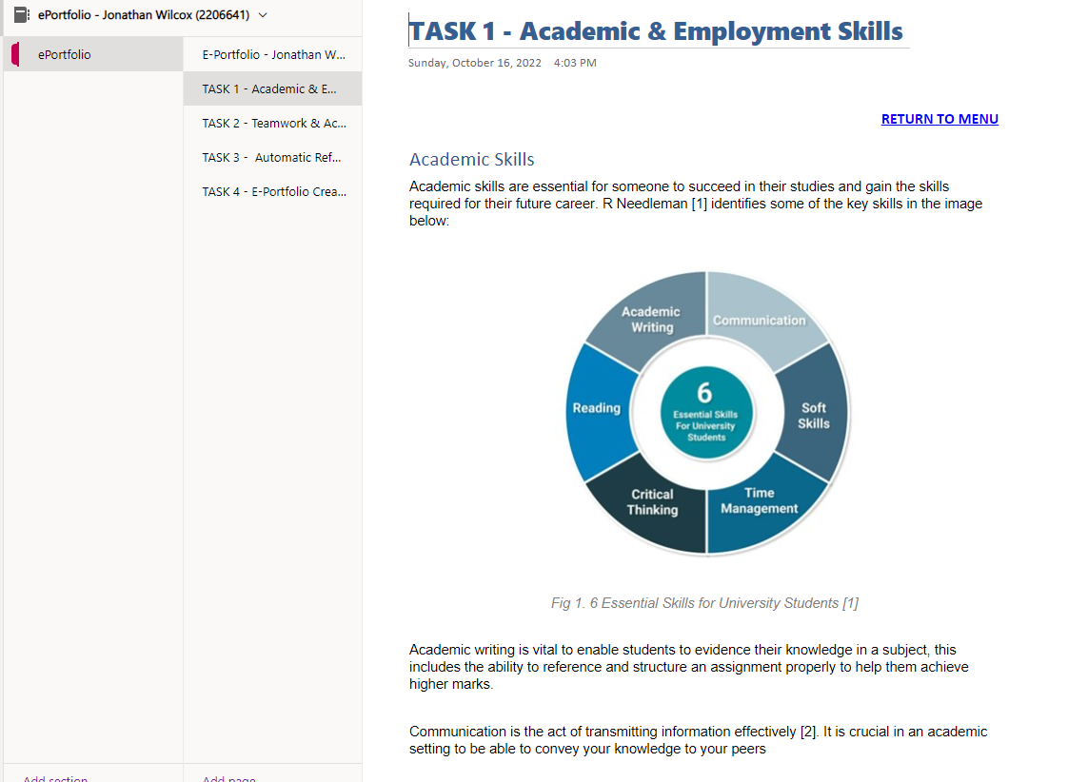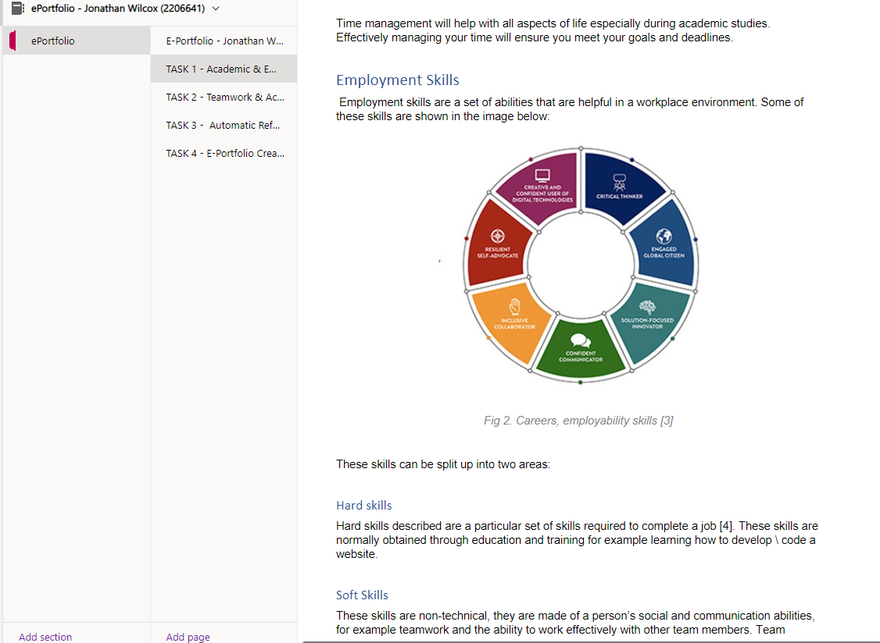
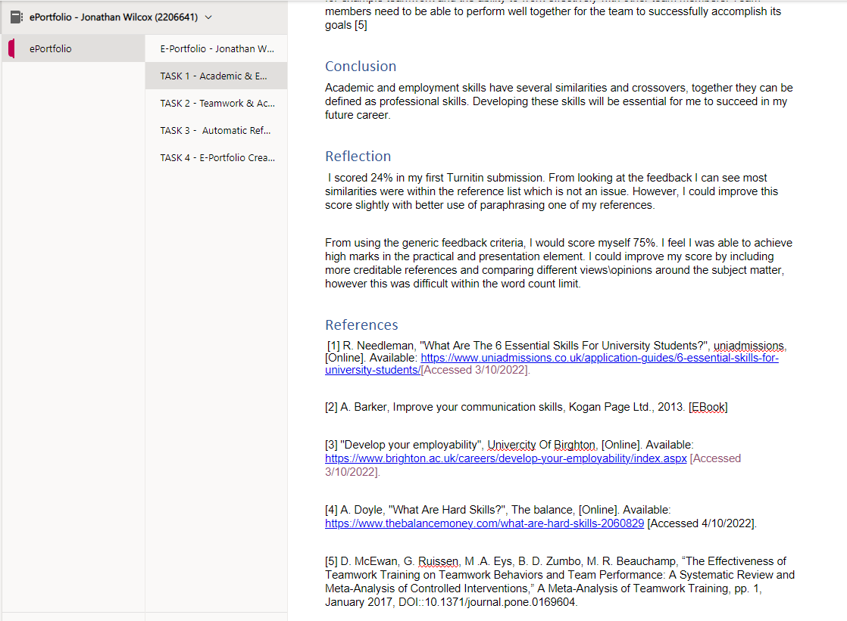

Task 2 – Academic Poster

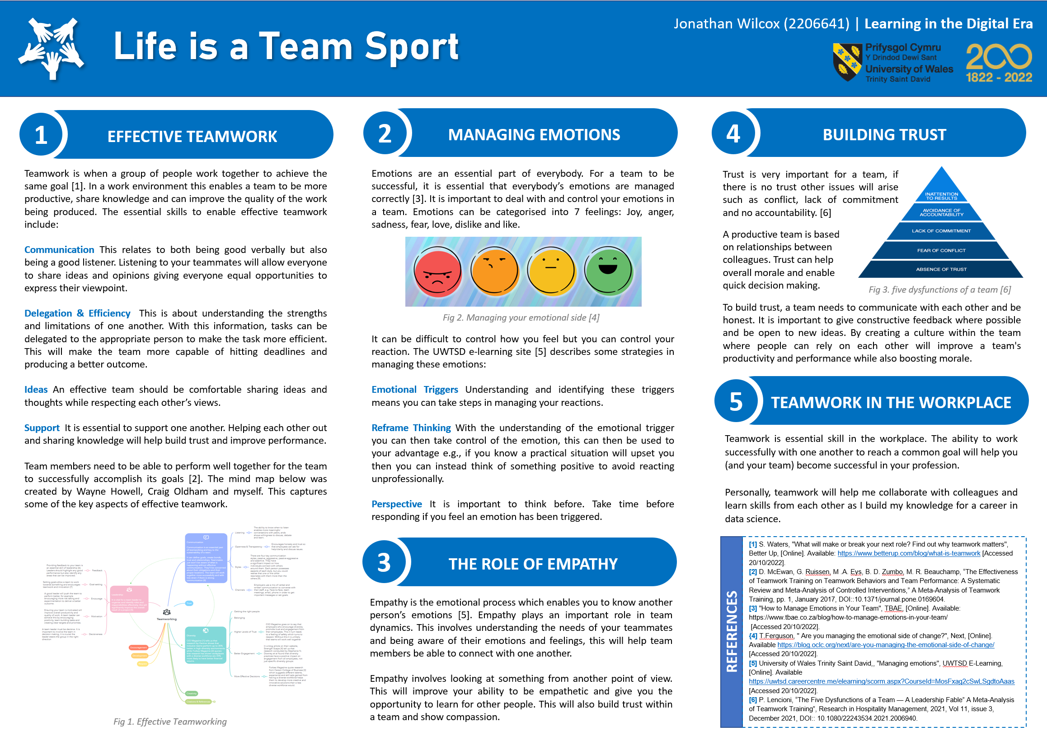

Academic Poster Link:
Life Is A Team Sport - Jonthan Wilcox (2206641).pptx (sharepoint.com)

Mind Map Link:
Teamworking - MindMeister Mind Map

Task 3 – Automatic Referencing Tool
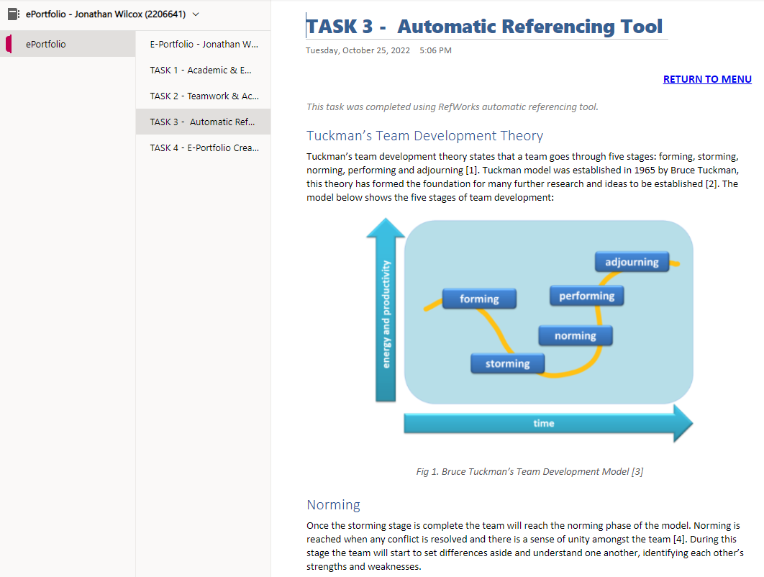

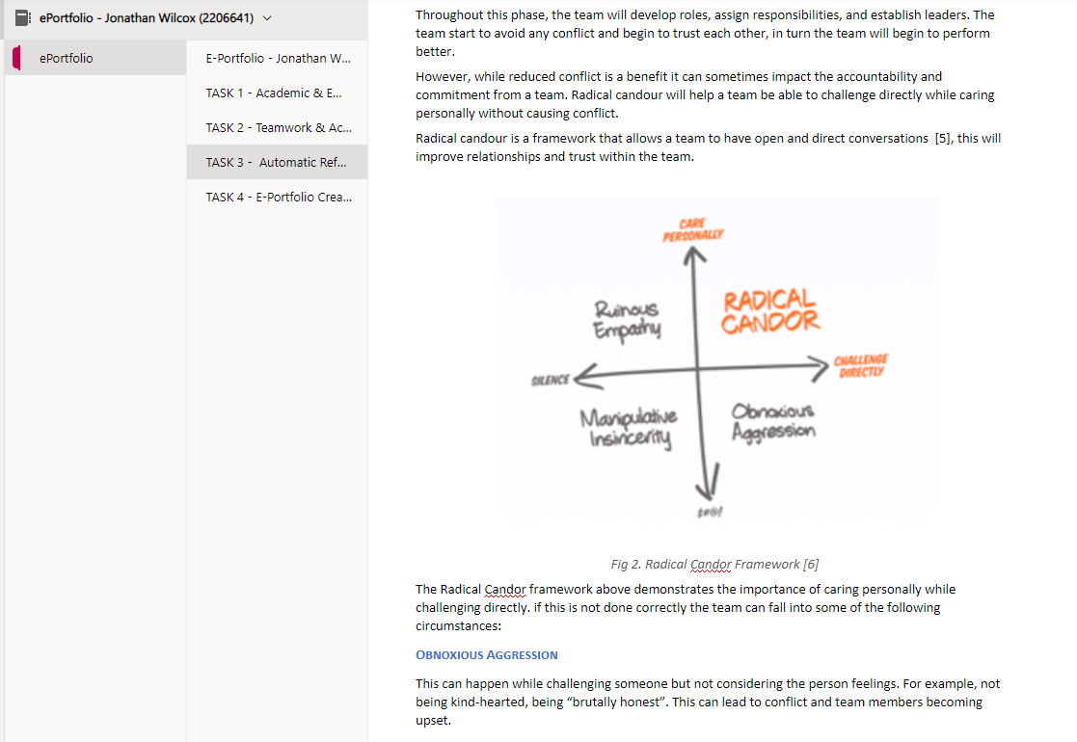

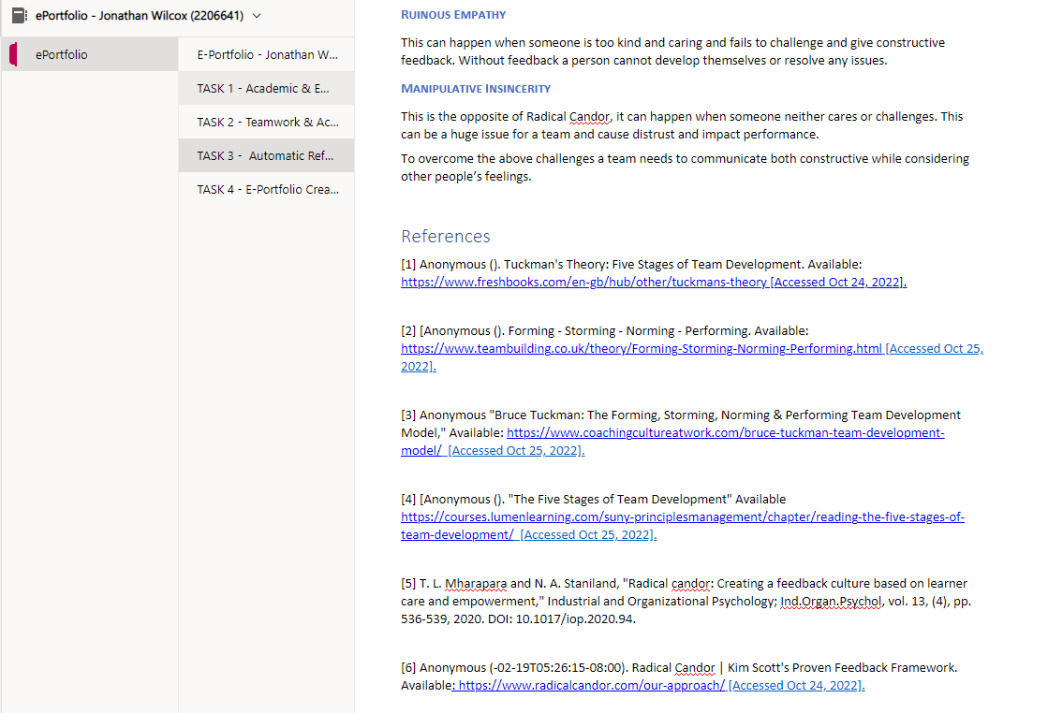

Task 4 – E-Portfolio Creation & Review


