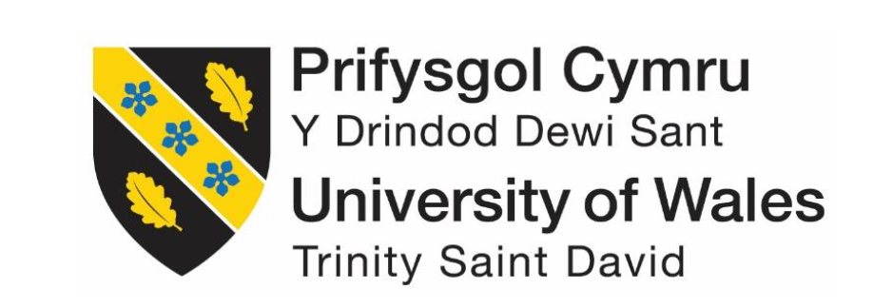

A Critical Investigation On

Why The Brands Requiring Fashion Shows To Held In Order To Showcase Their Product Lines

Kowshick Ahmed
Student Id: 1811758

Contents
1 Chapter – 1 Introduction Part 3
1.1 Background of the study 3
1.2 Problem statement 5
1.3 Aims and objectives 6
1.4 Research question 6
2 Chapter – 2 Literature review 6
2.1 Introduction 6
2.2 Terminology “Fashion shows” 6
2.3 Terminology “Brands and product lines” 7
2.4 Theory of Silence Spiral 7
2.5 Equity theory 9
2.6 Engel kollat blackwell (EKB) model 9
2.7 Positive Impact of fashion shows on the brands 10
2.8 Negative impact of the fashion shows on the brand 12
3 Chapter – 3 Research Methodology 13
3.1 Introduction 13
3.2 Approaches 14
3.3 Design 15
3.4 Methods 16
3.4.1 Group Discussion 16
3.4.2 Interviews 16
3.5 Data collection 17
3.6 Data analysis 17
3.7 Ethics 18
3.8 Reliability and validity 18
3.9 Limitations 18
4 Chapter – 4 Data findings, Analysis and Discussion 19
4.1 Introduction 19
4.2 Data from Group Discussion 19
4.3 Data from Interview 20
4.3.1 Q1. Why do think that your brand collaborate with fashion shows? 20
4.3.2 Q2. How fashion shows hold positive impact on brand for showcasing its product line? 21
4.3.3 Q3. How fashion shows hold negative impact on brand for showcasing its product line? 21
4.4 Theme Development Analysis 22
4.4.1 Theme Development Analysis based on Group Discussion 22
4.4.2 Theme Development Analysis based on Interviewees 22
4.5 Discussion and Results 24
4.5.1 Interview results: 24
4.5.2 Group discussion results: 25
5 Chapter – 5 Conclusion 25
5.1 Conclusion 25
5.2 Recommendation for better research 26
6 References 26

Chapter – 1 Introduction Part

Background of the study
In the present era, the high street fashion brands have almost similar product lines that makes difficult for the consumer to decide that product from which brand should be purchased (Hines and Bruce, 2007). Therefore, brands are in the continuous search of new communication strategies with the consumer to showcase their product lines. Among different promotional strategies, fashion shows are conducted in every level of the fashion industry (Chowdhary, 1989). The main fashion shows that attract the consumers around the world are the fashion week in New York, Milan, London and Paris. In these fashion weeks two type of fashion shows are majorly conducted, first is haut couture that includes the products are rarely transformed in the merchandise (Zhang, 2008). The figure 1 represents that in 2018, the maximum views gained by the audience is The New York Fashion week. Therefore, it can be concluded by this the product line that were displayed in these fashion week were of high cost and increased sales of them can be expected due to vast consumers reach.
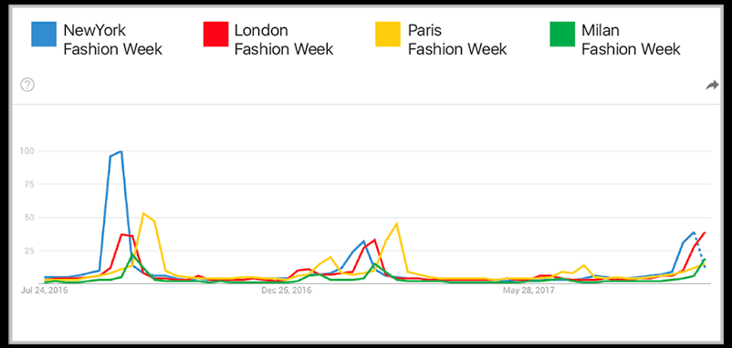
Figure 1: Shows fashion show taking lead in 2018
Source: https://www.stylumia.com/blog/real-time-leading-fashion-week/
The purpose of these product lines is to gain attention and creating hype that will lead to the distinction of the brand from its competitors. The second is the ready to wear shows that includes the impression of the product lines that are to be present in the upcoming season (Waddell, 2013).
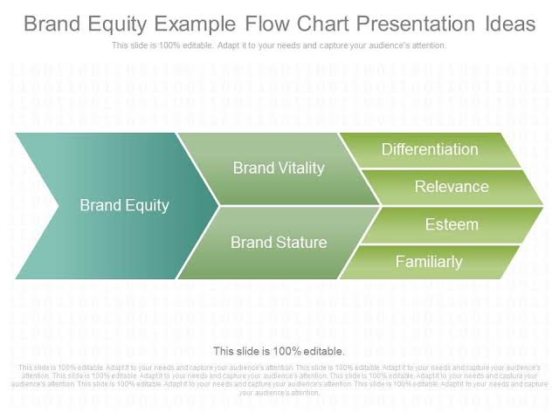
Figure 2: shows that flow chart of brand equity
Source: https://www.slideteam.net/custom-brand-equity-example-flow-chart-presentation-ideas.html
Figure 2 displays that brand equity is created from the brand validity and brand stature by the public. This can be achieved when brand differentiates form other in regard to its differentiation of the product, relevance to the culture and social norms, esteem and familiarity. Every brand encourages having variations in the format of the fashion shows but the most commonly used us the runway with the seats for the spectators on either side of it (Vittayakorn et al., 2015). The audience is in these fashion shows are mostly composed of the possible retailers of the brand, individual whose presence can have impact on the brand promotion, bloggers and press. In the prestigious fashions show of Paris and Milan, the most product lines are of previously established fashion designers but now a days high street fashion brands also conduct there fashion shows to display the best among their product lines to attract more consumers (Schweitzer, 2011). The affordability of the product line from the fashion week in Milan, Paris, London and New York gives the consumer the sense of uniqueness and satisfaction (Brun and Castelli, 2013). Other high street fashion brands conduct their own fashion shows that have a wide variation on location and format. This can be the formalized fashion shows to informal ones. The formalized fashion shows are conducted in the shopping centres or and other particular location whereas informal fashion shows are conducted to gain the maximum number of the consumer attention. The fashion shows targets the two groups among them one is consumers and the second is employees of the brand. The consumers are targeted so that they can be entertained and caught attention to the product line. The employees seek the interest of the consumers so that the product line can be enhanced according to the reviews gained by these consumers (Nueno and Quelch, 1998).
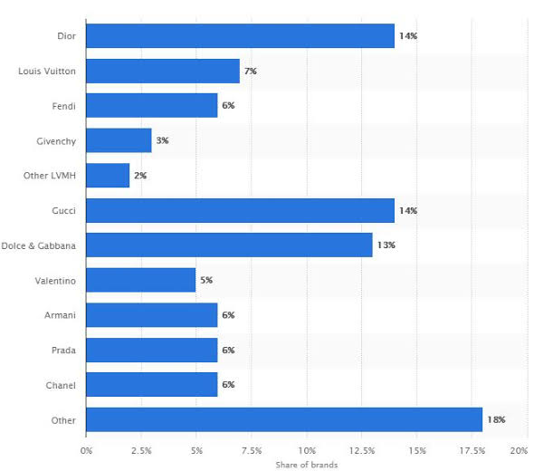
Figure 3: Interest of consumers in fashion brands in Paris fashion week 2019
Source: https://www.digital-clarity.com/blog/social-media-paris-fashion-week/

Problem statement
There are lots of problems faced by the brands so, to over come those problems fashion shows are organised to show case its product line. But, Fashion show does not only have positive impact on the sales and promotion of the brand but it has a negative impact as well. The idealization of the media idol is commonly seen among youngsters. The idealization of the physical features and bodies of the models in the fashion shows is perceived as a pressure from them and this leads to the dissatisfaction of women’s own body is commonly seen. Now a days people are debating on the non-realistic physique of the models and this have negative impact on the brands. Victoria Secrets is one of the examples. Also, the fashion shows are conducted by the high street fashion brands, due to this reason the cost and sometimes the material of the product line of these brands do not justify each other (Duggan, 2001).
The one type of communication between the consumer and the brands is the fashion show that plays a vital role in influencing and gaining attention of the consumers (Pride and Ferrel, 2006). These fashion shows helps in the display of the new product lines of brands for an upcoming season or year. This also helps brands in analysing the interest of the consumers. The fashion shows help in uniting the research of trends of the consumer choices and sales. This helps in generating the strategies by the brands to gain the maximum number of the consumers. So, to review completely about the fashion shows enduring the brand's product line this research report is carried out.

Aims and objectives
The aim of the present study is to analyse critically the positive and negative impact of the fashion show on the brands for showcasing their product line.
The objective of this research is mentioned below:
- To visualise the positive impact of fashion shows for brands in promoting or showcasing their product line with a larger audience
- To identify the negative impact of fashion shows for brands in promoting or showcasing their product line with a larger audience

Research question
The present study focused on the primary question that:
- What are negative the impacts does the fashion show have on showcasing the product line of the brand?
- What is positive impact does the fashion show have on showcasing the product line of the brand?

Chapter – 2 Literature review

Introduction
The second chapter discusses the thorough review of the existing literature about the topic. This will help in comprehending the impact of the fashion shows in showcasing the product line of the brand.

Terminology “Fashion shows”
Fashion show is the event that includes the display of the product lines of the brands with the help of performers that come up with some story telling regarding the product. There is always a purpose of presentation in these shows that are enhanced with the use of hardware equipment. The participant present reflects the product line and catwalks are conducted. Fashion shows tells the story that relates with the product by the use of different things and people. These shows act as a bridge between the audience and the brand, brands and the retailers also it helps the brands to create equity and enhance its image (Diehl, 1976). In the modern fashion shows things are kept in mind while designing the show is that it should be sensual creative. The five levels of fashion shows are attractiveness that it can attract a wide number of audiences, second is beauty that fashion show should be ecstatically good, creativity that links the brand and product line with the show, delicacy and engineering of the show (Skov et al., 2009). The good fashion show has the ability that create the awareness about the cultural and creativity in the audience by storytelling and creating the apt atmosphere. These fashion shows are conducted so that product line can be displayed in way that it gains attention of the consumers and secondly to review the product line with help of retailers and audiences so that improvement can be made and interest of consumers can be assessed (Parezo, 1999).

Terminology “Brands and product lines”
Brand is defined as some kind of a symbol or the name or any other thing that relates with one seller; also it differentiates with other sellers. Brand is the copyright of a particular seller that cannot be used by other (Aaker, 2006). The history of brands goes far behind in Egyptian culture in 27000BCE, in that era people use to mark their livestock to differentiate them from one and other. In the modern era, the concept of brand is very vast as it not only includes the marketing of the product line but also communication through different social media and fashion show platforms. These names or logos help the brand to differentiate itself from its competitors and create a permanent impression in the minds of the consumers. Product line is defined as the group of products from the same brand that are sold under a particular brand name (Farquhar, 1989). Different companies have verity in their product lines that can attract a large number of consumers. To increase the sales of the product, companies expand the offering with the product line that is widely acknowledged by the consumers. It is the psychology of human beings that it can trust on the brand having some previous good experience for a new product. Companies take advantage of this thinking and associate their new product lines with the previous brands. For example, a company having increased prices of its product may create a new product line with relatively low prices using the same brand to attract consumers (Quelch and Kenny, 1994).

Theory of Silence Spiral
The theory of “Silence Spiral” explains the mass media and how it influences the opinion of the people. In 1974, Neumann explained this theory in her book named "Journal of Communication.” Neumann believes in the concept that human is a social animal and like other living being has the fear of isolation. The theory of Silence Spiral is based on this concept. According to this theory:
‘when express their ideas and opinions, people will be actively involved and boldly express and diffuse of these ideas, if these ideas were agreed and widely welcomed; and for points which are of no or very few care (sometimes may cause oppose when expressed publicly), even if some people agree with these ideas but will remain silent. The silence of one party would cause momentum of the other party; over and over again, the voice of one party will be more and more powerful, and the other party more and more silent like the development of spiral’ (Noelle‐Neumann, 1974).
According to the author, the opinion of the public can be created by media, or their interpersonal opinion of different things and or according to their psychology. The public opinion can be a majority opinion that can be made by using the media; this awareness by media creates the spinal expansion in the interpersonal contacts due to which “advantage opinions speak loudly". The theory of Silence Spiral explains that the fear of isolation encourages the public to take the majority ideas and thus we can say that the media have power that can create an impact and implications. According to the Simmel, the fashion is created by some people who lead other people with their new ideas. According to the author:
"Fashion is always what some people use; most of them are on the road to accept it.(Noelle‐Neumann, 1974)"
Fashion has always been a catalyst of transition. When fashion appears to be popular, or even when only a few individuals embrace fashion, regardless of circumstances, influences all people, then it is no longer considered fashion, which can be interpreted as the end that fashion is prominent. It can be seen that the fashion show is the baseline of fashion by encouraging common people to gain potential benefits. When models wearing the high fashion outfits show up in runway shows, their dresses are regarded to be "advantageous" to wear. The trends that a particular fashion show becomes industry and people start to follow it. As this trend becomes majority and people try to follow it as they fear that not following the latest trends will make them out dated and lonely. The person who creates the trends become the pioneer and people chase its ideas (Simmel, 1906).

Equity theory
Equity theory developed by J. Stacy Adams in 1963 explains that balance of resources between the consumer and the brand. It is the measure of the cost of the product and benefits obtained by the consumer to buy that product. According to this theory, the balanced system should be devised to maximize the individual’s benefits to satisfy the consumer about the brand and its product line. Inequality of the resources leads to dissatisfaction of the consumer with the brand therefore, less sales of its product line may be expected and decrease in the profitability.
Brand equity is defined as a well-known brand due to its better promotional strategy and brand image due to better quality of its product lines. This may leads to the loyal consumers that will prefer the brand over its competitors.
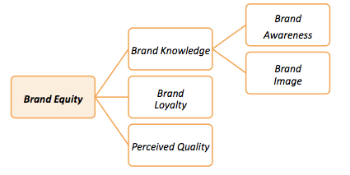
Figure 4: Brand equity. Source: (Cobb-Walgren et al., 1995)

Engel kollat blackwell (EKB) model
According to EKB model, there are the five key steps the consumer go through while purchasing the product from the brand. The first step is the input, at this stage the consumer is exposed with the marketing of the product through various sources like social media, blogs, television or fashion shows. The second step is the analysing the brand and its product with its competitors. In this step any past experience with the brand is taken into account or the comparison of prices and quality of the product with its competitors are analysed. The next step is decision making stage in which the consumer decides to purchase the product in the presence of different internal and external factors. Internal factor can be how the consumer sees himself after purchasing the product. Brands can influence the purchase power of the consumer at the information stage and by modifying the external factors by installing the desire of purchasing the brand’s product (Tidwell, 2015).

Positive Impact of fashion shows on the brands
Rehman et al., performed a study to correlate the buying behaviour of the consumers with the sales promotion. Overall, this article focus on the different techniques that are used to sale the product in the fashion industry. Data was collected by using survey method in which questionnaire was filled by the respondents and in this study respondents are the consumers. To analyse the data different statistical methods were applied especially structural equation modelling. The findings of the study suggest that the personal behaviours of the consumers like open mindedness and stability have positive impact on the sales of the product this verify the EKB model that brands can influence the consumers at the information stage (Rehman et al., 2017)
Fionda and Moore et al., performed a study to assess the factors that affects the sales of the luxury fashion brands. To collect the data qualitative approach was considered. Surveys were conducted in 12 international retailers of luxury brands and questionnaire was filled and respondents in this study are managers of those retailers’ brands. The findings of this study suggests that there are nine factors including brand signature, heritage, exclusivity, product integrity, mass communication, clear brand integrity plays a key role. Among the mass communication, fashion shows enhance the sales of the product line. According to the article, it is the priority of each and every brand to create the awareness of its product line through different strategies like social media, print media and fashion shows. Different brands especially luxury brands conduct the fashion shows that increase the equity and awareness of brand and its product line in a better way because in the modern era, people are more interested in the fashion than ever before. This study verifies the brand equity theory that brand image influences the sales of the particular brand (Fionda and Moore, 2009)
Zawadzka et al., conducted a case study to analyse different marketing strategies to improve the brand awareness. For this purpose H&M brand was taken under account. Fashion marketing is a strategy that the brand follows to increase awareness among the public about the product line. The marketing strategy highly influences the company behaviour both commercially and sales of the product. Now a day’s people are more aware of their needs and value of the product. Therefore, these marketing strategies should be done in the way that it fulfills those gaps and questions that a consumer have for that brand. For the collection of data, both qualitative and quantitative ways were adopted as the mixed method techniques have the ability to develop more comprehensive understating of the problem. Interviews were done from the employees and retailers of the brand. Both secondary and primary data were collect. The secondary data helps in assessing the problem that under lies behind the query. In this study, the secondary data was collected from the previously published literature and company website whereas; the primary data was collected through direct interviews done in the surveys. During the making of the questionnaire it was kept in mind that question included should be close ended questions. The population size of the study was 100 subjects both males and females. Random sampling was done for this purpose. Results of the study suggests that the marketing strategy especially through the fashion shows of H&M brand tells some story or is based on some particular idea that is executed in the fashion shows. And the profitability of the brand increases when importance was given to the brand equity and EKB model was introduced for making promotional strategy (Zawadzka, 2015).
Christophe et al., performed a study, that elaborated that with increasing the number of the brands in the world, the option of same product from different brands are increased. In other words, the competition among the brands has drastically increased. Thus, the brands need to achieve the different marketing strategies to gain consumers and sales of their product line. These strategies may include the fashion shows and print media (Christopher et al., 2004). Taplin et al., performed a study that suggests that traditional fashion retailers need to move one step ahead to compete in the market by making the strategies and trends for the fashion in the next season. This will highly increases the sales and profitability of the brand. One of the techniques is the introduction of the fast fashion (Taplin, 2014).
Another study was conducted to analyse the changes in the business strategies of the Burberry Company. In 1998, the shares of the company started to decrease and one of the reasons of decrease in the shares was the use of traditional promotional strategies by the company. Burberry Prorsum that is the luxury product of this brand was promoted in the fashion shows. It was sold through the retailers and the reputed stores to meet the increased demands of the consumers. The Burberry London was also promoted through the fashion shows and it includes the ready-to-wear items for the men and women. The company takes help of the three strategies and improve them to increase the profitability and sales. Among them were advertisement, fashion shows and magazines. Advertisement was done according to the seasonal product lines and it makes up to maximum of the expenditure that is kept for the marketing purpose. The second strategy is the fashion shows, to increase the active relationship of the brand with the consumers these fashion shows were conducted in a better way. The company make sure that these fashion shows may have maximum coverage through social media, magazines and newspapers around the world. In addition to this, the company shares the brochure that contains the collection of the brand of that season to increase the product exposure to the consumers. The images of the products from the fashions shows are displayed in different websites and social media. Burberry Company increases the sales of its product lines when fashion shows with better vision were conducted along with the advertisement to achieve the international media coverage. Along with these two, the active media coverage of these fashion shows increases the awareness of the product line among the consumers thus increasing the sales and profitability of the company.
Hou et al.., performed a study to analyse the commercial and cultural factors of the fashion shows. According to author fashion shows is the type of communication of the brands with its consumers. The type and purpose of these fashion shows can varies from one and other but the end result that is expected from these shows is the increase in the sales and profitability of the brands. According to the study the function of the fashion shows is give the sense of the social status to the people who can buy from these brands, as the product line of these brands is high and is not in the range and affordable of every other person. Fashion shows have the ability to change the trends and face of fashion every now and then. This is done by setting the agenda for every year and then making the product line and doing promotion of it through the fashion shows. The popular information in these fashion shows of the brands act as the trend that is followed by the people around the world. The second step in stetting the trends is the ‘compulsory specifications’. This is done to make the trend according to the social and cultural norms of the society. This is executed by the upper society that can afford the product line of the brand and the members of the brands. The middle ground among communicators and the audience is the display of the fashion show. Model reduced garments are known as beautiful clothes. Models define the standards of beauty of the media and, through success, propagate these values. (Hou, 2015).

Negative impact of the fashion shows on the brand
Solomon et al., studied the negative impact of fashion shows that mass media creates the hype of the product line so much that consumers loss their ability of awareness or affordability to buy the product line. This created depression and anxiety in the youngsters when they are unable to buy any product from the brands (Solomon, 2010).
Calogero & Thompson et al., published the study in 2010 regarding the impact of models perfect features and bodies on the common people. The study states that dissatisfaction of bodies and weight are often seen in individuals having consumption of fashion through social media and especially fashion shows(Calogero and Thompson, 2009). Same results were shown by the studies conducted by Engeln-Maddox, Lindner, Tantleff-Dunn & Jentsch et al., that showed that women who were exposed to the high street fashion tends to make an explicit comparison of their features and bodies in comparison to those models shown in the fashion shows (Engeln–Maddox, 2005, Lindner et al., 2012). Bucchianeri & Corning et al., used the comparison theories (Festinger, 1954), to assess the thinking of the models that take part in the fashion shows. The results of these studies suggested that the model who look upwards are tend to be depressed and feel negative about them. Whereas, the models who looks downwards were in good health both mentally and physically (Gondoli et al., 2011). This gives negative impact on the brand as the consumer might think that the product line is for specific consumers with perfect bodies.
Rosenthal et al., performed a study that most of the brands like Zara, H&M, and New Look charge high prices for their product lines in fashion shows even if their product is often cheap and disposable (Anguelov, 2015).

Chapter – 3 Research Methodology

Introduction
Research methodology states the introduction of research path, design and the selection of the right method of data collection. The research is based on the analysis of the critical process of using fashion shows to hold to promote the products. The study will assess the demands for the fashion shows to enhance the product line sales from the brands and the impact of the fashion shows on the promotion of the product lines of brands. This chapter outlines the research methods as a qualitative and exploratory study to find the research from the theme analysis.
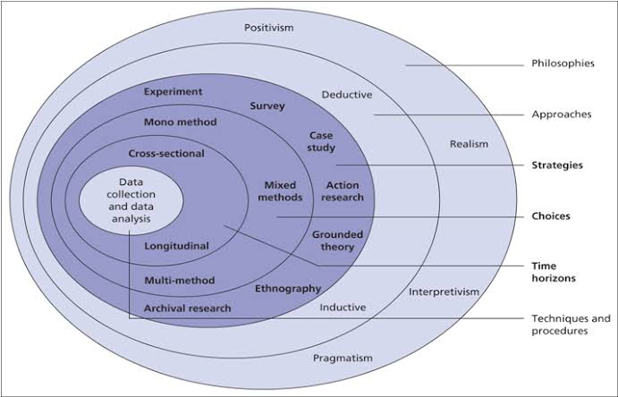
Figure 05: Research Onion: [Source: (Bresler and Stake, 2017)]

Approaches
The approaches useful for the examinations are encompassing the qualitative as well as quantitative research (Bresler and Stake, 2017). Qualitative research is the one which revolves around the qualitative data with no facts and figures. The second one is the quantitative analysis that includes the percentages, numbers and statistics. This study is based upon the qualitative study. Qualitative research is suggested for the fashion shows study due to the various reasons. In the first stage, qualitative research is aimed at the discovery of the ideas with the general objectives of the investigation. The idea that is under development in this study is the use of fashion shows for showcasing the brand’s product line.
The approach for the qualitative study is interpretation and observation (Fletcher, 2017). The data collection approach that is available in this study is the unstructured and free form. The research independence state that the research is mainly involved in this process. The results of this study are mostly subjective. The results will not provide the figures, but only facts. The samples are not included in this research as human beings, but only the investigations and facts and data available online. The study will also emphasize the changes in behaviour and the effects of fashion shows.
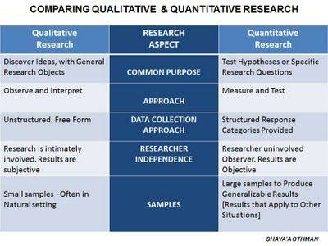
Figure 06: Qualitative Research: Source: [(Humphries, 2017)]

Design
Research design includes the three key models encompassing explanatory, exploratory and descriptive (Humphries, 2017). Illustrative research design provides emphasis on the consideration of hypothesis and quantitative analysis of the study through testing the hypothesis. The exploratory studies provide detailed analysis of qualitative nature through considering an already existing topic for research. The research will also emphasize the consideration of the new item that falls under the category of exploratory. Under this research method, the original issue of the study is analyzed without the hypothesis. Being a study of qualitative nature and the new item in this field of study, the research is categorized as exploratory research.
Exploratory research is selected for this study due to five key concerns (Perez-Soltero et al., 2006). In the first stage, the precise formulation of the issues is possible through this. The fashion shows have the vast nature of the functions and effects on consumers. This study will resolve their huge effect on a small level of the discussion through this method. The exploratory research will support more knowledge about the issues for researchers. It will also establish the priorities for the future time of research. It will also design an effective information collection process. The research will determine the nature of interlink of different variables understudy in this regard.
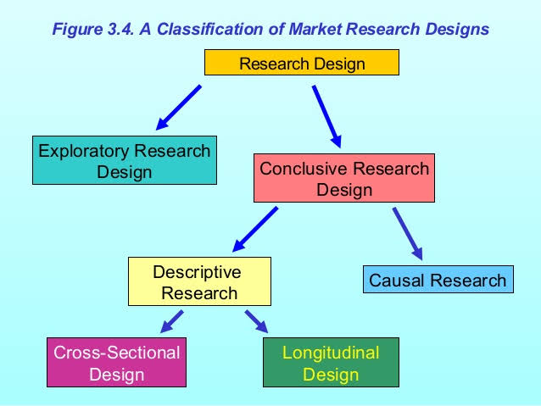
Figure 07: Types of Research: [(Walliman, 2011, Walliman, 2017)]

Methods
Primary methods of data collection encompass the projective techniques, Delphi technique, focus group interviews, questionnaire methods and interview methods. Qualitative methods of the data collection include the different methods such as the group discussion, online data collection through journal articles, interviewing, focus group analysis and the observation (Hair et al., 2009, Humphries, 2017). Among all these effective methods, the research selected group discussion and interviewing the brand ambassadors and brand heads. The interviews will provide qualitative and perceptional data about the role of fashion shows in brand showcasing their product line.

Group Discussion
The group discussion is also an unstructured and open discussion format for more information collection. Group discussion will include the 3 brand heads and 2 london based Fashion show organiser on the open topic of “fashion shows impact on brands”.

Interviews
The interviews for this study will include the open-ended questions with the interviewee who will have the freedom to answer (Wildemuth, 2016). The interviewee receives the full information and detailed guidance for each question so that the answers will be clear. The interviewees will include the 3 brand heads and not 3 brand ambassadors. These two parties will be able to communicate the impact of fashion shows on the showcasing the product line of branded organisations. The interview is feasible as the detail and depth of information in this data collection method is secure. The interview can also perform more for the improvement of the percentage of responses and information quality. The dependability and accuracy of the responses provided by the interviewee can be traced through the probing and observation. Brands included for this discussion are Loreal, Lakme and Victoria’s Secret. Loreal’s brand ambassador is Camila Cabello. Ananya Pandey is brand ambassador for Lakme and Louise Cooney is the brand ambassador of Victoria’s Secret.

Data collection
Data collection can be devised in the two key methods. The first one is the primary method of the data collection, and the second one is the secondary (Wu, 2011, Yap and Gaur, 2014). The primary method includes information that has not been analyzed and processed, whereas the secondary data includes the information that has been processed and analyzed. For this study, the data collection is taken from the primary and secondary both so it is a mixed study. In terms of secondary study, the data is taken from the online existing journals and websites for the development of literature. In the case of the primary method of data collection, the two forms of the data collection are available in this study. The first method considered is the interviewing method, whereas the second one is the group discussion method. The study is termed as a mixed-method study. This data collection ensures that there are fewer chances of lack of generalizability for this study. The respondents are also able to provide valid information as they are participating in a vast scope of the study for the future time in fashion industries and brand management.

Data analysis
The theme development analysis model is one of the key forms of data analysis (Bresler and Stake, 2017, Burchardt et al., 2016). The studies can infer the themes as keywords used by the focus groups and interviewees in their responses to the discussion and interview on the role of fashion shows in the brand as negative and positive roles. The data analysis will support in the short run data analysis with the least cost. The data themes will provide a quick outlook over the keywords and the perception of interviewees. It will also state the focus for future studies in the effect of fashion shows in promotion of brands. The study will also emphasize the role of these developments. There are various theme developing software, but the researchers consider Nvivo for theme development and analysis.

Ethics
Ethics can be stated as the difference between right and wrong (McKenny et al., 2017). The ethics are clear for every field of working and research or daily life. The ethics in this research are also clear as there is a higher rate of the involvement of human beings. This research will ensure that there is no theft of information or misuse of the information in the scheduled time. The information will be safe. The information will also be used in the directions as mentioned before this research. The ethics will also ensure that physical involvement is not required in this research, so there is no expectation of any physical harm in this study. The respondents will also feel it open and easy to communicate about their views for fashion shows as no threatening is permissible for this research. The researchers will also show more interest in participation for this research as they will receive the trust and ethic's compliance for this research.

Reliability and validity
Reliability states that this research provides a reliable data collection method, and it can be used to find the research question's answer (Humphries, 2017). The research will also emphasize the research aims as the base for the selection of research data collection method. The research will also represent that the validity of the research is high. These methods are also usable in future studies in fashion show's effect analysis. The reliability and validity will be selected as the face validity and test-retest reliability. The already used methods for data collection are selected for this research, whereas validity is allowed by the supervisor.

Limitations
The following are the major limitations of this research:
- The research is qualitative only as there is a limited scope of the study in terms of the period.
- The research includes two methods of the data collected through the qualitative form of data collection. In contrast, the more than two methods in combination with the questionnaires can be used for the data collection.
- Data collection and analysis through interviews and themes can often ignore the key information.
- The research includes only the fashion show's effects, whereas the advertisement, brand ambassadors and celebrity marketing can also be assessed as the role players in sale enhancement of brands.
- The research is limited in the scope as it considers a mixed level of the analysis. Still, the second method, as well as the primary method, is not encompassing the quantitative analysis. The lack of numbers will reduce generalisability.

Chapter – 4 Data findings, Analysis and Discussion

Introduction
In this report, the data collected from the interviews and group discussion. The data are presented in group discussion and interview sections. These data is further analysed using the Theme Development analysis tool to draw the results and provide conclusions for this research.

Data from Group Discussion
Group discussion will include the 3 brand heads and 2 London based Fashion show organisers on the open topic of “fashion shows impact on brands”. There are 5 participants in a group discussion and it is conducted through video conference. The time allocated is roughly 30 minutes. The important highlights are noted by researcher and its presented below:
Topic: “fashion shows impact on brands”
The brand head of Loreal dicusses that collaborating with other designers on The Fashion Weeks has played a significant role in the marketing of the brand and it has shown a significant impact on the awareness of latest product lines among consumer thus increasing the profitability of the brand. This year the company launched a new product line in collaboration with the late Karl Lagerfeld and to increase the marketing of the product line A list celebrities were invited as a guest like Cara Delevingne and Gigi Hadid. Thus, brand head of Loreal concludes that the fashion shows are playing the positive role in the brand. Lakme brand head discussed that the brand is Indian based and most of its major Fashion Shows held in India. This reduces the marketing of the product line in the western countries. The brand head agrees that to increase consumers Lakme should take part in The Fashion Weeks of Milan, London and New-York. Moreover, the Lakme brand head stated that they are trying to outreach the celebrities with huge fan following around the world to to take part in its fashion shows. Presently, more Indian celebrities are the part of the fashion show therefore, to increase the consumers outside the India, diversity of celebrities needs to be reached. Victoria’s secret head discussed that a negative impact of fashion shows have been seen on the brand in the recent years. This is attributed to the physique of the models which is considered unreal and is backlashed by social media and the public. Therefore, this year the fashion show was canceled and the brand is making a new strategy for the fashion shows in the next years. Both the two London based fashion shows organizers agreed on the fact that there is doubt that people have eyes on The Fashion Week around the world. These fashion shows with the help of celebrities creates hype about the brands that increase the sales of the product lines of the brand. Thus, highly playing positive impact on the sales of the brands. The organizers added that the new concepts and ideas to proceed the fashion shows is always the priority of brands these days as every brand wants anything unique for their fashion shows that could enhance the awareness of the brand among consumers.

Data from Interview
The open ended interview questions are designed for conducting interviews. The interview is focused to 3 brand heads from are Loreal, Lakme and Victoria’s Secret based in London. There are three interview questions asked by an interviewer to different individual. The opinion of these three different brands head on the interview questions is mentioned below.

Q1. Why do think that your brand collaborate with fashion shows?
Loreal Brand Head: Fashion shows have always been used for setting trends and increasing the awareness of brand’s new product lines among the consumers. Loreal take part in almost all the fashion shows of The Fashion Week each year to outreach the consumers around the world. Loreal Brand has the vision that with a good product line a good marketing strategy is a necessity in the present era and collaborations of the brand with fashion shows plays this part.
Lakme Brand Head: The fashion shows are the source of showcasing the new product line and creating its hype. Now a days people are more keen to know the latest trends and follow the celebrities. Therefore, including the most followed celebrities in these fashion shows and showcasing the brand highly increase the consumers.
Victoria’s Secret brand Head: The purpose of the brand to collaborate with the fashion shows is to display its product line in a high profile setting. Celebrities who wear these product lines are followed around the world. The fashion shows of the Victoria’s Secret brand have always been an attention due to the creative set design according to the different themes running within the show.

Q2. How fashion shows hold positive impact on brand for showcasing its product line?
Loreal Brand Head: Loreal believes that in the present era the making a marketing strategy to make brand equity is complex. Fashion shows are viewed by the huge number of people, media, editors of newspapers and bloggers around the world. Also, the celebrities chosen by the brand for catwalk on the runway have a fan following. Therefore, the fashion shows, plays a huge role to reach out large consumers. This will increase the hype of the brand and have a positive impact on the sale as brand conscious people will try to purchase the product line at any cost.
Lakme Brand Head: Lakme Brand head stated that the sales and equity of the brand, increase when a famous celebrity take part in the Lakme Fashion show. Lakme considered the fashion shows as the important source of marketing of its new product line every year.
Victoria’s Secret brand Head: The Victoria’s Secret fashion shows had been attracting hundreds of celebrities and entertainers each year. These shows, play a significant impact on creating the hype and awareness of the product lines of the brand. These shows had been featured on the television in America at the prime time. Therefore, fashion show had been acting as a huge positive impact on the sale of the brand.

Q3. How fashion shows hold negative impact on brand for showcasing its product line?
Loreal Brand Head: Loreal Brand head stated that there is positive response given by the social media and consumers about the showcasing the product line through fashion shows. The head stated that they have not seen a negative impact of these fashion shows on the brand equity so far.
Lakme Brand Head: Lakme Brand Head stated that the participating fee of the brand to include in The Fashion Week between 200,000 and 1,000,000 USD that is not affordable for the regional brands. Due to this, a large number of brands could not participate in these fashion shows. Therefore, fashion shows have a negative impact as they have a huge burden on the brand.
Victoria’s Secret brand Head: During the present years, Victoria’s Secret fashion shows are under huge criticism as the social media and consumers have the impression that the product lines are created only for the women with a perfect physique. This impression has been generated due to the physique of celebrities that walk on the runways. Therefore, the fashion shows are giving a negative impact on the brand.

Theme Development Analysis
The theme development, analysis based on group discussion and interview brings results for this research.

Theme Development Analysis based on Group Discussion
Question No- 1 | Fashion shows impact on brands?
DATA coding
  - Positive for Loreal brand.
  - Negative for Victoria’s secret brand.
  - No brand showed no impact of fashion shows.
  - Both impact observe in Lakme brand.
Theme Development | The Loreal brand participate in The Fashion Week around the world and brand believes that brand imparts a positive impact. The Lakme have both the negative impact as these shows act as the burden for the brand and a positive impact because it increases the awareness of the brand among consumers. There is a negative impact of the fashion shows seen for the Victoria’s secret brand due to the image generated that the brand is only for perfect physique women.

Theme Development Analysis based on Interviewees
Question No- 2 | Why do think that your brand collaborate with fashion shows?
DATA coding
  - Because it increases awareness of the brand.
  - Because it creates the hype of the brand.
  - To give an impression that the brand is only affordable for upper class consumers who follow high street fashion.
  - All of the above
Theme Development | Loreal and Lakme brands heads have the opinion that they considered that a brand should collaborate with the fashion shows to increase the awareness of its product line as well as to create hype among the consumers. Victoria’s secrets considered all of the above reason to collaborate with the fashion shows.

Question No- 3 | How fashion shows hold positive impact on brand for showcasing its product line?
DATA coding
  - To gain attention of the consumer.
  - To communicate with the consumer
  - To gain review about the product line so that brand may know about product in that gain most positive reviews.
  - All of the above
Theme Development | All three brand considered that fashion shows are the source of all the three options stated above.

Question No- 4 | How fashion shows hold negative impact on brand for showcasing its product line?
DATA coding
  - Showing product wore by the model of perfect physique
  - It gives the impression that the brand has a product line for upper class consumers.
  - The huge cost to conduct the fashion show.
  - None
Theme Development | Lakme brand head believes that the fashion shows do not have any negative impact on the brand. Lakme head stated that the cost of fashion shows is a burden on the brand. Victoria’s secrets head stated that in the recent years the negative impact is seen due the impression that the product is worn by the model of perfect physique

Discussion and Results
The Discussion is done based on the above theme development. The theme development shows this results as:

Interview results:
The results of the interview conducted on the three most acknowledge brands Loreal, Lakme and Victoria’s secrets were compiled and showed that all the three brands were agreed on the fact that fashion shows need to be conducted and collaborations should be done in order to create hype and awareness of the brands among the consumers. The positive impact of the fashion shows was seen on Loreal, positive and negative impact on Loreal whereas, the negative impact of the fashion shows was stated by the Victoria’s secret’s head. Loreal believes that the fashion show increase the awareness of its new product lines and considered as the high street, fashion brand because it actively participate in The Fashion Weeks in London, Milan, Paris and New York. Lakme brand head believes that the participation fee in the most viewed Fashion Weeks in London, Milan, Paris and New York is huge and that the reason the brand cannot or rarely participate in them. Although, the fashion show in India mange to get the regional consumers at large. Victoria’s secret’s head stated that fashion show has the negative impact because it has given the wrong impression of the brand to the consumers.

Group discussion results:
In the group discussion the brand heads of Loreal, Lakme and Victoria’s secret and two fashion show organizers were included and the group discussion shows a positive and negative aspects of the fashion shows on displaying their product lines. The brand head of Loreal was very optimistic about these fashion show as she believes that they play a huge role in creating a brand image and equity. The brand head added that Loreal collaborate with the top celebrities and other brands in these fashion shows to create more hype and awareness. Loreal head believes that the fashion shows in India are mostly viewed by the regional consumers that why most of the consumers of brands are regional as well. This is due to a huge participation fee for The Fashion Week in Paris, London, Milan and New York which act as the burden to the brand. The Victoria’s secret brand head discussed that fashion shows of this brand have been hyped so much in the past. But now the brand is facing criticism from its perfect sized models. The two fashion show organizers highly believes that these shows are a huge source of building the brand image and equity.

Chapter – 5 Conclusion

Conclusion
Fashion shows is a marketing strategy that the brand follows to increase awareness among the public about the product line. Every brand encourages having variations in the format of the fashion shows each year. The main fashion shows that attract the consumers around the world are the fashion week in New York, Milan, London and Paris. This study was conducted to analyse the impact of fashion shows on the brands. For this purpose, a qualitative study was conducted, including group discussion and interviews from three major brands heads, including Loreal, Leakme and Victoria’s secrets and two fashion show organizers. The group discussion was conducted by taking all the subjects on video conference and time allocated for the discussion was kept 30 minutes. The important points of the discussion were noted. Then an interview was conducted with the participants of the study and for this purpose, open ended questionnaires were prepared and filled by three brand heads included. The results of the study reveal variation of impact that fashion shows have on brands. The Loreal brand head was very positive about collaborating of fashion shows. She added that the brand collaborate with different designers and celebrities in these fashion shows to increase the awareness of the brand among the consumers moreover it gives the impression of a high street fashion brand. Lakme brand head believes that fashion show has regional impact on the consumers as it is conducted in India therefore, the brand needs to participate in The Fashion Week of Paris, Milan, London and New York. Victoria’s secret brand head believe that there fashion shows were hyped due to the creativity and including entertainers in the show. But, unfortunately image of the brand that it is only for perfect size women has contributed in the negative image. Therefore, a brand needs to change this perception by making alterations in the theme and models of the show. From this study, we can conclude that the fashion shows can have both negative and positive impacts on the brand’s equity and sales.

Recommendation for better research
A larger prospective study should be done in the future to eliminate the limitations of this study. A study with increased number of brand should be conducted from all around the world. Moreover, with the qualitative data there should be an addition of quantitative data to validate the results of qualitative data.

References
AAKER, D. A. 2006. Brand portfolio strategy. Strategic direction, 22.
ANGUELOV, N. 2015. The dirty side of the garment industry: Fast fashion and its negative impact on environment and Society, CRC Press.
BRUN, A. & CASTELLI, C. 2013. The nature of luxury: a consumer perspective. International Journal of Retail & Distribution Management, 41, 823-847.
CALOGERO, R. M. & THOMPSON, J. K. 2009. Potential implications of the objectification of women's bodies for women's sexual satisfaction. Body image, 6, 145-148.
CHOWDHARY, U. 1989. Fashion information seeking by younger and older consumers. Clothing and Textiles Research Journal, 8, 49-55.
CHRISTOPHER, M., LOWSON, R. & PECK, H. 2004. Creating agile supply chains in the fashion industry. International Journal of Retail & Distribution Management, 32, 367-376.
COBB-WALGREN, C. J., RUBLE, C. A. & DONTHU, N. 1995. Brand equity, brand preference, and purchase intent. Journal of advertising, 24, 25-40.
DIEHL, M. E. 1976. How to produce a fashion show, Fairchild Publications.
DUGGAN, G. G. 2001. The greatest show on earth: A look at contemporary fashion shows and their relationship to performance art. Fashion Theory, 5, 243-270.
ENGELN–MADDOX, R. 2005. Cognitive responses to idealized media images of women: The relationship of social comparison and critical processing to body image disturbance in college women. Journal of Social and Clinical Psychology, 24, 1114-1138.
FARQUHAR, P. H. 1989. Managing brand equity. Marketing research, 1.
FESTINGER, L. 1954. A theory of social comparison processes. Human relations, 7, 117-140.
FIONDA, A. M. & MOORE, C. M. 2009. The anatomy of the luxury fashion brand. Journal of brand Management, 16, 347-363.
GONDOLI, D. M., CORNING, A. F., SALAFIA, E. H. B., BUCCHIANERI, M. M. & FITZSIMMONS, E. E. 2011. Heterosocial involvement, peer pressure for thinness, and body dissatisfaction among young adolescent girls. Body Image, 8, 143-148.
HINES, T. & BRUCE, M. 2007. Fashion marketing, Routledge.
HOU, R. An analysis on Commercial and Cultural Functions of Fashion Show Spread. 1st International Conference on Arts, Design and Contemporary Education (ICADCE 2015), 2015. Atlantis Press.
LINDNER, D., TANTLEFF-DUNN, S. & JENTSCH, F. 2012. Social comparison and the ‘circle of objectification’. Sex roles, 67, 222-235.
NOELLE‐NEUMANN, E. 1974. The spiral of silence a theory of public opinion. Journal of communication, 24, 43-51.
NUENO, J. L. & QUELCH, J. A. 1998. The mass marketing of luxury. Business horizons, 41, 61-61.
PAREZO, N. J. 1999. The Indian fashion show. Unpacking culture: Art and commodity in colonial and postcolonial worlds, 243.
PRIDE, M. & FERREL, C. 2006. Marketing; Library Edition, Houghto. New York: Houghton Mifflin Company.
QUELCH, J. A. & KENNY, D. 1994. Extend profits, not product lines. Make Sure AllYour Products Are Profitable, 14.
REHMAN, F. U., BIN MD YUSOFF, R., BIN MOHAMED ZABRI, S. & BINTI ISMAIL, F. 2017. Determinants of personal factors in influencing the buying behavior of consumers in sales promotion: a case of fashion industry. Young Consumers, 18, 408-424.
SCHWEITZER, M. 2011. When Broadway was the runway: Theater, fashion, and American culture, University of Pennsylvania Press.
SIMMEL, G. 1906. The sociology of secrecy and of secret societies. American journal of sociology, 11, 441-498.
SKOV, L., SKJOLD, E., MOERAN, B., LARSEN, F. & CSABA, F. F. 2009. The fashion show as an art form. Creative encounters, 2-37.
SOLOMON, M. R. 2010. Consumer behaviour: A European perspective, Pearson education.
TAPLIN, I. M. 2014. Global commodity chains and fast fashion: How the apparel industry continues to re-invent itself. Competition & change, 18, 246-264.
TIDWELL, P. Compensatory Versus Non-Compensatory Choice Strategies in Limited Problem Solving Consumer Behavior: Engel-Kollat-Blackwell Versus Howard Models. Proceedings of the 1996 Academy of Marketing Science (AMS) Annual Conference, 2015. Springer, 220-224.
VITTAYAKORN, S., YAMAGUCHI, K., BERG, A. C. & BERG, T. L. Runway to realway: Visual analysis of fashion. 2015 IEEE Winter Conference on Applications of Computer Vision, 2015. IEEE, 951-958.
WADDELL, G. 2013. How fashion works: Couture, ready-to-wear and mass production, John Wiley & Sons.
ZAWADZKA, S. 2015. Implementation of Marketing Strategies Practiced by Western and Eastern European Fashion Brands: H&M and Reserved Case.
ZHANG, Q. Analysis on the successful case of efficient supply chain in ZARA. 2008 4th International Conference on Wireless Communications, Networking and Mobile Computing, 2008. IEEE, 1-4.

BRESLER, L. & STAKE, R. 2017. Qualitative Research Methodology in Music Education.
BURCHARDT, J., HOMMEL, U., KAMURIWO, D. S. & BILLITTERI, C. 2016. Venture capital contracting in theory and practice: implications for entrepreneurship research. Entrepreneurship Theory and Practice, 40, 25-48.
FLETCHER, A. J. 2017. Applying critical realism in qualitative research: methodology meets method. International Journal of Social Research Methodology, 20, 181-194.
HAIR, J., BUSH, R. & ORTINAU, D. 2009. Marketing Research: In a Digital Information Environment.
HUMPHRIES, B. 2017. Re-thinking social research: anti-discriminatory approaches in research methodology, Routledge.
MCKENNY, A. F., ALLISON, T. H., KETCHEN JR, D. J., SHORT, J. C. & IRELAND, R. D. 2017. How should crowdfunding research evolve? A survey of the entrepreneurship theory and practice editorial board. Entrepreneurship Theory and Practice, 41, 291-304.
PEREZ-SOLTERO, A., BARCELO-VALENZUELA, M., SANCHEZ-SCHMITZ, G., MARTIN-RUBIO, F. & PALMA-MENDEZ, J. T. Knowledge audit methodology with emphasis on core processes. European and Mediterranean Conference on Information Systems, 2006. 1-10.
WALLIMAN, N. 2011. Research Methods: The Basics.
WALLIMAN, N. 2017. Research methods: The basics, Routledge.
WILDEMUTH, B. M. 2016. Applications of social research methods to questions in information and library science, ABC-CLIO.
WU, K.-W. 2011. Customer Loyalty Explained by Electronic Recovery Service Quality: Implications of the Customer Relationship Re-Establishment for Consumer Electronics E-Tailers. Contemporary Management Research, 7.
YAP, C. & GAUR, S. 2014. Consumer Dissonance in the Context of Online Consumer Behavior: A Review and Research Agenda. Journal of Internet Commerce, 13, 116-137.

