

LEVEL 5
MODULE CODE: LCBB5004
ASSESSMENT TYPE: REPORT
ASSESSMENT NUMBER: 2
ASSIGNMENT TITLE: MANAGING PEOPLE
LECTURE’S NAME: MARY MARCH
NUMBER OF STUDENT: 1817472
NAME STUDENT: IULIANA-MARINELA RADU
Contents
Introduction 3
Reviewing the concept and drivers of employee engagement 4
Evaluating diagnostic tools to measure the engagement 7
Constructing an employee value proposition, including strategies to raise levels of engagement 10
Conclusion 14
References 15

Introduction
Engagement can increase an employee’s performance and job satisfaction. This report will be discussed how the Chief Executive of the organisation can apply the drivers of employee engagement to increase employee engagement in the organisation (Hodges, 2016). Evaluating engagement with the diagnostic tools will be attempted too. To achieve the strong employee value promotion necessary steps and strategies will be described in this report. In this critical time Making the workplace “Covid-19 safe” and engage with employees are mandatory to survive in the marketplace.

Reviewing the concept and drivers of employee engagement
Employee Engagement: Emma (2011, p. 27) stated that employee engagement refers to the relationship between the organisation and its employee in the workplace. Engaging people in the workplace influences employees to be more enthusiastic about the work and takes positive action towards the workplace. Employee engagement can improve performance for both organisations and employees. Employee engagement is also referred to as a commitment where employees put their best efforts to achieve company’s goal. To drive employees to achieve the company’s goals organisations need to motivate the employees and engage with them to understand their need and wants from the organisational context.
Engagement Drivers: Hodges (2016, p. 71) stated that to survive in the marketplace companies need to engage with the employees as human resources are the most crucial part of the organisations and still they are neglected by many organisations. Statistics show that high engagement with employee’s results in a good performance and helps the organisation to survive in rough times (Carbonara, 2018). There are various drivers to engage with the employees through the drivers varies based on the organisations internal and external environmental factors.
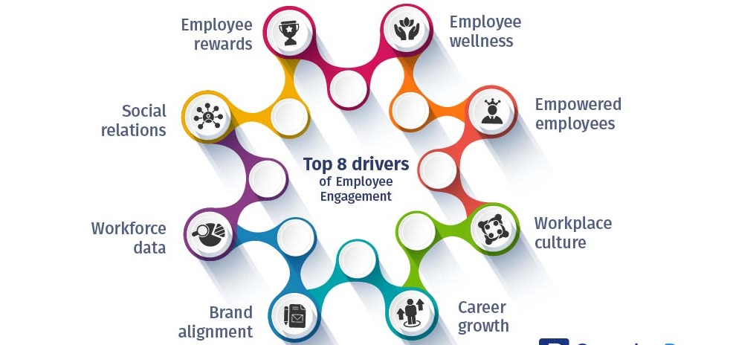

Figure 1: Drivers of employee engagement (Clark, 2012).
Employee Wellness: This program is mainly for the improvement of employees’ health and to solve many health-related problems of the employees. Chief Executive has recently Measures that the organisation has already taken the steps to ensure the workplace “Covid-19 safe”. This driver will reduce the employee’s obstacles with their health problems. With a hygiene workplace employees will be more motivated into the workplace (Tewari, 2020).
Empowered Employees: empowering employees refers to include employees in the decision-making process and provide the powers to control over their daily activities within the organisations (Emma, 2011). This helps the organisations to achieve job satisfaction, job performance and commitment of the employees towards the workplace. Flexible working time in the organisation will increase the employee’s satisfaction level.
Workplace culture: workplace culture plays a vital role in employee engagement as the organisation's factors depend on the culture it’s operating. Culture defines the organisations and their regulations and policies (Carbonara, 2018). With proper regulations and policies employees could be easily engaged with the organisations.
Career growth: employees have both personal and professional goals and organisations need to understand the need for their growth within the organisation by fulfilling their goals. To help to fulfil their personal and professional goals organisations could arrange different activities to motivate them (Tewari, 2020). If employees don’t see any growth in the organisation they won’t be enough motivated and work with their full potentials. Organisations need to make an environment where employees can improve themselves to achieve their career goals.
Employee Rewards: Employees get to be excited when they get any reward offered. Thanking employees with proper reward is a great behaviour towards the employees. This rewards system in the organisation could help the organisation achieve employee satisfaction towards the job (Simpson, 2014). They will be more motivated towards the job as this plays a vital role to motivate them.
Social relationship at work: Relationships of the employers and co-workers in the organisations are mandatory for cultivating social relationship in the workplace. Building a connection within the workers is important for making an effective environment for workers (Simpson, 2014). Employees need to be motivated by their seniors and they need to gather information from them.
Workforce data: To understand the employee’s engagement level organisations need to survey the employee’s behaviours within the organisations and rate their approaches towards other employees. Some promoters have the highest level of engagement in the organisations (Kelleher, 2014). Passives are the person who has a moderate level of engagement within the organisation and lastly, some detectors have the lowest engagement level in the organisations.
Brand alignment: With the help of aligning the employees with the organisations goals and objective helps the employees to be motivated towards achieving organisations goals (Kelleher, 2014). Working extra hours in the workplace to achieve their goals are results of being an integral part of the organisation.
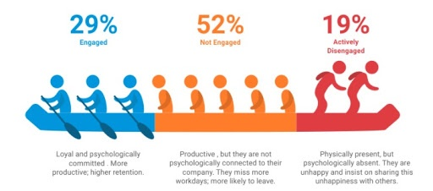

Source: Reflection of employee engagement (Carbonara, 2018)

Evaluating diagnostic tools to measure the engagement
Diagnostic Tools to Measure Engagement: Chief Executive has recently discovered that employee engagement can improve employee performance within the workplace. And to understand and measure the engagement organisations need to evaluate with some diagnostic tools. Which will helps the organisation to understand employee’s engagement and take proper steps to use this effectively within the organisations (Emma, 2011). To survive in the market in any critical situations organisations need to work alongside the employees and cope with them. In this COVID-19 situation, employees need to be more engaged than ever as this is a critical time for both organisation and the employees. There are some diagnostic tools to measure engagement to ensure future success.
Employee Surveys: Forgetting feedback from the employees about their feelings and attitude towards the organisation surveys are the most common to use. To increase the participation rate in the survey Chief Executives could take it anonymously. This will help to get an honest review from the employees (Byrne, 2015). To measure and understand engagement in the organisation's surveys could be very effective in organisations. Questions in the surveys could be like are you giving your maximum effort in the workplace? Or if they are satisfied with the organisation's culture. The most important question would be if they can link their works and organisational goals.
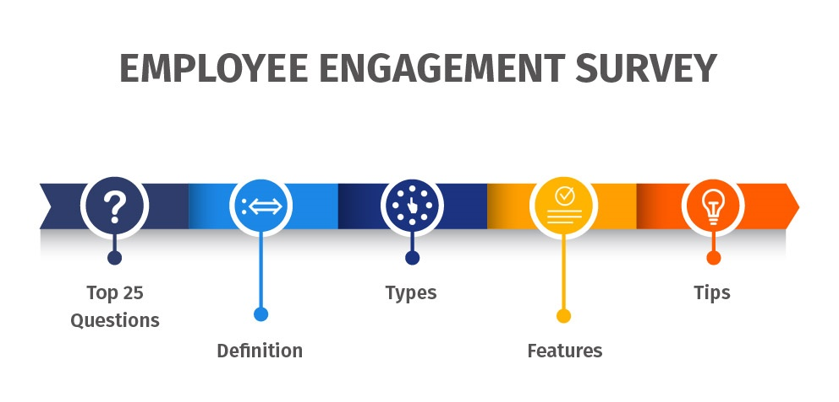

Figure 2: employee engagement survey (McIlwraith, 2016).

HR software: From the survey, it’s not possible to get accurate information as employees not provide ongoing and holistic feedback in the survey. So organisations are implementing software programs to supplement periodic surveys (Byrne, 2015). Modern HR software’s can collect proper data and measure employee’s satisfaction within the organisation. Taking surveys and managing the employees at a time is possible with these software programs. This helps the organisations to take approaches by measuring employee’s data and engagement level. To achieve the company’s wide-goals they need to measure if the organisations are happy and satisfied with the organisational culture.
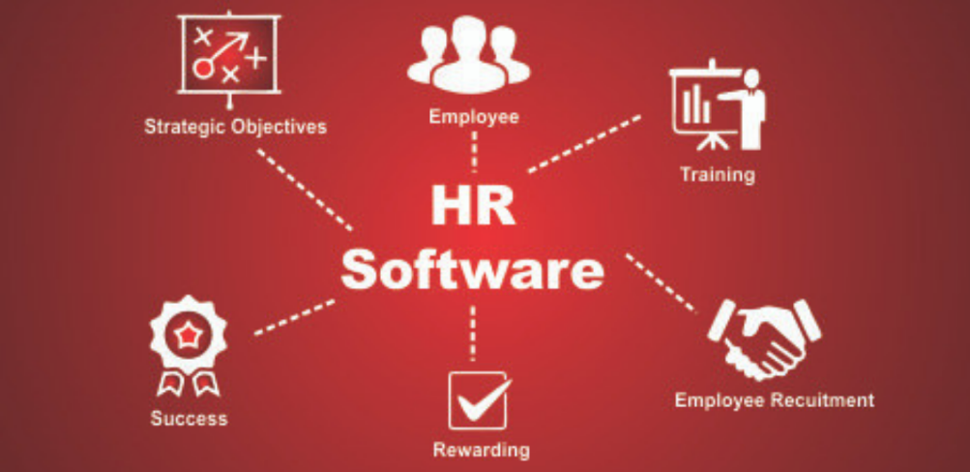

Figure 3: HR Software (hrtools.com)

Social Media: Internal social media networks can measure the engagement level of employees. This tool is very popular among modern business strategies and an effective way to monitor the employees. In this social media, they use to take conversations among them and share ideas between them. This allows the organisations to understand employee’s motives and their adapting level into the organisations (McIlwraith, 2016). To get a common idea over the organisations and its culture social media tools are very effective.

Take Advantage of The Employee Lifecycle: The lifecycle of the employees begins with the recruitment process. After that the development process, managing performance, engaging and motivating, recognition and final farewell. Within these processes, it’s possible to collect feedback from the employees. Continuously collecting employee’s feedbacks and engaging with them throughout their life cycle will help the organisation to understand and adapt to the employee's engagement (McIlwraith, 2016). Organisations can organise different employee engagement programs to increase engagement with the employees within the organisation. With proper engagement with the employee, they can give their maximum efforts to achieve the objectives of the organisation.

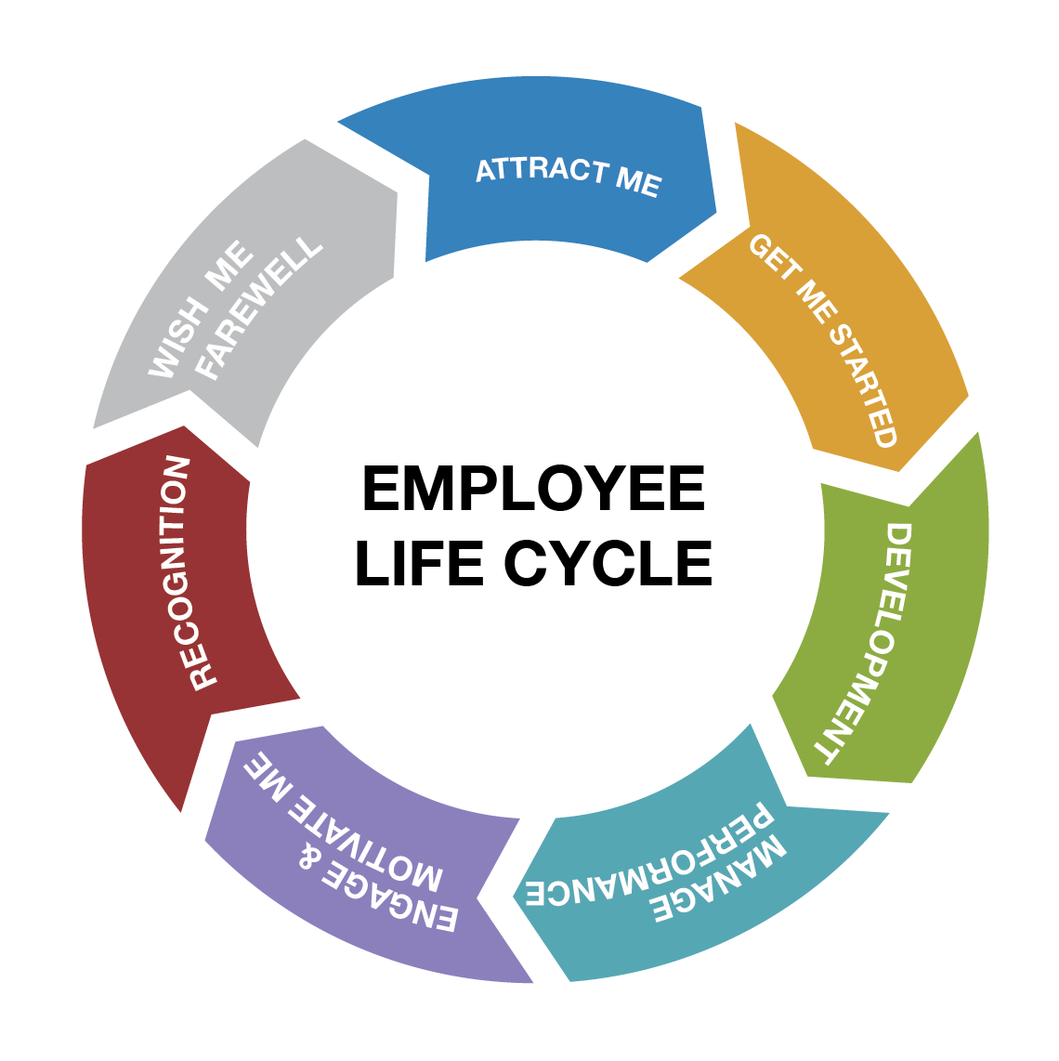

Figure 4: Employee Lifecycle (Simpson, 2014).

Constructing an employee value proposition, including strategies to raise levels of engagement
Employee Value Proposition: employee value proposition refers to the set of benefits provided by the organisations to employees. Benefits could be monetary and non-monetary both. In returns, employees try to provide the maximum effort to the organisation. With proper skills and capabilities, employees contribute to the organisations to achieve the company’s goals (Simpson, 2014). To construct an employee value proposition organisations need to follow six steps.
Steps to Creating an Employee Value Proposition:
Assessing what organisations currently offer: The process of developing an employee value proposition starts with the basics as the organisations need to understand its capabilities (Jessup-Ramsay and Whitney, 2015). What they can offer and what they can’t. According to the task description, the Chief Executive has assessed their organisation's current situation where they were not enough engaged with the employees.
Interviewing existing and past employees: To create a strong EVP organisation need to survey their employees. To get the proper result from the employee’s organisations need to get information from past employees also to understand what they could have done to help them stay in the organisation (McIlwraith, 2016). Questions could be like do they like to work in the organisation and what could help them to be more engaged in the organisation. And what kind of support they expect from the organisations.
Defining the key components of your EVP: This will help the organisation to attract and retain top talent in the organisation. EVP could help the organisations to segment different roles and level into levels for example EVP recent graduates and EVP for professionals (Clark, 2012). With the proper evaluation of these two different key components of EVP, organisations can build an effective and great employee value proposition.

Writing employee value proposition: After assessing how much value could be delivered from the organisation to employees it’s required to write a strong employee value proposition statement (McIlwraith, 2016). The EVP statement has to be clear, unique and inspirational to be effective in the context of any organisation.
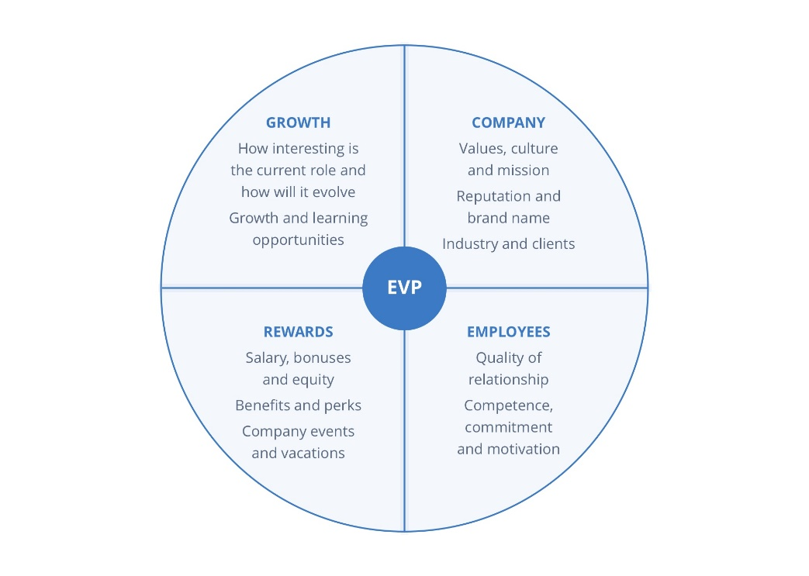

Figure 5: employee value proposition (Simpson, 2014).

Promoting EVP Through The Right Channels: EVP is useless unless it’s well communicated between the organisations. To be perfectly communicated through the organisation it needs to be promoted through the right channel within the organisations. Organisations need to build this channel from the starting level of employee cycles starts from the recruiting process of the employees into the organisation (Clark, 2012). To improve the proper channel within the organisation they need to follow some proper steps and the channel contains awareness, consideration, and interview, offer and finally hire.

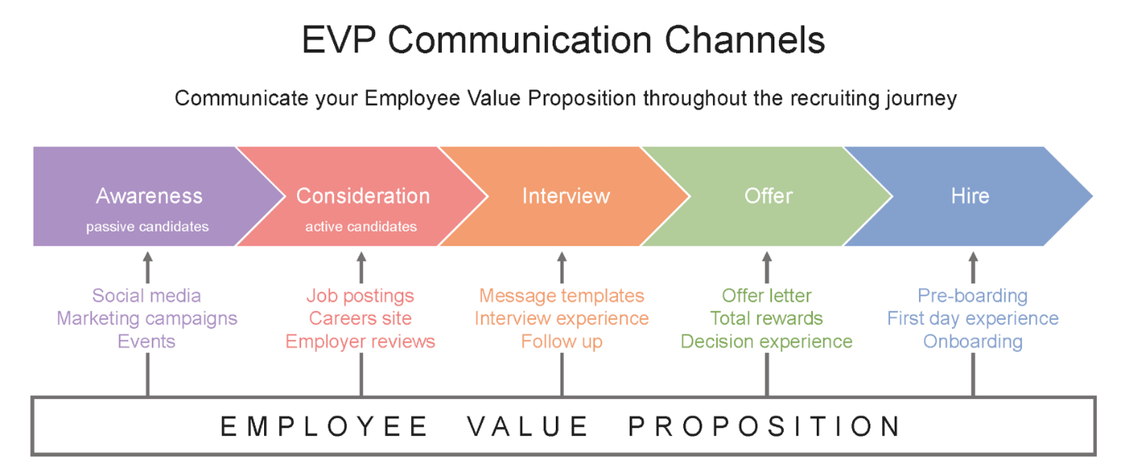

Figure 6: EVP Communication Channels (Simpson, 2014).

Reviewing the results: Evaluating the whole process of EVP within the organisation is mandatory to measure its effectiveness in the organisation. They need to measure the increase in the applications, for example, an increase in the passive responses from the employees (McIlwraith, 2016). Higher engagement in social media is needed to be reviewed by the organisations as this is very popular among the employees nowadays.

Strategies to Raise Levels of Engagement: organisations need to let the employees engage between them within the organisation with proper flexibility. As Chief Executive in this task is providing employees facilities like Working from home and Flexible working time to increase their satisfaction. Properly developing the EVP and evaluate it into the organisations will increase the engagement level in the organisation too (Hodges, 2016). Previously discussed the strategies like building the right channel to communicate between the employees with the organisations and between them. Finally, the organisations need to evaluate the strategies and its effectiveness within the context of the business organisations. In this competitive market, organisations need to engage with their employees more to be successful in the marketplace.

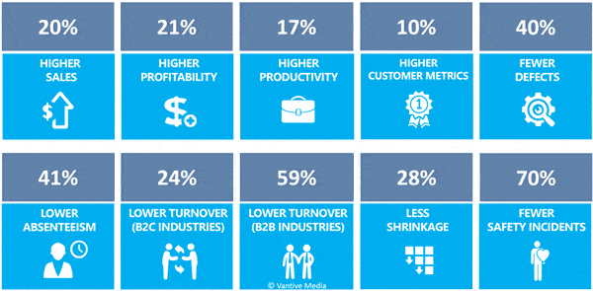

Figure 6: influences of increased Engagement in the organisation (Byrne, 2015)

Conclusion
Employee engagement is a crucial factor for modern organisations as they need to engage with their employees to bring innovation and attract the market towards the organisation. Chief Executive Need to increase the engagement with employees by applying those engagement drivers in the organisations and with proper applying for the driver's job satisfaction and performance of the employees could be achieved. After applying engagement drivers, evaluating and measuring the engagement into the organisation. Different strategies to increase the engagement levels could be very effective which Executive need to apply in the organisation.

References
Byrne, Z. (2015). Understanding Employee Engagement. New York: Routledge.
Carbonara, S. (2018). Manager's Guide To Employee Engagement. Warriewood, N.S.W.: Woodslane Press.
Clark, T. (2012). Employee Engagement Mindset. Blacklick: McGraw-Hill Publishing.
Emma, B. (2011). Employee Engagement. Bradford: Emerald.
Hodges, J. (2016). Employee Engagement For Organizational Change. Blacklick: McGraw-Hill Publishing.
Jessup-Ramsay, R. and Whitney, A. (2015). HR Manager's Guide To Employee Wellness Programs. Toronto, Ont.: Carswell.
Kelleher, B. (2014). Employee Engagement For Dummies. Randburg: KR Publishing.
McIlwraith, A. (2016). Information Security And Employee Behaviour. London: Routledge.
Simpson, H. (2014). Federal Employee Engagement And Performance. Randburg: KR Publishing.
Tewari, I. (2020). Factors that Drive Employee Engagement in Organizations: A Review. International Journal of Psychosocial Rehabilitation, 24(5), pp.6767-6773.

