Emms_Kerri_2518327_ BMDS7009-CW2
Programme, Project and Change Management in Health and Social Care
MSc Digital Transformation of the Health and Care Professions

Cyber Security in Aneurin Bevan Health Board

Introduction

Aneurin Bevan University Health Board (ABUHB) is one of the largest NHS organisations in Wales, providing acute, primary, community, and mental-health services for around 600,000 people across the Gwent region, including Blaenau Gwent, Caerphilly, Monmouthshire, Newport, Torfaen and parts of South Powys (Aneurin Bevan University Health Board, no date). The organisation holds and exchanges a substantial volume of sensitive information across internal teams and external partners, in both digital and paper-based forms. As reliance on digital systems, networked medical devices, and wider digital infrastructures continues to grow, ensuring robust information governance (IG) and cyber security has become essential for safe and effective patient care (NHS Wales, 2024) .This level of prevalent technology and data has huge potential to improve healthcare, but the security of the data and devices must be paramount. Healthcare is a target for cybercrime due to the above, a breech in the Cyber Security and have detrimental effect on patients. Staff (Coventry and Branley, 2018).

ABUHB is no exception to the increasing Cyber security threats, Phishing and Information security presents one of the highest threats to Staff and the health board (Coventry and Branley, 2018). The necessity and urgency to be able to effectively respond to phishing attempts quickly has never been more critical. The proposed initiative addresses these concerns by recognising that ABUHB manual processing tasks are no longer sufficient to keep up to date and react effectively to modern Phishing attempts.

Within ABUHB, Information Security Policy dictates, that Staff must complete mandatory security training when joining ABUHB, this training is then repeated biannually as refresher training through e-learning modules (NHS Wales, 2021). However, these e-Learning modules although conductive in highlighting Cyber Security issues and making people aware of phishing scams, are limited due to the increasing complexity of Cyber-attacks. Online learning modules that are generic for Security training such as utilised at ABUHB is a step in the right direction in acknowledging the security risk ABUHB face. The limitation aspect of this training is highlighted in Applied Science article which highlights that in a high diversity environments that this type of training can be difficult to achieve as there are diverse levels of target groups that require the training and one training for all parties is challenging to complete well (Hatzivasilis et al., 2020). As a supporting infrastructure ABUHB offer Cyber Security threats documents, Cyber Awareness days and frequently asked questions documents for all staff at ABUHB via Health Board Intranet. These documents underpin secure information handling. The National Centre for Cyber Security supports the theory of advanced Cyber Phishing Training and Muti-Layered approaches to training as shown in publication Phishing attacks: defending your organisation (The National Cyber Security Centre, 2024).

Phishing continues to be one of the most widespread and persistent cyber threats confronting organisations (NI Cyber Security Centre, 2025). This is no different for the NHS. On 22 March 2023, the UK government released its cyber resilience strategy for health and social care UK Government, (2023), setting out a plan to strengthen the sector by 2030. The strategy highlights that good cyber security is essential for patient safety, protecting frontline staff, and maintaining public trust in digital services. It focuses on reducing cyber risks, safeguarding patient, and staff data, and ensuring that organisations can recover quickly if a cyber-attack occurs (Bianca Piachaud-Moustakis, 2023). Attackers increasingly target key personnel, exploiting human behaviour as a primary point of vulnerability. Evidence shows that user education combining awareness raising, structured training, and meaningful assessment is among the most effective strategies for reducing organisational risk (Hatzivasilis et al., 2020).

The core issue in ABUHB with the current Cyber Security Training is the inefficiency and inconsistency of the current phishing-training workflow, which makes the process slow and inefficient, and training is not provided in a timely manner. ABUHB training programme from simulations is generic, and training relies heavily on manual review and follow-up. A journal produced by international journal of advanced computer science and applications highlights how generic security training rarely changes users’ behaviour regarding security, which highlights the need for change (Alsaqer et al., 2025). Within ABUHB, the management of phishing simulations and user responses is currently a labour-intensive process, requiring significant manual effort to review results, identify high-risk individuals, and assign follow-up training. This approach limits the cyber security team’s capacity to deliver timely, targeted interventions and constrains opportunities for strategic improvement. Automating this workflow would address inefficiencies and allow ABUHB staff immediate and personalised feedback.

To address these challenges, this essay outlines an imagined improvement initiative designed to enhance cyber-security resilience across ABUHB.

The initiative proposes introducing automated Phishing programme and learning pathways that are triggered when users fail phishing simulations This enables immediate, individualised training while reducing the administrative burden on cyber-security staff. By identifying repeated failures and escalating individuals to more specialised training when standard modules prove insufficient, the initiative aims to promote meaningful behaviour change and strengthen cyber-security competence across the workforce. The programme seeks to improve the Health Board’s overall cyber resilience by streamlining processes, freeing staff capacity, and ensuring that users are better equipped to recognise and respond to cyber threats. To support this theoretical initiative, DMAIC will be used to provide a clear, structured approach for defining the problem, measuring performance, analysing gaps, designing improvements, and planning future control. The aim of the improvement is to build a more automated solution for ABUHB to reduce vulnerability and increase and create focus training to all ABUHB to have a more robust security presence.

Table 1 summarises the project’s aim, relevant policy considerations, and defined scope.

Table 1 -Aims, Policy and Scope and Objective
 | Description
Aim | The aim of this improvement initiative is to enhance ABUHB’s cyber-security resilience by automating the phishing-training workflow, enabling real-time learning responses tailored to individual user needs.
Policy | The initiative will operate within existing IG frameworks while providing the data needed to audit compliance more effectively.
Scope | The scope of this project is limited to automating phishing-training pathways and compliance monitoring at ABUHB. This includes saving staff time by reducing manual work and enabling targeted training and escalation for the right users. It does not include any changes to cybersecurity systems, policies, or incident-response processes.
Methodology | DMAIC is a structured, data-driven approach that improves processes through five stages: Define, Measure, Analyse, Improve, and Control (American Society for Quality, no date).
Objectives | The main objective of the Project is to strengthen ABUHB’s cyber security resilience by automatically providing quick, personalised training whenever staff fail phishing simulations. It reduces manual workload, supports users who repeatedly struggle, and helps improve awareness and behaviour across the organisation. It will also free up valuable time by reducing manual tasks and eliminating unnecessary workload in ABUHB Cyber Security team.

Methods

This essay will look to utilise DMAIC as a framework tool. DMAIC is a structured, datadriven approach that improves processes through five stages: Define, Measure, Analyse, Improve, and Control American Society for Quality (no date),as shown in Figure 1 . This method of analysis provides a better fit for the opportunity of Phishing at ABUHB than other methods such as Prince 2 or PDSA .

Although both PRINCE 2 and PDSA are more commonly used in ABUHB as a methodology analysis tool, DMAIC is more structured and data driven method which would be more beneficial to ABUHB when using large amount of data. (American Society for Quality, no date) DMAIC is more suitable regarding the data analysis and structure required of the proposed solution due to the analytical data it will be required to review across all employees at ABUHB. Plan-Do-Act-Study (PDSA) is more suitable and wore widely used in ABUHB for minimal changes. Six Sigma highlight the advantages and disadvantages of both DMAIC and PDSA in the article PDSA vs DMAIC: Choosing the Right Process Improvement Model (SixSigma, 2024). Due to the complexity of the Data and analysis PSDA would not be suitable.

PRINCE 2 could be applied; however, the governance approach may stall the project and hinder project progress when looking and dealing with behaviour workflows and workflows , the advantages and disadvantages of Prince 2 methodology can be found in article on research gate, detailing Benefits and Issues in Managing Project by PRINCE2 Methodology (Pawar and Mahajan, 2017).

Figure 1 illustrates the structured stages of the DMAIC methodology, being applied to proposed improvement in Cyber security at ABUHB.
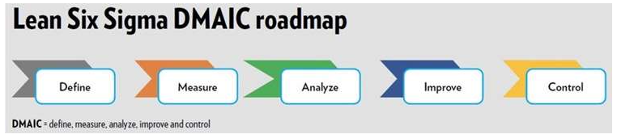
Figure 1 - DMAIC Diagram (American Society for Quality, no date)

This study applies a DMAIC guided mixed method approach to examine and design improvements to ABUHB’s phishing training workflow and wider cybersecurity awareness processes(American Society for Quality, no date). The approach combines documentary analysis with Document sources collected through review of Government policies, national guidelines, peer-reviewed articles, and organisational records from ABUHB. Qualitative insights gathered via structured input from ABUHB staff, Cyber implementation leads, and user feedback to ensure a comprehensive understanding of existing practices.

This improvement initiative would be implemented across the whole ABUHB organisation, targeting all staff groups with corporate email accounts and access to organisational digital systems.

The Improvement would include.
- automated phishing simulations,
- automated, adaptive learning pathways triggered by user interactions with simulated phish, and
- integrated compliance tracking.

The programme will involve a procurement exercise, as at present, the only viable option is to source the required solution from the external market. The intention is to procure a proven, fully developed solution from private sector organisation with the appropriate capability, product maturity, and functionality to meet the required service needs. ABUHB do not currently have the capability to create the phishing solution in house.

To support the analysis of both the proposed and the existing phishing tool at ABUHB, Table 2 summarises the key advantages and disadvantages of the current solution.

Table 2 - Advantages and Disadvantages of Current Phishing Solution
Advantages | Disadvantages
Lower operational costs make it more feasible for large organisations like ABUHB with thousands of staff. | Significant manual effort is required to review phishing results, identify high-risk individuals, and assign training.
The process already yields results, users are trained, phishing simulations run successfully, and security awareness improves.  Even with manual steps, it still identifies high-risk users and supports targeted follow-up. | This reduces capacity for strategic cyber security work and slows down improvement efforts.  Because workflows rely on manual steps, simulations take longer to set up, run, analyse, and follow up on.
Allows Target Training , even if this is Manually intensive | As phishing campaigns increase in volume or complexity, the current process may struggle to keep pace.
Human involvement reduces the risk of automation errors or inappropriate escalation. | Because simulation failures are not always followed by immediate training, opportunities to reinforce learning in the moment are missed.

The proposed solution provides the capability to:
- Deliver targeted phishing simulations.
- Provide point of need learning to reduce phishing susceptibility.
- Improve cybersecurity and information governance awareness.
- Enhance policy dissemination, monitoring, and compliance tracking.
- Support consistent staff development at enterprise scale.
- Enable secure access for employees, agency workers, contractors, and auditors.
- Analyse user behaviour to identify high risk groups.
- Strengthen organisational resilience and service availability.
Anticipated benefits of the new solution would meet the main objective to strengthen ABUHB’s cyber security resilience by automatically providing quick, personalised training whenever staff fail phishing simulations. Which would address the issue of generic training, (Alsaqer et al., 2025). It reduces manual workload, supports users who repeatedly struggle, and helps improve awareness and behaviour across the organisation. It will also free up valuable time by reducing manual tasks and eliminating unnecessary workload in ABUHB Cyber Security team. The advantages of the proposed solution would also include reduced exposure to clinical harm, reduced reputational damage, and lower financial risk; improved staff competence in recognising and reporting threats; along with measurable improvements in compliance. This would be a major improvement over ABUHB traditional, manual security awareness and email threat management practices. It would replace inconsistent, labour-intensive processes with a fully automated, scalable, and data driven approach. Automated training campaigns, scheduled reminders, and continuous phishing simulations ensure consistent staff engagement and measurable behaviour change, supported by baseline and ongoing PhishProne percentage tracking.

ABUHB also need to consider promoting change culture as highlighted by Branley-Bell, Coventry and Sillence (2021), which evaluates how Technology and traditional training alone do not change cybersecurity behaviour in healthcare in isolation. It highlights how NHS Staff often know what to do, but daily pressures like time and fatigue make secure behaviour difficult. ABUHB need to ensure that a broader approach that considers people, processes and culture is needed. Research from several European healthcare organisations shows that involving staff and focusing on long-term cultural change improves behaviour (Branley-Bell, Coventry and Sillence, 2021). This supports the need for behaviour focused, and timely phishing training at ABUHB.

Implementation Plan
The DMAIC guided plan provides a clear and evidence-based way for ABUHB to move from a manual phishing training process to a fully automated, scalable, and data driven system. This will help the organisation:
- Deliver training more quickly and effectively across ABUHB.
- Improve compliance monitoring and visibility of cyber risks at ABUHB.
- Strengthen protection against cyber threats at ABUHB.
- Reduce Wate in ABUHB Staff manual workload on technical teams.
Overall, the approach supports ABUHB’s digital transformation goals and helps build a stronger cybersecurity culture through improved staff behaviour and awareness. Figure 2 illustrates how DMAIC framework can be used for ABUHB.

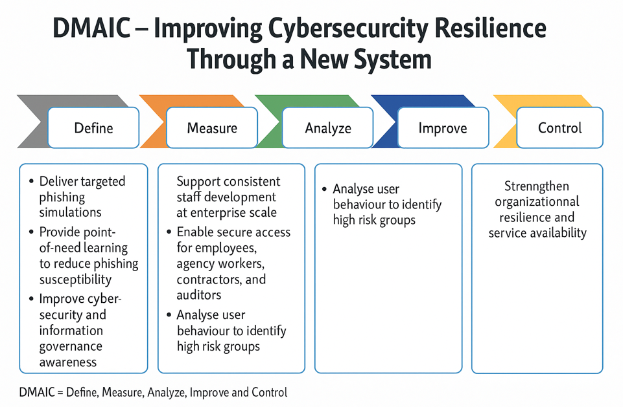
Figure 2 - Adapted version of DMAIC. Adapted from (American Society for Quality, no date)

Proposed Implementation Stages

Implementing an improved phishing simulation and cyber awareness platform within ABUHB requires a structured, evidence-based approach grounded in organisational change and cyber security research. To ensure the change is measurable, sustainable, and effective, the DMAIC model provides a clear, data driven framework for ABUHB to use (American Society for Quality, no date). It supports problem identification, baseline measurement, analysis of root causes, testing of solutions, and controlled long term adoption. To initiate the implementation process, the following structured stages shown in Table 3 and detailed below, could be undertaken at ABUHB.

Table 3 - DMAIC Implementation plan detail
Method (DMAIC) | Stage | Stage Title | Reference
Define | 1,2,3 | Identify Key Stakeholders at ABUHB.  Establish Success Criteria.  Gather User Feedback on Current Processes at ABUHB. | (Freeman and McVea, 2001; Elzinga, 2018; Keup, 2021)
Measure | 4 | Assess Current Process Efficiency | (Gavrilenko, 2015)
Analyse | 5,6 | Define new Technical and Compliance. Requirements for New ABUHB Platform.  Analyse Findings and Produce Procurement Specification. | (Atlassian, 2020)
Improve | 7,8 | Conduct a Pilot Phase with Selected Provider.  Analyse Pilot Results and Gather Feedback. | (Leon, Davis and Kraemer, 2011)
Control | 9 | Implement Full-Scale Rollout. | (Kotter, 1996)

Table 4 provides a summary of each stage along with the core objectives and key activities of the implementation of the Phishing initiative at ABUHB.

Table 4 Overview of the nine key stages in the implementation programme Phishing at ABUHB

Stage | Description of stage
Stage 1: Identify Key Stakeholders at ABUHB | ABUHB Team need to map all relevant stakeholder groups, including Cyber Security, Digital Business Unit, Information Governance, Workforce & OD, departmental managers, and end users, to ensure comprehensive organisational engagement. The importance of this process of including and identifying stakeholders is highlighted in research such as Stakeholder theory and (Freeman and McVea, 2001) If stakeholders are not included in a project like ABUHB’s phishing simulation misalignment and resistance to change are more likely to occur.
Stage 2: Establish Success Criteria | ABUHB need to establish clear success indicators required by the Phishing Campaign solution. Although project teams commonly aspire to deliver successful results, many fail to articulate the specific metrics or conditions by which success will be assessed (Keup, 2021). Using this Theory, the ABUHB project need to establish strategic recordable metrics, such as reductions in phishing susceptibility, improved training completion rates, and decreased manual workload for the Cyber Security team. This was Success of programme can be accurately measured.
Stage 3: Gather User Feedback on Current Processes at ABUHB | Collecting qualitative insights from staff regarding the existing phishing simulations and associated training at ABUHB is Critical. This will involve surveys, interviews, and focus groups at ABUHB to understand user experience and perceived gaps. This feedback that these teams receive at ABUHB serve as a critical mechanism for understanding employee perceptions and identifying the communication needs of different organisational groups. It enhances the effectiveness of organisational communication by accelerating the learning process, enabling teams to adjust strategies, clarify messages, and maintain progress toward shared objectives(Elzinga, 2018).
Stage 4: Assess Current Process Efficiency | ABUHB need to evaluate the time and resources required to deliver phishing simulations and follow-up training under the current system. This includes assessing manual tasks, delays, and capacity constraints. An article written by Artur Gavrilenko  states “Put simply, process efficiency describes how well a workflow transforms resources into value (Gavrilenko, 2015).  For ABUHB to efficiently measure the process efficiency within DMAIC, the process must be supported by clear KPIs (key performance indicators) This is key to ABUHB as DMAIC is a data driven model so to be used effectively KPIs must be established.
Stage 5: Define new Technical and Compliance Requirements for New ABUHB Platform | ABUHB need to develop detailed specifications for the required automated phishing and training solution, including cybersecurity standards, Information Governance requirements, and technical integration needs. Clear technical requirements created by ABUHB lay the groundwork for a project that to deliver accurately and consistently (Atlassian, 2020).
Stage 6: Analyse Findings and Produce Procurement Specification | ABUHB need to analyse all collected data to create a robust procurement specification. This document will support a competitive market exercise to identify suitable platform providers (Atlassian, 2020).
Stage 7: Conduct a Pilot Phase with Selected Provider | ABUHB should Implement a controlled pilot with the chosen supplier to evaluate system functionality, usability, automation features, and alignment with organisational needs. It would be advised that ABUHB pilot group consists of a range of staff likely to be targeted such as Management and Finance. It would also be useful to add nursing and secretaries, where high volumes of information are held and it would also give a more rounded view of ABUHB requirements. Once completed ABUHB will have a clearer idea on if the solution is suitable. Leon, Davis and Kraemer (2011) , discuss and analyse the role and interpretation of pilot studies in clinical research. ABUHB should have a clearer understanding on the suitability of the solution , for health board by considering a wider mix of pilot study staff prior to deployment
Stage 8: Analyse Pilot Results and Gather Feedback | The next step will be the evaluation of the pilot outcomes, examining system performance, user engagement, training effectiveness, and operational impact. This should include ABUHB engagement with staff and stakeholders, using their feedback to refine requirements further. As stated by Leon, Davis and Kraemer, (2011) “Pilot results can inform feasibility and identify modifications needed in the design”.
Stage 9: Implement Full-Scale Rollout | Stage 9: Implement Full-Scale Rollout  Following successful pilot validation, ABUHB can proceed with health board wide deployment, supported by communication plans, staff training materials. ABUHB may also use a framework such as Kotter whose Change Model can help ABUHB In incorporating and delivering digital transformation roll out ( Kotter, 1996).G

Discussion

As healthcare becomes increasingly dependent on digital systems, the risk of cyberattacks continues to grow. Incidents like the 2017 WannaCry attack in Ireland highlight how quickly NHS services can be shut down, blocking access to vital patient information and disrupting care (Ghafur et al., 2019) and (Moore et al., 2023). Rising cyber-attack threats highlight why strong cyber security and effective staff training are essential for ABUHB, where digital safety directly affects patient care and service continuity. As more digital tools are introduced in ABUHB, more potential threats emerge, making ongoing, engaging cyber security training even more critical. To combat this issue ABUHB could apply Mendelow stakeholder matrix to identify and engage key stakeholders. The stake holder matrix as shown in Figure 3 identifies high Poer and High Interest groups, Low Power low interest and Low power High interest and adopt the engagement effectively.

Figures three illustrates the Mendelow power matrix as described in (Bernstein, Weiss and Curry, 2020).

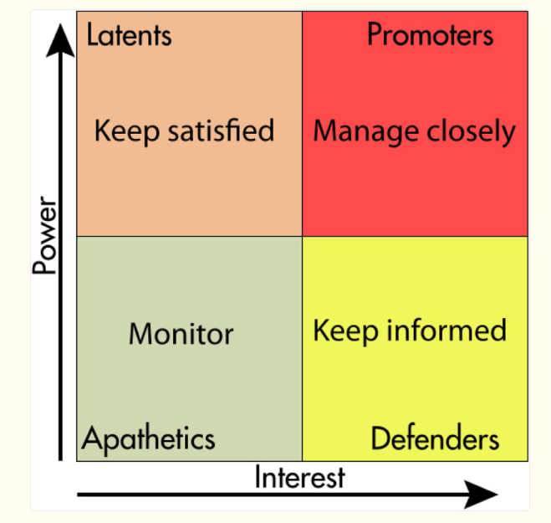
Figure 3 Medlow Matrix (Bernstein, Weiss and Curry, 2020).
Using the information in Stage 7 of the methods section. The stakeholder mapping could be completed as

- High Power High Interest ABUHB (Manage Closely) staff Members - Senior Leadership, SIRO, Finance.

- High Power Low Interest (Keep Satisfied) - Welsh Government (WG sit outside of the Day to day so interest would be lower)

- Low Power High Interest - Nursing and Secretaries

- Low Power Low interest – Facilities staff, Porters, Maintenance staff

DMAIC provides a structured, data driven framework for process improvement, but it has notable constraints when applied to a cybersecurity behaviour change initiative at ABUHB. The Framework doesn’t fully capture cultural Barriers with ABUHB, which poses risk to the success of the programme, as resistance to change poses one of the largest barriers to successful implementation (Kotter, 2011). ABUHB project team, must ensure that staff stay engaged and interact directly in cybersecurity training, because people have different digital skills, levels of confidence, and reactions to new training. These human factors affect how well any cybersecurity improvement will work (Yeng, Fauzi and Yang, 2021). A fundamental flaw of DMAIC is that although it will offer ABUHB a clear, structured, data driven way to improve processes. it also has limits for changing staff behaviour (Kressmann and Mueller-Seeger, 2026).

Building on this analysis, this essay has reviewed the initiative of Phishing solution for ABUHB , however there are key risks that need to be continually reviewed to ensure the project’s success at ABUHB. The table below highlights Key risks to the improvement initiative within the Cyber team at ABUHB.

Table 5 - Key risks to the Cyber Phishing initiative
Risk | Reference
Behaviour – ABUHB staff may resist the new Training and Cyber Solution. This resistance – DMAIC does not support this risk well. | (Kressmann and Mueller-Seeger, 2026) (Kotter, 2011).
Culture - ABUHB staff may struggle to adapt to new culture, and approach of Cyber Security. DMAIC does not fully consider culture in its processes. | (Kressmann and Mueller-Seeger, 2026).
Blame Culture – ABUHB Staff whether perceived or real may see the Phishing initiative as a blame culture and forced training. This may stop staff engaging with the process and reduce the effectiveness of the phishing implementation. To combat this ABUHB could look to incentivise teams with high reporting of Phishing. Where a report Phishing button is utilised and highest reporting teams are rewarded. | (Lupton and Sarwar, 2021)
Agility in evolving Threat Digital treats evolve quickly and ABUHB must adapt rapidly. The structured nature of DMAIC can be counterproductive where structure of the framework, and detailed processes are not as flexible for ABUHB in a high-risk environment. | (ENSIA, 2026).

The proposed solution at ABUHB has a solid fundamental structure to be a benefit to the organisation. The Proposed solution offers ABUHB a chance to reduce waste in wasted time and staffing, increase productivity of teams, keep staff engaged with bespoke training and offer higher level of cyber security. This does come at an additional cost which would need to be evaluated by the health board, but with the correct approach and budget the implementation of this initiative would be highly beneficial.

- The proposed initiative could further support ABUHB in future and potentially be adapted to create a security dashboard. ABUHB could utilise the dashboard to give real time information on
visibility of staff risks.

- Further development on training progresses and common trends

This could influence ABUHB future decisions regarding security and support long term digital goals. It could turn training information and results into usable insights.

I did not use generative AI to produce any of the text as defined in the specification.
References
Alsaqer, A. et al. (2025) ‘Phishing Simulation as a Proactive Defense: A Customizable Platform for Training and Behavioral Analysis’, International Journal of Advanced Computer Science and Applications, 16(6). Available at: https://doi.org/10.14569/IJACSA.2025.01606104.
American Society for Quality (no date) Learn and Quality - DMAIC, American Society for Quality. Available at: https://asq.org/quality-resources/dmaic (Accessed: 2 February 2026).
Aneurin Bevan University Health Board (no date) The Health Board, NHS Wales. Available at: https://abuhb.nhs.wales/about-us/the-health-board/ (Accessed: 2 February 2026).
Atlassian (2020) Why Requirements Management is essential for Project success, Atlassian. Available at: https://community.atlassian.com/forums/Jira-articles/Why-Requirements-Management-is-essential-for-Project-success/ba-p/1471034 (Accessed: 19 February 2026).
Bernstein, S.L., Weiss, J. and Curry, L. (2020) ‘Visualizing implementation: contextual and organizational support mapping of stakeholders (COSMOS)’, Implementation Science Communications, 1(1), p. 48. Available at: https://doi.org/10.1186/s43058-020-00030-8.
Bianca Piachaud-Moustakis (2023) ‘Protecting the NHS from Cyber Attacks: A strategy on cyber resilience for health and social care organizations has been set out by the UK government.’, Pharmaceutical Technology Europe, 35(5). Available at: https://go.gale.com/ps/i.do?id=GALE%7CA751251208&sid=googleScholar&v=2.1&it=r&linkaccess=abs&issn=17537967&p=HRCA&sw=w&userGroupName=anon%7E13d30e5b&aty=open-web-entry (Accessed: 2 February 2026).
Branley-Bell, D., Coventry, L. and Sillence, E. (2021) ‘Promoting Cybersecurity Culture Change in Healthcare’, Proceedings of the 14th PErvasive Technologies Related to Assistive Environments Conference. New York, NY, USA: ACM, pp. 544–549. Available at: https://doi.org/10.1145/3453892.3461622.
Coventry, L. and Branley, D. (2018) ‘Cybersecurity in healthcare: A narrative review of trends, threats and ways forward’, Maturitas, 113, pp. 48–52. Available at: https://doi.org/10.1016/j.maturitas.2018.04.008.
Elzinga, D. (2018) Why you need to collect employee feedback during change, Culture Amp. Available at: https://www.cultureamp.com/blog/collect-employee-feedback (Accessed: 17 February 2026).
ENSIA (2026) ENISA Threat Landscape 2026. Available at: https://www.enisa.europa.eu/publications/enisa-threat-landscape-2025 (Accessed: 19 February 2026).
Freeman, R.E.E. and McVea, J. (2001) ‘A Stakeholder Approach to Strategic Management’, SSRN Electronic Journal [Preprint]. Available at: https://doi.org/10.2139/ssrn.263511.
Gavrilenko, A. (2015) What Is Process Efficiency and How to Improve It in 10 Steps, AproveIT. Available at: https://approveit.today/blog/what-is-process-efficiency-and-how-to-improve-it-in-10-steps (Accessed: 17 February 2026).
Ghafur, S. et al. (2019) ‘The challenges of cybersecurity in health care: the UK National Health Service as a case study.’, The Lancet. Digital health, 1(1), pp. e10–e12. Available at: https://doi.org/10.1016/S2589-7500(19)30005-6.
Hatzivasilis, G. et al. (2020) ‘Modern Aspects of Cyber-Security Training and Continuous Adaptation of Programmes to Trainees’, Applied Sciences, 10(16), p. 5702. Available at: https://doi.org/10.3390/app10165702.
Keup, M. (2021) Understanding Project Management Success Criteria, PM-Project Manager. Available at: https://www.projectmanager.com/blog/understanding-project-management-success-criteria (Accessed: 17 February 2026).
Kotter, J. (1996) Leading Change Why Transformation Efforts Fail. Available at: https://web-docs.stern.nyu.edu/executive/Leading%20Change_Kotter.pdf (Accessed: 20 February 2026).
Kotter, J.P. (2011) Leading Change. Vahlen. Available at: https://doi.org/10.15358/9783800646159.
Kressmann, K. and Mueller-Seeger, J. (2026) ‘A systematic review of organizational culture change from the micro-macro perspective’, Management Review Quarterly, 76(1), pp. 913–953. Available at: https://doi.org/10.1007/s11301-025-00498-5.
Leon, A.C., Davis, L.L. and Kraemer, H.C. (2011) ‘The role and interpretation of pilot studies in clinical research’, Journal of Psychiatric Research, 45(5), pp. 626–629. Available at: https://doi.org/10.1016/j.jpsychires.2010.10.008.
Lupton, B. and Sarwar, A. (2021) ‘Blame at Work’, Business and Professional Ethics Journal, 40(2), pp. 157–188. Available at: https://doi.org/10.5840/bpej2021323109.
Moore, G. et al. (2023) ‘A resilient workforce: patient safety and the workforce response to a cyber-attack on the ICT systems of the national health service in Ireland’, BMC Health Services Research, 23(1), p. 1112. Available at: https://doi.org/10.1186/s12913-023-10076-8.
NHS Wales (2021) ‘Information and Security Policy’, All Wales Policy [Preprint]. All Wales NHS.
NHS Wales (2024) ‘NHS Wales Information Governance Policy’, NHS Wales - Unpublished.
NI Cyber Security Centre (2025) Phishing, NI Cyber Security Centre. Available at: https://www.nicybersecuritycentre.gov.uk/articles/phishing (Accessed: 2 February 2026).
Pawar, R.P. and Mahajan, K.N. (2017) ‘Benefits and Issues in Managing Project by PRINCE2 Methodology’, International Journal of Advanced Research in Computer Science and Software Engineering, 7(3), pp. 190–195. Available at: https://doi.org/10.23956/ijarcsse/V7I3/0134.
SixSigma (2024) ‘DSA vs DMAIC: Choosing the Right Process Improvement Model.’, SixSigma.us [Preprint]. Available at: https://www.6sigma.us/process-improvement/pdsa-vs-dmaic/ (Accessed: 19 February 2026).
The National Cyber Security Centre (2024) ‘Phishing attacks: defending your organisation’, The National Cyber Security Centre [Preprint]. Available at: https://www.ncsc.gov.uk/pdfs/guidance/phishing.pdf (Accessed: 28 January 2026).
UK Government (2023) A cyber resilient health and adult social care system in England: cyber security strategy to 2030. Available at: A cyber resilient health and adult social care system in England: cyber security strategy to 2030 (Accessed: 2 February 2026).
Yeng, P.K., Fauzi, M.A. and Yang, B. (2021) ‘Assessing the effect of human factors in healthcare cyber security practice: An empirical study’, 25th Pan-Hellenic Conference on Informatics. New York, NY, USA: ACM, pp. 472–476. Available at: https://doi.org/10.1145/3503823.3503909.

