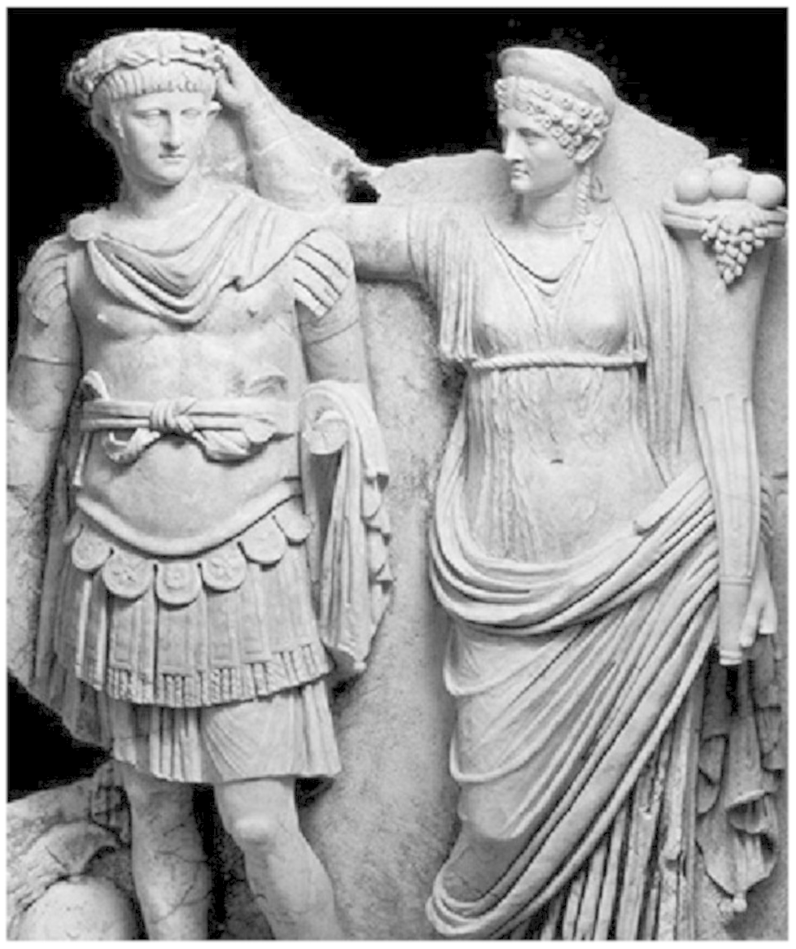

Claire Mann 1602593
HPAH6037
Murder, Mayhem and Megalomania: The Life and Times of Emperor Nero
8 October 2021

Critically discuss why many of Nero’s cultural and athletic pursuits were so controversial for some members of the Roman elite.

Born in 37AD and initially named Lucius Domitius Ahenobarbus, he was the son of Gnaeus Domitius Ahenobarbus and Agrippina the Younger, his father died when he was just three years old, resulting in him having an unsettled childhood. At the age of twelve, though Suetonius quotes eleven, his great uncle the emperor Claudius adopted him, after marrying Agrippina, and gave him the name Nero Claudius Caesar Augustus Germanicus. On 13 October 54AD suddenly, and some say suspiciously, the emperor Claudius died, Tacitus suggests he died as a result of being poisoned by Agrippina. The death of Claudius, teamed with Agrippina’s drive and determination, set the stage so to speak, for Nero. She was able to side-line Claudius’s biological son Britannicus and have her son ascend the throne, becoming the fifth emperor of Rome and the last of the Julio-Claudian dynasty, at just 17 years of age. Initially Nero’s reign went well, he gained a reputation for political generosity, prompting power-sharing with the Senate and ending closed door political trials. However, Nero’s real passion was in the arts, he considered himself a very good singer, poet, musician, performer and above all, sportsman. He was convinced that if he failed to achieve artistic and athletic glory, he was a failure as an emperor and as a Roman, so to pursue his passions he left ruling responsibilities to the philosopher Seneca, the prefect Burrus and his mother. Some of Cassius Dios sources suggest things didn’t work quite like that, he wrote ‘at first Agrippina managed for him all the business of the empire’ and in another source “…he had, according to report, but a weak and indistinct voice, so that he moved his whole audience to laughter and tears at once. Beside him stood Burrus and Seneca, like teachers, prompting him; and they would wave their arms and togas at every utterance of his and lead others to do the same.
Nero took up lessons in singing and dancing, Suetonius claims that ‘he undertook all the usual exercises for strengthening his voice. He would also lie on his back with a slab of lead on his chest, use enemas and emetics to keep down his weight, and refrain from eating apples and every other food considered deleterious to the vocal cords’. Yet still his voice was described as husky and feeble or slight and indistinct. Nero made his debut in Naples in 64AD, during his performance the ground began to shake, he continued with his rendition throughout the earthquake, as the show came to an end, he thanked both his audience and the gods for the applause. This visit clearly meant the world to Nero as he considered Naples the place where he was baptised into the world of art.
After his stint in Naples he ventured to Greece, the first ruling emperor to visit old Greece since Augustus, and he did not act as Roman tourists usually acted. Tourism was not the reason for his visit, he didn’t go for sightseeing, he went to be seen. Nero’s mission in Greece was to compete in the six great athletic contests of the time, with artistic ones of singing and acting only being added for Nero’s sake: the Actian Games at Nicopolis; the Olympian Games at Olympia; the Nemean and the Heraean Games at Argos; the Isthmian Games at Corinth; and the Pythian Games at Delphi. Of all the events that took place in these venues, there were four that the emperor was particularly interested in: the emperor of Rome sang on stage, accompanying himself on the lyre; he acted in tragedies, wearing masks and costume and supported by one or more other actors; he raced chariots in several places; and he participated in the contest of heralds, so that he could announce his own victories. Suetonius states ‘He also sang roles in tragedies, playing heroes and gods, likewise heroines and goddesses, with the mask modelled in the likeness of his own face and that of whatever woman he was in love with. Among others, he sang the roles of Canace about to give birth, Orestes the matricide, the blinded Oedipus, and the mad Hercules.’ While Dio’s account is ‘He wore masks sometimes resembling his roles, sometimes resembling his own face; all his female masks were fashioned in the likeness of Sabina, so that she, even though dead, might tread the stage’. Behaviour like this from the emperor surely caused outrage. David Wiles explains the difference with Greek and Roman thoughts on masks in his book on the semiotics of masks “While the Greeks who put on a mask created a new life form, I would suggest that the Roman who put on a mask resurrected a dead being.’
No other emperor prior to Nero were men of the arts and letters in the way he was. One of the many ways that the old Roman traditions were tarnished by Nero was his dedication to artistic and athletic excellence, and his appearance as a competitor in the games or on the stage. The view of the people of Rome was that artists and athletes were despised, and positions only for dishonourable criminals, slaves or professionals. Certainly not for the emperor. However, even with this view, Tacitus claimed that for many years after Nero’s death, the people of Rome sang his songs and poems.
Whatever people’s thoughts were on Nero, his belief was he was a star performer in every aspect of the arts and athletics. On 9 June 68 AD when he took his own life, final words to frantically utter from his mouth were
‘What an artist dies in me’ Qualis artifex perio’ just to conclude his very dramatic, yet short life.

Bibliography

Primary Sources
Cassius Dio Roman History 61.3.2
Cassius Dio Roman History 61.20.2-4
Suetonius: Nero, 20.1
Tacitus: The Annals of Imperial Rome
Books
Alston, Richard. 1998. Aspects of Roman History AD 14-117 (London, England: Routledge)
Champlin, Edward. 2005. Nero (London, England: Belknap Press)
Journal Articles
Mouratidis, John, "Nero: The Artist, The Athlete And His Downfall", Journal Of Sport History, 12 (1985), 6
Slater, Niall W., "Nero's Masks", The Classical World, 90 (1996), 33-40 <https://doi.org/10.2307/4351898>
Websites
"Nero", HISTORY, 2021 <https://www.history.com/topics/ancient-history/nero#section_2> [Accessed 8 October 2021]

Tacitus: The Annals of Imperial Rome
"Nero", HISTORY, 2021 <https://www.history.com/topics/ancient-history/nero#section_2> [Accessed 8 October 2021].
John Mouratidis, "Nero: The Artist, The Athlete And His Downfall", Journal Of Sport History, 12.1 (1985), 6.
Cassius Dio: Roman History 61.3.2
Cassius Dio: Roman History 61.20.2-4
Suetonius: Nero, 20.1
Edward Champlin, Nero (Cambridge, Mass.: Belknap Press of Harvard University Press, 2003), p. 54.
Ibid, p55
Ibid.
Niall W. Slater, "Nero's Masks", The Classical World, 90.1 (1996), 33-40 <https://doi.org/10.2307/4351898>.
Cassius Dio: Roman History 63.9.5
Slater, Niall W., "Nero's Masks", The Classical World, 90 (1996), 33-40 https://doi.org/10.2307/4351898 p.36

