Programme control
ACBA6000
Deborah Hughes
Liam Berner
1706870

Introduction
The information contained within this proposal relates a proposed new library building (Y Fforwm) for the University of Wales Trinity St David. A project programme schedule was produced using software showing the critical path of the project construction phase. Site specific reports for time, cost and resources required for the work activities have been compiled. An investigation into the performance, productivity of the contract was carried out and possible increase in productivity was identified. A sketch of the site plan is included in this document showing the layout of the proposed construction site with a further sketch showing the construction site within the area of surrounding building for reference. Further, the project programme schedule compiled exceeds the contract period by two weeks, 10 working days and a suggestion to reduce the project programme schedule is included in this document.
Gantt Chart View
The Gantt view shows the contract period for the project of 144 days using the resources and timings as costed for the schedule. The resources used to complete this Gantt chart view were conversations and information obtained from various contractors, sub-contractors and suppliers. Their information was based on historical evidence and experience of similar projects to determine realistic times for the specialist work required within the contract (Cooke B, Williams P, p.205, 2009).
Task Name | Duration | Start | Finish | Predecessors | Resource Names
Contract Period | 144 days | Wed 05/05/21 | Mon 22/11/21
Site Set Up | 8 days | Thu 06/05/21 | Mon 17/05/21
Site Access | 1 day | Thu 06/05/21 | Thu 06/05/21 |  | Foreman
Facilities and Material Preparation | 2 days | Fri 07/05/21 | Mon 10/05/21 | 4 | Foreman
Amenity Arrival | 2 days | Tue 11/05/21 | Wed 12/05/21 | 5 | Foreman
Material Delivery | 3 days | Thu 13/05/21 | Mon 17/05/21 | 6 | Foreman ,Machinery,Plant driver
Machinery Delivery | 2 days | Thu 13/05/21 | Fri 14/05/21 | 6 | Machinery
Site Clearance | 5 days | Fri 07/05/21 | Thu 13/05/21 | 4 | Machinery,Plant driver
Ground Works | 25 days | Mon 10/05/21 | Fri 11/06/21
Piling | 6 days | Mon 10/05/21 | Mon 17/05/21 |  | Machinery,Plant driver
Excavation | 10 days | Tue 18/05/21 | Mon 31/05/21 | 11 | Machinery,Plant driver
Foundations | 6 days | Tue 01/06/21 | Tue 08/06/21 | 12 | Concrete[1],Foreman
Reinforced Steel | 4 days | Tue 01/06/21 | Fri 04/06/21 | 12 | Steel[1]
Concrete Pour | 4 days | Tue 25/05/21 | Fri 28/05/21 | 12FS-5 days | Concrete[1]
Access to level groundworks | 2 days | Mon 07/06/21 | Tue 08/06/21 | 17 | Foreman
Drainage | 5 days | Mon 31/05/21 | Fri 04/06/21 | 15 | Ground works,Machinery,Plant driver
Concrete pour ground finish | 2 days | Wed 09/06/21 | Thu 10/06/21 | 16 | Concrete[1]
Access to machinery works | 1 day | Fri 11/06/21 | Fri 11/06/21 | 18 | Machinery
Phase 1 | 56 days | Tue 08/06/21 | Tue 24/08/21
Machinery delivery (crane) | 1 day | Tue 08/06/21 | Tue 08/06/21 |  | Machinery,Plant driver
Steel frame assembly floor, walls | 37 days | Wed 09/06/21 | Thu 29/07/21 | 21 | Steel Frame Kit[1]
Construction of roof | 13 days | Mon 19/07/21 | Wed 04/08/21 | 22FS-10 days | Carpenter
Weathering finishes too roof | 16 days | Tue 03/08/21 | Tue 24/08/21 | 23FS-2 days | Carpenter
Phase 2 | 37 days | Mon 19/07/21 | Tue 07/09/21
Exterior brick between steel | 28 days | Mon 19/07/21 | Wed 25/08/21 |  | Bricks[1]
Insulation external and internal | 15 days | Tue 20/07/21 | Mon 09/08/21 | 26FS-28 days | Carpenter
Opposite works exterior | 17 days | Fri 06/08/21 | Mon 30/08/21 | 29SS+3 days | Carpenter
Internal bricking | 27 days | Mon 02/08/21 | Tue 07/09/21 | 27FS-6 days | Bricks[1]
Window fitting | 10 days | Mon 23/08/21 | Fri 03/09/21 | 29SF+21 days | Carpenter
Phase 3 | 23 days | Tue 03/08/21 | Thu 02/09/21
Internal bricking opposite | 14 days | Mon 16/08/21 | Thu 02/09/21 | 34SS-6 days | Carpenter
Complete window fitting | 3 days | Fri 27/08/21 | Tue 31/08/21 | 32SS-11 days | Carpenter
First fix electric | 14 days | Tue 10/08/21 | Fri 27/08/21 | 35SS-2 days | Electrician
First fic carpentry | 14 days | Fri 06/08/21 | Wed 25/08/21 |  | Carpenter
First fix services | 14 days | Tue 10/08/21 | Fri 27/08/21 | 35SS-2 days | Electrician ,Services Engineer
Phase 4 | 46 days | Tue 10/08/21 | Tue 12/10/21
Internal fire proofing | 30 days | Tue 10/08/21 | Mon 20/09/21 |  | Carpenter
Services second fix + finish | 22 days | Fri 20/08/21 | Mon 20/09/21 | 38SS-10 days | Electrician ,Services Engineer
Test services | 4 days | Mon 20/09/21 | Thu 23/09/21 | 42SS-9 days | Services Engineer
Plasterboarding | 17 days | Fri 10/09/21 | Mon 04/10/21 | 39SS-30 days | Carpenter,Platerboard[1]
Plastering | 17 days | Mon 20/09/21 | Tue 12/10/21 | 41SS-10 days | Plasterer
Final phase | 62 days | Fri 27/08/21 | Mon 22/11/21
Painting and decorating | 23 days | Tue 28/09/21 | Thu 28/10/21 |  | Painter and Decorator
Interior furnishing and decorating | 16 days | Fri 29/10/21 | Fri 19/11/21 | 44 | Painter and Decorator
Final services testing | 3 days | Wed 17/11/21 | Fri 19/11/21 | 45FS-3 days | Services Engineer
Handover | 1 day | Mon 22/11/21 | Mon 22/11/21 | 46 | Foreman

Resource Sheet
Included in this resource sheet are items of material that are quantified by either the item amount, linear metre, cubic metre or per 1000 of. This information is based on historical evidence supplied by others with experience of similar projects.
Resource Name | Type | Material Label | Initials | Group | Max. Units | Std. Rate | Ovt. Rate | Cost/Use | Accrue At | Base Calendar | Code | Rate
Foreman | Work |  | F |  | 500% | £25.00/hr | £0.00/hr | £0.00 | Prorated | Standard
Concrete | Material |  | C |  |  | £100.00 |  | £0.00 | Prorated |  |  | Per Cubic Metre
Machinery | Work |  | M |  | 500% | £30.00/hr | £0.00/hr | £0.00 | Prorated | Standard
Plant driver | Work |  | PD |  | 500% | £16.00/hr | £0.00/hr | £0.00 | Prorated | Standard
Carpenter | Work |  | C |  | 600% | £18.00/hr | £0.00/hr | £0.00 | Prorated | Standard
Electrician | Work |  | E |  | 300% | £18.00/hr | £0.00/hr | £0.00 | Prorated | Standard
Steel | Material |  | S |  |  | £30.00 |  | £0.00 | Prorated |  |  | Per lin Metre
Steel Frame Kit | Material |  | SF |  |  | £30.00 |  | £0.00 | Prorated |  |  | Per lin Metre
Bricks | Material |  | B |  |  | £500.00 |  | £0.00 | Prorated |  |  | Per 1,000
Platerboard | Material |  | PB |  |  | £6.00 |  | £0.00 | Prorated |  |  | Per Sheet
Plasterer | Work |  | P |  | 100% | £15.00/hr | £0.00/hr | £0.00 | Prorated | Standard
Ground works | Work |  | G |  | 500% | £15.00/hr | £0.00/hr | £0.00 | Prorated | Standard
Services Engineer | Work |  | S |  | 300% | £16.00/hr | £0.00/hr | £0.00 | Prorated | Standard
Painter and Decorator | Work |  | P |  | 400% | £15.00/hr | £0.00/hr | £0.00 | Prorated | Standard

Time Schedule
This information is based on historical evidence supplied by others with experience of similar projects.
Task Name | Work | Duration
Contract Period | 1152 hrs | 144 days
Contract Period | 1152 hrs | 144 days
Site Set Up | 208 hrs | 8 days
Site Access | 8 hrs | 1 day
Foreman | 8 hrs
Facilities and Material Preperation | 16 hrs | 2 days
Foreman | 16 hrs
Ammenitie Arrival | 16 hrs | 2 days
Foreman | 16 hrs
Material Delivery | 72 hrs | 3 days
Foreman | 24 hrs
Machinery | 24 hrs
Plant driver | 24 hrs
Machinery Delivery | 16 hrs | 2 days
Machinery | 16 hrs
Site Clearance | 80 hrs | 5 days
Machinery | 40 hrs

Addressing Performance Issues Considered against Productivity and Incentivisation
The Gantt chart produced for the schedule shows a critical path with the productivity required to achieve the critical path contract outcome. One item on the critical path which could be considered to increase productivity would be the use of a second tower crane for a period during the contract. The erection of the steel frame as shown on the schedule allows for a period of 37 working days to erect the steel frame of the building as can be seen in the Gantt chart view above.
The contract will require a tower crane to be on site for the majority of the main building construction. The introduction of a second tower ‘crane?’ sited as shown in the following site sketch plan will be required on site only for the duration of the erection of the steel frame for the building. The use of a second tower crane could reduce the contract period by at least 10 working days potentially reducing the contract period and the critical path by 10 working days. The reduction in the contract period can be achieved by increasing the resources on site to complete the project, namely the second tower crane (Cooke B, Williams P, p.377, 2009).
The introduction of a second tower crane will allow concurrency of the site operations required to erect the steel frame (Cooke B, Williams P, p.377, 2009). The decrease in the amount of time required to erect the steel frame will allow elements of the construction shown on the critical path to start earlier and bring forward the completion date of the contract. As can be seen on the Gantt chart the introduction of a second tower crane allows other activities on the critical path to change (CIOB, p.94, 2014). The affect on the critical path seen in the project schedule Gantt chart can be seen between figure 1 and figure 2. The second crane allowing for continuity of work seen as greater efficiency during the erection process avoiding operative or resources to work inefficiently or stand idle (Cooke B, Williams P, p.209, 2009).
The scenario above detailing the introduction of a second tower crane could be considered an incentive to the client allowing them to take possession of the building and have use of the resource, building earlier than shown in the original Gantt chart schedule.

Figure 1.
Original Gantt chart schedule including single tower crane use
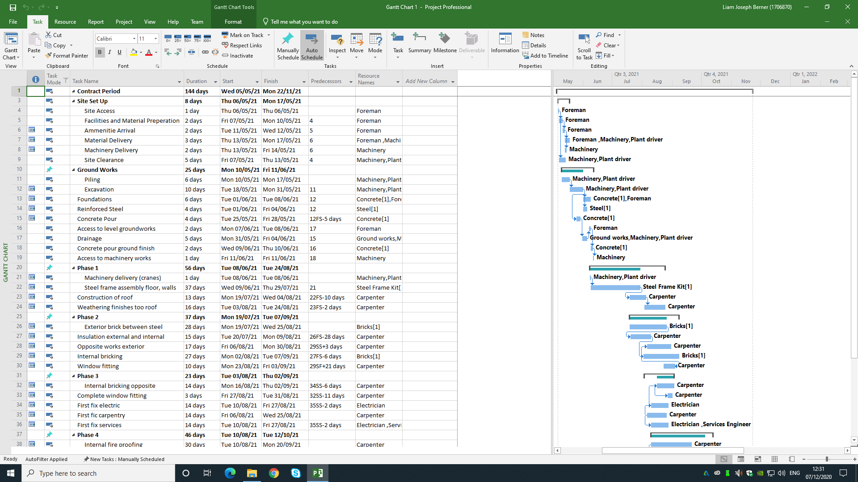

Figure 2
Reduction required in contract completion date
Gantt chart view of schedule after second crane is added
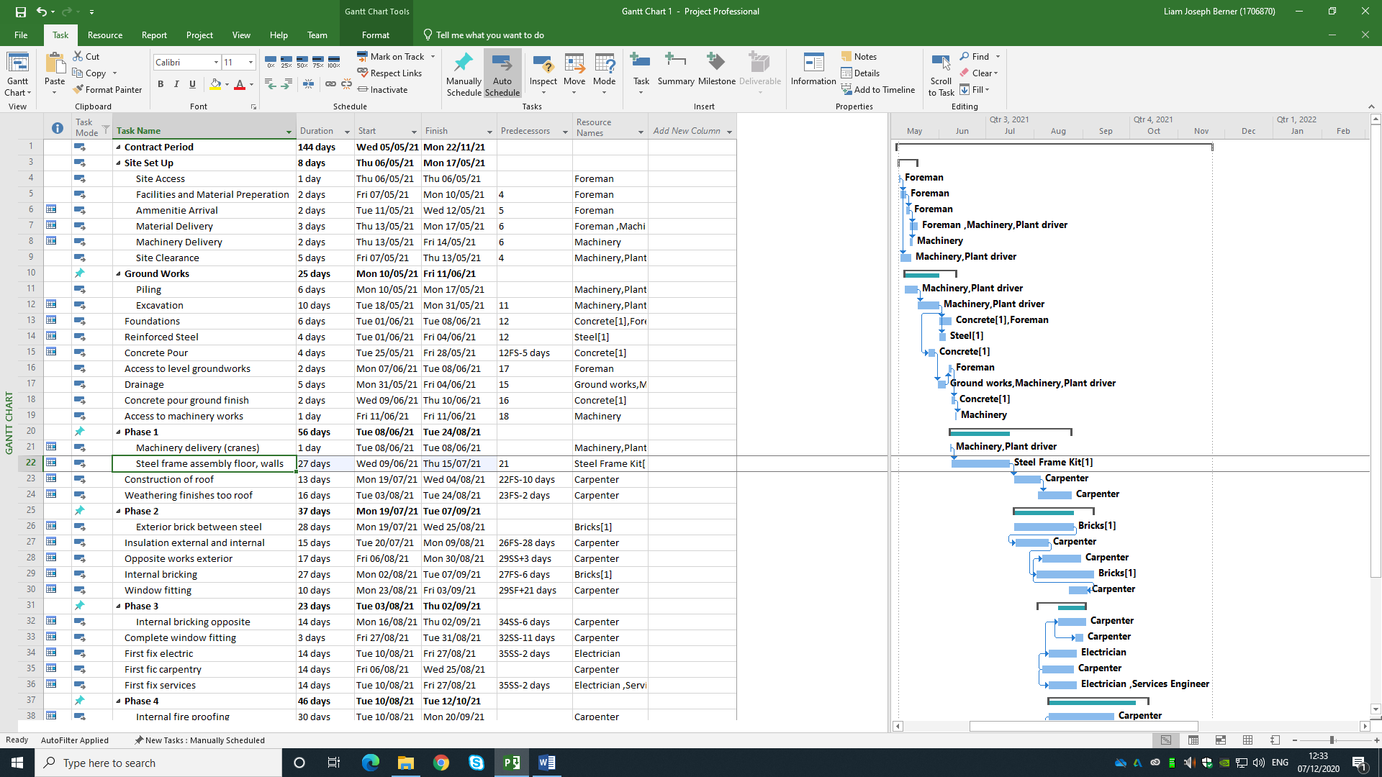

Site Plan Sketch
The following site plan sketch details the road area marked in red with areas to the side of the carriage way marked in blue to allow for articulated vehicles to access the site and unload materials. The road layout is designed to work as a one-way system allowing for a narrower carriage way within the site (March C, p.243, 2017). The areas marked in green are pedestrian areas only which allow foot traffic to pass from one side of the site access road to the other, this design considering the safety of the site operatives (March C, p.244, 2017).
The facility areas marked with a green hatch are a requirement for the construction (Health, Safety and Welfare) regulations 1996 which regulation 22 requires the provision of washing facilities, clean drinking water, sanitary connivences and an area to be used in bad weather (March C, p.246, 2017).
Consideration of the value of materials and items to be stored on site can be seen in the area marked within the purple hatched valuable items compound and lockup store. The construction process will require items of value required to be stored on site prior to fixing (March C, p.247, 2017). With items with a short shelf life stored securely within this area.
The siting of two tower cranes is shown on the plan in the orange areas. The tower crane adjacent to the road is positioned to allow the radius of the crane to move all materials within the construction site area (March C, p.249, 2017). A further ‘crane?’ marked in orange is shown to the rear of the library building if required to reduce the timescale of the project schedule.

Figure 3.
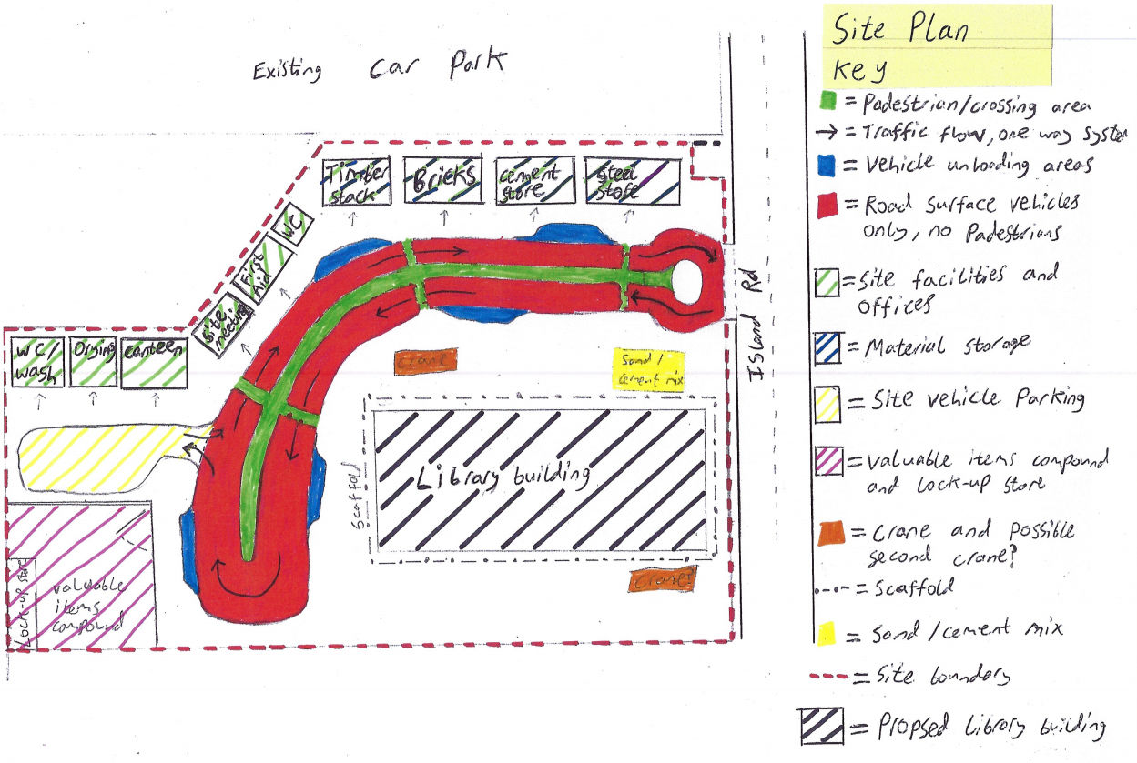

Site Layout Including Surrounding Area or Reference
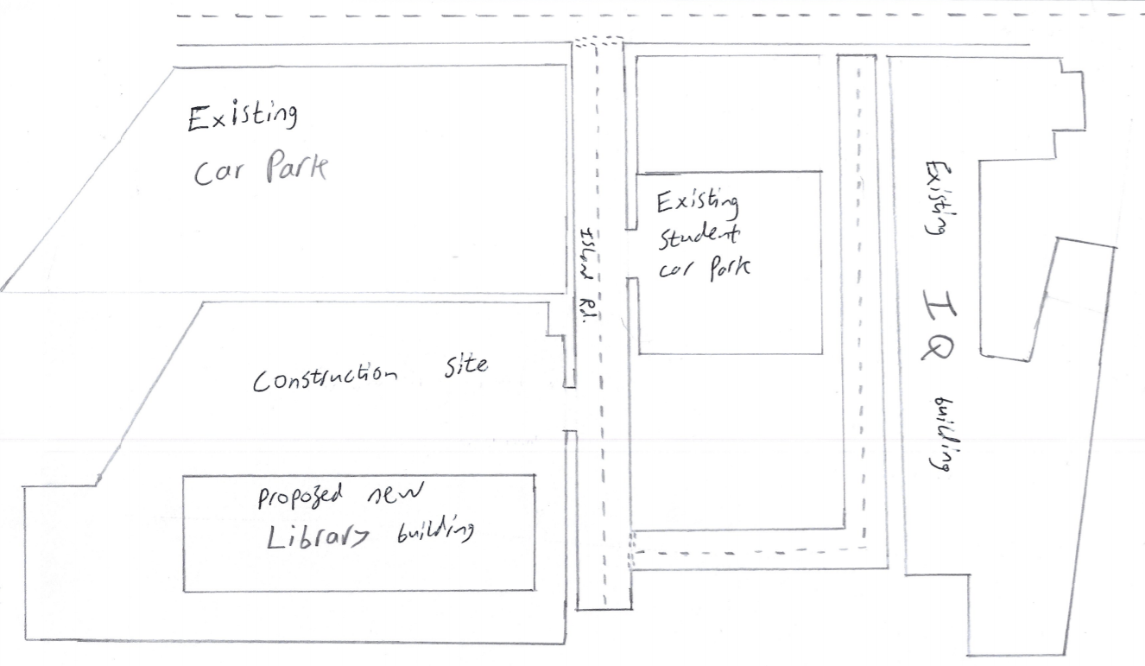

Programme Investigation and Potential to Shorten Schedule in Gantt Chart
The schedule produced in the Gantt chart shows a project completion date that is two weeks, ten working days beyond the contract completion date. I have identified an area where the timescale for the schedule can be reduced to finish inline with the contract completion date. The detailing required to achieve the contract completion date has been considered against the client’s needs, project constraints, project duration and budget limits (March C, p.115, 2017).
In the Gantt chart schedule produced for the project the time to erect the steel frame is 37 working days as shown in figure 1. I consider that the introduction of a second tower crane can bring the project completion date inline with the contract completion date through sequencing of the crane operations to reduce the time period required (Cooke B, Williams P, p.200, 2009). The use of two cranes working as a team with a common objective whilst interacting with each other would reduce the time allowed for craneage (March C, p.53, 2017). With the cranes working in conjunction they are operating within a task group (March C, p.53, 2017). A task group is set up specifically to complete a task or solve a problem. The group is then disbanded on completion of the task the group was formed to carry out (March C, p.54, 2017). The operation and output of the task group can be seen in figure 2 which shows a reduction of ten working days.
The introduction of a second crane will require coordination of operations with the specialist sub-contractor who will erect the steel frame and the tower crane operating company (Illingworth. J. R, p.271, 2000). The tower crane operators from previous experience will have records of output per crane which operates one hook. The hook on a crane is capable of moving a tonnage of steel each working day. The introduction of a second tower crane will increase the tonnage of steel per day which can be lifted into place for the steel frame erection (Illingworth. J. R, p.273, 2000). The extra tonnage which the second tower crane makes possible to be lifted into the steel frame erection can be seen in the reduced time frame for the steel frame erection task in the Gantt chart shown in figure 2. Any assessment of operational quantities has been developed for the schedule in the Gantt chart by determining realistic timescales based on the information supplied by the tower crane sub-contractors (Cooke. B, Williams. P, p.205, 2009).
It would be my recommendation after considering the constraints of the project site the introduction of a second tower crane would achieve the client’s requirement of reducing the project schedule by 2 weeks, 10 working days inline with the contract completion date.

References
CIOB, (2014) Code of Practice for Project Management for Construction and Development, Fifth Edition, Oxford, Wiley Blackwell
Cooke B, Williams P, (2009) Construction Planning, Programming and Control, Third Edition, Oxford, Wiley Blackwell
March C, (2017), Construction Management Theory and Practice, Oxford, Routledge
Illingworth J. R, (2000), Construction Methods and Planning, Second Edition, Oxford, Routledge

