

Name – Jake Howells

Student Number – 2407082

Course – HND Quantity Surveying

Module – Construction Technology 2

Table of Contents
Introduction 3
Structural Frame and Foundations 4
Ground Conditions and foundation choice 7
Frame Choice (Steel Frame) 7
Structural strength and stability 8
Fire Safety 8
Sustainability 9
Buildability and Programme efficiency 9
Building Envelope 10
Envelope system 10
Window and glazing 11
Roof recommendation 11
Prefabrication vs On site construction 13
Prefabrication 13
Safety and Logistics of on site 13
Environmental benefits of Prefabrication 14
On Site 14
Cladding 15
M&E 15
External Works 16
Conclusion 16
References 18

Introduction
This report will be a detailed and client friendly explanation of the proposed construction approach for a medium to high rise hotel near singleton hospital in Swansea. As the client is new to construction it will explain the choices made clearly and understandable. The decisions made in this report will consider Swansea’s local climate, ground conditions, coastal exposure, safety, sustainability, long term performance and structural stability

As Swansea experiences high amounts of rainfall, strong winds and sometimes coastal gusts due to how close it its to the Bristol channel. Therefore these weather conditions will affect the durability of the choice of material and the design of the structural frame. The sites underlaying geology typically includes a mix of glacial deposits sandy soils and areas of weathered rock, therefore for these ground conditions pile foundations would be more suitable to transfer the load of the building and long term stability

There are 3 key components that will be discussed in this report
- Structural frame and foundation selection
- Building envelope materials and construction methods
- Prefabrications compared to onsite construction
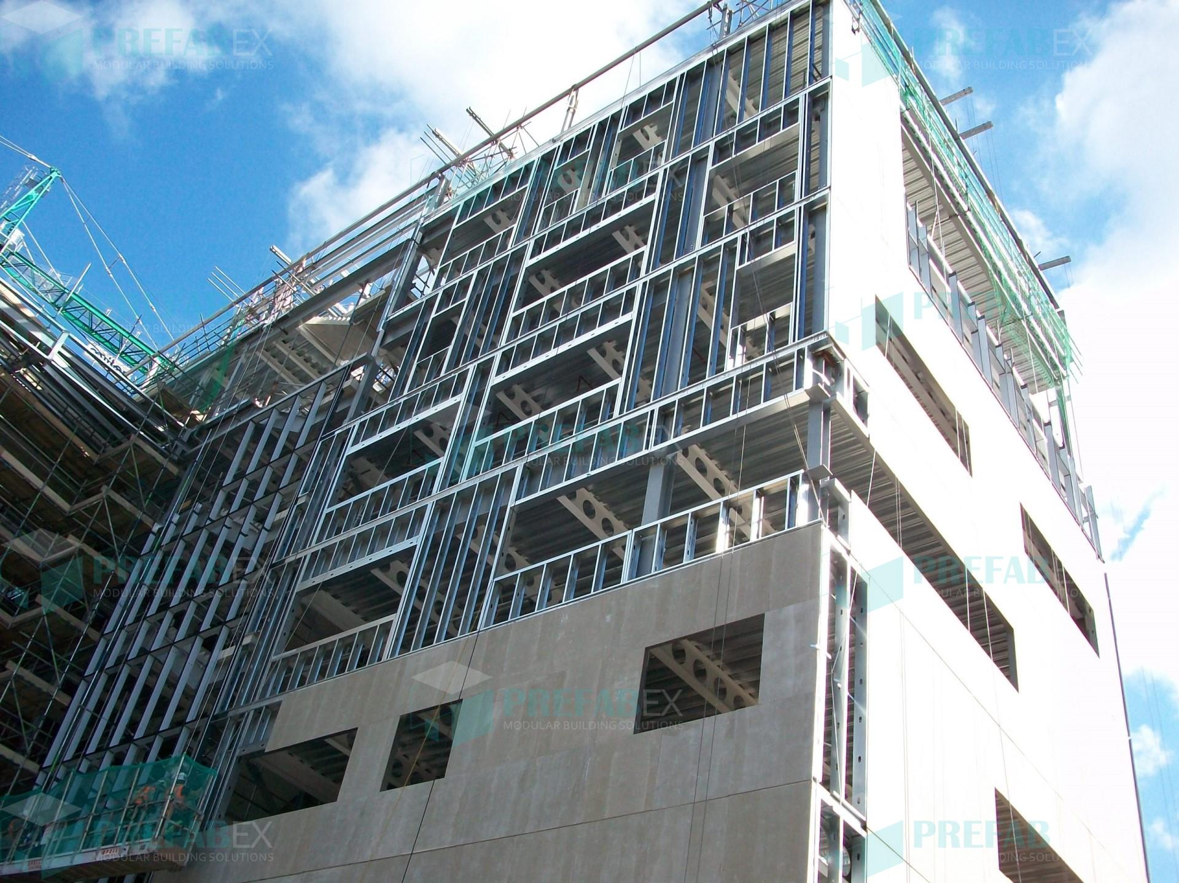

(Prefabex, 2025)

Structural Frame and Foundations
Looking at the surveys of the Swansea bay area suggests mixed superficial deposits including sands, gravels and glacial till. Therefore due to the variability means that shallow foundations may not be suitable for supporting a multi storey hotel, therefore Its recommend that bored pile foundations are used as they offer many benefits such as reduced settlement risk which is essential for multi storey buildings, there is lower vibration than driven piles which minimises the disruption and they are a reliable load bearing capacity regardless of the variability in the soil. (kirk, 2018)
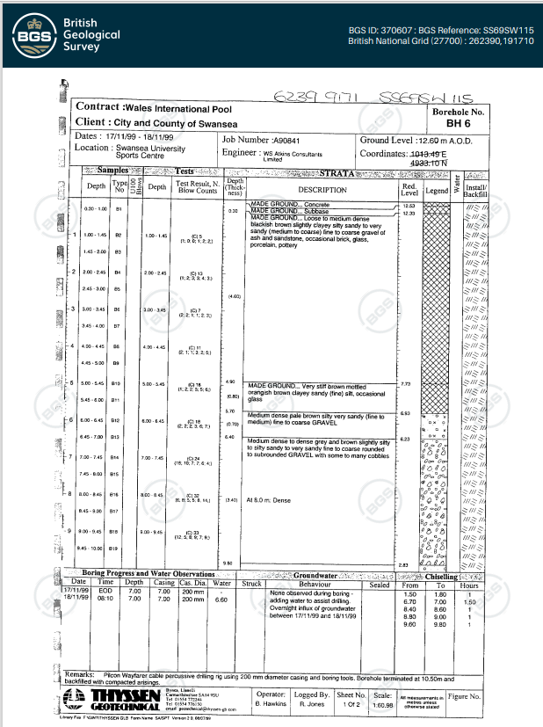

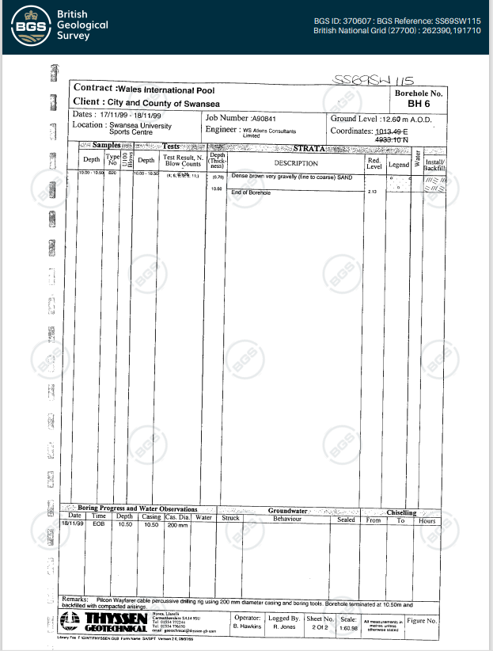

(British Geological Survey, 2025)

Ground Conditions and foundation choice
The underlying ground conditions at the Swansea bay contains soft superficial deposits and variable layers of sand, glacial till and gravel over weather rocked. Therefore pile foundations would be suitable as they ensure a reliable load transfer and minimise settlement for a mid to high rise hotel, not only that bored pile foundations also reduce vibration and noise which is important due to the proximity to singleton hospital. Please see the above-mentioned borehole logs. (Lees, 2021)

Frame Choice (Steel Frame)
A structural steel frame is recommended, this includes fabricated steel columns and beams supporting metal-deck floor slabs this allows for a lightweight and efficient structure. The hotels lateral stability is provided by a reinforced concrete central core, it will contain the lifts and stairs which ensures stiffness against the wind loads and improves the structural performance in the coastal environment of Swansea. Steel frames are used often in hotels due to their speed of assembly, high strength to weight ratio and the flexibility with the internal layout. (Steel, 2016) (www.sciencedirect.com, n.d.) (Dahl, 2014) (Fu, 2018)
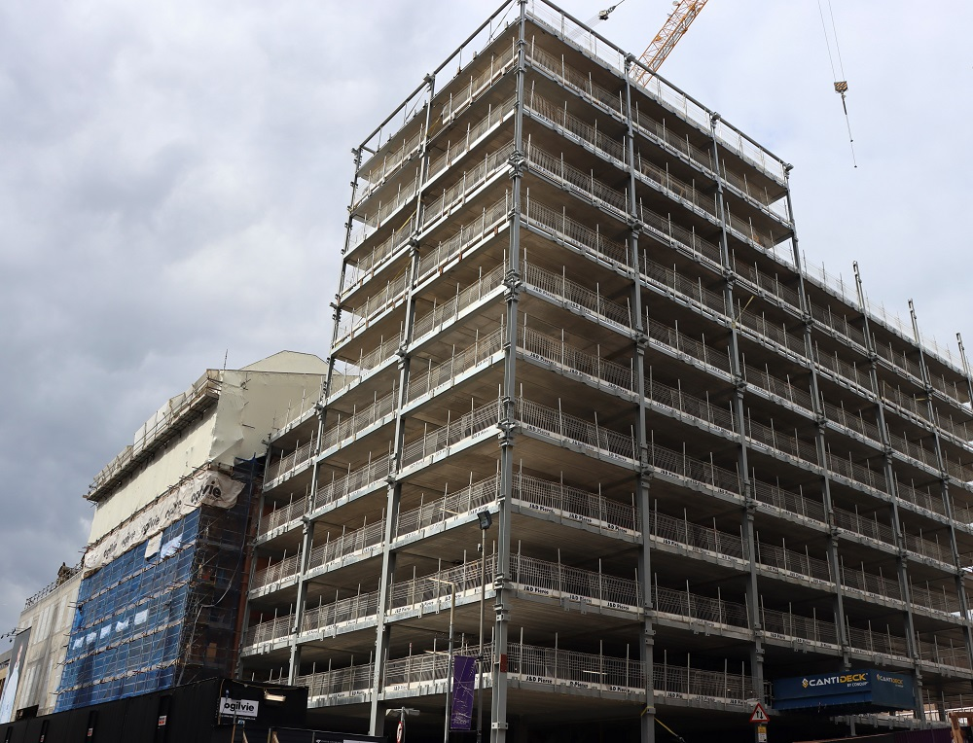

(Knight, n.d.)

Structural strength and stability
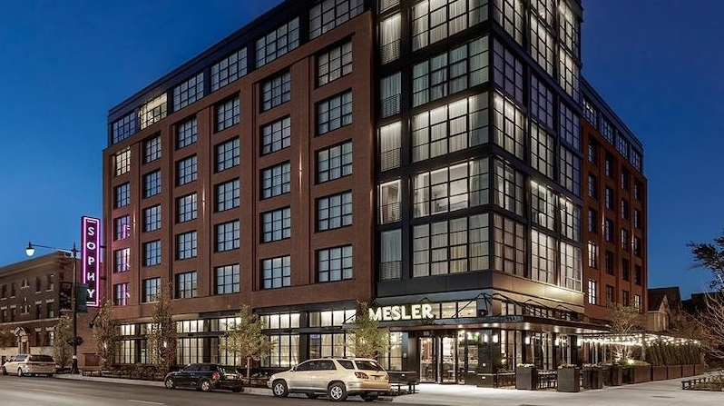
A steel frame provides very good performance under wind loads which is very important in Swansea’s coastal climate. It is lighter weight compared with concrete reduces loads on the pilling system and minimizes foundation costs. The central concrete core acts as the main stability system, resisting wind included sway and providing stiff fire resistant calculation zones The use of steel frames with a concrete core is widely used in mid-rise hotels across the united kingdom because it balances speed, fire safety and structural performance. (Lawson, n.d.) (Outrank, 2021)
(Steel, 2016)

Fire Safety
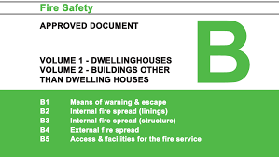
A steel frame will require fire protection normally in the for if intumescent coatings or board-based encasement systems, these are proven and widely available and compliant with the uk regulations for multi storey buildings When it is protected it can provide up to 60-90 minutes of fire resistance this depends on the height of the hotel and the escape route strategies the steel frames will meet the requirements of Approved document Part B. The concrete core also provides fire resistance which ensues that the escape routes re protected for the guests. (Steelconstruction.info, 2014) (DIY Doctor, n.d.)

Sustainability
A steel frame offers strong sustainability advantages because structural steel in the UK supply chain typically contains a high percentage of recycled content and it is fully recyclable at the end of its life. Combined with non-composite floors and modern steel fabrication, this can reduce embodied carbon when compared with a full reinforced concrete frame. Steel construction also reduces the waste on site and allows for off-site prefabrication which improves quality controls and minimising the impact on the environment. (Outrank, 2021)

Buildability and Programme efficiency
One of the major advantages of using a steel frame is its speed of construction as the components are fabricated off site and erected rapidly which allows for follow on trades to begin earlier, therefore this supports a shorter over programme time and reduces disruption near the hospital and lower the project risk. Steel frames also allows for slimmer structural zones which increases the amount of usable floor area and is an important consideration in hotel design where efficiency will drive profit. (White, 2017) (Outrank, 2021)
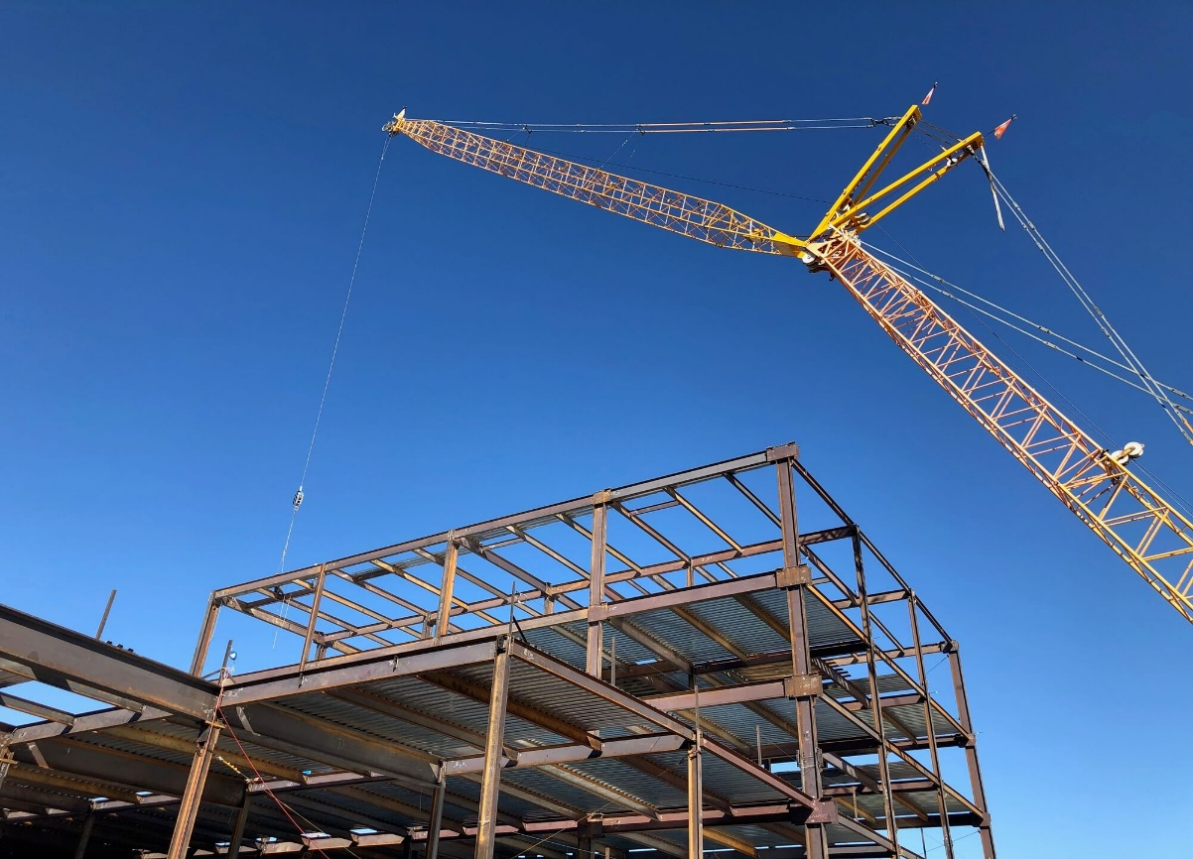

(tombaker, n.d.)

Building Envelope
The building envelope has a crucial role in determining the long term performance, comfort, safety and energy efficiency of the hotel, given Swansea’s challenging coastal climate, the envelope must be designed to withstand high rainfall, salt exposure, strong winds and wind driven rain. These conditions place pressure on material durability and watertightness making it essential to select systems with proven resistance to moisture and corrosion. (Hospitality.Institute, 2024)

Envelope system
A ventilated rain screen cladding system is the most appropriate choice for this development due to its strong performance in wet and windy climates. The ventilated cavity allows for moisture to drain and evaporate minimising the risk of water penetration and condensation and the non combustible wool for the insulation.
This complies with the requirements for approved document B for buildings over 18 meters which require A1/A2-s1,s0 rated materials. Therefore fibre cement and high pressure laminate panels (A2- Rated) panels provide moisture resistance, fire resistance and durability making them suitable for coastal environments. (Equitone.com, 2019) (HM Government, 2010)
However an alternative option is using brick-slip cladding which offers a more traditional aesthetic and strong durability, although it is more heavy and more labour intensive when installing it provides long term resilience and low maintenance. (Clarke, 2025) (www.realbrickcladding.co.uk, 2021)
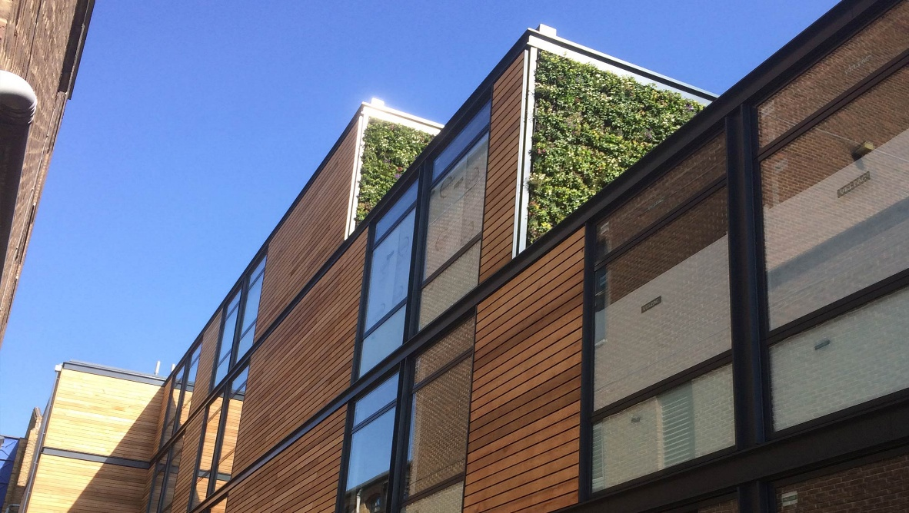

(Contemporary Structures, 2023)

Window and glazing
It is recommended that the window specification for this hotel includes thermally broken aluminium frames paired with low emissivity glazing which will provide good thermal performance, durability and resistance to the coastal conditions in Swansea, the thermal break reduces the heat loss and cold bridging, whilst it also helps retain the internal heat and improve the guests comfort without reducing the natural daylight. Aluminium frames are suitable for exposed coastal environments with the correct finish, which offers long term resistance to corrosion. All of the windows are to be designed to comply with BS 6375 ensuring adequate performance in airtightness, watertightness and wind resistance which is essential in this location. (Everest, 2024)
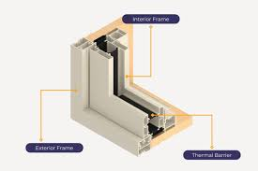
(admin, 2025)

(Keane, 2024)

Roof recommendation
A warm flat roof system is recommended as it is has strong thermal performance, good waterproof reliability and is suitable for the exposed coastal climates which is beneficial for Swansea. By placing the insulation above the structural deck the warm roof arrangement keeps the structure warm, and reduces the condensation risk in a hotel environment which has high internal moisture levels, and it improves the overall engine efficiency of the hotel. The warm deck system incorporates a vapour control layer, rigid insulation and a high performance single ply waterproof membrane, when these are all together they provide excellent resistance to wind uplift, heavy rainfall and uv exposure whilst also being very durable. (Foster, 2023) (Topseal, 2023)
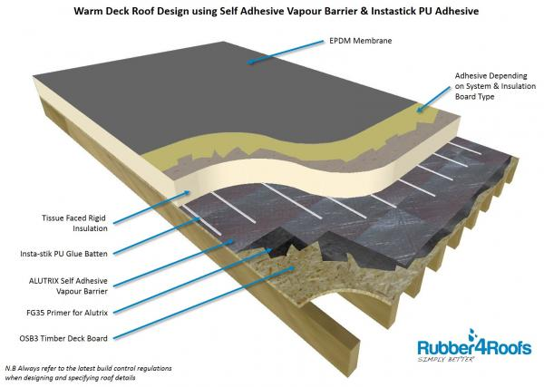
(Rubber4Roofs Ltd, 2019)

Prefabrication vs On site construction

Prefabrication
Prefabrication provides many advantages for a medium to a high-rise hotel in Swansea, because it reduces the construction timeline, lowers the amount of disruptions on site and it improves the consistency of the workmanship. By using off site construction components like bathroom pods, service risers and the façade panels can be manufactured in controlled factory environments, therefore the project will benefit from stricter quality accuracy checks that are not always possible with on site construction. Outside. The factories can maintain very tight tolerances, specialist machinery and doing repeatable assembly process with very good accuracy, this strengthens the overall build quality and reduces the likelihood of any defects during the hotel’s lifetime. The consistency is particularly important in these types of projects where rooms must meet specific standards to satisfy the guests expectations and the operational efficiency, therefore this consistency is much easier to achieve through prefabrication compared to on site construction. (Barbara, 2024) (UK Construction Week 2024)
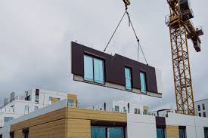

(Wells®, 2023)

Safety and Logistics of on site
Another massive benefit of prefabrication it its positive impact on construction safety and logistics, the area which is close to the singleton hospital area is a constrained and a sensitive location with lots of pedestrian activity and movement, steady vehicle traffic and hospital access requirements, meaning a reduction in the on site activities can seriously reduced the congestion and operational risks. Prefabrication reduces the number of operatives needed in the tight spaces on site and reduces hazardous tasks carries out at height or in bad weather conditions. The factory made units can be delivered at the right time meaning fewer materials are stored on site, reduction in manual handling and less waste. Therefore this leads to a safer working environment and lower the environmental impact to the surrounding areas. (Barbara, 2024)

Environmental benefits of Prefabrication
Prefabrication also has many environmental benefits as factory production typically generates less waste because the materials are accurately measured and can be reused, unlike on- site cutting which often results in multiple off cuts and disposal, the controlled manufacturing can also incorporate more efficient insulation, air tightness detailing and material optimisation, which would be more achievable in more unpredictable weather conditions. The reduced site traffic and fewer deliveries will help to cut out carbon emissions which is very advantageous in Swansea’s urban coastal zone, where the local sustainability policies encourage low-carbon development. In addition the manufacturing environments are increasingly powered by renewable energy which further improves the overall carbon footprint of the prefabricated components. (Barbara, 2024) (Aghasizadeh et al., 2022)

On Site
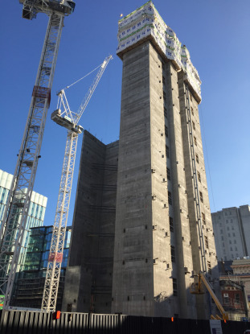
Although there are many advantages to off site construction there are certain elements of the hotel are still better suited to traditional on site construction, especially the ones that require continuous structural coordination. For example the reinforced concrete core takes on essential stability components such as the lifts shafts, vertical service risers and the stair enclosures. Therefore constructing these in situ will allow the team to maintain precise alignment between the core and the steel frame and then adjusting the reinforcement, wall thickness and formwork as needed during the build. The coastal environments like Swansea present additional challenges due to wind exposure and rainfall conditions that make it difficult to rely on rigid prefabricated concrete modules that cannot be adjusted once delivered. Therefore on site construction provided more flexibility and real time response to the design tolerances. (Concrete Centre, 2024)

(www.sciencedirect.com, n.d.) (Fu, 2018)

Cladding
The Cladding installation is another component that benefits from being carried out on site, the façade systems must be aligned accurately to ensure weather resistance, especially in coastal Swansea where there is salt in the air and strong winds increase the risk of corrosion and water penetration. Therefore installing the façade on site allows the team to check the fire stopping, the cavity barriers and the insulation continuously based on the actual built dimensions rather than relying on the pre manufactured measurements. This is particularly important in an environment where fire safety standards have become more strict following the Grenfell tower incident.
(tony, 2025) (HM Government, 2010)

M&E
The mechanical and electrical systems (M&E) also typically require on site installation because they heavily depend on the coordination with the structural frame, room layouts and ceiling heights. Even when the M&E modules such as the risers or plant skids can be prefabricated the final connections, routing and commissioning must occur on site due to the complexity of the hotel services and any last minute layout adjustments. This flexibility is particularly valuable for these types of building as acoustic performance, fire compartmentation and maintenance access must all be considered together. On site installation ensures that these systems are tailored precisely to the build geometry which helps maintain long term reliability and safety. (Lamb, 2018) (admin, 2025)
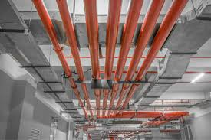

(analytics@artemisdigital.com, 2024)

External Works
Lastly the external works such as the drainage and drainage connections, landscaping, access paths and trenches/ trenches for services are always completed on site because they rely on the ground conditions that cannot be fully predicted during the design stage. This site is close to the coats which may present variable soil strength and groundwater levels, which makes it unsuitable for prefabricated ground infrastructure. On site construction allows the engineers to modify the gradients if needed, introduce reinforcement and bedding materials in response to the real time soil behaviour which ensures long term durability and correct and adequate draining for the hotel. (Kane Construction, 2024) (mdmteam@mosaiconline.co.uk, 2023) (mdmteam@mosaiconline.co.uk, 2024)
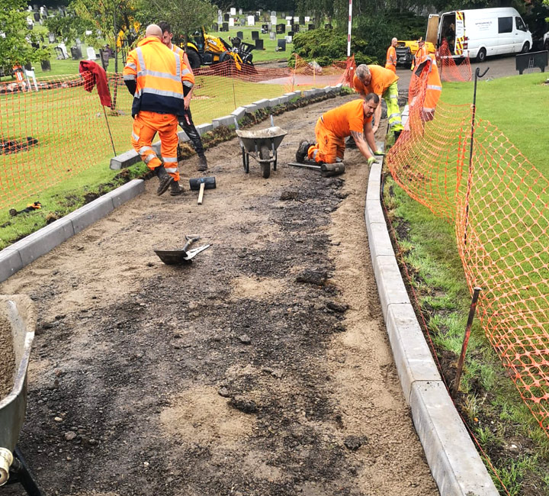

(Bestco, 2025)

Conclusion
In conclusion this report presents a practical and a clear construction strategy for the medium to high rise hotel in Swansea, taking in to consideration of the ground conditions, coastal weather conditions and the current safety and sustainability requirements.
The steel structural frame is supported by bored reinforced concrete piled foundations which provides a stable and efficient solution for the site, while the concrete core ensures that there is lateral stability and fire escape routes. The building envelope which includes cladding, high performance glazing and a warm deck roof system is designed to be able to withstand Swansea’s exposed costal conditions whilst also improving energy efficiency and durability.
The hybrid construction approach which combines prefabrication with traditional on site methods offers the best balance for the quality, efficiency and flexibility of the construction process for the hotel. Overall this proposed method offers a safe, durable and sustainable hotel approach for the given location.

References
Aghasizadeh, S., Tabadkani, A., Hajirasouli, A. and Banihashemi, S. (2022). Environmental and economic performance of prefabricated construction: A review. Environmental Impact Assessment Review, 97 :https://doi.org/10.1016/j.eiar.2022.106897.

admin (2025). BS 6375 UK Standard | FireResist. [online] FireResist. Available at: https://fireresist.co.uk/bs-6375-uk-standard/ [Accessed 30 Dec. 2025].

admin (2025). From design to delivery: The Elite approach to M&E project management - The Elite Group | Buildings For Life. [online] The Elite Group | Buildings For Life. Available at: https://elitegroupltd.co.uk/from-design-to-delivery-the-elite-approach-to-me-project-management/ [Accessed 30 Dec. 2025].

analytics@artemisdigital.com (2024). What is an M&E system? How is it designed & installed in construction? [online] THACO INDUSTRIES. Available at: https://thacoindustries.com/en/what-is-mechanical-electrical-system/.

Barbara (2024). Benefits Of Prefab Construction & How Different it is from Traditional Construction - Architectural Wallsz. [online] Architectural Wallsz. Available at: https://awallsz.co.uk/benefits-of-prefab-construction-how-different-is-from-traditional-construction/.

Bestco. (2025). Bestco Surfacing Ltd. [online] Available at: https://bestcosurfacing.co.uk/services/groundwork-services [Accessed 31 Dec. 2025].

British Geological Survey (2025). GeoIndex - British Geological Survey. [online] mapapps2.bgs.ac.uk. Available at: https://mapapps2.bgs.ac.uk/geoindex/home.html?layer=BGSBoreholes.

Clarke, L. (2025). The Negatives Of Using Brick Slips. [online] Reclaimed Brick Company. Available at: https://reclaimedbrickcompany.co.uk/blogs/yard-display/the-negatives-of-using-brick-slips?srsltid=AfmBOoq-ATLckGDBLKmk1jD-u_oYuz-FabWXd21o1mx0MRAL-qrqhgT7 [Accessed 30 Dec. 2025].

Concrete Centre. (2024). Piling. [online] Available at: https://concretecentre.com/Structural-design/Building-Elements/Foundations/Piling.aspx?feed=a4091125-9a6b-4497-be48-e5fa36aea526 [Accessed 30 Dec. 2025].

Contemporary Structures (2023). What is Rainscreen Cladding? A Complete Guide. [online] Contemporary Structures. Available at: https://contemporarystructures.co.uk/what-is-rainscreen-cladding/.

Dahl, K.K.B. (2014). Bella Sky Hotel - taking precast concrete to the limit. Structural Concrete, 15(4), pp.441–447.: https://doi.org/10.1002/suco.201400017.

DIY Doctor. (n.d.). Building Regulations Approved Document B for Fire Safety in Domestic and Non-Domestic Buildings. [online] Available at: https://www.diydoctor.org.uk/projects/buildingregulationsb.htm.

Equitone.com. (2019). What Is a Ventilated Rainscreen System? | EQUITONE Fiber Cement Facade Guide. [online] Available at: https://www.equitone.com/en-us/what-is-a-ventilated-rainscreen/.

Everest (2024). Low-E (Low-emissivity) Glass Explained | Everest. [online] www.everest.co.uk. Available at: https://www.everest.co.uk/glass/low-e-glass/.

Foster, M. (2023). Warm Roof or Cold Roof? Choosing the Right Design for Flat Roofs. [online] Garland UK. Available at: https://garlanduk.com/blog/warm-cold-roof/.

Fu, F. (2018). Design and Analysis of Tall and Complex Structures. Saint Louis: Elsevier Science & Technology.

HM Government (2010). Fire safety: Approved Document B. [online] GOV.UK. Available at: https://www.gov.uk/government/publications/fire-safety-approved-document-b.

Hospitality.Institute. (2024). Hotel Building Envelope Design: Structure, Exterior Facilities and Landscaping | Hospitality.Institute. [online] Available at: https://hospitality.institute/bha507/hotel-building-envelope-design-structure-exterior-landscaping/ [Accessed 30 Dec. 2025].

Kane Construction (2024). Why is Drainage Important? Benefits & Solutions in Construction. [online] Kane Construction. Available at: https://www.kaneconstruction.co.uk/why-is-drainage-important/.

Keane, S. (2024). Thermally Broken Windows: 3 Reasons to Have Them In Your New Home - Southern Star. [online] Southern Star. Available at: https://southernstarwindows.com.au/thermally-broken-windows/.

kirk (2018). Driven Precast Concrete Piling. [online] Aarsleff. Available at: https://aarsleff.co.uk/solutions/driven-precast-concrete-piling/.

Knight, M. (n.d.). Steel frame complete on Glasgow’s newest hotel. [online] www.ogilvie-construction.co.uk. Available at: https://www.ogilvie-construction.co.uk/news/item/301-steel-frame-complete-on-glasgow-s-newest-hotel.

Lamb, A. (2018). Make way for the revolution – inside SES Engineering Services’ M&E factory - CIBSE Journal. [online] CIBSE Journal. Available at: https://www.cibsejournal.com/case-studies/make-way-for-the-revolution/.

Lawson, R. (n.d.). Light Steel Modular Construction Technical Information Sheet ED014. [online] Available at: https://steel-sci.com/assets/downloads/LSF/ED014%20Download.pdf.

Lees, A. (2021). What are the types of piles and their construction methods? [online] www.tensar.co.uk. Available at: https://www.tensar.co.uk/resources/articles/what-are-the-types-of-piles-and-their-construction-methods.

mdmteam@mosaiconline.co.uk (2023). The Benefits of Civil Engineering Groundworks | GAM. [online] GAM Civil Engineering. Available at: https://gamcivilengineering.co.uk/the-benefits-of-civil-engineering-groundworks/.

mdmteam@mosaiconline.co.uk (2024). The Importance of Groundworks in Construction | Nicholls Plant Hire. [online] Nicholls Plant Hire. Available at: https://nichollsplanthire.co.uk/the-importance-of-groundworks-in-construction/ [Accessed 30 Dec. 2025].

Outrank (2021). Pros and Cons Of Steel Frames. [online] Springfield Steel Buildings. Available at: https://www.springfieldsteelbuildings.com/blog/pro-and-cons-of-steel-frames/?srsltid=AfmBOooMJ9xhAwQxh-sy8_zqvYwQ8yY2hhDNJAJbP2ht-pJILE2rSZKi [Accessed 30 Dec. 2025].

Prefabex. (2025). Modern Hotel Construction with Steel Frame | Steel Framed Hotel Building. [online] Available at: https://www.prefabex.com/our_galleries/modern-hotel-construction-steel-frame [Accessed 31 Dec. 2025].

Real brick cladding (2021). Advantages and disadvantages of brick cladding. [online] Available at: https://www.realbrickcladding.co.uk/advantages-and-disadvantages-of-brick-cladding.

Rubber4Roofs Ltd (2019). Warm Roof Design - Rubber4Roofs Ltd Knowledge Base. [online] Helpscoutdocs.com. Available at: https://rubber4roofs.helpscoutdocs.com/article/95-warm-roof-design [Accessed 31 Dec. 2025].

Science direct (n.d.). Concrete Core - an overview | ScienceDirect Topics. [online] Available at: https://www.sciencedirect.com/topics/engineering/concrete-core.

Steel, B. (2016). Steel Framing: The Future of Hotel Construction. [online] BuildSteel.org. Available at: https://buildsteel.org/projects/non-residential/steel-framing-the-future-of-hotel-construction/.
Steelconstruction.info (2014). Fire and steel construction. [online] www.steelconstruction.info. Available at: https://www.steelconstruction.info/Fire_and_steel_construction.

tony (2025). Façade installation challenges – and how we solve them - Eden Facades. [online] Eden Facades. Available at: https://edenfacades.co.uk/facade-installation-challenges-and-how-we-solve-them/ [Accessed 30 Dec. 2025].

Topseal. (2023). Hotel Flat Roofing - Topseal. [online] Available at: https://www.topseal.co.uk/hotel-flat-roofing/.

tombaker (n.d.). Steel Erection Process: Best Practices and Safety Tips. [online] https://buyabeam.com/. Available at: https://buyabeam.com/blogs/steel-beams/steel-erection-process/.

UK Construction Week 2024. (2024). REVOLUTIONISING CONSTRUCTION: THE PROS AND CONS OF PREFAB AND MODULAR CONSTRUCTION. [online] Available at: https://www.ukconstructionweek.com/blogs/revolutionising-construction-pros-cons-prefab-modular-construction.

Wells®. (2023). Prefabricated Construction Comprehensive Guide | Wells. [online] Available at: https://www.wellsconcrete.com/about/news-insights/what-is-prefabrication/.

White, G. (2017). The Advantages & Disadvantages Of Steel Frame Construction. [online] Glwengineering.co.uk. Available at: https://blog.glwengineering.co.uk/the-advantages-disadvantages-of-steel-frame-construction.

