Diary:
Project Idea: Comparing Assassins Creed Odyssey’s representation of Antiquity, compared to archaeological opinion from academics. Examine the similarities and differences between these.
- Game content- AC Odyssey, set in Greece 442BC very large with a lot of historical places in detail and includes a lot of lore and myth.
- Audience- Younger as they will likely understand video games.
- Vocabulary- I will use nuances and vocabulary that younger people understand. For example, linking to other games without having to explain what the games are and the types of games, like RPG and MMORPG.
- Visual Element- Getting photos from the games and putting these against actual relics found from this time period.
- Narrative- More academic and unbiased or Personal?
- Themes- Is the game romanticised or based on realism? Does either make it more enjoyable?
- What to look at- Daily life of Greeks presented in NPC’s in game, or monuments and ancient religious buildings?
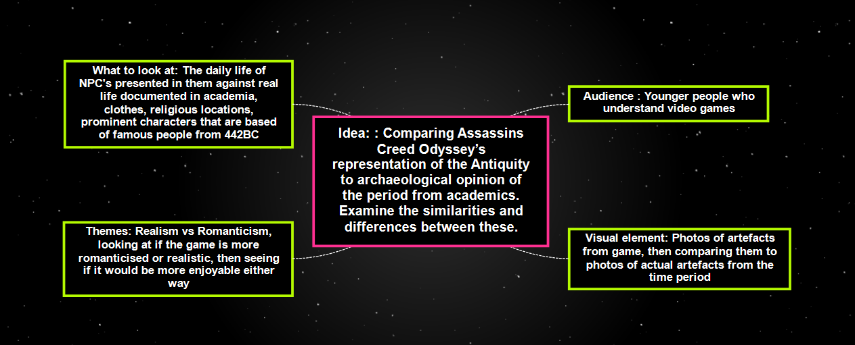

- Quentin’s idea: think of game, rethink role of game, one hand enjoyment factor of tasks, information embedded within archaeological report. Girl died in Athenian plague, Phoibe. HYPER TEXTING, QR CODES, BRIDGE GAP BETWEEN GAME AND INFO. KEY ASPECT TO TOURISM LINKING GAME TO REAL LIFE WEBSITES. LINKING GAME WITH AKROPOLIS, GAME ENGINE BECOMES A FRONT PIECE TO SOURCE ENGINES OF OTHER LOCATIONS.
- LOOK AT SECOND LIFE. Degrees, job interviews. Doctors and big businesses there.

- Here is taking info from academic sources and embedding into narrative, could go further, possibility for gaming industry to step into other realms. Example Phoibe, reanimated and giving them persona. Could be doing more. Perhaps people who play ac creed might be more attractive to be academic.

- Story board of Phoibe, this could be hyperlink to other stories and info.
- Another example, Sokrates. Even down to small details like pottery.
- Open up from the game to engage with real history.
- Is an option to turn on or off, could then be incorporated to curriculum and be a module for university
- Puts responsibility onto gaming platform.
- Put into wider context, we live in world where people need phones and QR codes for shop, cinema due to Covid-19, in hospitals they use animated realities for training, diagnosing. As the world gets more technology driven, gaming platform draws info from academia, way of saying it can further.
- Can also argue it takes the fun out of it, overly complicated. Opportunity to switch it off solves it. Technology is terrifying and we only select bits we are comfortable with.
- Presentation 5/6 slides, broad intro, methodology, game structure. Structure, what will end result be if you want one, what is it I’m aiming towards, reference list, bibliography, PowerPoint.
- Take position people are aware of gaming, explain hyperlinking and some elements, don’t need to overexplain.
- Make essay VISUAL!

- Notes off Quentin’s lecture:
- Creativity, sources and resources
- How did get idea in long term rejection, 5 slides
- Make very visual
- Own images
- Presentation of arch on tv through medium of dance
- 1st slide: Introduce self, module and level
- My idea is… to compare realism and romanticism to see how we can democratise the game to make it more accessible and pair it with themes like tourism and the use of the game as a new form of engagement via e.g. curriculum
- 2nd: Methodology: parameters: how limited I am, focus, set out where I’m going, any theories considering, semiotics
- 3 storyboards
- Based on idea: use game program to make history accessible at all levels, schools, tourism, people who like romantic idea but don’t know about history.
- Does semiotics/ symbology get represented better via realism or romanticism
- Talking about way to expand links available
- Storyboard and talking about how to expand it and if it is romanticised or real and problems or good of democratising it and how we could do it
- Each para: realism vs romanticism, how to expand, is semiotics represented well would it better if this were more realistic or romanticised
- 3rd: background and context: key issues and themes: world moving online, what are you building on, whose research are you following, medium used and why, speed, cost and accessibility
- Building on Ubisoft tour or origins and odyssey during covid
- Look at museums that do virtual tours and vs game: is tour as engaging as game, which demographic: as focussing on opening up to world open to all
- Visual reconstruction in archaeology was a start
- 4th: Diary of work done so far: how ideas have changed, first word doc and second. Put first and second word doc into 2 different mind maps
- 5th: summary: present end result, aiming rewards further research outcomes, where this piece would finish if I did it over 3 months? Objectives I’d like to see but not able to achieve. How I conceive project in long run
- 6th: reference list/ bib
- Rough sketch or storyboard
- Democratising, making accessible
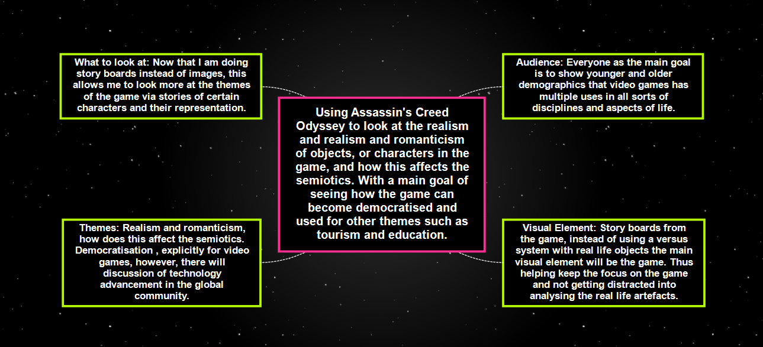

13/12/2020 PowerPoint feedback
- Tony bennet work on museums in contemporary situation, democratisation of museums.
- Likes abandonment of physical presence and democratisation.
- One of issues could explore further, notion of democratisation, assumption the tech is universal, as much as a lot of people have access to computer gaming and tech. a lot of people don’t, could look at contrast between advanced tech places and 3rd world.
- Hyperlinking- story boards or flow diagram, how many points in game will Sokrates be hyperlinked to. Where would hyperlinks would be in game? Get screengrabs of where you would put them, tie hyperlink into the audience. Tour with hyperlinks.
- Condense story boards.

Conclusion: After making my rough notes that are very untidy, but are a basic description of what I need to do and an evolution of these ideas, I did a lot of reading and have an idea of what to do for my assessment.

Assessment: Assessing the Realism vs Romanticism and Semiotics of Assassins Creed: Odyssey, In Order To Look At How the Game Can Be Democratised and How Democratisation Would Be Put Into the Game

Video games are extremely popular in today’s society, the possibilities are endless, this essay will look at how we can democratise video games. Using the game Assassin’s Creed: Odyssey I will be looking at the realism vs. the romanticism and semiotics in order to understand how the game functions at the moment, then seeing how we can democratise the game in order connect it into other areas, such as education or tourism. The game already offers slight insight some areas of ancient Greek life, however, the historical accuracy is put somewhat into question. This does not mean the game needs to be accurate, but we could connect the game to accurate information, in order to pair the game properly with education we need a tool, for example hyperlinks. These hyperlinks would connect to researched academic sources that offer in depth information on something, you, the player is interested in. With just an idle glance at modern society, one can see a large part of the world is heavily reliant on technology, for example there are tools in the world such as Second Life which allow the user to live online, getting married, jobs and meeting with friends without stepping out of your home. The Entertainment software association has stated that, as of 2019 65% of American adults play video games (Entertainment Software Association, 2019), meaning that video games can be expanded in order to interact more with other parts of life and the internet. A problem that you may have with this, if you are in fact a gamer is, will this interfere with gameplay and turn games into advertising devices? This is a concern that will need to be addressed and making sure that democratising games doesn’t impede on the player itself. Thus, the theme of this essay is to look at how we can democratise video games and why this could be helpful to a new online generation.
The first example below is of the representation of Sokrates that is presented in the game, there are three separate stills of things he has said in the game. Looking at the speech and story from these scenes I will look at the realistic or romantic light he is painted in, then the semiotics to see if there is any meaning to his character portrayal, and finally democratisation, looking to see how this character could be used as a tool to expand the game. In order to understand Sokrates I will be using Plato’s Apology for The Life of Socrates, as his work can be seen as a first-hand source and account of Sokrates, both living during the same lifetimes and both in Athens. The response by Plato is meant to be Sokrates as himself. Plato writes Sokrates as calling himself a ‘gadfly’ (Plato: 18) to the city, meaning that he picked at the city, almost as if he were feeding off them. He goes on to relate Athens to an old horse that ‘needs to be aroused by stinging’ (Plato: 18), it is a very affectionate piece of writing boasting of the need for Sokrates in Athens. In scene 1 and 3 Plato’s view of Sokrates seems to have been acquired by developers, with Sokrates questioning our character for his own amusement. This is the way his quest lines work, dilemmas he is quite well known for such as a good person vs a good citizen are translated into game by posing situations that contain the elements of the dilemma to the player, giving them the choice and helping understand Sokrates. This tells us that the game has presented Sokrates as quite realistic to how his student Plato saw him. However, as seen below in scene 2 Sokrates is telling the player that he has one of his students posing as a guard at the Akropolis undercover, in order to spy on Kleon. At this point in the game Sokrates is involved with other famous figures in an undercover scheme to take down Kleon and trying to help avoid the Mytilean Massacre that Kleon had planned for their revolt. He is seen at a later point in the game having a debate set up with our character to sway the minds of Atheneans about the pending slaughter. In recorded history we know it was Diodotus who actively ‘opposes the execution of the Mytileans’ (Verlag: 162). Thus, telling us the game has inserted Sokrates into a situation and portrayed him as a saviour of a nation that he himself was not historically attributed to being. Overall, from his speech Sokrates can be seen to be rather realistic, however the actual events in the game have been manipulated in order to romanticise the character as more heroic.
This heroic notion may play into the semiotics and what the game would like us to associate with Sokrates character for the rapport between us and Sokrates, speaking of semiotics pertaining to Sokrates is very fitting as Plato’s work Cratylus is one of the earliest works of semiotics, regarding etymology and again using Sokrates as a character. As signs are polysemic, denotations can differ between people, but the signs and meaning of the game are important on how we perceive the characters and interpret situations. In regard to signs shown in the game we can see that Sokrates is portrayed as a man who is always smiling, even in the most dire situations, this can be seen to be a sign that Sokrates is meant to be a happy character for us and thus being friendly, we should trust him and keep him as a companion in the game. Using facial expression as a sign the game is trying to tell us who is bad, however this is a classic trope in video games. For example, if we look at Mario and Wario from Super Mario Bros by Nintendo, the eyebrows for Wario are directed pointed down on the inside to signify anger, whereas Mario has raised eyebrows in the middle to create an excited more cheerful look, signifying who is morally good and bad. In game Sokrates can be seen to have straight eyebrows, a western perspective of eyebrows shown by western magazines like Marie Claire is that if a person has straight eyebrows the person is ‘confident and assertive’ (Valenti, 2014). These western perspectives have been used in the game’s character design to secure our opinion of Sokrates as an assertive person and with them raised to show happiness, we are meant to believe he is confident, assertive, happy and morally on the right side.
From what the game has shown, Sokrates is quite an in-depth character that is used throughout the game to move the story forward and test our character, creating a very interesting view of him. With such detail the player is most likely going to associate Sokrates with being a prominent character in history, this is where we could implement the hyperlinking strategy. Putting a button underneath his dialogue that when clicked takes you to an academic article talking about sokrates work and what he has written, in order for the reader to start leaning should they choose. Alternatively, assuming the person doesn’t have internet, there could be two options, one to take you to an article and the other to show you a list of Sokrates works so you can write them down yourself. This strategy would open the game up to the academic world, by helping the player get a greater knowledge on the characters in game and the work they did, the problem with this is that the storyline will not match the historical action. Therefore, should we put a marker in game to show what is historically accurate and what is not so the player does not get unenthused when they learn about the history. I don’t believe so, the game has a warning at the start to say the event are based on but not accurate information, we could change the starting warning to say that the game will offer information links in game to those who want to learn more. Moreover, if we offer titles instead of links to online articles, this could encourage the person to use a library, furthermore, we could put underneath the list pop up that comes up when you click it a website name for finding books in local libraries. This is in order to stop the abandonment of physical presence in libraries, which I am quite passionate about, although our society is ever evolving and heading in the direction of making things accessible online, a large percent of the world do not even have access to internet, therefore libraries are their only way of reading. I believe the democratisation we put in game should try to encourage physical usage of libraries, without imposing my views.

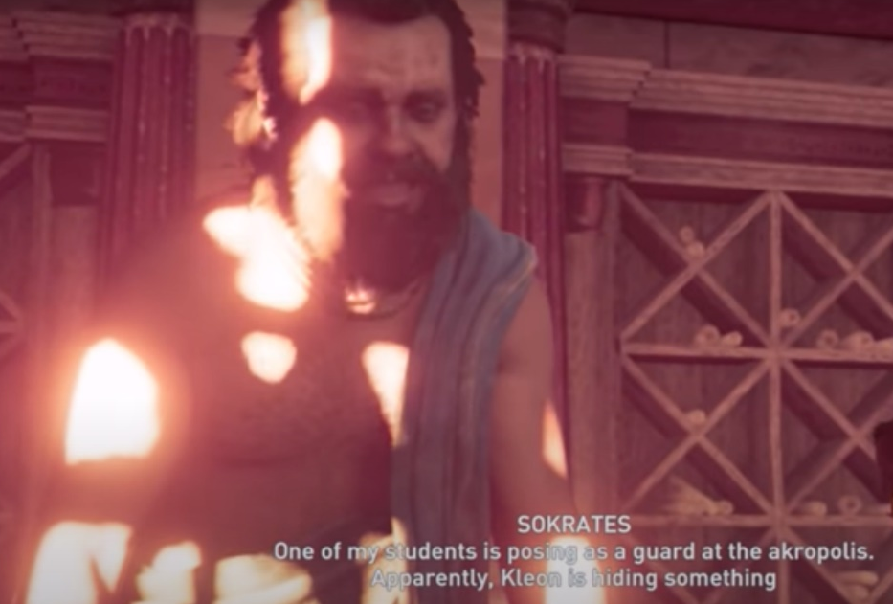
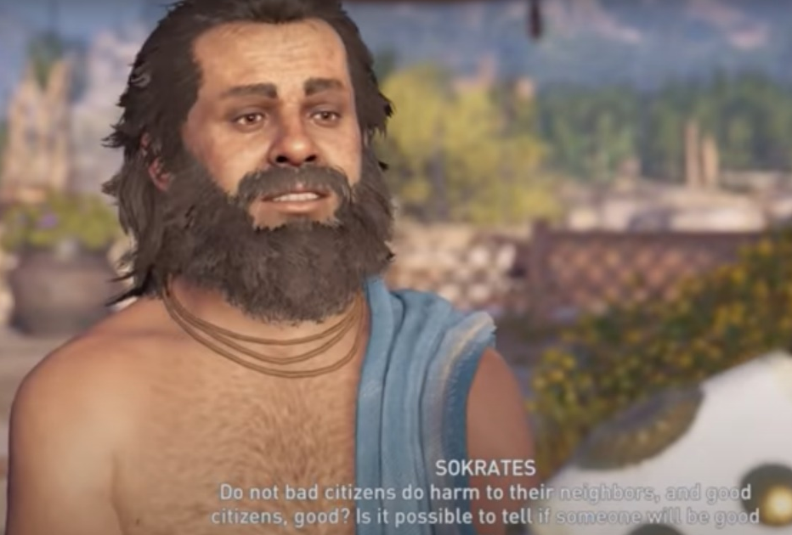

(Ubisoft, 2018)
(Ubisoft, 2018)
Scene 2: Here Sokrates tells the main character that he has one of his students “posing as a guard at the Akropolis”, this is in order to spy on Kleon.
Scene 1: Here Sokrates says “Do not bad citizens do harm to their neighbours, and good citizens, good? Is it possible to tell if someone will be good or bad without first giving them a chance?”.

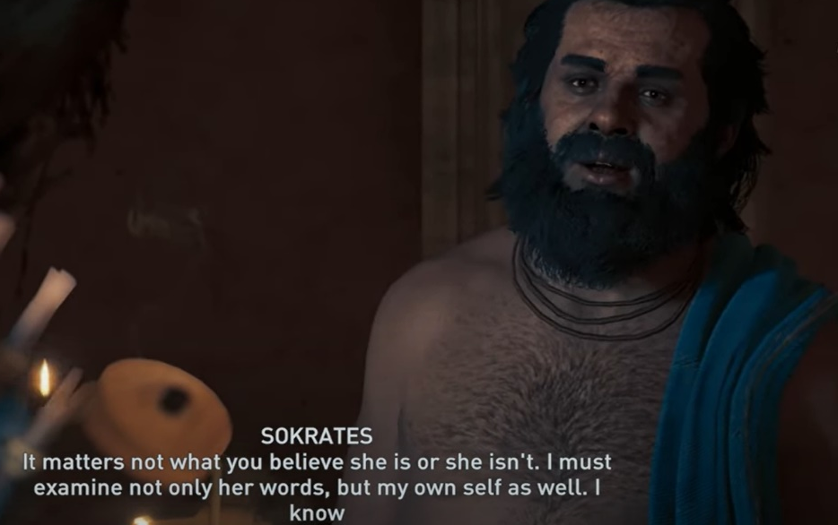
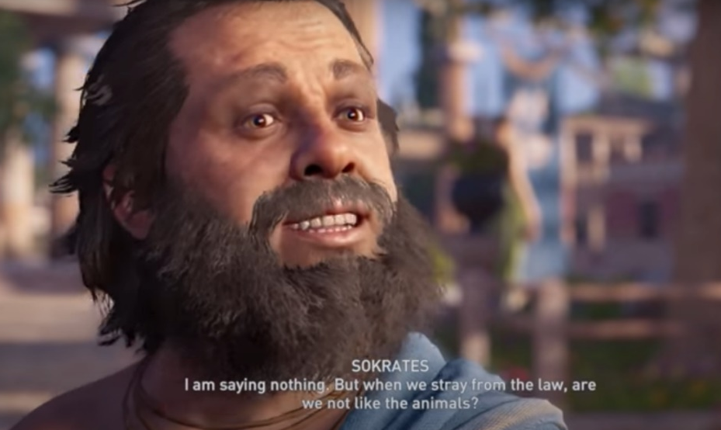

(Ubisoft, 2018)
(Ubisoft, 2018)
Scene 3: In this scene Sokrates queries us, if “we stray from the law, are we not like animals?”. He is asking us this in context to man who had defiled the earth in a way that offended the gods and killed a man, but believes one is worse than the other.
Scene 4: In this scene Socrates says that in reply to being called the wisest man by the pythia, he responded “I know nothing”.

After looking at characters, it’s clear that there is a mix of realism and romanticism, but how does this fair in accordance with architecture? That is what we will look at, below I have compiled 2 images of 2 buildings from the Acropolis in Ancient Athens. Of the pictures below, on the top row are images of the Parthenon in the game and a remodel by Expedia the travel company. On the bottom row are two images of the Erechtheion, the left is from the game and the right is real life in the modern day
There are many ways to view the Acropolis in real life, via virtual tours and ways to see it reimagined from its prime via apps like Mozaik, however Assassin’s creed Odyssey has made the Acropolis detailed with inside views of the temples, detailed textures, activity of NPCs (non-player character) in regards to worship and daily life outside the buildings. Looking at the Parthenon in regards to the rebuild that Expedia made most likely using experts in the field there are a lot of commonalities between the two, like the gold circle decoration at the top of the pillars, there are 8 pillars in front of each exactly alike the modern day remains. The pediment is also extremely similar, with detailed architectural stories unfolding, there is also a strong use of primary colour in the frieze which is present at a lot of classical Greek temples. The columns are also very realistic, being Doric columns in both models, which the real Parthenon also used (Ancient Greece, 2020). At the front of the Parthenon in the game there two statues of men, which are not depicted in the Expedia remodel, this could be artistic additives chosen by the game, but as we are focussing on the core model of the building these extra features are not need to analyse. From the analysis of the two models made by completely separate companies there seems to be a lot of similarity, with a quick google of the ruins of the Parthenon one can see the link, the shape is extremely similar and the size and columns. There are also features that the Greeks were known for such as primary colour and art outside the building. As for the Erechtheion there is an easier comparison due to using the real image on the right, one can see just by glance that the caryatids are extremely similar, Athena’s Doric garb on the statues are basically identical. However, if one looks close there is a difference in the legs, on the real one the inner leg is exposed toward the centre, in the game every leg is exposed on the same side. The modern remains are missing their arms, the game has Athena holding what seems to be phialai, which is reported from Roman copies to be what they actually held (Cartwright, 2012) , just like Cartwright’s model (Cartwright, 2012), as a historian making the redesign Cartwright has a mass of historical knowledge and would have portrayed the statue columns realistically as best to his knowledge. Therefore, the game designers have done research in creating the Erectheion caryatids as historically accurate as possible. They both have six caryatids, with four in front and two behind on the outer sides. Although we cannot see the colour on the modern one, there are very muted tones in a light orange/red and green, there are other versions envisioned by historians like the aforementioned Mark Cartwright that portray Athena in a bright red (Cartwright, 2012), this would be more in tune with the strong use of primary colour the Greeks used. Overall as we have looked at only part of the Erechtheion we only have a partial comparison of one of the main features, but from what we have seen there is a strong similarity with little difference, as for the Parthenon it is very in line with other remodels and takes the remains into its model with a lot of aspects. I would say that the architecture is extremely realistic and does the originals a lot of justice, they did not have to add massive differences to make the game more exciting, instead they opted to do their research and try to remaster the ancient buildings in their original glory.
These building were temples and as such they were places of worship, covered in symbols that represented the goddess or god the temples were dedicated to. The semiotics of such building were local to Greece in these times, an outsider coming to Greece and seeing a structure with small figures of a man with a lion would probably not infer that this was the story of Hercules and the Nemean lion, however growing up in Greece and hearing these stories they would understand the symbolisation of such places. According to the British museum the frieze on the Parthenon is a presentation of worship from the ‘ideal community’ of Athens to Athena, this is because the people of Pericles’ period wanted to be remembered ‘at their best’ (British Museum, 2018). This knowledge by the British museum of the people in Pericles’ time wanting to be remembered at their best is something that would only be understood by the artists, rulers and people of the time, the symbolism of these portraits being an ‘ideal community’ would not translate to someone just observing them. The pediments however, contained stories of myth, the birth of Athena on the east and the battle between Athena and Poseidon on the West (Cartwright, 2014). In the game, although you cannot see in the photo clearly there are basic statues in the pediment of chariots, riders, horses, men laying down, even a woman with two snakes on the floor near her, and the East and West are the same. Although the placement is very realistic, I do not see much realism in the pediments, I see no connection to what they originally were documented to be. This is not romanticised either, it is more of a basic filler in order to make the game quicker, it is strange that certain elements are so realistic and researched, whereas this is just pointless filler on such a famous building. In terms of semiotics there is not much symbolism in the pediment, however the maiden riding the chariot with a shield could possibly be Athena and therefore the game has used some symbolism on the building that was dedicated to her. This lack of attention to detail and symbolisation of the pediment was not shown in the very realistic caryatids at the Erechtheion, the previously discussed phialai are very symbolic to the Greeks as they were used for ‘making libation’ (University of Oxford, 2020), to the Greeks using the phialai on the Athena caryatids would symbolise the offering to the goddess and putting this in the game offers in depth symbols to those with knowledge on Greek objects.
This knowledge of Greek objects took me quite a while to work out in my research as the amount of symbols in classical temples like these are very detailed and niche, in order to help people understand more there are a few ways we could democratise the game, via hyperlinks to advance the knowledge of players. I believe it would be quite important to make the information available to players, due to the sheer amount of knowledge I missed out on just playing through the game such as the phialai that I originally mistook for a discus. A major example I saw that could have linked tourism with the game was the article by travel company Expedia on the remodel of the Parthenon, if the games version had been put in the article as well we could have hyperlinked the article to the site which has travel details about Greece on it. In physical terms of the game I think it could be a good idea to have an information representative like maybe characters called the tourists who are a cult and appear ancient Greek but have a distinct characteristic to show they are a tool appear at the beginning of each town and offer you information and links on what you want to know about famous attractions and cults in the town, maybe the people who lived there as well. This would mean that the information would be in one location and not interfere with the game as much. These links that the ‘tourist cult’ would offer could include links to the museums that house these artefacts, such as the British museum that houses parts of the pediment from the Parthenon. These links could direct the player to online museum tours, however as I previously mentioned the issue of physical presence in museums the idea to direct people to physical museums would be preferred. This would be preferable, but looking at present day instead of the future, with Covid-19 being so heavily present, this seems irresponsible as they cannot go there and we do not know when they will be able to frequent museums again, moreover, Sylaiou et al found that ‘A significant positive correlation was revealed between enjoyment and both AR objects’ presence and VR presence.’ (Sylaiou et al, 2010) in relation to using these on museum tours, as the world evolves with technology and now the awful pairing of Covid-19, it would seem that a movement to try and increase physical presence in these places is very hard. However, there is research being done to talk about this physical abandonment in a lot of academic areas like Tony Bennet a sociologist, Carla Everstijn who focusses on human behaviour and media, technology and society and Carla Straughan who works with museums, arts and heritage, and tourist attractions around the world.
From the information analysed here via the themes of realism, romanticism, semiotics and democratisation the game has presented itself very realistically, which offers the chance to make the game more academically accurate with some touch ups on details such as the Parthenon, there is a lot of room to add in hyperlinks and a lot of ways to connect the game to the outside world and use it to introduce people to new subjects. This could be implemented in many games, for example in cyberpunk has a world based on new technology, you could link it to engineering and work on artificial intelligence. However, I would not want to tamper with the game too much, so possibly putting a hub or character somewhere in the game to access information could be a good idea. The idea of interconnectedness would bring together video games with so many other areas. Although in my essay I only looked very in detail at the game and a couple elements, if I had more time I would like to have expanded my knowledge further and looked at other areas and other ways of democratising the game and what this would mean.

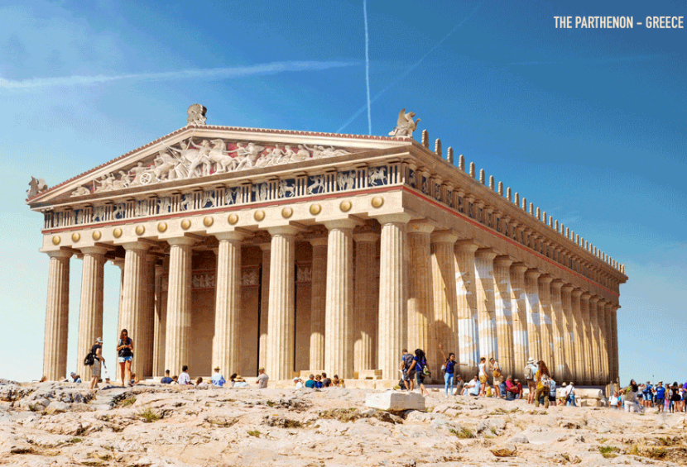
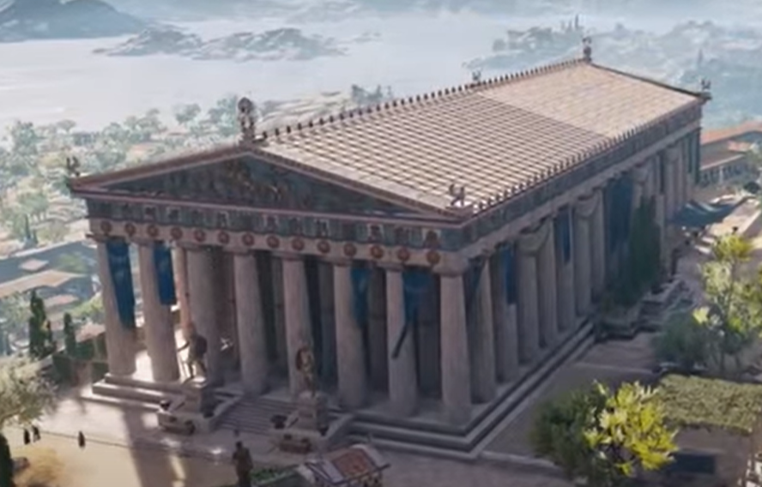

(IGN, 2018)
(Expedia, n.d)
Image 2: The Parthenon remastered digitally.
Image 1: The Parthenon from Assassin’s Creed: Odyssey.
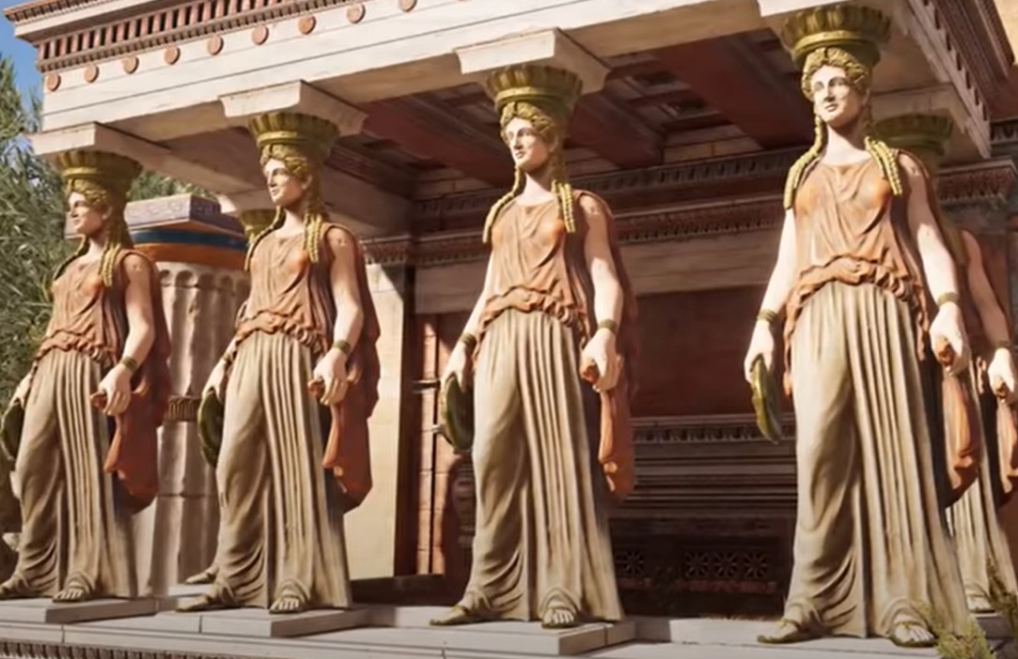
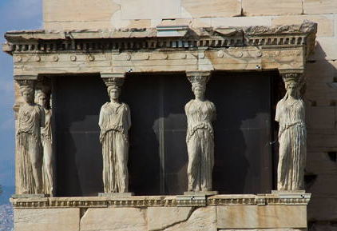

Image 4: The Erechtheion in modern day, reality.
(Schnarr, 2012)
(IGN, 2018)
Image 3: The Erechtheion from AC: Odyssey.
From the information analysed here via the themes of realism, romanticism, semiotics and democratisation the game has presented itself very realistically, which offers the chance to make the game more academically accurate with some touch ups on details such as the Parthenon, there is a lot of room to add in hyperlinks and a lot of ways to connect the game to the outside world and use it to introduce people to new subjects. This could be implemented in many games, for example in cyberpunk has a world based on new technology, you could link it to engineering and work on artificial intelligence. However, I would not want to tamper with the game too much, so possibly putting a hub or character somewhere in the game to access information could be a good idea. The idea of interconnectedness would bring together video games with so many other areas. Although in my essay I only looked very in detail at the game and a couple elements, if I had more time I would like to have expanded my knowledge further and looked at other areas and other ways of democratising the game and what this would mean.

Bibliography
- Entertainment Software Association. 2019. 2019 Essential Facts About the Computer and Video Game Industry. Available from: https://www.theesa.com/esa-research/2019-essential-facts-about-the-computer-and-video-game-industry/
- Assassins Creed Odyssey (standard edition). 2018. Xbox. Montreal. Ubisoft, [Game].
- E. E. Garvin. (ed.) Plato: The Apology of Socrates. Alberta: University of Alberta (2013) Available from: https://sites.ualberta.ca/~egarvin/assets/plato-apology.pdf
- Debnar, P. 2000. DIODOTUS’ PARADOX AND THE MYTILENE DEBATE (THUCYDIDES 3.37-49). Rheinisches Museum Für Philologie, 143(2), 161-178. [Online: http://www.jstor.org/stable/41234453] [Accessed: 29th December 2020]
- Valenti, L. 2014. What your eyebrows say about you. Available from: https://www.marieclaire.com/beauty/a6732/what-eyebrows-means/
- Ancient Greece.org. 2020. The Parthenon. Available from: https://ancient-greece.org/architecture/parthenon.html
- Cartwright, M. 2012.Caryatid. Available from: https://www.ancient.eu/Caryatid/
- Cartwright, M. 2020. Erechtheion with Original Paintwork Reconstruction. Available from: https://www.ancient.eu/image/12365/erechtheion-with-original-paintwork-reconstruction/
- British Museum. 2018. An introduction to the Parthenon and its sculptures. Available from: https://blog.britishmuseum.org/an-introduction-to-the-parthenon-and-its-sculptures/
- Cartwright, M. 2014. The Parthenon Sculptures. Available from: https://www.ancient.eu/article/780/the-parthenon-sculptures/
- University of Oxford. 2020. Phiale. Available from: https://www.beazley.ox.ac.uk/tools/pottery/shapes/phiale.htm
- Sylaiou et at. 2010. Exploring the relationship between presence and enjoyment in a virtual museum. International Journal of Human-Computer Studies 68(5), 243-253. [Online: https://www.sciencedirect.com/science/article/abs/pii/S1071581909001761] [Accessed 29/12/2020]
- Expedia. 2020. 7 ancient ruins around the world, reconstructed. Available from: https://viewfinder.expedia.com/7-ancient-ruins-around-world-reconstructed/
- Schnarr, T. (2012) Acropolis, Athens (Greece). [image] Available at: https://whc.unesco.org/en/documents/116832 [Accessed 29th December 2020]

