MODULE CODE: LCLM6004
MODULE: RESEARCH METHODS FOR BUSINESS
Assignment Title: Component 1. Business Research Proposal
Submission Date: 16.03.2026
STUDENT NAME: Camelia Daniela Popa
STUDENT ID: 2312338

Table of Contents
Introduction 4
Problem statement 4
Research aim, objectives and questions 5
Aim 5
Objectives 5
Questions 5
Literature review 6
Market dynamics influencing pricing and market saturation in the UK beauty salon industry 6
Factors influencing consumer-based decisions and risk factors in the UK 7
Adapting to the innovation wave with a technological solution in the industry 8
Government and non-government aspects to foster the UK cosmetic industry 9
Theoretical Underpinning 9
Literature Gap 10
Research Methodology 10
Data collection 10
Sampling strategy 10
Research ethics 10
Data reliability 10
Validity consideration 11
Business relevance and implementations 11
Recommendations 11
Conclusion 11
Reference List 12

Introduction
The performance parameters of any organisation, driven by internal and external factors, can reflect on its overall performance. Various aspects, such as economic drifts due to inflation rates or regulatory alterations for market dynamics, can affect the business. Hence, the study will intend to analyse the probable factors influencing the business performance of Laser Clinics. The UK-based company has been active in the cosmetic industry since 2008, with over 200 clinics globally and 229,000 new clients in this time (LinkedIn.com, 2026). Hence, the business structure of the firm and its activity with research and methodology will be discussed in the following section of the study. In addition to that, the business relevance of the firm and its growth are influenced by the rapid implementation of additional factors to influence business positively.

Problem statement
The issues surfacing in beauty and personal care organisations from 2025 have created a negative outlook for the business to thrive in the UK. Frequent price hikes, with a probable jump of 20 to 30% over an annual horizon, can disrupt the supply chain if consumers are left in the lurch (Euromonitor International, 2026). In addition to that, geopolitical aspects of business maintenance and their direct impact on the price sensitivity can have pessimistic effects on the marketability of new products. Therefore, the organisation in consideration here can ensure such factors are considered and mitigated accordingly to ensure no further probable disruptions in the market can have a negative impact.
Product coverage of different demographics shows the public preferences, with almost 46% of the users considering the healthcare and beauty products essential for their daily usage (Barclays Bank UK PLC, 2026). Additional focus on the latest trends in the industry, as per services, in an affordable pricing setup, is a realistic issue that needs to be addressed as per the user requirements. Growing concern regarding the lengthy documentation process and extra efforts to deal with the administration is a major issue for the consumers, as per reviews (Glassdoor LLC, 2026). Therefore, the company can intend to address the issues surfaced with internal procedures that need to be followed to fasten the interface and services. Hence, improvements in the consumer perception in the digital spaces can improve the services of the firm effectively to attract new audiences.
The Laser Clinics UK has been recognised as an Elite Top 100 franchise in the UK region in 2023 (Laser Clinics United Kingdom, 2026). Limiting complexity for the users to follow with a simplified form of data management with integrated Artificial Intelligence-based internal tools can help the online buyers. For instance, sourcing the tools required for treatments from unreliable suppliers can affect the qualitative perception of the users. These are some of the key challenges that need to be answered by the firm with the effective usage of proper verification of suppliers to meet the required industry standards.

Research aim, objectives and questions

Aim
This research study aims to investigate the complex business situation affecting consumer perceptions of products from laser clinics in the UK.

Objectives
- To analyse the impact of competitive pricing and market saturation on consumer trust and perceived value in the Laser Clinics in the UK
- To evaluate how marketing strategies shape decision-making and perceptions of risk in consumers.
- To investigate how technological advancement influences service quality and regulates customer satisfaction.
- To recommend strategic government and non-government approaches to mitigate existing problems in the context of the respective UK business.

Questions
- How do competitive pricing and market saturation create an impact on consumer trust and perceived value in the Laser Clinics in the UK?
- How do marketing strategies shape decision-making and perception of risk in consumers in the UK?
- How do technological advancements influence service quality and regulate customer satisfaction?
- What strategic government and non-government approaches can be fostered to mitigate and minimise existing issues that persist in the context of respective UK businesses?

Literature review

Market dynamics influencing pricing and market saturation in the UK beauty salon industry
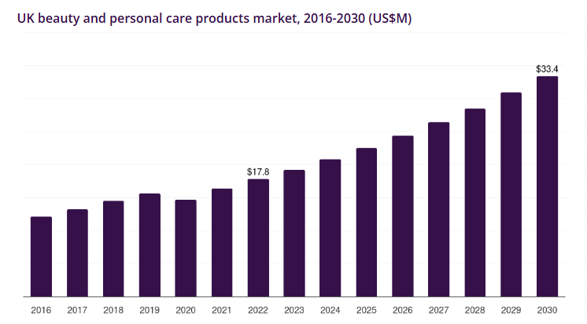
Figure 1: Market dimension of Cosmetic products in the UK
(Source: Grand View Research, 2026)
The UK beauty and personal care industry has evolved with a Compound Annual Growth Rate (CAGR) of 8.2% in the projection of 2023 to 2030. Hence, it is inevitable that revenue generation as per market saturation, influenced by added market segments, has been a major influencing aspect for the industry to attract more consumers on a frequent basis (Saunders, Lewis and Thornhill, 2019). Therefore, projection of the business in the industry as per the standard of the required demand should be kept in check to grow rapidly. The consumer perception of emerging business models, including the regional business market, can enable the companies to grow effectively. The key aspects of cosmetic service offering at an affordable rate, with the intention of prolonging the existing structure, will be necessary to reach new audiences. The cosmetic companies in the UK region can intend to focus on essential marketability of the products to make confined changes to the services (Turcu and Brancu, 2025). Hence, it will ensure that the issues related to probable changing factors of consumer perception aspects are addressed in a professional manner.

Factors influencing consumer-based decisions and risk factors in the UK
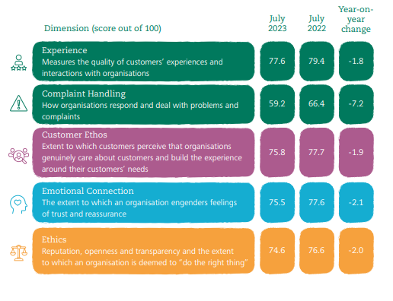
Figure 2: Factors influencing employee performance and customer satisfaction in the UK
(Source: Institute Of Customer Service, 2026)
The January 2026 UK Customer Satisfaction Index (UKCSI) has indicated a rating of 78.2 out of 100 which is 2.1 points from the previous evaluation of January 2025 (Institute of Customer Service, 2026). Therefore, effective usage of the five most influential factors, such as experiences, Compliant handling, Customer ethics, emotional connection and ethical aspects, can have a major say in the progression of customer satisfaction. According to Adams (2007), these are some unavoidable factors that can enable the business to grow rapidly and attract more users in the coming period. The cosmetic-based companies can ensure efficient services for the consumers with high-end query resolution. Based on the approach of Kaiser-Meyer-Olkin, maximising the data extracted from consumer behaviour can be used accordingly. Four major aspects of customer retention can be denoted among the users of the product, such as Support and Facility Factors (SFF), Employee Performance Factor (EPF), Customer Relation Factor (CRF) and Communication Factor (CMF) (Islami et al., 2024). Effective measurements of these factors set by the consumers in the buying preferences should be considered for the prospect of growth in the services.

Adapting to the innovation wave with a technological solution in the industry
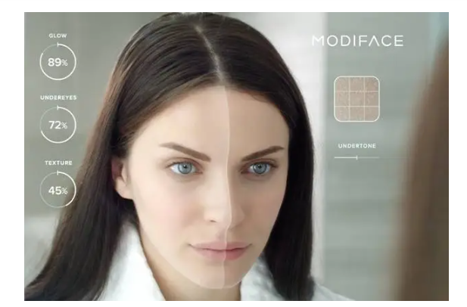
Figure 3: ModiFace Skin AI tool as a recommendation for treatment
(Source: PRESCOUTER, 2018)
Integration of artificial intelligence in the skin care industry can be a game-changer for the users of the services to denote their requirements with personalised expert-based suggestions. Based on the suggestions of Crowther and Lancaster (2009), the concise implementation of any aspect of the business into the regular aspect of services can enhance user satisfaction. Therefore, the inclusion of AI-based suggestions to the users can help cosmetics-based companies to recommend to consumers based on their skin types (Al‐Dhubaibi et al., 2025). Hence, prioritising the users by making the process of choosing specific services faster and more precise in nature.

Government and non-government aspects to foster the UK cosmetic industry
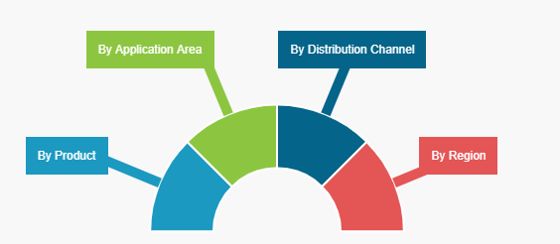
Figure 4: The UK legislation governing the Cosmetic Market
(Source: Fortune Business Insights 2026)
The UK cosmetic industry, as per the regulations set by the UK government, is required to focus on the Cosmetic Product Safety Reports (CPSRs). Hence, focusing on the customer complaints regarding a specific product or service by maintaining effective support and sustainability to keep the production process compatible for use by people from different age groups will be necessary. Product allocation as per demand and quantifying the nature of services delivered to the users should be part of the non-governing aspect of the industry. Thus, the inclusion of clinical and user trial-based distribution of several brands, with an overall valuation projected at 1.7 billion in the European region (Fortune Business Insights, 2026). Hence, complying with the rules and regulations as per the standard of GB classification can ensure further growth in the market segmentation for the consumers in this region.

Theoretical Underpinning
Complexity Theory
Application of complexity theory effectively applies the principles of natural processes within the business. It considers an organization as the ecosystem where all the operations and departments relate to each other. Application of this theory on complex business situations suggests that any brand or firm is made of interconnected agents and issues arise from self-organisation of the individual departments or employees. It also suggests that self-organisation issues occurred by the employees or any department may lead to large or unpredictable complexities. This may also harm the central control of the organization or entity.

Literature Gap
Review of the literature in this study effectively analyses all the identified issues in the context of current business operations. However, it discusses the issues in a very broaden context without specific focus on any organisation. Thus, this study aims to further analyse and evaluate the topic in the context of Laser Clinics in the UK.

Research Methodology
For this research study, a qualitative research approach will be used. The choice of this approach is justified because it helps in capturing subjective, emotional and sensory experiences of customers which are considered crucial for driving loyalty and satisfaction. Furthermore, a qualitative research method generates an insight into the consumer preferences, motivation and trends that cannot be explained with the implementation of a quantitative method. In addition, it has been observed that a qualitative research method offers a deeper understanding of consumer behaviour, market dynamics, and organisational nuances (Abacademies.org, 2026). Another reason for choosing this research method is that it helps to understand how beauty and salons interpret and comply with aesthetic regulations and sustainability requirements.

Data collection
Data collection of the information will be based on journals, articles and websites relevant to the study. Hence, keeping the contextual analysis of the topic cohesive in nature with effective quality maintenance (Whang et al., 2023). The usage of historical evidence in the case of consumer satisfaction of the company will be documented based on probable steps to be taken to keep the productivity at the top half of priorities.

Sampling strategy
Sampling strategy of the data will be based on the definition of the sampling unit and the purposeful use of the data gathered from it (Cooper and Schindler, 2014). The statistical data will be based on the information derived from the Journals, articles and websites.

Research ethics
Protecting the authenticity of the data used, with proper mention of the findings and their sources, will be done. In that process, the study will ensure anonymity of its core origin and that the findings are authentic.

Data reliability
The information collected for the study will be standardised in a format. Additionally, maintaining clear documentation of the sources will be followed to keep the information reliable. In order to maintain data reliability this research will source the information that are already verified and peer reviewed.

Validity consideration
The usage of data in this study will be recent in nature and based on up-to-date information’s available in the online portals. In this context, this study aims to collect the information that is published prior to past 5 years from now.

Business relevance and implementations
The research proposition will allow the organisation to reflect on the current activities in the consumer management system. The additional area of emphasis and its execution will be done based on gradual improvement to the consumer handling system (Walliman, 2004). The prospect of following the industry standards of the UK cosmetic business can allow them to update their own projection of several internal and external aspects at the same time. This can influence the stakeholders of the firm to work on developing precise plans to evolve the standard of customer handling.

Recommendations
The data extracted from the study will be based on the probable steps to improve the current standard of consumer proceedings. Therefore, the organisation under consideration here can ensure the inclusion of faster and more efficient consumer handling with the integration of an automated reply for the queries, which can help them to develop better steps to manage consumers. In addition to that, keeping in mind the global outreach of the cosmetic industry can also help them grow further globally as a brand.

Conclusion
The projection of business in the UK industry through the lens of Laser clinics UK was to develop their consumer perceptions to attract more users. The literature-based understanding of the topic to discuss on pricing factors, probable risk factors, technological influence and the UK legislative adaptation of the cosmetic industry was included in the study. Additionally, the focus was also on a methodical approach, as secondary quantitative research was followed for the study to be relevant and up to date with the data required for the completion of the analysis. The applicability of the mentioned proposition with probable suggestive options was also added in later stages of the study. These are some of the major points discussed throughout the course of this research.

Reference List
Abacademies.org (2026) Quality insights, profitable outcomes: Mastering qualitative research in business. Available at: https://www.abacademies.org/articles/quality-insights-profitable-outcomes-mastering-qualitative-research-in-business-16583.html#:~:text=Qualitative%20research%20methods%20offer%20a,%2C%20and%20ultimately%2C%20profitable%20outcomes (Accessed: 15 February 2026).
Adams, J. (2007) Research Methods for Business and Social Science Students. 2nd Sage Publications, Delhi
Al‐Dhubaibi, M.S., Mohammed, G.F., Atef, L.M., Bahaj, S.S., Al‐Dhubaibi, A.M. and Bukhari, A.M. (2025) ‘Artificial intelligence in aesthetic medicine: applications, challenges, and future directions. Journal of Cosmetic Dermatology, 24(6), p.e70241. Available at: https://doi.org/10.1111/jocd.70241
Barclays Bank UK PLC (2026) The beauty boom: redefining consumer ‘essentials. Available at: https://home.barclays/insights/2024/09/the-beauty-boom-redefining-consumer-essentials/ (Accessed: 12 February 2026)
Cooper, D. R., and Schindler P. S. (2014) Business Research Methods. 12 th ed. McGraw Hill
Crowther, D., and Lancaster, G. (2009) Research Methods: A Concise Introduction to Research in Management and Business Consultancy. 2 nd Elsevier Butterworth-Heinemann, Oxford.
Euromonitor International (2026) Beauty and Personal Care: Half-Year Update 2024. Available at: https://www.euromonitor.com/beauty-and-personal-care-half-year-update-2024/report?recid=9099254496109&id=804924 (Accessed: 12 February 2026)
Fortune Business Insights (2026) Beauty & Personal Care. Available at: https://www.fortunebusinessinsights.com/makeup-market-102587
Glassdoor LLC (2026) Laser Clinics. Available at: https://www.glassdoor.co.uk/Reviews/Employee-Review-Laser-Clinics-E2328431-RVW84416484.htm
Grand View Research (2026) UK Beauty And Personal Care Products Market Size & Outlook. Available at: https://www.grandviewresearch.com/horizon/outlook/beauty-and-personal-care-products-market/uk (Accessed: 8 February 2026)
Institute Of Customer Service (2026) UK Customer Satisfaction Index (UKCSI). Available at: https://www.instituteofcustomerservice.com/research-insight/ukcsi/ (Accessed: 14 February 2026)
Islami, V., Rizan, M., Wibowo, S.F. and Sebayang, K.D.A. (2024) ‘Study of service quality, trust and brand image on customer satisfaction and customer loyalty of beauty clinic consumers’: Literature review. Journal of Law, Social Science and Humanities, 1(2), pp.105-111. Available at: https://myjournal.or.id/index.php/JLSSH/article/view/153
Laser Clinics United Kingdom (2026) As Seen Online/In Print. Available at: https://www.laserclinics.co.uk/in-the-media/ (Accessed: 10 February 2026)
LinkedIn.com (2026) Laser Clinics United Kingdom. Available at: https://uk.linkedin.com/company/laserclinics-uk (Accessed: 13 February 2026)

