Module: Effective Team Working and Communication
Module code: BMSW4002
Programme: Certificate of Higher Education Skills for the Workplace
Internal Verifier: Yohan Mendis
Tutor: Muhammad Islam
Student: Tunde Brigitta Petkes/2124153
Name of Institute: University of Wales Trinity Saint David

Table of Contents
1 Introduction 2
1.1 Overview of the team working 2
2 Model of teamwork 3
2.1 Tuckman team development stages 3
2.2 The T7 Model of Team Effectiveness 4
3 Role of creating effective team 4
4 Impact of effective teamwork on team success 5
4.1 Advantages of effective team 5
4.2 Barriers to effective team working 6
5 Conclusion/recommendation 8
5.1 Recommendation 8
6 References 10

Introduction
As the new development strategy, Next Plc has planned to launch a new product line targeting the young audience, besides other factors, one of the other aspects that need to be a focused on for accomplishing the objective is to have an effective team working. The team is required to be comprised of people from different Next stores which are located across the globe. To accomplish the set goals, it is necessary that effective team working and communication should be maintained. In the following assignment, discussion related to the aspects that need to be focused on for developing an effective team will be discussed alongside the barriers to team working shall also be highlighted.

Overview of the team working
A team is made up of people who work together to complete interdependent tasks in support of a mutual objective (Liao, 0217). Some teams have a limited lifespan, such as those devoted to ongoing continuous improvement or development teams focused on developing new products. However, teams cannot be formed by individuals who are incompatible with one another.
Team effectiveness is referred to as the capacity of a team to accomplish the set goals or objectives, which are administered by the organisation or authorised personnel. In order for the teams to be effective, the leaders or the managers must develop a working environment and team culture that should be able to foster and balance the performance and well-being of the employees. Ensuring team effectiveness is considered essential for gaining success for the organisation because it has been identified that highly effective teams tend to accomplish the set goals and objectives more frequently. Moreover, in comparison to ineffective team members, they are much more engaged and with that have a strong relationship with the other members (Mathieu et al., 2019). For Next Plc, it is necessary that for accomplishing the set objectives related to the product launch, the focus needs to be given to developing an effective team will high morale and resilience. Building an effective team is never an easy task; especially in recent years, the process has become much more complex. Along with this, the changing trends have made it much more difficult, majorly because the team has become increasingly global, project-driven and virtual. Hence it is required that the Management of Next Plc should focus on taking a much more systematic approach for assessing how well the team is performing and ensuring success; furthermore, it shall also help evaluate where improvements are required as it will help improve the performance.

Model of teamwork
Along with this, the implementation of different models and tools would also help develop an effective team. The following section will discuss Next in line with different models and theories. One of the commonly used and discussed models for effective team working is Tuck’s stages of team development.

Tuckman team development stages
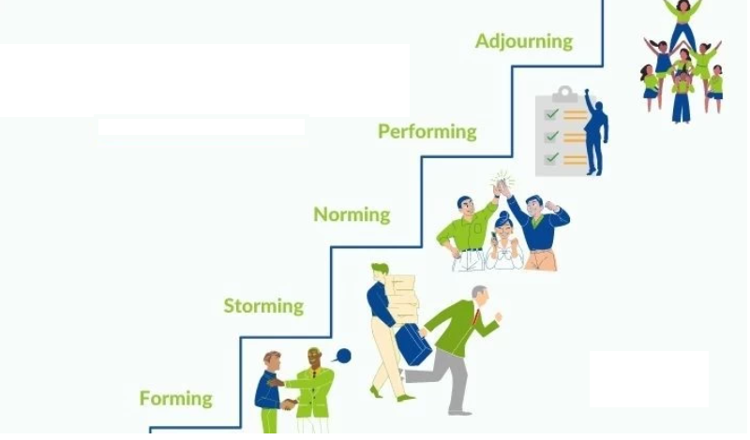
Figure 1 Tuckman's stages of team development
Source: (Super, 2020)
The model helps explain the way the ability and maturity of the team are developed alongside the way relationships are established with the changing leadership and environment. Moreover, it is also helpful in providing an understanding of the different stages involved in developing an effective team. Furthermore, it is also helpful in providing practical training to the team members and making sure that they work to their full potential (Peralta et al., 2018). All the stages discussed in the model have their specific focus with that they correspond to different levels of feelings, group tasks and behaviours. The model highlighted that increasing awareness related to the different stages and identifying the core reason why certain things are happening would be helpful in positively affecting the team's overall productivity and process (Fink-Samnick 2020). In consideration of the stages of team development identified by Tuckman, Next Plc can gain benefit from implementing this teamwork model in various aspects. In addition, the model will be helpful for Next Plc to develop groups and train individuals to work wisely in the team. Correspondingly, this training and focus on employees will help individuals to work up to their best potential. Likewise, in consideration of Next Plc scenario on facing challenges of lack of experienced teamwork and weak communication within the team will be eliminated following Tuckman Model of team formation. Also, it will emphasise enhancing the maturity and ability of an individual, as well as targeting to establish better relationships among the team. As a result, using the five phases of team development, Next Plc can construct teams, manage obstacles more peacefully, communicate information efficiently, deliver exceptional outcomes, and analyse results to uncover growth prospects.

Role of creating an effective team
Allocating the respective team roles is considered necessary for developing a successful and effective team. Without defining the different roles, it would be challenging to accomplish the set goals and is most likely to lead to miscommunication and confusion among the team members, which eventually leads to affecting the overall performance of the organisation. Identifying the team objectives and then allocating the team roles depending on the strengths and weaknesses of the members is considered essential for the success of the organisation (Guinan, Parise and Langowitz, 2019). Along with this, it will also help create a much more balanced team that has highly motivated members who can fulfil the defined roles that leads to the success of the team. In the case of Next Plc, for successfully launching the product as per the requirement and set schedule required that the team members should have a clear understanding of the set objectives and should have well-defined roles. Ensuring this will be helpful in not only the accomplishment of the tasks but, at the same time, will also lead to adequate monitoring of the overall process (Lacerenza et al., 2018).
Influential team role was defined by Meredith Belbin and described as a tendency of an individual to contribute, behave and interrelate with the members in a specific manner. Through the study, it has been identified that the most robust and most effective team are the group that has the most incredible diversity of personality types as it will lead to making up for the other strengths and weaknesses for creating a well-balanced team. Belbin has defined 9 major team roles that would help develop an effective team.
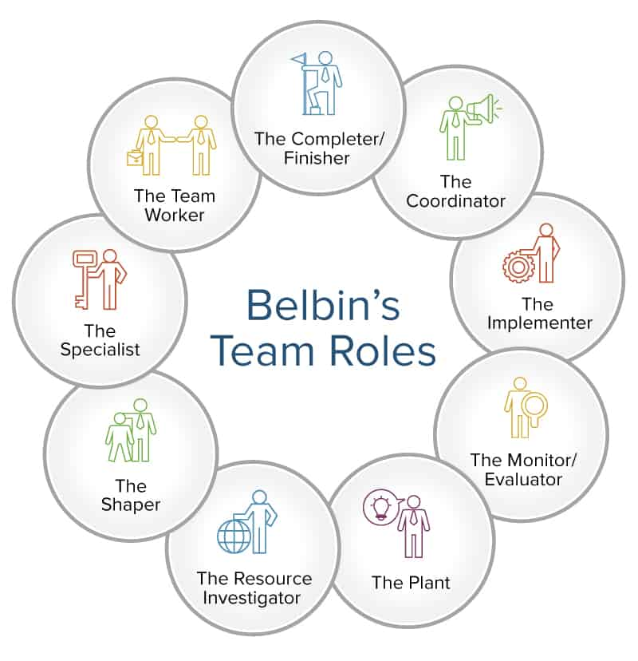
Figure 3 Belbin's team roles
Source: (Aranzabal, Epelde and Artetxe 2022)
The abovementioned team roles work as a guideline and are helpful for the leaders in designing and building strong and successful teams. The team role model is referred to as one of the most successful and popular team management and building tool for the business. To accomplish the set objectives, the Management of Next Plc must make sure that the allocated team roles should be as per the defined model as it will help make sure that an effective team should be developed that have the required skills and abilities (Lynch, Lynch and Clemens, 2018).

Impact of effective teamwork on team success

Advantages of effective team
In the present globalised and fast-changing environment, team working is essential for ensuring success and maintaining a solid position in the market. Several of the studies illustrate that organisations that focus on team working are most likely to innovate much faster and identify mistakes much more quickly, which eventually leads to finding a better solution for the identified issues, which eventually leads to attaining high productivity for the organisation. Enhancing the efficiency of the team members will lead to increased productivity and overall performance, which will benefit the organisation at the individual level and as a whole. For example, the sales department thrives on building healthy competition, which leads to closing more deals for the business and thus eventually benefiting the organisation when working as a team (Soukup et al., 2018)
Developing an effective team is considered essential in building solid associations between the other members; this will eventually lead to maintaining an enjoyable working environment for the workforce. It has been identified that a pleasant working environment helps ensure higher productivity and helps in accomplishing the goals much more quickly and efficiently. Along with this, several statistics demonstrated that employees that work as a team are most likely to accomplish the set goals and tasks much faster and more efficiently than in comparison to the workforce that works individually (Acton, Braun and Foti 2020). Working in a team leads to minimising the workloads for all the members through sharing responsibilities and ideas among each other. Employees have various deadlines to accomplish, which creates pressure and stress for them. In such situations, team working is significant because it helps share the work pressure and meet the goals in a shorter time scale. Teamwork is considered vital as it leads to reducing stress and with that allows the team members to be scrupulous and thorough when fulfilling the tasks (Handke et al., 2020).
Referring to this, Song et al. (2019) mentioned that employees who are most likely to work individually are most likely to have low morale and thus are less accountable. While working in a team, it is considered essential to maintain accountability. Organisations overall have the opportunity of gaining benefit from teamwork because employees are most likely to complete tasks and projects before the deadline because of increased efficiency and productivity. Effective team working has a significant impact on the overall working environment where people appreciate each other, leads to high morale, which will is reflected in high performance and productivity. With that, it leads to maintaining strong relationships among the team members. This interaction resulted in providing excellent learning opportunities and acquiring new skills. An increase in performance, productivity and efficiency all leads to ensuring success for the organisation in the long run.

Barriers to effective team working
Encouraging the factors that can lead to improving team working in the organisation is considered an excellent idea, but at the same time, if there is a lack of communication among the team members, then it is most likely that all the efforts would be of no use for the business (). With the analysis of the case study, it is identified that the company is planning to expand its current product range. The accomplishment of the tasks required developing a team with employees across the different outlets of the brand to accomplish the task, one of the essential components of effective communication. The case study indicated that lack of communication and effective team working is among the significant challenges faced by the employees. The issue has been experienced especially during team meetings; communication is one of the significant areas that need to be focused on to ensure the accomplishment of the set goals and successfully launching the new product range (Malande et al., 2019).
Related to this, Bui et al. (2019) mentioned that ensuring good communication is considered essential within the working environment for collaborating with the team members. To maintain effective communication among the team members, certain aspects need to be focused on. This includes using verbal and non-verbal communication skills alongside active listening and other elements as well.
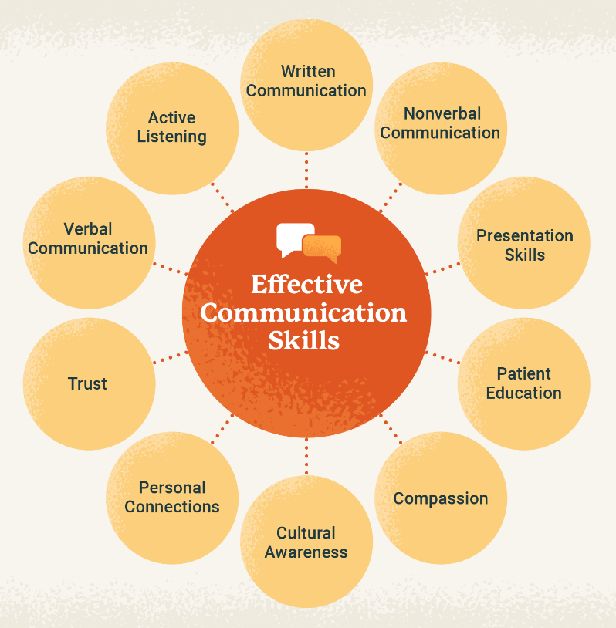
Figure 4 Effective communication skills
Source: (Drossman, et al., 2021)

Conclusion/recommendation
The discussion highlights the importance of communication. Along with this, it identified that Next Plc, to launch the new product line successfully, needs to make sure that effective team development should be done along with this focus should be given to maintaining strong communication among the team members. Moreover, it is concluded that to maintain effective communication, the focus needs to be given to allocating the roles to the team members as per their abilities and strengths. Moreover, the adoption of Belbin team roles would also be beneficial in developing an effective team.

Recommendation
Next Plc needs to ensure that the abovementioned areas should be focused on to ensure effective communication among the team members. Furthermore, there are other tools and techniques as well that be adopted for maintaining strong communication as well and, with that, assessing whether the communication is maintained within the workforce.
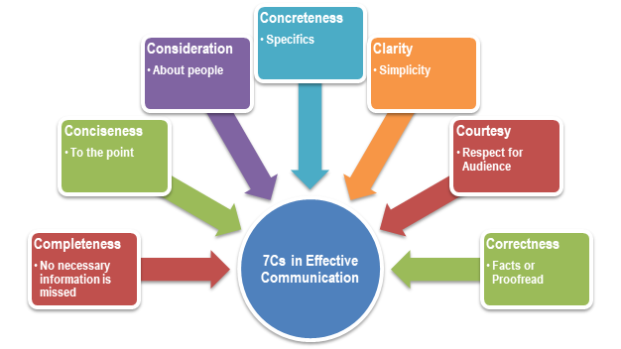
Figure 5 7 C's of communication
Source: (Arfaoui, et al., 2020)
One of the most commonly used frameworks is the 7C's of communication, which is referred to as a checklist for ensuring that communication is effectively maintained among the employees. For Next Plc, to ensure the correct result, it is necessary to make sure that communication is effectively maintained and should be clear. For launching the new product line for the company, different tasks will be involved that require effective communication between the team members. Adapting the 7 C's model would be helpful for the managers to communicate the tasks quickly and that also will help measure the overall performance. Referring to the framework, communication and the message must be clear and concise, along with this clarity should be maintained. Furthermore, maintaining effective communication will be helpful for the company is working more efficiently. This will also help maintain help maintain high will eventually lead to creating a healthy culture which will lead to enhancing the overall performance and productivity.

References
Acton, B. P., Braun, M. T. and Foti, R. J. (2020) “Built for unity: assessing the impact of team composition on team cohesion trajectories,” Journal of Business and Psychology, 35(6), pp. 751–766.

Aranzabal, A., Epelde, E. and Artetxe, M. (2022) “Team formation based on Belbin’s roles to enhance students’ performance in project based learning,” Education for Chemical Engineers, 38, pp. 22–37.

Arfaoui, M. A. et al. (2020) “Physical layer security for visible light communication systems: A survey,” IEEE Communications Surveys & Tutorials, 22(3), pp. 1887–1908.

Bui, H. et al. (2019) “The resilient organisation: A meta-analysis of the effect of communication on team diversity and team performance,” Applied Psychology, 68(4), pp. 621–657.

Drossman, D. A. et al. (2021) “A Review of the Evidence and Recommendations on Communication Skills and the Patient-Provider Relationship: A Rome Foundation Working Team Report,” Gastroenterology, 161(5), pp. 1670–1688.

Fink-Samnick, E. (2020) “Leveraging Interprofessional Team-Based Care Toward Case Management Excellence: Part 2, Team Development, Interprofessional Team Activation, and Sustainability,” Professional Case Management, 25(1), pp. 5–18.

Guinan, P. J., Parise, S. and Langowitz, N. (2019) “Creating an innovative digital project team: Levers to enable digital transformation,” Business Horizons, 62(6), pp. 717–727.

Handke, L. et al. (2020) “Interactive effects of team virtuality and work design on team functioning,” Small-Group Research, 51(1), pp. 3–47.

Kusio, T. and Dolot, A. (2019) Project management: human factor REDAKCJA NAUKOWA: TOMASZ KUSIO, ANNA DOLOT Project management: human factor Spis treści.

Lacerenza, C. N. et al. (2018) “Team development interventions: Evidence-based approaches for improving teamwork,” American psychologist, 73(4).

Liao, C. (2017) “Leadership in virtual teams: A multilevel perspective,” Human Resource Management Review, 27(4), pp. 648–659.

Lynch, D. S., Lynch, M. J. and Clemens, C. M. (2018) “Belbin Team Roles: Assessing behavioral interaction to improve communication,” in The Handbook of Communication Training, pp. 308–320.

Malande, O. O. et al. (2019) “Barriers to effective uptake and provision of immunisation in a rural district in Uganda,” PloS one, 14(2).

Mathieu, J. E. et al. (2019) “Embracing complexity: Reviewing the past decade of team effectiveness research,” Annual Review of Organizational Psychology and Organizational Behavior, 6, pp. 17–46.

Peralta, C. F. et al. (2018) “Team development: definition, measurement and relationships with team effectiveness,” Human Performance, 31(2), pp. 97–124.

Sigwela, T. (2020) The relationship between authentic leadership, psychological empowerment, work engagement and team effectiveness (Doctoral dissertation). Stellenbosch: Stellenbosch University.

Song, Q. et al. (2019) “Impact of the usage of social media in the workplace on team and employee performance,” Information & Management, 56(8).

Soukup, T. et al. (2018) “Successful strategies in implementing a multidisciplinary team working in the care of patients with cancer: an overview and synthesis of the available literature,” Journal of multidisciplinary healthcare, 11.

Super, J. F. (2020) “Building innovative teams: Leadership strategies across the various stages of team development,” Business Horizons, 63(4), pp. 553–563.

