


Constantin Polgar
2116259

February 14, 2022

We spoke about reward and recognition, how nice is that?
I will guide you now on how to create group dynamics and how to resolve conflicts.
The credit for “Group Dynamics” goes to Kurt Lewin (Wheeler, 2008). a psychologist and change management expert who in the 1940s noted that individuals take on roles and behaviours when they work in a group. Group Dynamics describes the effects of these roles and behaviours on other group members also on the group. The most essential element here is the interaction of the individuals involved as groups develop based on interactions, feelings, or activities. By interacting with each other they will develop different attitudes toward each other. To have an effective team, management must create and encourage positive group dynamics. Team members must trust each other so they can work toward collective decisions, and they are held accountable for outcomes. It Is important as it can directly impact creativity, productivity, and effectiveness.
Key strategies to create and maintain positive group dynamics:
- Conduct team health checks, observe them at work, seek feedback from outside (customers).
- Create team charters by offering clearly defined roles
- Enhance team culture using team-building exercises, build trust and respect between team members, or support open communication.
- Pay attention! Always observe and know what’s going on. Any kind of unaccepted behaviour such as bullying, racism, should be addressed immediately and reinforced positive: trust and respect, sharing ideas, collaborating.
When there is a lack of cohesiveness and group dynamics take a negative turn, teams will start to suffer as conflicts will become inevitable.

Effective conflict handling and delegation
In 1965 Bruce Tuckman created a model that describes the phases teams tend to go through from the incipient phase to completion of projects. ( Bonebright, Denise A, 2010)
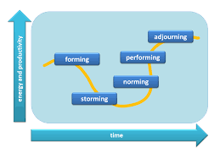

Conflict is natural to occur within teams and even though is expected to appear in the storming phase, it can occur at any time and conflict is an essential element for development and performance. It is likely to appear at this phase as groups lack unity, they become hostile to one another, they concentrate more on how to impress individually rather than focusing on the project
Conflict occurs within teams for reasons such as stress, poor communication, fear, or misunderstanding.
Analyzing Coveys model: 7 habits of highly effective people, the keys for conflict resolution are discussions and negotiation as teams strive for a win-win resolution and develop a collaborative team, otherwise the most desired. To overcome conflict, habits 4, 5 and 6 state clearly how showing respect sympathy, listening to all ideas that members must share and creating synergy by asking for solutions and cooperating will bring teams back to shared goals.

Even though it might be unpleasant, handled correctly, it leads to development.
I have a negative example from a workplace where one day, I and a team member had started a massive argument, close enough to a fight and the manager simply watched the entire scene without any intention of stopping the conflict. Questioned, days later, he maintained the idea that it wasn’t his problem…In this scenario, there was a major lack of respect, poor leadership and no signs of improvement so resigning seemed to be a wise decision.

Kilman's conflict resolution model is another great tool to use when instability arises.
This tool comprises 2 key terms:
- Assertiveness: a communication style by being able to express your feelings, thoughts, beliefs, and opinions in a manner that doesn’t violate the rights of others.
- Cooperativeness: a personality trait concerning the degree to which a person is generally agreeable in their relations with other people as opposed to aggressively self-centred and hostile.

Resolving conflicts using Kilman’s model:
-proacting
-communication
-flexibility
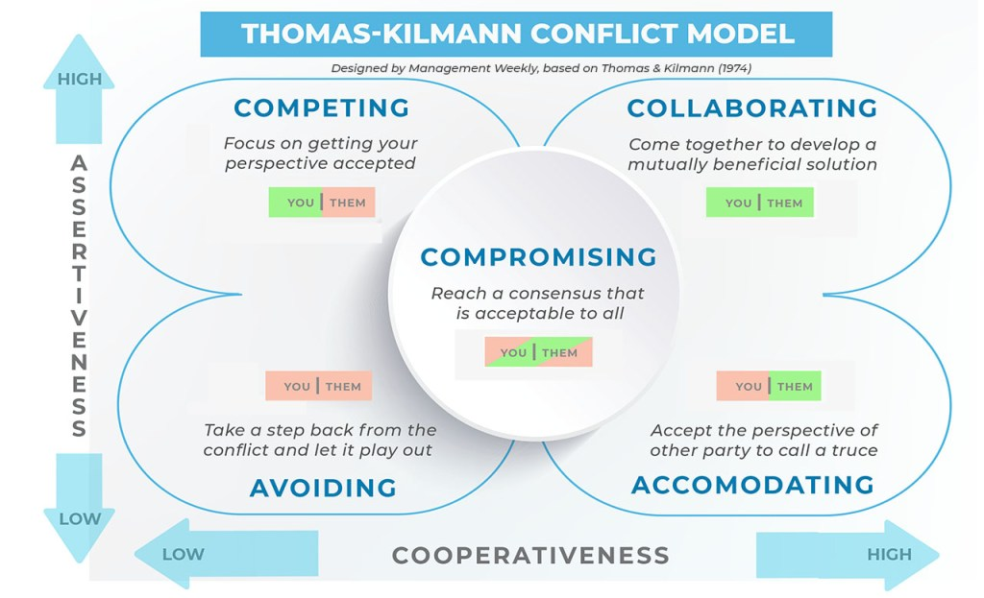

Delegation is a person or a group, officially elected to represent another or others, if you wish: empowered or authorized. The act of delegation in important as it states clearly wht needs to be done, clarifies outcomes, provides, contacts and support and agrees on deadlines

References

Wheeler, L. (2008). Kurt Lewin. Available at: https://compass.onlinelibrary.wiley.com/doi/full/10.1111/j.1751-9004.2008.00131.x (Accessed: 13/02/2022).

Bonebright, Denise A. (2010). 40 years of storming: a historical review of Tuckman's model of small group development. Available at:
https://web-p-ebscohost-com.ezproxy.uwtsd.ac.uk/ehost/detail/detail?vid=0&sid=fc53b9b0-2b3b-46a8-a580-dfbb7f97cc4f%40redis&bdata=JnNpdGU9ZWhvc3QtbGl2ZQ%3d%3d#db=eue&AN=48149645 (Accessed: 13/02/2022).

