REPORT: PHYSIOLOGY

This essay aims to discuss the normal and abnormal physiology, health and nutrition status of young male who engages in unhealthy alcohol consumption behaviours and exceeding recommended limits on a daily basis. The data has been gathered using a health and fitness questionnaire. The data will then be analysed and evaluated and advice on improving his health will be made in line with the present health guidelines. The essay’s main focus be on the intellectual, emotional, physical and spiritual need of the participant. For confidentiality sake, a pseudonym has been used: MicheaL Ndlovu

Intellectual and emotional health

According to the information gathered on the questionnaire, Micheal is a young man who enjoys his drink and mainly drinks to cheer himself up and sometimes to be able to sleep. There has been some proof from previous studies that consuming huge amounts of alcohol may lead to increased risk of developing mental health difficulties and drinking alcohol can contribute to some mental health difficulties like depression (http://www.timetostop.net/alcohol/mental.html). Alcohol also exhausts the central nervous system, and this could lead to the fluctuation in our mood.
Alcohol can also “numb” emotions and this helps the individuals to refrain from thinking about difficult issues going on in their lives (PsychCentral, 2014). One of the major difficulties related to consumption of alcohol to sort out mental health problems is that daily alcohol drinking changes the chemistry of the brain. It lessens the levels of the brain serotonin- an essential chemical in depression (http://www.mentalhealth.org.uk). Therefore, this reduction, periodic process starts when someone drinks to ease depression, which causes the serotonin in the brain to be reduced, causing the individual to feel even more depressed, and as a result requiring more alcohol to then sedate this depression (Mental Health Foundation, 2006). In order for Micheal to achieve general wellness, he needs to develop new hobbies such as visiting the gym a number of times in a week, engaging in more outdoor activities and to consider joining a dance class to meet new people. Having hobbies and activities to participate in, is an important role in achieving overall wellness ( Marrow, 2011). Intellectual health is deemed essential as the stimulation of the brain supports the smooth flow of the blood,oxygen and the nutrients to the brain (Martynoga, 2916). There are strategies that are being put in place to support the individuals to drink sensibly. In Wales, the Mental Health Measure (2010) has proposed that the legal standards on health boards and local authorities are increased to support people with mental health difficulties. According to the data collected, Micheal is from a close knit family and has a good cycle of friends that he meets up with regularly for a drink. This is important for humans to maintain good relations and partnerships as it enhances self-esteem and boost confidence ( Okada, 2012). People are a social species and depend on the company of other people for the fulfilment in their lives ( Tomasello, 2014).

Nutrition and alcohol:

Micheal has revealed he does exceed the recommended alcohol intake limit and this happens on a daily basis. While he is out drinking, he consume a lot of take aways and the junk food. Our bodies requires nutrients from the food we eat for growth, maintainance and repair of tissues (http://www.alcoholthinkagain.com.au). This consists of carbohydrates, fats, proteins, vitamins and some minerals ( Whitney, E.; & Ebook library, 2013). Alcohol consumption interferes with the intake of vitamins like A, B1, B12, C, D, E and folic acid, which can see them removed as waste instead of being used (Whitney, E., & Ebook library,2013). Alcohol can minimise inhibitions and self-constraint and for that reason the drinkers tend to make poor nutritional judgments while drinking and afterwards, maximising the appetite for unhealthy food, for example foods high in fat, salt, calories and take aways ( Piazza-Gardner, A. K., & Barry, A.E, 2014). Alcohol consumption can lead to malnutrition by substituting the foods required for vital nutrients and by interrupting with the saturation, storage or metabolism of the important nutrients (http://www.verywellmind.com). It is recommended that Micheal starts to eat healthy and reduce his alcohol intake. He should consider following the diet recommendations such as food guide pyramid ( it includes a high consumption of fruits and vegetables, with lower intake of dairy and white meat, an incredible small amount of red meats and processed foods), drinking an considerable amount of water each day as it helps to flush out toxins from our bodies and keeps them functioning accordingly (http://www.bouldermedicalcenter.com). In order to have the best level of health, it is important to have a good level of hydration (Jequier and Constant, 2010).

SPIRITUALITY
This part of evaluation will discuss about the spiritual life in general not the religion, where one is committed to a certain framework. Royal College of Psychiatrists (2015) states that, spirituality is not necessarily tied to any particular religious belief or tradition. It’s a way of caring for other people or how connected any individual can be to people and the entire world. People learn through challenges in life, it is a way an individual develops and mature. Spiritual healing brings something new in mind, then one forgets the past, sense of hope and peace control the entire mind. However, to be spiritual orientated one has to practice to an organised religion and be committed to attending church services. Wales NHS UK (2009) agrees that spiritual and religious care plays an important role to patients and realises to have remarkable impact on patient’s outcome. Really spirituality is a characteristic of human reality that gives it it’s humanness.
The health questionnaire indicates that Michael was not religious orientated but believed spiritually. The fact that Michael believed spiritually within his surrounding and outside his surroundings. According to spirituality is connected to a supernormal, non-rational, but all to do with mental health and physical health

The World Health Organisation, European Union and other bodies, National governments and parliaments have developed alcohol policies in order to minimise the damage of alcoholism (World Health Organisation, 2010). Aimed at youngsters and young adults are seen as a vital way to minimise dangers of alcohol misuse. Raising the age at which legal drugs like alcohol can be bought, prohibiting or limiting advancement of alcohol has also been urged as supplementary ways of minimising the damage of alcohol reliance and misuse. Conclusive, proof based educational campaigns in the mass media about the aftermath of alcohol misuse have been urged. Advice for parents to restrict alcohol amongst teenagers, and assisting young people suffering from mental health issues have also been urged (Crews, F; He, J; Hdge, C, 2007). Public Health Wales started a programme of Alcohol Brief Advice training for primary care staff in November 2010. Alcohol short advice is explained as a short, proof based, methodical conversation about alcohol drinking with a client to instigate and support the person to think about or consider a change in their relationship with alcohol in order to minimise their intake (http://www.wales.nhs.uk). At the moment NHS advice insists on that men should not repeatedly consume more than three to four units per day and women should not exceed more than two to three units of alcohol per day (NHS Choice. Alcohol units, 2013). The Welsh Assembly Government currently begun a ten year approach to substance abuse (WAG, 2008). This approach aims to decrease the damage induced by alcohol and other substances (Welsh Assembly Government, 2008). In Octob er 2008 internal Welsh Assembly Government and outside stakeholders groups, were established to promote a physical activity action strategy for Wales. This plan sets out to boost heightened levels of physical activity in order to attain an enhanced health and well-being. Evidence displays that compelling health benefits are accomplished through bearable increment in physical health for those individuals who are less active. Plans to increase the effect of the Change4life campaign in Wales, through developing an idea to influence and motivate, and by linking the targeted audience with the confined resources that can assist them with their behaviour. The Public health Wales Board approved the yearly report 2012-13 on the implementation of the Welsh government’s Together for Mental Health strategy. This report urges that mental health promotion should be made a predominant source of health, social care and justice services, and mental and physical health should be considered as one.

Conclusion
In conclusion, the evaluation findings of the report from a health questionnaire which was completed on a one – to –one basis. The report analysed the findings of the physical wellbeing, emotional and spiritual health and intellectual being of Michael Ndlovu. The research has demonstrated in depth search of the chosen topic, however, emotional and spiritual including intellectual had limited information on search that may result inadequate facts on the topic. Although Michael’s health, according to his questionnaire seems fairly to a healthy wellbeing. The report also discussed the government strategies put in place preventing more health damage to people’s wellbeing and encouraged people to exercise, participate in different activities and eat healthy diet as indicated on the eat well guide. The report also discussed how Michael can prevent the behaviours of excessive alcohol intake. Some guides how Michael can improve his life style are attached to this report.

LIFESTYLE QUESTIONNAIRE
Introduction:
Health Promotion and Wellness is the main key to healthy life style, kindly complete this questionnaire to the best of your understanding. May you kindly hand the questionnaire to our receptionist when completed.

Name …Michael …Ndlovu………………… Date of Birth 10/12/1995……
Do you drink alcohol? Yes { y } No { }
If Yes, how often –
Drink less than 1 bottle of beer/day { }
1 – 6 bottles of beer/day { }
7 – 14 bottles of beer/day { X}
15 – 24 bottles of beer/day { }
indicate maximum number of
bottles of beer taken per day {10}
preferred brandy of alcohol {X}
Fosters Lager
If No, have you –
never taken alcohol { }
drink on special occasion { }
drink only on week-ends { }
drink everyday/weekends {X}

Do you suffer from diabetes? Yes { } No {X}
Do you have high blood pressure? Yes { } No {X}
Have you ever had a stroke? Yes { } No {X}
Does anyone in your family suffer
from any of the above problems? Yes {X} No { }

Diet
Healthy eating is essential to our bodies on a daily routine and balanced diet. Please tick the box according to your routine.
I eat meat, eggs, fish or dairy products {X}
I eat a variety of foods plus fruits and
vegetables {X }
I eat no meat { }
I eat freshly prepared foods only {X}
I eat frozen foods twice a week {X}
I eat large chips four times a week { }
On special diet and watch my weight { }

Smoking
Please tick the most category that describes your daily number of cigarettes taken per day.
I never smoked {X}
I smoke 1-10 cigarettes/day { }
I smoke 11-20 cigarettes/day { }
I smoke more than 30 cigarettes/day { }

Exercise
Exercise is good to maintain a healthy body, raises your pulse and deep breathing after 20 – 30 minutes continuously activity. Examples of activities; walking, running and cycling including many more.

How many times a week do you perform the activity –
No activity { }
once a week { }
twice a week {X}
once or twice a month { }

Reference
Crews et al (2007) Adolescent cortical development: a critical period of vulnerability for addiction. Available at: DOI:10.1016/j.pbb.2006.12.001. Accessed 15th May 2019
David et al (2006) Alcohol misuse prevention for young people: a systematic review reveals methodological concerns and lack of reliable evidence of effectiveness. Available at: https://doi.org/10.1111/j.1360-0443.1997.tb02911.x (Accessed 14th May 2019)
Dr. Cornah. D (2004) The impact of spirituality on mental health - Mental Health Foundation. A Review of Literature. London. Available at: https://www.mentalhealth.org.uk/sites/default/files/impact-spirituality (Accessed 13th May 2019)
Health in Wales (2009) Spiritual Care Doing Well, Doing Better Standards for health services in Wal… Consultation on Standards for Spiritual Care Services in the NHS in Wales. Available at: https://www.wales.nhs.uk/spiritualcare. (Accessed 14th May 2019
Jéquier; E. & Constant, F. (2010) Water as an essential nutrient: the physiological basis of hydration: Available at:
https://www.nature.com › european journal of clinical nutrition › review. (Accessed 12th May 2019)
Koenig. H.G. (2012) Religion, Spirituality, and Health. The Research and Clinical… - Hindawi. International Scholarly Research Notices. Available at: https://dx.doi.org/10.5402/2012/278730. (Accessed 13th May 2019)
Martynoga. B. (2016) How physical exercise makes your brain work better Education: The Guardian. Available at: https://www.theguardian.com/...how-physical-exercise-makes-your-brain-work-better. (Accessed 12th May 2019)
Mental Health Foundation (2006) Cheers? Understanding the Relationship between Alcohol and Mental Health. London: Mental Health Foundation. Available at: https://www.mentalhealth.org.uk/campaigns/mhaw/... (Accessed 13th May 2019)
Mental Health (Wales) Measure (2010) This law places new legal duties on local health boards and local authorities about the assessment and treatment of mental health problems. Available at: https://gov.wales>health>nhswales>law (Accessed 12th May 2019)
New Health Guide: Fitness & Wellness. Available at: https://www.newhealthguide.org/the-importance-of-eating-nutritious-food.html. (Accessed 13th May 2019)
Okada et al (2012) Self-esteem enhancement programs can improve self-esteem in school-age children.
Nursing Diagnosis Handbook - E-Book: An Evidence-Based Guide to ... Available at: https://books.google.co.uk/books?isbn=032339032 (Accessed 15th May 2019)
Piazza-Gardener et al (2004) A qualitative investigation of the relationship between alcohol consumption, physical activity, eating disorders and weight consciousness. American Journal of Health Education, 45 (3), 174-182
Public Health Wales: Substance Misuse - Drugs & Alcohol. Available at: http://www.wales.nhs.uk/sitesplus/888/page/72997 (Accessed 12th May 2019)
Psych Central (2014) Alcohol May Not Help: Alcohol Impact on your Mental Health
Welsh Assembly Government: Working Together to Reduce Harm: The Substance Misuse Strategy for Wales 2008-2018. Available at: https://gweddill.gov.wales/topics/people-and-communities/communities/safety/substancemisuse/publications/strategy. (Accessed 13th May 2019)
Tomasello. M. (2014) The ultra‐social animal: European Journal of Social Psychology,Volume 44, Issue3: Available at: https://doi.org/10.1002/ejsp.2015. (Accessed 14th May 2019)
Whyte. E. (2013) Understanding nutrition, 2nd edition: Melbourne: Cengage Learning Australia
World Health Organisation (2010) Global strategy for reducing alcohol consumption - World Health. Available at:
https://www.who.int/substance_abuse/msbalcstragegy. (Accessed 10th May 2019)

The diagram below is a guide to help Michael maintain a healthy diet.

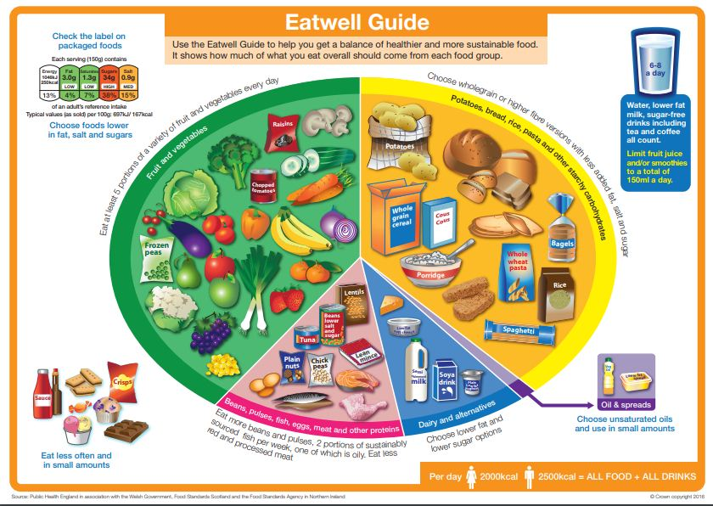

This guide shows percentages of different categories in life style how it can affect wellbeing.

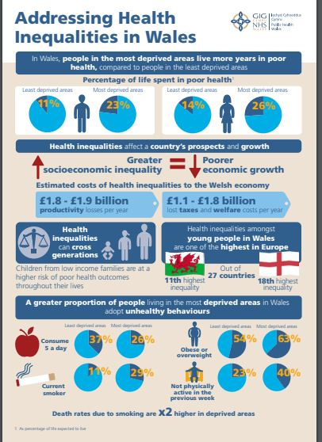

The diagram shows how Michael can keep fit and maintain a healthy life style

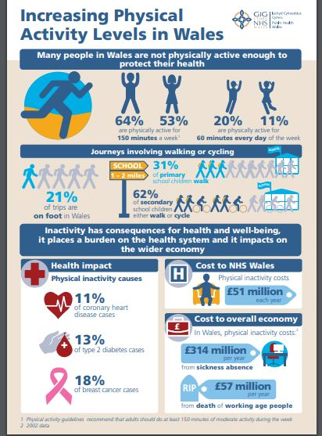

The diagram shows the effects of alcohol; Michael is made aware of the damages caused by too much intake of alcohol.

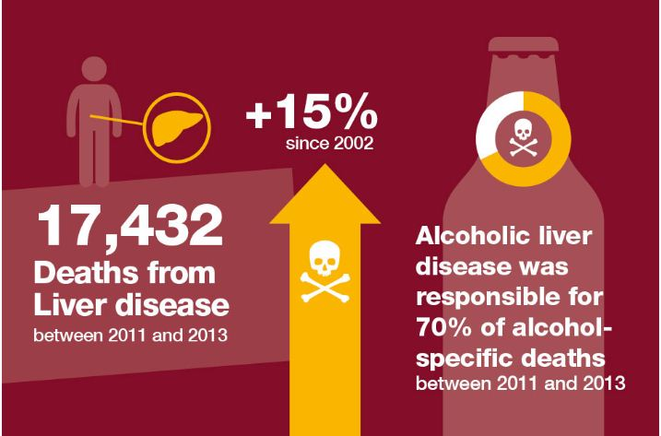

Michael can also live a healthier life and reduce chances of suffering different diseases.

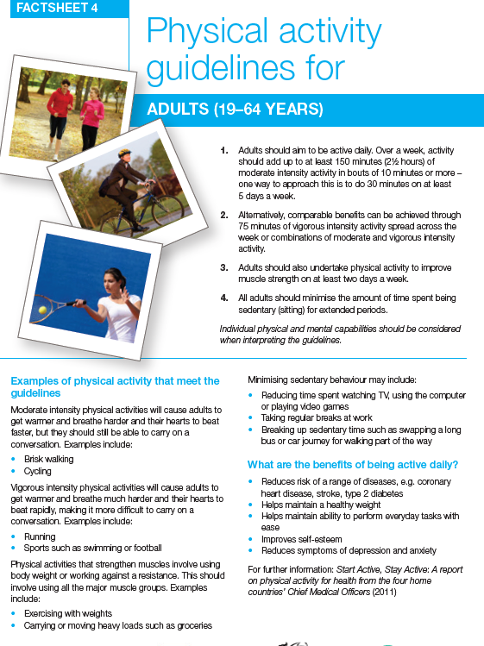

Michael can refrain from excessive drinking habits.



