

Academic Discipline of Hospitality and Tourism Management

Contemporary Themes in the Hotel and Hospitality Sector

BMIH6001

Artificial Intelligence in hospitality and tourism
Student name: Iulia Dascal
Student ID:2127529
Lecturer: Dr Ernest Balutie Wavei

Table of Contents
Assessment 2 3
Introduction: Overview of Contemporary Theme 3
Importance and Relevance to the Hospitality Sector 4
Background of the Hotel and Hospitality Industry 5
Literature Review: Key Theories and Concepts 6
AI in Hospitality: Impact on Guest Services and Operations 7
Methodology: Research Approach and Data Collection 8
PEST Analysis: Understanding the Broader Impact 9
Industry Responses and Case Studies 10
Conclusion: Key Findings and Insights 11
Recommendations for the Future of the Hospitality Industry 12
Reference 13

Assessment 2

Introduction: Overview of Contemporary Theme
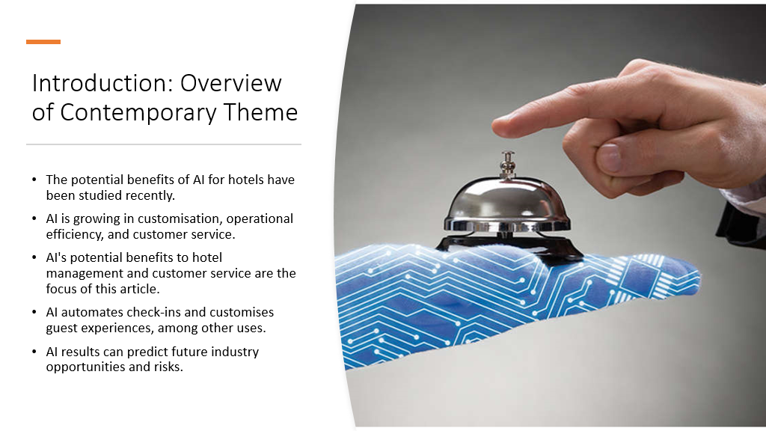
AI's impact on hotels will be examined in this session. AI has transformed corporate processes and customer service. AI-enabled automated technologies and customised experiences are affecting hotel customer engagement and productivity. It plans to use AI for predictive analytics to forecast demand and adapt visitor experiences to boost pleasure. The future of AI and its incorporation into these sectors, notably the hotel industry, is the focus of this essay.

Importance and Relevance to the Hospitality Sector
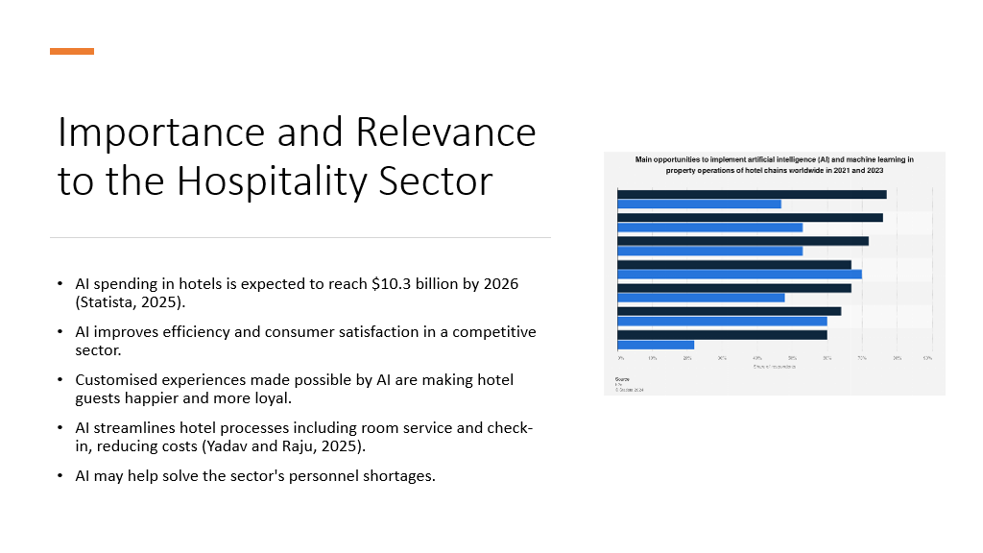
It is becoming more and more clear that artificial intelligence is crucial to the future success of the hotel business. The hotel AI market is expected to surpass $10 billion by 2026, according to Statista, (2025). This uptick is mostly attributable to AI's capacity to improve operational efficiency, personalise visitor experiences, and uplift customer service. By better understanding their guests' individual preferences, hotels may be able to leverage AI to their advantage and stay ahead of the competition (Yadav and Raju, 2025). Also, it streamlines operations, saves money, and automates tedious processes. During periods of industry difficulties, like labour shortages, AI becomes more important in guaranteeing service quality.

Background of the Hotel and Hospitality Industry
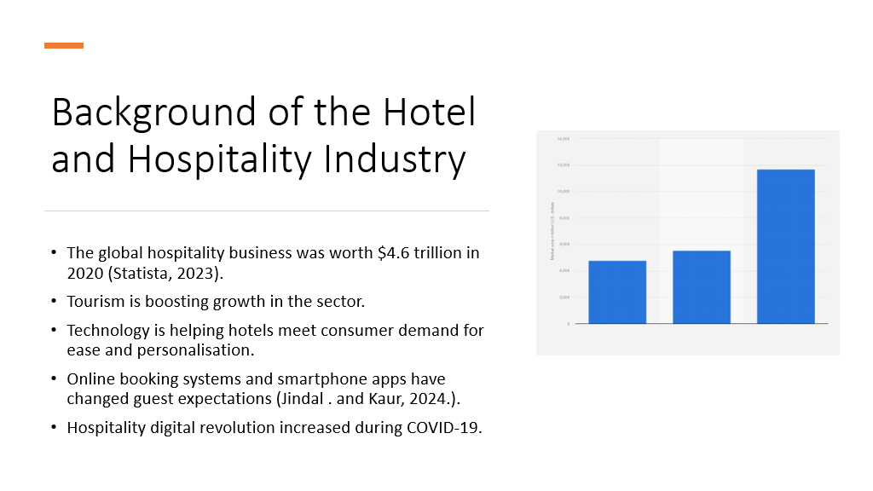
In 2020, the worldwide hospitality business was worth $4.6 trillion (Statista, 2023). Demand for innovative services and experiences has never been stronger due to rising tourism. Tech is key to satisfying customer expectations. Online booking systems and mobile apps have transformed the guest experience, increasing demand for personalised services. The COVID-19 epidemic accelerated industry digital transformation (Jindal . and Kaur, 2024.). This transition has enabled the incorporation of AI, which is essential for industry growth and adaptability.

Literature Review: Key Theories and Concepts
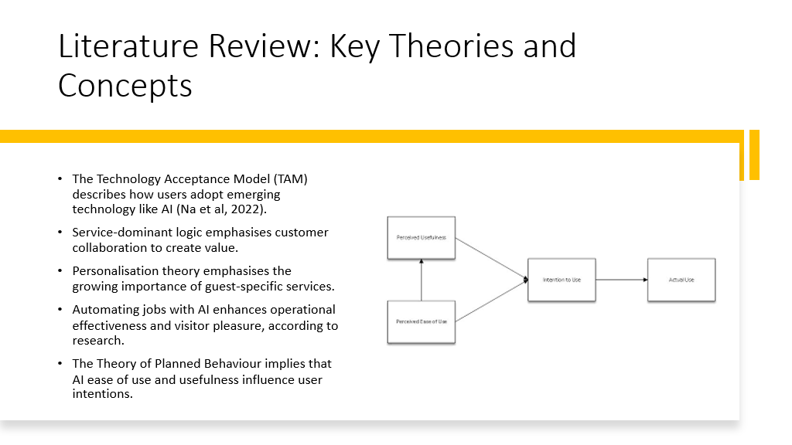
Key models aid our knowledge of hospitality AI theory. The Technology Acceptance Model (TAM) describes how people adopt emerging technology like AI. Service-dominant logic, which views service as a provider-consumer collaboration, is also important. AI personalises experiences, supporting Personalisation Theory (Na et al, 2022). AI improves guest pleasure and operational efficiency, according to numerous research. According to the Theory of Planned Behaviour, guests' propensity to use AI-driven services depends on their perceived utility and ease of use.

AI in Hospitality: Impact on Guest Services and Operations
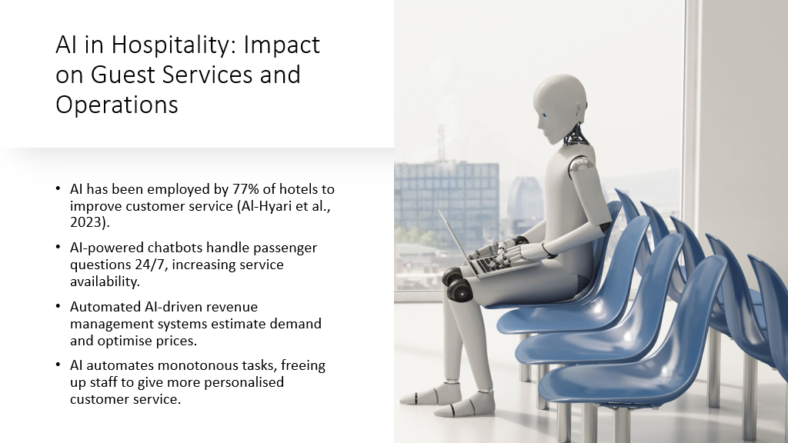
AI is revolutionising hotel guest services by delivering highly personalised experiences. AI-driven systems can set lighting, temperature, and entertainment to each guest's preferences. Chatbots and other AI-powered technologies are allowing hotels to answer tourist questions and provide quick support 24/7. Additionally, 77% of hotel firms are already using AI to improve the guest experience (Al-Hyari et al., 2023). Hotels can adjust rates with AI-powered revenue management systems to predict demand more accurately and boost revenues. AI frees up hotel staff to focus on personalised service rather than robotic check-ins, improving visitor satisfaction. Automation and personalisation have transformed the industry.

Methodology: Research Approach and Data Collection
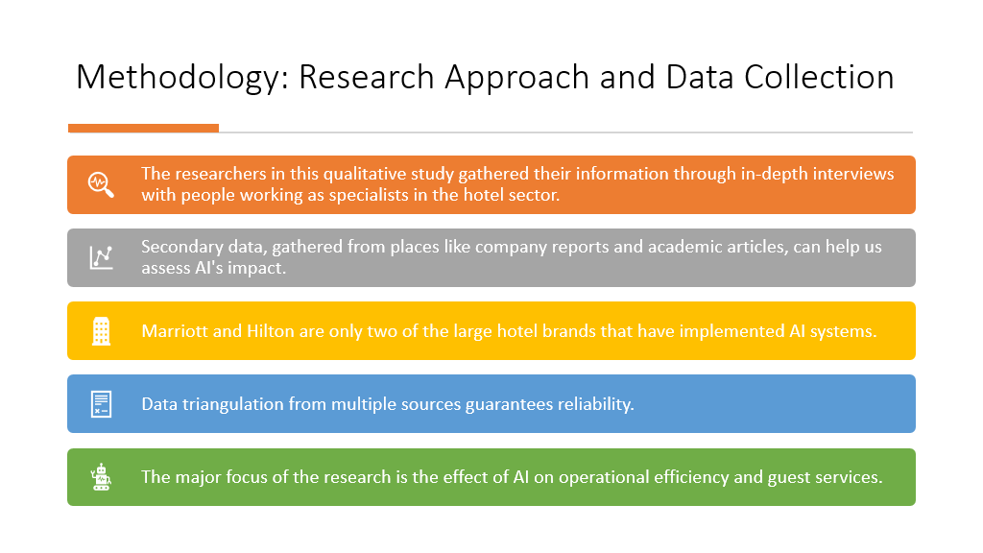
Among the professionals whose in-depth interviews constitute the foundation of this qualitative study are hotel managers and IT specialists. Business reports, academic articles, and relevant case studies (such as those from Marriott and Hilton) are examples of secondary sources that might help one understand the real-world effects of AI. The utilisation of many sources in data triangulation ensures the validity of the results. The hotel industry is constantly looking for new ways to innovate, and AI is one of those ways that might improve client experiences and make operations run more smoothly.

PEST Analysis: Understanding the Broader Impact
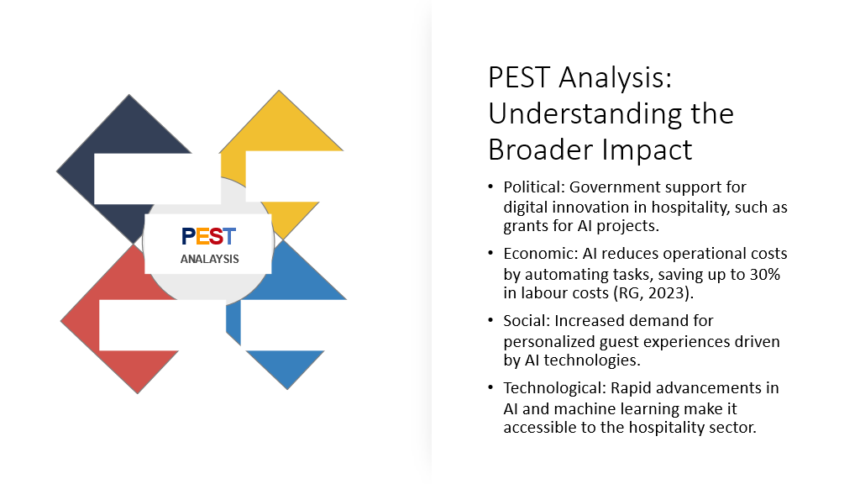
PEST investigation examines AI's wider impact on hospitality. Digital innovation is supported by government incentives for hospitality tech adoption. Labour costs are estimated to drop 30% due to AI automation. AI can provide customised experiences that guests expect socially. Modern AI and machine learning make it easier for hotels to adopt these technologies. AI optimises energy use, saving hotels money and benefiting the environment.

Industry Responses and Case Studies
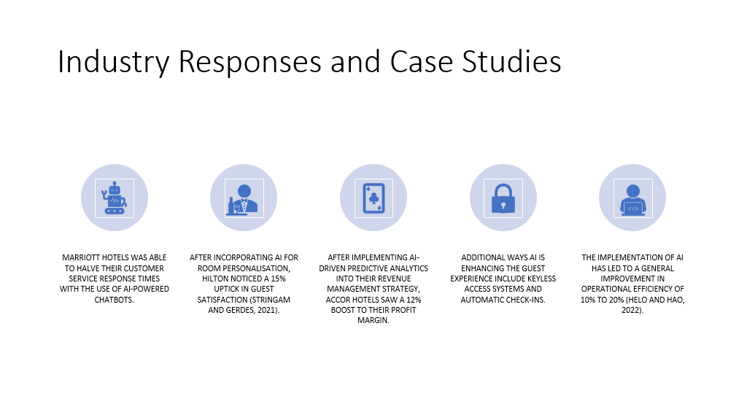
The hospitality industry's response to AI has been nothing short of spectacular. The use of AI-powered chatbots allowed Marriott to halve customer service response times while simultaneously improving passenger interaction. The application of AI allowed Hilton to tailor guest rooms, leading to a 15% improvement in satisfaction (Stringam and Gerdes, 2021). The use of AI-driven predictive analytics for revenue management helped Accor Hotels achieve a 12% improvement in profitability (Helo and Hao, 2022). Additionally, AI-powered features, such as keyless entry systems and automatic check-ins, improve the guest experience. Several hotel businesses have shown a 10–20% improvement in operational efficiency after implementing AI.

Conclusion: Key Findings and Insights
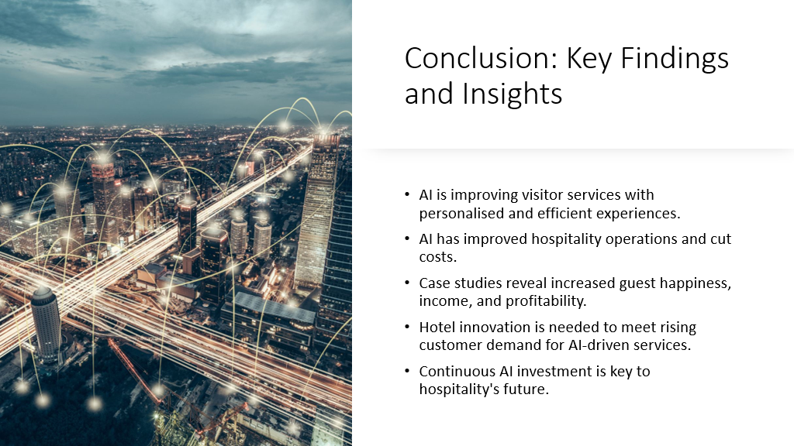
AI is transforming the hospitality business, according to this study. Personalised guest services boost satisfaction and loyalty. Cost savings and operational efficiency have increased with AI deployment. Marriott and Hilton's case studies reveal increased guest pleasure, revenue, and profitability. Hotels must innovate to meet rising client expectations for AI-driven services. AI investment is crucial to the industry's future.

Recommendations for the Future of the Hospitality Industry
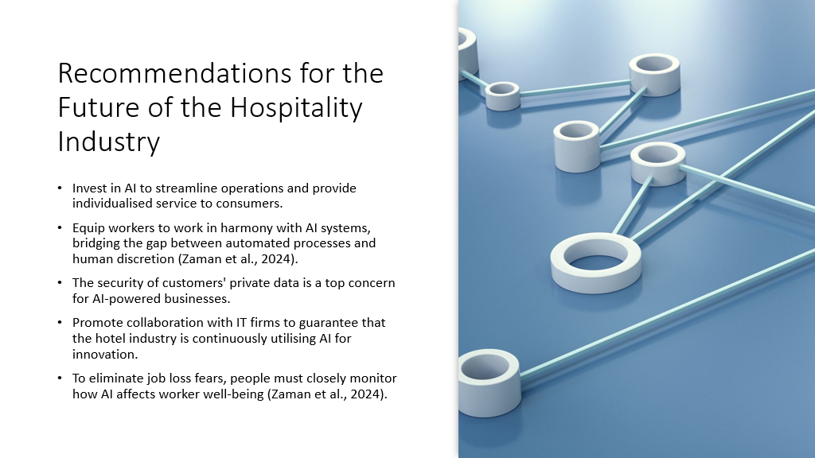
The hospitality industry needs cutting-edge innovation to use AI effectively and improve visitor and business experiences. Staff training in AI is necessary to reap the benefits of automation without sacrificing service. Hotels must prioritise consumer privacy to gain their trust. The tech sector must keep partnering with tech companies to innovate. AI's effects on workers must be monitored due to job security and fairness concerns.

Reference
Al-Hyari, H.S.A., Al-Smadi, H.M. and Weshah, S.R., 2023. The impact of artificial intelligence (AI) on guest satisfaction in hotel management: An empirical study of luxury hotels. Geo Journal of Tourism and Geosites, 48, pp.810-819.
Helo, P. and Hao, Y., 2022. Artificial intelligence in operations management and supply chain management: An exploratory case study. Production Planning & Control, 33(16), pp.1573-1590.
Jindal, R. and Kaur, H., 2024. Managing Guest Expectations and Safety With AI and Smart Solutions. In Utilizing Smart Technology and AI in Hybrid Tourism and Hospitality (pp. 118-139). IGI Global.
Na, S., Heo, S., Han, S., Shin, Y. and Roh, Y., 2022. Acceptance model of artificial intelligence (AI)-based technologies in construction firms: Applying the Technology Acceptance Model (TAM) in combination with the Technology–Organisation–Environment (TOE) framework. Buildings, 12(2), p.90.
RG, (2021), “AI and Automation in Reducing IT Operational Costs“, Available at https://www.researchgate.net/publication/383330174_AI_and_Automation_in_Reducing_IT_Operational_Costs [Accessed on 17th January]
Statista, (2023), “Market size of the hospitality industry worldwide in 2023, with forecasts for 2024 and 2029“, Available at https://www.statista.com/statistics/1247012/global-market-size-of-the-hospitality-industry/ [Accessed on 17th January]
Statista, (2025), “Artificial Intelligence - Worldwide“, Available at https://www.statista.com/outlook/tmo/artificial-intelligence/worldwide [Accessed on 17th January]
Stringam, B.B. and Gerdes, J.H., 2021. Hotel and guest room technology. University of South Florida (USF) M3 Publishing, 17(9781732127593), p.6.
Yadav, N. and Raju, S.S., 2025. Smart Hotel Technologies Redefining Guest Convenience and Operational Efficiency. In Marketing Technology-Infused Hospitality: Upskilling Frontline Employees for Competitiveness (pp. 25-56). IGI Global Scientific Publishing.
Zaman, S.I., Jamil, S., Zaman, S.A.A. and Jiang, Y., 2024. Engaging the Modern Workforce: Bridging the Gap Between Technology and Individual Factors. Journal of the Knowledge Economy, pp.1-41.

