
Human Resource Management
STUDENT NAME – Parmar Bhumika manish
STUDENT ID – 2240158
MODULE CODE - LCMB7000
LECTURER NAME – gladius david kulothungan
SUBMISSION DATE – 23 AUG 2023

AN ANALYSIS OF THE CURRENT STATE OF THE UK LABOR MARKET AND EMERGING CHANGES IN HUMAN RESOURCING STRATEGIES IN THE POST-COVID, POST-BREXIT EXTERNAL ENVIRONMENT

Abstract
The paper investigates the current state of the British labour market and evaluates the forthcoming alterations in human resourcing tactics in the aftermath of COVID and Brexit, two events that have drastically altered the external environment. Things like unemployment rates and the growth of remote work are considered alongside the impact of Brexit on the labour force. The study also goes into the changing HR landscape, discussing trends like the increase in telecommuting, the value of diversity and inclusion, and the use of technology in recruitment and employee administration.

Table of Contents
Introduction 4
Current State of the UK Labor Market 4
Skills Shortages 5
Remote Work Trends 6
Emerging Changes in Human Resourcing Strategies 6
Adaptation to Remote Work 7
Diversity and Inclusion 8
Leveraging Technology 9
Brexit's Impact on Workforce Planning 9
Conclusion 10
Recommendations 10
References 11

Introduction
As a consequence of the COVID-19 pandemic and Brexit, the British job market has seen significant changes in recent years. Since COVID and Brexit have occurred, the external environment has changed significantly, presenting both new risks and opportunities for enterprises. The combined effects of the global COVID-19 outbreak and the United Kingdom's secession from the European Union (Brexit) have had a profound effect on the British work market. As stated by Gray and Broadhurst (2023), these two phenomena have combined to create an external environment that is both complicated and fast-changing, compelling businesses of all stripes to rethink their approaches to human resources. Unemployment rates skyrocketed in the United Kingdom as the early shockwaves of the COVID-19 outbreak resonated through the labour market. As a result, the government launched the Coronavirus Job Retention Scheme, a game-changing action that helped to steady employment numbers.
As the nation began the long road to recovery after the epidemic, the job market saw subtle changes that highlighted the divergent paths taken by different sectors. Simultaneously, the United Kingdom's decision to leave the European Union added further complexities to the labour market. Organisations have adapted their human resource management practises in light of the challenges posed by Brexit, especially in the areas of workforce planning and talent acquisition. Human resources departments are in the forefront of adapting to these changes by developing policies that emphasise flexible work arrangements, more diversity and inclusion, the use of technology, and the cultivation of home-grown talent (Du and Shepotylo, 2022). Understanding how the pandemic has affected unemployment rates, skill shortages, and the rise of remote work is the focus of this paper. It also examines how the post-COVID and post-Brexit external environment is causing shifts in organisational approaches to human resource management. This research provides insights into how organisations are navigating this changing terrain to maintain resilience, sustainability, and competitiveness in the modern workplace by examining key aspects, case studies, and suggestions.

Current State of the UK Labor Market
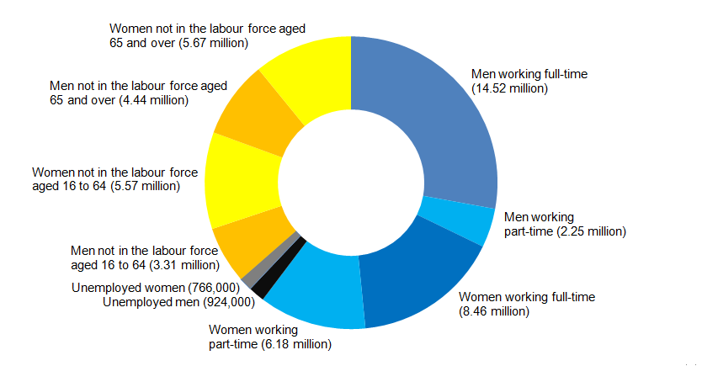
Figure 1: UK Labour Market
(Source: Vidmar et al. 2020)
The spread of the COVID-19 epidemic has had a profound effect on the British labour market. Unemployment skyrocketed in the early phases of the epidemic, although government measures like the Coronavirus Job Retention Scheme helped soften the blow. The latest numbers show that the unemployment rate has stabilised at a certain percentage. As cited by Baum et al. (2023), the COVID-19 epidemic and the United Kingdom's departure from the European Union (Brexit) have both had significant effects on the labour market in recent years. As companies were forced to deal with extraordinary disruptions caused by the epidemic, massive furloughs and closures were implemented. The rapid introduction of the Coronavirus Job Retention Scheme by the UK government, on the other hand, rescued enterprises, stabilised the labour market, and cushioned the blow. As the country struggled to recover from the epidemic, different industries saw differing patterns of decline and recovery (Vidmar et al. 2020). Others, such as e-commerce, technology, and healthcare, showed resilience and even growth, whereas sectors like hotel, travel, and retail suffered greatly owing to lockdowns and decreased customer activity. The unemployment rate has dropped to a certain percentage as the economy has opened back up, according to the most recent statistics. However, problems still exist, and they are especially severe in the areas of work quality and underemployment.

Skills Shortages
The continuous skills shortage in particular areas, such as technology, healthcare, and engineering, is one of the primary difficulties in the UK labour market. As a result, competition for skilled workers has heated up, forcing businesses to be creative in their recruitment and retention strategies. As cited by Biginas and Koumproglou (2022), uncertainty over Brexit and the continuing epidemic have only exacerbated the skills shortages that have plagued the UK labour market for some time. Particularly hard hit are sectors such as technology, healthcare, engineering, and skilled crafts, which are all having trouble filling critical positions with adequately qualified people. Organisations have been forced to reconsider their recruiting tactics and engage in training and upskilling programmes as a result of the skills gap between the talent pool and the needs of the modern labour market.
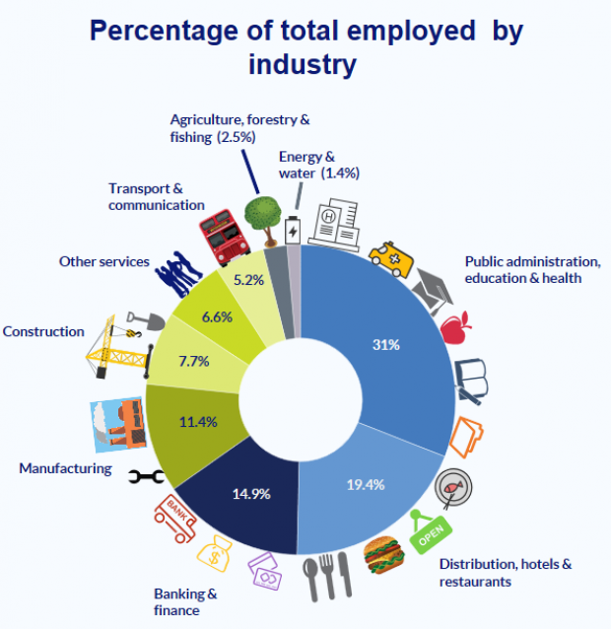
Figure 2: Percentage of total employed by industry
(Source: Shittu et al. 2022)
The uncertainties of the pandemic and Brexit have exacerbated the skills shortages that have plagued the UK labour market for some time, especially in the fields of technology, healthcare, engineering, and the skilled trades. As a result of these shortages, businesses have implemented new methods, such as increasing spending on training and education (Shittu et al. 2022). Companies are actively working to close the skills gap between what they need and what is available in the labour market by forming partnerships with educational institutions and launching focused skill development projects. An organization's capacity to change and thrive in the face of adversity is reflected in its dedication to training and education.

Remote Work Trends
The spread of the pandemic hastened the development of telecommuting policies. As regulations were relaxed, many workers returned to the office, but many others still do remote work. The result has been a rethinking of employee benefits and the rise of flexible, hybrid work arrangements. As stated by Fritsche et al. (2020), remote employment, which emerged as a need during the epidemic, has changed the nature of the UK labour market in a lasting way. While some workers have gone back to the office, many others are still using some kind of remote or hybrid work arrangement. Because of this change, businesses are rethinking their workplace rules and procedures to better facilitate remote collaboration, protect the health of their employees, and keep production at a steady rate. As a result of the combined effects of the COVID-19 epidemic and Brexit, the British labour market has seen substantial upheaval (Herman et al. 2021). Unemployment skyrocketed after the first shock, but government initiatives helped stabilise the situation. Sectors have shown varying tendencies as the recovery continues, and skills shortages continue to be a major issue. Changes in workplace interactions have resulted from the shift to remote work, requiring new approaches to human resources. This report's latter parts examine the post-COVID, post-Brexit shifts in human resource strategy, providing concrete examples of how businesses are adapting to the new environment to maintain competitiveness and resilience.
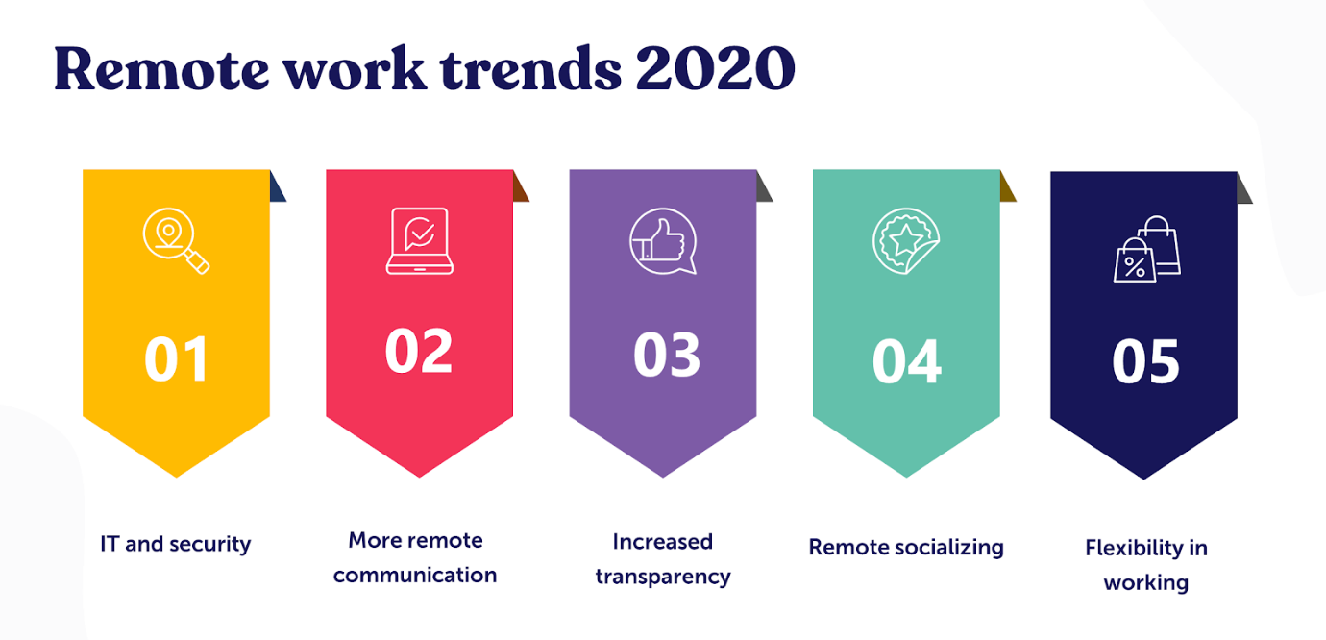
Figure 3: Remote work trends
(Source: McCann et al. 2023)
New dynamics in the workplace have emerged as a result of the increased use of remote work during the epidemic. Some workers have moved back to the office, while many others choose to do their jobs from home or a combination of the two. As narrated by McCann et al. (2023), this change has prompted businesses to rethink their approach to the workplace. Workplace practices have shifted to accommodate the increased use of remote workers without sacrificing productivity or employee satisfaction. To adapt, businesses have started using things like teleconferencing and online team-building exercises to better connect with their employees and customers. The continued importance of telecommuting demonstrates the pandemic's continuing impact on changing the nature of employment.

Emerging Changes in Human Resourcing Strategies
Both the pandemic and Brexit have altered the playing field, requiring companies to adjust their human resource policies and practices. Organisations in the United Kingdom have had to reevaluate their human resource strategy in light of the confluence of the COVID-19 epidemic and the Brexit transition (Markova and King, 2022). All sorts of novel strategies for dealing with recent developments are included in these adjustments.
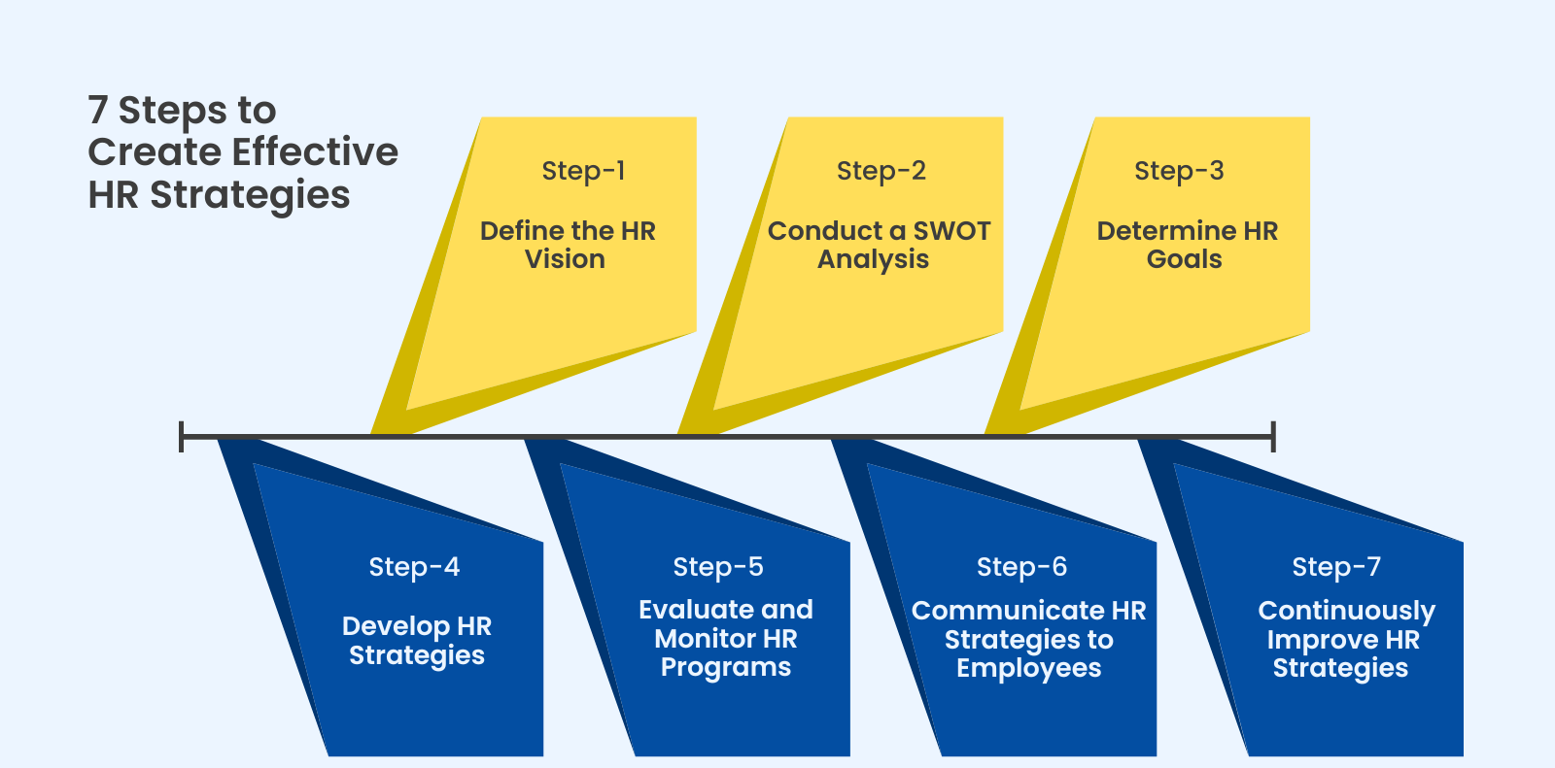
Figure 4: 7 steps to create effective HR strategies
(Source: Etherington et al. 2022)
Human resource strategies have been readjusted in response to the combination of COVID-19 and Brexit. As stated by Etherington et al. (2022), companies are adopting flexible approaches to deal with changes in the workforce brought on by factors like Brexit and the rise of the freelance economy. These alterations in approach demonstrate the adaptability and creativity of businesses as they face new problems. Human resources departments are preparing for a post-pandemic, post-Brexit world by focusing on things like flexible work, diverse teams, technology integration, and local talent development.

Adaptation to Remote Work
The HR department has had to learn to manage remote teams efficiently despite the many obstacles they've faced. This entails dealing with concerns about work-life balance, employee engagement, and productivity. In order to improve remote teamwork, communication, and assessment, new methods and technologies have arisen. The fast increase in telecommuting during the epidemic stressed the need for flexible work arrangements to be included into human resource plans (Bastianes, 2023). In order to facilitate remote work, virtual meetings, and project management, businesses have to act quickly to deploy appropriate technological solutions. In addition, they had to think of creative ways to monitor productivity without infringing on employees' personal time. Many businesses now use a results-based strategy, in which outputs are prioritised above inputs like hours put in. To encourage a culture of responsibility and independence, performance reviews have been revamped to place more emphasis on significant outputs and milestones reached. Virtual team-building exercises, frequent check-ins, and digital collaboration platforms are just some of the new practices that have been incorporated into day-to-day operations to promote successful communication and involvement.
Due to the pandemic's acceleration of the remote work paradigm, significant changes in human resource management are required. As narrated by Hickey (2023), these days, businesses are more likely to use outcome-based performance appraisals, foster a culture of trust and autonomy, and streamline their operations by using digital platforms for seamless cooperation. The freedom that comes with working remotely is inspiring new methods of team building, frequent check-ins, and online involvement. The ability of businesses to adjust to new ways of working is a key factor in maintaining a highly-motivated and productive staff. The reorientation of human resources practises to permit remote work is an example of how companies are redefining work rules to meet the needs of a dynamic labour market.

Diversity and Inclusion
The value of welcoming all people has been highlighted. More and more businesses are seeing the benefits of fostering diverse and welcoming environments. Studies have demonstrated that teams with members from a variety of backgrounds perform better on tasks requiring creativity, invention, and problem-solving. The growing focus on diversity and inclusion has prompted major shifts in organisational approaches to human resource management. More and more businesses are realising that multicultural teams perform better in areas such as innovation, problem-solving, and creativity (Peters et al. 2021). Companies are rethinking their hiring procedures to make them more inclusive and hence more likely to attract candidates from a wide range of backgrounds. Human resources departments are aggressively advertising for members of historically under-represented groups, and they are also developing plans to foster a more welcoming environment for all employees. It is now the norm to implement efforts like mentoring programmes, training to address unconscious bias in recruiting, and more. As cited by Hosein et al. (2023), the strategic relevance of creating a work environment in which all workers feel valued and appreciated is being recognised by the incorporation of diversity and inclusion targets into performance indicators.
Transformational shifts in human resource strategy have resulted from the re-emphasis on diversity and inclusion. As narrated by Gherghina and Munro (2023), in an effort to build a more diverse workforce, several companies have begun using inclusive recruiting practices, providing unconscious bias training and promoting mentoring programmes. The strategic importance of inclusive workplaces is shown by the incorporation of diversity targets into performance measurements. Companies are changing their hiring policies to be more inclusive as they learn the importance of a diverse workforce to driving innovation. This change in HR approach exemplifies the company's dedication to providing a space where all employee's experiences and perspectives are valued and respected.

Leveraging Technology
The HR industry has been revolutionised by technological advancements. Candidates are being found, screened, and evaluated with the use of AI and data analytics. Moreover, ATSs and LMSs expedite recruiting procedures and enable remote employee training and development, respectively. In the aftermath of the epidemic and Brexit, there has been a refocus on the need of using technology in human resource initiatives. From the first stages of the hiring process, all the way through to the maintenance of current staff (Wood et al. 2023), AI and data analytics are becoming more important tools for human resource professionals. Tools driven by AI help find the best applicants by evaluating their qualifications, work history, and cultural fit. Initial contacts with candidates are handled by automated chatbots, who respond to questions and provide details about available positions and how to apply. By analysing data, businesses may learn about shifts in their workforces and use that knowledge to prepare for the future. Learning and development programmes are also being propelled by technological advancements. In order to help workers develop their skills and advance in their careers, many companies are beginning to use learning management systems (LMS).

Brexit's Impact on Workforce Planning
Brexit, foreign workers' availability has changed. Because of possible gaps created by limits on overseas recruiting, companies have been forced to reassess their personnel planning methods. Human resource strategies are increasingly focused on developing and enhancing homegrown talent. With Brexit, companies have had to factor in the possibility of a shortage of foreign workers and make preparations accordingly. Companies have been concentrating on upskilling and reskilling local employees to fill certain tasks as a means of mitigating these issues. As stated by Manfredi-Sánchez and Smith (2023), organisations are increasingly prioritising the development of a competent workforce that is in line with their changing demands, which has led to a rise in the popularity of apprenticeship programmes, mentorship schemes, and bespoke training initiatives. The external environment after COVID and Brexit has prompted changes in human resource strategy in the United Kingdom. In light of the shift in the talent market brought on by Brexit, businesses are reconsidering their approaches to remote work, diversity and inclusion initiatives, process automation via technology, and workforce planning altogether. Collectively, these approaches illustrate the flexibility and adaptability that modern businesses need to survive and prosper. To maintain competitiveness and growth in the face of the ever-changing UK labour market, human resourcing strategies must be flexible.

Conclusion
The confluence of the COVID-19 epidemic and Brexit has had a profound effect on the British labour market. Human resource management techniques have evolved as businesses respond to new threats and opportunities. These shifts concentrate on remote work, diversity and inclusion, technology use, and creative workforce planning. Adaptability in human resource management is essential for long-term success as the external environment continues to change.

Recommendations
The following suggestions are made in light of the analysis provided:
- Both HR and remote workers alike will benefit from further business investments in technology.
- Human resource policies and practices should prioritise diversity and inclusion because of the positive effects it has on innovation and creativity.
- Working together with schools to create unique training programmes is one way to deal with skill gaps.
- Organisations may proactively adjust their resource allocation methods if they keep an eye on changes in the labour market and official regulations.

References
Bastianes, M., 2023. Multilingualism, diversity, and performing arts. A home for Spanish language theatre in post-Brexit gentrified London. International Journal of Cultural Policy, pp.1-15.
Baum, T., Rubio, J.C. and Congreve, E., 2023. ReWAGE Evidence Paper: Work, Wages and Employment in the UK's Hospitality Sector.
Biginas, K. and Koumproglou, A., 2022. Small Businesses and the Changing Competitive Environment. In Small Business Management and Control of the Uncertain External Environment (pp. 99-109). Emerald Publishing Limited.
Du, J. and Shepotylo, O., 2022. UK trade in the time of COVID‐19: A review. The World Economy, 45(5), pp.1409-1446.
Etherington, D., Jones, M. and Telford, L., 2022. Challenges to Levelling Up: Post-COVID precarity in “left behind” Stoke-on-Trent. Frontiers in Political Science, 4, p.1033525.
Fritsche, U., Brunori, G., Chiaramonti, D., Galanakis, C., Hellweg, S., Matthews, R.A.P.C. and Panoutsou, C., 2020. Future transitions for the bioeconomy towards sustainable development and a climate-neutral economy—knowledge synthesis final report. Publications Office of the European Union, Luxembourg, 10, p.667966.
Gherghina, A.M.S.2.D.S. and Munro, M., 2023. Finding housing, making home: Romanian migrants in post-Brexit/post-Covid UK.
Gray, N. and Broadhurst, K., 2023. Post-Brexit regional policy in England: exploring ‘Levelling Up’in practice. Regional Studies, pp.1-12.
Herman, E., Rubery, J. and Hebson, G., 2021. A case of employers never letting a good crisis go to waste? An investigation of how work becomes even more precarious for hourly paid workers under Covid. Industrial Relations Journal, 52(5), pp.442-457.
Hickey, R., 2023. Financial sustainability in a marketised and partially autonomous environment: the case of small new public universities in England. Oxford Review of Education, pp.1-17.
Hosein, R., Gookool, R., Saridakis, G. and Sookram, S., 2023. Leveraging growth spillovers to navigate CARICOM trade relations in the post-COVID-19 global space. EuroMed Journal of Business.
Manfredi-Sánchez, J.L. and Smith, N.R., 2023. Public diplomacy in an age of perpetual crisis: assessing the EU's strategic narratives through six crises. Journal of Communication Management, 27(2), pp.241-258.
Markova, E. and King, R., 2022. Brexit, Covid and Bulgarian migrants in the UK: stay or return?. Southeast European and Black Sea Studies, pp.1-21.
McCann, P., Ortega-Argilés, R., Sevinc, D. and Cepeda-Zorrilla, M., 2023. Rebalancing UK regional and industrial policy post-Brexit and post-Covid-19: Lessons learned and priorities for the future. Regional Studies, 57(6), pp.1113-1125.
Peters, M.A., Hollings, S., Zhang, M., Quainoo, E.A., Wang, H., Huang, Y., Zhou, S., Laimeche, A., Chunga, J.O., Ren, Z. and Khomera, S.W., 2021. The changing map of international student mobility. ACCESS: Contemporary Issues in Education, 41(1), pp.7-28.
Shittu, E., Kantamaneni, K. and Campos, L.C., 2022. Investigating how COVID‐19 has challenged the Eurocentric concept of ‘development’: a case for sustainable food systems in the UK. Food and Energy Security, 11(4), p.e416.
Vidmar, M., Rosiello, A. and Golra, O., 2020. Resilience of new space firms in the United Kingdom During the early stages of COVID-19 crisis: The case for strategic agility. New Space, 8(4), pp.172-178.
Wood, G.T., Onali, E., Grosman, A. and Haider, Z.A., 2023. A very British state capitalism: Variegation, political connections and bailouts during the COVID-19 crisis. Environment and Planning A: Economy and Space, 55(3), pp.673-696.

