INTERCULTURAL COMPETENCE REPORT
Cultural Awareness
Student name Alina Elena Craciun
Student number 2212851
Module title FOREIGN LANGUAGE AND CULTURE AWARENESS
Module code BMIH5003
Lecturer name Giulia Chifari

Table of Contents
INTRODUCTION 3
MAIN BODY 3
CONCLUSION 5
RECOMMENDATION 6
REFERENCES 7

Globe Societal Clusters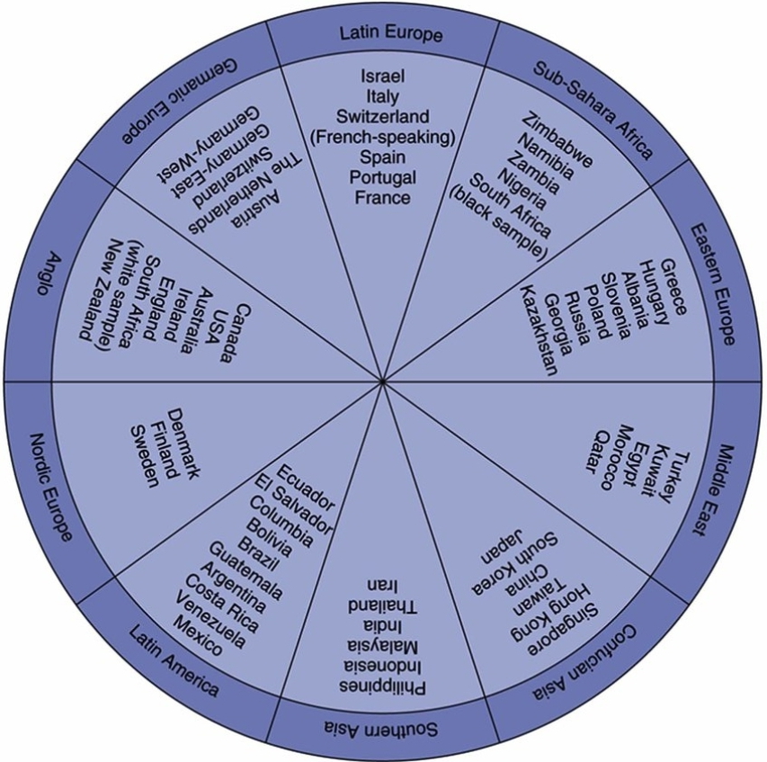

INTRODUCTION
Global expansion is a growth strategy which comprise of taking the business operations and the products from their home market to the new markets. It is a procedure through which the businesses are moving from their home market to expand in the foreign markets. Businesses while expanding will be facing the issues regarding multilingual languages and intercultural competencies (Jiang, Law and Li, 2020). The report is based on Diversity hotel and Spa in London which has recently expanded their business operations in France. The general manager of the company will be visiting the new hotel before their inauguration to train them. The report will be providing the culture and the customs of France and using GLOBE country analysis, the values and practices of the chosen country are described.

MAIN BODY
Culture and customs of France
French culture is focusing on the fashion, culture, art and language. France is having a rich culture in the tourism field and they are attracting a large number of customer base due to several tourist attractions. France is rich in diverse culture and the country is having different regions and historic culture. The French people are best known for their love towards food and wine and the French cuisine is said to be the best within the world. The French culture is known for their customs and traditions. The French people likely to use their native language in communicating with one another and the French families are valuing to spend more time with their friends and families.
For expanding the business into new horizons it is important for the organizations to determine the culture and leadership styles followed in that particular country. As Diversity hotel and spa in London is expanding their hotel in France, it is important for their manager to have an understanding of the cultures and the leadership styles. While using the GLOBE project culture and leadership study, evaluation of France is done (Yang, Cheung and Li, 2022).
GLOBE stands for the Global Leadership and Organizational Behaviour Effectiveness. This project was started in the year 1993 and many countries were investigated for determining their clusters and their cultures.
Within this project the countries are framed in nine cultural dimensions, each of which is having different aspects of the cultures. There are ten clusters in the GLOBE project where group of several countries are made according to the cultural aspects they are following. France is coming in the Latin Europe cluster of the GLOBE project. This cluster includes Italy, Spain, France, Portugal and Switzerland. All these countries are speaking French and this cluster is all about the West Europe. Within this cluster the countries are having high scores on power distance and they have scored low on human orientation.
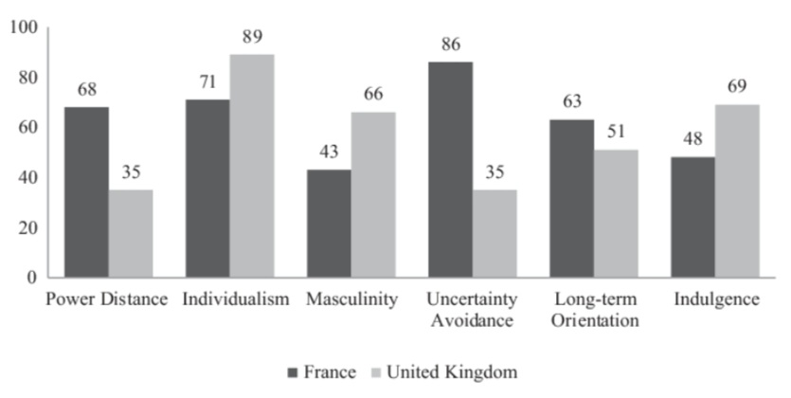

A high power index culture is showing that France is accepting an unequal distributions of the power. France is having smaller middle class families and they are promoting respect for the authorities and ranking of the roles. Also, France is having low scores in human orientation which shows that the people living there are motivated through material belongings and power with them. These countries are providing social and economic support for the well- being of the individuals. Whereas, the Diversity hotel and spa in London is operating in London which is coming in the Anglo cultural cluster. These societies are more performance oriented and they are focusing on individualism as they are scoring low on in- group collectivism (Woo and et. al., 2019). The hotel is valuing to provide training and development to their staff and they are valuing competitiveness. Also, they are dependent and the staff and the individuals within the hotel are putting greater emphasis on becoming unique.
Cultural awareness and sensitivity is significant for the Diversity hotel and Spa in London while considering both the guests and the staff. The hotel is expanding from London to France. Both the countries have different norms and cultures.
It is important to evaluate the effectiveness of cultural intelligence and sensitivity for the hotel personnel, so as to provide their customers with excellent services. As the culture of both London and France is different. Cultural sensitive staff will be able to provide the guests with excellent services. The guests at the hotel will be culturally diverse so in order to determine their needs and wants it is important for the hotel personnel to have the knowledge regarding cultural intelligence (Woo and Mun, 2020). The culture of the hotel visitors at France will be different than those who visit in the London hotel. So, the management of France hotel have to be given training regarding cultural sensitivity and managing diverse visitors.

CONCLUSION
From the above- mentioned report it can be evaluated that for the businesses thinking to expand in different horizons it is important to determine the cultures and the customs of the country. The above presented report is highlighting the insights regarding the GLOBE project’s culture and the leadership study. The report is comparing the culture of France and UK for the hotel so as to determine the cultural differences and leadership styles followed by them. The report is concluding that for the hotels it is important to understand several cultures and the leadership styles.

RECOMMENDATION
Diversity Hotel and Spa in London is recommended to:
- Training and development: Provide training and development programs to hotel staff for cross- cultural training so that the staff of France and London will be able to communicate in an effective manner.
- Diversified visitors: The visitors will be of diverse backgrounds and thus the staff have to be given the training regarding customer satisfaction and understand their several needs on the basis of their cultures.

REFERENCES
Books and Journal
Jiang, N., Law, R. and Li, L., 2020. Impacts of peer-to-peer accommodation on the hotel industry: Hoteliers’ perspectives. International Journal of Hospitality Management, 88, p.102516.
Yang, H., Cheung, C. and Li, W., 2022. Intercultural communication competency practices in the hotel industry. Journal of China Tourism Research, 18(1), pp.162-184.
Woo, L., Assaf, A.G., Josiassen, A. and Kock, F., 2019. Internationalization and hotel performance: Agglomeration-related moderators. International Journal of Hospitality Management, 82, pp.48-58.
Woo, L. and Mun, S.G., 2020. Types of agglomeration effects and location choices of international hotels in an emerging market. Tourism Management, 77, p.104034.
Christiansen, B., Branch, J.D. and Karmowska, J. (2020) Cultural Factors and Performance in 21st Century Businesses. Hershey : IGI Global.
Maheshkar, C. and Sharma, V. (2018) Handbook of Research on Cross-Cultural Business Education. Hershey: IGI Global.
Abramson, N.R. and Moran, R. (2018) Managing Cultural Differences: Global Leadership for the 21st Century. 10th Ed. Abingdon: Routledge
Nedelko, Z. and Brzozowski, M. (eds) ‘Recent advances in the roles of cultural and personal values in organizational behavior’ in Ordóñez de Pablo, P. (2020) Advances in Human Resources Management and Organizational Development Book Series. Hershey: IGI Global.

