The first 1,000 days of a child's life are defined as the time between conception and the age of two. This is a crucial stage in which ones, physique, characteristics, neurodevelopment, and immune system develop. A foetus shares the mother's quality of life. But this isn't just about her physical condition. The foetus is also aware of her mental stability. (Gerhardt, 2014)
Children born into stable and loving households where their emotional and physical needs are addressed are more likely to grow up to be better educated, more financially secure, and healthier adults, and therefore are more likely to provide their own children with the same opportunities. (Gerhardt, 2014)
When a child is conceived, the mother’s health and lifestyle choices have a significant impact on her unborn child. As life in the womb is a peak time where a child develops and grows. Poor nutrition at this period may cause a baby's body structure and function to change in an undesirable way that raises the likelihood of future health problems (Public Health, 2011)
Smoking is the leading cause of preventable disease and premature death. It is responsible for a variety of illnesses, including cancer, heart disease, and lung disease. Smoking during pregnancy is harmful to mothers and their unborn children, and it can lead to long-term health issues for new-borns, toddlers, and adults. This is due to the fact that the baby need oxygen to grow, and smoking limits the amount of oxygen in the mother's blood. (NICE, 2010)
Birth weight is a significant determinant of subsequent health. Babies born weighing less than 2,500g are at risk of developmental, cognitive, and metabolic issues, as well as diabetes and heart disease. Low birth weight is caused by being born too soon, being born too little or because of a genetic factor or what the mother has gone through since conceiving the baby. (Public Health, 2011)
Breastfeeding protects new-borns from sickness and infections, and breastfed babies have a lower risk of developing asthma, eczema, and diabetes. Breastfeeding mothers are less likely to develop breast or ovarian cancer and are more likely to reach a healthy weight after giving delivery. Breastfeeding and socioeconomic status have an inverse relationship. Low mother age, low educational attainment, and low socioeconomic status all have a significant influence on baby feeding patterns. If new-borns were exclusively breastfed for the first six months, imbalances encountered by mothers and children from low-income homes would be decreased. (NICE Guidance, 2008)
Breastfeeding strategies that support exclusive breastfeeding during the first six months of an infant's life should be encouraged further. The biggest benefit is expected to be gained by intervening in the early postnatal weeks, when the likelihood of breastfeeding withdrawal is highest. Having as much help as possible during those delicate early weeks is critical to making breast feeding simpler and giving baby the greatest start in life (NICE Guidance, 2008)
Subsequently, a pregnant mother's health, diet, and stress levels might have had an impact on her baby's development. Even after the infant is born, their physical surroundings, diet, and relationships may all have a long-term influence on their health and happiness. Pregnancy Birth and Baby (2019)
The nourishment that a foetus receives from their mother through their mother's diet is the essential fuel that powers much of this extraordinary change that occurs whilst in the mother’s womb. Nutrients are required for the formation of new neurons beginning in pregnancy. Neurons are the cells that make up the tissue that transmits and receives nervous impulses, as well as the cells that surround axons which are cell that transmit signal around the body. Couperus, J. W. & Nelson. (2006) Axons are coated with myelin, a fatty substance that speeds up the speed of nerve impulses passing from one cell to another. Nutrients also contribute to the development of synapses which is the central nervous system and is key to the development of the brain and its ability to recollect and preserve memories. (Cherry, 2020)
Consequently, the formation off all these factors gives a foundation for learning abilities However these neurodevelopmental processes can be compromised when a woman does not consume enough calories, protein, fatty acids, or important micronutrients throughout her pregnancy 1000 Days (No Date)
Poverty and what occurs as a consequent. Such as, the higher likelihood of malnutrition, weakens the foundation of what is required for one to develop according to what the developmental milestones suggest. Consequently, through a lack of the nutrition needed to sustain one’s organs, nonlogical development and the body’s ability to function appropriately. This can lead to premature mortality and severe morbidities such as poor health, and considerable loss of neurodevelopmental development. (Cusick, Michael Georgieff 2013)
As nutrition is the fuel that propels much of this early brain development. Nutrition provides the foundation for a child's cognitive capacities, physical skills, and socio-emotional development beginning in pregnancy and continuing throughout early life. 1000 Days (No Date)
The importance of nutritious foods throughout childhood is essential to good health short and long term. Providing the correct combination of meals to babies from the moment they begin eating solids, which is ‘usually’ occurs from 6months. 1000 Days (No Date)
As nutrition can have an effect upon their perspective about food as they make choices upon it within their lives. Hence why by ensuring that infants are faced with a variety of flavours and textures as well as, have access to fruit and vegetables. Means that they are more likely to grow up eating the vast variety of foods that are required to have a notoriously valued and vast diet that consits of the key aspects highlighted by the eat well plate. The reality is that by the age of three, a child's eating preferences and dislikes appear to be firmly developed and difficult to change. Campbell (No Date)
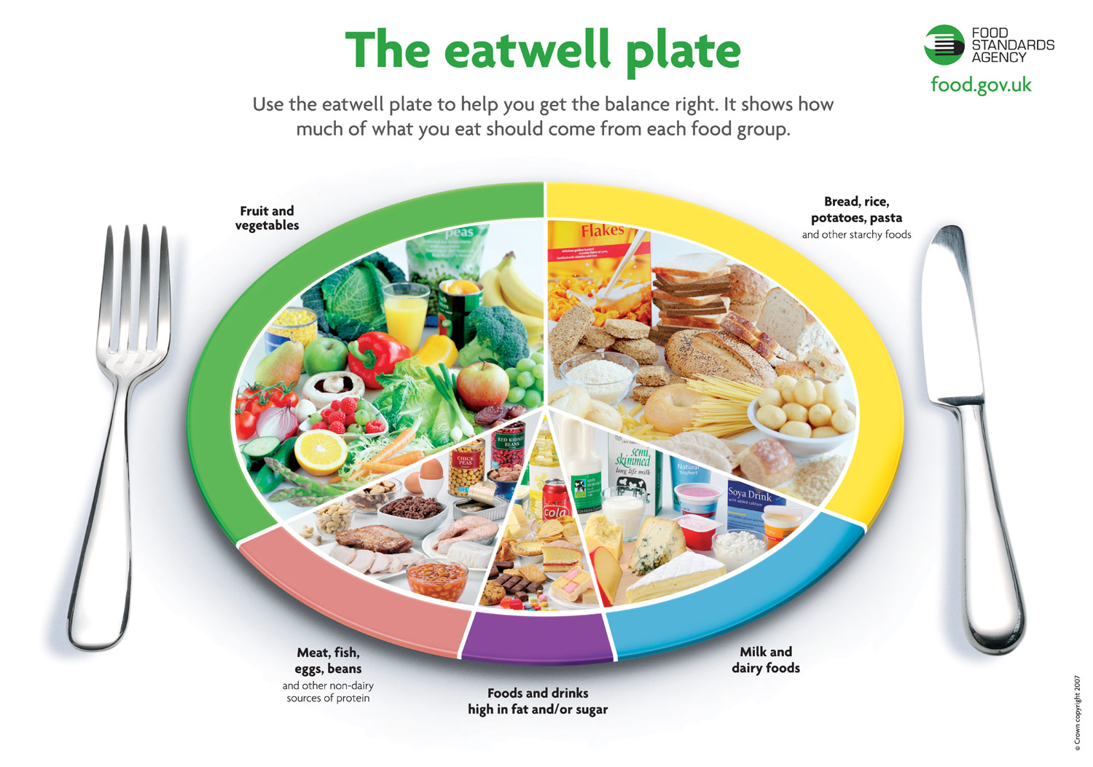
Therefore, if a child has not tasted fruits and vegetables, they may be reluctant then to go on and try them throughout their life. Overall, the first few years are essential in terms of laying the foundations for a lifetime of healthy eating and, as a result, the health benefits that come as a result, of eating well. Campbell (No Date)
While the human brain develops and changes throughout life, the most rapid phase of brain development and adaptation occurs between the final trimester of pregnancy and the first two years of life. At 5 months of conception occurring, the human brain is a smooth, bi-lobed structure. By 9 months, it has gyri and sulci, indicating substantial complexity and resembling an adult's brain. 1000 Days (No Date)
Studies on the interaction between a new-born and his or her mother have been utilised to detect new-borns’ cognitive capacity. Bruner's 1960 'cognitive growth' theory proposed that contextual and experience elements influenced a child's development (Smith, 2002). Trevarthen's (1977) research on baby communication during the first six months of life revealed that a pattern of social behaviour development was established in all five new-borns in the study. (Nutbrown,2005)
Bruner's work also suggests that a learner, even at a very early age, is capable of acquiring any knowledge as long as the teaching is structured, which contradicts Piaget and other theorists’ assumptions. (McLeod, 2019)
Two of Bruner's Modes of Representation
Enactive (0 - 1 year)
This is the initial type of memory. During the first year of life which is similar, to Piaget's sensorimotor stage, this approach is utilised. Thinking is totally reliant on physical activities, and new-borns learn through doing rather than through thinking. It entails encoding and storing physical action-based information in our memory. A new-born, for example, may recall shaking a rattle as a sort of movement as muscle memory. Many physical activities, such as learning to balance on a beam, continue in this style later in life (McLeod, 2019)
Iconic
Information is stored in the brain as sensory representations (icons), primarily visual ones. For some, this is apparent, while for others, it is not. This is why, when learning a new subject, having diagrams or drawings to accompany the verbal information is often beneficial. Other mental representations (icons) such as hearing, smell, or touch are also used in thinking. (Garrison, 2017)
This app demonstrates how by clicking a given image or animal produces a distinct sound such as, a cow goes ‘moo’, and a sheep goes ‘baaa’. The action is controlled by a simple touch, on a specific button or area on the screen. The action remains the same as it is touching the screen. However, a child will grasp the difference in the animal on each button based on the associated sound and associate that with touching a specific button or area on the screen. (Garrison, 2017)
https://youtu.be/oEfZRgpXl2g
Infants learn about the environment largely through their senses and motor abilities, according to the Piagetian viewpoint (Harris, 2005). These fundamental motor and sensory abilities provide the groundwork for the cognitive talents that will emerge during the later phases of cognitive development.
Sensorimotor, preoperational, concrete operational, and formal operational are the four phases of Piaget cognitive theory. Piaget belief is children utilise their personal experiences to expand their understanding of the world. Even if they are not taught or influenced by other children or adults, children can learn on their own. This is because children have an intrinsic incentive to learn. (Sherrell, 2021)
Piaget theory somewhat corresponds with Bruner's Modes of Representation. Especially relating to the Enactive model that occurs between 0 - 1 year. However, unlike Bruner, Piaget classified the sensorimotor phase into six distinct substages, each with its own set of developmental milestones rather than like Bruner who divided his into 3 different areas. Spencer (No Date)
Reflex
An infant will have the tendency to react immediately to touch or another stimulus, often sucking and clutching onto the carer or an object. These behaviour's will gradually become intentional overtime and used as a self-soothing tool or to show emotions such as love and how strong their attachment is too someone. (Richards, 2020)
Primary circular reactions
This substage occurs between 1month of age and the 4th month. The baby will start making certain behaviours for their own amusement. If they create an unintentional sound or movement and feel comforted by how it feels, they'll do it again. This can include thumb-sucking to sooth themselves when tired or destressed. Cooing and smiling when they are having fun or enjoy what they are seeing or hearing. Such as if an adult hiccups they can coo because they feel laughter. (Sumaroka, Bornstein, 2008)
Secondary circular reactions
A developing child will begin to utilise items to learn about the world between the ages of 4 and 8 months. This process usually begins by mistake, but as the baby grows to enjoy their ability to make things happen, they will repeat these actions. (Barrett, 2009)
They may throw or drop a toy, shake a rattle, or bash items together to produce appealing sounds such as bashed and swooshes. They'll be able to create additional sounds on their own as well. They'll chuckle, create speech-like noises, and make sound to indicate enjoyment, enthusiasm, or unhappiness, for instance. (Barrett, 2009)
Coordinating secondary circular reactions
Between the ages of 8 months and a year, a child will begin to integrate their learnt talents and reflexes to reach goals. For example, they may crawl across the room to pick up a toy or push aside toys that are in the way of the one they desire. During this stage an infant learns how to plan and organise behaviour in response to ideas that they have. (Morin, 2019)
Tertiary circular reactions
This stage of the model occurs between the ages of 12 and 18 months, marking the start of toddlerhood. At this time, the child can explore and learn more about their environment by using previously learnt motor coordination, planning, and experimenting. (Berk, 2001)
During this stage children have the tendency to disassemble items in order to reassemble them, or they may repeat specific actions to observe what occurs each time. Whether it is, stacking blocks then hitting them over to see what occurs each time or crumpling a piece of paper up to experience the different noises it makes and the textures of it. During this stage is now possible for a child to finish a task by carrying out a set of planned steps which they form within their own head. OptimistMinds (2021)
Understanding and responding to simple directions or requests can also occur, as they have the ability to start connecting words in which they have learnt and understood the meaning of. In which allows them to form simple sentences that they can utilise in responding and understanding what is specified when simple instructions are given such as 'pick your toys up' or 'stop' if there is danger presented. (Augustyn, Zuckerman, 2009)
Further likes and dislikes can occur as they listen to or enjoy particular short stories and songs. That they can recollect and sing to themselves to provide enjoyment. An example of this is sing, nursery rhymes when carrying out activities or asking for particular books that they know they like at bedtime. (Augustyn, Zuckerman, 2009)
Symbolic/representational thought
This final subphrase involves the formation of symbolic thinking, which is a significant step. According to Piaget's hypothesis, children begin to realise that symbols may represent objects from the age of 18 months. This builds on the idea of object permanence, which is the understanding that items persist even when they are not in front of them nor can be seen. (Ketchum, 2018)
A child by this stage may recall and repeat words or acts from the previous day at this stage. Whether it is recollecting what they seen such as, someone giving high fives and then using it themselves. Imaginative play is common during this time, and the child's vocabulary will grow significantly as they hear what other say then repeat it their environment. This could include if an adult referred to a doll as a baby the child would refer to the doll as baby rather than doll or dolly. They may ask simple questions and make requests using only one or two words. Many of which consits with why. (Raypole, 2019)
Symbolic thought, in addition to assisting children in communicating, is an important component in developing a child's creative talents. Encouraging symbolic thought growth through self-expression and make-believe scenarios also aids in the development of children's social and creative talents. Because symbolic cognition connects immaterial concepts to real things and occurrences, it enables children to correlate a specific event, place, or object with abstract ideas such as feelings. This contributes to the formation of a child's perspective and, later in life, enables children to make hypothetical judgements, assess relative values, and express emotions in a multitude of forms. (Ketchum, 2018)
Where a child has become "fixated" at levels of primary and secondary circular reactions. Therefore, they were not progressing in accordance with the ‘normal’ developmental milestones. Primary circular reactions were believed to be involving repetitive characteristics directed toward them self this included self-harm out of frustration or anger, and secondary circular reactions are believed to be repetitive motor mannerisms directed toward the environment. (Barrett, 2008)
Pikler's goal was to ensure the emotional wellbeing of new-borns and young children. In the 1930s, she realised that building stable attachment was the key to attaining this. She considered respectful care, particularly during physical care, as one of the most important methods for attaining this. She also recognised the significance of enabling the child's self-initiated activity and its profound impact on the child's self-image, self-control, and a variety of other factors. Marlen (No Date)
Pikler’s, finding She reasoned that if a child was given the time, freedom, and support of a reliable adult to engage in self-initiated movement, a child's motor development may occur naturally and without direct adult involvement. However, this was frequently interrupted by well-intentioned parents who trained their children to sit, stand, and walk before they were physically capable of doing so. (Marlen, 2017)
The interaction between caregiver and child is fundamental to the Pikler method, since Pikler thought that "the relationship is everything." It is a question of life for the child. Tardos (2010). Pikler "developed a culture of ways to touch, pick up the new-born, and hold them in the arms of the parents, how to pay attention to them, and how to respond to their signals. As a result of this method, a psychological space is created that improves the infant's growth in whatever situation they face throughout life. (Marlen, 2017)

References
https://www.nurseryworld.co.uk/features/article/eyfs-best-practice-all-about-pikler
https://www.healthline.com/health/baby/sensorimotor-stage#substages
https://courses.lumenlearning.com/suny-lifespandevelopment/chapter/piaget-and-the-sensorimotor-stage/
https://publications.parliament.uk/pa/cm201719/cmselect/cmhealth/1496/1496.pdf
https://www.futurelearn.com/info/courses/infant-nutrition/0/steps/25409
https://medium.com/interactive-designers-cookbook/jerome-bruner-cognitive-learning-abf4b3318c75
food.gov.uk
https://moodle.uwtsd.ac.uk/mod/url/view.php?id=384481&redirect=1
https://www.medicalnewstoday.com/articles/325030
https://www.simplypsychology.org/bruner.html
https://medium.com/interactive-designers-cookbook/jerome-bruner-cognitive-learning-abf4b3318c75#:~:text=In%20Bruner's%20research%20of%20cognitive,enactive%2C%20iconic%2C%20and%20symbolic.&text=This%20type%20of%20representation%20happens,then%20stored%20into%20our%20memory.
https://www.futurelearn.com/info/courses/infant-nutrition/0/steps/25409
https://www.pregnancybirthbaby.org.au/the-first-1000-days
https://blogs.rch.org.au/ccch/2019/05/02/the-first-1000-days-leaves-a-legacy-on-learning/
https://maternalmentalhealthalliance.org/tag/wales/
https://thousanddays.org/why-1000-days/building-brains/
NICE Guidance PH11 Improving the nutrition of pregnant and breastfeeding mothers and children in low-income households (2008).
https://www.verywellmind.com/structure-of-a-neuron-2794896
https://qbi.uq.edu.au/brain/brain-anatomy/axons-cable-transmission-neurons#:~:text=Each%20neuron%20in%20your%20brain,be%20received%20by%20other%20neurons.
https://www.verywellhealth.com/synapse-anatomy-2795867
https://www.verywellmind.com/sensorimotor-stage-of-cognitive-development-2795462
Tertiary Circular Reactions (A 5 Point Guide) | OptimistMinds
https://www.massey.ac.nz/~wwpapajl/evolution/assign2/KS/piaget3.html
https://thousanddays.org/wp-content/uploads/1000Days-Nutrition_Brief_Brain-Think_Babies_FINAL.pdf
https://www.medicalnewstoday.com/articles/325030
https://www.hellomotherhood.com/what-is-symbolic-thought-in-child-development-9744668.html
https://www.unicef-irc.org/article/958-the-first-1000-days-of-life-the-brains-window-of-opportunity.html
https://www.nurseryworld.co.uk/features/article/eyfs-best-practice-all-about-pikler
Couperus, J. W. & Nelson, C. A. (2006). Early Brain Development and Plasticity, in Blackwell Handbook of Early Childhood Development (editors McCartney, K. and Phillips, D.). Oxford, UK: Blackwell Publishing Ltd.
https://link.springer.com/referenceworkentry/10.1007%2F978-0-387-79061-9_2578
Melissa N. Richards, in Encyclopedia of Infant and Early Childhood Development (Second Edition), 2020
M. Sumaroka, M.H. Bornstein, in Encyclopedia of Infant and Early Childhood Development, 2008
Marilyn Augustyn, ... Barry S. Zuckerman, in Developmental-Behavioral Pediatrics (Fourth Edition), 2009
ROWLAND P. BARRETT, in Developmental-Behavioral Pediatrics, 2008
http://www.cwmtafuhb.wales.nhs.uk/sitesplus/documents/865/Item%20No%2013%20Annual%20Report%202011.pdf
https://www.teachearlyyears.com/under-2s/view/the-pikler-approach-part-1

