BAEd Primary Education with QTS
Student number: 1701466
Module: The Rights of the Child: Inclusion and Diversity
Module Code: ECAD5003
Module Lead: N. Ryder

Assignment title:
Based on evidence from current research and policy as well as on data gathered from a group questionnaire, critically discuss an inclusive approach to supporting the needs of a particular group of pupils. Focus on one specific learning difficulty, disability or additional need for your discussion. Use ICT skills developed within the module to present your findings.

This assignment will explore some of the challenges and opportunities for development that are made available to learners with Additional Learning Needs (ALN), also recognised as Special Educational Needs (SEN), in a typical mainstream classroom. For the purpose of this assignment, the writer will adopt the definition of SEN/ALN provided by the Education Act (1996): a child has a SEN/ALN if a learning difficulty results in a need “for special educational provision” (Education Act 1996). The United Nations Convention of the Rights of the Child (UNCRC) (UNICEF, 1989) emphasise that all children have a legal right to education that encourages the development of interests, talents and mental and physical abilities (UNICEF, 1989), which underpins the draft ALN Code for Wales (Welsh Government, 2017). The UNCRC also highlights that children with special needs should have access to education that encourages holistic development whilst also encouraging social integration when possible and appropriate (UNICEF, 1989).
At present, the Welsh education system encourages regular assessment of pupil progress against levels, however Donaldson (2017) highlights that the new curriculum will instead be a learning continuum, and learners’ progress will be measured against progression steps. Furthermore, Donaldson acknowledges that learners with ALN will also be able to move along the learning continuum at their own pace, which is crucial to appropriate development (Donaldson, 2017). Supporting the proposed curriculum is the concept of personalised learning, an approach that allows learners to take some control of their learning and explore topics that interest them (OECD, 2006; DfES, 2007).
The ALN that this assignment will primarily focus upon is dyslexia, a condition that most researchers agree is a specific learning difficulty (SpLD) and affects language learning (The Dyslexia Association, 2019; Rose, 2009), although researchers have their own opinions regarding the extent of the effects of dyslexia upon the individual. Dyslexia Wales (date unknown) highlights that dyslexia is not a condition that solely affects language learning, impacting memory, organisational and sequencing skills amongst others. In comparison, Rose (2009) argues that dyslexia effects children of all abilities and is a learning difference that largely affects language learning and fluency. The data gathering element of this assignment was completed as part of a group, therefore the decision to focus upon dyslexia was made after reflecting upon our own teaching experiences, and how prevalent dyslexia was in the 10 schools we have collectively taught in. During initial research, we considered focusing upon Autism Spectrum Disorders, however, as identified by the National Health Service (2018), dyslexia is thought to affect up to 1 in 10 people in the UK, unlike Autism which is thought to affect 1 in 100 people in the UK (National Health Service, 2019). These statistics indicate that the probability of teaching a child with a diagnosis of dyslexia is more likely than teaching a child with a diagnosis of Autism, therefore in theory practitioners may have developed more strategies to support a child with dyslexia and have more experience in supporting a child with a diagnosis of dyslexia.
As identified by Glazzard et al. (2015, p.74) “children with dyslexia are individuals,” confirming that whilst there might be some approaches to teaching and learning that children with dyslexia typically respond well to, regardless of ability or any diagnosis every child is an individual and should be treated as one. Additionally, dyslexia is recognised as a “multi-faceted” learning difference (Lawrence, 2009, p.21) due to the different types and symptoms of dyslexia a child can present. This is supported by the National Health Service (2018) who recognise that individuals with a diagnosis of dyslexia will have a “unique pattern of strengths and weaknesses.” Therefore, in order to begin to provide appropriate support to a child diagnosed with dyslexia, the practitioner should ensure that any methods and approaches to teaching and learning are appropriate for the child on an individual basis.
In order to widen the research field, otherwise limited to personal research and experience, a questionnaire about dyslexia was distributed electronically amongst staff who are currently working in a mainstream school within Wales. A questionnaire was chosen as the method to gather data due to its potential to simultaneously gather both qualitative and quantitative data (McLeod, 2018). The questionnaire falls into both categories due to the open questions, which enables opinions to be shared and analysed, and closed questions, which allows numerical data to be gathered and compared. Another reason that a questionnaire was selected as the supporting data collection method for this assignment was for its comparable nature and how participants could have time to process questions, in contrast to an interview which would require an immediate response (Survey Any Place, 2019). For this assignment we were required to create and distribute the questionnaire in groups. We decided that in order to consider multiple aspects of the effects of dyslexia upon the child, each member of the group would research a different aspect of dyslexia, formulate questions and then consult the group when changes would be made. To ensure compliance with ethical standards, including the General Data Protection Regulation (GDPR) (Information Commissioner’s Office, 2018) and the BERA guidelines (British Education Research Association, 2018), all participants were informed of their right to withdraw during or after completion of the questionnaire, what data would be collected and if or how it would be stored. It was decided that to ensure anonymity was ensured on our behalf no identifying questions would be included within the questionnaire. This included avoiding questions that ask for sensitive and personal data.
As identified by Dauncey (2016, p.16) “local authorities are using different means of meeting the SEN/ALN of their pupils,” which is reflected in the inconsistent percentages of learners with ALN and the percentages of learners with a statement of SEN or Education, Health and Care Plan (EHCP) who attend mainstream settings. Children are issued with an EHCP if their school cannot provide the appropriate support using the resources that they already have available to them in the setting (GOV.uk; Douglas Silas Solicitors, 2018). Whilst some local authorities (LA) issue more EHCPs than others, this does not necessarily equate to greater support for children with SEN within these LAs, as each individual child’s personal needs should be accounted for and the most suitable approach to supporting the child should be taken (Glazzard et al., 2015; Bell and McLean, 2012). The Association of Teachers and Lecturers (ATL) (2016) argue that due to the changeover from statements to EHCPs children with less complex ALN who previously had a statement of SEN are not always supported with an EHCP. The ATL (2016) argue that children with diagnoses such as dyslexia fall into the group of children who will not automatically be given an EHCP. Due to Dauncey’s report (2016) highlighting the different approaches to supporting children with dyslexia across different LAs in Wales, it was decided that the questionnaire would be distributed amongst staff across seven counties in Wales to aid the comparison of both school and county approaches to supporting learners with dyslexia.
One misconception about dyslexia is that it only affects language learning, primarily reading and writing. Green and Reid (2011) highlight that whilst difficulties in reading, writing and spelling are regularly recognised as common characteristics of dyslexia, other less recognised characteristics can also indicate dyslexia. These characteristics include but are not limited to processing and memory difficulties, difficulty organising information and sequencing events (National Health Service, 2018; The Dyslexia Resource, date unknown; British Dyslexia Association, date unknown). This was reflected in the responses gathered from the questionnaire (see appendix 1), particularly the first response which acknowledged that whilst language skills can initiate dyslexia screening, other characteristics should be considered when assessing a child for dyslexia (see Figure 1).
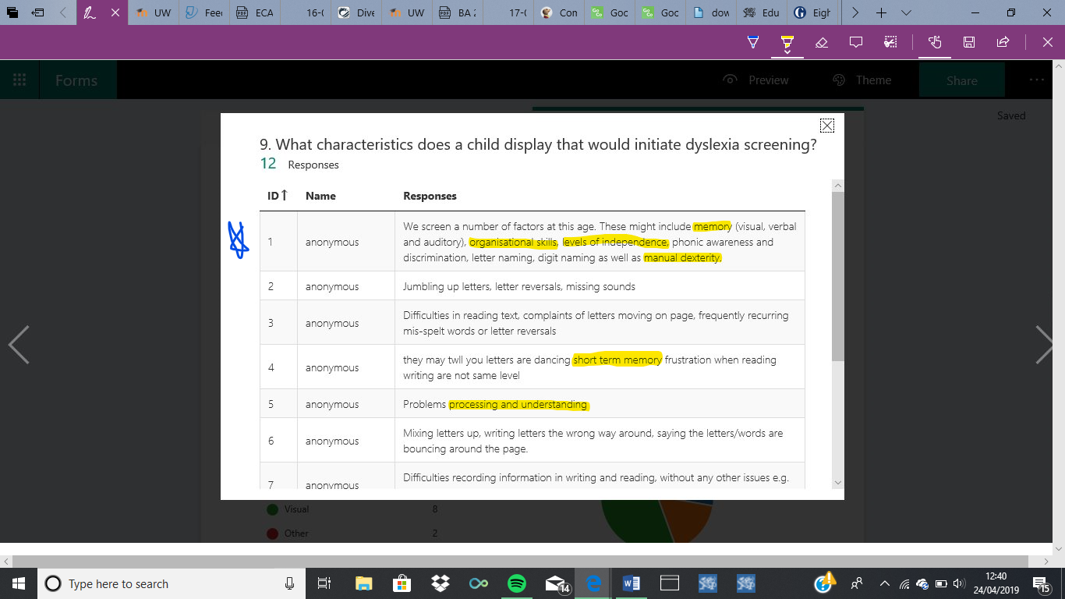
Figure 1 Characteristics of Dyslexia
During my placement in two schools, I experienced teaching multiple learners with both suspected and diagnosed dyslexia in Year 3 and 4. When teaching a child with dyslexia in Year 3, I noted that he was often disengaged and showed limited enthusiasm and progress during activities that relied upon one learning style yet thrived when he was actively engaged and utilising multiple learning styles simultaneously. Pollard and Tann (1993) believe that for children to benefit from learning experiences they must not only be aware of the purpose of the activity but also be motivated to complete it. Arguably, he may not have seen purpose in the learning activity therefore had little motivation to complete the task. In comparison, a child in Year 4 expressed feelings of self-doubt and low self-esteem when asked to undertake activities involving reading text, sometimes exclaiming that she ‘can not read.’ This child struggled with decoding words, therefore where possible she would avoid reading unless the practitioner employed creative approach to encourage the child to participate in activities. Whilst displaying some typical characteristics of dyslexia, including letter reversal, both of these children highlighted how easily a learning difficulty can be masked by poor attitude to learning and low self-esteem. Bell and McLean acknowledge this, drawing the reader’s attention to how children with dyslexia, and other learning difficulties, often disguise their confusion, inability or frustrations with bad behaviour or retaliation (Bell and McLean, 2012).
Glazzard et al. (2015) identify an abundance of techniques which can be used to support all children, but particularly those with dyslexia. However, Fox and Surtees (2010, p.20) argue that practitioners should “not force a child to work in a particular way if he/she is uncomfortable.” This supports Bell and McLean’s view that “learning should be individualised” (Bell and McLean, p.133) rather than presuming that all children with dyslexia learn best in the same way. This approach is supported by the Centre for Educational Neuroscience (CEN, date unknown), who argue that each child could have their own learning style, regardless of whether they have any ALN. These learning styles include auditory, tactile visual and kinaesthetic. The Reading Well (2018) highlight that multi-sensory learning that involves auditory, visual, kinaesthetic and tactile learning opportunities, allows learners to discover the learning approach that suits them most effectively, whilst also building skills in the other areas. Within the questionnaire we asked which approach or approaches to learning are typically most effective when supporting children with dyslexia. This question had the option to select more than one answer, indicating a multi-sensory approach to learning. The results highlighted mixed opinions, with 44% of the 11 participants who responded saying that they believe a visual approach to learning supports children with dyslexia the most, whilst 17% of the 11 participants who answered the question argued that auditory was the most beneficial (see figure 2). In contrast, a further 11% of the 11 participants who responded to the question provided a written answer, explaining that a multi-sensory approach that is based upon the individual is most effective. These responses highlight that whilst there are some learning similarities between children with dyslexia, all children learn in their own way, therefore a personalised learning approach is arguably the most beneficial for the child.
Figure 2 Responses suggesting most effective learning styles
Active and multi-sensory learning is valued by countless practitioners and researchers alike. Many researchers argue that a successful, effective teacher employs an active and multi-sensory teaching and learning approach as a core element of classroom practice (Elton-Chalcraft and Twiselton, 2018; Bell and McLean, 2012; Lawrence, 2009; Green and Reid, 2011). Crucially, teaching and learning approaches that encourage learners to be actively involved in their development of understanding benefits all learners, not just children with a learning difference such as dyslexia (Glazzard et al., 2015). Furthermore, multi-sensory approaches to learning allow learners of all abilities to develop a more concrete understanding of concepts through their active involvement, whilst also developing cross-curricular and personal skills, including co-ordination, sequencing, communication, teamwork and concentration (Dominica, date unknown; Multi-Sensory World, 2019; The Reading Well, 2018).
As identified by Dauncey (2016), in recent years the percentage of pupils with a SEN statement has declined, whilst the percentage of pupils with a SEN attending a mainstream setting has increased. Despite this, supportive interventions are often led by untrained staff, suggesting that despite an increase in children with ALN attending mainstream settings the amount of training that staff receive has not changed (Special Needs Jungle, 2018; Bell and McLean, 2012). In support of this, the questionnaire revealed that whilst 75% of the 12 practitioners who responded have experience supporting children with dyslexia, 58% of the 12 participants have received no training to support these children (see figure 3). Ideally, in order to appropriately support the children in their academic and personal development, staff should receive appropriate training, particularly those who provide interventions.
The characteristics of dyslexia are broad and as a result the approach to supporting children with dyslexia should be based upon the individual child (Glazzard et al., 2015; Lawrence, 2009; National Health Service, 2018). Many researchers argue that there are multiple elements of dyslexia, all of which impact the learning process in different ways including difficulties with memory and sequencing, emotional development, behaviour and academic aspects of learning (Glazzard et al., 2015; The Dyslexia Resource, date unknown). As identified by the National Council for Special Education (NCSE, date unknown), learners with a diagnosis of dyslexia can often be withdrawn, distracted or behave in a challenging manner as a result of their learning difference. Through observation on the Professional Teaching Experience (PTE), I noticed that the Year 3 teacher regularly ensured that all learners, both with and without a dyslexia, were appropriately supported when undertaking tasks individually or as part of a group. This entailed ensuring that learners were aware of their expectations, potential approaches and resources they could use to support themselves. As a result of the practitioner checking in with the students, challenging behaviour was reduced, and learners’ emotional wellbeing was prioritised through establishing their level of confidence with the task at hand.
Figure 3 Results showing percentage of participants with Dyslexia training
The Warnock Report (1978) highlights that children with ALN generally have at least one of three needs: additional resources or support to access the curriculum, a modified curriculum, or a different social and emotional structure to the learning process. One child observed during the PTE exhibited a need for greater support to access the curriculum and for emotional support and different social structures, however in comparison another child just required emotional support, emphasising the need to recognise all learners as individuals.
Within the questionnaire the participants were asked to share any resources or ways that they support children with dyslexia. It is intriguing that each response to this question is unique, whilst the responses do hold some similarities, the participants have highlighted that each LA, school and individual class teacher’s approach to supporting children is different (see figure 4). The responses show that the majority of the practitioners do not employ any specific resources to support learning, instead providing general changes to reading and writing materials. Crucially, responses 8 and 9 both mention how children should be encouraged to record their work in various ways. Glazzard et al. (2015) identify that practitioners should encourage learners to record their progress in a variety of ways, including with photographs, audio and video recordings and sketches. This allows learners to concentrate on developing their understanding of the concept, rather than focusing their energy upon recording their understanding in a written format (Glazzard et al., 2015). Furthermore, this approach to learning would encourage children with dyslexia to develop wider skills, including communication and collaboration with peers.
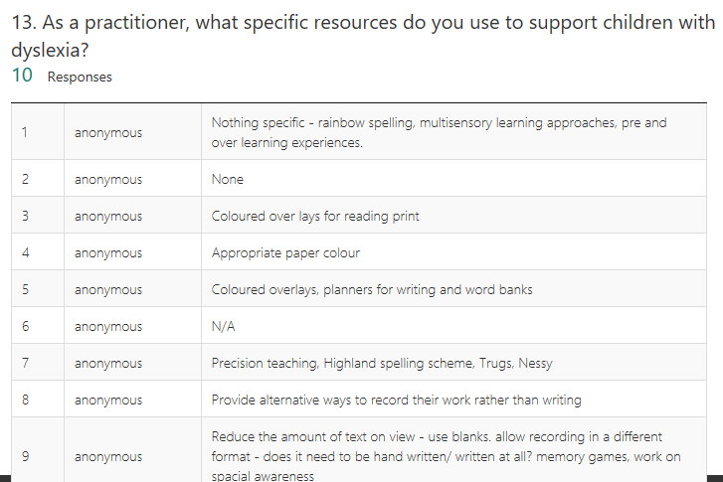
One participant mentioned over-learning as an approach to supporting children with dyslexia (see figure 4). Bell and McLean (2012) suggest that in order to appropriately support children with dyslexia, practitioners must make activities as engaging as possible due to the need to repeat content in an over-learning approach. One approach to this is to employ multi-sensory attitude to teaching and learning, which not only allows learners to become actively engaged in the learning process, but also encourages re-visiting aspects of learning whilst still encouraging learners to remain engaged (Glazzard et al., 2015). Furthermore, a multi-sensory approach to over-learning is a method to encourage development of the learners’ chosen learning styles whilst also being provided with opportunities to develop alternative learning styles.
Figure 4 Different views of how to support children
Whilst dyslexia is recognised as a learning difficulty that primarily affects language learning and processing, the effects of dyslexia upon the individual can vary (National Health Service, 2018; The Dyslexia Association, 2019). In reflection of this, Rose (2009) suggests that dyslexia is actually a continuum of language learning and processing difficulty, as opposed to a distinct group of learners. It is recognised that dyslexia and other learning differences can lead to emotional and behavioural challenges, often stemming from low self-esteem that has manifested as a result of the learning difference (NCSE, date unknown; Dyslexia Improvements, 2015). The questionnaire asked the participants to identify whether dyslexia impacts a child’s self-image or behaviour. As shown in figure 5, the majority of participants believe that dyslexia has a profound effect upon the emotional stability of a child. Dyslexia Improvements (2015) argues that a child can improve their self-image and level of confidence by persevering with challenges and approaching them with a positive, problem-solving attitude. Whilst this ethos should be fostered in all classrooms regardless of whether any children within the class have a diagnosis of dyslexia, it can only be entirely effective if the children are provided with the tools to tackle challenges and develop their self-confidence. During the PTE I trialled this approach to supporting learners in their development of self-confidence, including learners with dyslexia. I observed that when provided with various resources and tools to support their learning and development of understanding of a concept, learners thrived and exhibited high levels of enthusiasm and perseverance as a result. Imrie (2013) acknowledges the potential effect that appropriate resourcing and support can have upon the learning experience for any child, particularly a child with dyslexia. Furthermore, Imrie (2013) recommends utilising and exploring technology to support learners with dyslexia within the classroom, however, also alludes to the need for practitioners to be aware of the individuality of learners’ academic needs and preferences, therefore a technology-based approach may not suit all children with dyslexia. Meanwhile, the questionnaire asked participants to share their views upon how much support technology can provide when teaching children with dyslexia. When asked to rate how beneficial technology is when supporting children with dyslexia, over 70% of the 11 participants who responded scored technology as either 4 or 5 stars out of five, supporting the concept that technology can be an effective tool when effectively utilised. Supporting this even further, whilst on my PTE I regularly supported a child with dyslexia and noted that when using specific applications on an iPad he was able to access learning much more seamlessly than when he wasn’t provided with a device. In order to appropriately support learners using technology, practitioners must not only consult the child in question but also carry out extensive research to establish whether the application would appropriately enhance the learning experience in areas that the child requires support within.

Figure 5: Responses to the effects of dyslexia on self-image
In conclusion, the first step towards supporting a child with an ALN, dyslexia or otherwise, is to consider them as an individual, using child-first language to support this. In relation to this, any approaches to supporting a child with dyslexia, or any other learning difference, should consider the needs, interests and ability of the individual child (Glazzard et al., 2015). Crucially, as identified by the Welsh Government (2012) children should not need a formal diagnosis of dyslexia in order to receive support, especially if the support they require can be provided by the school with resources that have already been acquired. The triangulation of personal experience, research and data gathered from the questionnaire has highlighted that to support a child most appropriately in their academic endeavours the child must be consulted throughout the learning process, including the planning stages (Welsh Government, 2018). Ultimately, this means that practitioners should hold conversations with their children, discussing and observing natural learning styles and abilities, therefore establishing how to most appropriately support the child. A multi-sensory, resource-rich approach to learning that encourages learners to explore their preferred learning style both independently and with peer support is, ultimately, the approach that could arguably support children with dyslexia most effectively whilst still encouraging inclusion within a mainstream classroom.

References
Association of Teachers and Lecturers (2016) Lack of funding means SEND pupils aren’t adequately supported- ATL. Available at: https://www.atl.org.uk/latest/press-release/lack-funding-means-send-pupils-arent-adequately-supported-atl (Accessed: 23/04/2019)
Bell, S. and McLean, B. (2012) ‘Good practice in training specialist teachers and assessors of people with dyslexia,’ in Peer, L. and Reid, G. (ed.) Special Educational Needs: A Guide for Inclusive Practice. London: SAGE Publications.
British Dyslexia Association (date unknown) Indicators of Dyslexia. Available at: https://www.bdadyslexia.org.uk/parent/indication-of-dyslexia (Accessed: 24/04/2019)
British Educational Research Association [BERA] (2018) Ethical Guidelines for Educational Research. 4th edn. Available at: https://www.bera.ac.uk/researchers-resources/publications/ethicalguidelines-for-educational-research-2018 (Accessed: 23/04/2019)
CEN (date unknown) Children have different learning styles. Available at: http://www.educationalneuroscience.org.uk/resources/neuromyth-or-neurofact/children-have-different-learning-styles/ (Accessed: 28/04/2019)
Dauncey, M. (November 2016) Research Briefing: Additional Learning Needs (ALN) in Wales. Cardiff: National Assembly for Wales.
DfES (2007) An Investigation of Personalised Learning Approaches used by Schools. Available at: https://webarchive.nationalarchives.gov.uk/20130323005808/https://www.education.gov.uk/publications/eOrderingDownload/RR843.pdf (Accessed: 26/04/2019)
Dominica, S. (date unknown) ‘Teaching Students with Dyslexia using Multi-Sensory Learning Techniques,’ Brighthub Education [blog]. Available at: https://www.brighthubeducation.com/special-ed-learning-disorders/79992-multi-sensory-activities-for-students-with-dyslexia/ (Accessed: 24/04/2019)
Donaldson, G. (2017) Successful Futures. Crown copyright. Available at: http://gov.wales/docs/dcells/publications/150317-successful-futures-en.pdf (Accessed: 25/04/2019)
Douglas Silas Solicitors (2018) FAQs about SEN. Available at: https://www.specialeducationalneeds.co.uk/faqs-about-sen.html (Accessed: 23/04/2019)
Dyslexia Improvements (2015) Dyslexia Self-Esteem. Available at: http://dyslexiaimprovements.com/self-confidence-and-self-esteem-for-children-who-struggle-with-dyslexia/ (Accessed: 29/04/2019)
Education Act 1996, c. 56. Available at: http://www.legislation.gov.uk/ukpga/1996/56/section/312 (Accessed: 21/04/2019).
Elton-Chalcraft, S. and Twiselton, S. (2018) ‘Moving towards novice from expert teacher,’ in Burnett, C. and Cremin, T. (ed.) Learning to Teach in the Primary School. 4th edn. Oxon: Routledge.
Fox, S. and Surtees, L. (2010) Mathematics Across the Curriculum: Problem-Solving, Reasoning and Numeracy in Primary Schools. London: Continuum.
Glazzard, J. et al (2015) Teaching and Supporting Children With Special Educational Needs and Disabilities in Primary Schools. 2nd edn. London: Learning Matters.
GOV.uk (date unknown) Children with Special Educational Needs and Disabilities. Available at: https://www.gov.uk/children-with-special-educational-needs/print (Accessed: 23/04/2019)
Green, S. and Reid, G. (2011) 100+ Ideas for Supporting Children with Dyslexia. 2nd edn. London: Continuum.
Imrie, D. (2013) ‘Supporting students with dyslexia: tips, tricks and tech for teachers,’ The Guardian, 9th September. Available at: https://www.theguardian.com/teacher-network/teacher-blog/2013/sep/09/supporting-students-with-dyslexia-teachers-tips-pupils (Accessed: 29/04/2019)
Information Commissioner’s Office (2018) Guide to the General Data Protection Regulation. Available at: https://assets.publishing.service.gov.uk/government/uploads/system/uploads/attachment_data/file/711097/guide-to-the-general-data-protection-regulation-gdpr-1-0.pdf (Accessed: 23/04/2019)
Lawrence, D. (2009) Understanding Dyslexia: A Guide for Teachers and Parents. Berkshire: Open University Press.
McLeod, S. (2018) Questionnaire. Available at: https://www.simplypsychology.org/questionnaires.html (Accessed: 29/04/2019)
Multi-Sensory World (2019) About Us. Available at: https://www.multi-sensoryworld.co.uk/pages/about-us (Accessed: 24/04/2019)
National Health Service (2018) Dyslexia. Available at: https://www.nhs.uk/conditions/Dyslexia/ (Accessed: 22/04/2019)
National Health Service (2019) Autism. Available at: https://www.nhs.uk/conditions/autism/ (Accessed: 22/04/2019)
NCSE (date unknown) Dyslexia and Challenging Behaviour. Available at: https://www.sess.ie/dyslexia-section/dyslexia-and-challenging-behaviour (Accessed: 27/04/2019)
OECD (2006) Schooling for Tomorrow: Personalising Education. Paris: OECD Publishing.
Pollard, A. and Tann, S. (1993) Reflective Teaching in the Primary School: A Handbook for the Classroom. 2nd edn. London: Cassell Education.
Rose, J. (2009) Identifying and Teaching Children and Young People with Dyslexia and Literacy Difficulties. Available at: http://www.thedyslexia-spldtrust.org.uk/media/downloads/inline/the-rose-report.1294933674.pdf (Accessed: 29/04/2019)
Survey Any Place (2019) 10 Advantages and Disadvantages of Questionnaires. Available at: https://surveyanyplace.com/questionnaire-pros-and-cons/ (Accessed: 29/04/2019)
The Dyslexia Association (2019) What is Dyslexia? Available at: https://www.dyslexia.uk.net/what-is-dyslexia/ (Accessed: 29/04/2019)
The Dyslexia Resource (date unknown) What is Dyslexia? Available at: https://dyslexiaresource.org/information-about-dyslexia/what-is-dyslexia/ (Accessed: 24/04/2019)
The Reading Well (2018) Multi-sensory Learning: Quick Facts about Multi-Sensory Learning. Available at: https://www.dyslexia-reading-well.com/multisensory-learning.html (Accessed: 24/04/2019)
The Warnock Report (1978) Special Educational Needs: Report of the Committee of Enquiry into the Education of Handicapped Children and Young People. Available at: http://www.educationengland.org.uk/documents/warnock/warnock1978.html (Accessed: 29/04/2019)
UNICEF (1990) The United Nations Convention on the Rights of the Child. Available at: https://downloads.unicef.org.uk/wp-content/uploads/2010/05/UNCRC_united_nations_convention_on_the_rights_of_the_child.pdf?_ga=2.259947722.1736870539.1556135645-1629601584.1554107493 (Accessed: 29/04/2019)
Wales Dyslexia (date unknown) What is dyslexia? Available at: www.walesdyslexia.org.uk/about-dyslexia/what-is-dyslexia (Accessed: 29/04/2019)
Welsh Government (2018) Additional Learning Needs Transformation Programme. Cardiff: Crown.
Welsh Government (2012) Current literacy and dyslexia provision in Wales. Available at: https://dera.ioe.ac.uk/16215/7/120820literacydyslexiaen_Redacted.pdf (Accessed: 29/04/2019)
Welsh Government (2017) Draft Additional Learning Needs Code. Available at: http://www.senedd.assembly.wales/documents/s59527/Draft%20Additional%20Learning%20Needs%20Code%20February%202017.pdf (Accessed: 25/04/2019)

Appendices

Appendix 1

This screenshot shows that some practitioners are aware of less commonly recognised characteristics of Dyslexia that can support the diagnostic process (highlighted yellow).

