Marketing plan for holiday inn

Name. ANDLEEB MADEHA
student ID number: 2239506
The module title: Marketing Essentials BMIH4005
Your lecturer’s name. Dale clarks
Word Count 1250

Introduction:
Holiday Inn is a renowned hotel brand which was established in 1952 and has become a symbol of comfort and hospitality worldwide. As a leading player in the hospitality industry Holiday Inn has continuously adapted to the evolving needs of travellers. This essay provides a comprehensive analysis of Holiday Inn through a SWOT analysis and its objectives, and presents a strategic plan encompassing tactics, actions, control measures, and a conclusion Holiday Inn a renowned hotel brand, has become synonymous with comfort and quality accommodations worldwide. and a concluding assessment of its position in the market.

SWOT Analysis
Strengths:
Established Brand: Holiday Inn has a strong brand reputation built over several decades.
Global Presence: The brand has a widespread international presence, offering a wide range of accommodations and services. Commitment to quality service and customer satisfaction.
Loyalty Program: The IHG Rewards Club provides incentives for frequent guests, fostering brand loyalty.
Broad Customer Base: Holiday Inn caters to various customer segments, including business travellers, families, and tourists.
Operational Efficiency: The hotel chain has streamlined operations, ensuring consistent service delivery. Extensive network of hotels across key tourist destinations. Diverse portfolio of hotel options to cater to various customer segments.
Weaknesses:
Intense Competition: The hospitality industry faces fierce competition, which can affect market share and pricing power and also penetration in emerging Limited markets.
Property Maintenance: Some older Holiday Inn properties may require renovations to maintain competitiveness which mean Rising customer expectations and changing preferences
Overdependence on Online Travel Agencies: Overreliance on third-party booking platforms can limit direct customer engagement. Inconsistencies in service quality across different properties.
Opportunities:
Emerging Markets: Expanding into emerging economies presents opportunities for growth and market penetration.
Experience-driven Travel: Catering to the growing demand for unique and personalized experiences can attract a wider customer base.
Sustainable Tourism: Emphasizing sustainability initiatives can appeal to environmentally conscious travellers.
This also includes Expanding into emerging markets, such as Asia and Africa plus Leveraging technological advancements to enhance customer experience. Meeting the growing demand for sustainable and eco-friendly accommodations. And Developing partnerships with airlines and other travel service providers. Also Capitalizing on the rising trend of experiential travel.
Threats:
Economic Instability: Global economic downturns can impact the travel and hospitality industry.
Disruptive Technologies: Advancements in online booking platforms and home-sharing services can disrupt traditional hotel models. Disruptive online platforms also challenging traditional hotel booking channels.
Changing Consumer Preferences: Shifts in customer preferences towards alternative accommodations may impact hotel occupancy rates.
And also increasing regulations and compliance requirements. And Emergence of sharing economy models, like Airbnb. Also Negative impact of geopolitical events and natural disasters on travel patterns

Objective:
The objective of Holiday Inn is to establish and maintain a leading position in the global hospitality industry by delivering exceptional guest experiences, driving revenue growth, and expanding its market presence and Enhance customer satisfaction and loyalty by consistently delivering exceptional service which includes personal touch to its customers and Increase market share in emerging economies through targeted expansion it also Embrace sustainable practices and offer eco-friendly options to attract environmentally conscious travellers it has Strengthen brand image by focusing on innovation, digitalization, and technological advancements which has definitely Maintain profitability and financial stability through cost optimization and revenue management.

Strategy:
Holiday Inn utilizes various channels, including loyalty programs, customer feedback systems, and targeted promotions, to create a sense of community and loyalty among its customers. The brand encourages guest participation through initiatives such as online reviews and social media contests, allowing guests to share their experiences and generate positive word-of-mouth. Holiday Inn emphasizes reliability, consistency, and affordability. They position themselves as a trusted and familiar choice for traveller’s, offering a consistent quality of service across their global network. Holiday Inn's marketing messages revolve around comfort, convenience, and value for money, resonating with their target market's desire for reliability and affordability.
Holiday Inn's strategic approach focuses on four key pillars:
Guest Experience: Continuously enhancing guest satisfaction through personalized services, modern amenities, and seamless technology integration.
Market Expansion: Expanding the hotel chain's footprint in both existing and new markets, capitalizing on emerging opportunities.
Brand Differentiation: Offering unique experiences and catering to specific customer segments to stand out from competitors.
Sustainability: Implementing eco-friendly practices and engaging in responsible tourism to meet evolving consumer expectations.
Tactics:
Holiday Inn is a popular hotel chain that offers accommodations and services to travellers around the world. so Holiday Inn may be implementing, here are some general strategies that hotels often employ to attract and satisfy guests
Quality service: Holiday Inn places a strong emphasis on providing excellent customer service. Their staff is trained to be friendly, attentive, and responsive to guest needs. Ensuring a positive guest experience is crucial for any hotel's success.
Comfortable accommodations: Holiday Inn aims to provide comfortable and well-appointed rooms for guests. They typically offer amenities such as comfortable beds, clean and spacious bathrooms, Wi-Fi access, and in-room entertainment options.
Loyalty programs: Like many hotel chains, Holiday Inn likely has a loyalty program in place to reward frequent guests. These programs often offer perks such as free nights, room upgrades, and other benefits to incentivize guests to choose Holiday Inn for their stays.
Renovations and Upgrades: Revitalizing older properties to ensure they meet modern guest expectations.
Digital Transformation: Investing in technology to improve guest experiences, streamline operations, and drive direct bookings.
Targeted Marketing: Segmenting the customer base and creating tailored marketing campaigns to reach specific audiences.
Partnership Development: Collaborating with travel agencies, airlines, and other service providers to enhance brand visibility and attract new customers.
Training and Development: Investing in employee training programs to ensure consistent service quality across all properties.
Customer-Centricity:
. Continuously monitor and analyse customer feedback to identify areas for improvement.
. Invest in staff training programs to ensure consistent service quality across all properties.
. Leverage data analytics and personalized marketing to enhance guest experiences and drive loyalty.
Global Expansion:
. Identify key target markets and invest in strategic partnerships for market entry.
. Adapt hotel designs and amenities to suit local preferences and cultures.
. Leverage digital marketing and online booking platforms to increase visibility and accessibility.
Sustainability:
. Implement energy-efficient practices, waste reduction, and recycling initiatives.
. Develop green building standards for new properties and refurbishments.
. Collaborate with suppliers and vendors committed to sustainable practices
these tactics may vary depending on the specific location and market conditions.
Actions:
Property Renovations: Allocate resources to refurbish and modernize older hotels, ensuring a consistent brand experience.
Technology Investments: Implement cutting-edge systems for online bookings, mobile check-ins, and personalized guest interactions.
Sustainability Initiatives: Introduce energy-efficient practices, waste reduction measures, and community engagement programs.
Market Research: Continuously monitor market trends, customer preferences, and competitive landscapes to inform strategic decision-making.
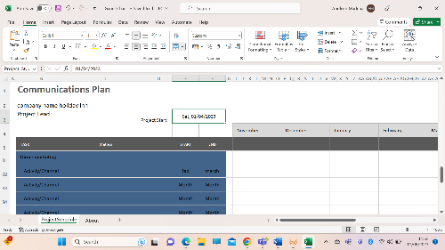

Control:
Holiday Inn employs various control mechanisms to monitor progress and evaluate the effectiveness of its strategies, Holiday Inn exercises over its hotels. Holiday Inn is a brand owned by InterContinental Hotels Group (IHG), which is a global hotel company. While IHG provides overall brand standards and guidelines to ensure consistency across Holiday Inn properties, individual hotels within the brand typically operate under franchise agreements or management contracts. Here are some key points for the control exerted by holiday inn
including:
Key Performance Indicators (KPIs): Tracking metrics such as occupancy rates, revenue per available room (RevPAR), guest satisfaction scores, and market share.
Guest Feedback: Soliciting and analysing guest reviews to identify areas for improvement and address any concerns promptly.
Regular Audits: Conducting internal audits to ensure compliance with brand standards, quality assurance, and operational efficiency.
Financial Reporting: Analysing financial statements to assess revenue growth, cost management, and profitability.
Conclusion:
Holiday Inn's strength lies in its strong brand reputation and global presence, coupled with its commitment to customer satisfaction. By embracing a customer-centric approach, expanding into emerging markets, and prioritizing sustainability, Holiday Inn can position itself as a leader in the evolving hospitality industry. Through consistent execution, monitoring, and control measures, Holiday Inn can realize its objectives, reinforce its market position, and continue to deliver exceptional experiences to travellers Holiday Inn's strategic framework, incorporating a comprehensive SWOT analysis, clear objectives, well-defined strategies, tactical actions, and effective control mechanisms, positions the brand for continued success in the global hospitality industry. By focusing on guest experiences, market expansion, brand differentiation, and sustainability, Holiday Inn aims to maintain its leading position and adapt to evolving consumer expectations.

References:
- "Regional headquarters".
- ^ "Holiday Inn Hotels & Resorts - Our brands - InterContinental Hotels Group PLC". InterContinental Hotels Group. Retrieved October 10, 2017.
- ^ "Supplementary Information" (PDF). International Hotels Group. March 31, 2009. Retrieved June 6, 2009.
- ^ Ryan Chittum (September 20, 2005). "The Holidome Returns: Slumping Holiday Inn Expands Water Parks". The Wall Street Journal.
- ^ "Wallace E. Johnson: Co-founder of Holiday Inn chain". Los Angeles Times. April 29, 1988. Retrieved June 25, 2012. Fowler, Glenn (April 29, 1988). "Wallace E. Johnson, Co-founder of Holiday Inns chain in 1950's". New York Times. Retrieved June 25, 2012.
- ^ Rob Baker (December 4, 2014). "Twenty Humdrum Holiday Inn Postcards from the Fifties and Sixties". Flashbak.
- ^ "Holiday Inns corp. found guilty of monopoly practices". The Daily Journal. September 6, 1973. p. 4. Retrieved January 2, 2023.
- ^ "HNN - Hoteliers bid adieu as Holidex checks out". Hotelnewsnow.com. Archived from the original on August 14, 2020. Retrieved April 14, 2017.
- ^ "Astronaut Glenn to be guest at opening of first Trav-L-Park". The Indianapolis Star. August 20, 1970. p. 56. Retrieved November 21, 2022.
- ^ "Daytona Beach Morning Journal - Google News Archive Search". google.com.
- ^ Half Brains and Half Luck by Kemmons Wilson. p 52-53
- ^ Caitlin L. Horton (July 2015). "The Holiday Inn Great Sign". Memphis Type History. Retrieved April 14, 2017.
- ^ Wade, Betsy (December 16, 1990). "On the Road, Sleeping for Less". The New York Times.
- ^ "You get what you pay for in economy motels". The News and Courier/Evening Post, Charleston, SC. November 11, 1990.
- ^ "Holiday Inn Enters New Market Area". Daily News, Bowling Green, Kentucky. October 8, 1990.

Appendix:
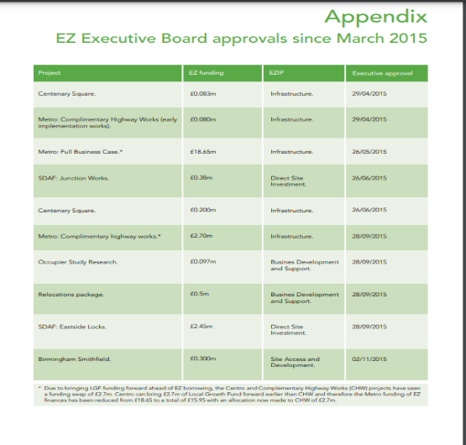

Presentation:





