Task 1 – FEA Simulation
A)
It is my task to simulate and analyse the forces that would be applied to a Basketball Hoop during the action of a slam dunk. Along with information given to me (the material of the hoop is comprised of steel, and the person performing the action weighs 98kg), and along with independent findings carried out during my research, I must strengthen and improve the bracket’s performance characteristics.
FEA simulation is a highly recommended means of testing the strength and durability of a product. This software allows designers to see if their design can withstand under a certain weight load, indicating the areas of high stress and where to strengthen.
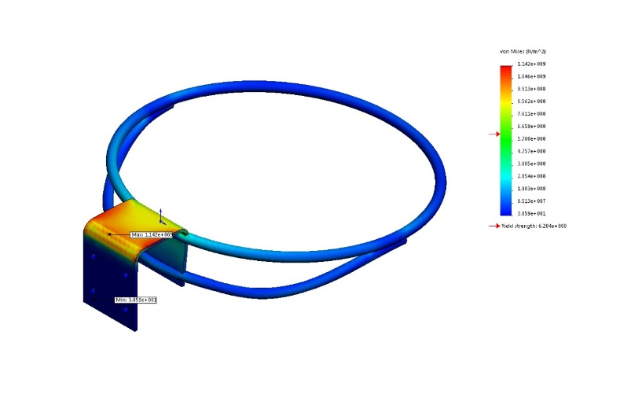
This image is the un-improved basketball hoop used to identify the areas of stress under the weight of 98kg, which is the equivalent of 988N. The simulation indicates if the design has passed or failed under the force through calculating the maximum value of Von Mises, and comparing to the yield strength of the chosen material. The yield strength of the steel hoop is 6.204e+008(N/m^2), and in this study the Von Mises is greater than yield strength of 1.142e+009(N/m^2). As a result, the bracket can’t cope with the stress of the force. This discovery is beneficial to where I need to strengthen.

Improvement 1
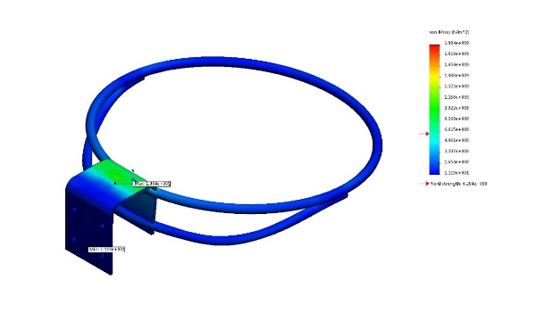
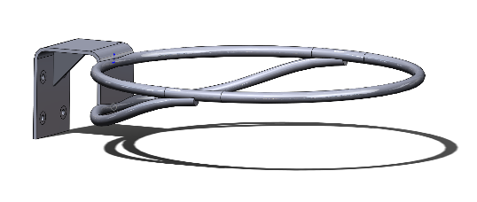

I noticed the stress was occurring on the top section of bracket, and to improve this I added a single rib to the underside of the bracket to strengthen this section. Although there is improvement in the performance, the force of 988N is too significant for the hoop, and subsequently fails the simulation once the stress is calculated at 1.984.009(N/m^2).

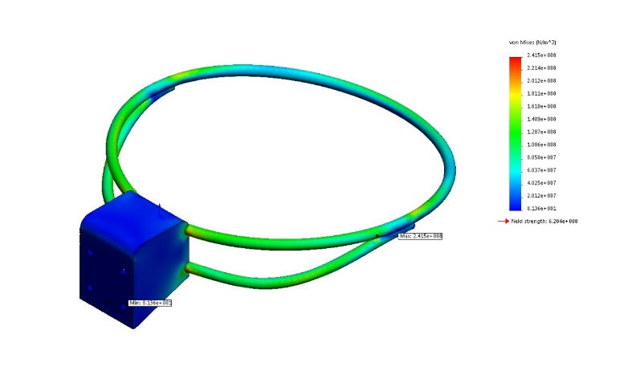
Improvement 2
In this modification, I have added walls to either side of the bracket, with the intention to prevent the flexibility that occurs at the top of the bracket. And with this new design upgrade, the strength has been vastly improved, and the hoop can withstand the 988N force comfortably, with minimum Von Mises value being 2.415e+008(N/m^2).
A basketball hoop not only should tolerate the weight of a person, but should also undergo the stress from a person’s gravitational force of the impact and hanging from the hoop for a small period of time. To account for this, I will analyse further simulations to see whether the design can endure up to 2500N of force and still perform its purpose.
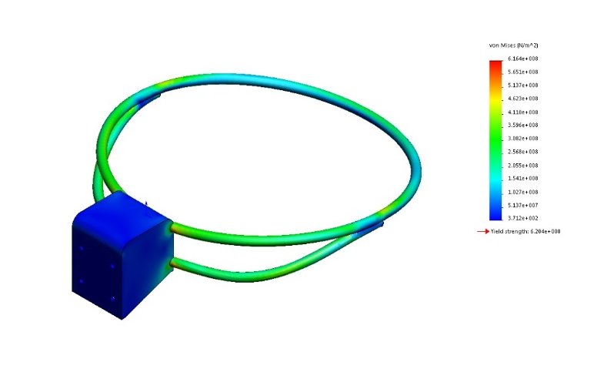

With applying near to three times the weight of the person performing the action, the improvement to the bracket is enough to withstand the force of 2500N, with the minimum Von Mises value being 6.164e+008(N/m^2), in comparison to the steel’s yield strength of 6.204+008(N/m^2).

Improvement 3
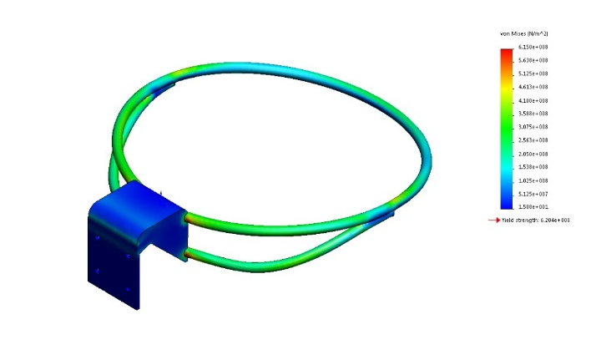
Although the last design was a success, I was eager to improve the design aesthetics yet hold/improve the performance of the hoop under the force of 2500N. Despite the minute drop in performance, this design will perform to the same level as the previous improvement with a successful outcome, allowing the hoop withstanding the action of a slam dunk.

B)
Similar to the previous task, I am to analyse the Bolmen stool (material being Polypropylene) from IKEA with a loading of 100kg. Through strengthening the underside of the stool with adding multiple ribs, I must ensure a Safety Factor of 3 is achieved.

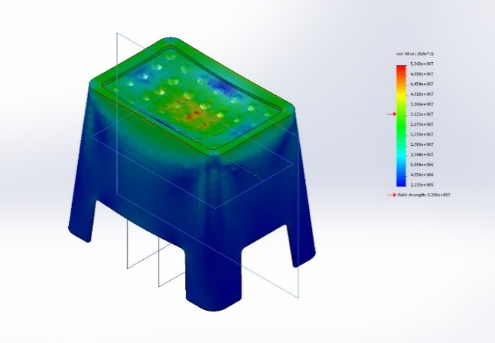

The images above represent the un-improved stool with no ribs used under the force of 988N. To the left it shows the stress being too much for the unaltered stool to endure, with the yield strength inferior at 3200e+007(N/m^2) to that of the minimum Von Mises value at 5.343e.007(N/m^2).

Improvement 1
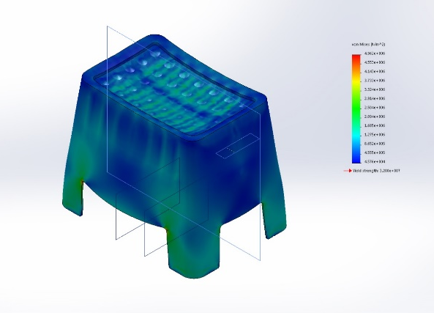
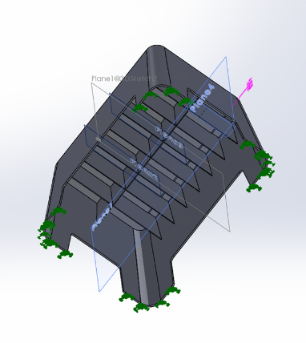

The first improvement I made to the underside of the stool was to reinforce it with one long rib running through the centre, followed by 7 additional ribs at the depth of 80mm. I acknowledge this is a lot of material, but felt as though I needed a base to work upon, and if this rib design would accommodate the weight.
As expected with the number of ribs and the depth used, the modification was able to surpass the forces of 988N easily, with achieving 4.962e+006(N/m^2), where the minimum yield strength the material can endure is 3200e+007(N/m^2). Along with this, based on the specified forces applied to the specified perimeter of the stool (top), the lowest factor of safety found in this design is 11.7575. The minimum safety requirements is stated as 3, yet although this design excels this figure, and proves my improvement is very durable, I am intrigued to see if I can apply three times the weight and can still continue performing its purpose.

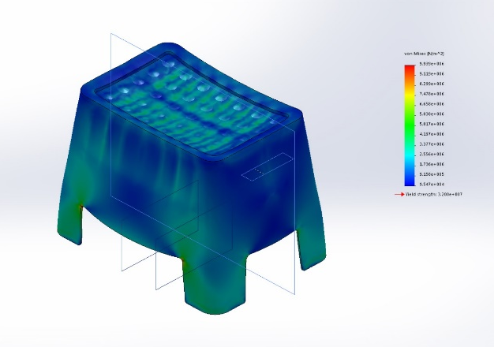
3000N has now been applied to the top perimeter to the stool, and the design is still exceeding the requirements to pass the stress trial, with the Von Mises value being recorded at 9.939e+006(N/m^2). Despite the forces being so high, this design can still obtain a safety factor of 3 with the lowest factor recorded being 3.87214.

Improvement 2
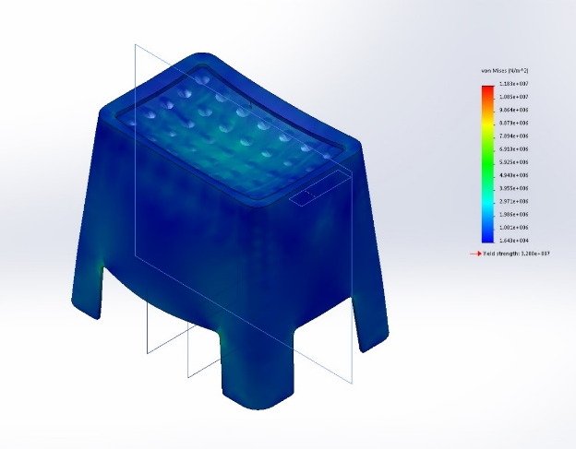
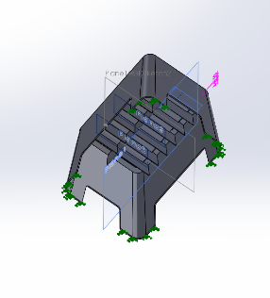

Due to the safety factor being unnecessarily high in the previous improvement, I have over engineered the reinforcements. I decided to reduce the depth of the ribs to 40mm, and see if this design would still be able to achieve the necessary requirements. Yet again there is no signs of high stress levels, and the adjustments to the ribs have successfully withstood the force of 988N, with the Von Mises value reaching its highest point at 1.183e+007(N/m^2). However, the safety factor has dropped dramatically, to find the lowest factor of safety is 3.6906.
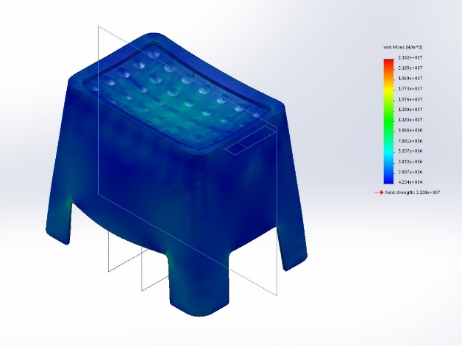
With 3000N enforced on the modified stool, it is still yet displaying any considerable displacement or stress to the design. Despite this, the model no longer requires the obligatory safety factor of 3, with the ribs only enduring 1.21537.
Although the task is only asking for the stool to tolerate 10kg worth of force, I am keen to design a rib construction that can sustain a high value of force, to contain the possibility of someone jumping on the stool.

Improvement 3
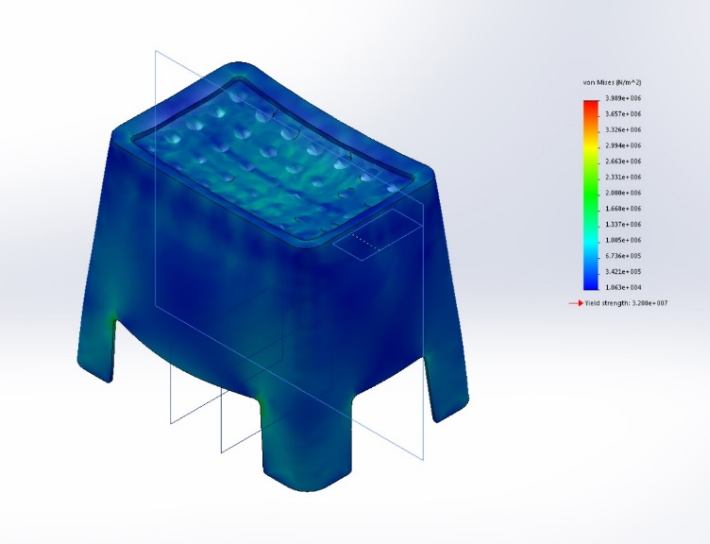
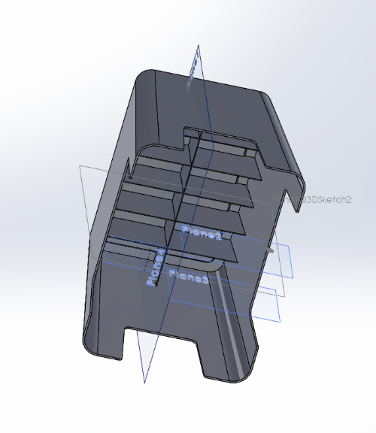

With this design, I tried to accommodate the two previous modifications with adjusting the depth of the ribs to 70mm, along with reducing the number of ribs from 7 going across the underside to 5. With the force of 988N being applied, the rib construction easily passes the stress with the minimum Von Mises value being 3.989e+006(N/m^2). The factory of safety is also easily achieved with the design obtaining 8.02296.
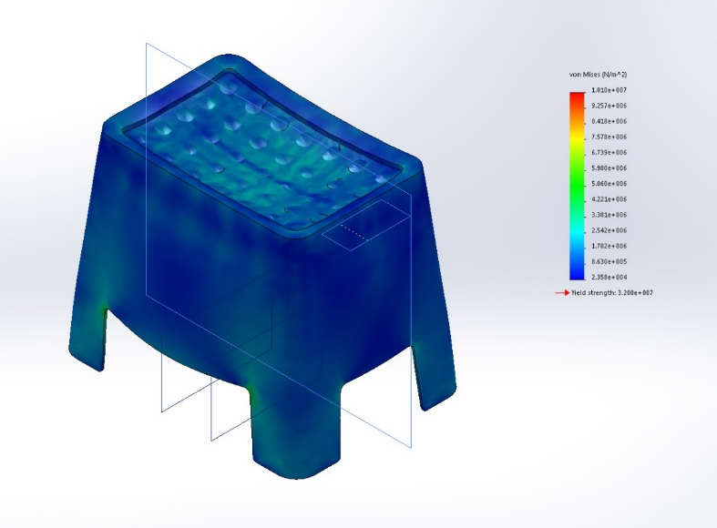
Applying further force with 2500N, this design not only surpassed the stress demands through withstanding 1.010e+007(N/m^2), it was also able to achieve a suitable safety of 3.16934.

Task 2 - Flow Simulation
It is my task to simulate and analyse two separate types of vehicles travelling at the speeds of 30mph and 100mph. It is my intention to study the velocity and flow trajectories for each vehicle with regard to their design characteristics.
Flow simulation is a great means of studying cars aerodynamics, and is widely used by automotive designers to observe how airflow has an effect on their design’s performance.
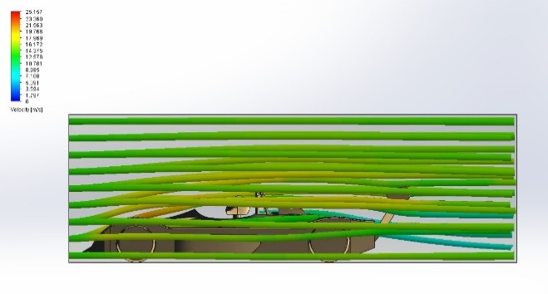
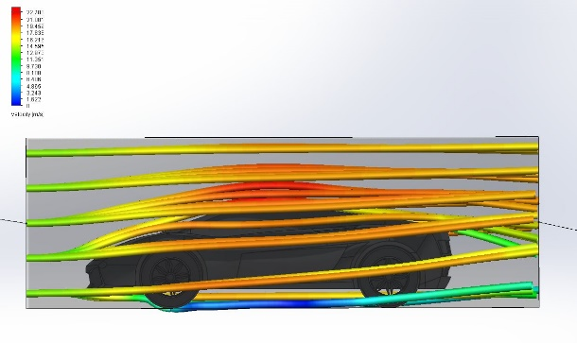
30MPH – Inlet

Images above show how two separate vehicals experience 30mph air velocity through inlet. The lamborghini to the left sufferes velocity at highs of 22.703(m/s) towards the roof area. This is the region where the highest occurance of drag will take place. Due to the more aerodynamically designed Race Car, the volume of velocity recorded is less signuficant, where the highest volume is in the reigion of 18.000(m/s) – 19.000(m/s). It is clear to see that the air trojectory is circluating underneath the Lamborghini, wheras the Race Car is pushing the airflow to the sides of its perimiter. This is a result of the design of the lamborghini being a lot higher off the ground in comparison the to the Race Car.

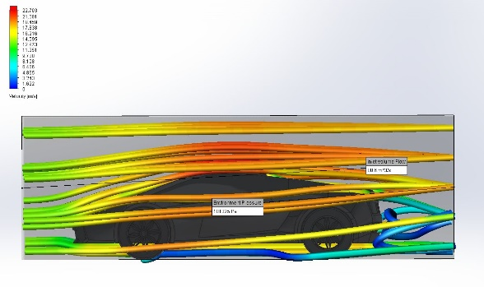
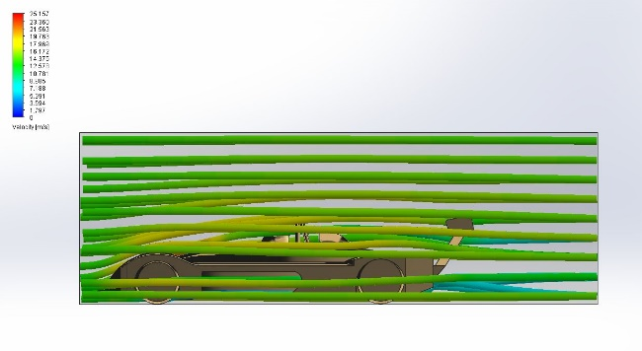
30MPH – Outlet

It is clear to see that the velocity decleirates once flow trajectory reaches the low preassure area behind the Lamborghini. This velocity is recorded in the region of 3-8(m/s), creating reistance. Anylising the Race Car, there is no low preasure circulating at the rear, yet the air trojectory flows straight as a result of the aerodynamics.

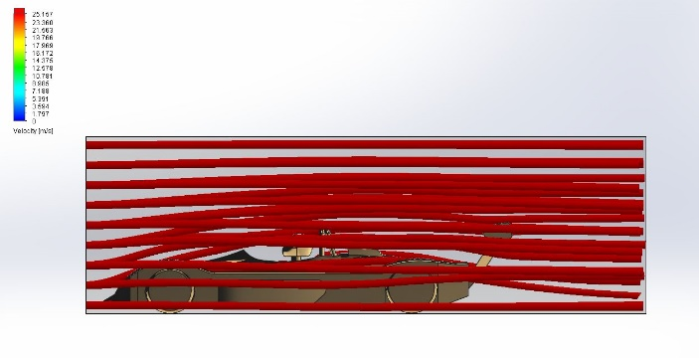
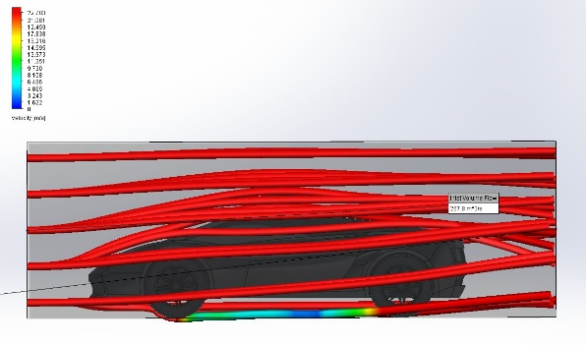
100MPH - Inlet

The inlet images at 100Mph shows the velocity is constantly 22.703(m/s) surrounding the Lamborghini, and the air trajectory is tight to the body of the vehicle, which indicates the car is suffering with drag. Despite the velocity has increased to 25.157(m/s), due to its aerodynamic properties, minimal drag is seen on the Race Car, and the air flow is passing over the body more smoothly.

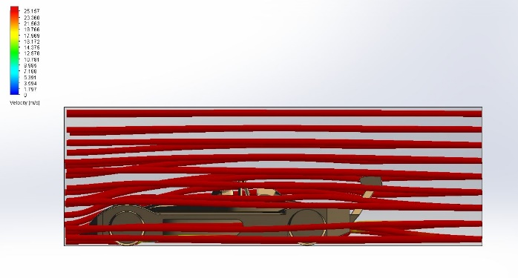
100MPH – Outlet
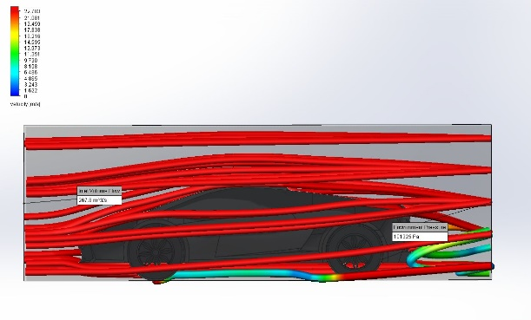
Similar reults the the 30Mph where the Race Car is projecting its air trojectory straight through its aerodynamic design, However the results show velocity has increased at the rear of the Lamborghini. The velocity has increased to the volume of between 6-14(m/s).

Task 3 - Plastic Simulation
My intention in this task is to simulate the moulding of a funnel and a drill, and ensure by adding appropriate gate locations, that they could be successfully moulded. I will gather and anylise the output results the key elements of injection moulding.
Funnel
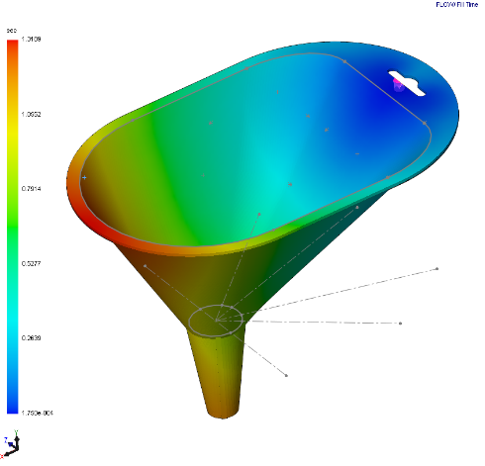
Fill time
For my first injection simulation, I have chosen one single injection gate. I placed it on the lip due it being the highest point of the subject. This image to the left shows the time it takes to fill apart, and depicts what area of the mould is being filled the fastest, blue indicating the the instant time of fill, and the red indicating the maximum time it has taken to finish the mould. The overall time taken to mould this part is 1.3109 seconds

.
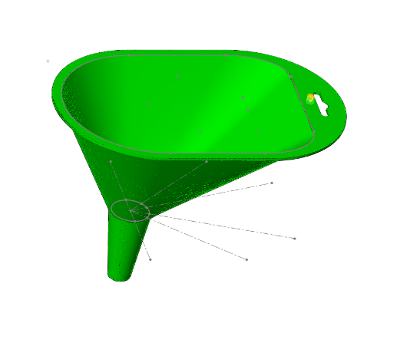
Ease of fill
I have used ease of fill as an output result to determin whether the cavity fills successfully. The simulation that I have undertaken to anylise this part inducates that the whole area of my funnel can be filled under normal injection preassures.

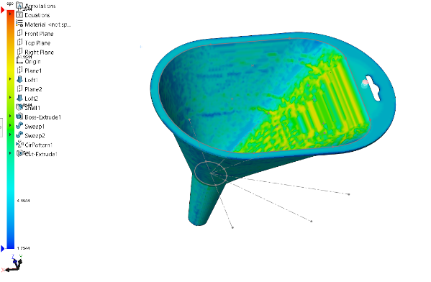

Cooling time
This image shows the cooling time it has taken for the part to cool inside the tool. For a manufacture, it is important to know this data. The cooling time it has taken for this part to cool is 17.5244 seconds, which isncredibly interesting due to the majoity of the part cooled within 10.0544 seconds.

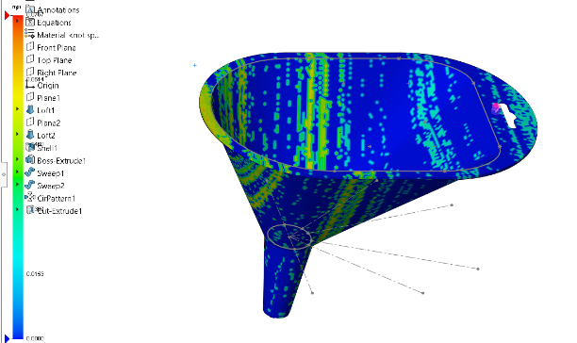
Sink marks
Sink marks appear on a part when areas have cooled faster than others, and as a result they materialize into sink marks. Despite this, this occurrence can be managed through modelling a part with uniform wall thicknesses, and applying the injection gate to a thicker region of the part. In this case, the has a number of sink marks that can be rectified. This could be done through applying the injection gate to the other side of the funnel, as this area has been flagged up as a thicker section.

Air trap
Air entrapment is the occurrence of trapped air inside a part cavity, and is formed within the injecting moulding process. This can have implication of the final piece once cooled, which include distortion and incomplete filling. To prevent this occurring, including a second gate location to a part would force out any air pockets that may have found itself within the mould out into the atmosphere.

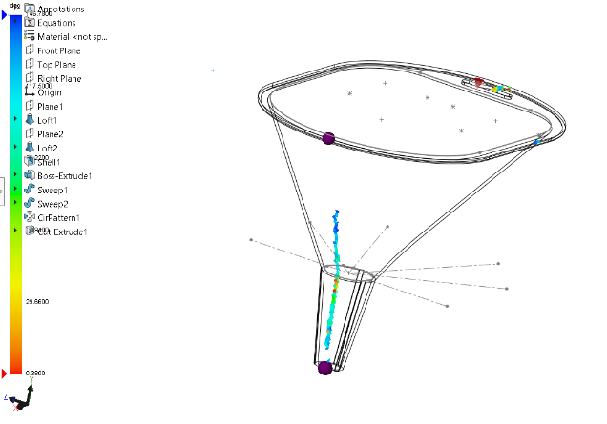
Welding Lines
Weld lines are formed when two or more materials of plastic join together during the injection moulding process. These areas are resulted in deformation and often result in a weakened section. The welding line that has occurred in this piece has developed on the opposite side of my injection gate which is normal occurrence, however due to the purpose of a funnel, this is not likely to be a problem due to it not likely to endure any stress.

Drill
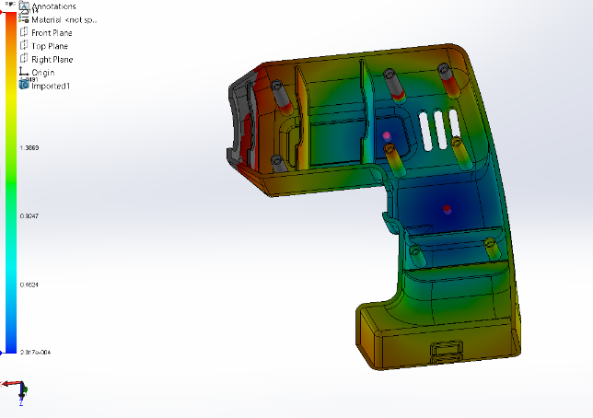
Fill Time
The location where I have applied an injection gate has been thoughtfully placed in a location where a logo sticker would be placed. This would hide the injection gate from the consumer. The other injection gate has been applied in a different area or the part where the plastic can spread evenly. Through using two gates, I can make a comparison between this and the previous funnel. The overall part took 2.3114 seconds to fill.

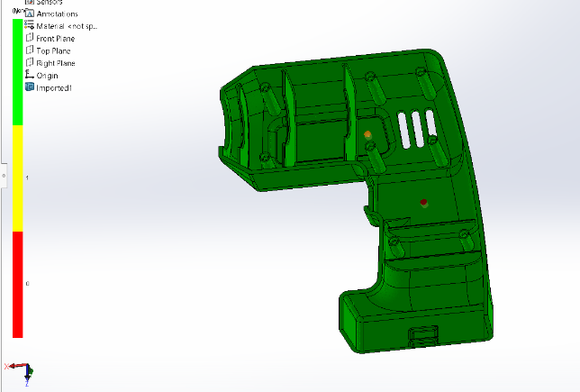
Ease of fill
This shows a good placement of the injection gates due to indication of a successful fill with the normal injection pressures of 27.6mPa throughout the whole part.

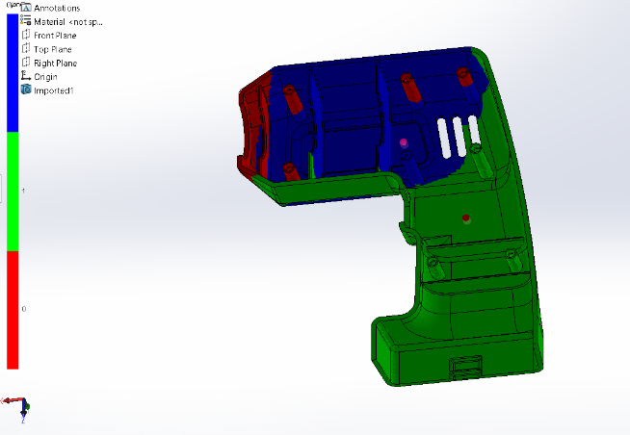
Gate filling contribution
Gate filling contribution is a simulation to analyse what certain gate fills what section of the part when two injection gates are used. This also simulation also shows the welding line that is created once the two gate’s materials meet.

Task 4 - Undercut & Draft Analysis
The final task requires me to analyse an undercut and draft upon a pre-defined camera body. The importance of simulating a draft analysis is very important to inspect any sections of the camera body that will need a draft in order to free itself with ease once the cooling has finished. The undercut analysis simulation will provide me with the knowladge that is key to determine whether the camera will or won’t be allowed to be removed from the tool.
Draft Analysis
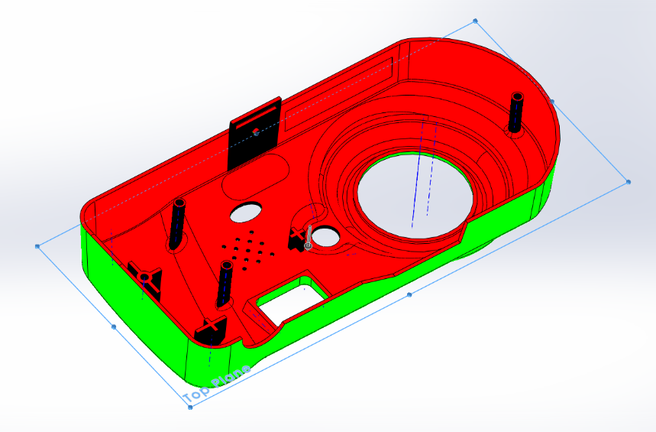

The draft analysis results have told me that the areas highlighted in red are the negative drafts, areas highlighted in green show the positive drafts, and the areas highlighted in black are the sections where a draft is required.
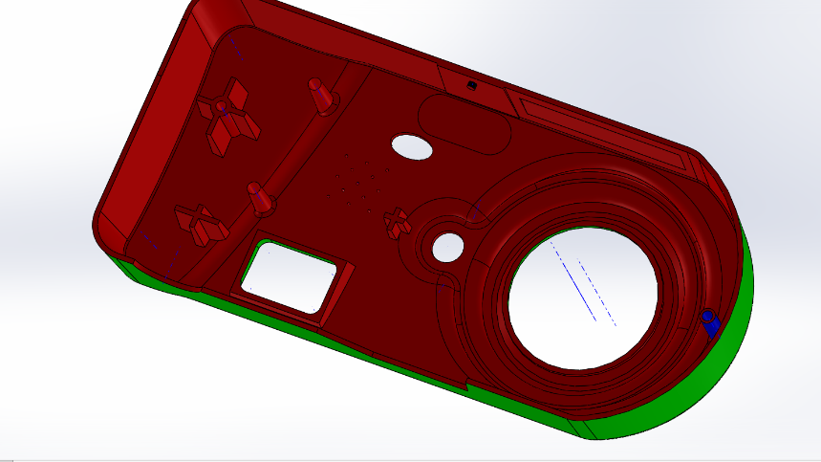

I was successful in modifying the draft in the required sections to a 5mm draft angle. As a result, this once required draft angle has new been rectified and is now allowed to be released from the tool without damaging the mould.

Undercut Analysis

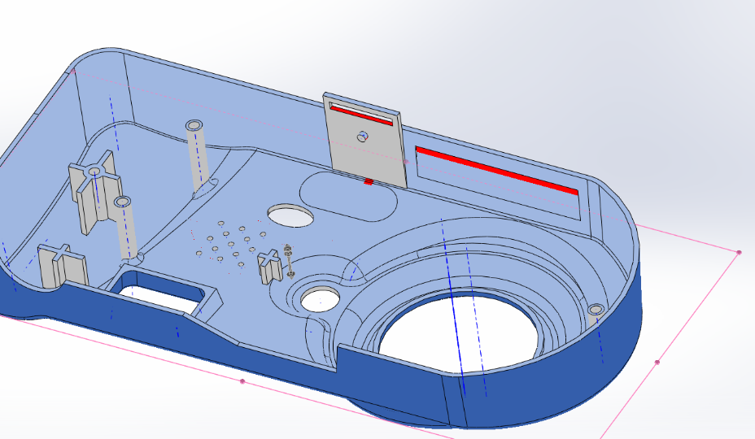

Through simulating the undercut analysis, a number of undercuts were highlighted that would cause a problem when being removed from a tool. A compromise must either within the design, or within the manufacturing aspect of the tooling. I was made aware through the simulation that the clip was creating an undercut. This could be removed to allow the part to be removed freely, however this clip is an important aspect of the design, therefore, a sliding core might be more appropriate, however this would be a very expensive tool to have to allow this part to be made. A sliding core is used to allow designs that need to accommodate for undercuts with necessary features.

Simulation of Real World Scenarios

Application of Simulation Tools

Toby Gleave
P150567



