Module Code: LCHS4003

Module: Introduction to Health and Social Care

Portfolio: (Poster and Essay)

Name: Shackeria Nash Korylco

Student ID: 2509257

Lecturer: Daniel Haruna


Red Rose Care, 2024

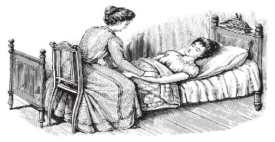
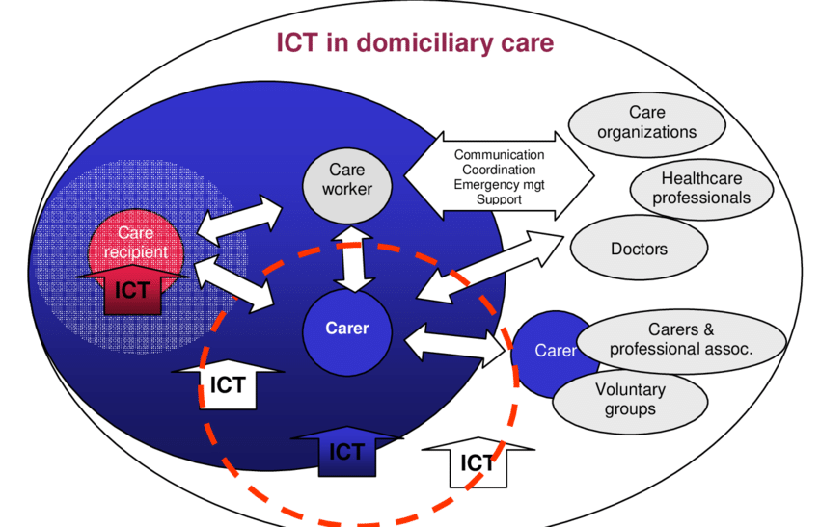
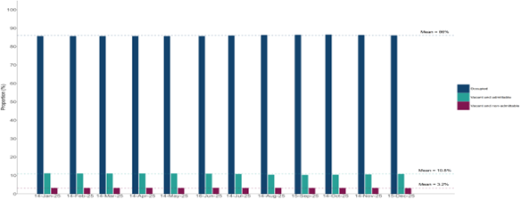
Domiciliary care, sometimes known as "dom care," is when qualified carers offer assistance and support in the convenience of your own home. To ensure that you or your loved one can keep their freedom and quality of life, this service covers assistance with daily tasks including meal preparation, personal hygiene, and domestic duties. (Rose Care, 2025)​
Domiciliary carers who put their client's welfare first enhance the experience and demonstrate the value of a loving and supportive workplace culture in providing professional domiciliary care. (Leaf Care)

Services may include personal care for the client, regular household chores both inside and outside the home, and other related domestic services required to keep a person in a respectable state of health, cleanliness, dignity, safety, and comfort in their home. (Department Of Health, 2024)​​. Domestic Assistant-receiving assistance with daily or weekly tasks around the house is known as domestic care. domestic help can help you remain independent at home without the burden of daily housework and duties.​​Personal care- Trained carers can come to your house and assist with showers, baths and getting dressed in a respectable and safe manner.​​
Specialist care- Specially trained nurse can provide care for individuals with complex needs at home.​​ Overnight or live in Care- Carers can stay over at nights for help with assistance during the night. (Hamstead Care Group,2022)
The origins of care can be traced back to the early mid-20th century, a time of substantial societal upheavals and the aftermath of World War ll. As the nation rebuilt itself, the necessity to meet the healthcare demands of an ageing population became increasingly apparent.​
Home care outside of friends and family was primarily available to the privileged until 1601. Rich people could hire servants to take care of elderly or sick family members.​ Home-based care was made possible for people who had difficulty accessing standard healthcare facilities thanks to volunteer and charitable organisations. The National Health Service (NHS) was created in 1948. The NHS was to ensure accessibility and by offering healthcare services to everyone. (Amaiva Group, 2026). The 1929 Local Government Act made it possible for local governments to provide care for the elderly, but it did not mandate it. (Home Care, 2026)

Domiciliary Care Services in the Community
Domiciliary Care
Functioning of service
History
Challenges
When it comes to helping people who want to continue receiving care in their own homes, domiciliary care services are essential. These services encounter numerous obstacles in the UK that affect sustainability and efficacy. Workforce Challenges- Limited Training and Support- Some home care providers might not have the time to maintain their training, not get much assistance. Inadequate training will lower the quality of care provided, raise stress levels among home care providers, and raise the possibility of staff burnout. Heavy Workload- providing care in a limited timeframe which therefore can be physically and mentally demanding. (Access Group, 2026). Knowing the scope of the problem is essential when demand rises and resources become scarce. Teams frequently deals with difficult instances with urgent requirements and little preparation time, and they are under pressure to pick up the slack.
Capacity tracker, 2025
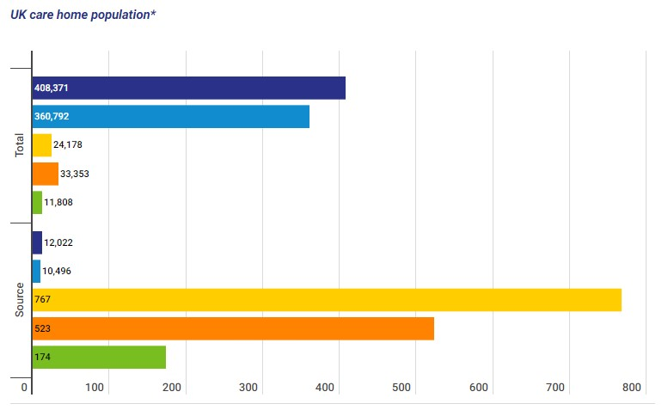
Home Care, 2025

UK Care home population, 2023
Solutions

It's critical to carefully evaluate the kind of support and procedures you should provide to assist the home care team. Keeping everyone connected, in my opinion, is crucial for fostering a sense of teamwork among individuals working independently in various places. Having a wellbeing officer on staff who can offers mindfulness training will also help to improve challenges (Skills for Care, 2026).

Pharmacy Services

Pharmacy Services History

Leading London chemist and druggist form the pharmaceutical society of Great Britain on April 15, 1841. In those days, anybody could establish up shop and sell you any medications they want. There were no restrictions or regulations on drugs at all. You wouldn't be able to tell as a patient if you were receiving the correct medication, a counterfeit one, or something that would poison you. It goes without saying that there were many concerned chemists who wished to elevate their profession.
They first met in London in April 1841 at the Crown and Anchor Tavern, which was located at the intersection of Arundel Street and the Strand. William Allen proposed the creation of the Pharmaceutical Society of Great Britain as a remedy in this situation. Only members with a recognised qualification would be admitted to this autonomous association. They established a 40-member council to draft legislation and rules. in February 1843, Queen Victoria gave the Society a Royal Charter of Incorporation. (They would begin referring to themselves as "Royal" in 1988.)
The Pharmaceutical Society encouraged the use of a recognised emblem to assist patients in identifying pharmacies throughout the 20th century. The less confusing phrase "pharmacy" took the place of "chemist. Pharmacy technicians and chemists are licensed healthcare providers with the knowledge and abilities to assist you in enhancing your health and well-being. (Royal pharmaceutical Society, 2026). The idea of pharmaceutical care develops through a methodical, all-encompassing approach, which calls for the chemist to collaborate with the medical team, identify and address current and potential drug-related issues, and shield patients from potential medication side effects.
The function of pharmacy services today has evolved because in addition to filling prescriptions, chemists can offer guidance on minor medical issues and sell certain medications without requiring you to schedule a visit with a general practitioner. (General pharmaceutical council, 2026)
It is imperative that pharmacy schools adapt their curricula to meet the evolving needs of the pharmacy profession considering the evolving landscape of pharmacy practice. Critical thinking abilities, problem-solving techniques, and decision-making during medication should all be enhanced by the instruction.

With the correct actions, pharmacies can take the lead in patient care, relieving hospitals and general practitioners of some of the burden. Pharmacies may become more than just locations to pick up prescription drugs in the future; they may develop into community centres that offer consumers medical services.
When it comes to managing chronic conditions and minor illnesses, pharmacies may be the first-place people turn to for assistance.
To enhance the patient experience and support the pharmacy's growth, several operational, technological, and regulatory adjustments will need to be made. (EY,2023)
To put it simply, community pharmacies and pharmacists play a crucial role in improving healthcare accessibility, maximising the benefits of medications, and helping patients receive effective therapy and disease management, all of which improve clinical outcomes. Therefore, the pharmacy professional's top priorities include medication surveillance, patient medication monitoring, identification and avoidance of potential side effects, appropriate communication, and information regarding medication use.
Pharmacy service users are mostly worried about a variety of issues that are addressed and would appreciate a larger role for community pharmacies in tackling the difficulties that health care in England is now facing.
Pharmacists must improve their professional look, devote more time to patient counselling, assist patients in managing their prescriptions, and extend their working hours to accommodate client needs to provide better pharmacy services. Patients who experienced limitations in their activities and those who achieved less than they would have liked were less happy with pharmacy services in terms of quality of life. (PubMed Central, 2020).

References

Amaiva Group (2026) The Evolution of Domiciliary Care: A Journey Through Time. Available at: https://www.amaiva.group/post/the-evolution-of-domiciliary-care-a-journey-through-time (Accessed on 20 January 2026)

Braemar Finance (2023) Facts & figures: UK Care Home Sector. Available at https://www.braemarfinance.co.uk/s/insights/blog/facts-figures-uk-care-home-sector-MCXEQ2ZU7QKVFOBOP272VSXJDDWQ (Accessed on 12 February 2026)
Department of Health (2024) Domiciliary care. Available at https://www.health-ni.gov.uk/articles/domiciliary-care (Accessed on 20 January 2026)

Department of Health and Social Care (2025) Adult social care provider statistics, England: quarterly update Available at https://www.gov.uk/government/statistics/adult-social-care-provider-statistics-england-quarterly-update-to-december-2025/adult-social-care-provider-statistics-england-quarterly-update-to-december-2025 Acessed on 5 February 2026
EY (2023) How pharmacy innovation could improve patient health care in England. Available at https://www.ey.com/en_uk/insights/health/how-pharmacy-innovation-could-improve-patient-health-care-in-england (Accessed on 12 February 2026)
General pharmaceutical council (2026) Standard you can expect using pharmacy services https://www.pharmacyregulation.org/patients-and-public/standards-you-can-expect-using-pharmacy-services
Hamstead Care Group 2024) Challenges in Domiciliary Care Services. Available at https://hampsteadcaregroup.co.uk/f/challenges-in-domiciliary-care-services?blogcategory=Home+care
Helping hands home care (2025) What domiciliary care. Available at: https://www.helpinghandshomecare.co.uk/home-care-services/domiciliary-care/what-is-domiciliary-care/#:~:text=Domiciliary%20care%2C%20often%20referred%20to,comfort%20of%20your%20own%20home (Accessed on 20 January 2026)

Home Care (2026) History of home care in the UK. Act of Relief for the Poor. Available at: https://www.homecare.co.uk/advice/a-history-of-home-care (Accessed on 20 January 2026)

Leaf Complex Care, What is an example of domiciliary care
https://leafcare.co.uk/home-care-services/domiciliary-care/#:~:text=Domiciliary%20care%20is%20a%20type,household%20chores%20and%20meal%20preparation. (Accessed on 26 January 2026)
(Accessed on 26 January 2026)
NHS 111 Wales (2026) Pharmacies. Available at https://111.wales.nhs.uk/localservices/pharmacyfaq/ (Accessed on 21 January 2026)

PubMed Central Al-Jumaili, A. A., Ameen, I. A., & Alzubaidy, D. A. (2020). Influence of Pharmacy Characteristics and Customer Quality of Life on Satisfaction of Community Pharmacy Customers. Innovations in pharmacy, 11(1), 10.24926/iip.v11i1.2434. Available at: https://doi.org/10.24926/iip.v11i1.2434. Accessed on February 19, 2026)

PubMed Central Toklu, H. Z., & Hussain, A. (2013). The changing face of pharmacy practice and the need for a new model of pharmacy education. Journal of young pharmacists : JYP, 5(2), 38–40. Available at: https://doi.org/10.1016/j.jyp.2012.09.001 Accessed on February 19 2026)

Red Rose Care (2024) Red Rose design. Available at:
https://redrose-care.co.uk/what-is-domiciliary-care/ (Accessed on 20 January 2026)

ResearchGate (2026) ICT in domiciliary care The landscape of ICT use in domiciliary care and IPTS research scope. Available at
https://www.researchgate.net/figure/The-landscape-of-ICT-use-in-domiciliary-care-and-IPTS-research-scope_fig2_256461760 (Accessed on 26 January 2026)
Royal pharmaceutical Society (2026) History of the Society https://www.rpharms.com/about-us/history-of-the-society
Skills for Care (2026) Wellbeing challenges and advice for domiciliary care worker. Available at: Wellbeing challenges and advice for domiciliary care workers (Accessed on 18 February 2026)
The Access Group (2026) Challenges in home care for care workers. Available at: https://www.theaccessgroup.com/en-gb/blog/hsc-the-challenges-facing-the-domiciliary-care-market/ (Accessed on 20 January 2026)

Training Express 2026 What is domiciliary Care? Roles and Responsibilities, and Career Pathways Available at https://trainingexpress.org.uk/what-is-domiciliary-care/ (Accessed on 21 January 2026)

