Financial Management for the Hotel Industry

-Comparative Analysis of Shangri-La and Travelodge-
Student Name :Madalina Buhus
Student id:2210857
Tutor Name:Tristan Hawkins

Table of Contents
Introduction 3
Company Profiles 3
Shangri-La Hotels 3
Travelodge Hotels 4
Comparative Analysis 5
Total Revenue and Financial Health 5
Market Positioning and Brand Perception 7
Growth Potential 9
Financial Commitment to CSR 10
Recommendations 11
Conclusion 12
References 13

Introduction
The hotel industry is characterised by intense competition, compelling companies to implement advanced strategic financial management practices to maintain a competitive edge.This report provides a comprehensive comparative analysis of two distinct entities within this sector: Shangri-La Hotels and TravelodgeHotels. These groups vary in terms of their markets, positions, and approaches. This hotel brand operates more than 100 hotels globally, and with annual high revenues from the upscale segments, it offers luxurious accommodations. Shangri-La in 2023 saw its consolidated revenue grow by an astonishing 46. 5 % to £1,713.4 million, making it well-positioned in the luxury segment (Shangri-la, 2024). Travelodge is targeting the low-budget market; it operates around 570 hotels in the UK, Ireland, and Spain and reports a revenue of £1,035. 2 in 2023, which was 14% higher than in the previous year (Travelodge, 2024). This discussion shall further detail these strategies by focusing on factors like total revenue, market positioning, growth prospects, and CSR, helping to understand how each brand optimises its competitive advantages to succeed in the highly saturated hotel industry. In the following analysis, the functional activities and competitive positioning of Shangri-La and Travelodge for capturing the respective clients shall be revealed.

Company Profiles

Shangri-La Hotels
Shangri-La Hotels and Resorts is a renowned luxury hotel chain based in Hong Kong, and it has over 100 hotels in its portfolio. Shangri-La is a pioneer luxury hotelier. The company enjoys the reputation of offering luxurious accommodations and exceptional service to the high-end target market of business and recreational travellers. The consolidated revenue of this group in 2023 also soared to £1,713. 4 million, an increase of 46. 5% compared to the previous year (Shangri-la, 2024). This impressive financial performance indicates its well-established position within the luxury segment, particularly due to the brand's ability to sustain a true Asian hospitality experience. The company's strategic vision goes further than luxury; it is an attempt to provide a unique experience that, at its heart, is traditional yet topical for its target audience. All the properties are to carry out the culture of the region they are in, as well as modern-day facilities for comfort. Furthermore, Baxter and Srisaeng (2020) stated that Shangri-La had adopted sustainability strategies in its operations,intending to have more environmentally friendly and socially responsible practices that would attract customers who are mindful of the impact of their purchases on society.
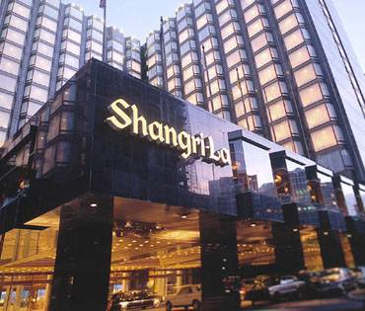
Figure 1: This depicts the Shangri-La Hotel in Colombo.
Source (Shangri-La, 2012)

Travelodge Hotels
Travelodge, on the other hand, operates primarily in the economy hotel segment, currently offering services in more than 575 locations in the UK, Ireland and Spain. Travelodge, therefore, aims to capture the market of low-end consumers who require cheap accommodation but do not want to stay in a substandard hotel. In the report Travelodge in 2023, the company's revenues were reported to be £1,035. 2 million, 14% more than the previous year (Travelodge, 2024). This shows the operational capacity of the enterprise and the clientele that looks for good value for their money in a commercial accommodation facility. By occupying the economy segment, Travelodge will achieve high sales volume, which will give the company relatively low operating costsand, hence, sustainable profitability with increased market penetration. These hotels provide essential services that are important for a comfortable stay without many of the luxurious features observed in some other hotels, which are suitable for business and other travellers who are on the move and in need of simple accommodation. Furthermore, Travelodge aims to polish the delivery of service by integrating technology and infrastructure in the booking system and in the guest experiences (López-Andreu et al., 2019). Concentrating on economy and usefulness does not downplay the quality of the properties or the clients' satisfaction.
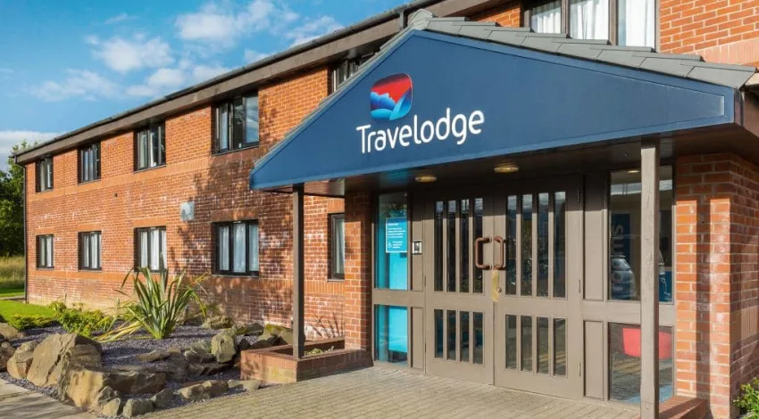
Figure 2: This depicts the Travelodge Kilmarnock.
Source (Travelodge, 2024)

Comparative Analysis

Total Revenue and Financial Health
Shangri-La Hotels
Shangri-La presents a good picture of its financial stability as it mainly derives its revenues from sales of services in the hospitality and business travel segments. The revenue of Shangri-La in 2023 was recorded to be at £1,713. 4 million, which means a 46. 5% increase compared to the year 2022 (Shangri-la, 2024). This growth can be attributed to its diversified global portfolio and the various continents where it operates, which minimises market and economic risk inherent in single-location operators.
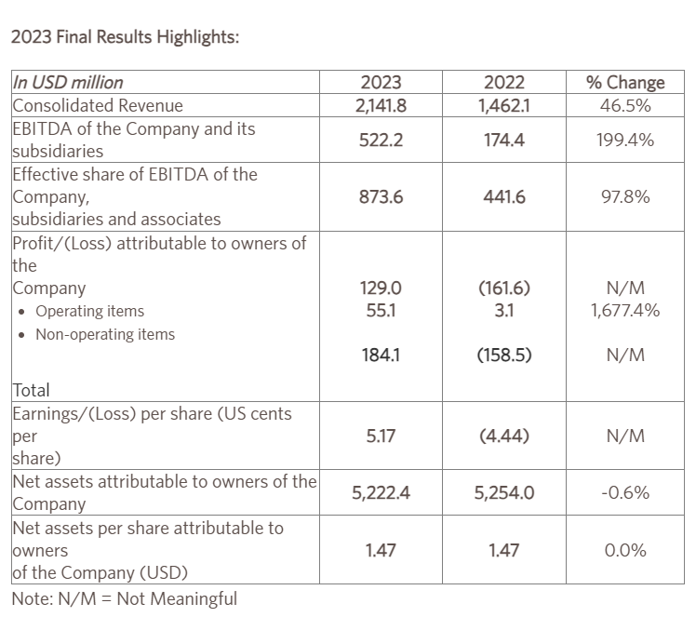
Figure 3: This depicts the annual result of Shangri-La Hotels 2023.
Source (Shangri-La, 2024)
Travelodge Hotels
On the other hand, Travelodge relies on its major source of income from low-end tourists and corporate organisations. However, based on the company's annual report, the total revenue in the year 2023 was £1,035. 2 million, and it has increased by 14% from the previous year (Travelodge, 2024). However, Travelodge remains profitable because this chain operates at a high level of velocity and maintains strict cost control; thus,Travelodge's business model is quite effective in providing low-priced hotel services.
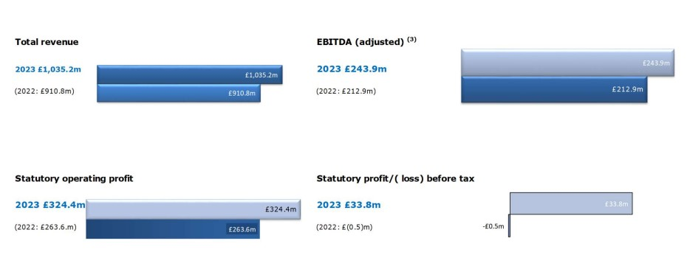
Figure 4: This depicts the annual report summary of Travelodge 2023.
Source (Travelodge, 2023)
Comparison
The Revenue per Available Room (RevPAR), a key metric in the hospitality industry, highlights the contrasting strategies of the two groups. Shangri-La's luxury positioning allows it to command a significantly higher RevPAR compared to Travelodge (Ning, 2021). However, Travelodge's streamlined and efficient operational model ensures it remains profitable, effectively catering to its market segment.
Hotel Group | 2023 Revenue | % Increase from 2022 | Market Segment | RevPAR
Shangri-La | £1,713.4 M | 46.5% | Luxury | High
Travelodge | £1,035.2 M | 14% | Budget | Moderate
Table 1: This depicts the Comparative Revenue Table.
This table illustrates the financial performance of both hotel groups in 2023, reflecting their strategic positioning and operational focus within their respective segments.

Market Positioning and Brand Perception
Shangri-La Hotels
Shangri-La Hotels and Resorts is a luxury brand targeted at the global luxury traveller business and the leisure traveller. Shangri-La is famous for luxurious amenities and high-quality service, ensuring guests have an exquisite time. This focus on luxury is illustrated through specific details in the hotel and the personalisation of guest relations. Consequently, Shangri-La maintains a high RevPAR, $200, in 2023, proving the effectiveness of its strategy to attract a target demographic with a preference for exclusive, upscale services and surroundings (Shangri-la, 2024). It also has strategic locations in some of the world's premier cities and tourist destinations, thus catering for affluent guests.
Travelodge Hotels
On the other hand, Travelodge is positioned to target guests who are on a low budget and would prefer to pay less for their lodgings, preferably families and businesspeople who will only spend one or two nights in a hotel. It is to provide facilities and amenities like a comfortable hotel at a low cost without giving the feeling of a cheap hotel (Kee et al., 2020). For example, Travelodge in 2023 could boast an average RevPAR of about $50, so they lay in the middle to low segment range. Now, Travelodge operates its hotels near transport facilities and urban areas across the United Kingdom, Ireland, and Spain. This has helped extend its market appeal to a large population of people needing low-cost accommodation.
Comparison
The comparison of Shangri-La's and Travelodge's market situations demonstrates significant differences inpositioning regarding the targeted customer segments. Shangri-La's luxury positioning also makes it possible to target high-end travellers whom consumers are willing to pay more for quality products and services. Therefore, while the limited range of services and amenities appeal to those cost-oriented leisure and business travellers, the company targets an even larger audience of those willing to pay less for a place to stay.
Hotel Group | Target Market | Brand Perception | Typical Guest Demographic | RevPAR
Shangri-La | High-end luxury | Luxury, quality, service | Wealthy business and leisure travellers | $200
Travelodge | Budget accommodations | Value, affordability | Budget-conscious families and business travellers | $50
Table 2: This depicts the Market Positioning Table.
This table summarises the strategic market positioning and brand perceptions of Shangri-La and Travelodge, showcasing how each brand effectively meets the preferences and expectations of its targeted customer base. The clear distinction in their positioning strategies highlights their respective focuses and market segments, from luxury to budget accommodations.

Growth Potential
Shangri-La Hotels
Shangri-La has great expansion prospects for development, especially in the rapidly developing countries where luxury tourism is quickly gaining popularity. The company has also focused on countries like Asia-Pacific, particularly having more than 50 hotels and the Middle East, with a five-year expansion plan to expand by 10% (Shangri-la, 2024). It is noted that luxury tourism in these regions is rising at a rate of 7-10% per year due to the growing prosperity and the shift towards luxury travel. The strategic direction of continuing growth can be seen from recent operations, such as initiating hotels in Saudi Arabia and the Maldives to target the high-end leisure and business traveller markets.

Travelodge Hotels
There are quite good prospects for Travelodge's development as a company, especially in the field of cheap accommodation in Europe. Travelodge currently operates approximately 570 properties and aims to grow this base by roughly 5% each year in the next five years across both metropolitan and developing regions (Travelodge, 2024). Specifically, the budget hotel segment in Europe has been growing at the approximate rate of 5-6 percent year-on-year due to the rising customer traffic in search of cheap accommodation. Travelodge operates at a low cost, which has enabled it to expand quickly and has increased its flexibility.
Comparison
Both Shangri-La and Travelodge exhibit robust potential for expansion but target different customer bases and geographic regions. Shangri-La focuses on high-end luxury markets, capitalising on the increasing demand for opulent accommodations (Nakai, 2021). In contrast, Travelodge aims to expand within the budget hotel sector, where demand continues to rise for economical travel solutions.
Hotel Group | Target Regions | Market Segment | Annual Growth Target | Key Growth Drivers
Shangri-La | Asia-Pacific, Middle East | Luxury | 10% over 5 years | Increase in luxury travel and high-income demographics
Travelodge | Europe | Budget | 5% annually | Rising demand for budget accommodations
Table 3: This depicts the Growth Potential Table
This table now includes specific growth targets and the key drivers for each hotel group, outlining their strategic plans and the market dynamics influencing their expansion strategies.

Financial Commitment to CSR
Shangri-La Hotels
Shangri-La has been traditionally famous for its extreme focus on Corporate Social Responsibility (CSR) and numerous investments in various sustainability projects. Currently, the brand invests about 1. 5% of its overall earnings in CSR initiatives, which address issues such as environmental protection, preservation of cultural assets, and social involvement (Emmanuel et al., 2024). Some of its projects are energy-saving initiatives, waste management, and local craftsmen's support, proving that Shangri-La cares for the environment of the host countries. Moreover, under the "Sanctuary, Shangri-La's Care for Nature Project", the company has embarked on various biodiversity projects in its properties globally.
Travelodge Hotels
In addition, Travelodge operates sustainably and spends 0. 5% of its annual revenue on community investment or CSR activities, as follows (Source: Travelodge, 2024). It covers environmental management, energy use, waste disposal methods of its own company, and community development contexts. Here are some ways that travel lodges have embraced corporate social responsibility: In various hotels, efficient illumination has been achieved using LED lights and devices that ensure minimum water consumption.
Comparison
Although Shangri-La and Travelodge are both involved in CSR, the scope and implementation of CSR in Shangri-La are more extensive and connected to its luxury segment, requiring more extensive communication with stakeholders (Ning et al., 2021). Travelodge is positioned as an economy hotel chain, and, therefore, it implements utilitarian sustainable solutions that might be interesting to its target audience.
Hotel Group | Annual CSR Investment | Focus Areas | Notable Initiatives
Shangri-La | 1.5% of annual revenue | Environmental sustainability, cultural heritage, community engagement | Sanctuary project, local artisan support
Travelodge | 0.5% of annual revenue | Environmental footprint reduction, community welfare | Energy-efficient lighting, water-saving devices
Table 4: This depicts the CSR Commitment Table.
This table outlines the financial commitment and key focus areas of CSR for each hotel group, highlighting the scope and scale of their respective initiatives. Shangri-La's more extensive investment reflects its broader CSR approach, aligning with its luxury brand image and global presence.

Recommendations
Shangri-La
Shangri-La should continue leveraging its strong market position in the luxury sector by enhancing digital transformations. This includes integrating advanced technologies such as AI to personalise guest experiences and streamline operations (Kee et al., 2020). Developing a robust digital ecosystem can help Shangri-La enhance customer engagement and offer services that exceed expectations, strengthening its competitive edge in luxury hospitality.

Travelodge
This opportunity implies that Travelodge can expand further by adopting technology to improve operations and consumption satisfaction. It also entails enhanced online reservation and mobile check-in forms to increase the number of clients (Ning, 2021). Furthermore, acquiring new channels to extend its targeting of young travel customers through social networks may significantly affect the growth of the company's cheap hotels segment.

Conclusion
Comparing the strategic management of Shangri-La and Travelodge, it is possible to state that the companies belong to different segments of the hospitality industry. Shangri-La competes directly through the luxury segment and global presence, focusing on quality and sustainability, unlike Travelodge,which focuses on the value proposition, efficiency, and growth. All the groups' strategies reveal where their brands are, what their target market is, and how they have positioned themselves in the market to address certain consumers' demands.

References
- Baxter, G. and Srisaeng, P., 2020. Environmentally sustainable hotel operations: The case of the Shangri-La Group. วารสารเพื่อการพัฒนาการท่องเที่ยวสู่ความยั่งยืน, 2(2), pp.1-26.
- Emmanuel, A.U., Hilda, O.O. and Adenubi, A., 2024. The Application of Eco-Aesthetic Principles into the Design Proposal of Hotels.
- Kee, D.M.H., Ang, Z.L., Woh, M.T., Soleimani, M., Jayant, J., Quttainah, M.A. and Pandey, R., 2020. Shangri-La Hotels and Resorts' People and Culture Strategy in Deriving Employee Satisfaction. Advances in Global Economics and Business Journal, 1(1), pp.1-11.
- López-Andreu, M., Papadopolous, O. and Jamalian, M., 2019. How has the UK hotels sector been affected by the fissuring of the worker–employer relationship in the last 10 years?.
- Nakai, A., 2021. Strategies of Forbes five-star hotels for attracting guests in Japan amid the COVID-19 pandemic.
- Ning, Y., 2021, December. Research on the Development Path of Wuhan International Brand Hotel Based on the Interpretive Structure Model Method. In Proceedings of the 2021 4th International Conference on E-Business, Information Management and Computer Science (pp. 435-443).
- Shangri-la (2024). Shangri-La Group. [online] Available at: https://www.shangri-la.com/group/media/media_post?post=Shangri-La%20Group%20Releases%202023%20Full%20Year%20Results.
- Travelodge (2024). Travelodge | Great value hotels throughout the UK & Ireland. [online] Travelodge. Available at: https://www.travelodge.co.uk/.
- Travelodge (2024). Travelodge Investor Site. [online] www.travelodge.co.uk. Available at: https://www.travelodge.co.uk/investors/home.
- Wu, S.Y., 2021. A Study on Promotion Strategies and Purchase Intention during the epidemic situation-In the Travelodge Industry.

