

LCDB7001: ENTREPRENEURIAL PERSPECTIVES

MODULE CODE LCDB7001

Research topic: Impact of entrepreneurship education on
entrepreneurial intention

Student ID: 1815478
Module Lecturer’s Name: Dr Gladius Kulothungan

Table of Contents
1.0 Introduction 2
1.1 Research Title 3
1.2 Background and Context 3
1.4 Research Rationale 4
1.3 Research Aim and Objectives 5
1.4 Research Questions 6
1.5 Research hypothesis 6
2.0 Theoretical framework – Models and theories used in the study 7
2.1 Discussion and selection of theoretical framework 7
2.2 Overview of theories 7
2.3 Theory of Planned Behavior 8
2.4 Shapero and Sokol`s Entrepreneurial Event Model 9
2.5 Conceptual Framework 10
3.0 Research methodology 11
3.1 Research approach 12
3.2 Research design 12
3.3 Research methods 13
3.4 Data sources 13
3.5 Sampling techniques 13
3.6 Data analysis tools 14
3.7 Ethical issues 16
4.0 Key literature and the gaps your research addresses 16
5.0 Facilities, access to required data and resources available for the investigation 18
References 19

Introduction

Entrepreneurship education is a process of giving knowledge and motivation to inspire the success of entrepreneurial activities (Ibrahim et al., 2015). Normally entrepreneurship education provides to various level of studies including school level, high school level as well as university level. According to Hala (2019), Entrepreneurial intentions indicate the attitudes and ideas of people to become self dependent. Entrepreneurial intentions are also connected with creative ideas and new development of concept in the entrepreneurship. In this research proposal; the effects of Entrepreneurship education will be described. This dissertation includes aim and objectives, backgrounds, theoretical framework and literature reviews on the topic and also finds the gaps of literature reviews. The methodologies used in for the dissertation are mentioned in this proposal.

1.1 Research Title

The title of the research is “critically analysis the impact of entrepreneurship education on entrepreneurial intention”

1.2 Background and Context
As the number of the program of entrepreneurship education is growing, there is a hope regarding the entrepreneurship impact on the entrepreneurial activity. The study unveils about the contribution of the entrepreneurship education program to the intention of entrepreneur. This study is important to the university environment. In spite of the lacking of clear scientific answers of entrepreneurship education on the students, the program is growing day by day. Katz (2018) said that Skills of the entrepreneur is the capacity to recognize and take advantage of lucky breaks and to design and oversee imaginative procedures that are of social, social or money related worth. A study by Menzies and Paradi (2013), in order to be a successful entrepreneur, one must have the knowledge of planning, managing, organizing, influencing and controlling. He or she also must have the skills such as creativity, problem-solving, mobilizing resources, communication, and coping with uncertainty, ambiguity and risk. An entrepreneur’s mind must be settled with several things which are self-efficacy, valuing the ideas of others, and motivation and perseverance (Fayolle, 2016). To make the entrepreneurship education powerful to improve the capabilities of students it is significant that the limit of the schools in making strong and invigorating learning conditions like the individual skills and inspiration of teachers. The segregation happening of entrepreneurship education can't happen in the outside of the school. It might require working in association with outside associations so as to encourage learning in different ways.
It is witnessed that a significant growth of entrepreneurship education has occurred in the developed countries in the past two decades (Lil and Wu, 2019). From 1979 to 2001 the number of entrepreneurship education programs has increased in the US (Katz, 2018) and the investment in entrepreneurship education programs is increasing day by day (Gwynne, 2018). The basic purpose of entrepreneurship education is to develop entrepreneurial capacities and mindsets into the university curriculum in European Commission. There is a positive impact of entrepreneurship education that is significant methodological deficiencies which in turn limit the result of the entrepreneurial education. The studies that have been done in the past could not measure the direct impact of an entrepreneurship education on the practical life. The excessively positive picture is thus flipped around and there is proof of just a couple of concentrates with vigorous research structures. There are several researches in the impact of entrepreneurship education. Peterman and Kennedy (2013) stated that in spite of the positive effect from entrepreneurship education, there is little rigorous research of the entrepreneurship education and its impact.
The previous studies of entrepreneurship education are-Paul et al. (2010) found that the entrepreneurship education and outcomes are under-researched and there is link between the two. There is a negative impact of entrepreneurship education which has found by two studies (Gwaynne, 2018). At second glance, there is a positive impact of entrepreneurship education that is significant methodological deficiencies which in turn limit the result of the entrepreneurial education (Menzies and Paradi, 2013). Oosterbeek et al. (2010) state that there should be more research on different base of entrepreneurship education programs, and it is availed that entrepreneurship education system has very little effect. According to some researches there is a continuous effort to expand entrepreneurship education program. On the other hand, there is a lack of effective research and results regarding the impact of entrepreneurship education.

1.4 Research Rationale

There is both the ambiguous results about the impact and lack of effective studies. Thus, it is necessary for the entrepreneurs to understand the impact of entrepreneurship education on entrepreneurial activities. The research question is that how entrepreneurial intention develops throughout an entrepreneurship education program. It is imperative to comprehend whether there is a connection between the length of an enterprise training system and conceivably expanding contact with length. The short program motivates participants on the other hand long program can de-motivate participant. Matthews and Liguori (2018), identifies that the research gap is the stability of entrepreneurial intentions and the questions are about do we need to achieve lasting changes (Mahendra et al., 2017).

As the entrepreneurship education has a positive impact on entrepreneurial intentions it is a matter of consideration that how long the impact last? If at the end of the entrepreneurship education program the strength of entrepreneurial intentions fall there would be an important impact regarding the entrepreneurship education programs. However, the entrepreneurs have to verify the strength and weakness of entrepreneurial intention at the end of entrepreneurship education program. Intention refers to the planned behavior (Higgins et al., 2018), while entrepreneurial intention is not about the planned behavior of venture creation (Shook and McGee, 2013). The researchers are ager about the longitudinal testing of the impact and influence of entrepreneurship education (Peterman and Kennedy, 2013), on entrepreneurial intentions and actual behavior (Souitaris and Zerbinati, 2017).

Souitiaris and Zerbinati (2017) mentioned that the major benefit of the entrepreneurship education programme is the trigger-events including the moments, experiences or events through entrepreneurship education programme which increase or decrease the intention of the entrepreneurs. Shapero and Sokol`s Entrepreneurial Event Model (1982), agree with them and mentioned that entrepreneurship education programs are "displacement event" which change perceptions of a target behavioral terms of feasibility and desirability (Fayolle et al., 2019). In entrepreneurship educational question arises about is the entrepreneurship education program source of trigger-events? If it is a trigger event then in which trigger-event the program has an impact on the intention of the entrepreneur? As a result the entrepreneurs have to identify and gather more relevant data about the positive and negative trigger-events that have impact on the entrepreneurial intention.

1.3 Research Aim and Objectives

Research Aim

The proposed study aims to analyze the impact of entrepreneurship education on entrepreneurial intention. To meet the purpose this study will aim to conduct both primary and secondary research. As part of secondary research, the proposed study will conduct a critical literature review. As part of primary research, the proposed study will, first, formulate suitable research methods and then conduct primary research focusing on the objectives defied.

Research Objectives

- To analyze the impact of entrepreneurship education on entrepreneurial intention
- To understand the effectiveness of duration of entrepreneurship education on entrepreneurial antecedents and intention
- To analyze the impact of entrepreneurship program on stability of entrepreneurship intention
- To explore how entrepreneurial education and intention influence self-employment
- To find out trigger-events in entrepreneurship education program which influence an individual to be an entrepreneur

Research Questions

- What is the impact of entrepreneurship education on entrepreneurial intention
- How duration of entrepreneurship education does affects entrepreneurial antecedents and intention?
- How does entrepreneurship program affect stability of entrepreneurship intention?
- How does entrepreneurial education and intention influence self-employment?
- What
- What trigger-events of entrepreneurship education program do influence an individual to be an entrepreneur?

1.5 Research hypothesis

H1: Entrepreneurship education program has positive impact on entrepreneurial intention
H2: Greater attitude of self-employment has greater impact on entrepreneurial intention
H3: Longer entrepreneurship education programme has positive impact on entrepreneurial intention
H4: Higher time elapse after the end of an entrepreneurship education programme has negative impact on entrepreneurial intention
H5: Higher entrepreneurial intention positively encourages individuals to be self-employed

2.0 Theoretical framework – Models and theories used in the study

2.1 Discussion and selection of theoretical framework

This section of the chapter includes the explanation of merits and demerits of related models of the questions and objectives of the research that are prescribed before. This explanation helps to develop the theoretical framework of the dissertation. The model of entrepreneurial event and planned behavior model have 2 kinds of strengths. The both model comprised with the statistical data (Kollmann and Kuckertz, 2016). This model has several merits and helps to develop concept and framework for the research. The both methods affect the intentions of the theory developer (Souitaris and Zerbinati, 2017) stated that entrepreneurial behavior is connected with entrepreneurial event model (EEM). It is considered as a variable that indicates that the reasons of becoming an entrepreneur and stating the potential behavior of the entrepreneur. The propensity factors are related with the model of entrepreneur. Shapero and Sokol suggested that this variable is not an original model but the improvement and development of the model of entrepreneur depends on this variable (Katz, 2018). According to The entrepreneurial event model; the process of creating new and modern business and developing process of business are mentioned but not only the behavior pattern of the entrepreneur.

2.2 Overview of theories

After analyzing the literature review related with entrepreneurial intention & entrepreneurship education, the model and theory of Icek Ajzen’s is more suitable (Fayolle et al., 2019). This event model related with planned behavior is applied in several entrepreneur behavior analyses (Linan and Javier Santos, 2007). For this reason; the main review of the research is concerned with 2 models or theories.

According to the theory of event model related with planned behavior, there are two contributions for analyzing the intention research as well as evaluating the planned behavior of the entrepreneur. The first contribution is connected with self-efficacy that suggested by Busenitz et al. (2013). Self-efficacy is a concept of entrepreneur that indicates the confidence and belief of the people about their own strengths and abilities to perform a task successfully by ensuring the efficiency level of performance. In case of entrepreneurship intention dissertation; the self-efficacy concept is widely applied to gain equality in the actual behavior and performance with the planned behavior of the entrepreneur. The second concept is termed as Bird’s model of intention. This model is suggested by Barbara Bird (1988). According to this model; the most vital part is that the necessity of intentions of the entrepreneur for developing the state of the organization as well as the better executing of the entrepreneurial opinions, plans and ideas (Bechard and Gregoire, 2015). According to this model; the entrepreneurial intentions and ideas are very effective and also rational, based on analysis of cause effect relationship and holistic. Additionally; this theory of event model also suggested and developed by (Dickson and Weaver, 2018).

2.3 Theory of Planned Behavior

The root and basic platform of planned behavior theory is connected with the Theory of reasoned action (TRA). This theory is suggested by (Ajzen and Fishbein, 1980). According to this theory; there are three consecutive factors are related. The first one is behavioral intention, the second one is subjective norms and final one is attitudes. The first factor ‘behavioral intention’ normally is perceived on the basis of following two factors subjective norms and attitudes. It can be stated that the stronger the positive attitudes and social norms, the stronger the behavioral intention. This represents that there is perfect positive relationship among these three factors. The intention affects the attitudes and norms of an entrepreneur. Therefore; the high level of intention prosperity depends on the high level of positive behavior and attitudes (Andrew et al., 2012). Behavioral intention (BI) is used as a tool of measuring strengths and weaknesses of specific subjective norms and attitudes. Subjective norms (SN) explains the process of removing the pressure and challenges from friends and others through the special use of norms. One example can make it clear; suppose when an entrepreneurship gets more pressure from family members and friends, it is hard for the entrepreneurship to perform effective attitudes and norms. Normally this theory consists of the following issues:
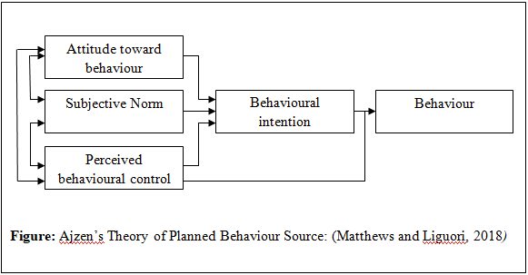

2.4 Shapero and Sokol`s Entrepreneurial Event Model

Shapero and Sokol introduced the entrepreneurial event model (EEM) in 1982 and at the time of introducing the model it was not proposed as intention model. But it was quickly used and seen in the literature as an entrepreneurial intention model (Katz, 2018). The model explains about the process of leading the entrepreneurial event in launching a new business (Hala, 2019). According to the model some inertia leads human behavior as long as some events are displaced. This inertia are previously undesired behaviors. An example about the inertia is a displacement from a job increase the desirability of self-employed.
Shapero and Sokol (1982) mentioned that there are three categories of life path changes those are: the first category is the negative displacements such as being fired, angered, getting divorced or becoming widowed, insulted, bored, reaching middle age. The second category is about getting the things such as graduating from high school, university, finishing military duty or being released from jail. This category is special because it is potentially interesting for entrepreneurship education programs as the students as the students are confused about what to do after graduation.
The third category is about the positive nature which is the positive pulls from the partner, investor or customers and mentor. According to this category behavior depends on the credibility of the alternatives and the propensity to act of the entrepreneurs. The perceived desirability and feasibility of the specified behaviors are the credibility in this context (Kollmann and Kuckertz, 2016). Thus, the perceived desirability and feasibility are not enough to execute a specified behavior. For the execution of the specified behavior, a precipitating event, a displacement event and propensity to act are needed. Accordingly, if a displacement event triggers intellectual procedures and changes view of plausibility and attractive quality, the individual may act if the validity of the predetermined conduct is higher than that of the choices and if the individual has a general penchant to follow up on that activity.
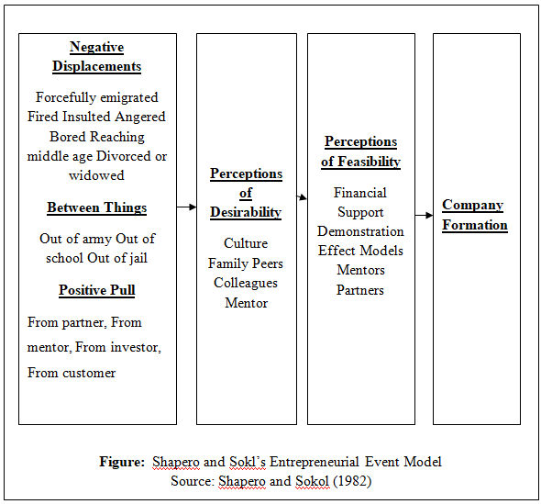

2.5 Conceptual Framework

Several constructs like attitude toward behavior (ATB), perceived behavioral control (PBC), subjective norms (SN) and entrepreneurial intention (EI) are used to measure the impact of entrepreneurship education. The participation in entrepreneurship education increases above constructs and the relationship is positive. The short duration of entrepreneurship education limits the strength the impact of the entrepreneurship education. The constructs get stronger with the longevity with the entrepreneurship education program. As the time elapsed after the completion entrepreneurship education program the value of the constructs is decreasing. As more time elapses the values of the constructs decrease. The theory of planned behavior is discussed as follows. The following dataset is used to verify the applicability of the theory. In this theory the relation between entrepreneurial intention and self-employment is verified. The probability of self-employed is increased with the entrepreneurial intention. At the final stage the review is made about the impact of the entrepreneurship education on the impact of the it on the self-employment. The review also verifies whether there is a of the increase or decrease of the entrepreneurship education on self-employment.
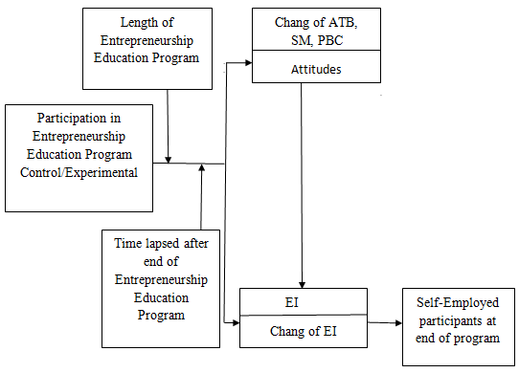
Figure: Conceptual framework

3.0 Research methodology

According to Robson (2016), methodology is a term that defined as the scientific methods of solving the problems or answering the questions related with a research. This research has also some questions about the research topic ‘the impact of entrepreneurship education on entrepreneur activities’. For this reason; methodology is required completing the dissertation and answering the questions related with a research. This chapter describes the various approaches, designs, methods, sources and sampling techniques of the research and mentions the actual methodologies of this research functions.

3.1 Research approach

One of the important methodologies of the research is concerned with the approach of the research. It has two kinds inductive and deductive (Robson, 2016). Based on the research questions and objectives; it is an accurate decision to apply the deductive approach. In case of both questions and hypotheses of the research; this approach is considered as the most suitable and effective to find the exact impact of the research topic. Along with the deductive approach; this dissertation also is used the quasi-experimental design that also very helpful to meet up the exact outcome of the research topic. The questionnaire is one of the vital methods of gathering the available primary information for this research work (Robson, 2016). According to base on the research topic, this approach is very suitable to measure and evaluate the development of entrepreneurial intentions of individual who takes participate in the programme. in case of deductive approach; the first process includes the review on the research topic and after that the depended and independent variables are analyzed (Saunders, 2015). This approach has used sampling technique to collect data and analyze the depended and independent variable. In the same way; this research has two variables; first variable is entrepreneurship education and other is entrepreneurial intention”. Therefore; the research questionnaire is structured and depended on the research variables.

3.2 Research design

Research design may classify into various types including exploratory and descriptive. Exploratory design of the dissertation applies at the time of new research when the no exact information is known the researcher or the researcher has a little knowledge of the research topic (Saunders, 2015). . At this design; most of the researcher tries to demonstrate new and modern ideas, generate hypothesises and test the hypothesis through feasibility study (Robson, 2016). Descriptive design of the dissertation applies at the time of existing research when the information is known to the researcher or the researcher has an adequate knowledge of the research topic (Saunders, 2015). At this design; most of the researcher tries to demonstrate the answer of who, where and what. According to based on the research questions; the exploratory design is suitable to generate hypothesises and test the hypothesis through feasibility study.

3.3 Research methods

Research methods are connected with the quantitative as well as qualitative ways (Robson, 2016). According to based on the research questions; the not only the quantitative but also the qualitative methods are suitable to generate hypothesis and test the hypothesis through feasibility study. The structured questionnaire is applied to collect quantitative data for this work.

3.4 Data sources

The mix of primary and secondary data is applicable for this research. The sources relating with primary date collection normally includes the interview, observation, case studies, and questionnaire (Robson, 2016). Basically; the past research works relating with this research topic, official statistics, website, government report journals articles are the main categories included in the sources of secondary data. The structured questionnaire is applied to collect, develop and generate quantitative data for this dissertation.

3.5 Sampling techniques

The term ‘Sampling’ is a very popular term in the research field. It mentions the use of small part of population but matter of fact that this part focuses the views of whole population. Basically this sampling has two types’ probability and non-probability sampling (Saunders, 2015). Probability sampling is connected with probability by which all members of population have a chance to response (Hakim, 2014). But Non-probability sampling is connected with non-probability by which all members of population don’t have a chance to response (Hakim, 2014). In case of survey in the entrepreneurship education programme, probability sampling is applied but in case of questionnaire; this research is used 100 students of both participating entrepreneurship education programme or not. 75 students are participating but remaining 25 are not. Another reason of using non probability sampling is for taking interview of the 15 students who participated in entrepreneurship education program.

3.6 Data analysis tools

Quantitative data analysis

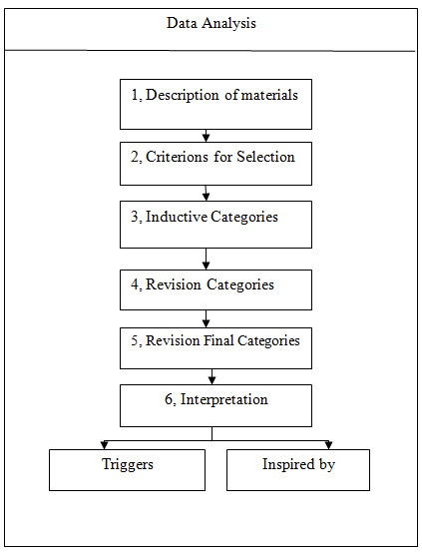
The above figure shows the method of analyzing the quantitative data analysis in case of a dissertation. This research analyses the quantitative data by following specific stages. First stage is the description of materials, second is the criterion for selection, third is the inductive categories, fourth is the revision categories, fifth is revision final category is the interpretation on the basis of triggers and inspired (Hakim, 2014).

Qualitative data analysis
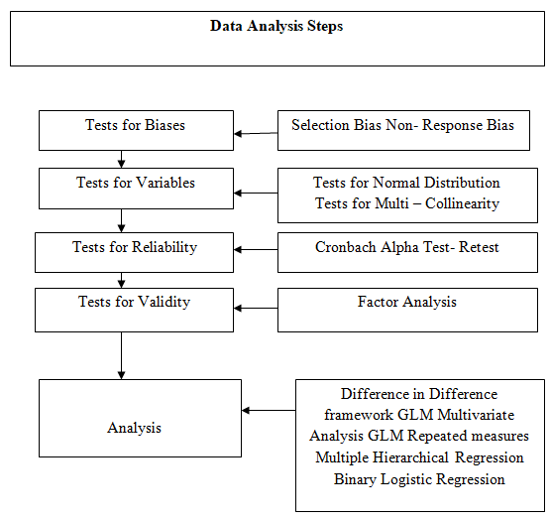
The above figure shows the method of analyzing the qualitative data analysis in case of a dissertation. The first step is the selection bias non- response, then test for variables; test for reliability and validly of the research qualitative data and finally analysis the data carefully to ensure the outcomes of the research objectives (Hakim, 2014).

3.7 Ethical issues

The ethical issues are related with the morality, and rules and regulations of the research work. This research is followed the ethical issues strictly to meet up the research questions answers and obtain the research objectives as well as ensure the research acceptability to the respected party (Hakim, 2014). This research is free from bias and no pressure on the participants to response the questionnaire. The personal information of the respondents are strictly controlled and prepared the research according to guidelines of the supervisor.

4.0 Key literature and the gaps your research addresses

Most of the literature reviews are concerned with the specific or only one field of related study but entrepreneurship education has an impact of several fields. Gwynne (2018) mentioned that there is a huge gap between the actual outcomes of the entrepreneurship education impact in the previous studies that’s why; there is a potential opportunity to do another research for identifying impacts. Patricia and Silangen (2016) said that the exact relationship between entrepreneurship education and entrepreneurial intentions are still not addressed. According to Ortiz et al. (2015), it will require more research works for identifying the real impact of entrepreneurship programmes. Marzi and Caputo (2018) mentioned there is a little outcome produced in the field of study. The large part of the outcomes is still unknown to the previous researchers.

At this dissertation; the participants are provided their opinions in the questionnaire and found that the school students do not have enough knowledge about the concept of entrepreneurship. Due to this reason; the school students are able to set the future career as an entrepreneur (Dickson and Weaver, 2018). But the situation of university students is different because they have adequate knowledge and information of the concept of entrepreneurship and they are well informed about the economic and other environmental factors to take better decision for becoming an entrepreneur. On the contrary; some university students do not want to become an entrepreneur. That’s why; it is compulsory to provide adequate entrepreneurship education to them for ensuing the better entrepreneurship intentions. The study of Marzi and Caputo (2018) revealed that the compulsory entrepreneurship programmes in the school and university levels produce a voluntary significant. However, the research on university level is not well developed and that is why; it is necessary to do another research on the impact of entrepreneurship programmes in the university level. The previous studies on the entrepreneurship educational programmes produce four outcomes including the effect of lengths of the entrepreneurship education on entrepreneurial intention, the post period efficiency of entrepreneurial education program, the exact relationship between entrepreneurial intention and programs and finally the related trigger-events connecting with educational programs (Higgins et al., 2018).

Fayolle (2016) identified in his study the answer of the effectiveness of educational programmes on entrepreneurial intentions. He also suggested that there is greater influence of entrepreneur programs on the intentions of the entrepreneur but a little purpose. According to Fayolle et al. (2019), there is needed to do study on the entrepreneurship educational programmes for finding large and effective outcomes of the research topic. Although Gwynne (2018) suggested that the effect of entrepreneurship education is long-term basis and his study has prepared as short term basis as well as not measured the post stability of the programmes. Fayolle (2016), Souitaris and Zerbinati (2017) mentioned that the some important key points are missing in the previous studies that will be presented in the further dissertation on the educational programmes on entrepreneurial intentions. According to the study of Souitaris and Zerbinati (2017), the new and modern approaches are used in the research and identified the major advantages of entrepreneurship education programme. Most of the researcher only focused the little part of the advantages of entrepreneurship education programme. For this reason; this study will comprise the both advantages and disadvantages of entrepreneurship education and will find the actual impact of it on the entrepreneur intentions.

A study by Shook and McGee (2013) show that the previous studies failed to establish link between entrepreneurial intention and venture creation. Additionally, several authors have done longitudinal researches understand the link between self-employment as well as entrepreneurial intention (Patricia and Silangen, 2016). As entrepreneurial intention is considered as one of the effective measure of the development of entrepreneurship education, it has significant impact on the economy and society that have come under deep consideration of researchers. Majority of the researchers have focused on entrepreneurship education and improvement of skills entrepreneurship. However, Souitaris and Zerbinati (2017) have developed a new concept regarding the benefits of entrepreneurship education program. The key finding of this research is that entrepreneurship education program can play a significant role to find out entrepreneurship trigger-events which in turn influence the intention of entrepreneurs. This finding was supported by other study done by Souitaris and Zerbinati (2017), where the finding of their research discloses that more researches are needed on the triggers of entrepreneurship education programmes. Additionally, very few studies were conducted on how languages affect entrepreneurship opportunities.

Further, larger sample size including big number of people can benefits the further researcher to meet the aims and objectives of this proposed research. Then, detailed investigations as well as analysis of entrepreneurship education programmes are needed to meet the research goals. This is because it is essential to test how good practice programme affect individual intention, rather than considering variability of programme content. Souitaris and Zerbinati (2017), suggested to do further study on the comparison of good practice of entrepreneurship education regarding entrepreneurship intention that needs to develop self-reported measures for identifying imminent risk of research reliability and validity. Then, the impact of time as well as duration on entrepreneurial intention is great interest for practitioners and education studies due to their resource utilization and effectiveness. Marzi and Caputo (2018) suggested that entrepreneurship education is active in current world. The more an individual learns the more they get opportunity of entrepreneurship in business world. Finally, there has been vague idea regarding the theory of planned behavior that encourage the researchers to further test and evaluate this theory. In this case, the researchers can focus on time aspects and develop a link between self employment and entrepreneurial intention.

5.0 Facilities, access to required data and resources available for the investigation
The researcher has good facilities to accomplish the proposed study because the researcher is financial capable and has available time to do the research. Additionally, the researcher has wider access to required data. The researcher has access to his university resources. Additionally, several other resources can be accessed as required. The researcher has available resources including knowledge and technologies, times and financial capability to complete the proposed study. Thus, the researcher strongly believes that the proposed study can successfully completed on time.

References

Armitage, C. J. and Conner, M. (2011) Efficacy of the Theory of Planned Behaviour, British Journal of Social Psychology, Vol. 40 (2), P.371-399.
Andrew C. Jerome C. Katz (2012). Entrepreneurial Action, 2nd Ed. City: Oxford: McGraw Hill
Busenitz, L. W., Shepherd, D. and Zacharakis, A. (2013) Entrepreneurship Research in Emergence, Journal of Management, Vol. 29(3), P.185-208.

Bechard, J. and Gregoire, D. 2005. Entrepreneurship Education Research Revisited, Academy of Management Learning & Education, Vol. 4(1), P. 22-43.

Cohen, L. and Manion, L. (2018) Research Methods in Education. 3rd Ed. London: Routledge.

Dickson, P. and Weaver, K. M. (2018) Entrepreneurial selection and success, Journal of Small Business and Enterprise Development, Vol. 18(2), 139 - 158.

Fayolle, A. Kyro, P. and Linan, F. (2015) Developing, Shaping and Growing Entrepreneurship. 4rth Ed, City: London: Prentice Hall

Fayolle, A. (2016) Effect of Entrepreneurship Education and Social Context on Student`s Intention, Journal of International Management, Vo.24 92), P. 309-323.

Fayolle, A. Kariv, D and Mataly, H.(2019), The Role and Impact of Entrepreneurship Education, 5th Ed. City: London: Kogan Page

Gwynne, P. (2018) More Schools Teaching Entrepreneurship. Research Technology Management, 51(2), P. 16-28.

Hakim, C. (2014) Research Design: Successful designs for social and economic research. 2dn Ed. London: Routledge.

Hala, H. (2019). The impact of entrepreneurship education on entrepreneurial intention, Journal of Entrepreneurship, Vol. 23 (1), P.1-18
Hytti, U. and Kuopusjarvi, P. (2014) Evaluating and measuring entrepreneurship and enterprise education, Journal of Business Venturing, Vol. 20 (2), P. 245-253
Higgins D. Jones P and McGowan.(2018) Creating Entrepreneurial Space. 4th Ed. City: Harlow: Prentice Hall.
Ibrahim, W, N, A. Bakar, A. Asimiran, S. Mohamed S. and Zakaria, N, S. 2015
Impact of Entrepreneurship Education on the Entrepreneurial Intentions, Journal , International Education Studies, V, 8 (12) p141.

Ireland, R. and Webb, J. (2017) Exploration of Entrepreneurship Research. Journal of Management, Vol. 38(3), P.391-427.

Katz, J. A. (2018) A Different Perspective on the State of Entrepreneurship Education, Journal of Small Business Management, Vol.55(4), P.350-366.

Kollmann, T. and Kuckertz, A. (2016) Venture archetypes and the entrepreneurial event, Journal of Enterprising Culture, Vol. 14(1), P.27-48.

Li, L. and Wu, D. (2019). The Entrepreneurial education and students' entrepreneurial intention. Journal of Global Entrepreneurship Research. V,( 1 )P 1-13

Linan, F. (2014) Intention-based models of entrepreneurship education. 3rd Ed. Harlow: University of Seville.
Marzi G. and Caputo A. (2018), Responsible Entrepreneurship Education, 3rd Ed, City: London: Pearson Publication.

Menzies, T. and Paradi, J. (2013) Entrepreneurship education and engineering students, International Journal of Entrepreneurship & Innovation, Vol. 14(2), P.121-132
Matthews C, H. Liguori E,W.( 2018), Annals of Entrepreneurship Education and Pedagogy, 3rd Ed, City: Oxford: Sage Publication
Mahendra, A, M. Djatmike, E, T and Hermawan, A . (2017) The Effect of Entrepreneurship Education on Entrepreneurial Intention. Journal of International Education Studies; Vol. 10, No. 9; p 1-9
.Maresch, D . Harms, R. Kailer, N. and Wurm , B,W . The impact of entrepreneurship education on the entrepreneurial intention, Journal of Technological Forecasting and Social Change ,V.104 (2016). P,172-179
Mahendra ,A , M. Djatmika, E, T. and Hermawan, A. The Effect of Entrepreneurship Education on Entrepreneurial Intention. Journal International Education Studies; Vol. 10, P1- 9. 2017
Mwasalwiba, E. S. (2010) Entrepreneurship Education: A Review of Its Objectives, Teaching Methods, and Impact Indicators. Education & Training, Vol. 52(1), P. 20-47.

Neck, H, M. Greene, P, G. and Brush, C, G. (2014) Teaching Entrepreneurship. 2nd Ed. City: Harlow: Pearson Publication.

Oosterbeek, H. and Ijsselstein, A. (2010) The impact of entrepreneurship education on entrepreneurship skills and motivation. European Economic Review, Vol. 54(3), P.442-454.

Ortiz P, M. Gomez, J, A. Torres F, B. and Armengot C, R. (2015). Education Tools For Entrepreneurship 2nd Ed, City: London: Prentice Hall.

Patricia, P. Silangen, C. (2016) The Effect of Entrepreneurship Education on Entrepreneurial Intention. Journal, DeReMa (Development Research of Management): V,11(1) P,1-184

Page W. Elizabeth J. and Shaver K, G. (2009). Handbook of University-wide Entrepreneurship Education. 3rd Ed. City: London: Kogan Page
Paul D. Reynolds R. and Curtin. (2010). New Business Creation: An International Overview. 2nd Ed. City London: Prentice Hall
Peterman, N. and Kennedy, J. (2013) Enterprise Education: Influencing Students' Perceptions of Entrepreneurship, Entrepreneurship: Theory & Practice, 28(2), P. 129-144.

Ratten, V. and Ratten, H. (2017) Social cognitive theory in technological innovations, European Journal of Innovation Management, Vol. 10(1), P. 90-108

Robson, C. (2016) Real World Research. 3rd Ed. Oxford: Blackwell.

Saunders, M. (2015) Research Methods for Business Students. 8th Ed. London: Prentice Hall

Shook, C. L. and McGee, J. E. (2013) Venture Creation and the Enterprising Individual: A Review and Synthesis, Journal of Management, Vol. 32(3): 179-199.

Souitaris, V. and Zerbinati, S. (2017) Do entrepreneurship programmes raise entrepreneurial intention? Journal of Business Venturing, Vol. 26(4), P.66-91.

Thompson, E. (2019) Individual Entrepreneurial Intent, Entrepreneurship: Theory & Practice, Vol. 33(3), P. 269-294.

