LCBB4002
Community Engagement
Assessment 2
Reflective Evaluation

Student name: sabrina izmana
student number: 1909493
lecturer’s name: tanja nathan

Reflective practice is a way of studying one's own experience, following some steps for improvement. This has benefits in self-knowledge which is a key component in emotional intelligence and understanding development.
Reflective practice develops the ability to think creatively, critically analyse and make decisions Reflective practice is the way to recognise and realise what we learn and the information we receive. The reconfiguration and ordering of what is known to us requires an active participation in the learning process, correlating ideas and concepts with personal experience.
Reflecting on developing the information we know, this realisation allows us to understand what we asked for, why we did it and how it happened. Through reflection, learning is accumulated, a prioritised and personalised. Viewing problems from different perspectives causes assumptions and patterns of stable component and increases the imagination in thinking.
Reflective practice has the result: increasing self-awareness, critical analysis, ability to regulate emotionally, increase communication skills and decrease fear of expression.
Reflective practice has helped me to understand the mistakes but also the good things done in a work.Recently at the University I had to write a report on Volkswagen Group, I had to analyse the company and therefore make the report of 2000 words.First of all I was extremely scared and confused because it was the first time I had to do this but I downloaded it.Reading all this information I learned a lot of new things but my mistake was that I did not make a writing plan after which it was much easier for me to write because I read too much information that was in excess.
In writing this report on Volkswagen Group I also used the time during university hours because sometimes I did not have time at home but so I should not do because on January 16th I have an exam at accounting fundamentals and writing the report I was not attentive to hours. More I do not repeat this mistake again.
The steps I followed in the report helped me to write faster only because at the beginning of the report I was confused my thoughts were flying and for a few days I could not get hold of it because I knew a lot of information but I still did not realise How to start and how to restructure to be as understandable as possible.
The mistake was that I started writing a report without studying what it means, how to write it, and what writing steps it has.Now that I have analysed the mistakes, I have studied the steps and terms of a report and the next time I will be able to write quickly and without fear, of course, having had the experience would have been easier for me than the experience of beating the theory.
What we learn in everyday life and what we write in school The college college has no value without experience.
The relevant theory and experience both highlight your knowledge.
So the experience is a knowledge or skill regarding a certain job or activity that we have accumulated over time, since we have been dealing with this for a very long time.While the theory of relevance is the principle that the communication process involves not only coding, transferring and decoding but also many other elements including inferences and context.
Together with experience, we also learn the theory of relevance because you cannot go out in front of an audience and communicate concrete facts without fear if you have no experience.But there are also different things between these two:

Theory of relevance Experience
In different environment The environment In a certain environment

Requires less time in knowing Time For experience it takes a long
Steps theory Time to demonstrate knowledges

Demonstrate the knowledge of The mode You demonstrate your
The theory by the way you Experience by the way you work
Write and communicate

These two components are extremely important now.
I also needed experience and theory of relevance in a role play from the university to the lesson Community engagement where as an exercise I had to say a problem and the steps to solve it within a job such as I chose housekeeping as this is the field I am currently working on, it has helped me a lot in the experience to handle the assignment given.
The lack of theory gave me a little trouble.
My success was in the fact that I was able to explain the problem concretely and I explicitly expressed its solution.
But you wonder what is a role-playing game? It is an activity of communication either in your role or in the role of someone else using imagination or reality.This work can be done in groups but also individually, this technique is an excellent tool for students to be involved and interact more actively with their colleagues, and at the end of this game the person chosen by the teacher gives you feedback.
As I stated above, I discussed well the explanation of problems and the solution but I still have to work on how to express myself,I have to work with mastery of emotions and bring a wider context in this game.
Conclusion
WE all make mistakes but we must analyse them, reflect on them and so we will be able to grow in knowledge and skills.They always analyse many times and then after the work, it says that the Romanian Proverb '' seven times measures and once cuts '' before making important decisions it analyses well and then gives action to your thoughts.
We must work hard to gain experience as well as life and work, study hard to evolve the relevant theory within us and thus obtain them all with great care.

P.S Never leave the work for the last hundred meters as I did because because
of the Holidays of other assessments
I was not able to write the words needed in this project!

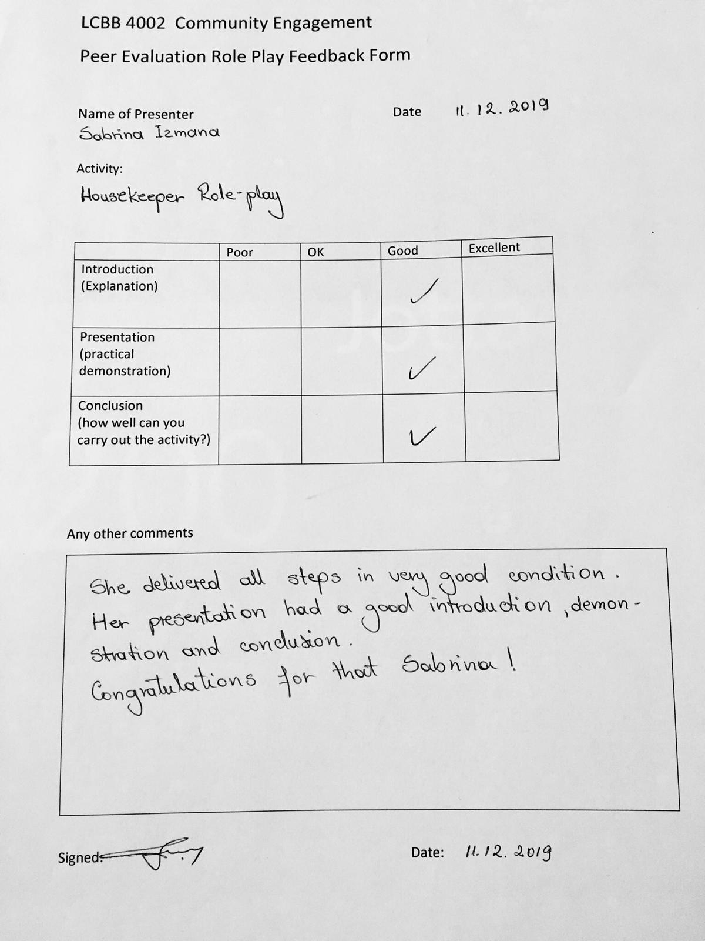

References

- https://www.cambridge-community.org.uk/professional-development/gswrp/index.html Cambridge International Education Teaching and Learning Team
- his paper outlines the main assumptions of relevance theory (Sperber & Wilson 1985, 1995, 1998, 2002, Wilson & Sperber 2002) https://www.phon.ucl.ac.uk/publications/WPL/02papers/wilson_sperber.pdf
- https://www.collinsdictionary.com/dictionary/english/experience

