
SUSTAINABILITY IN THE CLEANING INDUSTRY:
OPPORTUNITIES AND CHALLENGES
A Case Study of Principle Cleaning Services
Independent Project / Dissertation LCLM6005
Author: Adney Sacramento
Student Number: 2317949
Supervisor: Rameses Manalang
Institution: University of Wales Trinity Saint David
Date: July 2026

Tables of Contents

Tables of Contents 2
Abstract 4
CHAPTER 1: INTRODUCTION 5
1.1 Context of the Study 5
1.2 Problem Statement 6
1.3 Aim 6
1.4 Objectives 7
1.5 Research Questions 7
1.6 Significance 7
1.7 Scope and Limitations 7
CHAPTER 2: LITERATURE REVIEW 9
2.1Introduction 9
2.2 Theoretical Foundation: The Triple Bottom Line 9
2.3 Sustainability in Service and Facilities Management 11
2.4 Green Cleaning Practices and Opportunities 12
2.5 Challenges and Barriers 13
2.6 Theoretical Framework 14
2.8 Case Study: Principle Cleaning Services 15
2.9 Gaps in the Literature 16
CHAPTER 3: METHODOLOGY 17
3.1 Introduction 17
3.2 Research Philosophy 17
3.3 Research Approach and Design 17
3.4 Research Strategy: Single Case Study 18
3.5 Data Collection Methods 18
3.6 Sampling 19
3.7 Data Analysis 19
3.8 Ethical Considerations 19
3.9 Reliability, Validity and Limitations 20
3.10 Chapter Summary 20
CHAPTER 4: RESULTS AND DISCUSSION 21
4.1 Introduction 21
4.2 Strategic Architecture and Organisational Structure 21
4.3 Drivers and Motivations 23
4.4 Governance, Certification and Reporting 24
4.5 Barriers to Implementation 25
4.6 The Social Pillar: People, Wellbeing and Community 27
4.7 Balancing Sustainability with Cost and Client Expectations 29
4.8 The Role of Technology and Innovation 30
4.9 Anticipated Future Demand 31
4.10 Synthesis and Discussion 31
CHAPTER 5: Conclusion, Recommendations and Limitations 34
5.1 Summary of Key Findings 34
5.1 Conclusion 34
5.2 Recommendations for the Organisation 35
5.3 Recommendations for Future Research 36
5.4 Limitations of the Research 36
6. REFERENCES 38
Appendices 43
Appendix 1: Application for ethical approval 43
Appendix 2 Participation Consent Form 58
Appendix 3 Participant Information Sheet 60
Appendix 4 Interview Questions 62
Appendix 5 Environmental policy 63
Appendix 6 Earth Day 71
Appendix 7 Suitability Spotlight 77
Appendix 8 Workplace wellbeing certificate 81
Appendix 9 Planet Mark Certificate 82
Element 2 83
Kolb’s reflective model 83
Element 3 85
Methodology poster 85

Abstract

Sustainability has become a critical concern in the cleaning industry as clients' expectations and environmental rules are becoming more stringent. The possibilities and difficulties of adopting sustainable practices are examined in this dissertation.
Using Principle Cleaning Services as a case study and guided by the Triple Bottom Line framework (people, planet, profit).
Using a qualitative case study approach that draws on primary and secondary data and document analysis, the research examines the company's environmental initiatives, including the use of green cleaning products, waste reduction, and energy efficiency measures. Findings reveal that adopting sustainability enhances brand reputation, client retention, and competitive advantage, yet is constrained by higher operational costs, insufficient staff training, and supply chain limitations.
The study recommends targeted investment in employee training and long-term cost-benefit planning to support wider industry adoption.

CHAPTER 1: INTRODUCTION

1.1 Context of the Study

Commercial cleaning holds an unusual place within facilities management: it is labour-intensive, fiercely competitive, and under growing public and client pressure over its environmental impact. Cleaning work consumes large quantities of water, energy and chemicals, generates significant single-use plastic waste, and depends on transport and equipment that add to carbon emissions, placing the sector firmly within wider conversations about how service industries, not only manufacturing, contribute to environmental harm.

The industry is now experiencing what commentators describe as a structural shift, as clients demand greener products, clearer reporting and visible social responsibility from providers (Novagems, 2025; ToolSense, 2023). Sustainability criteria are increasingly embedded in procurement decisions across both public and private sectors, turning sustainability from a marketing add-on into a condition of market access. With the global professional cleaning market projected to reach roughly $400 billion by 2027, and commercial and healthcare cleaning as its fastest-growing segments (Novagems, 2025), the scale of the sector means even small efficiency gains carry meaningful cumulative environmental benefit.

This study is grounded in the Triple Bottom Line (TBL), which judges organisational performance against economic, social and environmental criteria together rather than treating profit as the only measure of success (Williams, 2016). For cleaning specifically, this means sustainability is not just about switching to biodegradable chemicals, but also about protecting worker welfare, using resources efficiently, and staying commercially viable a balance that matters enormously in an industry built on low-paid, often outsourced labour. Recent bibliometric work confirms the TBL remains the dominant lens for studying corporate environmental and social performance (Sustainability, 2025), supporting its use as this study's guiding framework.
Within the UK, this thinking is increasingly visible in practice. Principle Cleaning Services, a London-based provider founded in 1989, now employee-owned with over 2,800 staff has publicly committed to becoming the UK's most sustainable cleaning company (Principle Cleaning Services, 2024), introducing a five-point sustainability plan, eliminating single-use plastics in parts of its operations, adopting water-recycling systems, launching a stakeholder-informed ESG strategy, and trialling autonomous window-cleaning robotics (Principle Cleaning Services, 2023; Tomorrow's Cleaning, 2025). Together, these initiatives make Principle a timely, useful case for examining how sustainability commitments are put into practice, and what helps or hinders that process.

Principle has since merged with Churchill's Portfolio division to join Churchill Group, an employee-owned specialist group. After more than 37 years, Principle retains its own brand and its reputation for cleaning London's landmark buildings, while gaining access to greater investment and innovation capacity at group level (Principle Cleaning Service, 2026). This recent change adds a further layer of interest: whether greater scale will accelerate Principle's sustainability ambitions or complicate them.

1.2 Problem Statement

Despite widespread rhetorical commitment to sustainability, a persistent gap remains between stated ambition and consistent delivery. The literature repeatedly points to the same obstacles: the higher upfront cost of eco-certified products and efficient equipment, doubts about the real environmental performance of "green" products, staff resistance to new ways of working, and the risk of greenwashing (Janitorial Manager, 2025; Trisonwells, 2025). Smaller providers in particular struggle to absorb transition costs without outside support (ContractorPlus, 2026), suggesting firm size and capital access shape sustainability adoption significantly.
At the same time, the potential upside is substantial: sustainability can strengthen brand reputation, justify premium pricing, attract environmentally conscious clients, and cut long-term costs (Novagems, 2025; ToolSense, 2023). What is far less understood is how a single, large commercial provider navigates these competing pressures day to day — the gap this dissertation sets out to address through Principle Cleaning Services as a case study.

1.3 Aim

The dissertation critically examines Principle Cleaning Services as a detailed case study to illustrate the benefits and difficulties of implementing sustainability in commercial cleaning.

1.4 Objectives

- To Analyse Principle's current sustainability practices.
- To identify the key challenges it faces in implementing sustainable cleaning solutions.
- To evaluate the competitive-advantage opportunities sustainability offers the company.
- To develop strategic recommendations for Principle's sustainability initiatives.

1.5 Research Questions

- RQ1: What opportunities does sustainability present to organisations in commercial cleaning?
- RQ2: What are the key obstacles and difficulties
- to implementing sustainable practice in the industry?
- RQ3: How has Principle Cleaning Services approached designing and implementing its sustainability strategy, and what does this reveal about practice across the wider sector?

1.6 Significance

Academically, cleaning remains under-researched compared with manufacturing, hospitality and construction, despite being a major global employer of low-paid workers and a substantial user of resources. Applying TBL and corporate sustainability theory here helps close that gap (PMC, 2025). Practically, the findings may help cleaning managers, facilities clients and policymakers identify which interventions are most feasible and which barriers most need addressing, whether through regulation, certification or procurement standards. For Principle itself, the study offers an external, evidence-based view of its current practice, potentially useful as it evolves within the newly merged Churchill Group.

1.7 Scope and Limitations

The research is restricted to the commercial and corporate cleaning segment, excluding domestic and industrial hazardous-waste cleaning, which sit under different regulatory conditions. As a single-case study combining primary interviews with secondary, publicly available material, including Principle's own sustainability publications, the findings are context-specific rather than statistically generalisable. Material published by Principle itself is treated critically and triangulated against interview data and independent commentary where possible; these limitations are revisited in Chapter Three.1.8 Structure

The dissertation is divided into five chapters and two supplementary sections. Chapter One provides an overview of the background, problem, goals, objectives, research questions, and significance.

Chapter Two reviews the sustainability literature and the Principle case, identifying gaps the study addresses.
Chapter Three details the methodology.
Chapter Four presents and discusses findings against the literature.
Chapter Five offers recommendations, conclusions and limitations, followed by References and Appendices.
Element 2 is Kolb's Process Reflection;
Element 3 is a Methodology Poster summarising the research design.

CHAPTER 2: LITERATURE REVIEW

2.1Introduction

This chapter reviews the literature on sustainability in the commercial cleaning sector, moving from broad theoretical foundations to a focused case study of Principle Cleaning Services (PCS), and then identifies gaps the dissertation aims to address.

2.2 Theoretical Foundation: The Triple Bottom Line

The chapter opens by grounding the discussion in the Triple Bottom Line (TBL) framework, the dominant lens through which corporate sustainability is understood. TBL evaluates organisations across three interlinked dimensions—economic performance, social equity, and environmental stewardship (commonly shorthanded as profit, people, and planet). Its appeal lies in refusing to reduce organisational success to financial metrics alone, instead treating social and environmental outcomes as equally important measures of performance.
A key theoretical move in this chapter is drawing on Williams (2016), who challenges the more optimistic "win-win" reading of TBL. Rather than assuming environmental, social, and economic goals can be pursued simultaneously without compromise, Williams argues that these three pillars are frequently in tension and that managing sustainability is better understood as an ongoing process of "paradox management", a continuous negotiation of trade-offs rather than a problem that can be permanently solved.
This paradox lens is presented as especially relevant to labour-intensive, low-margin service industries like commercial cleaning. The chapter illustrates this with concrete tensions: choosing a more expensive biodegradable chemical improves environmental performance but strains already-thin margins; conversely, cutting staffing levels to reduce resource use might help the environmental bottom line while harming workforce wellbeing. This framing is important methodologically, because it gives the dissertation a way to interpret inconsistencies in PCS's practices not as failures, but as an expected feature of balancing genuinely competing priorities.
The chapter also notes that TBL scholarship has evolved, with recent bibliometric work shifting attention toward how TBL principles are operationalised in firm-level strategy rather than treated as an abstract reporting exercise. Related research suggests TBL alone is insufficient without attention to operational integration, supply chains, and measurement systems. This matters for the dissertation because it reorients the analysis away from simply asking whether an organisation claims to be sustainable, and toward how sustainability commitments are embedded in day-to-day service delivery, procurement, and workforce management, precisely the focus of the latter case study.
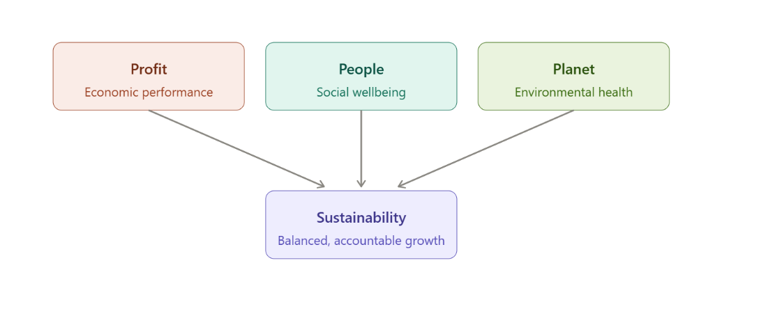

Figure 1 Triple Bottom Line Diagram

Fig. 1 demonstrates how the three pillars of profit, people, and planet each feed into the overall goal of Sustainability, rather than standing as separate, competing priorities.
However, Williams (2016) argues that these three dimensions frequently exist in tension with one another, and that managing sustainability is therefore best understood not as the pursuit of straightforward 'win-win' outcomes but as an ongoing process of paradox management, in which trade-offs between competing priorities must continually be negotiated. This is a significant departure from earlier, more optimistic accounts of sustainability that implied environmental, social and economic goals could be pursued simultaneously without meaningful compromise. Williams' perspective instead suggests organisations should expect ongoing friction between these dimensions rather than treating any single initiative as a permanent resolution.
This paradoxical perspective is particularly relevant to labour-intensive, low-margin service sectors such as commercial cleaning, where the pressure to minimise operating costs can sit uneasily alongside the environmental cost of premium eco-certified products or the social cost of workforce conditions. A cleaning contractor operating on thin margins may find that the environmentally preferable option, such as a more expensive biodegradable chemical, directly conflicts with commercial pressure to minimise costs. Equally, decisions intended to improve environmental performance, such as reducing staffing levels to cut resource use, may generate negative social consequences for the workforce. The TBL framework, read through Williams' paradox lens, therefore provides a theoretically appropriate way of capturing these tensions rather than assuming they can be neatly resolved. This is arguably one of the framework's most useful contributions to the present study, offering a vocabulary for interpreting instances where Principle Cleaning Services' practice appears inconsistent, not necessarily as failure, but as an expected feature of managing genuinely competing priorities.
More recent bibliometric reviews indicate that the TBL literature has continued to evolve since its original formulation, with increasing attention paid to how TBL principles are operationalised within firm-level strategy and operations, rather than treated purely as an abstract reporting framework (Sustainability, 2025). Complementary research emphasises that TBL alone may be insufficient to capture the full complexity of organisational sustainability. Operational integration, supply chain considerations and measurement systems are needed to translate TBL principles into practice (PMC, 2025). This operational turn is significant for the present study because it shifts the analytical focus away from whether an organisation claims to be sustainable and towards how sustainability commitments are embedded within day-to-day service delivery, procurement and workforce management, which is precisely the focus of the case study presented here.

2.3 Sustainability in Service and Facilities Management

The chapter then narrows to the service sector context, noting that most foundational sustainability literature originated in manufacturing, where environmental impact is tied to controllable production facilities. Service sectors like cleaning face a different set of challenges: resource efficiency, workforce practices, and client relationships across multiple dispersed sites rather than a single site.
Industry sources suggest that sustainability has shifted from a peripheral marketing concern to a core competitive advantage in cleaning services, with green credentials increasingly used to attract corporate clients and justify premium pricing. This reflects a broader pattern where market and client pressures rather than regulation are the primary drivers of sustainable practice in this sector.
A significant point raised here concerns procurement: public and private clients increasingly build environmental criteria into tender specifications and supplier codes of conduct, meaning a cleaning provider's sustainability credentials can directly affect its ability to win or keep major contracts. This helps explain why large providers like PCS, which service prestigious landmark buildings, face particularly intense ESG scrutiny. By contrast, smaller contractors may feel less immediate pressure but risk being progressively locked out of higher-value contracts if they can't demonstrate comparable credentials. The chapter flags this as a potential structural divide in the industry larger, better-resourced firms securing premium work while smaller operators fall further behind.

2.4 Green Cleaning Practices and Opportunities

This section catalogues the concrete practices cleaning organisations use to pursue sustainability:
- Substituting conventional chemicals with biodegradable, low-toxicity alternatives
- Adopting energy-efficient equipment
- Implementing water conservation and recycling
- Reducing waste, including eliminating single-use plastic packaging

The literature frames these using the same profit-people-planet structure as TBL, noting that efficiency measures which reduce resource use can also improve profit margins—a meaningful point given the cleaning industry's typically thin (around 7%) margins, where even modest operational savings can have outsized financial impact. This allows sustainability to be pitched in financial terms, not just ethical ones.

Technological innovation is presented as a second major opportunity, particularly through automation and robotics. Industry stakeholders have identified collaborative robotic cleaning as a potential "game-changer" for efficiency and environmental performance, while still allowing human oversight. This aligns with PCS's partnership with a robotics provider to introduce autonomous window-cleaning technology across London high-rises—positioned as integral to its sustainability strategy rather than a separate initiative.
Certification schemes are the third opportunity discussed. Standards like the US EPA's Safer Choice mark, Green Seal, EcoLogo, and sector-specific frameworks like the ISSA Cleaning Industry Management Standard for Green Buildings provide external verification of environmental claims. These are particularly valuable given the risk of greenwashing, offering clients independent assurance that sustainability marketing is substantiated rather than superficial.

Finally, the chapter highlights reputational and stakeholder-facing benefits: sustainable practice is linked to better employee engagement and retention, stronger brand positioning, and improved client relationships built on transparent communication. For PCS specifically, sustainability appears to extend beyond environmental measures into social and community initiatives, multi-year charitable partnerships and staff volunteering—consistent with the "people" pillar of TBL.

2.5 Challenges and Barriers

Despite these opportunities, the chapter identifies substantial and recurring barriers:
Cost is the most frequently cited obstacle. Eco-friendly products and energy-efficient equipment typically carry higher upfront costs than conventional alternatives, and smaller operators often lack the capital or financing access needed to transition. Inflationary pressures compound this problem, squeezing the margin available for sustainability investment and forcing organisations to balance price competitiveness against environmental ambition.

Product and market uncertainty is a second barrier. Not all products marketed as "green" meet rigorous independent standards, requiring additional due diligence or third-party certification. This connects to the broader problem of greenwashing—the literature argues that greenwashing is especially damaging to client trust, and that exposed false claims cost organisations more reputationally than genuine sustainable innovation would have cost in the first place.

Organisational and human factors form a third category. Staff may resist new procedures or remain sceptical of green products compared to familiar alternatives, particularly where training is inadequate. The chapter argues this human dimension is often underemphasised relative to cost-related barriers, despite being just as significant—even a well-designed sustainability policy will fail without properly trained and consulted frontline staff. Supply chain disruption is a related concern, since availability of certified sustainable products can fluctuate, creating operational risk for organisations contractually committed to sustainable delivery.

Measurement and data challenges round out the barriers. Accurately monitoring resource consumption, particularly water use across dispersed client sites, is described as a significant and "looming" challenge. Without robust measurement systems, organisations struggle to demonstrate genuine progress or identify further efficiency gains, reinforcing Williams' (2016) argument that sustainability management is an ongoing, unresolved process rather than a one-off implementation task.

2.6 Theoretical Framework

The chapter builds an integrated theoretical framework combining three perspectives:

- Resource-Based View (RBV): explains how sustainability practices can become strategic resources that generate competitive advantage when properly managed. Applied to cleaning, this suggests that things like proprietary water-recycling systems, robotics partnerships, or verified certifications may function as valuable, hard-to-imitate resources that differentiate a provider from less sustainable competitors.

- Sustainability-oriented innovation: research shows firms deliberately reshape their philosophy, products, and processes to generate social and environmental value alongside economic returns directly relevant to the innovation opportunities discussed earlier (robotics, technology partnerships).

- Stakeholder theory: explains the relational mechanisms through which firms create joint value with stakeholders, with reciprocal relationships underpinning social welfare and sustained organisational performance. This helps explain PCS's reported structured stakeholder consultation in developing its ESG strategy, suggesting meaningful stakeholder engagement may be a precondition for a successful sustainability strategy.

The chapter also situates sustainability challenges within the "grand challenges" literature, which frames sustainability as requiring management research to produce practical, measurable societal impact, linking the operational-level decisions examined later in the dissertation to a wider societal context.

The three theoretical strands are deliberately combined rather than treated singularly, on the basis that no one theory fully explains how sustainability translates into business success. Each illuminates a different facet of competitive resource, innovation process, relational value creation and together they offer a more complete analytical lens than any single theory alone.

2.8 Case Study: Principle Cleaning Services

The chapter then turns to PCS as a concrete example of how these opportunities and challenges play out in practice. Founded in 1989 and now employee-owned with over 2,800 employees and turnover exceeding £100 million, PCS positions itself as London's leading commercial cleaning partner, servicing high-profile landmark buildings. Its scale distinguishes it from the smaller operators discussed elsewhere in the literature, placing it among the providers best positioned to absorb the costs of sustainability transition. The company has stated an explicit ambition to become the UK's most sustainable cleaning company, organised around a five-point sustainability plan.

Recent corporate developments are also noted: after 37 years of independent operation, PCS joined the Churchill Group and merged with Portfolio, aiming to combine shared values, greater operational scale, and enhanced investment capacity while preserving its established brand identity. The chapter suggests this may strengthen PCS's capacity for ambitious sustainability initiatives through access to group-level resources, though it may also introduce new coordination challenges.

Reported initiatives include eliminating single-use plastics, plastic-free packaging, chemical-free processes, water-saving and recycling systems, and closed-loop recycled consumables. In 2023, the company launched a formal ESG strategy informed by structured stakeholder engagement interviews and surveys with over 250 stakeholders combined with a business impact assessment and materiality analysis, used to build a strategic framework around measurable KPIs. This is presented as evidence of methodological rigour beyond simple marketing commitments, aligning with the operational-integration perspective found in broader TBL scholarship.
PCS has also pursued technological and partnership-based initiatives, including the autonomous window-cleaning robotics mentioned earlier and collaboration with waste management partners to improve recycling rates and cut vehicle emissions across a major London property portfolio. Social initiatives, multi-year charitable partnerships, and staff volunteering further reflect the social dimension of TBL.
Importantly, the chapter flags a limitation: because much of this evidence comes from PCS's own published material, it should be read as an account of stated intent rather than independently audited proof of outcomes a limitation the dissertation addresses methodologically in the following chapter.

2.9 Gaps in the Literature

The chapter closes by synthesising the literature's broad consensus on opportunity categories (cost efficiency, client demand, certification, innovation, reputation) and challenge categories (cost, product uncertainty, greenwashing risk, staff resistance, measurement difficulty). However, it notes that much of this literature comes from industry commentary and corporate white papers rather than peer-reviewed research, reflecting the sector's relative neglect within mainstream sustainability scholarship. Existing sources also tend to describe practices in general or aggregate terms, with little in-depth, case-based examination of how a single organisation navigates these tensions.
Four specific gaps are identified:

- SME-focused barrier literature is rarely tested on large firms; it's unclear whether barriers found in smaller companies apply in the same way to a large, resource-rich contractor like PCS, or whether different constraints emerge (e.g., coordinating sustainability across a large, dispersed workforce).

- Cleaning is treated as subordinate within facilities management literature; rather than as a distinct industry with its own supply chains and labour practices, leaving cleaning-sector dynamics under-theorised.

- Frontline operative perspectives are largely absent; existing accounts privilege management, client, and certification-body viewpoints, despite frontline practices ultimately determining implementation success.

- Disconnect between health/environmental product research and business-focused sustainability literature; meaning the practical tension between product efficacy, worker safety, and environmental claims is rarely examined within a single organisational case.

CHAPTER 3: METHODOLOGY

3.1 Introduction

The methodological strategy used to answer the study questions outlined in Chapter One is described in this chapter. It addresses the methodology, research design, data gathering techniques, sampling, data processing, ethical issues, and study constraints.

3.2 Research Philosophy

The research philosophy used in this study is interpretivist. According to interpretivism, organisational phenomena, such as the implementation of a sustainability strategy, are best understood through the meanings, decisions and contexts constructed by the actors involved, rather than through universal, generalisable laws typical of a positivist approach. Since the research questions ask how an organisation has approached sustainability and why particular opportunities and challenges arise, rather than testing a predefined hypothesis numerically, an interpretivist stance is judged most appropriate.

3.3 Research Approach and Design

A qualitative approach is adopted, using a single exploratory case study design. Yin (2018) describes the case study as well suited to "how" and "why" enquiries, especially in situations where the researcher has little control over the event, and it's difficult to distinguish it from its real-world environment.
This aligns with the present study: Principle Cleaning Services' sustainability practice cannot meaningfully be separated from the wider commercial, regulatory and client-driven context in which it operates. Yin (2018) further argues that case studies should be underpinned by clear theoretical propositions that guide data collection; this dissertation uses the Triple Bottom Line framework and Williams' (2016) paradox-management perspective as the guiding propositions.

3.4 Research Strategy: Single Case Study

Principle Cleaning Services was purposively selected for three reasons. First, it is a large-scale commercial cleaning provider operating in a major metropolitan market, broadly representative of the corporate cleaning segment defined in Section 1.7. Second, it has publicly committed to an explicit sustainability ambition and published sufficient material to permit meaningful analysis. Third, its recent transition to employee ownership and documented use of formal stakeholder engagement and materiality assessment make it a theoretically interesting case through which to examine the operational-integration perspective on TBL discussed in Chapter Two. A single-case design was chosen over a comparative multiple-case design to allow depth of analysis within the scope of this dissertation, consistent with Yin's (2018) guidance that a single case is justified where it is revelatory or exemplary.

3.5 Data Collection Methods

This research uses both primary and secondary data, enabling cross-source triangulation.
(Yin, 2018).

Primary data. Eight semi-structured interviews were conducted with Principle Cleaning Services employees: the Head of Sustainability, a Manager, a Contract Supervisor and a frontline Cleaning Operative. This composition was designed to include the frontline perspective identified in Section 2.8 as underrepresented in existing literature, alongside the managerial perspective more commonly captured in industry commentary. 6 Interviews were conducted face-to-face and 2 were conducted online via Teams, approximately 20-30 minutes, were audio-recorded with consent, and transcribed verbatim. The interview schedule was built around the opportunity and challenge categories from the literature review (cost, client demand, certification, innovation, reputation, workforce factors and measurement difficulty), supplemented with open questions on participants' own experience.

Secondary data. This was drawn from three source categories: material published by the case organisation (Principle Cleaning Services, 2023; 2024); independent trade publications (Tomorrow's Cleaning, 2025); and the broader academic and industry literature reviewed in Chapter Two, used to contextualise the case evidence. Combining interview data with these sources allows participants' accounts to be checked against the organisation's published claims and independent commentary, reducing reliance on any single source.

3.6 Sampling

Sampling operates at two levels: participant selection and source selection. Interview participants were purposively sampled across different levels of the organisational hierarchy to capture a range of perspectives on how sustainability is designed, communicated and experienced. Access was facilitated through the organisation's sustainability team, which identified suitable individuals; this gatekeeper-mediated access is acknowledged as a potential source of bias in Section 3.9.
For secondary data, purposive sampling prioritised sources published from 2016 onwards to ensure currency, given the pace of change in sustainability standards and client expectations.

3.7 Data Analysis

Data is evaluated using thematic analysis, a method suitable for discovering repeating patterns of meaning across qualitative sources.
Interview transcripts and secondary material were coded together, following an initial familiarisation stage, according to the opportunity and challenge categories identified in the literature review. These codes were organised into broader themes and interpreted against the study's conceptual framework, enabling systematic comparison between the case evidence and patterns established in the wider literature. Interview participants are referred to anonymously by role: Head of Sustainability (SB), Portfolio Manager (LS), Account Manager (RS), Business Development Manager (WS), Contract Supervisor (RC) and Cleaning Operative. Direct quotations from interviews are distinguished typographically from secondary source material.

3.8 Ethical Considerations

Before collecting data, the researcher received ethical approval from his or her institution.
All participants received a participant information sheet in advance, gave informed consent, were informed of their right to withdraw at any stage without providing a reason, and were assured of anonymity and confidentiality. Participants are identified only by role, and transcripts were reviewed to remove identifying details. Recordings and transcripts were preserved securely and used just for this dissertation.
Because interviews were arranged with the case organisation's assistance, participants were reminded, in writing and verbally, that responses would not be shared with their employer in identifiable form.
Secondary sources are accurately attributed throughout; information published by the case organisation is treated critically rather than reproduced as fact; and no confidential or commercially sensitive information has been used beyond what participants voluntarily disclosed.

3.9 Reliability, Validity and Limitations

Case study research is sometimes criticised for limited generalisability, and this is acknowledged: findings specific to Principle Cleaning Services cannot be assumed to apply uniformly across the industry. However, Yin (2018) argues that case studies apply to theoretical ideas rather than populations.
Hence, the value of this study lies in testing and refining the applicability of TBL and paradox-management theory within the cleaning sector, rather than producing statistically representative findings. Reliability is strengthened through triangulation across primary and secondary sources. A further limitation concerns the small interview sample of four participants, which cannot be statistically representative of the wider workforce. Because participants were identified via the organisation's sustainability team, there is a risk of selection bias towards those more favourably disposed to, or better informed about, the sustainability agenda. This is partially mitigated by triangulating accounts against independent sources and including a frontline operative but cannot be fully eliminated. A related limitation is continued partial reliance on material published by the case organisation itself, creating residual risk of positive self-presentation bias, mitigated through critical reading and cross-referencing.

3.10 Chapter Summary

This chapter has set out an interpretivist, qualitative, single-case study methodology following Yin (2018), explaining the rationale for selecting Principle Cleaning Services. It has described the combination of primary interviews and secondary data, the thematic approach to analysis, the ethical considerations relevant to human-participant research, and the limitations affecting interpretation of the findings. Together with the conceptual framework in Chapter Two, this methodology provides the basis for the findings, discussion and conclusions that follow.

CHAPTER 4: RESULTS AND DISCUSSION

4.1 Introduction

This chapter critically discusses findings from eight semi-structured interviews with Principle Cleaning Services employees across the organisational hierarchy: a Head of Sustainability (SB), a Business Development Manager (WS), a Portfolio Manager (LS), an Account Manager (RS), a Site Supervisor (RC), and three Cleaning Operatives. This cross-hierarchical sampling reflects the finding that strategic intent formulated at senior level does not automatically translate into operational practice (Bansal and Song, 2017; Aguinis and Glavas, 2019).
The chapter follows standard practice for reflexive thematic analysis (Braun and Clarke, 2019). However, each theme is used as a lens to actively interrogate, rather than simply catalogue, the coherence and limitations of participants' accounts. Seven themes emerged inductively, covering (1) Strategic Architecture, (2) Drivers and Motivation, (3) Governance, (4) Barriers, (5) Social Pillar, (6) Cost/Client Balancing, and (7) Technology, followed by anticipated demand and a concluding synthesis addressing the dataset's methodological limitations. Each theme is illustrated with anecdotal evidence, interpreted against the wider literature and, where warranted, read against the grain of participants' own framing.

4.2 Strategic Architecture and Organisational Structure

A striking convergence across all eight interviews was the description of a formalised, strategically embedded sustainability function, rather than an ad hoc or purely reputational exercise. The Head of Sustainability described a dedicated department created five years prior, structured so that every team member works across environmental, social and governance topics rather than specialising narrowly - a choice intended to prevent the silo effect the interviewee suggested is common among competitors. This resonates with Elkington's (2018) triple bottom line framework, requiring the simultaneous pursuit of people, planet and profit rather than treating environmental management as a bolt-on function. The Head of Sustainability was explicit that safety, commercial viability and "the planet" were considered in that order - reflecting Carroll's (2016) pyramid of CSR, in which economic and legal responsibilities remain foundational, with ethical responsibilities such as environmental stewardship built on top rather than substituted for them.
The strategy itself was reported to rest on four pillars - Environment, People, Innovation, and Health, Safety and Wellbeing - co-produced through consultation with internal teams, operatives, supervisors, clients and supply chain partners. This is consistent with stakeholder theory (Freeman, Phillips and Sisodia, 2020), which holds that organisations sustain legitimacy by incorporating stakeholder interests rather than privileging shareholders alone. The Business Development Manager corroborated this multi-pillar structure, describing the company's partnership with Planet Mark and net-zero commitments, and characterising the guiding logic as a triad of
WS stated that:
"What is morally right, what is ethical, and what is financially viable"
an almost verbatim restatement of Carroll's (2016) economic-ethical balancing act. The Portfolio Manager, whose remit covers high-profile commercial buildings, emphasised a related but distinct anchor: health and safety compliance, illustrating that even within one organisation "sustainability" is refracted differently by functional role, consistent with Geissdoerfer et al.'s (2018) observation that sustainable business model innovation manifests as a portfolio of context-specific practices rather than a single template.
At operational level, however, the picture becomes more fragmented - arguably the single most important finding of the chapter rather than a peripheral caveat. The Supervisor's account reduced the corporate strategy to three practical pillars - eco-friendly products, waste reduction and recycling, and efficient resource use - while the Cleaning Operative described sustainability primarily as following procedures and avoiding waste. This gradient recurs in the CSR implementation literature, where formal commitments lose specificity and become "enacted" rather than "espoused" moving down the hierarchy (Aguinis and Glavas, 2019). A less charitable reading is also available: the compression could reflect not merely a communication gap but a genuine absence of strategic content at the point of delivery, such that the four-pillar architecture functions largely as a reporting and tendering artefact rather than a framework that meaningfully guides day-to-day behaviour. The data cannot fully adjudicate between these readings, since no independent observation was undertaken and the operative-level account rests on a single interview. What can be said with more confidence is that Principle Cleaning Services has institutionalised sustainability structurally, but that translation into a shared operational vocabulary across roughly 3,300-3,500 staff and 700-800 sites remains incomplete - a tension revisited in section 4.5 and the concluding synthesis.

4.3 Drivers and Motivations

The origin story of the sustainability function offers a clear illustration of client-driven institutional change, though it also warrants interpretive caution. According to the Head of Sustainability, the department was created after the then Chief Executive noticed that sales tenders increasingly contained sustainability questions the business could not answer, prompting the recruitment of a dedicated sustainability lead. This exemplifies what institutional theorists term coercive and mimetic isomorphism (Bansal and Song, 2017):
The organisation adopted new structures because external market signals - procurement requirements embedded in tender documentation - made the absence of a sustainability capability commercially untenable. The Head of Sustainability characterised the subsequent trajectory as self-sustaining, describing the growth of initiatives as being "like a snowball," suggesting a shift from externally imposed to internally generated motivation, consistent with the progression from compliance-driven to values-driven CSR described by Aguinis and Glavas (2019). It should be noted, however, that this is precisely the narrative a senior sustainability practitioner has both professional and personal incentive to tell:
It casts compliance-driven origins favourably and frames the interviewee's own department as an organic success story. This does not mean the account is inaccurate, but it should be read as sensemaking (Aguinis and Glavas, 2019) rather than independently verified fact.
The Business Development Manager identified the COVID-19 pandemic as a particularly significant inflexion point, noting that cleaning staff continued to work on client sites throughout, reframing cleaning as an essential public-health service rather than a purely cosmetic one - consistent with post-pandemic literature documenting how COVID-19 accelerated ESG integration across service industries by elevating the "social" pillar's salience (Grewatsch et al., 2021). The Supervisor and Cleaning Operative, by contrast, offered a generic, multi-causal account, citing client expectations, environmental responsibility, legal compliance and competitive advantage in combination rather than a single triggering event. Taken together, these accounts illustrate a common finding in CSR diffusion research: origin stories are specific at senior level but become abstracted into generalised expectations as they diffuse (Aguinis and Glavas, 2019).

4.4 Governance, Certification and Reporting

All participants referenced formal certification and reporting mechanisms, indicating investment in externally verifiable governance infrastructure rather than reliance solely on self-reported claims. The Head of Sustainability described a publicly available annual sustainability report explicitly designed to show underperformance as well as progress - reflecting the assurance principles underpinning the Global Reporting Initiative standards (GRI, 2021). Particularly notable was the use of the TOMs (Themed Outcomes Measures) framework to monetise social value - for example, converting the employment of a previously homeless individual into an estimated annual public-purse saving of roughly £32,000, incorporating reduced NHS and police contact alongside increased tax contributions. This operationalises social value measurement under the Public Services (Social Value) Act 2012, following the approach set out by the National Social Value Taskforce (2018), in which organisations translate qualitative outcomes into financial proxies legible to commercially minded stakeholders. This translation is not neutral, and two limitations should be registered.
First, the £32,000 figure was offered without its underlying calculation, so its evidential weight rests on trust in a methodology this research could not audit.
Second, converting a complex life change into a single monetary proxy discards information: it captures public-purse savings but says little about dignity or long-term wellbeing. The monetisation strategy should be understood as a rhetorically effective device for reaching commercially minded stakeholders, rather than a comprehensive account of social value created.
The Business Development Manager described a parallel governance architecture: ISO 50001 (energy management) certification, verification through the Science Based Targets initiative, and an internal reporting team producing both per-contract ESG impact reports and a company-wide annual report. The Portfolio Manager corroborated this with reference to ISO 14001 certification and formal "portfolio sustainability governance" reporting addressing Scope 1, 2 and 3 emissions, in line with tiered emissions classification standards (GRI, 2021). Layering externally audited standards with an internally developed metric such as TOMs amounts to a hybrid governance strategy, combining standards that confer legitimacy and comparability with bespoke metrics tailored to the organisation's social mission.
At operational level, reporting becomes considerably thinner. The Account Manager indicated that external sustainability data is compiled by auditors separately, while account-level client reporting occurs monthly, quarterly or annually - account managers functioning as a translation layer between corporate governance infrastructure and client-facing communication. The Supervisor's account reduced this to monitoring of chemical use and staff compliance, while the Cleaning Operative stated reporting was not part of the operative role.
This is broadly consistent with the reporting model implicit in the GRI (2021) standards, in which strategic-level integrated reporting rests on operational-level compliance monitoring that rarely surfaces externally but remains essential to its integrity. It also, however, creates an auditability gap the interview data alone cannot close: the annual report and TOMs figures are assembled several layers away from the operatives and supervisors whose practices generate the underlying data, and no participant described a mechanism verifying frontline reporting inputs before aggregation upward. This does not mean the published figures are unreliable, but the evidential chain connecting operative-level behaviour to boardroom-level metrics rests, at several points, on self-report rather than independent measurement.

4.5 Barriers to Implementation

Workforce characteristics emerged as the most consistently cited barrier - a large, linguistically diverse, time-pressured workforce spread across hundreds of dispersed sites. The Head of Sustainability characterised this as the central challenge: approximately 3,300 staff across 700 London sites, many working long hours, many speaking English as a second language, set against a sustainability department of only around twelve people, such that "these are also the people making day-to-day decisions that most affect our sustainability performance...yet they're time-poor and hard to reach.
The Account Manager corroborated this almost exactly, noting that without translation support, language barriers.

Account Manager RS stated this:
"Can present a significant barrier, as staff may not fully understand the importance of the practices being introduced."
The Business Development Manager offered a more mitigating account, arguing that because roughly 70 per cent of managers had been promoted internally, and many speak English as a second language, informal peer support reduces the barrier's severity - illustrating that the same condition can be framed simultaneously as a risk and a latent asset, depending on who is speaking. This divergence maps onto Ely and Thomas's (2020) distinction between deficit-based and integration-and-learning perspectives on diversity, but their own argument is that organisations only capture diversity's benefits by actively restructuring power around it, not by passively relying on informal support; on that stricter reading, the Business Development Manager's account describes an organisation that has avoided the worst consequences of the barrier rather than converted it into capability. The unverified 70 per cent figure, and its tension with the Account Manager's starker account of the same condition, are consistent with a broader pattern, developed in section 4.10, whereby risk is minimised as accounts move up the hierarchy.
Cost pressure was the second major barrier, framed differently by seniority. The Head of Sustainability described the hardest client conversations as those where cost is the only consideration, but noted sustainable products have become progressively more price-competitive, enabling reallocation of spend within a category to offset a higher-cost substitution elsewhere. The Account Manager described an almost identical tactic at contract level: consolidating deliveries across contracts to generate logistics savings that subsidise sustainable adoption. The Portfolio Manager described whole-life costing models showing that battery-powered machinery's higher upfront cost falls over time through durability and efficiency gains - consistent with the sustainable business model literature (Geissdoerfer, Vladimirova and Evans, 2018) and the broader argument, associated with Bansal and Song (2017), that well-structured sustainability investment need not trade off against commercial performance. This is, nonetheless, a claim made by the party responsible for selling that investment case to clients, with no independent financial data available to verify the implied payback periods; it should be treated as stated commercial rationale rather than an audited finding. The Supervisor and Cleaning Operative, by contrast, experienced cost pressure as a constraint on available products rather than a variable they could manage.
A third, structural barrier was the incompatibility between short-hours contracts and meaningful sustainability engagement. Both the Business Development Manager and Account Manager independently identified brief, low-hour contracts as the hardest context for embedding sustainable practice, since limited time leaves no capacity for training. The Account Manager additionally identified outdoor areas as posing distinct challenges, since unpredictable hazards such as biohazardous waste necessitate stronger chemicals than acceptable indoors - a tension the Supervisor also raised regarding high-risk sites. This reflects the "eco-efficiency paradox," whereby sustainability and safety objectives, though frequently mutually reinforcing, can sit in direct tension requiring hierarchical prioritisation (Grewatsch, Kennedy and Bansal, 2021).
Finally, an under-examined barrier, raised uniquely by the Head of Sustainability, was the long-time horizon of sustainability targets - some extending to 2040 - colliding with the short-term tempo of day-to-day delivery, such that initiatives are repeatedly deprioritised ("we'll do that tomorrow") until months or years elapse without progress. This mismatch is consistent with strategy literature on the difficulty of holding wicked, long-horizon problems alongside short-horizon operational pressure (Grewatsch, Kennedy and Bansal, 2021), and offers a partial explanation for the interviewee's related observation that an earlier, failed attempt at digitising paper checklists left staff sceptical, slowing the subsequent paperless rollout - consistent with the corrosive effect of prior change failure on employee trust in low-wage service contexts (Schneider and Harknett, 2019).

4.6 The Social Pillar: People, Wellbeing and Community

A distinctive and recurring feature across the interviews was the prominence of the social, or "people," pillar relative to the environmental pillar - a balance that runs counter to the popular conflation of "sustainability" with environmental management alone. The Head of Sustainability described a portfolio of people-focused initiatives, including a personal development day awarded annually to every employee, usable for any purpose unconnected to their job, and a charitable partnership - previously with a children's hospice that has since closed following a funding shortfall, currently with a homelessness charity. The interviewee explicitly linked this to career progression,
Head of Sustainability SB observing that:
"Some of today's cleaners go on to become future managers - including current board members who started as cleaners,"
connecting social investment directly to capability development, consistent with the human capital theory of CSR (Aguinis and Glavas, 2019).
This theme was echoed with striking consistency across the other interviews, despite their independent origin. The Portfolio Manager highlighted an employee ownership scheme, instantiating what Freeman, Phillips and Sisodia (2020) would characterise as the internalisation of employees as primary stakeholders rather than a factor of production. The Business Development Manager described formal partnerships providing employment pathways for individuals from disadvantaged backgrounds and for individuals with Down syndrome, characterising these as having the greatest overall impact of any initiative. The Account Manager offered a strikingly congruent account, describing the direct employment of individuals who have experienced homelessness, framed as helping "provide them with a sense of purpose and routine." That an almost identical emphasis surfaced independently across three interviewees at different tiers suggests this initiative has achieved a cultural salience most KPI-driven environmental initiatives had not, consistent with Aguinis and Glavas's (2019) observation that CSR initiatives with high emotional resonance diffuse further internally than abstract environmental metrics.
A significant limitation must be acknowledged, however: every account was given by a manager describing someone else's experience, and no employee who had themselves moved into the role through such a pathway was included in the sample. The chapter can report with confidence that this initiative is managerially salient and repeatedly cited as a source of pride, but it cannot, on the present evidence, speak to how it is actually experienced by its intended beneficiaries - whether felt as genuine inclusion or, as critics of similar corporate schemes have cautioned, functioning primarily as a reputational asset.
This is a gap in the evidence rather than a criticism of the initiative itself, but it should temper confidence in this otherwise consistent theme.
Employee wellbeing, particularly the management of long and irregular hours, was raised by the Head of Sustainability, who described offering full-time hours plus overtime to reduce reliance on multiple jobs, increasing visibility into total hours and enabling mental health support - while acknowledging candidly that the organisation has no control over work taken on once staff leave a Principle-managed site. A parallel mental health training programme for managers was also described.
The Portfolio Manager referenced a more technologically mediated intervention: a scheduling system capping continuous shift length, while conceding
Portfolio Manager LS stated that:
"This system isn't perfect yet."
Together, these accounts illustrate an organisation experimenting with both relational and technological mechanisms for managing a well-documented occupational risk in low-wage service work - routine instability and fragmented hours across multiple employers (Schneider and Harknett, 2019) - while acknowledging the limits of managerial control once employment boundaries are crossed.

4.7 Balancing Sustainability with Cost and Client Expectations

Client relationships emerged as the central mediating variable determining how far, and how fast, sustainability initiatives could be advanced on any given contract. The Head of Sustainability described concentrating effort on contracts where client culture already supports the agenda, while accepting that clients whose culture is not yet engaged will "catch up over time as the wider conversation grows" rather than being pushed. The Business Development Manager described a similarly staged approach: understanding.
Business Development Manager stated that:
"Each client's position within their individual ESG journey."
This segmentation logic is consistent with Bansal and Song's (2017) argument that firms differentiate sustainability effort by context, allocating disproportionate early effort to receptive adopters and using their visible success to draw laggards toward the mainstream. This logic is commercially sound, but it carries an equity implication neither interviewee raised: if effort concentrates on already-receptive clients, the sites and workers associated with less-engaged clients - plausibly the smaller, shorter-hours contracts already identified in section 4.5 as the hardest context for sustainable practice - risk a compounding disadvantage, receiving both the least organisational support and the least innovation. The data cannot establish whether this is occurring in practice, but the segmentation strategy as described creates a structural risk it does not appear to mitigate.
The Portfolio Manager's account of the battery-powered machinery transition illustrates triple-bottom-line reasoning applied to a single procurement decision: higher upfront cost offset over the equipment's life by reduced fuel costs (profit), reduced emissions (planet), and more ergonomic design reducing physical strain (people).
The Head of Sustainability described an almost identical example independently, indicating convergent strategic reasoning across distinct interviews.
Both accounts mirror the "win-win-win" logic originally associated with the triple bottom line, though, following Elkington's (2018) own later critique of the model, such simultaneous alignment is the exception in the transcripts rather than the rule; most examples instead described active trade-off management rather than costless mutual reinforcement.

4.8 The Role of Technology and Innovation

Technology was framed by participants primarily as enabling infrastructure for two purposes: reducing the resource intensity of cleaning tasks and generating data to measure sustainability performance at scale.
Participants referenced battery-powered and cordless machinery, water-efficient devices such as the "i-mop" system, autonomous cleaning robots, sensor-equipped washroom monitoring, and, at an early stage, cleaning drones.
The Head of Sustainability offered a notably candid account of the genuine trade-offs technology introduces, observing that some newer equipment "needs no chemicals but uses more water," raising a comparative resource-use question between a mop-and-bucket and a cleaning drone - consistent with the systems-thinking caution articulated by Grewatsch, Kennedy and Bansal (2021), that technological substitution frequently shifts rather than eliminates environmental burden across resource categories.
This candour is a positive sign of internal critical awareness, but no participant described a formal life-cycle assessment being conducted to resolve such trade-offs; the evidence stops short of demonstrating a systematic resolution method, as opposed to ad hoc managerial judgement.
On the data side, the Head of Sustainability described a carbon accounting platform, Position Green, integrated with waste contractor and utility invoicing data to reduce manual entry - reflecting the GRI's (2021) emphasis on systems integration as a precondition for credible reporting at scale.
The Portfolio Manager referenced a comparable digital scheduling platform and an internal innovation fund through which staff can apply for support to develop new ideas - consistent with the "open innovation" literature's emphasis on distributed, bottom-up idea generation complementing centrally directed R&D (Chesbrough, 2017).
The Account Manager grounded these themes in operational reality, describing sensor-based washroom monitoring that determines cleaning frequency dynamically, underscoring that digitisation here serves compliance and efficiency simultaneously, not solely sustainability.

4.9 Anticipated Future Demand

Looking forward, participants converged on the expectation that client and regulatory expectations will continue to rise, though they differed on which dimension would dominate. The Head of Sustainability identified water scarcity as an under-recognised but rapidly emerging concern, citing extended hot weather, wildfires and hosepipe bans, and anticipated growing demand for waterless cleaning technology.
The Business Development Manager anticipated carbon emissions and carbon credits shaping expectations, while noting that public understanding of these mechanisms remains limited - a gap consistent with well-documented low public carbon literacy even among populations broadly supportive of climate action (Whitmarsh and Corner, 2017).
The Portfolio Manager anticipated pressure on indoor air quality standards, while the Account Manager and Supervisor anticipated incremental, demand-led growth in specific product categories rather than a step-change. This diversity of expectation illustrates that anticipated demand is filtered through each participant's functional vantage point, consistent with upper echelons theory as revisited by Neely et al. (2020), which argues that managerial cognition systematically shapes organisational perception of environmental change.

4.10 Synthesis and Discussion

The interviews depict an organisation in which strategic sustainability commitment is genuine and well institutionalised - evidenced by formal certification, dedicated staffing, published reporting, and financially quantified social value measurement - but whose translation into consistent frontline practice remains constrained by structural features intrinsic to the sector:
A large, linguistically diverse, dispersed and time-poor workforce; short-duration, low-margin contracts; and client organisations at widely varying points along their own sustainability journeys.
The consistency with which independently interviewed participants across different tiers identified the same barriers and flagship initiatives lends the findings a degree of internal triangulation.
This convergence should not, however, be read uncritically as straightforward validation of the organisation's account of itself. Natow's (2020) analysis of elite interviewing cautions that individuals in positions of organisational power may provide information that is confident and internally consistent while nonetheless shaped by institutional interest, and the same logic plausibly extends to employees interviewed, with management's knowledge, about their own employer.
All participants were, in effect, speaking on the record about the organisation that employs them, using vocabulary (the four pillars, the TOMs figures, the named flagship initiatives) a well-run internal communications function would be expected to have disseminated consistently.
The convergence is therefore genuinely double-edged: it may indicate that Principle Cleaning Services has successfully embedded a shared sustainability narrative across a large workforce - itself a meaningful achievement - or that a well-rehearsed corporate narrative has been reproduced back to the researcher by participants with limited independent means, or incentive, to depart from it.
First, the interview data alone cannot fully distinguish between these explanations; a more definitive account would require methods - direct site observation, anonymised employee surveys, or internal documents not intended for external audiences - that fell outside this study's scope.
A second limitation concerns the sample itself. All eight interviewees were current employees discussing their employer, most plausibly identified through management channels rather than randomly selected - a common constraint in single-organisation case study research that likely under-represents sceptical employees, and, as noted in section 4.6, excludes entirely the disadvantaged-background employees repeatedly cited as the organisation's flagship achievement. The findings should be read as an account of how sustainability is understood and narrated by a purposively varied but organisationally embedded set of employees, not as an independently verified picture of outcomes.
None of this undermines the substantive value of the findings, but it sharpens what can and cannot be concluded from them. The data support, with reasonable confidence, that sustainability strategy at Principle Cleaning Services is genuinely more developed and more consistently referenced across levels than the low industry baseline the Head of Sustainability herself described; that this architecture nonetheless undergoes systematic compression from senior to frontline level; and that the barriers participants converged on - workforce diversity and time poverty, cost-sensitive short-hours contracts, and long sustainability horizons colliding with short-term operational pressure - are structural features of the sector rather than organisation-specific failings, unlikely to be resolved by communications effort alone. What the data cannot support is any independently verified claim about the magnitude of impact achieved, or how initiatives are experienced by the beneficiary populations least represented in this sample.
The principal implementation challenge facing Principle Cleaning Services, on this reading, is not the design of sustainability strategy but its diffusion and verification across a large, dispersed workforce - a challenge mirroring well-documented findings in the CSR implementation literature (Aguinis and Glavas, 2019) - and it is to this diffusion and verification gap that the following chapter's recommendations are directed.

CHAPTER 5: Conclusion, Recommendations and Limitations

5.1 Summary of Key Findings

This dissertation set out to examine how Principle Cleaning Services conceptualises, implements, and measures sustainability, and what barriers and enablers shape this process. The findings show an organisation that frames sustainability explicitly as a source of competitive differentiation, supported by an integrated environmental-social-governance team structure, a four-pillar strategy developed through workforce and client consultation, formal certification and emissions reporting, and a monetised approach to social value measurement via the TOMS framework. The organisation has translated significant client-driven institutional pressure into what appears, on the evidence of both interviews, to be a substantively embedded rather than symbolic sustainability programme, consistent with the theoretical distinction proposed by Hyatt and Berente (2017).
At the same time, the research identified persistent, structural barriers: a very large, linguistically diverse, time-poor frontline workforce; long sustainability time horizons in tension with short-term client pressures; uneven resourcing and adoption across sites; and the perennial difficulty of reconciling sustainability ambition with cost-sensitive client relationships in a low-margin sector.

5.1 Conclusion

Despite these limitations, this dissertation offers a detailed, cross-level account of how sustainability is understood and operationalised within a large, labour-intensive commercial cleaning organisation. This sector remains comparatively underexamined in the sustainability literature relative to manufacturing, construction, and other resource-intensive industries. The case of Principle Cleaning Services illustrates that meaningful sustainability implementation in this sector is achievable, but is neither quick nor straightforward: it depends on sustained institutional commitment, an integrated rather than fragmented organisational structure, credible and monetised social value reporting, and above all a long-term, patient approach to engaging a large, diverse, and time-constrained frontline workforce whose everyday decisions ultimately determine whether strategic sustainability ambitions are realised in practice.

5.2 Recommendations for the Organisation

Several practical recommendations arise from the findings:

First, given that both interviewees identified frontline engagement rather than board-level buy-in as the principal barrier to implementation, the organisation should consider investing further in accessible, multilingual sustainability training designed specifically for a time-poor, linguistically diverse workforce, rather than relying primarily on materials designed for office-based or English-first staff.

Second, given the demonstrated success of the sustainability apprenticeship model in generating simultaneous environmental, social, and commercial value, the organisation should consider expanding this model across a wider range of client contracts, particularly larger or longer-term contracts where the investment can be recovered over a longer period.

Third, given the Head of Sustainability's identification of water scarcity as an under-addressed future concern, the organisation would benefit from beginning to pilot waterless cleaning technologies now, ahead of anticipated increases in client demand, in order to establish an early-mover position analogous to the one it has already secured in green product certification.

Finally, given the divergence noted between the strategic and operational accounts regarding the visibility of formal certification and governance detail, the organisation may benefit from ensuring that certification and reporting achievements (such as ISO 14001, ISO 50001, and SBTi alignment) are communicated as clearly to operational and portfolio-level management as they evidently are to the central sustainability function, to support consistent messaging to clients at every level of account management.

5.3 Recommendations for Future Research

This dissertation offers a starting point for further research rather than a definitive account of sustainability implementation within the cleaning sector. Future research would benefit from extending the dual-informant design used here to include the perspectives of frontline cleaning operatives themselves, whose experience is currently represented only second-hand through the accounts of senior stakeholders, despite being repeatedly identified, by those same stakeholders, as the group with the greatest day-to-day influence over the organisation's environmental footprint.
A comparative multi-organisation case study, examining several cleaning providers of varying size and sustainability maturity, would also help to establish whether the patterns identified here, particularly the relationship between institutional pressure and substantive versus symbolic strategy adoption, generalise beyond a single, unusually well-resourced organisation.
Finally, longitudinal research tracking the progress of specific initiatives discussed in this dissertation, such as the paperless digitalisation programme or the 2040 sustainability project referenced by the Head of Sustainability, would offer valuable insight into how long-horizon sustainability commitments are sustained, or abandoned, over time.

5.4 Limitations of the Research

Several limitations should be acknowledged. First, as a qualitative single-case study, the findings are not statistically generalisable to the wider cleaning and facilities management sector. They should instead be understood as offering analytic generalisation to comparable organisational contexts (Yin, 2018). Second, the research relies on the accounts of two senior stakeholders, both of whom hold senior positions and have organisational investment in the sustainability agenda; this raises the possibility of favourable self-presentation bias and means that frontline operative perspectives are not directly represented in the primary data. Third, the two interviews, while complementary, were not identical in scope or depth across all themes; for example, the technical certification detail offered by the Portfolio Manager was not matched in depth by the Head of Sustainability, which may reflect genuine differences in role focus but could equally reflect differences in interview conditions or time available. Finally, the study is cross-sectional, capturing a single point-in-time account of an ongoing and evolving sustainability programme; several of the initiatives discussed, including the paperless transition and the 2040 project, are explicitly incomplete at the time of writing, and their ultimate outcomes cannot be assessed within the scope of this dissertation.

Taken together, these limitations do not undermine the core findings, but they do define the boundaries within which those findings should be interpreted. The study offers a credible, cross-level account of how sustainability is designed and delivered within one organisation, rather than a claim about typical practice across the wider cleaning and facilities management sector.

6. REFERENCES

Alayón, C.L., Säfsten, K. and Johansson, G. (2022) 'Barriers and Enablers for the Adoption of Sustainable Manufacturing by Manufacturing SMEs', Sustainability, 14(4), p. 2364.
Álvarez Jaramillo, J., Zartha Sossa, J.W. and Orozco Mendoza, G.L. (2019) 'Barriers to Sustainability for Small and Medium Enterprises in the Framework of Sustainable Development-Literature Review', Business Strategy and the Environment, 28(4), pp. 512-524.
CCMSPB (2025) Sustainability and Green Cleaning Practices. Cleaning Forward | CCMS. Available at: https://ccmspb.com/sustainability-and-green-cleaning-practices/ (Accessed: 10 July 2026).
Companies House (2026) Principle Cleaning Services Limited: Company Overview. Available at: https://find-and-update.company-information.service.gov.uk/company/02333935 (Accessed: 10 July 2026).
ContractorPlus (2026) 2026 Green Cleaning Business Trends. Available at: https://contractorplus.app/blog/green-cleaning-business-trends (Accessed: 10 July 2026).
Durrani, N., Raziq, A., Mahmood, T. and Khan, M.R. (2024) 'Barriers to Adaptation of Environmental Sustainability in SMEs: A Qualitative Study', PLOS ONE, 19(5), e0298580.
Principle Cleaning Services (2026) Principle joins Churchill Group to continue building on 37 years of specialist expertise. Available at: https://principleclean.com/principle-joins-churchill-group-to-continue-building-on-37-years-of-specialist-expertise/ (Accessed: 20 July 2026).
Janitorial Manager (2025) 5 Ways to Move Towards Eco-Friendly and Sustainable Cleaning Practices. Available at: https://www.janitorialmanager.com/blog/5-ways-to-move-towards-eco-friendly-and-sustainable-cleaning-practices/ (Accessed: 10 July 2026).
Madrid-Guijarro, A. and Duréndez, A. (2024) 'Sustainable Development Barriers and Pressures in SMEs: The Mediating Effect of Management Commitment to Environmental Practices', Business Strategy and the Environment, 33(2), pp. 949-967.
Novagems (2025) Challenges and Opportunities in Cleaning Businesses. Available at: https://novagems.com/challenges-and-opportunities-in-cleaning-businesses/ (Accessed: 10 July 2026).
Planet Mark (2023) Exploring Sustainability in the Cleaning Industry: Opportunities and Challenges. Available at: https://www.planetmark.com/news-and-blogs/sustainability/exploring-sustainability-in-the-cleaning-industry-opportunities-and-challenges/ (Accessed: 10 July 2026).
Principle Cleaning Services (2023) Sustainability. Available at: https://principleclean.com/sustainability/ (Accessed: 10 July 2026).
Principle Cleaning Services (2024) Cleaning Services. Available at: https://principleclean.com/ (Accessed: 10 July 2026).
PMC (2025) Future Trends and Guidance for the Triple Bottom Line and Sustainability: A Data-Driven Bibliometric Analysis. Available at: https://pmc.ncbi.nlm.nih.gov/articles/PMC7423869/ (Accessed: 10 July 2026).
Sustainability (2025) Triple Bottom Line in Sustainable Development: A Comprehensive Bibliometric Analysis, Sustainability, 17(5), p. 1932. Available at: https://www.mdpi.com/2071-1050/17/5/1932 (Accessed: 10 July 2026).
Tomorrow's Cleaning (2025) Principle Leads the Way for Cleaning Sector Sustainability. Available at: https://www.tomorrowscleaning.com/cleaning-news/cleaning-up-on-sector-sustainability (Accessed: 10 July 2026).
ToolSense (2023) Sustainability in the Cleaning Industry. Available at: https://toolsense.io/sustainability/sustainability-in-the-cleaning-industry/ (Accessed: 10 July 2026).
Trisonwells (2025) Why Eco-Friendly Cleaning Products Will Matter More Than Ever in 2026. Available at: https://www.trisonwells.com/post/why-eco-friendly-cleaning-products-will-matter-more-than-ever-in-2026 (Accessed: 10 July 2026).
Williams, J. (2016) 'Managing the Tensions at the Intersection of the Triple Bottom Line: A Paradox Theory Approach to Sustainability Management', Journal of Public Policy & Marketing, 35(2), pp. 249-261.
Yin, R.K. (2018). Case Study Research and Applications: Design and Methods. 6th edn. Thousand Oaks, CA: SAGE.
Adams, R., Jeanrenaud, S., Bessant, J., Denyer, D. and Overy, P., 2016. Sustainability-oriented innovation: A systematic review. International Journal of Management Reviews, 18(2), pp.180–205.
Bridoux, F. and Stoelhorst, J.W., 2016. Stakeholder relationships and social welfare: A behavioural theory of contributions to joint value creation. Academy of Management Review, 41(2), pp.229–251.
George, G., Howard-Grenville, J., Joshi, A. and Tihanyi, L., 2016. Understanding and tackling societal grand challenges through management research. Academy of Management Journal, 59(6), pp.1880–1895.
Hitt, M.A., Xu, K. and Carnes, C.M., 2016. Resource-based theory in operations management research. Journal of Operations Management, 41, pp.77–94.

Braun, V. and Clarke, V. (2019) 'Reflecting on reflexive thematic analysis', Qualitative Research in Sport, Exercise and Health, 11(4), pp. 589–597.
CDP (2023) A Wave of Change: The Role of Companies in Building a Water-Secure World. London: CDP Worldwide.

Saunders, M., Lewis, P. and Thornhill, A. (2019) Research Methods for Business Students. 8th edn. Harlow: Pearson.
Social Value Portal (2024) The National TOMs Framework. Available at: https://www.socialvalueportal.com (Accessed: 1 August 2026).
Tuan, L.T., Hoang, T.A. and Nguyen, D.T. (2019) 'Employee participation in sustainability initiatives: a perspective from Vietnam', Business Strategy and the Environment, 28(3), pp. 430–442.
Yin, R.K. (2018) Case Study Research and Applications: Design and Methods. 6th edn. Thousand Oaks, CA: Sage.

Aguinis, H. and Glavas, A. (2019) 'On corporate social responsibility, sensemaking, and the search for meaningfulness through work', Journal of Management, 45(3), pp. 1057-1086.
Bansal, P. and Song, H.-C. (2017) 'Similar but not the same: Differentiating corporate sustainability from corporate responsibility', Academy of Management Annals, 11(1), pp. 105-149.
Braun, V. and Clarke, V. (2019) 'Reflecting on reflexive thematic analysis', Qualitative Research in Sport, Exercise and Health, 11(4), pp. 589-597.
Carroll, A.B. (2016) 'Carroll's pyramid of CSR: taking another look', International Journal of Corporate Social Responsibility, 1, article 3.
Chesbrough, H. (2017) 'The future of open innovation', Research-Technology Management, 60(1), pp. 35-38.
Elkington, J. (2018) '25 years ago I coined the phrase "triple bottom line." Here's why it's time to rethink it', Harvard Business Review, 25 June.
Ely, R.J. and Thomas, D.A. (2020) 'Getting serious about diversity: Enough already with the business case', Harvard Business Review, 98(6), pp. 114-122.
Freeman, R.E., Phillips, R. and Sisodia, R. (2020) 'Tensions in stakeholder theory', Business & Society, 59(2), pp. 213-231.
Geissdoerfer, M., Vladimirova, D. and Evans, S. (2018) 'Sustainable business model innovation: A review', Journal of Cleaner Production, 198, pp. 401-416.
GRI (Global Reporting Initiative) (2021) GRI Standards: Universal Standards. Amsterdam: Global Reporting Initiative.
Grewatsch, S., Kennedy, S. and Bansal, P. (2021) 'Tackling wicked problems in strategic management with systems thinking', Strategic Organization, 21(3), pp. 721-732.
National Social Value Taskforce (2018) National TOMs Framework: For Social Value Measurement. London: National Social Value Taskforce.
Natow, R.S. (2020) 'The use of triangulation in qualitative studies employing elite interviews', Qualitative Research, 20(2), pp. 160-173.
Neely, B.H., Lovelace, J.B., Cowen, A.P. and Hiller, N.J. (2020) 'Metacritiques of upper echelons theory: Verdicts and recommendations for future research', Journal of Management, 46(6), pp. 1029-1062.
Schneider, D. and Harknett, K. (2019) 'Consequences of routine work-schedule instability for worker health and well-being', American Sociological Review, 84(1), pp. 82-114.
Whitmarsh, L. and Corner, A. (2017) 'Tools for a new climate conversation: A mixed-methods study of language for public engagement across the political spectrum', Global Environmental Change, 42, pp. 122-135.

Elkington, J. (1997) Cannibals with Forks: The Triple Bottom Line of 21st Century Business. Oxford: Capstone.

Kolb, D.A. (1984) Experiential Learning: Experience as the Source of Learning and Development. Englewood Cliffs, NJ: Prentice-Hall.

Elkington, J. (1997) Cannibals with Forks: The Triple Bottom Line of 21st Century Business. Oxford: Capstone British Cleaning Council (n.d.) Industry reports and standards guidance.
Principle Cleaning Services (n.d.) Sustainability and CSR reporting.

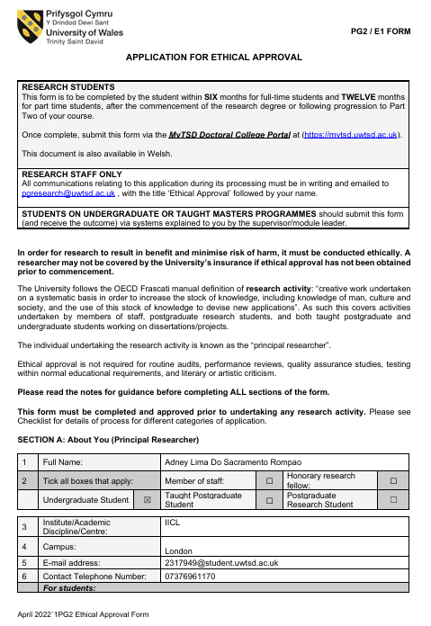
Appendices

Appendix 1: Application for ethical approval
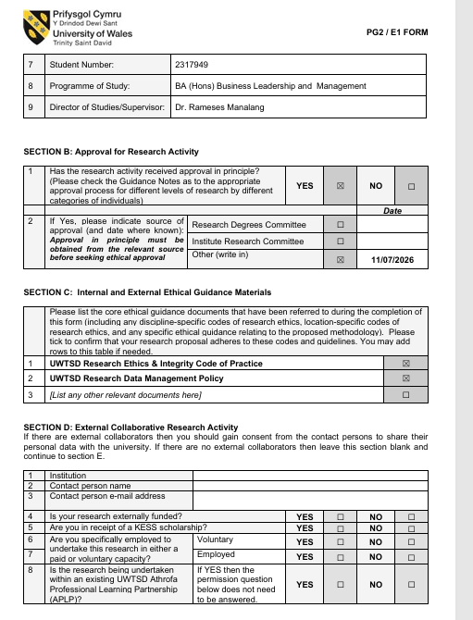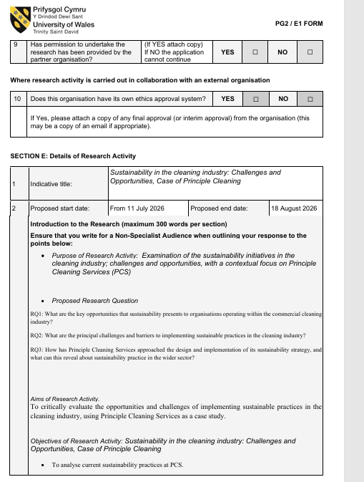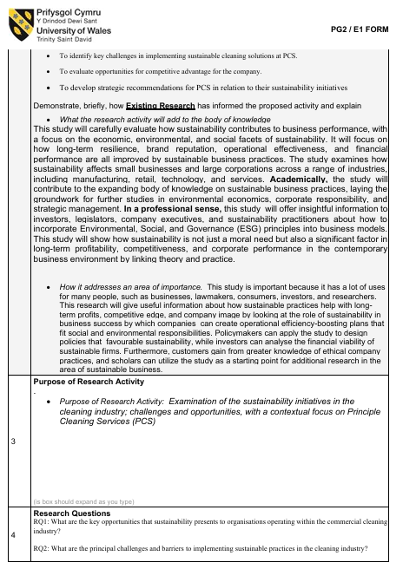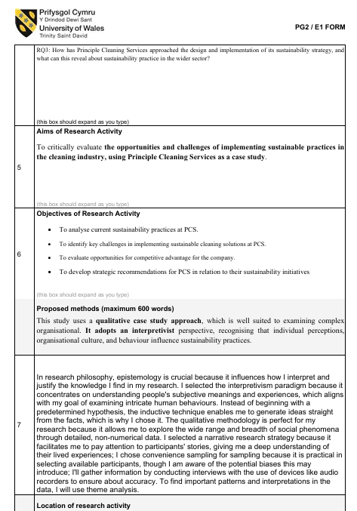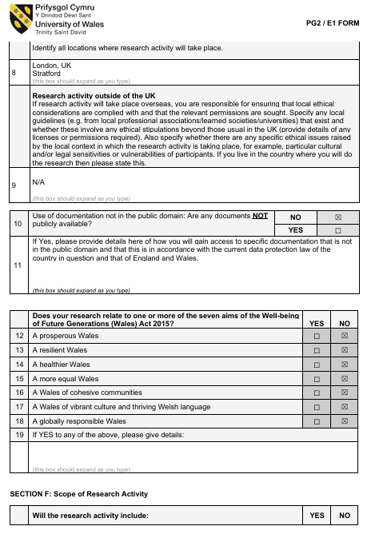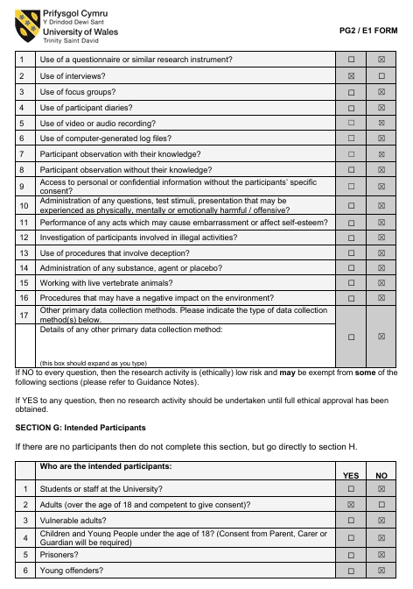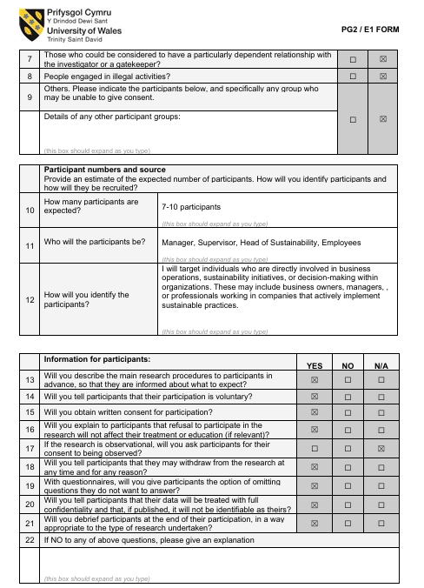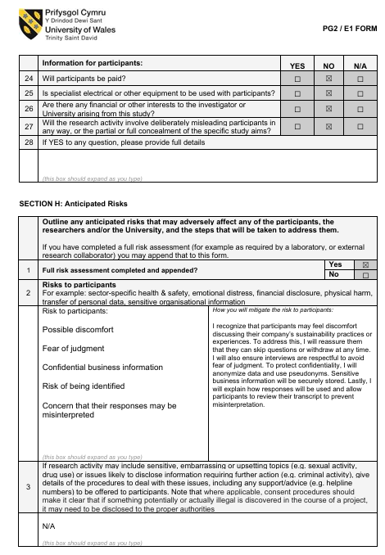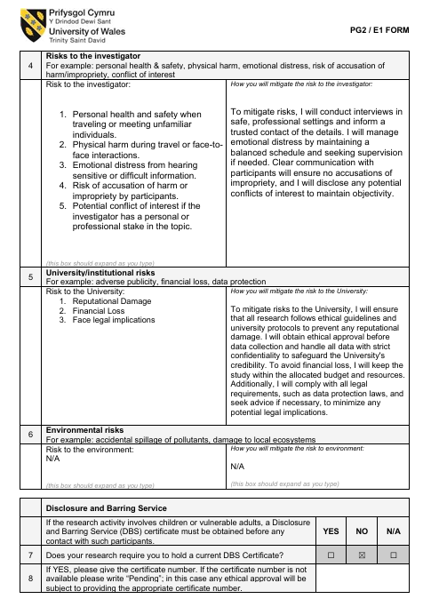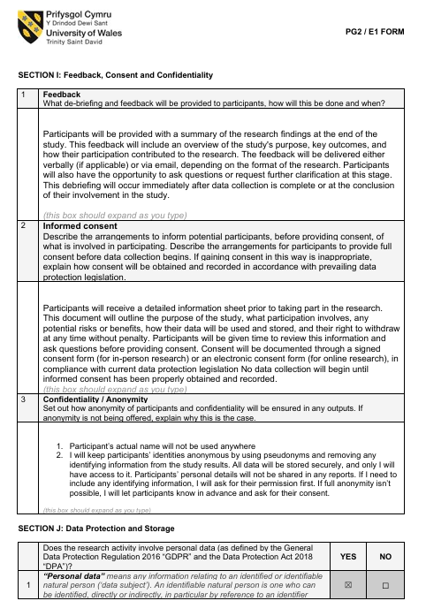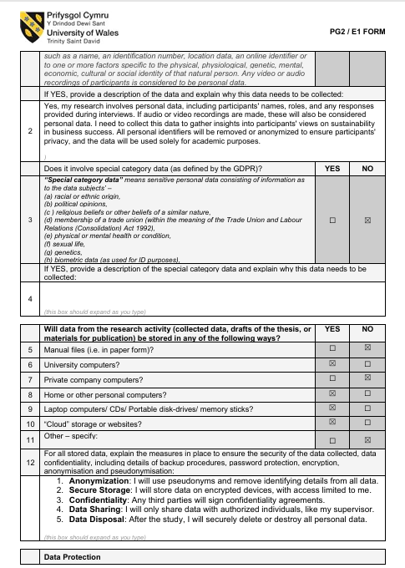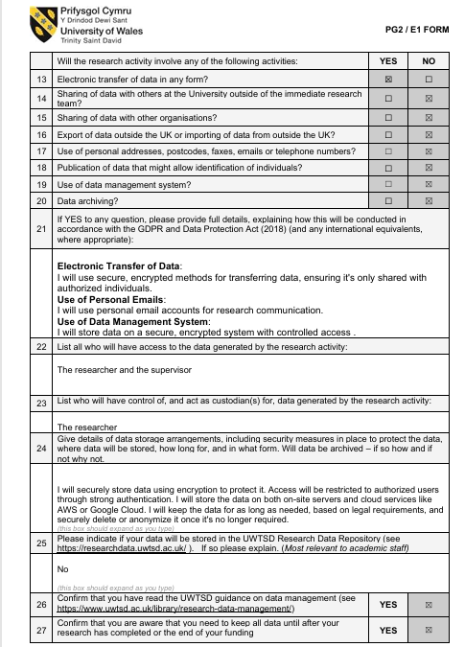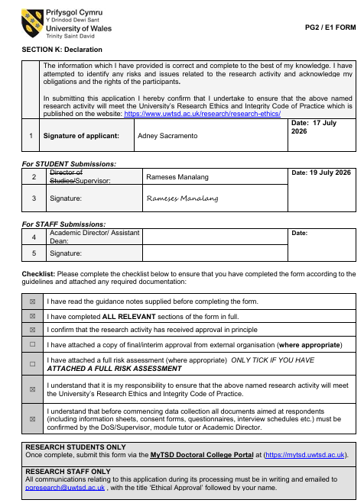

Appendix 2 Participation Consent Form

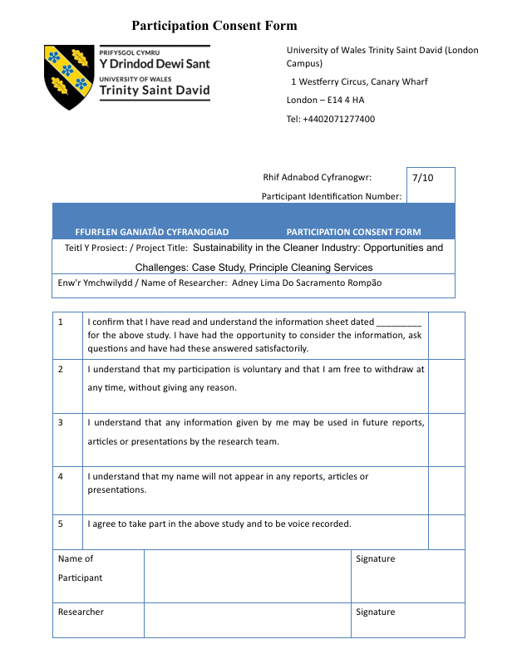

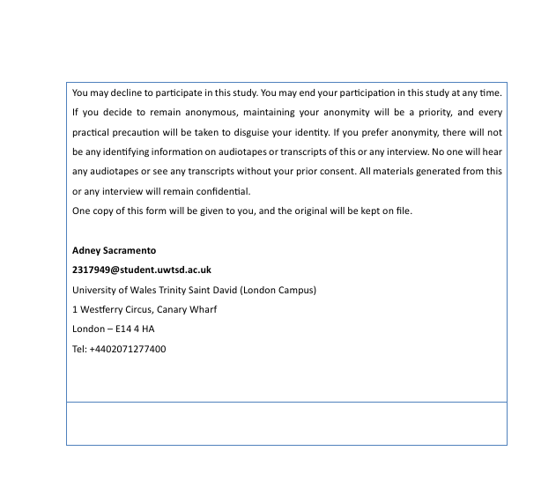

Appendix 3 Participant Information Sheet
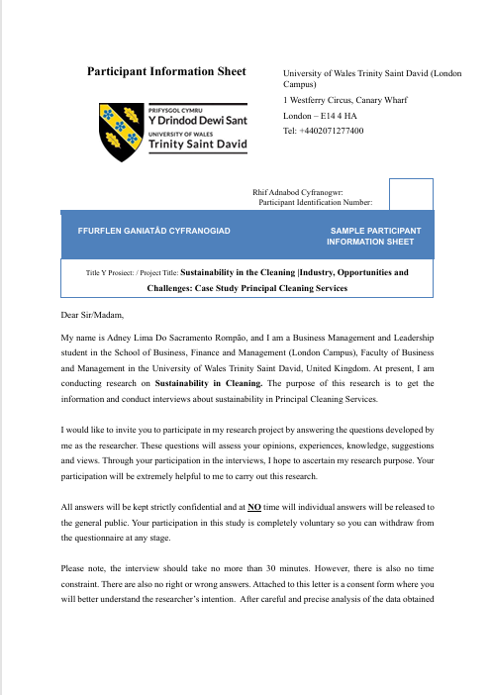

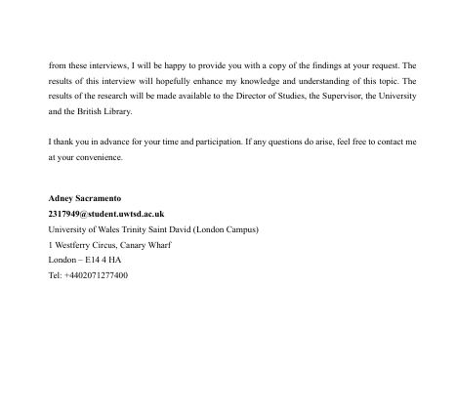

Appendix 4 Interview Questions

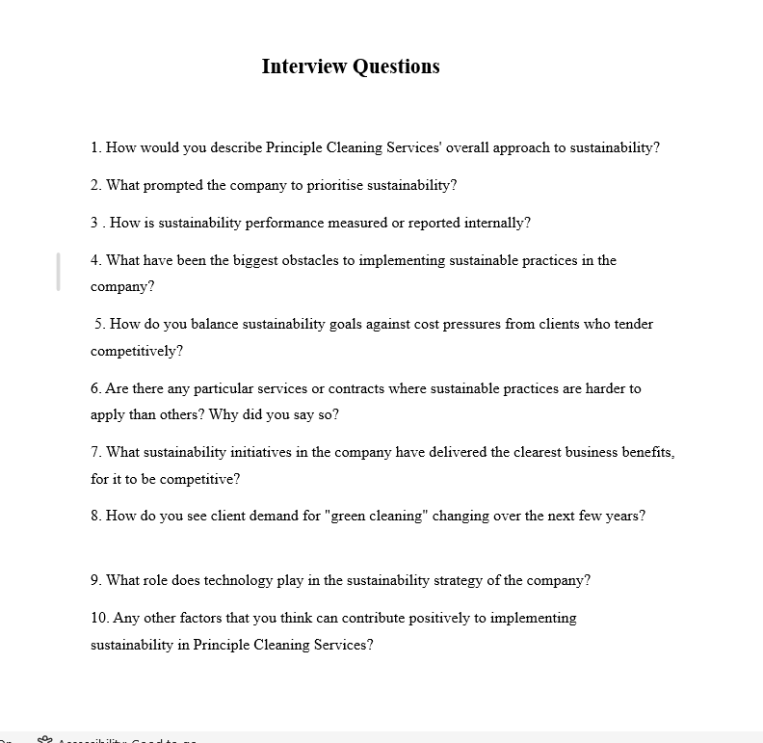

Appendix 5 Environmental policy

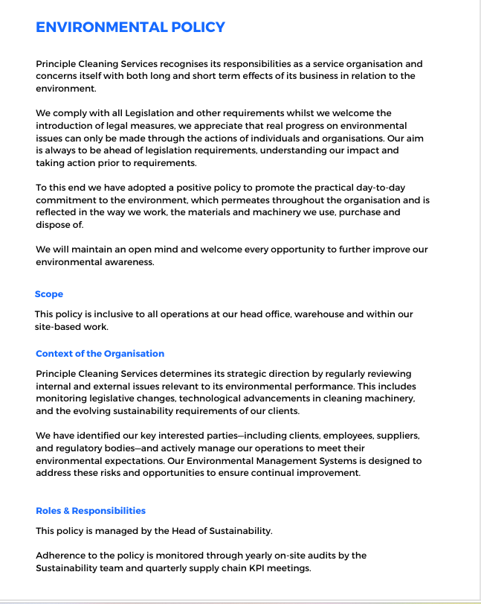

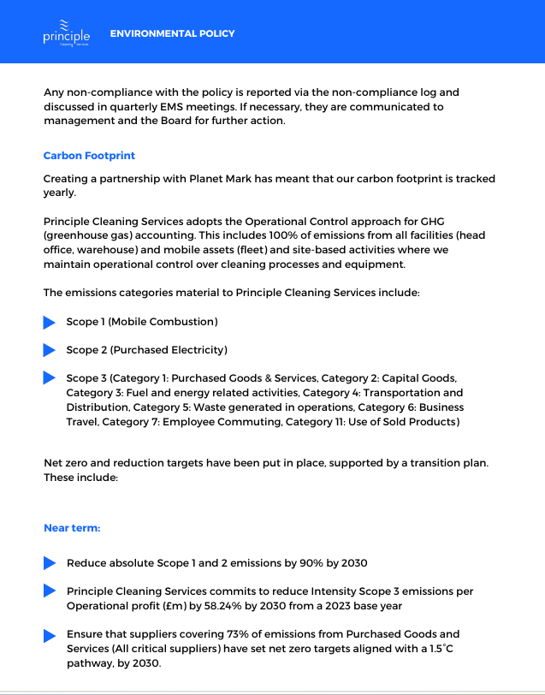

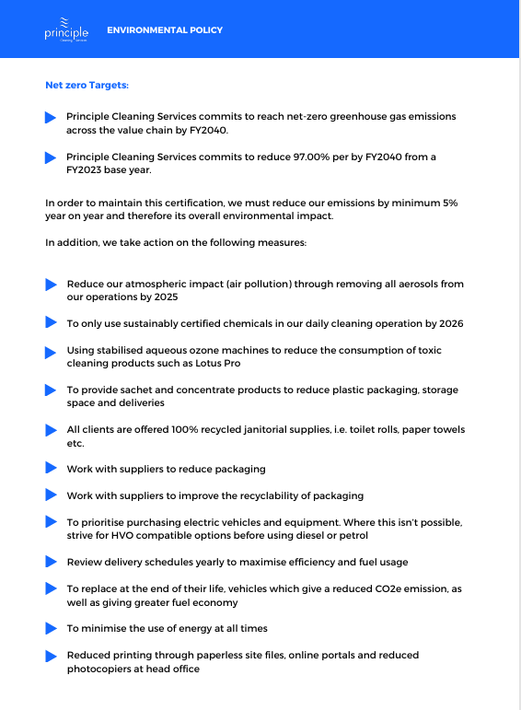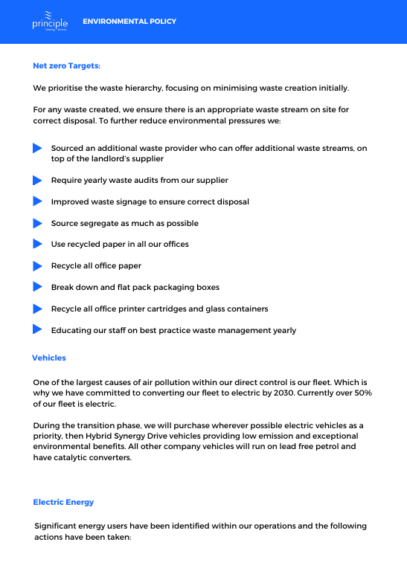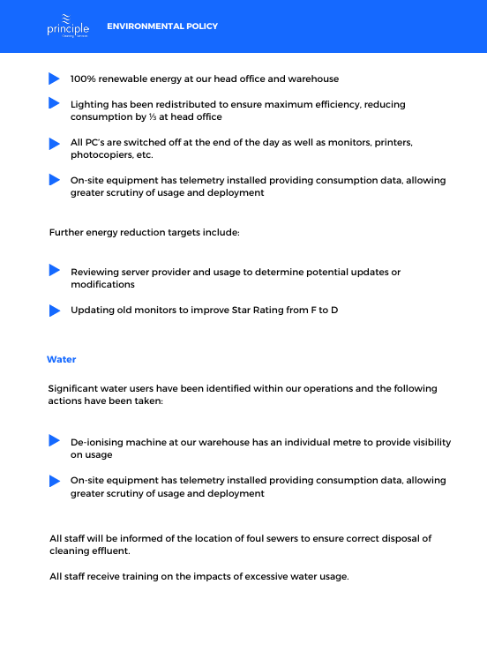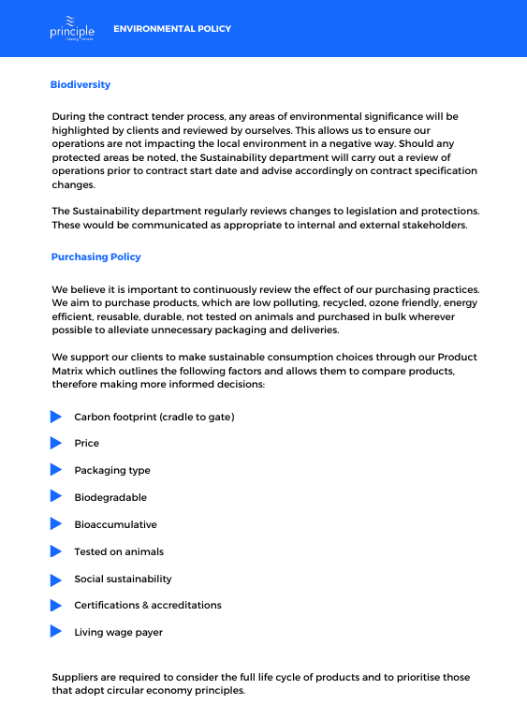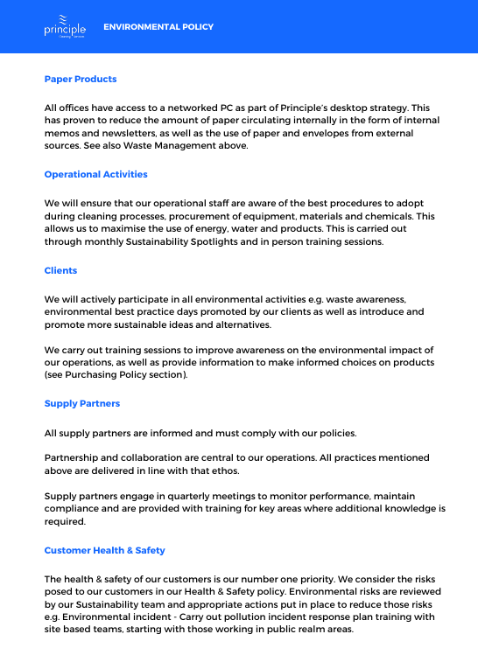

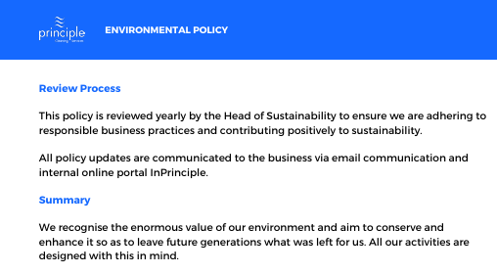

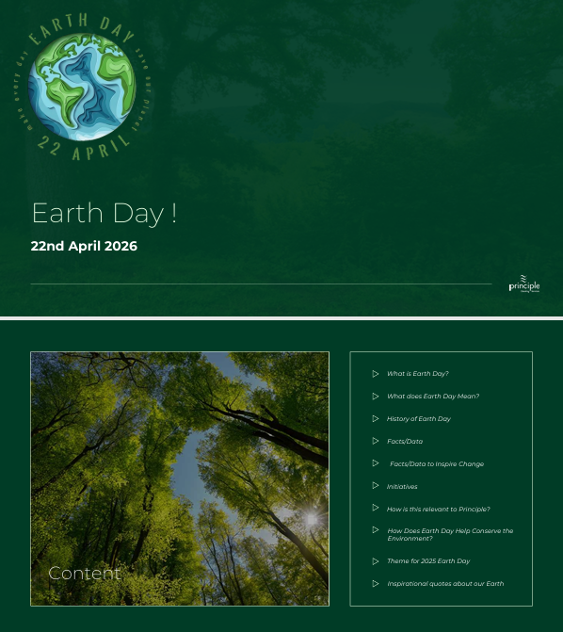
Appendix 6 Earth Day

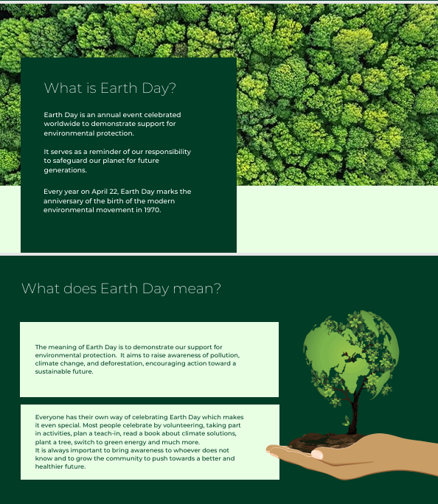

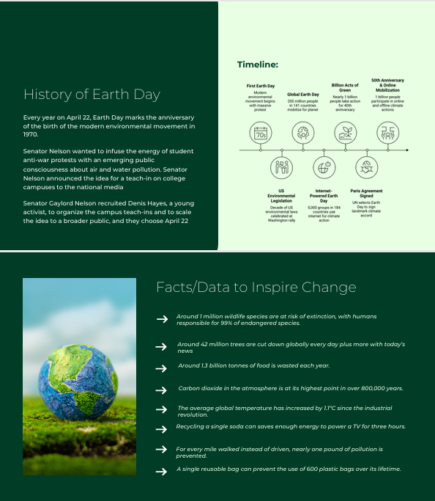

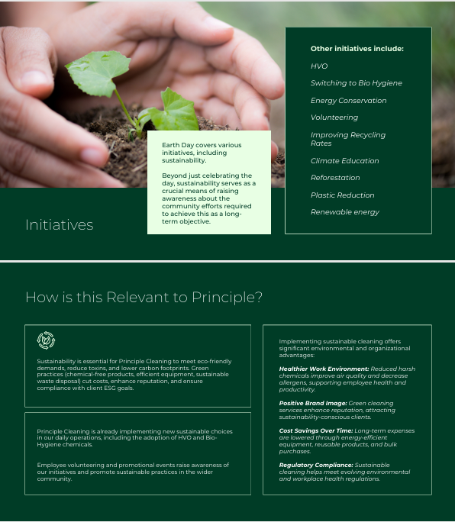

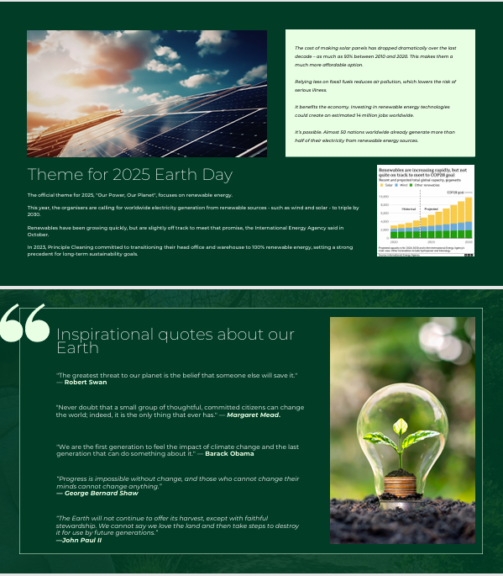

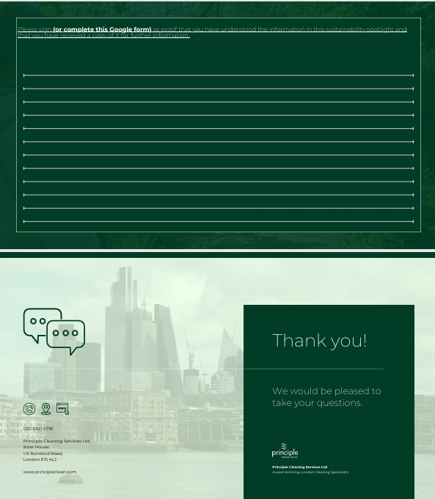

Appendix 7 Suitability Spotlight

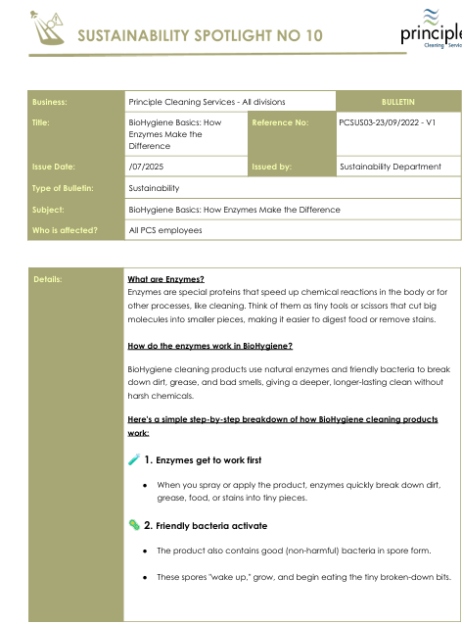

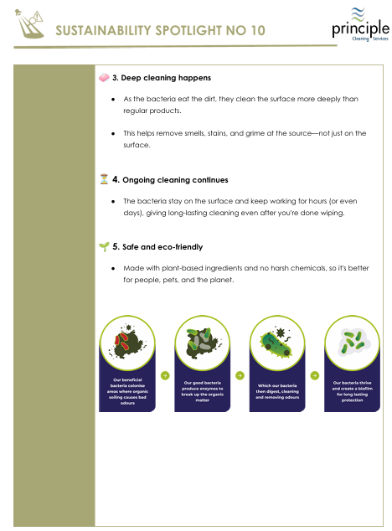

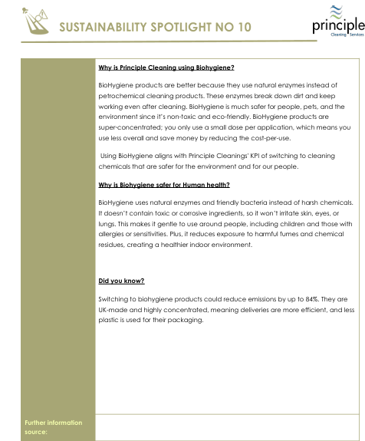

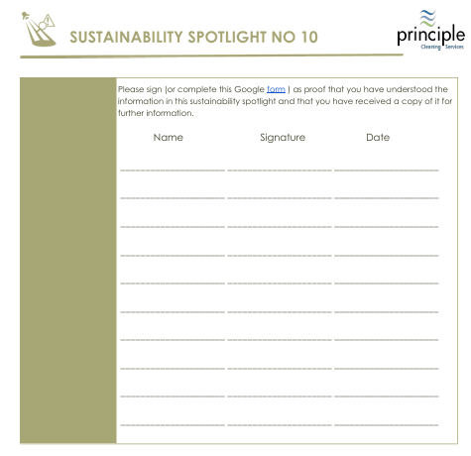

Appendix 8 Workplace wellbeing certificate

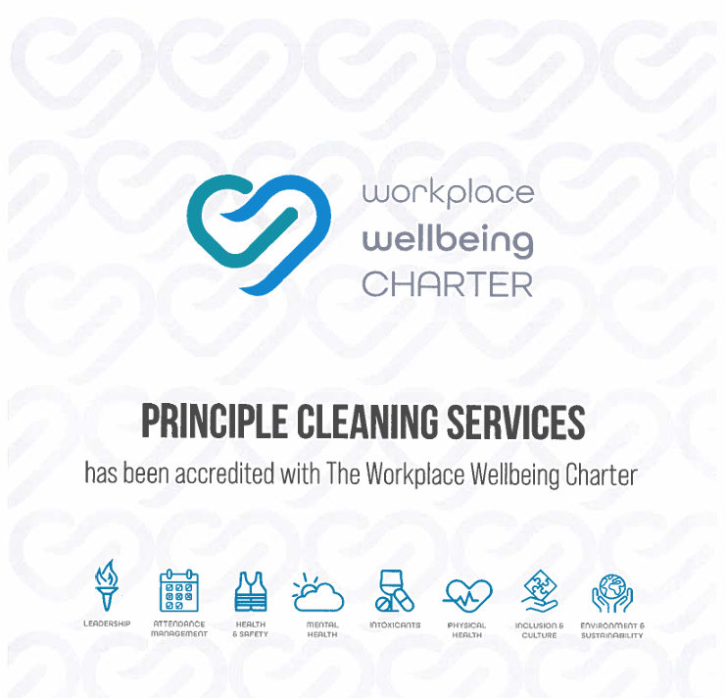

Appendix 9 Planet Mark Certificate

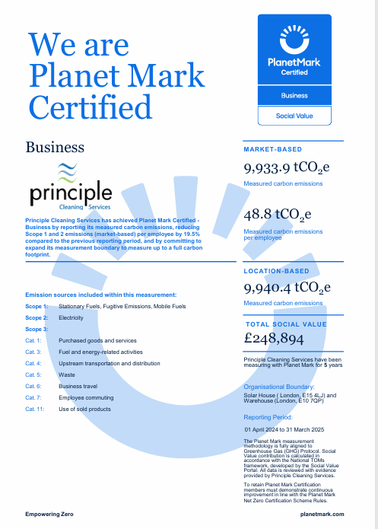

Element 2

Kolb’s reflective model

Reflective Essay: Researching Sustainability in the Cleaning Industry — A Case Study of Principle Cleaning Services
Undertaking a dissertation on sustainability within the cleaning industry, using Principle Cleaning Services (PCS) as a case study, was a demanding but genuinely formative experience. Using Kolb's (1984) Learning Cycle Concrete Experience, Reflective Observation, Abstract Conceptualisation, and Active Experimentation this essay reflects on that process and what I learned from it.

Concrete Experience

The starting point was designing and conducting research into how PCS approaches sustainability, balancing environmental commitments with operational and commercial pressures. This involved reviewing company sustainability reports, industry literature on green cleaning practices, and analysing secondary data on waste reduction, energy use, and supply chain practices within the facilities management sector. I also had to grapple with limited primary access to the company, which meant relying heavily on published reports and existing case studies rather than direct engagement with staff.

Reflective Observation

Looking back, the research process was more complex than I initially anticipated. I found it straightforward to identify the opportunities PCS pursued, such as reduced chemical usage, energy-efficient equipment, and staff training on sustainable practices, but I underestimated how difficult it would be to critically evaluate the challenges, particularly around cost implications and the tension between sustainability commitments and client demands for low-cost service delivery. I initially leaned too heavily on descriptive reporting of PCS's stated initiatives rather than critically interrogating them. It was only after feedback and further reading that I recognised the gap between corporate sustainability rhetoric and operational reality, a common issue in service-sector sustainability research.

Abstract Conceptualisation

This experience deepened my understanding of sustainability theory as applied to labour-intensive service industries. Frameworks such as the Triple Bottom Line (Elkington, 1997) helped me see that PCS's sustainability efforts needed to be assessed not just environmentally, but socially (e.g. staff welfare, fair wages) and economically (cost-competitiveness in a low-margin industry). I also came to appreciate that cleaning is often an overlooked sector in sustainability discourse, despite its material environmental footprint through chemical use, water consumption, and waste. Conceptually, I learned that sustainability transitions in such industries are constrained less by lack of intent and more by structural industry pressures: tight contracts, client expectations, and thin margins.

Active Experimentation

In the future, this experience has changed how I approach research design and critical analysis. In future projects, I would seek to build in primary research such as interviews with operational staff or clients earlier in the process, rather than relying solely on secondary sources, to strengthen the critical depth of my analysis. I would also apply a more structured critical framework from the outset, rather than retrofitting theory onto findings after the fact. This dissertation experience has ultimately improved my ability to interrogate claims of sustainability critically rather than accepting them at face value, a skill I intend to carry into future academic and professional work.

Conclusion

The application of Kolb's cycle to this reflective process has clarified the developmental trajectory from initial methodological difficulty to substantive conceptual insight, thereby contributing to both a more robust dissertation and a more rigorous research practice for future academic and professional contexts.

Element 3

Methodology poster



