Exploring Young Females’ Perspectives on Masculinity:
Implications for Promoting Healthy Relationships in Youth Work

Kayleigh Cowdery
2218436

6th May 2025

ECYW6001
Yr Athrofa: Education and Humanities

DECLARATION FORM


Dissertation Declaration Form.

1. This work has not previously been accepted in substance for any degree and is not being concurrently submitted in candidature for any degree.
Signed…K. Cowdery….………………………………………………………………………
Date ……06.05.25…………………………………………………………………………....

2. This dissertation is being submitted in partial fulfilment of the requirements for the degree of: BA Hons Youth Work and Social Education (ETS Endorsed) ……………
Signed…K. Cowdery….………………………………………………………………………
Date ……06.05.25…………………………………………………………………………....

3. This dissertation is the result of my own independent work/investigation, except where otherwise stated.
Other sources are acknowledged by footnotes giving explicit references.
A reference list is appended.
Signed…K. Cowdery….………………………………………………………………………
Date ……06.05.25…………………………………………………………………………....

4. I hereby give consent for my dissertation, if accepted, to be available for photocopying, inter- library loan, and for deposit in the University’s digital repository
Signed…K. Cowdery….………………………………………………………………………
Date ……06.05.25…………………………………………………………………………....

Supervisor’s Declaration.
I am satisfied that this work is the result of the student’s own efforts.
Signed: ……………………………………………………………………………………….
Date: ……………………………………………………………………………....................

AI DECLARATION

I confirm that I have not used any AI tools in the research and creation of this assignment. I confirm that I have not presented any AI generated materials as my own work. I confirm I have copies of my drafts, notes, and other resources I used, which I may be asked to provide in evidence.

CONTENTS
DECLARATION FORM & AI DECLARATION 2-3
CONTENTS 4
ACKNOWLEDGEMENTS 5
ABSTRACT 6
ACRONYM 7
1. INTRODUCTION 8-11
2. LITERATURE REVIEW 12-21
3. METHODOLOGY/METHODS 22-31
4. PRESENTATION OF DATA 32-63
5. DISCUSSION OF RESULTS 64-68
6. CONCLUSION AND RECOMMENDATIONS 69-73
7. REFERENCES 74-78
8. APPENDICES 79
8.1. Appendices 1 Ethics Form 81-96
8.2. Appendices 2 Information Pack 97-100

ACKNOWLEDGEMENTS

I would like to express my sincere thanks to the young people who took part in this research. Their openness and insights have been invaluable. I also appreciate the support and encouragement from my peers, whose discussions have enriched my journey. A special thank you to my lecturers and mentors for their guidance, patience, and constructive feedback. Lastly, I am grateful to my friends and family for their unwavering support and belief in me throughout this process.

ABSTRACT

This dissertation explores young females' perspectives on what it means to be a ‘good male,’ focusing on promoting healthier relationships and positive masculinity in Youth Work. Through interviews with six Welsh young women (aged 12–25), the research identifies key qualities they value in males, such as emotional intelligence, respect, and open communication. The findings challenge traditional masculinity, showing that young women view ‘good masculinity’ as empathetic and rooted in equality.

Based on these insights, the study offers six recommendations for Youth Work practice, including promoting positive male role models, supporting mental health, and co-creating a toolkit for positive masculinity. These recommendations are grounded in key theories and align with policy frameworks like the Well-being of Future Generations (Wales) Act (Welsh Government, 2015) and the Equality Act (UK Government, 2010).

ACRONYM

CSJ Centre for Social Justice

HM Hegemonic Masculinity
NEET Not in Education, Employment, or Training
UN United Nations
UNCRC United Nations Convention on the Rights of the Child
WG Welsh Government
YWIWRG Youth Work in Wales Review Group
- INTRODUCTION

Recent reports, such as the Lost Boys report (CSJ, 2025), highlight growing concerns about the social, emotional, and relational challenges faced by boys and young men in the UK. These issues include poor educational performance, heightened isolation, increased unemployment rates, and the negative impact of online influences. For instance, only 60% of boys reach the expected developmental level by age five, compared to 75% of girls (CSJ, 2025). Boys are also more likely to experience school exclusions, attend university less frequently, and face a higher risk of becoming NEET after leaving school (CSJ, 2025). Following the pandemic, the number of young men who are NEET has risen by 40%, while the increase for young women is only 7% (CSJ, 2025).

Alongside these challenges, concerns about male mental health and identity continue to rise (CSJ, 2025). Suicide remains the leading cause of death for men under 50 in the UK, and many young men grow up without positive male role models or environments where they can safely explore their emotions and relationships (CSJ, 2025). The Lost Boys report (CSJ, 2025) also emphasises the impact of harmful online content, particularly misogynistic and violent ideologies, which shape young men's perceptions of masculinity and hinder their ability to form healthy, respectful relationships.

Youth Work has an important part to play here. It provides young people with safe, informal spaces where they can explore their identity, gender, and relationships in a supportive environment (YWIWRG, 2022). By creating inclusive spaces that challenge harmful gender stereotypes, Youth Work can support young people to build confidence, foster a sense of belonging, and develop vital social and emotional skills (CLD Standards Council Scotland, 2019; YWIWRG, 2022).

Research Aim and Rationale

The aim of this research is to explore how young females in South Wales perceive and define the qualities of a ‘good male’, especially in the context of their personal relationships. While a lot of research around masculinity focuses on male perspectives or wider societal norms, there is a gap when it comes to understanding female views on masculinity.

This focus is crucial, particularly in communities in Wales where traditional gender norms such as the idea that ‘women belong in the kitchen’ remain prevalent. According to WEN (2024) gender roles present significant barriers to equality. Women in Wales are 3.5 times more likely to be economically inactive due to caring or domestic responsibilities and almost three times more likely to work part-time in comparison to men. These responsibilities, alongside the cost-of-living crisis, contribute to the gender pay gap and push many women (especially single parents) into poverty (WEN, 2024).

By focussing on the voices of Welsh young females, this study seeks to uncover the qualities they value in boys and men, with the aim of challenging traditional gender roles and inequalities within relationships. By exploring these perspectives, the study aims to provide valuable insights for Youth Work practice, specifically in fostering healthy and equitable relationships among young people (CSJ, 2025). As a result, this research seeks to contribute to the reshaping of dominant narratives surrounding masculinity, actively challenging the structural and cultural gender imbalances that continue to influence young people’s lives today (CSJ, 2025).

This research reflects policies such as the Equality Act (UK Government, 2010) and the vision set out in Well-being of Future Generations (Wales) Act (WG, 2015). It also supports the recommendations of the Lost Boys report (CSJ, 2025), which calls for cross-sector collaboration in tackling gender issues.

This research also contributes to the United Nations Sustainable Development Goals (UN, 2015), particularly Goal 5, which focuses on achieving gender equality and empowering all women and girls. The study also upholds the principles of the UN Convention on the Rights of the Child (UNICEF, 1989), by supporting young people’s rights to non-discrimination (Article 2), to have their views respected (Article 12), to freedom of expression (Article 13), and to protection from all forms of violence (Article 19).

Aligning with the core values of Youth Work such as inclusion, empowerment, and active participation, this study underscores the importance of supporting young people’s holistic development (CLD Standards Council Scotland, 2019). It seeks to foster their personal, social, and educational growth, while empowering them to find their voice, drive change, and realise their full potential within their communities (CLD Standards Council Scotland, 2019). Furthermore, it supports the aims of the Youth Work Strategy for Wales (Welsh Government, 2019), particularly in ensuring that Youth Work is accessible, inclusive, and valued, and that young people are supported to thrive.

Methodological Approach

This study uses a qualitative, youth-informed approach (CLD Standards Council Scotland, 2019) to better understand how young women (aged 12-25) conceptualise masculinity. By collecting data through open-ended questionnaires, this qualitative research (Lim, 2024) aims to gain a nuanced understanding of young females' lived experiences. Thematic analysis (Braun and Clarke, 2006) will be employed to interpret the data and identify key patterns in their responses.

Structure of the Dissertation

Following this introduction (Chapter 1), the dissertation is organised into six chapters:
- Chapter 2 provides a review of existing literature on masculinity, gender norms, and relationships, highlighting gaps that this study seeks to address.
- Chapter 3 outlines the methodology, including data collection, ethics, and analysis.
- Chapter 4 presents the findings from the six young female participants.
- Chapter 5 critically discusses these findings in relation to wider debates on masculinity and Youth Work.
- Chapter 6 offers practical recommendations for Youth Workers, aiming to challenge harmful gender stereotypes and promote healthy and equitable relationships among young people.

2. LITERATURE REVIEW
This dissertation seeks to explore the perspectives of young females in Wales on what it means to be a ‘good male’, with the aim of supporting the development of healthy relationships within Youth Work. As Jeffs and Smith (2010) argue, relationships are fundamental for personal growth and well-being. By investigating how young females’ views on the qualities that define a ‘good male’, this research seeks to uncover how these perceptions may shape boys’ and young men’s understanding of themselves, their interactions with others, and their role within wider society (Jeffs and Smith, 2010).

Given that traditional masculine norms often restrict emotional expression and reinforce harmful stereotypes, exploring young people's perceptions provides an opportunity for Youth Work practitioners to critically reflect on and challenge these constructs (Sapin, 2013). Such reflection can inform Youth Work praxis (Freire, 1996; Smith, 1994), fostering a voluntary, inclusive, and relationship-based approach (Opie and Williams, no date) that allows young people to engage in educational, expressive, empowering, and participatory experiences (YWIWRG, 2022). This is particularly significant in the context of Youth Work, as young people are navigating a critical stage of identity formation and beginning to internalise the values that will shape their future relationships and adult lives (Erikson, 1968).

In this context, the literature review will examine existing research on masculinity, critically engaging with debates surrounding both traditional and contemporary models. It will also identify gaps in current understanding that this dissertation seeks to address. Ultimately, the review aims to inform how Youth Work can support young people in redefining masculinity in ways that promote healthier, more equitable relationships.

This review will begin by defining masculinity, examining both traditional and contemporary understandings and their ongoing influence on boys and young men. It will then explore the characteristics of healthy relationships, and the qualities considered essential to their development. Finally, it will consider the role of Youth Work in challenging outdated masculine norms and promoting more inclusive, emotionally intelligent models of masculinity.

Defining Masculinity
Masculinity can be broadly understood as a social construct that encompasses the behaviours, language, and practices typically associated with men within specific cultural and social contexts, often defined in opposition to what is considered feminine (Whitehead and Barrett, 2001). It is not something biologically determined but is shaped through social, historical, and political processes (Connell, 1995). Masculinity is essentially about the social expectations and behaviours linked to being a man, reinforced daily through actions and broader societal institutions like the law, the economy, religion, education, and the media (National Democratic Institute, no date). These expectations are not only upheld by men but also by women, as seen when a mother encourages her son to ‘act like a man’ or discourages him from expressing emotions like crying (National Democratic Institute, no date). This is important to understand because it shows how gender norms are ingrained and perpetuated in everyday life, and how they shape the way young people, particularly boys, are socialised into their roles as men (National Democratic Institute, no date).
Traditional and Hegemonic Masculinity
Traditional masculinity has historically been framed around ideals of dominance, emotional restraint, and physical strength (Marquez, 2024). These norms were championed through cultural figures such as John Wayne and James Bond (Kimmel, 2008), promoting the suppression of emotional vulnerability and associating traits like empathy and care with femininity (Whitehead and Barrett, 2001). This idealised version of manhood is maintained through what Connell (1987) terms hegemonic masculinity (HM), which positions men as superior to women and even other men, particularly those who do not conform to these rigid norms (Jewkes et al., 2015). The Better Help Editorial Team (2024) suggest that boys and men socialised into rigid gender roles often experience emotional repression, leading to attachment insecurity, difficulties in forming meaningful relationships, and increased risks of violence towards those who do not conform to its standards.

Although HM remains pervasive, it is not the only model of masculinity. As Jewkes et al. (2015) note, masculinities are diverse, evolving with social dynamics and contexts. Nevertheless, HM remains particularly tied to heterosexuality, defined by what it is not: not gay, not female (Jewkes et al., 2015). Encouragingly, Jewkes et al, (2015) argue, young men have agency in how they engage with these traditional gender norms. While societal structures and patriarchal systems often benefit men, they are not confined to them. As Jewkes et al. (2015) argue, even with limited access to alternative models of masculinity, young men still have the power to challenge and resist these oppressive norms. Therefore, Youth Work can play a transformative role in offering alternative masculinities, allowing young men to reflect on the impact of traditional masculinity on their emotional well-being, relationships, and broader gender equity (Jewkes et al., 2015).

Alternative Masculinities
In recent decades, masculinity has undergone a significant transformation, shaped by cultural and social changes that continue to challenge traditional gender roles (Marquez, 2024). As Marquez (2024) notes, the push for gender equality, increased visibility of LGBTQ+ communities, and wider acceptance of gender fluidity have all contributed to more inclusive and diverse models of masculinity. Positive masculinity, explored through frameworks such as the Positive Psychology Positive Masculinity Paradigm (PPPM), offers a strength-based alternative to deficit-focused approaches (Kiselica, 2011). Rather than dismissing traits like self-reliance and courage, it encourages men to combine them with empathy, emotional expression and responsibility (Brothers in Arms, 2025). This more balanced view helps men form healthier relationships, manage stress, and become more emotionally available partners, fathers and role models (Brothers in Arms, 2025). At its core, positive masculinity is about rejecting outdated stereotypes and recognising that kindness, care, and emotional honesty are signs of strength, not weakness (Brothers in Arms, 2025).

Similarly, Anderson’s (2009) model of inclusive masculinity encourages young men to move beyond rigid norms and embrace vulnerability and emotional openness, traits traditionally seen as feminine. In more progressive contexts, young men are beginning to adopt these values, placing greater emphasis on emotional intelligence and equality in relationships (Anderson, 2009). However, this shift is far from universal. The Lost Boys report (CSJ, 2025) reveals a growing crisis among boys and young men in Britain, marked by rising mental health struggles, poor educational outcomes, obesity, and overrepresentation in the criminal justice system. A major factor is the epidemic of fatherlessness, with 2.5 million children growing up without a father figure at home (CSJ, 2025). This lack of consistent guidance and emotional support can leave boys struggling to develop a secure sense of identity and belonging (CSJ, 2025).

Technology has only amplified these challenges. Many boys are now turning to online influencers for direction, with figures like Andrew Tate gaining huge audiences by promoting hyper-masculine and often damaging messages (CSJ, 2025). However, the report argues that this is merely a symptom of a deeper problem. Too many boys are growing up without structure, discipline or purpose, and in the absence of strong, positive male role models, some are drawn to distorted versions of masculinity in search of meaning and identity (CSJ, 2025). This underscores the urgent need for a more positive, inclusive vision of what it means to be male in today’s world (CSJ, 2025).

Healthy Relationships and the Qualities That Support Them
Building on the need to move away from rigid, traditional models of masculinity, it is essential to explore how evolving ideas of what it means to be a ‘good male’ align with the values that underpin healthy relationships. A growing body of research points to key characteristics that support and sustain healthy relationships, including mutual trust, respect, honesty, kindness, and generosity (Department for Education, 2021). These are paired with the ability to establish and honour personal boundaries, protect privacy, practice consent, and manage conflict in constructive ways (Department for Education, 2021). Importantly, these qualities are not just desirable, they are necessary for creating relationships that feel safe, equal, and emotionally supportive (Department for Education, 2021).

Emotional intelligence underpins many of the key qualities needed for healthy relationships, helping individuals to communicate clearly, empathise with others, and respond appropriately to emotional situations (Goleman, 1995). Goleman (1995) defines emotional intelligence as the ability to understand and manage our own emotions while also recognising and responding to the emotions of others. This emotional awareness plays a key role in building respectful and empathetic relationships (Brackett et al., 2011). When emotional intelligence is lacking, even good intentions can be lost in poor communication or unresolved conflict (Brackett et al., 2011).

Research by Degges-White (2018) shows that women value ‘good male’ qualities such as honesty, respect, sensitivity, and integrity rather than traditional performances of masculinity reflecting strength, dominance, or heroism. Degges-White (2018) suggests that women value males who are emotionally present, fair, and supportive. She notes that the core of any strong relationship, romantic or otherwise, is built on basic human qualities such as being kind, honest, and treating each other with care. Degges-White (2018) also states that moral integrity is often highlighted as a key quality. This includes honesty, trustworthiness, mutual respect, and being accountable for one’s actions, traits that form the foundation of any secure and lasting relationship (Degges-White, 2018). Once respect is lost, especially if a woman feels undervalued or patronised, the relationship can quickly break down (Degges-White, 2018). Communication also plays a central role; when people are open and tactful in how they express themselves, they help to create a space where both feel seen and heard (Degges-White, 2018).

Equally important is relational sensitivity (Degges-White, 2018). Women express a need for males to show empathy, kindness, patience, and understanding, not just in moments of crisis, but as part of everyday interaction (Degges-White, 2018). These are the same traits valued among close friends and are essential for building trust and emotional safety (Degges-White, 2018). Emotional maturity is also crucial (Degges-White, 2018). It is not about suppressing emotion or always needing to ‘fix’ things, it is about knowing when to listen, when to support, and when to take things seriously (Degges-White, 2018).

Healthy relationships are also rooted in friendship (Degges-White, 2018). Women value emotional closeness, where their experiences are validated, and their contributions are appreciated (Degges-White, 2018). Support goes beyond kind words; it involves being present, sharing responsibilities, and showing up when it matters, whether that is emotionally, practically, or both (Degges-White, 2018). Crucially, women also want men who understand the broader social context they live in (Degges-White, 2018). This means being open to hearing about experiences of inequality, discrimination, or sexism, even when those experiences are not shared firsthand (Degges-White, 2018). Validating those experiences builds trust and shows a willingness to stand as an ally (Degges-White, 2018). Men also have a role to play in challenging the lingering gender norms that still shape many relationships and social spaces (Degges-White, 2018). True equality means not just sharing the load but ensuring women are not expected to work harder just to be seen as equal (Degges-White, 2018).

Ultimately, women want the men in their lives to be genuine allies, people who care about their success as much as their own and who bring emotional intelligence, fairness, and mutual respect into their relationships (Degges-White, 2018). While the order or expression of emotional needs may differ between individuals, the foundation of a healthy relationship remains the same: empathy, good communication, and a shared commitment to respect and understanding (Degges-White, 2018).

Conclusion: Informing Youth Work Practice
The need for alternative masculinities is particularly apparent when considering the struggles faced by young men today. The Lost Boys Report (CSJ, 2025) highlights a growing crisis where many boys are lacking positive male role models, experiencing emotional and educational setbacks, and turning to online influencers like Andrew Tate, whose hyper-masculine messaging often reinforces harmful stereotypes (CSJ, 2025). This highlights the urgent need to offer young men healthier, more constructive models of masculinity that embrace empathy, respect, and emotional intelligence (Anderson, 2009; Goleman, 1995).

Youth Work can play a pivotal role in this shift. Through its relational and strength-based approach, Youth Work can create spaces where young people, especially boys, can reflect on their identities, challenge rigid gender norms, and explore new ways of being (CLD Standards Council Scotland, 2019). Youth Workers are uniquely placed to act as trusted adults who can model inclusive, emotionally intelligent, and respectful behaviours. This might include showing vulnerability, active listening, setting respectful boundaries, and promoting equality in relationships. By doing so, they can demonstrate that positive masculinity is not about dominance or emotional detachment, but about authenticity, responsibility, and care.

The media has a role in challenging traditional ideas of masculinity and showing that there is more than one way to be a man (Marquez, 2024). Social media platforms like Instagram, YouTube, and podcasts have helped bring attention to people who value honesty, emotion, and self-expression over the old, rigid norms (Marquez, 2024). Celebrities like Harry Styles, who uses fashion to break gender boundaries, and Terry Crews, who speaks openly about emotions and healing, are good examples of this shift (Marquez, 2024). They show that masculinity can look different, whether it is sensitive, reflective, bold, or creative, and that these qualities are becoming more accepted in today’s culture (Marquez, 2024). These examples, when used in Youth Work discussions, can help young men see that masculinity can be expressed in diverse, meaningful, and socially responsible ways.

Finally, including the voices of young females in these conversations is essential. Their views on what makes a ‘good male’ can offer valuable insights that can help shape Youth Work and encourage more equal, healthier relationships. When Youth Work takes these perspectives seriously and builds them into practice, it can support boys to redefine masculinity on their own terms, without the pressure of outdated gender expectations. That said, it was difficult to find much existing research that focuses specifically on the views of young females. Most of the literature available relates to adult perspectives. This shows there is a clear gap, which this study aims to address.
Summary
This literature review has examined how traditional and emerging models of masculinity shape young people’s relationships and identities. It emphasised the importance of qualities such as emotional intelligence, respect, and empathy in fostering healthy relationships, and explored how these can be supported through Youth Work practice.

Crucially, the review identified a gap in the literature: the underrepresentation of young females’ views in conversations around masculinity. By addressing this, the dissertation aims to broaden understandings of what it means to be a ‘good male’ from the perspective of those often impacted by harmful expressions of masculinity. Their insights are positioned as valuable in shaping more inclusive, reflective, and supportive Youth Work approaches (CLD Standards Council Scotland, 2019).

The next chapter outlines the research methodology, including participant engagement, data collection methods, and the analytical process used to explore these perspectives in depth.

- METHODOLOGY/METHODS
This chapter outlines the methodological approach used to gather data from young females across South Wales. The research explores their perspectives on the qualities that define a ‘good male,’ with the broader aim of redefining masculinity and promoting healthier relationships within Youth Work.

Given the involvement of participants under the age of eighteen, the study was carefully designed to uphold the rights and wellbeing of all participants. In alignment with the UNCRC (UNICEF, 1989), this includes ensuring young people’s right to freely express their views in matters that affect them, taking their perspectives seriously, safeguarding their freedom of expression, and prioritising their best interests.

Rooted in these principles, along with the core values of Youth Work and supported by relevant theories and policies, this chapter critically explores the researcher’s methodological choices. These decisions are framed as praxis, which Smith (1994) describes as informed and committed action, shaped by reflection and understanding.

Methodology: A Qualitative Approach
A core strength of qualitative research lies in its ability to provide a holistic and in-depth understanding of complex social issues (Groundwater-Smith et al., 2015). It enables the collection of rich, descriptive data from multiple perspectives and allows for the exploration of the factors shaping people’s experiences and viewpoints (Groundwater-Smith et al., 2015). This approach is particularly well-suited to research focused on subjective experiences and meaning making (Cottrell, 2014). Unlike quantitative methods, which prioritise statistical generalisation, qualitative research delves into individual narratives, offering deeper insights into the participants’ lived realities.

Given that the aim of this study is to explore young females’ views on what constitutes a ‘good male,’ a qualitative approach provides the flexibility needed to engage with diverse and complex perspectives (Lim, 2024). This aligns with Youth Works’ values of empowerment, inclusion, and active participation (CLD Standards Council Scotland, 2019). By adopting a qualitative methodology, the researcher ensures that participants' voices are heard and respected in a way that honours their autonomy and lived experiences (Lim, 2024), a key aspect of youth work practice (CLD Standards Council Scotland, 2019).

Data Collection: Open-Ended Questionnaires
The study utilises qualitative, open-ended questionnaires, a method commonly used when working with young people (Groundwater-Smith et al, 2015). As Cottrell (2014) notes, open-ended questionnaires allow for a deeper exploration of personal attitudes, characteristics, and experiences, generating rich, detailed narratives rather than limiting responses to predefined options. This method enhances ecological validity by closely reflecting real-world contexts (Cottrell, 2014). It also offers greater inclusivity and accessibility, particularly in this study where participants are geographically dispersed across South Wales. Delivered in an online format, the questionnaires removed barriers related to location and scheduling, encouraging participation from a broad range of young females from varied backgrounds.

The use of open-ended questionnaires also reflects the researcher’s commitment to youth work principles such as empowering young people to express themselves freely and independently (YWIWRG, 2022). This approach upholds ethical standards by supporting young people’s autonomy, inclusion, empowerment, and active participation (CLD Standards Council Scotland, 2019).

However, it is important to acknowledge the challenges associated with qualitative, open-ended questionnaires. Since responses are not limited to predefined choices, findings can be unpredictable, making them more difficult to manage and analyse systematically (Cottrell, 2014). Recognising these challenges is essential for ensuring the correct approach to data analysis. To provide full transparency, the questionnaire used in this study is included in the information pack (see appendix 2), detailing the questions posed to participants.

Participant Recruitment
As a Youth Participation Officer at a national voluntary Youth Work organisation, the researcher successfully recruited six young females aged 12 to 25, all actively involved in the organisation’s Youth Initiatives. The recruitment process proceeded smoothly, largely due to the established foundation of trust and open communication between the researcher, participants, and their parents or guardians. This approach, as emphasised by Jeffs and Smith (2010) and Groundwater-Smith et al. (2015), is crucial in participatory work with young people. The existing familiarity was particularly beneficial in securing parental consent for those under 18, fostering a sense of comfort and confidence in the process. This aligns with the ethical guidelines outlined by BERA (2024), which stress the importance of clear communication and trust when obtaining informed consent from parents or guardians.

Participants were invited to take part through a combination of direct conversations, informal discussions, and follow-up emails. The researcher ensured that each invitation was tailored to the young people’s interests and engagement in Youth Work, making it clear how their insights could contribute meaningfully to the study. Sending an email was an effective way to provide additional details and allow participants to respond at their convenience, ensuring they had sufficient time and information to make an informed decision about their participation (BERA, 2024). This approach is consistent with the ethical principle of informed consent, which requires that participants fully understand the purpose of the study and their role in it, allowing them to voluntarily decide whether to participate (BERA, 2024).

Beyond handling logistics, the researcher’s deep understanding of each participant’s individual needs played a crucial role in crafting open-ended questions that were accessible, age-appropriate, and designed to encourage thoughtful responses. As and Groundwater-Smith et al. (2015) emphasise, tailoring research methods to the unique developmental needs of young people is central to fostering meaningful participation in research. This personal connection was especially significant given the study’s focus. By involving young people already engaged in Youth Work, the research remained grounded in real-life experiences and authentic perspectives (Lim, 2024).

The insights gained from this study have the potential to shape and enhance Youth Work practice within the organisation, where the researcher is actively leading a gender equality initiative. Encouragingly, several participants have already expressed a desire to collaborate further with the researcher, demonstrating their commitment to youth-led change and a more inclusive future (UN, 2019).

Ethical Considerations
All educational research conducted as part of a university degree must adhere to the ethical standards set forth by the British Educational Research Association (BERA, 2024). These guidelines provide a robust framework that ensures research is conducted with integrity, transparency, and methodological rigour. By aligning with BERA’s (2024) principles, this study demonstrates a strong commitment to protecting participants’ rights and dignity while making a meaningful contribution to the fields of education and youth work practice.

In adherence to these standards, this study is designed to uphold the core ethical values of respect, honesty, trust, fairness, and care (BERA, 2024). These principles inform every stage of the research process, from the development of data collection tools to participant engagement and data management. The researcher acknowledges the responsibility to conduct research that ensures equitable treatment and fosters a respectful, inclusive, and safe environment for all participants (BERA, 2024).

Additionally, the research is guided by the core values and ethical principles of youth work, including voluntary participation, empowerment, respect for the individual, and the promotion of equality and inclusion (CLD Standards Council Scotland, 2019). Furthermore, the study aligns with the UNCRC (UNICEF, 1989), particularly Article 12.

To ensure fully informed and voluntary participation, all individuals involved in the study, as well as their parents or guardians, were provided with an information pack (please see appendix 2). This included an information letter, a consent form, and a sample questionnaire. The information materials were designed to be accessible and age-appropriate to promote clarity and understanding. The letter introduced the researcher, the purpose of the study, and the significance of participants' contributions.

Participants were informed that the questionnaire would take approximately 30 minutes to complete, that there were no right or wrong answers, and that their responses would be treated confidentially. They were also clearly advised that participation was entirely voluntary, with the freedom to withdraw at any time without providing a reason. This aligns with BERA’s (2024) emphasis on participant autonomy as well as the voluntary principle of youth work. The consent form reinforced this message and included the following key points:

- Participation is voluntary and can be withdrawn at any stage.
- Data provided may be used in future reports, articles, or presentations.
- Personal identifiers will not be included in any public documents.
- Participant anonymity will be strictly protected.

In alignment with Groundwater-Smith et al. (2015), this consent process prioritised transparency, trust, and participant empowerment. Participants were encouraged to ask questions and reflect on the implications of their involvement, ensuring informed decision-making. Ultimately, it was essential that the participants understood fully what was expected from them as what they were consenting to (Cottrell, 2014).

Confidentiality and Data Protection
Confidentiality and data protection were central to the study’s ethical approach. Following best practices outlined by Cottrell (2014), stringent measures were implemented to protect all personal and sensitive information. All responses were anonymised through the use of neutral identifiers (e.g. ‘Participant 1’, ‘Participant 2’), and data was stored securely on password-protected electronic devices, with hard copies kept in a locked filing cabinet, accessible only to the researcher. Access to raw data was strictly limited, and in accordance with ethical and institutional policy, all data will be securely destroyed upon completion of the study and any required retention period.

Feedback and Dissemination of Findings
Consistent with BERA’s (2024) ethical guidelines, participants were given the opportunity to request a summary of the research findings upon completion of the study. This option was offered at the end of the questionnaire, where participants could provide an email address if they wished to receive a copy of the results. This approach not only promotes transparency and reciprocal engagement but also acknowledges the value of participants’ contributions. By sharing outcomes with those involved, the study fosters an open and respectful research environment, ensuring that participants are not merely subjects of research but active contributors throughout the whole process (BERA, 2024).

Data Analysis
The researcher utilised Braun and Clarke’s (2006) approach to thematic analysis to analyse the qualitative data. This method was chosen for its ability to identify, analyse, and report patterns or themes within the data, offering a rich and detailed understanding of participants' perspectives. The researcher began by familiarising themselves with the data through repeated reading of the responses to gain an in-depth understanding of the content. This approach allowed the researcher to explore and highlight key patterns in the data while ensuring that the analysis remained grounded in the participants' voices and experiences.

Limitations
The original research design aimed to explore young people’s perspectives on masculinity by including both young females and males. However, ethical approval for including young males was denied due to concerns about sensitive topics such as pornography, the incel movement, and other potentially harmful aspects of masculinity. These concerns raised safeguarding issues and the potential psychological impact on participants (and researcher). As a result, the study was refocused on young females, specifically exploring positive aspects of masculinity. This adjustment allowed the research to gain ethical approval while remaining within manageable and safe boundaries. However, the exclusion of young males limited the ability to compare female perspectives with male views, reducing the overall depth and richness of the findings.

The researcher had originally intended to use focus groups, which are valuable in qualitative research for fostering dynamic interaction and offering multiple data sources, such as real-time observations and audiovisual elements (Creswell and Creswell, 2018). However, due to time constraints, questionnaires were used instead. While effective for collecting individual responses, questionnaires did not provide the interactive dynamic of focus groups, which may have offered a more holistic understanding of young females' views and behaviours.

This study employed a qualitative research methodology to explore the perspectives of young females on the qualities that define a ‘good male’, with the broader aim of redefining masculinity and promoting healthier relationships within Youth Work. A qualitative approach was chosen for its capacity to provide a deep, holistic understanding of participants' views and experiences, aligning with Youth Work values of empowerment, inclusion, and active participation (CLD Standards Council Scotland, 2019).

The data was collected using open-ended questionnaires, which were distributed online to six young females aged 12 to 25 from a national Youth Work organisation in South Wales. The use of open-ended questions allowed for rich, detailed responses, providing insight into the participants’ personal attitudes, experiences, and perceptions of masculinity and healthy relationships. A thematic analysis approach (Braun and Clarke, 2006) was employed to analyse the data, identifying key themes related to masculinity, emotional intelligence, and the role of Youth Work in challenging traditional gender norms. The methodology focused on ethical principles, prioritising the rights and wellbeing of participants (UNICEF, 1989), particularly given their age and the sensitive nature of the topic. The study followed established ethical guidelines, ensuring informed consent, confidentiality, and participant empowerment throughout the research process (BERA, 2024).
- PRESENTATION OF DATA
This chapter presents findings from open-ended, qualitative questionnaires completed by six young females, aged 12 to 25, within a national voluntary Youth Work organisation in Wales. The research aims to address the dissertation question: Redefining Masculinity: Perspectives from Young Females in South Wales on the Qualities of a 'Good Male' to Foster Healthier Relationships in Youth Work. Each participant provided individual responses to a set of 13 diverse questions, offering personal insights and perspectives. As outlined in the methodology, the open-ended format of the questionnaire enabled participants to freely express their thoughts without restriction. In this section, responses are organised thematically. Each theme will capture key insights from the participants, accompanied by direct quotes where appropriate, to illustrate their perspectives effectively. The ‘P’ stands for participant.

Figure 1: Age Demographic
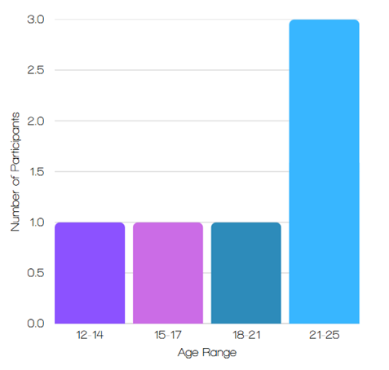
Figure 1 above presents the distribution of female participants in the study, categorised by age range.
Question 2: What Qualities Make Someone a ‘Good Male’?
Figure 2 illustrates the qualities most valued in a male, based on responses from the 6 female participants. The table highlights the frequency of mentions for each ‘quality’, showing that respect and kindness were the most cited attributes, each appearing four times. P1 stressed that respect should extend to all genders, identities, and cultures, highlighting that respectful males serve as role models.

Figure 2: Valued Male Qualities
Male Quality | Number of Mentions
Respect | 4
Kindness | 4
Empathy | 2
Honesty | 1
Emotional Expression | 1
Admitting Mistakes | 1
Maturity | 1
Sensitivity | 1
Confidence | 1
Treats People Equally | 1
Good Morals | 1
Gentleman Qualities | 1
Good Manners | 1
Feminist | 1
A Good Advocate | 1

Quotes from Participant 1:
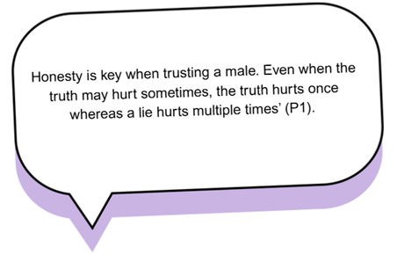
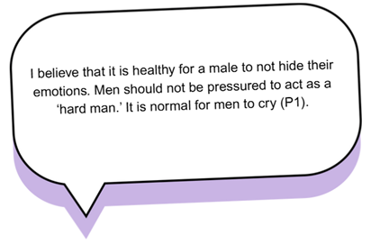
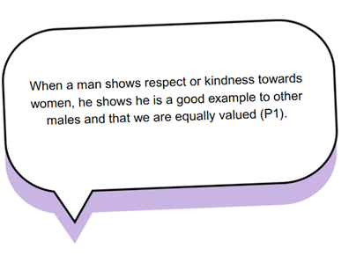
Question 3: How Does Society Influence How Boys Act?
Participants highlighted social media, traditional gender roles and stereotypes, societal pressure to conform, and media representation as key influences on male behaviour.

Social Media
P4, P5, and P6 noted that social media plays a significant role in shaping boys' behaviour. P4 expressed concerns about the impact of negative male role models online:
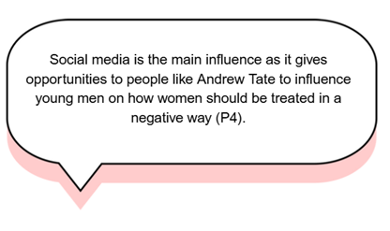
P6 further commented on how online content shapes perceptions of women:

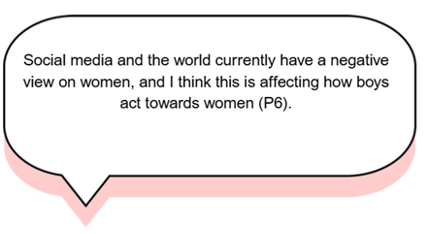
Traditional Gender Roles and Stereotypes
P1 and P2 highlighted how outdated gender norms are passed down through generations or embedded in cultural beliefs, reinforcing expectations such as:
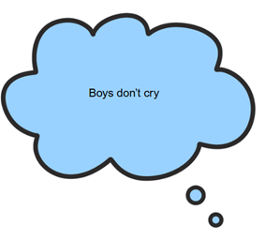
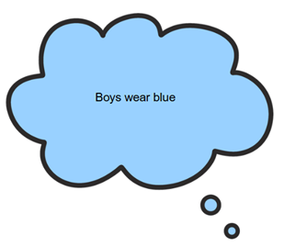
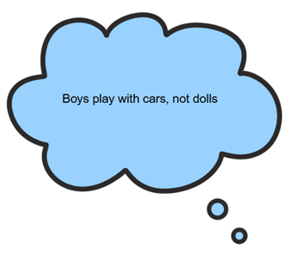
Pressure to Conform to Traditional Masculinity
P2, P3, and P4 discussed expectations for boys to ‘act manly’ and avoid traits perceived as feminine. P2 noted that this pressure extends beyond behaviour to appearance:

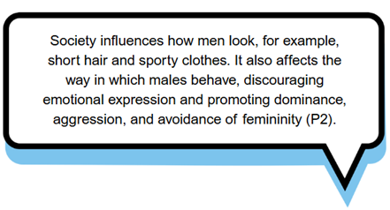

Media and Entertainment as Reinforcing Factors
P6 pointed out that music and video games contribute to violence, aggression, and anti-social behaviour. P3, P4, and P6 expressed concern about the normalisation of harmful attitudes towards women through entertainment and social media.

Question 4: What Can Emotional Intelligence Do for Males in Relationships?
Participants highlighted the role of emotional intelligence in enhancing mental health, relationships, personal growth, and self-awareness, as well as in challenging gender stereotypes. Figure 3 below illustrates how frequently young female participants echoed these key themes in their responses to the question.

Figure 3: Role of Emotional Intelligence
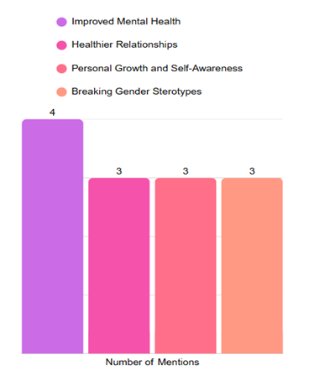

Health Benefits
P1, P2, P4, and P6 agreed that emotional openness helps reduce isolation, sadness, and low self-esteem while challenging stigmas around men’s mental health. P1 noted:
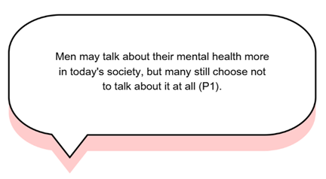
P2 explained the consequences of suppressing emotions:
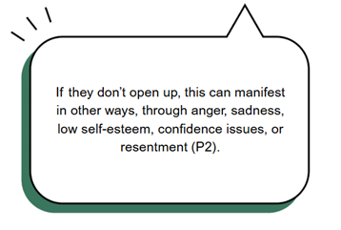

Healthier Relationships
P6 highlighted how emotional intelligence eliminates harmful stereotypes and improves communication:
It takes away the stereotypes that men can't talk about feelings… This can lead to fewer arguments and healthier relationships (P6).

Personal Growth and Self-Awareness
P2, P3, and P4 described emotional intelligence as key to self-development, making men more understanding, gentle, and aware of their actions. P3 stressed:

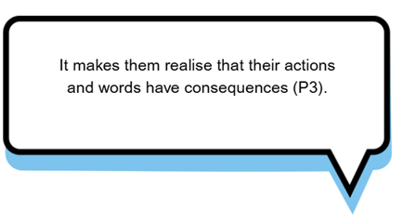
Question 5: Do Traditional Ideas about Being a Man Affect Relationships?
Participants highlighted several key themes regarding traditional masculinity and its impact on relationships. They noted that traits like toughness, independence, and emotional restraint contribute to gender inequality and emotional suppression. Cultural and media influences further reinforce outdated notions of masculinity, shaping societal expectations.

Gender Inequality and Emotional Suppression
P1, P4, and P6 pointed out that traditional gender roles create male dominance and female dependence, limiting equality:

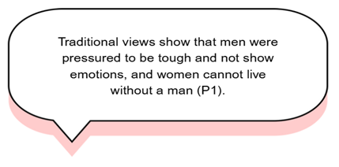
P1, P2, P3, and P6 agreed that expectations for men to hide emotions create tension and mistrust:
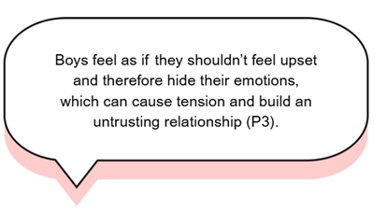

Cultural and Media Influence
P4 and P6 noted that media, social media, films, and family upbringing reinforce outdated masculinity, sometimes competing with modern education:

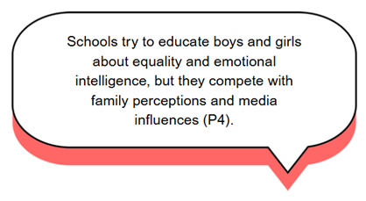

Changing Perspectives
While traditional norms persist, P2, P4, and P6 observed growing awareness and pushback, particularly in educational settings and among younger generations. However, P5 believed these ideas no longer have a significant impact:
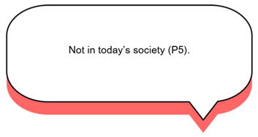

According to 5 out of 6 of the female participants, traditional masculinity still shapes relationships by reinforcing gender inequality and discouraging emotional openness, though shifting perspectives are challenging these outdated norms.

Question 6: Where Do You See Good Male Role Models, and What Makes Them Good Examples?
Young participants identified several key areas where they observe positive male role models, including personal relationships, community and educational settings, and the media and online influencers. The females suggest that the qualities that make role models stand out are their emotional intelligence, and their respect for women.

Personal Relationships
P2, P3, P5, and P6 highlighted fathers, grandfathers, uncles, youth workers, coaches, and colleagues as role models valued for their kindness, emotional openness, and respect for women. P3 noted:

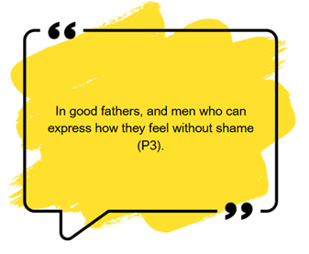

Community and Educational Settings
P2 and P4 pointed to schools, youth clubs, colleges, and sports teams, where positive male figures show fairness, empathy, and consistency:

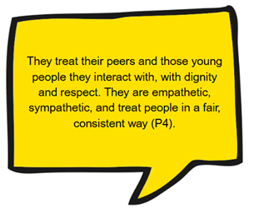
Media and Online Influencers
P1 acknowledged that social media and reality TV can shape perceptions of positive male figures, depending on representation:
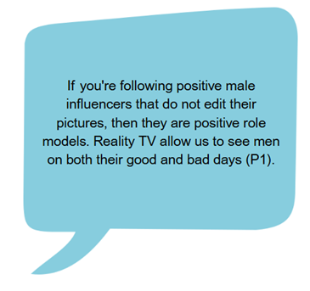

Emotional Intelligence and Respect for Women
P3, P4, and P6 emphasised the importance of emotional openness, empathy, and advocacy for women’s issues. P6 noted:

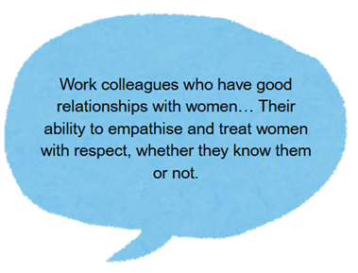
Question 7: How Do You Think Males Should Think and Act in Relationships?
In response to this question, the six young females provided thoughtful answers, highlighting key themes regarding how young males should approach relationships. Their perspectives underscored the importance of respect and consideration, the value of equality and partnership, the necessity of emotional maturity and personal growth, and the significance of responsibility and integrity.

Respect and Consideration
Several participants emphasised the importance of respecting a partner's wishes and setting personal boundaries. P1 highlights the pressure some young men face regarding sexual expectations, reinforcing the idea that respect includes listening and honouring a partner’s choices.
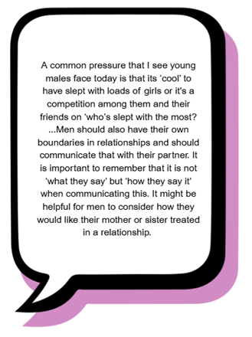
Similarly, P3 and P5 focus on respect as a foundational value for healthy relationships:
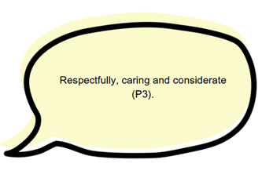

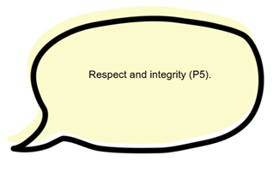

P2 and P4 discuss treating a partner as an equal, suggesting that mutual respect fosters stronger relationships:

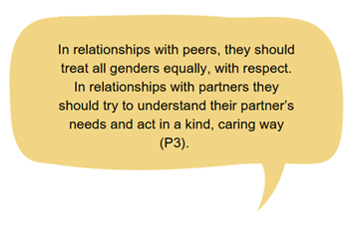
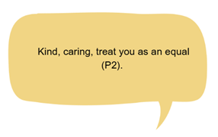
P6 extends this idea by emphasising the importance of working together and avoiding ‘weaponised incompetence’, ensuring that both partners contribute meaningfully to the relationship.

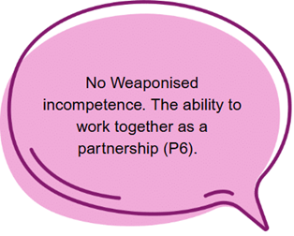

Emotional Maturity and Growth
P2 highlights the significance of learning from mistakes and striving to improve, reinforcing the idea that young males should approach relationships with a willingness to grow. They stated that boys should:

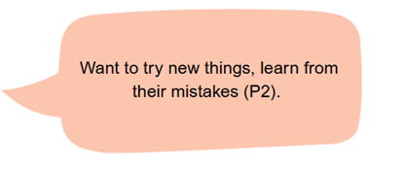

P6 mentions the importance of being ‘calm and collected’ suggesting that emotional stability plays a crucial role in maintaining healthy partnerships.

Responsibility and Integrity
The idea of being a good father or role model aligns with the theme of integrity and responsibility. P2 stated that men should:

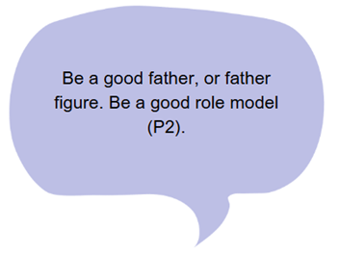
P5 mentioned respect and integrity which further supports this, reinforcing that relationships thrive on honesty, reliability, and ethical decision-making.

Question 8: How Do You Think the Media Shows Men, and How Does It Affect Your View of How Males Behave?
The responses from the six female participants highlighted several key themes regarding the media’s influence on how men are perceived and how their behaviour is shaped. Their insights reveal concerns about negative media influences, reinforcement of harmful stereotypes, traditional gender roles, toxic masculinity, and violence against women.

Negative Media Influence
P4 expressed concerns about how media often showcases negative male role models, leading young men to emulate harmful behaviours:

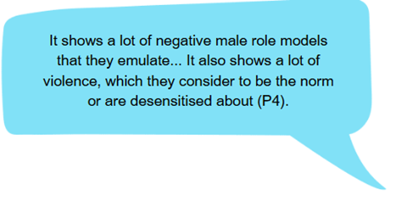

P6 shared fears regarding the impact of social media influencers such as Andrew Tate and the broader issue of violence against women:
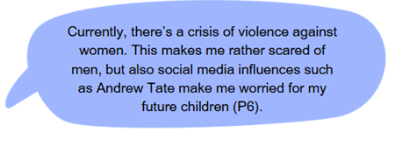

Traditional Gender Roles
P2 highlighted the pressure placed on men as providers and protectors:

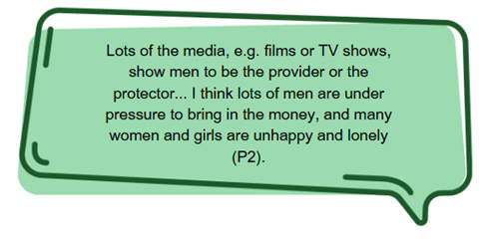

Toxic Masculinity and Violence
P4 and P6 pointed out how media normalises aggressive behaviour, desensitising young males:
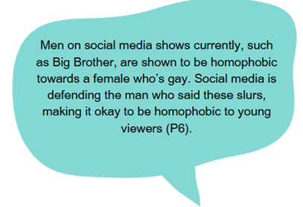
Varied Impact Across Media Platforms
P5 observed how media influence differs across platforms and generations:

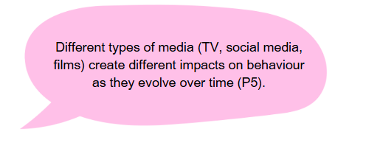
Social Media and Harmful Narratives
P1 explained how social media both can promote positive role models and reinforce negative behaviours:

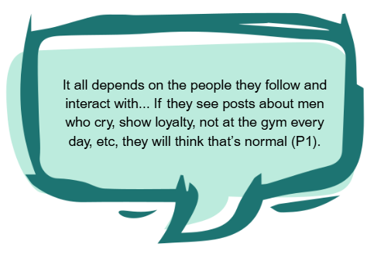

Question 9: What do you think can be done to help males develop healthy and respectful relationships with others?
The responses from the six female participants highlight several key themes regarding ways to support males in developing healthy and respectful relationships with others. Their answers align with several important themes, including education, challenging stereotypes, the role of positive role models, limiting harmful media influences, fostering resilience, encouraging social interaction, and teaching emotional intelligence. Figure 4 below illustrates the number of female participants who mentioned these themes in their responses.

Figure 4:
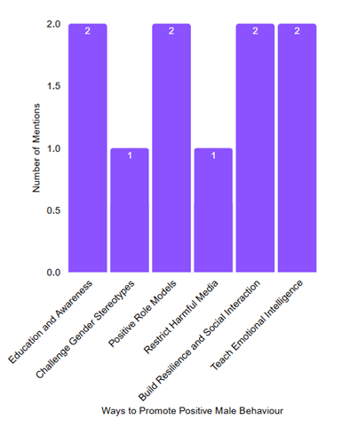

Education and Awareness
P1 and P4 emphasised the need to educate young males through schools, training, and media to raise awareness and understanding of healthy relationships.
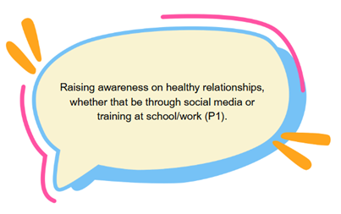

Challenge Gender Stereotypes
P2 encouraged breaking outdated expectations about masculinity and promoting self-expression:
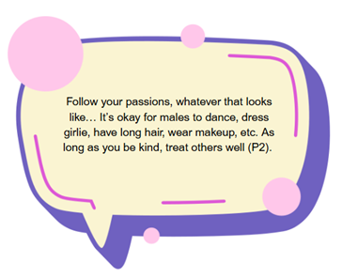

Positive Role Models and Family Involvement
P2 and P4 stressed the importance of positive role models, guiding young males towards respectful relationships:
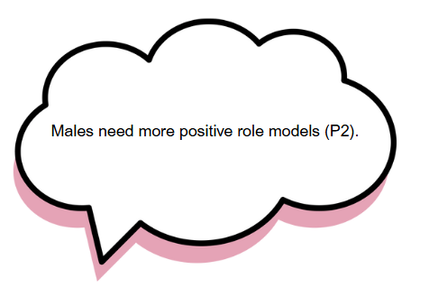

Restrict Harmful Media Content
P4 called for stronger restrictions on harmful media:

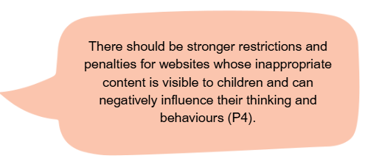

Build Resilience and Encourage Social Interaction
P2 and P5 encouraged spending less time online, engaging in real-life activities, and seeking support groups:

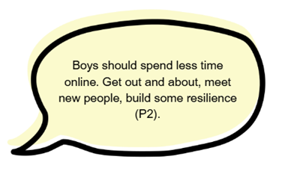

Teach Emotional Intelligence and Self-Awareness
P3 and P6 emphasised the importance of emotional openness, empathy, and respect in relationships:

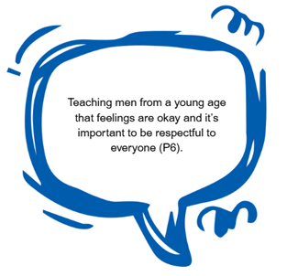
Question 10: How Important Do You Think Communication and Respect are in Relationships?
In response to this question, every young female participant emphasised that communication and respect are fundamental to maintaining healthy relationships. Key themes that emerged from their responses include their role in fostering trust and connection, ensuring mutual respect, and facilitating effective conflict resolution.

Trust and Connection
P1, P2, P3, and P5 described communication as the glue of relationships.

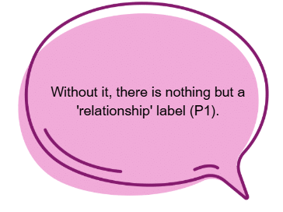

Mutual Respect
P2, P5, and P6 tied respect to trust, with its absence leading to breakdowns in support.

Conflict Resolution
P4 and P6 said internalised issues often escalate without honest conversation.

Question 11: Do You Think That Girls Are Expected to Solve Problems in Friendships and Relationships More Than Boys, and If So, How Does This Affect Relationships?
In response to these questions, the female participants shared their perspectives, revealing several themes. These included challenges associated with stereotypes about emotional responsibility, the pressures placed on girls in relationships, and the challenges that can arise in relationships when boys suppress their emotions.

Girls and Emotional Awareness
Many participants felt that girls develop emotional awareness at a young age, making them more open about their feelings than boys. P2 explained:
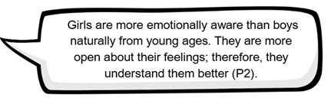
However, this difference also influences how conflicts are managed. P2 noted:
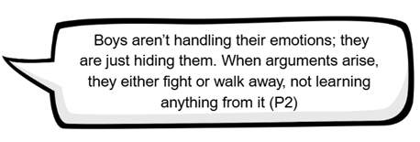

Stereotypes About Emotional Responsibility
Some participants pointed out that society often assumes girls are more capable of managing emotions, reinforcing traditional expectations. P3 answered:
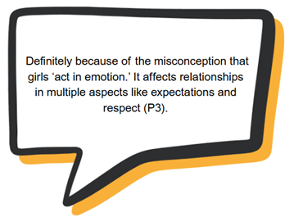

P4 added that girls are often seen as more sensitive, making them quicker to react to problems:
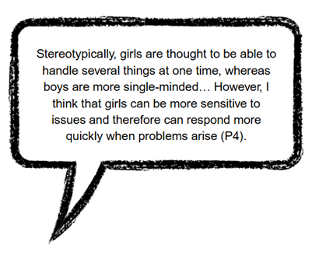

Pressure on Girls in Relationships
Some participants believed that this expectation places undue pressure on women, making relationships feel unbalanced. P6 shared concerns about emotional labour:
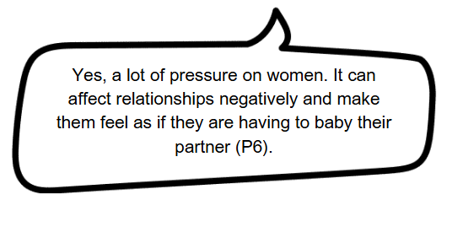

Similarly, P5 highlighted that girls are often expected to take on the role of emotional caregivers:
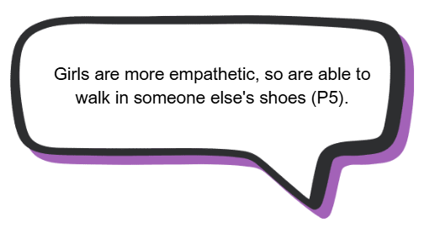

Boys Avoiding Emotional Growth
While girls are encouraged to handle emotions, some participants believed boys lack the same encouragement, leading to difficulties in emotional expression. This emotional suppression, as P6 suggested, could lead to long-term struggles in relationships and personal growth.

Question 12: Do you think Youth Work can Help Challenge Negative Ideas about Masculinity? If so, How?
Five out of six female participants believed that Youth Work can help challenge negative ideas about masculinity, while one remained unsure. Participants highlighted education and workshops, awareness and dialogue, positive role models, and safe spaces as key ways that Youth Work can foster healthier perspectives on masculinity.

Education and Workshops
Participants highlighted the importance of structured learning opportunities, such as educational programmes and workshops, in challenging harmful notions of masculinity.

Raising Awareness and Dialogue
Participants P1, P3, and P4 recognised the value of dialogue and awareness-raising activities. They emphasised that Youth Work can facilitate open discussions on societal views, provide opportunities for young men to express themselves, and offer workshops designed to challenge restrictive gender stereotypes.

Positive Role Modelling
P2 and P4 highlighted the significance of Youth Workers serving as positive role models. P4 praised Youth Workers for their empathy and ability to challenge toxic behaviours, asserting that Youth Work offers young people a supportive environment to be themselves, explore new opportunities, and engage in conversations that may not typically occur in formal education settings.

Safe Spaces
P2 and P6 acknowledged the importance of non-judgmental environments created by Youth Work. These safe spaces can allow young people to communicate openly, express themselves without fear of criticism, and explore healthier perspectives on masculinity (P2).

Question 13: What do you think are the main challenges young males face today?
The young female participants identified several challenges that young males face today, including emotional suppression and mental health struggles, identity confusion, largely influenced by media portrayals of masculinity, and the lack of positive role models.

Emotional Suppression and Mental Health
Participants P1 and P6 highlighted the pressures young males experience regarding body image, identity, and emotional stoicism, noting that societal expectations often discourage emotional expression. P6 also pointed to a lack of emotional education, which can leave young males without the necessary tools to navigate their feelings.
Identity Confusion
P4 emphasised that mixed signals from the media complicate young males' understanding of masculinity. The portrayal of rigid and sometimes conflicting ideals of what it means to ‘be a man’ can create unrealistic expectations and internal conflicts, making it difficult for young males to develop a secure sense of self (P4).

Role Model Gap
Several participants expressed concerns about the absence of positive role models, highlighting the impact of limited guidance and support.

Question 14: Any Further Comments
When asked if they had anything else to add, most participants did not provide further comments. However, P4 expressed concern, highlighting the significance of the topic:

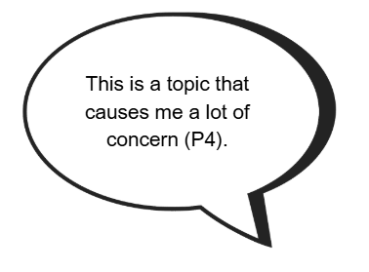
Summary
This data offers valuable insights into young females' perceptions of masculinity in Wales, focusing on the qualities they associate with a ‘good male.’ Key themes such as respect, emotional intelligence, and the rejection of traditional gender norms were consistently highlighted, reflecting a shift in how young people view masculinity and its influence on relationships.

The subsequent analysis will delve into these themes, positioning them within the context of existing literature. It will explore how these perspectives challenge or align with traditional views on masculinity and consider the implications for Youth Work in fostering healthier, equal relationships.

- DISCUSSION OF RESULTS
The data captured from the perspectives of young females in Wales offers compelling insights into their understanding of masculinity and the qualities they associate with a 'good male'. This aligns closely with the existing literature, particularly in how it highlights the importance of emotional intelligence, respect, and kindness, and the growing rejection of traditional masculine norms. These findings underscore the shift in understanding masculinity and its relationship to building healthy, respectful relationships, which has been discussed in the literature, including the works of Jeffs and Smith (2010) and Connell (1987).

Importance of Emotional Intelligence
The participants consistently emphasised respect, emotional intelligence, and rejection of traditional gender norms. These qualities directly resonate with the broader literature on the importance of emotional intelligence and its role in fostering healthy relationships. As Goleman (1995) defines emotional intelligence, it involves not only self-awareness and self-regulation but also the ability to empathise and respond appropriately in social contexts. This was reflected in the participants’ views that emotional intelligence in males contributes to self-awareness and better communication in relationships. Degges-White (2018) similarly emphasises that women value emotional maturity and kindness, traits which were highlighted by the participants as essential in a 'good male'. The data confirms that these qualities are foundational in fostering emotionally supportive and egalitarian relationships.

Media Influences
The concern about the influence of media and social media on young males, especially in perpetuating harmful behaviours like aggression, violence, and a limited view of masculinity, further supports the findings in the literature, notably the Lost Boys Report (CSJ, 2025) and Jewkes et al. (2015). These sources discuss how media and online influencers, particularly those promoting hyper-masculine ideologies like Andrew Tate, negatively impact young males’ identities and behaviours. The data in this study also pointed out the role of negative male role models online, particularly in music, video games, and social media, contributing to the reinforcement of damaging stereotypes. As Marquez (2024) notes, the need for a more positive, inclusive masculinity is pressing, and Youth Work must be part of the solution.

Positive Role Models
One key theme that emerged was the role of positive male role models in the participants' lives, such as fathers, uncles, youth workers, and coaches. This is in line with Jewkes et al. (2015), who argue that positive role models are crucial in reshaping masculinity. Furthermore, the emphasis on the importance of emotional intelligence and mutual respect in male role models echoes the framework of positive masculinity, as outlined by Kiselica (2011), which encourages emotional expression and empathy alongside traditional masculine virtues such as courage and responsibility.

Impact of Traditional Masculinity
The participants’ concerns about traditional masculinity reinforcing gender inequality and emotional suppression align closely with Connell’s (1987) theory of HM, which positions men as dominant figures who must suppress vulnerability. This is further reflected in the data, where young females identified how the expectation for males to hide emotions often leads to tension and mistrust in relationships. This connects to Degges-White’s (2018) argument that emotional suppression in men is detrimental to relationship dynamics, particularly when emotional responsibility falls disproportionately on women. The study’s findings that emotional intelligence in males reduces conflict and fosters healthier relationships, further support Brackett et al. (2011), who argue that emotional awareness is key to avoiding miscommunication and enhancing relationship satisfaction.

Challenging Traditional Masculinity
The data also touched on the emerging shift in how young males are beginning to challenge traditional masculinity. While some participants still believed that traditional masculinity impacted relationships, others noted that younger generations, particularly in educational settings, were increasingly questioning these norms. This is consistent with Jewkes et al. (2015), who argue that while HM remains pervasive, young men have agency to resist and redefine these rigid norms. The shift towards more inclusive, emotionally aware masculinities, as noted by Anderson (2009) and Marquez (2024), is reflected in the participants’ identification of emotional intelligence and respect as critical traits of a ‘good male’. These changing attitudes suggest that, although traditional masculinity persists, the younger generation is pushing for a more flexible and holistic understanding of masculinity, which this study reinforces.

However, the data also suggests that despite the growing awareness and pushback against traditional norms, the media and family structures continue to reinforce harmful stereotypes. The participants pointed out that while schools make efforts to educate both boys and girls about emotional intelligence and gender equality, these efforts are not sufficient in the face of pervasive media and family influences. This observation aligns with the Lost Boys Report (CSJ, 2025), which highlights that the media, alongside the lack of positive male role models, plays a significant role in shaping young males’ sense of identity and masculinity.

Potential of Youth Work
In terms of Youth Work, the findings from the data are strongly aligned with the literature’s emphasis on Youth Work's potential to challenge negative masculinities (Sapin, 2013; YWIWRG, 2022). Youth Work can be a transformative space where young people critically engage with societal norms and develop healthier, more inclusive perspectives (YWIWRG, 2022). The participants’ suggestions for Youth Workers to provide positive male role models, offer safe spaces for communication, and challenge harmful behaviours reflect the strategies outlined in the literature for addressing issues related to masculinity. It also supports the notion that Youth Work’s voluntary, inclusive, and relationship-based approach (Opie and Williams, no date) empowers young people to actively engage in shaping healthier versions of themselves. This approach not only promotes the development of positive, respectful relationships but also strengthens their sense of identity and role within society, while contributing to improved mental health and overall well-being (Jeffs and Smith, 2010).

Summary
The findings from this study are consistent with the literature on masculinity, healthy relationships, and the role of Youth Work in fostering positive change. The young females in this study emphasised qualities like emotional intelligence, respect, and kindness, which are crucial in developing healthy, equitable relationships. They also highlighted the significant influence of media and socialisation on male attitudes, aligning with research that critiques the harmful effects of traditional masculinity.

The data supports the notion that Youth Work can play a pivotal role in challenging negative masculine norms and offering alternative masculinities, which is in line with the goals of this dissertation, to provide insights for promoting healthier relationships through Youth Work practice.

Building on these insights, the following chapter will present the key conclusions and offer actionable recommendations for Youth Workers to address harmful masculine stereotypes and support young people in developing healthy, respectful relationships.

- CONCLUSION AND RECOMMENDATIONS
This dissertation set out to explore young females’ perspectives on what it means to be a ‘good male,’ with the aim of supporting healthy relationships and promoting positive expressions of masculinity through Youth Work. Through qualitative engagement with six young females aged 12–25 from a national Youth Work organisation, the research uncovered key insights into how young women understand and value qualities in male peers and partners. Across the responses from all questionnaires, participants emphasised the importance of emotional intelligence, mutual respect, honest communication and non-judgmental behaviours. These findings underscore the relevance of emotional and relational competencies in fostering positive relationships and affirm the value of listening to young women’s voices when shaping interventions aimed at young men.
The research explicitly answers the central question by highlighting that young female’s view ‘good masculinity’ as emotionally aware, respectful and grounded in values of empathy and equality. These findings are consistent with prior work in the field that critiques HM (Connell, 2005) and supports more inclusive, emotionally expressive forms of masculinity (Anderson, 2009; Kiselica, 2010). Participants also identified a range of socialising forces that influence how masculinity is learned and performed, including media, peers, family dynamics and school environments. These align with Bronfenbrenner’s Ecological Systems Theory (1979), which suggests that identity is shaped by interactions within interconnected systems.
Youth Work was consistently identified by participants as a powerful space for counteracting negative gender norms and promoting healthier alternatives. This is further supported by the literature, which positions Youth Work as a relational, strengths-based practice that facilitates emotional growth, critical reflection and inclusive participation (Jeffs and Smith, 2010; YWIWRG, 2022). The study demonstrates that Youth Work has a unique opportunity to equip young people with the skills and confidence to engage in respectful, healthy relationships, while also challenging rigid and damaging gender expectations (YWIWRG, 2022).
Based on the findings, six evidence-informed recommendations have been developed to strengthen Youth Work’s role in supporting positive masculinity:
Firstly, Youth Work should promote positive male role models. These role models should reflect a range of masculinities that are empathetic, emotionally literate and respectful. According to Bronfenbrenner’s Ecological Systems Theory (1979), reinforcing these examples across microsystems like school, family and community and Youth Work settings can positively influence identity development. This also reflects the educative and empowering pillars of Youth Work (YWIWRG, 2022).
Secondly, Youth Work should engage young people in critical discussions about media. Participants voiced concerns about the influence of toxic male role models, particularly online. Supporting young people to evaluate and challenge these portrayals, using Bandura’s Social Learning Theory (1977) as a framework, enables them to understand how media shapes behaviours and expectations. This supports the educative, empowering and expressive pillars of Youth Work (YWIWRG, 2022).
Thirdly, Youth Work must prioritise the creation of safe spaces for discussion and reflection. These spaces allow young people to explore their perceptions of masculinity, relationships and identity in a non-judgemental and inclusive environment (YWIWRG, 2022). Informed by Kolb’s Experiential Learning Theory (1984), these opportunities for reflection and dialogue help build emotional literacy and empathy, aligning with the participative and inclusive pillars of Youth Work (YWIWRG, 2022).
Fourthly, Youth Work should address the role of family upbringing. Families have a significant influence on how masculinity is internalised. Youth Work should engage parents and carers through resources and workshops that promote positive male role modelling and emotional support. This reflects Bronfenbrenner’s Ecological Systems Theory (1979), and supports the educative, inclusive and empowering pillars of Youth Work (YWIWRG, 2022).
Fifthly, Youth Work should support young males’ mental health. The research highlighted the need to challenge stigma and create spaces where boys can express vulnerability. Youth Work can support this through workshops on managing stress, fostering resilience and building coping skills. This approach reflects the educative, empowering and expressive pillars and aligns with Youth Work’s aim to support emotional development (YWIWRG, 2022).
Finally, the co-creation of a Positive Masculinity Toolkit is recommended. Young people, especially the young women involved in this study, could lead its development. The toolkit could include reflective activities, discussion prompts and resources for both young people and Youth Work practitioners. Involving young men in its creation would also allow for collaboration across genders. This supports the educative, inclusive, expressive, empowering and participative pillars of Youth Work, ensuring that practice is young person-led and rooted in their lived experiences (YWIWRG, 2022).
These recommendations provide practical ways for Youth Work to support young people in developing a more inclusive and emotionally healthy understanding of masculinity. They respond to the need for environments that challenge traditional gender norms and instead promote respect, emotional awareness and equality. This dissertation makes a significant contribution to Youth Work by highlighting young women’s voices in shaping gender-related practice. It builds on core Youth Work theories and connects directly with national policy agendas such as the Well-being of Future Generations (Wales) Act (2015), the Equality Act (UK Government, 2010), and the Youth Work in Wales: Principles and Purposes (YWIWRG, 2022).
While the study offers meaningful insights, it is not without limitations. The small, self-selected sample means findings cannot be generalised across all contexts, particularly as it does not capture the intersectional experiences of young people from different racial, cultural, or socio-economic backgrounds (Crenshaw, 1989). Including a broader range of identities would allow for a more nuanced understanding of how diverse experiences shape perceptions of masculinity.
Additionally, the study focuses solely on young female perspectives. Future research could include a broader range of voices, including boys and non-binary young people, and examine the long-term impact of implementing these recommendations in Youth Work settings. Evaluating the co-created toolkit could also generate valuable learning about Youth Work’s role in promoting cultural change. This aligns with the Youth Work Strategy for Wales (Welsh Government, 2019), which emphasises the importance of inclusive, young person-led approaches and the need for continuous evaluation to inform sustainable practice and policy development.
In conclusion, Youth Work has the potential to be a transformative space for young people to critically reflect on gender, challenge harmful norms and shape healthier, more equitable relationships. Through adopting these recommendations, Youth Work can support the development of inclusive masculinities that prioritise respect, empathy and emotional well-being. This will not only benefit young men but contribute to a more equal and compassionate society.

REFERENCES
Anderson, E. (2009). Inclusive Masculinity: The Changing Nature of Masculinity in Young Men. New York: Routledge.
Bandura, A. (1977) Social Learning Theory. Englewood Cliffs: Prentice-Hall.
Better Help Editorial Team (2024) Exploring Effect of the APA’s “Traditional masculinity” On Men and Boys. Available at: https://www.betterhelp.com/advice/mental-health-of-men-and-boys/why-does-the-apa-call-traditional-masculinity-harmful-to-men-and-boys/ (Accessed: 9 February 2025).
BERA (2024). Ethical Guidelines for Educational Research, 5th edn. London: British Educational Research Association.
Brackett, M. A. et al. (2011) ‘Emotional intelligence in the classroom: Skill-based training for teachers and students’, Emotional Intelligence: New Perspectives and Applications, 5(1), pp. 178-193.
Braun, V. and Clarke, V. (2006) ‘Using thematic analysis in psychology’. Qualitative Research in Psychology, 3(2), pp. 77-101.
Bronfenbrenner, U. (1979) The Ecology of Human Development: Experiments by Nature and Design. Cambridge: Harvard University Press.
Brothers in Arms (2025) Beyond the Macho Man: Exploring Positive Masculinity. Available at: https://brothersinarmsscotland.co.uk/information/mens-wellbeing-articles/2025/january/01/beyond-the-macho-man-exploring-positive-masculinity/ (Accessed: 10 February 2025).
Centre for Social Justice (2025) Lost Boys Report. Available at: https://www.centreforsocialjustice.org.uk/wp-content/uploads/2025/03/CSJ-The_Lost_Boys.pdf (Accessed: 6 February 2025).
CLD Standards Council Scotland (2019) Youth Work National Occupational Standards. Glasgow: CLD Standards Council Scotland.
Connell, R. W. (1987) Gender and Power: Society, the Person, and Sexual Politics. Stanford: Stanford University Press.
Connell, R. W. (1995) Masculinities. Berkeley: University of California Press.
Cottrell, S. (2014) Dissertations and Project Reports: A Step-by-Step Guide for Students. 4th edn. Basingstoke: Palgrave Macmillan.
Crenshaw, K. (1991) ‘Mapping the margins: Intersectionality, identity politics, and violence against women of color’, Stanford Law Review, 43(6), pp. 1241-1299.
Creswell, J. W. and Creswell, J. D. (2018) Research Design: Qualitative, Quantitative, and Mixed Methods Approaches. 5th edn. California: Sage.
Degges-White, S. (2018) 15 Things Women Want From the Men in Their Lives. Available at: https://www.psychologytoday.com/gb/blog/lifetime-connections/201806/15-things-women-want-from-the-men-in-their-lives (Accessed: 25 March 2025).
Department for Education (2021) Relationships and Sex Education (RSE) (Secondary). Available at: https://www.gov.uk/government/publications/relationships-education-relationships-and-sex-education-rse-and-health-education/relationships-and-sex-education-rse-secondary (Accessed: 25 March 2025).
Erikson, E. H. (1968) Identity: Youth and Crisis. New York: Norton.
Freire, P. (1996) Pedagogy of the Oppressed. London: Continuum.
Goleman, D. (1995) Emotional Intelligence: Why It Can Matter More Than IQ. New York: Bantam Books.
Groundwater-Smith, S., Dockett, S. and Bottrell, D. (2015) The Ethics of Research with Children and Young People. 2nd edn. London: Sage.
Jeffs, T. and Smith, M. K. (2010) Youth Work Practice. 2nd edn. London: Sage.
Jewkes, R. et al. (2015) ‘Hegemonic masculinity: Combining theory and practice in gender interventions’, Culture, Health and Sexuality, 17(2), pp.112–127.
Kiselica, M. S. (2011) A New Framework for Masculinities: Helping Young Men Cultivate Emotional Intelligence. New York: Wiley.
Kolb, D. A. (1984) Experiential Learning: Experience as the Source of Learning and Development. New Jersey: Prentice-Hall.
Lim, M. (2024) ‘What is qualitative research? An overview and guidelines’, Australasian Marketing Journal, 32(1), pp. 1–31.
Marquez, D. (2024) ‘The socialisation of masculinity and its impact on young men’, Youth Studies Journal, 35(2), pp. 215-230.
National Democratic Institute (no date) The meaning of masculinities. Available at: https://www.ndi.org/sites/default/files/ACFrOgAZ9X_S2Bl-K9iPv3XhiQ140Fw6QWeUNSQwJwuNXzShO1b_Wv9-Vbsw1KX0rkmdxRZ-nlwzPhL-WIQLh1agPgzn5s70jFg-wYO0cIafAvyfqfNvFQQX_UYSZKGjzuPLlyl2J_UFqRjaCxNs.pdf (Accessed: 9 April 2025).
National Health Service (no date) Where to get urgent help for menta health. Available at: https://www.nhs.uk/nhs-services/mental-health-services/where-to-get-urgent-help-for-mental-health/ (Accessed: 20 October 2024).
Opie and Williams (no date) Youth work and well-being. Available at: https://www.ewc.wales/site/index.php/en/about-us/get-involved/blog/youth-work-and-wellbeing-tim-opie-and-darrel-williams (Accessed: 12 April 2025).
Sapin, K. (2013) Essential Skills for Youth Work Practice. London: Sage.
Smith, M. K. (1994). Local Education. Community, conversation, action. Buckingham: Open University Press.
UK Government (2010) Equality Act 2010. Available at: https://www.legislation.gov.uk/ukpga/2010/15/contents (Accessed: 6 May 2025).
United Nations (2015) The 17 Goals. Available at: https://sdgs.un.org/goals (Accessed: 6 May 2025).
United Nations (2019). Gender Equality and Empowerment of Women and Girls: A Global Agenda. Available at: https://www.un.org (Accessed: 19 April 2025).
UNICEF (1989) A Summary of the UN Convention on the Rights of the Child. Available at: https://www.unicef.org.uk/wp-content/uploads/2019/10/UNCRC_summary-1_1.pdf (Accessed: 6 May 2025).
Welsh Government (2015) Well-being of Future Generations (Wales) Act 2015: the essentials. Available at: https://www.gov.wales/well-being-future-generations-act-essentials-html (Accessed: 6 May 2025).
Welsh Government (2019) Youth Work Strategy for Wales. Available at: https://www.gov.wales/sites/default/files/publications/2019-06/youth-work-strategy-for-wales.pdf (Accessed: 6 May 2025).
WEN Wales (2024) State of the Nation 2024 | WEN Wales Analysis. Available at: https://wenwales.org.uk/en/state-of-the-nation-2024-wen-wales-analysis-gender-equality/ (Accessed: 6 May 2025).
Whitehead, S. and Barrett, F. (2001) The Masculine Self. 2nd edn. London: Sage.
Youth Work in Wales Review Group (2022) Youth Work in Wales: Principles and Purposes. Available at: https://www.cwvys.org.uk/youth-work-in-wales-principles-and-purposes-2/ (Accessed: 23 January 2025).

- APPENDICES

  - Appendices 1: Ethics Form

APPLICATION FOR ETHICAL APPROVAL

RESEARCH STUDENTS
This form is to be completed by the student within SIX months for full-time students and TWELVE months for part time students, after the commencement of the research degree or following progression to Part Two of your course.

Once complete, submit this form via the MyTSD Doctoral College Portal at (https://mytsd.uwtsd.ac.uk).

This document is also available in Welsh.

RESEARCH STAFF ONLY
All communications relating to this application during its processing must be in writing and emailed to pgresearch@uwtsd.ac.uk , with the title ‘Ethical Approval’ followed by your name.

STUDENTS ON UNDERGRADUATE OR TAUGHT MASTERS PROGRAMMES should submit this form (and receive the outcome) via systems explained to you by the supervisor/module leader.

In order for research to result in benefit and minimise risk of harm, it must be conducted ethically. A researcher may not be covered by the University’s insurance if ethical approval has not been obtained prior to commencement.

The University follows the OECD Frascati manual definition of research activity: “creative work undertaken on a systematic basis in order to increase the stock of knowledge, including knowledge of man, culture and society, and the use of this stock of knowledge to devise new applications”. As such this covers activities undertaken by members of staff, postgraduate research students, and both taught postgraduate and undergraduate students working on dissertations/projects.

The individual undertaking the research activity is known as the “principal researcher”.

Ethical approval is not required for routine audits, performance reviews, quality assurance studies, testing within normal educational requirements, and literary or artistic criticism.

Please read the notes for guidance before completing ALL sections of the form.

This form must be completed and approved prior to undertaking any research activity. Please see Checklist for details of process for different categories of application.

SECTION A: About You (Principal Researcher)
1 | Full Name: |  | Kayleigh Cowdery
2 | Tick all boxes that apply: |  | Member of staff: | ☐ | Honorary research fellow: | ☐
 | Undergraduate Student | ☒ | Taught Postgraduate Student | ☐ | Postgraduate Research Student | ☐

3 | Institute/Academic Discipline/Centre: | Institute of Education and Humanities Centre for Childhood, Youth and Education
4 | Campus: | Carmarthen
5 | E-mail address: | 2218436@student.uwtsd.ac.uk
6 | Contact Telephone Number: | 07710619481
 | For students:
7 | Student Number: | 2218436
8 | Programme of Study: | BA Hons Youth Work and Social Education (ETS Endorsed)
9 | Director of Studies/Supervisor: | Angharad Lewis

SECTION B: Approval for Research Activity
1 | Has the research activity received approval in principle?  (please check the Guidance Notes as to the appropriate approval process for different levels of research by different categories of individual) |  | YES | ☐ | NO | ☒
 |  |  |  |  | Date
2 | If Yes, please indicate source of approval (and date where known): Approval in principle must be obtained from the relevant source prior to seeking ethical approval | Research Degrees Committee |  | ☐
2 |  | Institute Research Committee |  | ☐
2 |  | Other (write in) |  | ☐

SECTION C: Internal and External Ethical Guidance Materials
 | Please list the core ethical guidance documents that have been referred to during the completion of this form (including any discipline-specific codes of research ethics, location-specific codes of research ethics, and also any specific ethical guidance relating to the proposed methodology). Please tick to confirm that your research proposal adheres to these codes and guidelines. You may add rows to this table if needed.
1 | UWTSD Research Ethics & Integrity Code of Practice | ☒
2 | UWTSD Research Data Management Policy | ☒
3 | BERA Guidelines (2024) | ☒
5 | The National Occupational Standards for Youth Work (CLD Standards Council Scotland, 2019) | ☒
6 | Wellbeing of Future Generations (Wales) Act (2015) (Welsh Government, 2015) | ☒
7 | United Nations Convention on the Rights of the Child (UNCRC) (UNICEF, 1989) | ☒

SECTION D: External Collaborative Research Activity
If there are external collaborators then you should gain consent from the contact persons to share their personal data with the university. If there are no external collaborators then leave this section blank and continue to section E.
1 | Institution | N/A
2 | Contact person name | N/A
3 | Contact person e-mail address | N/A
4 | Is your research externally funded? |  | YES | ☐ | NO |  | ☒
5 | Are you in receipt of a KESS scholarship? |  | YES | ☐ | NO |  | ☒
6 | Are you specifically employed to undertake this research in either a paid or voluntary capacity? | Voluntary | YES | ☐ | NO | ☒
7 |  | Employed | YES | ☐ | NO | ☒
8 | Is the research being undertaken within an existing UWTSD Athrofa Professional Learning Partnership (APLP)? | If YES then the permission question below does not need to be answered. | YES | ☐ | NO |  | ☒
9 | Has permission to undertake the research has been provided by the partner organisation? | (If YES attach copy)  If NO the application cannot continue | YES | ☐ | NO |  | ☒

Where research activity is carried out in collaboration with an external organisation
10 | Does this organisation have its own ethics approval system? | YES | ☐ | NO | ☒
 | If Yes, please attach a copy of any final approval (or interim approval) from the organisation (this may be a copy of an email if appropriate).

SECTION E: Details of Research Activity
1 | Indicative title: | Exploring Young Females’ Perspectives on Masculinity:  Implications for Promoting Healthy Relationships in Youth Work
2 | Proposed start date: | 16th December 2024 | Proposed end date: | 7th May 2025
Introduction to the Research (maximum 300 words per section)
Ensure that you write for a Non-Specialist Audience when outlining your response to the points below:
- Purpose of Research Activity
- Proposed Research Question
- Aims of Research Activity
- Objectives of Research Activity
Demonstrate, briefly, how Existing Research has informed the proposed activity and explain
- What the research activity will add to the body of knowledge
- How it addresses an area of importance.
3 | Purpose of Research Activity  The purpose of this research is to investigate how young females in Wales conceptualise and express the qualities of a ‘good male’ within their personal relationships. By identifying and analysing the qualities they value, this study aims to shed light on the foundational elements of healthy relationships and their significance for overall emotional and social well-being.  Through a comprehensive literature review, the research will contextualise the importance of healthy relational dynamics in promoting positive outcomes for both genders. This theoretical framework will serve as a basis for understanding the interplay between female perceptions of masculinity and the qualities that contribute to fulfilling relationships.  By collecting insights directly from young females, the study aims to enhance young males’ understanding of female perspectives on masculinity. This understanding will highlight the behaviours and characteristics that foster positive interactions, mutual respect, and the sustainability of relationships.  Additionally, the research seeks to provide youth workers with actionable recommendations for the creation of a toolkit designed to promote healthy relationship dynamics, facilitate effective communication, and nurture positive expressions of masculinity among young people. Ultimately, the findings may help to cultivate an environment that encourages young individuals to question and challenge harmful stereotypes surrounding masculinity. In doing so, this research aspires to foster healthier relationships and improve the overall well-being of young people and their community.
4 | Research Question  How young females in South Wales perceive and define the qualities of a ‘good male’, especially in the context of their personal relationships., and how can these insights inform efforts to redefine masculinity and foster healthy relationships in Youth Work.
5 | Aims of Research Activity  - Investigate how young women conceptualise and articulate the characteristics of a 'good male' and identify the qualities they prioritise within their relationships.  - Examine the role of healthy relationships in promoting overall well-being and their significance in the lives of young individuals.  - Provide targeted recommendations for young males that reflect female perspectives on masculinity, emphasising the traits and behaviours that cultivate positive interactions and foster enduring relationships.  - Develop practical recommendations for youth work practices that integrate principles of healthy relationship dynamics, effective communication strategies, and the promotion of positive masculinity among young people.
6 | Objectives of Research Activity  - Conduct a comprehensive literature review exploring contemporary understandings of masculinity and the significance of healthy relationships in supporting young people's well-being.  - Distribute qualitative questionnaires to young females in Wales to explore their perspectives on masculinity and the characteristics they associate with positive male behaviours.  - Analyse participants' responses to identify key traits, values, and behaviours that contribute to respectful, emotionally intelligent, and lasting relationships.  - Examine the data to develop actionable recommendations for youth work practice aimed at fostering healthy relationship dynamics, enhancing communication skills, and promoting positive models of masculinity.  - Engage young people as collaborators in the research process, ensuring their voices are central to the analysis and final outputs. A feedback mechanism will allow participants to reflect on the findings and inform the development of recommendations (Youth Work in Wales Review Group, 2022; UNICEF, 1989).
 | Proposed methods (maximum 600 words)
7 | The researcher will employ the following methods to explore young females’ perspectives on masculinity and healthy relationships, with a focus on informing youth work practice:  - Literature Review  An initial literature review will be conducted to establish a critical understanding of current research on masculinity, healthy relationships, and their influence on young people's well-being. Following Cottrell’s (2014) staged approach, relevant books, journals, and academic databases will be systematically reviewed, with findings organised thematically and synthesised to inform the study’s design. The review will be revisited after data collection to refine conclusions and incorporate emerging literature.  - Qualitative Surveys  Open-ended surveys will be distributed to young females in Wales to gather diverse perspectives on masculinity and relationship expectations. The surveys will include clear information on purpose, estimated completion time, and the nature of the questions, ensuring accessibility and informed consent (BERA, 2024). This method aims to capture a broad range of voices and insights in a flexible, young person-friendly format (Cottrell, 2014).  - Thematic Analysis  Data from the surveys will be analysed using thematic analysis to identify recurring ideas, traits, and values associated with positive male behaviour and healthy relationship dynamics. Emerging themes will help highlight how young females define a ‘good male’ and what behaviours contribute to respectful, emotionally intelligent relationships.  - Report and Dissemination  A final report will present the literature review, key findings, and evidence-based recommendations for youth workers and practitioners engaging with young men. The report will aim to inform professional practice and contribute to wider discussions on gender equality and relational well-being in Youth Work settings.
Location of research activity
Identify all locations where research activity will take place.
8 | The research will be conducted online using Microsoft Forms; however, the researcher will engage with participants in person beforehand through their ongoing face-to-face Youth Work practice, as part of their professional role within the organisation.
Research activity outside of the UK
If research activity will take place overseas, you are responsible for ensuring that local ethical considerations are complied with and that the relevant permissions are sought. Specify any local guidelines (e.g. from local professional associations/learned societies/universities) that exist and whether these involve any ethical stipulations beyond those usual in the UK (provide details of any licenses or permissions required). Also specify whether there are any specific ethical issues raised by the local context in which the research activity is taking place, for example, particular cultural and/or legal sensitivities or vulnerabilities of participants. If you live in the country where you will do the research, then please state this.
9 | There will be no research activity taking place outside of the UK.

10 | Use of documentation not in the public domain: Are any documents NOT publicly available? | NO |  | ☒
10 |  | YES |  | ☐
11 | If Yes, please provide details here of how you will gain access to specific documentation that is not in the public domain and that this is in accordance with the current data protection law of the country in question and that of England and Wales.
 | Does your research relate to one or more of the seven aims of the Well-being of Future Generations (Wales) Act 2015? |  | YES |  | NO
12 | A prosperous Wales |  | ☐ |  | ☐
13 | A resilient Wales |  | ☐ |  | ☐
14 | A healthier Wales |  | ☒ |  | ☐
15 | A more equal Wales |  | ☒ |  | ☐
16 | A Wales of cohesive communities |  | ☒ |  | ☐
17 | A Wales of vibrant culture and thriving Welsh language |  | ☐ |  | ☐
18 | A globally responsible Wales |  | ☐ |  | ☐
19 | If YES to any of the above, please give details:
This research supports several key aims of the Well-being of Future Generations (Wales) Act 2015 (Welsh Government, 2015) by contributing to a more inclusive and supportive environment for young people through youth-informed insights into masculinity and relationships.
- A Healthier Wales
Youth work plays a vital role in supporting young people’s emotional development by meeting them where they are (Youth Work in Wales Review Group, 2022). Redefining masculinity and promoting healthier relationship dynamics contributes to improved emotional well-being, fostering respectful interactions and creating environments where young people can thrive.
- A More Equal Wales
Challenging rigid gender norms and promoting inclusive understandings of masculinity is essential for achieving gender equality. This research aims to dismantle harmful stereotypes and support more equitable relationships, contributing to a society where all young people are treated with fairness and respect.
- A Wales of Cohesive Communities
Evolving attitudes toward masculinity can strengthen peer and community relationships. By encouraging empathy, communication, and mutual respect, the research supports the development of more cohesive, inclusive, and connected communities among young people.

SECTION F: Scope of Research Activity
 | Will the research activity include: | YES | NO
1 | Use of a questionnaire or similar research instrument? | ☒ | ☐
2 | Use of interviews? | ☐ | ☒
3 | Use of focus groups? | ☐ | ☒
4 | Use of participant diaries? | ☐ | ☒
5 | Use of video or audio recording? | ☐ | ☒
6 | Use of computer-generated log files? | ☐ | ☒
7 | Participant observation with their knowledge? | ☐ | ☒
8 | Participant observation without their knowledge? | ☐ | ☒
9 | Access to personal or confidential information without the participants’ specific consent? | ☐ | ☒
10 | Administration of any questions, test stimuli, presentation that may be experienced as physically, mentally or emotionally harmful / offensive? | ☐ | ☒
11 | Performance of any acts which may cause embarrassment or affect self-esteem? | ☐ | ☒
12 | Investigation of participants involved in illegal activities? | ☐ | ☒
13 | Use of procedures that involve deception? | ☐ | ☒
14 | Administration of any substance, agent or placebo? | ☐ | ☒
15 | Working with live vertebrate animals? | ☐ | ☒
16 | Procedures that may have a negative impact on the environment? | ☐ | ☒
17 | Other primary data collection methods. Please indicate the type of data collection method(s) below. | ☐ | ☒
 | Details of any other primary data collection method:  N/A | ☐ | ☒
If NO to every question, then the research activity is (ethically) low risk and may be exempt from some of the following sections (please refer to Guidance Notes).

If YES to any question, then no research activity should be undertaken until full ethical approval has been obtained.

SECTION G: Intended Participants
If there are no participants then do not complete this section, but go directly to section H.

 | Who are the intended participants: | YES | NO
1 | Students or staff at the University? | ☐ | ☒
2 | Adults (over the age of 18 and competent to give consent)? | ☒ | ☐
3 | Vulnerable adults? | ☐ | ☒
4 | Children and Young People under the age of 18? (Consent from Parent, Carer or Guardian will be required) | ☒ | ☐
5 | Prisoners? | ☐ | ☒
6 | Young offenders? | ☐ | ☒
7 | Those who could be considered to have a particularly dependent relationship with the investigator or a gatekeeper? | ☐ | ☒
8 | People engaged in illegal activities? | ☐ | ☒
9 | Others. Please indicate the participants below, and specifically any group who may be unable to give consent. | ☐ | ☐
 | Details of any other participant groups:  N/A | ☐ | ☐

Participant numbers and source
Provide an estimate of the expected number of participants. How will you identify participants and how will they be recruited?
10 | How many participants are expected? | There will be approximately six young people.
11 | Who will the participants be? | The researcher will engage with six young female participants who are actively involved in Youth Work initiatives within the national youth organisation where the researcher is employed.
12 | How will you identify the participants? | The UNCRC emphasises that children and young people who can express their views should have the right to do so on matters that affect them, according to their age and maturity (UNICEF, 1989). As a result, prior to any research being carried out with young people, the researcher will attain their informed consent (BERA, 2024). In addition to attaining a signed consent form from parents or guardians of young people under the age of 18, an information sheet with clear, easy to understand information about the study will be given out, including contact details for parents or guardians to ask questions (BERA, 2024). Young people will be made aware that they can withdraw their consent to participate at any time, and this decision will be respected (BERA, 2024).

 | Information for participants: | YES | NO | N/A
13 | Will you describe the main research procedures to participants in advance, so that they are informed about what to expect? | ☒ | ☐ | ☐
14 | Will you tell participants that their participation is voluntary? | ☒ | ☐ | ☐
15 | Will you obtain written consent for participation? | ☒ | ☐ | ☐
16 | Will you explain to participants that refusal to participate in the research will not affect their treatment or education (if relevant)? | ☒ | ☐ | ☐
17 | If the research is observational, will you ask participants for their consent to being observed? | ☒ | ☐ | ☐
18 | Will you tell participants that they may withdraw from the research at any time and for any reason? | ☒ | ☐ | ☐
19 | With questionnaires, will you give participants the option of omitting questions they do not want to answer? | ☒ | ☐ | ☐
20 | Will you tell participants that their data will be treated with full confidentiality and that, if published, it will not be identifiable as theirs? | ☒ | ☐ | ☐
21 | Will you debrief participants at the end of their participation, in a way appropriate to the type of research undertaken? | ☒ | ☐ | ☐
22 | If NO to any of above questions, please give an explanation
 | N/A

 | Information for participants: | YES | NO | N/A
24 | Will participants be paid? | ☐ | ☒ | ☐
25 | Is specialist electrical or other equipment to be used with participants? | ☐ | ☒ | ☐
26 | Are there any financial or other interests to the investigator or University arising from this study? | ☐ | ☒ | ☐
27 | Will the research activity involve deliberately misleading participants in any way, or the partial or full concealment of the specific study aims? | ☐ | ☒ | ☐
28 | If YES to any question, please provide full details
 | N/A

SECTION H: Anticipated Risks

Outline any anticipated risks that may adversely affect any of the participants, the researchers and/or the University, and the steps that will be taken to address them.

If you have completed a full risk assessment (for example as required by a laboratory, or external research collaborator) you may append that to this form.
1 | Full risk assessment completed and appended? |  | Yes | ☐
1 |  |  | No | ☒
2 | Risks to participants  For example: sector-specific health & safety, emotional distress, financial disclosure, physical harm, transfer of personal data, sensitive organisational information
 | Risk to participants:  - Participants may experience emotional discomfort when discussing sensitive topics or sharing personal experiences.  - The handling and transfer of personal data could cause risks involving data privacy and security. | Mitigating Risk to Participants  - The researcher will foster a safe and supportive environment by clearly communicating that participants can choose how much or how little they wish to share in the questionnaire responses, with no judgment or pressure to disclose personal experiences.  - The questionnaire will be framed to focus on positive aspects of masculinity such as kindness, respect, empathy, and emotional intelligence, to reduce the likelihood of triggering or distressing content.  - Information about relevant mental health and support services (e.g., counselling organisations or helplines) will be shared with participants both before and after completing the questionnaire, should they wish to seek support.  - Although the research is conducted through online forms, the researcher is available for informal follow-up conversations in their ongoing face-to-face Youth Work practice, providing an opportunity for participants to reflect or raise any concerns following their participation.  - The researcher holds Mental Health First Aid certification and is equipped to signpost support services or respond appropriately should any issues arise.  - Participants will be informed that their participation is entirely voluntary and that they have the right to withdraw at any stage without consequence (BERA, 2024).  - All data will be handled in accordance with the UK Data Protection Act (1998) and the ethical guidelines set out by BERA (2024), ensuring anonymity, confidentiality, and secure data storage.
3 | If research activity may include sensitive, embarrassing or upsetting topics (e.g. sexual activity, drug use) or issues likely to disclose information requiring further action (e.g. criminal activity), give details of the procedures to deal with these issues, including any support/advice (e.g. helpline numbers) to be offered to participants. Note that where applicable, consent procedures should make it clear that if something potentially or actually illegal is discovered in the course of a project, it may need to be disclosed to the proper authorities
 | The researcher will take care to avoid potentially sensitive, distressing, or embarrassing topics within the questionnaire. All question prompts will be shared in advance with participants—and where appropriate, their parents or guardians—to ensure informed consent (BERA, 2024). Prior to distribution, the researcher will provide a pre-briefing in person through their youth work role to explain the nature and aims of the research and to remind participants of their right to withdraw at any stage without consequence (BERA, 2024). Although the research is conducted online, the researcher will be available in person to offer informal check-ins and support afterwards, should any participant feel unsettled. Participants will also be signposted to free listening and support services such as Samaritans, Shout Crisis Text Line, and Childline (NHS, 2023).
4 | Risks to the investigator  For example: personal health & safety, physical harm, emotional distress, risk of accusation of harm/impropriety, conflict of interest
 | Risk to the investigator:  - Conflict of Interest | How you will mitigate the risk to the investigator:  - Maintain transparency with young people and their parents or guardians regarding the research purpose, methods, and ethical considerations (BERA, 2024)
5 | University/institutional risks  For example: adverse publicity, financial loss, data protection
 | Risk to the University:  - Risk to Reputation  - Legal and Compliance Risks  (this box should expand as you type) | How you will mitigate the risk to the University:  - Adhere strictly to UWTSD (2022) Research Ethics & Integrity Code of Practice.  - Implement ethical research practices and keep up to date with GDPR training.  (this box should expand as you type)
6 | Environmental risks  For example: accidental spillage of pollutants, damage to local ecosystems
 | Risk to the environment:  N/A  (this box should expand as you type) | How you will mitigate the risk to environment:  N/A  (this box should expand as you type)

 | Disclosure and Barring Service
 | If the research activity involves children or vulnerable adults, a Disclosure and Barring Service (DBS) certificate must be obtained before any contact with such participants. | YES | NO | N/A
7 | Does your research require you to hold a current DBS Certificate? | ☒ | ☐ | ☐
8 | If YES, please give the certificate number. If the certificate number is not available please write “Pending”; in this case any ethical approval will be subject to providing the appropriate certificate number. | 001800172522

SECTION I: Feedback, Consent and Confidentiality

1 | Feedback  What de-briefing and feedback will be provided to participants, how will this be done and when?
 | After completing the research, the researcher will hold a debriefing session with participants to foster a supportive environment for reflecting on their experiences. This session will include a PowerPoint presentation and a summary report highlighting key findings, ensuring participants’ voices are acknowledged. This approach aligns with the values and principles of Youth Work as outlined by the Youth Work in Wales Review Group (2022) and recognises the rights established in the UNCRC (UNICEF, 1989).
2 | Informed consent  Describe the arrangements to inform potential participants, before providing consent, of what is involved in participating. Describe the arrangements for participants to provide full consent before data collection begins. If gaining consent in this way is inappropriate, explain how consent will be obtained and recorded in accordance with prevailing data protection legislation.
 | In accordance with BERA’s (2024) guidelines, the researcher will emphasise clarity and transparency throughout the research process, ensuring that all participants and their parents or guardians fully grasp the study's details. Alongside the consent form, an information pack will be given in a young person-friendly format will outline the study's purpose, tasks involved, and the reasons for collecting and reporting data, as well as policies regarding data retention and sharing (BERA, 2024). The decision-making process around consent will focus on building trusting and transparent relationships, providing clear and comprehensible information to all involved, and empowering participants to actively confirm or decline their involvement at any stage of the research (BERA, 2024; Groundwater-Smith et al., 2015).
3 | Confidentiality / Anonymity  Set out how anonymity of participants and confidentiality will be ensured in any outputs. If anonymity is not being offered, explain why this is the case.
 | In accordance with BERA’s (2024) guidelines, the researcher will prioritise confidentiality throughout the study, ensuring the protection of all electronically stored data and the management of identifying information (Cottrell, 2014). To safeguard participants' identities, the researcher will adopt various strategies, such as using designations like ‘Participant 1’ or ‘participant 2’ for individuals. Access to raw data will be strictly limited to the researcher, who will store it on a password-protected device or in a securely locked filing cabinet. This information will be permanently destroyed upon completion of the research.

SECTION J: Data Protection and Storage

 | Does the research activity involve personal data (as defined by the General Data Protection Regulation 2016 “GDPR” and the Data Protection Act 2018 “DPA”)? | YES | NO
1 | “Personal data” means any information relating to an identified or identifiable natural person (‘data subject’). An identifiable natural person is one who can be identified, directly or indirectly, in particular by reference to an identifier such as a name, an identification number, location data, an online identifier or to one or more factors specific to the physical, physiological, genetic, mental, economic, cultural or social identity of that natural person. Any video or audio recordings of participants is considered to be personal data. | ☐ | ☒
 | If YES, provide a description of the data and explain why this data needs to be collected:
2 | N/A
 | Does it involve special category data (as defined by the GDPR)? | YES | NO
3 | “Special category data” means sensitive personal data consisting of information as to the data subjects’ –  (a) racial or ethnic origin,  (b) political opinions,  (c ) religious beliefs or other beliefs of a similar nature,  (d) membership of a trade union (within the meaning of the Trade Union and Labour Relations (Consolidation) Act 1992),  (e) physical or mental health or condition,  (f) sexual life,  (g) genetics,  (h) biometric data (as used for ID purposes), | ☐ | ☒
 | If YES, provide a description of the special category data and explain why this data needs to be collected:
4 | N/A

 | Will data from the research activity (collected data, drafts of the thesis, or materials for publication) be stored in any of the following ways? | YES | NO
5 | Manual files (i.e. in paper form)? | ☒ | ☐
6 | University computers? | ☐ | ☒
7 | Private company computers? | ☐ | ☒
8 | Home or other personal computers? | ☐ | ☒
9 | Laptop computers/ CDs/ Portable disk-drives/ memory sticks? | ☒ | ☐
10 | “Cloud” storage or websites? | ☐ | ☒
11 | Other – specify: | ☐ | ☐
12 | For all stored data, explain the measures in place to ensure the security of the data collected, data confidentiality, including details of backup procedures, password protection, encryption, anonymisation and pseudonymisation:
 | Access to raw data will be strictly limited to the researcher, who will store it on a password-protected device or in a securely locked filing cabinet. This information will be permanently destroyed upon completion of the research.

 | Data Protection
 | Will the research activity involve any of the following activities: | YES | NO
13 | Electronic transfer of data in any form? | ☐ | ☒
14 | Sharing of data with others at the University outside of the immediate research team? | ☐ | ☒
15 | Sharing of data with other organisations? | ☐ | ☒
16 | Export of data outside the UK or importing of data from outside the UK? | ☐ | ☒
17 | Use of personal addresses, postcodes, faxes, emails or telephone numbers? | ☐ | ☒
18 | Publication of data that might allow identification of individuals? | ☐ | ☒
19 | Use of data management system? | ☐ | ☒
20 | Data archiving? | ☐ | ☒
21 | If YES to any question, please provide full details, explaining how this will be conducted in accordance with the GDPR and Data Protection Act (2018) (and any international equivalents, where appropriate):
 | N/A
22 | List all who will have access to the data generated by the research activity:
 | N/A
23 | List who will have control of, and act as custodian(s) for, data generated by the research activity:
 | Kayleigh Cowdery
24 | Give details of data storage arrangements, including security measures in place to protect the data, where data will be stored, how long for, and in what form. Will data be archived – if so how and if not why not.
 | Access to raw data will be strictly limited to the researcher, who will store it on a password-protected device or in a securely locked filing cabinet. This information will be permanently destroyed upon completion of the research.
25 | Please indicate if your data will be stored in the UWTSD Research Data Repository (see https://researchdata.uwtsd.ac.uk/ ). If so please explain. (Most relevant to academic staff)
 | N/A
26 | Confirm that you have read the UWTSD guidance on data management (see https://www.uwtsd.ac.uk/library/research-data-management/) | YES | ☒
27 | Confirm that you are aware that you need to keep all data until after your research has completed or the end of your funding | YES | ☒

SECTION K: Declaration
The information which I have provided is correct and complete to the best of my knowledge. I have attempted to identify any risks and issues related to the research activity and acknowledge my obligations and the rights of the participants.

In submitting this application I hereby confirm that I undertake to ensure that the above named research activity will meet the University’s Research Ethics and Integrity Code of Practice which is published on the website: https://www.uwtsd.ac.uk/research/research-ethics/
1 | Signature of applicant: | K. Cowdery | Date: 03.12.24

For STUDENT Submissions:
2 | Director of Studies/Supervisor: |  | Date:
3 | Signature: |  | Date:

For STAFF Submissions:
4 | Academic Director/ Assistant Dean: |  | Date:
5 | Signature: |  | Date:

Checklist: Please complete the checklist below to ensure that you have completed the form according to the guidelines and attached any required documentation:
☒ | I have read the guidance notes supplied before completing the form.
☒ | I have completed ALL RELEVANT sections of the form in full.
☒ | I confirm that the research activity has received approval in principle
☐ | I have attached a copy of final/interim approval from external organisation (where appropriate)
☐ | I have attached a full risk assessment (where appropriate) ONLY TICK IF YOU HAVE ATTACHED A FULL RISK ASSESSMENT
☒ | I understand that it is my responsibility to ensure that the above named research activity will meet the University’s Research Ethics and Integrity Code of Practice.
☒ | I understand that before commencing data collection all documents aimed at respondents (including information sheets, consent forms, questionnaires, interview schedules etc.) must be confirmed by the DoS/Supervisor, module tutor or Academic Director.

RESEARCH STUDENTS ONLY
Once complete, submit this form via the MyTSD Doctoral College Portal at (https://mytsd.uwtsd.ac.uk).

RESEARCH STAFF ONLY
All communications relating to thi s application during its processing must be in writing and emailed to pgresearch@uwtsd.ac.uk , with the title ‘Ethical Approval’ followed by your name.

STUDENTS ON UNDERGRADUATE OR TAUGHT MASTERS PROGRAMMES should submit this form (and receive the outcome) via systems explained to you by the supervisor/module leader.

  - Appendices 2: Information Pack


Rhif Adnabod Cyfranogwr: / Participant Identification Number: | (Researcher to Complete)
Teitl Y Prosiect: / Project Title: | Redefining Masculinity: Perspectives from Young Females in South Wales on the Qualities of a 'Good Male' to Foster Healthier Relationships in Youth Work.

CWESTIYNAU / QUESTIONS (Each section will expand as you write)

1 | What is your age range?  Age: (12-14) (15-17) (18-21) (21-25)
2 | What qualities do you think make someone a 'good male'?
3 | How do you think society influences how boys act in your community?
4 | What do you think emotional intelligence and being open about your feelings can do for men or boys in relationships?
5 | Do you think traditional ideas about being a man (e.g. being tough, independent, or not showing emotions) affects relationships between boys and girls? If so, how?
6 | Where do you see good male role models, and what makes them good examples?
7 | How do you think young males should think and act in relationships?
8 | How do you think the media shows men, and how does it affect your view of how males behave?
9 | What do you think can be done to help males develop healthy and respectful relationships with others?
10 | How important do you think communication and respect are in relationships? Why?
11 | Do you think girls are expected to handle emotions and solve problems in friendships and relationships more than boys? If so, how does this affect relationships?
12 | Do you think youth work can help challenge negative ideas about masculinity? If so, how?
13 | What do you think are the main challenges young males face today?

ENW A CHYFEIRIAD YR YMCHWILYDD | NAME & ADDRESS OF RESEARCHER  Kayleigh Cowdery, UWTSD, Carmarthen Campus. 2218436@student.uwtsd.ac.uk
Rhif Adnabod Cyfranogwr: / Participant Identification Number: | (Researcher to Complete)
Teitl Y Prosiect: / Project Title: | Redefining Masculinity: Perspectives from Young Females in South Wales on the Qualities of a 'Good Male' to Foster Healthier Relationships in Youth Work.

Rhowch flaenlythrennau yn y blwch / Please initial box
1 | Cadarnhaf fy mod wedi darllen a deall y daflen wybodaeth dyddiedig XXXX ar gyfer yr astudiaeth uchod. Rwyf wedi cael y cyfle i ystyried y wybodaeth, gofyn cwestiynau, ac rwyf wedi cael ateb boddhaol i’r rhain. |  | I confirm that I have read and understand the information sheet dated 28.03.25 for the above study. I have had the opportunity to consider the information, ask questions and have had these answered satisfactorily.
2 | Deallaf fy mod yn cymryd rhan o’m gwirfodd a bod croeso i mi dynnu’n ôl ar unrhyw adeg, heb roi rheswm. |  | I understand that my participation is voluntary and that I am free to withdraw at any time, without giving any reason.
3 | Deallaf y gellir defnyddio unrhyw wybodaeth a roddir gennyf mewn adroddiadau, erthyglau neu gyflwyniadau gan y tîm ymchwil. |  | I understand that any information given by me may be used in future reports, articles or presentations by the research team.
4 | Deallaf na fydd fy enw’n ymddangos mewn unrhyw adroddiadau, erthyglau neu gyflwyniadau. |  | I understand that my name will not appear in any reports, articles or presentations.
5 | Cytunaf i gymryd rhan yn yr astudiaeth uchod. |  | I agree to take part in the above study.
Enw’r Cyfranogwr / Name of Participant

Llofnod Rhiant/Gwarcheidwad os yw’r Cyfranogwr o dan 18 oed / Parent/Guardian signature if Participant is under 18:
Llofnod Cyfranogwr / Participant Signature:
Ymchwilydd / Researcher: |  | Kayleigh Cowdery |  | Llofnodwyd / Signature:

Cewch wrthod cymryd rhan yn yr astudiaeth hon. Cewch ddod â’ch cyfranogiad yn yr astudiaeth hon i ben unrhyw bryd. Os penderfynwch barhau’n ddienw, bydd sicrhau hynny’n flaenoriaeth a chymerir pob cam ymarferol i guddio pwy ydych. Os yw’n well gennych fod yn anhysbys, ni fydd unrhyw wybodaeth yn eich enwi ar dapiau sain na thrawsgrifiadau o’r cyfweliad hwn nac o unrhyw un arall. Ni fydd neb yn clywed unrhyw dapiau sain nac yn gweld unrhyw drawsgrifiadau heb eich cydsyniad o flaen llaw. Bydd deunyddiau a grëir yn sgil y cyfweliad hwn neu unrhyw gyfweliad arall yn aros yn gyfrinachol. | You may decline to participate in this study. You may end your participation in this study at any time. If you decide to remain anonymous, maintaining your anonymity will be a priority and every practical precaution will be taken to disguise your identity. If you prefer anonymity, there will not be any identifying information on audiotapes or transcripts of this or any interview. No-one will hear any audiotapes or see any transcripts without your prior consent. All materials generated from this, or any interview will remain confidential.
Ar ôl llenwi’r ffurflen, dychwelwch hi yn yr amlen a ddarperir (lle bo’n berthnasol). Rhoddir un copi i’r cyfranogwr a chedwir y gwreiddiol yn ffeil y tîm ymchwilio yn: | When completed please return in the envelope provided (if applicable). One copy will be given to the participant and the original to be kept on the file of the research team at:
ENW A CHYFEIRIAD YR YMCHWILYDD | NAME & ADDRESS OF RESEARCHER  Kayleigh Cowdery, UWTSD, Carmarthen Campus. 2218436@student.uwtsd.ac.uk

Rhif Adnabod Cyfranogwr: / Participant Identification Number: | (Researcher to Complete)
Teitl Y Prosiect: / Project Title: | Redefining Masculinity: Perspectives from Young Females in South Wales on the Qualities of a 'Good Male' to Foster Healthier Relationships in Youth Work.

Dear Participant,

My name is Kayleigh Cowdery, and I am currently studying within the Academic Discipline of Childhood, Youth, and Education. I am inviting you to participate in my research project which aims to explore how young females in South Wales perceive positive male traits and how these perceptions can inform approaches to fostering healthier relationships in youth work. Your insights will play a vital role in contributing to this research.

Attached to this letter, you will find:

- A questionnaire designed to gather your perspectives on masculinity traits and characteristics you associate with positive male role models.
- A consent form.

The questionnaire is expected to take approximately 30 minutes to complete. There are no right or wrong answers, and your responses are invaluable to this study. Your participation is entirely voluntary, and you may withdraw at any stage without any consequences.

Confidentiality:

Please rest assured that all responses will be treated with the utmost confidentiality and used solely for research purposes. At no point will individual data be disclosed publicly. This provides an opportunity to share your views in a secure and anonymous environment while contributing meaningfully to research aimed at promoting healthier relationships among young people.

Next steps:

Once the data analysis phase is complete, I will be happy to share a summary of the findings upon your request. The results will enhance our understanding of how young females' perspectives on masculinity can shape effective youth work practices. If you have any questions or would like further information, please do not hesitate to contact me at your convenience.

Thank you for considering this opportunity to participate. Your voice matters, and your input will help drive this research forward.

Kind regards,

Kayleigh Cowdery

