
Skills for the Workplace
Module Assignment Submission
Student Name: | Shaheed Ahmed
Student Number: | 1706300
Module No: | BMSK4003
Module Title: | Digital Skills and Research Methods
Lecturer: | Ze Zook

Statement of Confirmation of Authenticity
By the act of making this submission, the student declares that this is the work of the student named above. The work has not, in whole or in part, been knowingly presented elsewhere for assessment, or where assessment has been built on a previous assessment, this has been identified. Where materials have been used from other sources it has been properly acknowledged. If this statement is untrue, the student acknowledges that an assessment offence has been committed.
Attention is drawn to the plagiarism and unfair practice policies of both the University and of ILM.

Table of Contents
Introduction 3
Technology in Workplace: 3
Social Media: 4
LinkedIn: 4
Uses of Technology in the workplace through social network: 6
Safety and security of the social media and web-based applications for the workplace 8
Social Media Security Risk 8
How to avoid risk: 8
Legal Issue: 9
Ethical Issue 10
Bibliography 11
Appendix 1 12

Introduction
The first and most basic one is a technology is a means to complete a human goal. According to W. Brian Arthur, “The first and most important thing about technology is a means to complete human purpose.” (Arthur, 2009)
Regarding technology, according to Ian Barbour he said on his book” Ethics in an Age of technology”, “Technology may be defined as the application of organized knowledge to practical tasks by ordered systems of people and machines.” (Barbour, 1993)
Technology is a body of ability devoted to creating device, processing action and extracting of materials. (ramey, 2013)
The workplace technology is related with work and workplace. Workplace technology is very essential for an organization. If an organization have less technology then, that organization cannot be a profitable and good organization in market. For creating a better future in workplace, workplace technology should be known. Technology in the workplace make business and organization profitable. Nowadays technology take a maximum area in an organization. From front desk to upper level management all they need technology even without technology company cannot take decision.

Technology in Workplace:
If technology used in workplace it might increase employability. An organization keeps lots of data in a computer store. The calculation can be automated and data should backup that, if it affected or spoiled then data can recover. Not only keeping information and calculate it also used to know competitor situation. The higher-level manager’s work is not limited to phone calls or inter-office mail to interact other anymore. Nowadays multiple channels include in workplace for communication. it also helps to improve communication skills. Social media makes more easiest way to communicate with others.
Using technology, organization can get efficient employee for workplace. Now days job requirements are not limited in a boundary. For technology, and using internet the requirement advertises spread all over the world and company get more efficient workers from different place. Digital advertising also helps to marketing a product. People from all over the world know about that product through digital advertisement. Office technology save time by speeding up the work flow process, (Scott, n.d.). Digital system save paper, time and minimize errors. Video technology helps to make conference at any part of the world. Web based email helps an employee and organization to collect data and make communication with each other. Using technology file can be stored in cloud storage. Using cloud storage employee and organization can keep a backup file. There are lots of social network which may help employee and organization to make communication. LinkedIn, Facebook, Twitter, Instagram are famous social networks.
Technology sometimes may hamper for the organization and employee. For using high technology, employee get idle and cannot focus on work. Employee may have distracted from work. For higher technology employee might uses other site for their time pass which is not related to work and that is irrelevant. It also hampers the physical condition of employee. So, for this solution organization need to hire an inspector who done well or not.

Social Media:
Social media is the mutual of online communications channels devoted to community-based input, collaboration, interaction and content-sharing, (Rouse, 2013).
There are lots of social media which helps to communicate and organization. Here, I discuss about LinkedIn, which is very essential for organization and employee as well.

LinkedIn:
LinkedIn designed for specially organization. The goal of this site is, “connect the world’s professionals to make them more productive and successful”, (LinkedIn, n.d.)
We can know about the company by reading their goal. The social network is very helpful for business community. The main social media tool for a successful employee is LinkedIn. A strong profile of LinkedIn can give an opportunity for build a successful career.
An employee can build a strong communication with another employee in different sector. LinkedIn id should have from student life. (Firth, 2014).
- Create LinkedIn ID and build strong profile: A company should create a LinkedIn id for promote their business. A strong profile can be creating through giving an efficient CV, effective photograph, giving enough skills with evidence. An employee should give links to online portfolio, endorsement, recommendation, (Firth, 2014). For the business perspective, a company should update recent development of the company, creative tips, include recent completed project, new feature of the products.
- Update Profile: After building a strong profile a company need to update the profile picture. That can be the logo of the company
- Connecting with different area: A business organization perspective, they need to connect with others types of organization and by doing that, the organization can able to know new things and know about their lacking.
- Participate in other group: The employee need joining various types of group. The member of the groups is known various types of things and connecting each other. Ask question to professional and solving various types of problem can comes from the group.
- Interact: LinkedIn is a social network and the company ned to connect various types of people and discover valuable lead.
Digital marketing nowadays becomes popular. Marketing is not only at a certain area but also marketing can happen in social media. People use those most and if company use that advantage, it will help most to promote the business. Company can gather lots of information by using social media. Knowing about other company and competitor is great achievement for the individual company. Information are very essential for success. By using social network, we make a strong communication with other. Communication is very essential for workplace. We often might and a question around our brain that, how we achieve more communication skills? The answer should be find here. By using social network, we can make a strong communication with various types of people.
Social network increase efficiency of the company. They make popular to the people and increase productivity. Achievement of the company can be known by others and then the productivity automatically increases.

Uses of Technology in the workplace through social network:
Social network is very essential for workplace. Making communication, digital marketing, making group with other people and organization, know about trend and competitors, provide customer service all of these can be done through social media.
Twitter: The social network, Twitter is one of essential social network for workplace. An employee or an organization can know about trends are continuing in the world.
- Trends: It helps to know about trends. Knowing about trends is very essential for an organization and it helps to change the product of an organization. Employee can achieve new skills through the trends. Twitter helps to know about competitor.
- Digital Marketing: Digital marketing also can be done by twitter through advertise. Twitter help to a company to make brand awareness.
- Customer Service: Customer service also can be provided through twitter. When a customer gets a product, he might say about that product on twitter and using hashtag. According to twitter, 85% user agree on that, business when give the service to customer, it can be show in Twitter. (Twitter, 2016).
- Help to connecting loyal customer: Twitter helps to connect with potential customer for business. It helps to find and make communication with the outsider customers, who are hardly known personally (Twitter, 2016).
Facebook: Facebook is also an essential social network. There are lots of feature in Facebook. Facebook is most popular site all over the world. Sharing video, crating group, chat, discuss many other things can be done by Facebook. Creating a page and writing blog also helps to promote the business
- Digital Marketing: Facebook is very essential for digital marketing. Making brand awareness helps people learn more about products of an organization. Over two billion people use Facebook and over 700 million use Instagram every month, (Facebook, n.d.). So, it is a great opportunity for business organization to use Facebook. According to Facebook website, I find that 60% people on Instagram say they discover new product every day. (Facebook, n.d.). People who are connected before, they are more favourable to purchase new goods from business they are connected to. (Facebook, n.d.). Facebook helps to target the right audience and build awareness.
- Help people take action: By creating a Facebook page and linked with an app, a company can have encouraged people to visit their website, download their app People who have company app, it is easy to purchase the products from that company. People know about the shop. They can go and by using this process sells are increased. People can connect with the organization through Facebook. (Facebook, n.d.)
- Make Better Decision: Facebook have measurement tools that helps to see companies perform against goal and build better campaign for future.
Linked In: I mention above in details about linked in that how it can be very helpful for a business and for an employee. Linked in is very essential for professional life. A better image can be created in job market through linked in.
In the conclude we can say that, Twitter can be used for knowing about trend in market and through twitter we make a business communication, digital marketing. Twitter helps to gather information about competitors of other company. In workplace, we can know information, trend through creating this site.
Facebook is very essential social network for marketing and communication. we described above that how it helps for digital marketing. So, creating a Facebook profile is very helpful for digital marketing.
LinkedIn: LinkedIn the essential both for employee and organization. It helps to build up professional career and also helps to promote organization as well. participating in group, creating group, connect with different area can be done by LinkedIn.

Safety and security of the social media and web-based applications for the workplace

Social Media Security Risk
Social media is a global revaluation. Nowadays cyber hacking has increased. Company or a person can share their very personal information through social network. That might be in risk. Social media is safest way to communication because if one knows the proper use of privacy then it could be safer. There are some risk of social media including, share private information, human error, not paying attention, malicious apps and attacks, less knowledge about IT, privacy settings.
Social media
Human fault: Accidentally a post can be share through social media which should not share that might hamper business. If accidentally tweet or a post share in Facebook that might costly for that organization.
Lack of Attention: Some company not paying attention on social media. Leaving the account unmonitored can be also costly.
Malicious Apps Attack: People who have not sufficient knowledge about social media they do anything with it. Install an unknown and untrusted apps to device can be a reason for hacking.
Privacy: Setting on privacy should be strong. Some organization have giving less privacy in their social network but it should not be done. That also causes for hacking. Strong privacy prevents hacking.

How to avoid risk:
Create a policy: A social media policy should be created and that make legal the social media and registered for the company. Social media policy can the company’s brand safe while encouraging participation from employee. Policies are especially useful for organizations that operate more than one social media account to stay coordinated.(Jylian Russell, 2017) . there need to create a secure password, effective monitor and engage with brand monitor, using antivirus and hire professionals.
Training: Having enough knowledge on social media site, can be effective for using social media. How to safe from malware viruses, how to use social media, which software and apps are trusted these types of training should be given.
Limit Access: The access on company’s page, ID should be limited. Among of the employees who have more skills about social media he should done the job only.
Hire inspector: A company need to put someone to looking after about social media. His job only done with social media. That could be more safest way.
Invest in secure technology: Company need to invest properly. They need to analysis that which social media is safest site and they should invest on that mostly.
Safeguard Password: Password should be safeguard. There are lots of password management tools available which keeps password safe. Two step verifications, one login, added security layer make safer the account.
Scan: Scan the device is make more safest the social account. They deleted virus and malware.

Legal Issue:
When company use social media for different job they should ensure legal issue. Employer need to careful about disciplined of employee while they using social media. Employer don’t want to ruin their image in market by doing anything wrong through using social media but employee need to maintain some legal issue while they using social media.
Discrimination: Social media is public, when employee use discriminatory comment or use social media to harass then the company is liable.
Intellectual property: Employee cannot share anything regarding company which should not share the outside of the company.
Personal Information: As the posts are public, then personal issue and about personal things cannot be discussed in social media of company’s profile.
Employee Safety: Employee need to ensure their safety. One’s fault might be costly for others. So, it necessary to ensure about personal safety.
Copyright: Employee need to understand about the bound. They cannot post anything which is in copyright law.
The perspective of an employee, they should not post anything which hamper anyone. Employee should maintain privacy policy and terms and condition of an organization.

Ethical Issue
Company need to do their business to maintain ethics which include honesty, privacy, social sensitivity. Company should sell anything fraud by using social media. Honesty is very necessary for social media. And it is responsibility, creating a trustworthy value to the people.

Bibliography
Arthur, W. B., 2009. The Nature of Technology. New york(1020): Free Press.
Barbour, I., 1993. views of technology. In: Ethics in an Age of Technology. New York: Han Fransisco , p. 3.
Facebook, n.d. Facebook Business. [Online]
Available at: https://www.facebook.com/business/goals/build-awareness#
Firth, R., 2014. Social Media and Employability. [Online]
Available at: https://sites.google.com/a/my.shu.ac.uk/shusome/employability
LinkedIn, n.d. Linkedin. [Online]
Available at: https://press.linkedin.com/about-linkedin
ramey, k., 2013. WHAT IS TECHNOLOGY – MEANING OF TECHNOLOGY AND ITS USE. [Online]
Available at: https://www.useoftechnology.com/what-is-technology/
[Accessed 2018].
Rouse, M., 2013. social media. [Online]
Available at: http://whatis.techtarget.com/definition/social-media
Scott, S., n.d. Importance of Technology in the Workplace. [Online]
Available at: http://smallbusiness.chron.com/importance-technology-workplace-10607.html
Twitter, 2016. intro to twitter for business. [Online]
Available at: https://business.twitter.com/en/basics/intro-twitter-for-business.html
VidDictionary.com, n.d. Technology. [Online]
Available at: https://www.youtube.com/watch?v=vcTCC3e9qq0
Jylian Russell, 2017. 5 Social Media Security Risks and How to Avoid Them. social.

Appendix 1
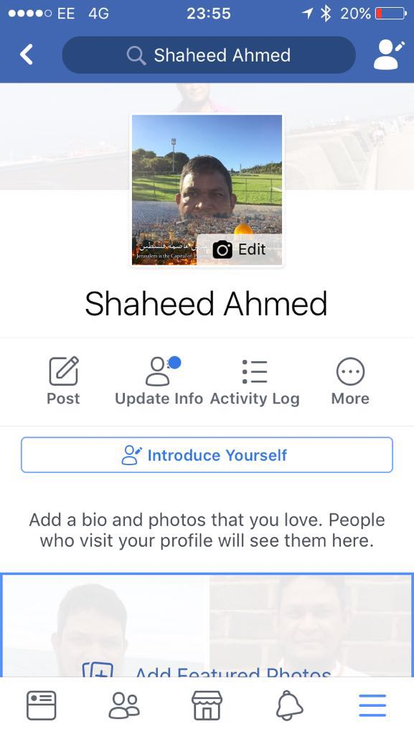

Figure 1 Evidence of Facebook Profile
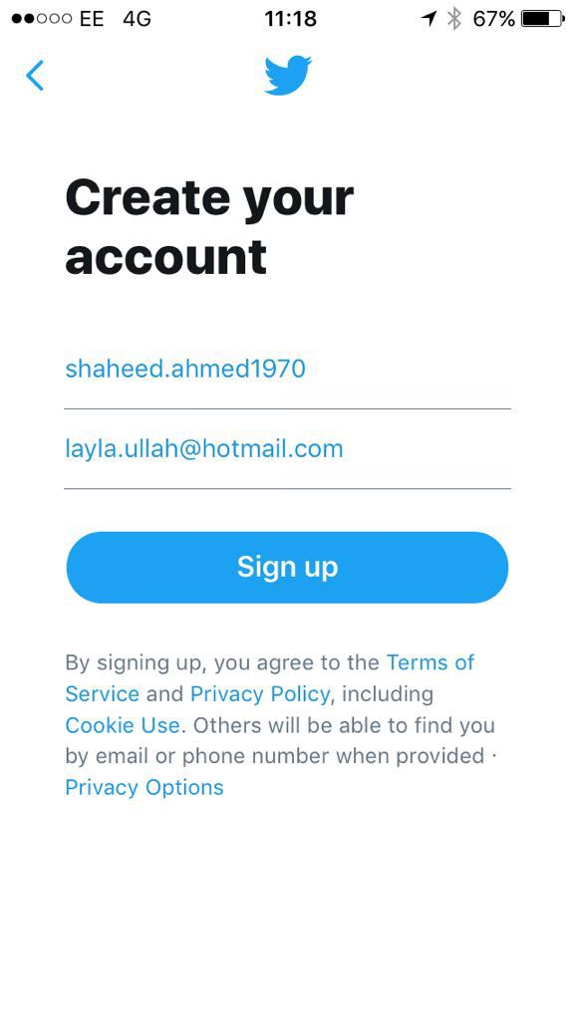
Figure 2 Evidence of creating twitter account

Figure 3 Evidence of Twitter Account

Figure 4 Evidence of twitter account

Figure 5 Evidence of Update Profile
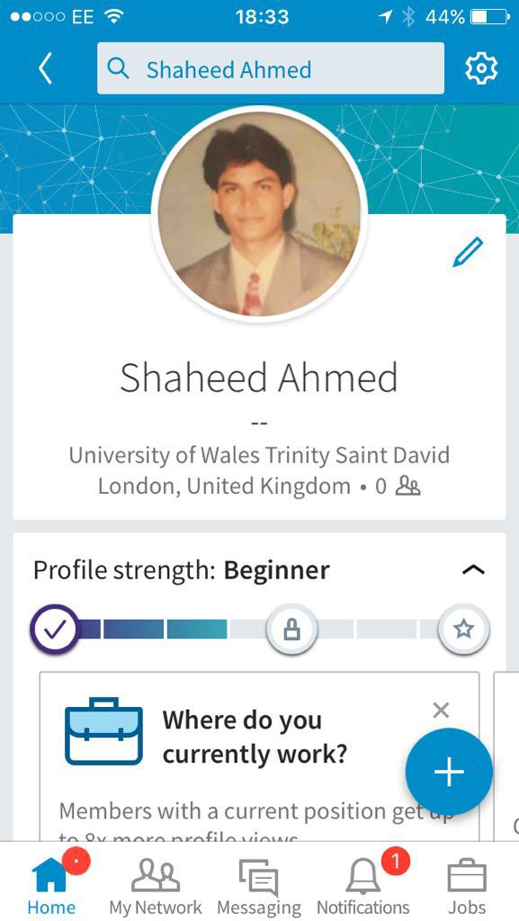
Figure 6 Evidence of LinkedIn Account

