
Applied Leadership and Management in the Workplace
Module Assignment Submission
Student Name: | Beverley Williams
Student Number: | 2421756
Module No: | BMSK4012
Module Title: | Enterprise and Intrapreneurship

Statement of Confirmation of Authenticity
By the act of making this submission, the student declares that this is the work of the student named above. The work has not, in whole or in part, been knowingly presented elsewhere for assessment, or where assessment has been built on a previous assessment, this has been identified. Where materials have been used from other sources it has been properly acknowledged. If this statement is untrue, the student acknowledges that an assessment offence has been committed.
Attention is drawn to the plagiarism and unfair practice policies of both the University and of ILM.

Table of Contents
Business Plan 4
1. Executive Summary 4
2. Introduction 5
Business Background/Details 5
Legal Status 6
Services 6
3. Market and Competitors 6
Market overview, size, and trends 6
HomeTail Retreat PEST & SWOT Analysis 7
The 7 P’S of Marketing. 8
Customers, Target market 9
Competitor Analysis 9
4. Sales and Marketing Strategy 11
Marketing Objectives 11
Marketing Strategies 12
Pricing Strategy 14
Income streams 15
Sales Forecast for 12 months for HomeTail Dog Boarding 15
Budget and Timeline 16
5. Operations 16
Location, Premises, Equipment 16
Production and Distribution Processes 17
People, Staff, Supplies 17
System and Procedures 17
Health and Safety, Quality Control, Legal Compliance 17
6. Financial Information 18
Cashflow Forecast 18
Set Up and Operational Costs 19
Sources of Finance 20
Profit and Loss Statement 21
References 22
Appendix 1 23
Appendix 2 24

Business Plan



1. Executive Summary
HomeTail Retreat Dog Boarding offers overnight dog boarding from a licensed home in Bridgend. We combine a calm, cage-free environment with thoughtful extras, such as dog walking and enrichment games. Our Mission is to become Bridgend’s most trusted premium alternative to standard kennels, providing personalised care for cherished companions. A secure garden will provide plenty of outdoor fun, and all activities will be tailored to your pet’s needs. Unique Selling Points: One-tier pricing, meet and greet beforehand, and no extra charge for pickup or collection within a five-mile radius of the HomeTail Retreat Dog Boarding Location. Loyalty cards will also be introduced to encourage repeat customers. Hours of Operation: Flexible hours to suit the busy lifestyles of pet owners, including 24/7 availability.
Enrichment Activities
Brain Teasers: Problem toys and snuffle mats that allow you to forage and solve problems naturally
- Kongs that have been frozen and filled with bananas, or calming goodies
- Scent work and problem-solving, like hiding and finding toys or treats
Exercise: Walking or adventure walking is healthy for both the body and the environment.
- Playtime with one person only—fetch, tug-of-war, or games specially created for you.
Comfort Zone: Cuddle time—belly massages and cuddles, and soothing music. Bedtime snuggle-ins, calming bedtime routines to get you sleeping.
At HomeTail Retreat Dog Boarding, I aim to offer a bespoke canine experience that focuses on personalised care, comfort, and a peaceful environment, together with customised attention to protect the health, happiness, and overall well-being of our four-legged friends.

2. Introduction

Business Background/Details
The idea for HomeTail Retreat Dog Boarding originates from my love of dogs, that’s been with me since childhood. I have years of experience providing dog care, and I have always had dogs as pets throughout my life. I treat our furry friends as family. The trend is moving away from traditional style kennels, as many dogs do not do well in that environment, and they often fall short in providing the homely environment and individual care that our pets are used to. HomeTail Retreat Dog Boarding is being set up to fill the gap, offering our services tailored to each pet's needs, personalised care, and comfort.
Business Name: HomeTail Retreat Dog Boarding
Type of Business: Home Boarding and Daycare for Dogs
Owner: Beverley Williams
Location: CF31, Bridgend
Business Structure: Sole trader

Legal Status
The reason I am setting up the business as a Sole Trader is that you have total control over your company when operating as a sole proprietor. I will be in charge of daily operations and decision-making, and I can swiftly adjust my company to the changing market thanks to this flexibility. Making big changes doesn't have to wait for other people's approval. A straightforward procedure will be used to register me to pay income tax, and any profits my business makes are mine after taxes are paid. Setting up and running your business can be less expensive if you work as a sole proprietor. For instance, when starting their businesses, sole proprietors frequently don't require expert advice. Nonetheless, getting professional advice can guarantee adherence and lessen possible risks associated with company ownership. If the firm does fail, however, you are personally responsible for any debts. Morris (2008)

Services
I will be offering home boarding with a fixed no-tier pricing strategy, as I believe all our furry friends should be treated fairly. Also included in the stay will be dog walking to be discussed with each pet owner upon boarding. Discounts will be available for more than one pet from the same family and for longer stays. In the UK, there are about 10.6 million pet dogs, with 28% of households owning at least one in 2024. PDSA (2024)
I expect to be busier around holidays and will have an online booking system in operation for customers to see available times. I will also have a Daycare service, which can be flexible to accommodate my customers' needs.

3. Market and Competitors

Market overview, size, and trends
The UK pet boarding services market was valued at approximately £783.2 million in 2024 and is projected to grow to £1.21 billion by 2030, reflecting a compound annual growth rate (CAGR) of 7.9% from 2025 to 2030. Dogs were the largest revenue-generating pet type in 2024. Horizon Grand View Research (2024)
There are 13.5 million dogs in the UK, with 36% of households owning at least 1. Since the COVID pandemic began, 3.2 million UK households have acquired a new pet. Martyn (2023)
This growth is driven by:
- Pet owners raising: Over 13.5 million dogs were recorded in the UK in 2024.
- Customer preferences: owners increasingly seek luxury, home-like environments with enrichment activities and personalized care.
- Growing travel and lifestyle changes: More people are traveling for work or leisure, increasing demand for reliable, high-quality pet care.
- Premium services: Boutique and wellness-focused boarding options are gaining popularity instead of traditional kennels.
These developments help HomeTail Haven Dog Boarding is to satisfy the growing demand for elegant, customer-oriented dog boarding in a home setting.

HomeTail Retreat PEST & SWOT Analysis
PEST

 | External factors influencing operations
Category | Key Considerations
Political | Licensing & inspection regulations. Home boarding requirements of local authorities - Pet welfare legislation
Economic | Spending by clients as a result of cost of living - Constant need for quality pet care - Insurance, maintenance, cost of supplies
Social | Rising expectations for personalized care – Focus on emotional & psychological pet well-being
Technological | Platforms for online booking & updating

Aguilar (1967)
S W O T

 | Internal strengths and growth outlook
Category | Details
Strengths | Homely atmosphere and tailored enrichment. Flexible drop-off and collection times, with the option for home collection.
Weaknesses | Limited to capacity. Awareness of business in the early stages. Licensing and set-up time.
Opportunities | Referrals from groomers. Premotions. Repeat business via loyalty rewards
Threats | Competition from local companies. Changing regulations with compliance.

Humphrey, A. (2005).

The 7 P’S of Marketing.
Product
Premium dog services, designed with love, cozy overnight stays, and dog walking.
Price
A one-tier pricking Package and discounts for longer stays, also offering a discount for a second family member.
Place
Home boarding in Bridgend, offering a safe environment with online booking and flexible scheduling available. We offer personalized care for your pet.
Promotion
We have also engaged with local dog groomers who are willing to promote our business, and word of mouth from customers.
People
I am a passionate dog lover and believe in treating every dog like a member of my family. I have a certificate in dog first aid and CPR, as well as a Diploma in Dog Behaviour and Dog Grooming for your peace of mind.
Process
An easy-to-use online booking system with real-time booking. Each dog will have a visit from me before boarding, and any routines will be tailored to your dog’s needs.
Physical Evidence
Professional and clean facilities
Friendly interactions

Booms & Bitner (1981)

Customers, Target market
Affluent Owners: 2 or more income families or retired individuals who keep their pets as family members and want personal attention.
Frequent Travelers: People who holiday or travel for business and need hassle-free boarding with flexibility in schedules.
South Wales and the surrounding areas, House or Apartment Dwelling Urban Pet Owners: Home-style boarding rather than kennels, no garden living, and a preference for local, approved suppliers who can deliver that extra bit of personal care
Rescue adopters or new dog owners: Individuals who might be afraid to leave their pet in a regular kennel and will be more comfortable in your home-like environment and play-style treatment.
Dog owners who have older or nervous dogs: Dog owners who eliminate traditional kennels because of nervousness or health requirements, and who respond to information packets and meet & greet. Seek out peaceful, quiet settings where you can receive one-on-one care. Value routines, updates, and careful handling.

Competitor Analysis
In Bridgend, there are a large number of home-based pet boarding services, such as Mary's Pooch Pad, Happy Pups Home Boarding Ang & Gwyn's Doggy Digs. These competitors offer very basic boarding, often with no common brand to give owners an emotional boost, no add-on experiences, and no loyalty incentives. Almost all have only basic internet listings. HomeTail Retreat differentiates itself with its boutique, enrichment-led approach, individualised care for elderly or nervous dogs, session-striking, modern pastel branding customer offers such as loyalty cards. These are the features that make HomeTail Retreat Dog Boarding stand out as a luxury alternative to standard kennels, and an experience that pet owners are unlikely to find elsewhere.
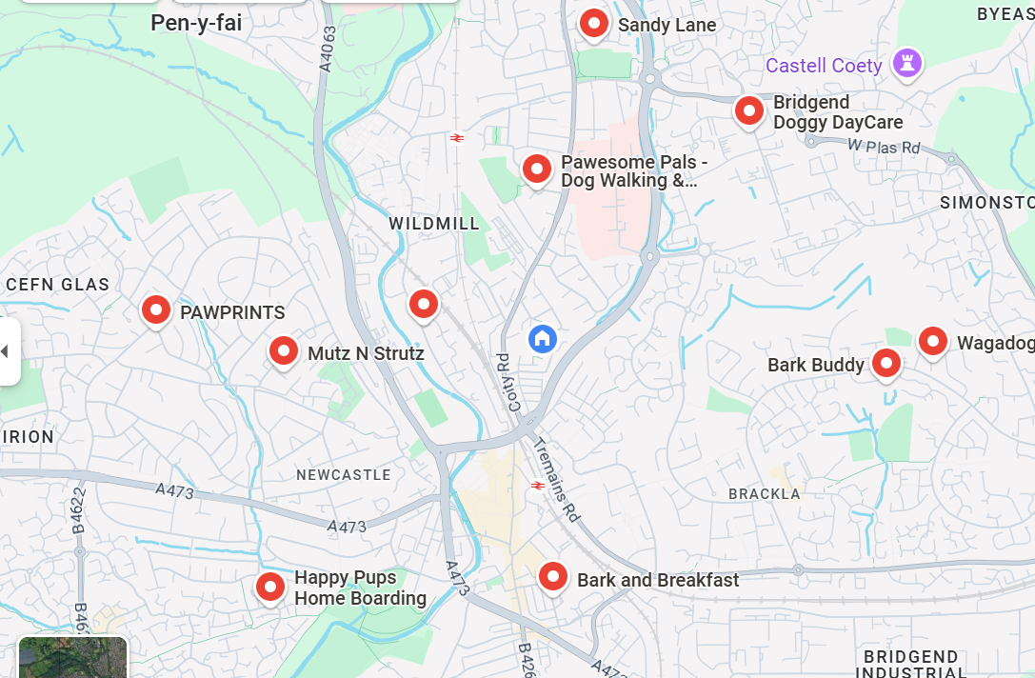
Google (n.d.)
I have also included another Comparison table from Google Maps of local home boarding near me in Appendix 1.
Here’s a competitor comparison table tailored for HomeTail Retreat Dog Boarding, focusing on local home boarding providers in the Bridgend area. This will help me identify our unique positioning and highlight opportunities for differentiation:
🐾 Competitor Comparison Table – Bridgend Area
Feature / Competitor | HomeTail Haven (My Business) |  | Ang & Gwyn's Doggy Digs |  |  | Happy Pups Home Boarding |  | Mary’s Pooch Pad | Pen-y-Bont Petmate
Type of Setting | Boutique home-based |  | Home-based |  |  | Home-based |  | Home-based | Home-based
Max Dogs at One Time | 1-2 (personalized care) |  | 4 |  |  | Not listed |  | Not listed | Not listed
Enrichment Activities | Yes – puzzles and Cuddles |  | Not specified |  |  | Not specified |  | Not specified | Not specified
Loyalty/Referral Program | Yes – loyalty card |  | No |  |  | No |  | No | No
Visual Branding | Pastel, modern, boutique aesthetic |  | Minimal |  |  | Minimal |  | Minimal | Minimal
Online Presence | Website + Instagram + Flyers |  | Basic listing |  |  | Basic listing |  | Basic listing | Basic listing
Target Audience |  | Affluent, anxious dog owners | General dog owners |  | General dog owners |  | General |  | General
Unique Selling Point (USP) |  | Boutique, enrichment-focused care | Small group boarding | Local licensed |  |  | Long-standing |  | Local availability

Find Pet Boarding (n.d.)

4. Sales and Marketing Strategy

Marketing Objectives
Grow local brand awareness by 50% in 12 months
A new business can realistically target a 50% occupancy rate if it effectively promotes and markets itself.
The high occupancy rate is directly associated with the success and profitability of HomeTail Retreat dog boarding business.
The goal, with its emphasis on the business's first year, makes it possible to create and institute marketing programs that generate early bookings and repeat clientele.
Accumulate 500 active followers on Instagram in nine months.
Track the number of followers you have on Instagram, especially the active ones.
Based on constant and engaging content, acquiring 500 active followers in 9 months can be a realistic target for my small business HomeTail Retreat Dog Boarding.
Numerous Instagram followers make HomeTail Retreat Dog Boarding think more in terms of a reliable and trustworthy location to board dogs and introduce the company more. A nine-month period in which to accomplish this objective provides growth in constructing a content approach, observing, and modifying efforts in order to reach the required number of new followers.

By six months, 25% of website visitors should be booking prospects.
To find out how many visitors end up booking inquiries, I will track the number of people visiting your site and filling out inquiry forms.
A 25% conversion rate in six months is a reasonable expectation if my site is well-designed and the features are user-friendly, and my promotions are effective.
By inviting more people to visit the place and reserve a stay, HomeTail Retreat Dog Boarding can grow and thrive.
Setting a 6-month timeframe for this objective enables the HomeTail Retreat Dog Boarding to focus on website optimization, monitoring, and iterative improvements to achieve the desired conversion rate.

Marketing Strategies
Develop a boutique brand by differentiation by developing HomeTail Retreat as a home-based alternative to the run-of-the-mill kennel.
Measure boutique branding program success through customer reviews, social media response rates, and brand recognition in the target market.
Creating a unique brand through targeted design and messaging is an achievable objective for a small company with a clear idea of its target market.
Boutique branding will install Hometail Retreat Dog Boarding as a luxury, personalized dog boarding company, which is necessary in order to attract the target clientele.
While there is no specific timeframe to this objective, it is ongoing and to constantly sustain and promotion of the boutique image in all marketing communications, website, and social media.
Improving the Google Business Profile and using focused local SEO techniques, one aims to increase visibility for local search queries like "dog boarding in Bridgend". This relates to actively making sure the company shows up when local potential clients are looking.
Google Business Profile's registration with the website. Tracking volume and sentiment of online reviews should all help to track improvement. Tracking these numbers will provide proof to see the outcome of local SEO projects.
Among the most significant techniques a small business can utilize to enhance its local search ranking position are the use of geographically specific keywords throughout its website, having a correct and compelling Google Business Profile, and requesting happy customers to post positive reviews.
Local searches have a direct impact on HomeTail Retreat Dog Boarding and customers' visibility. It's a great contributor to business growth since there's generally more inquiry and booking when there's higher exposure.
While local SEO is an ongoing process, the most critical tasks—like developing a solid Google Business Profile and incorporating location-based keywords—need to be completed within three months. Social media: Update with behind-the-scenes and dog news on Facebook and Instagram. This will build trust and relationships
Increase likes, comments, and shares on posts on social media. Increase activity on posts to over 500 likes in the first 12 months.
Post at least 4 times a week with at least one story. This will build credibility with my audience and increase awareness of my brand.
Achieve these goals by June 2006 by checking monthly engagement metrics.
Seasonal Promotions and discounts for booking during peak holiday periods.
Monitor the number of bookings generated over this period.
Seasonal reductions will increase and encourage repeat business.
Plan seasonal discounts at least 3 months before the holiday season to allow for communication with clients and give customers peace of mind that their dogs will be cared for.
Copy of brochure below to be placed in vets, dog groomers, and potential customers.
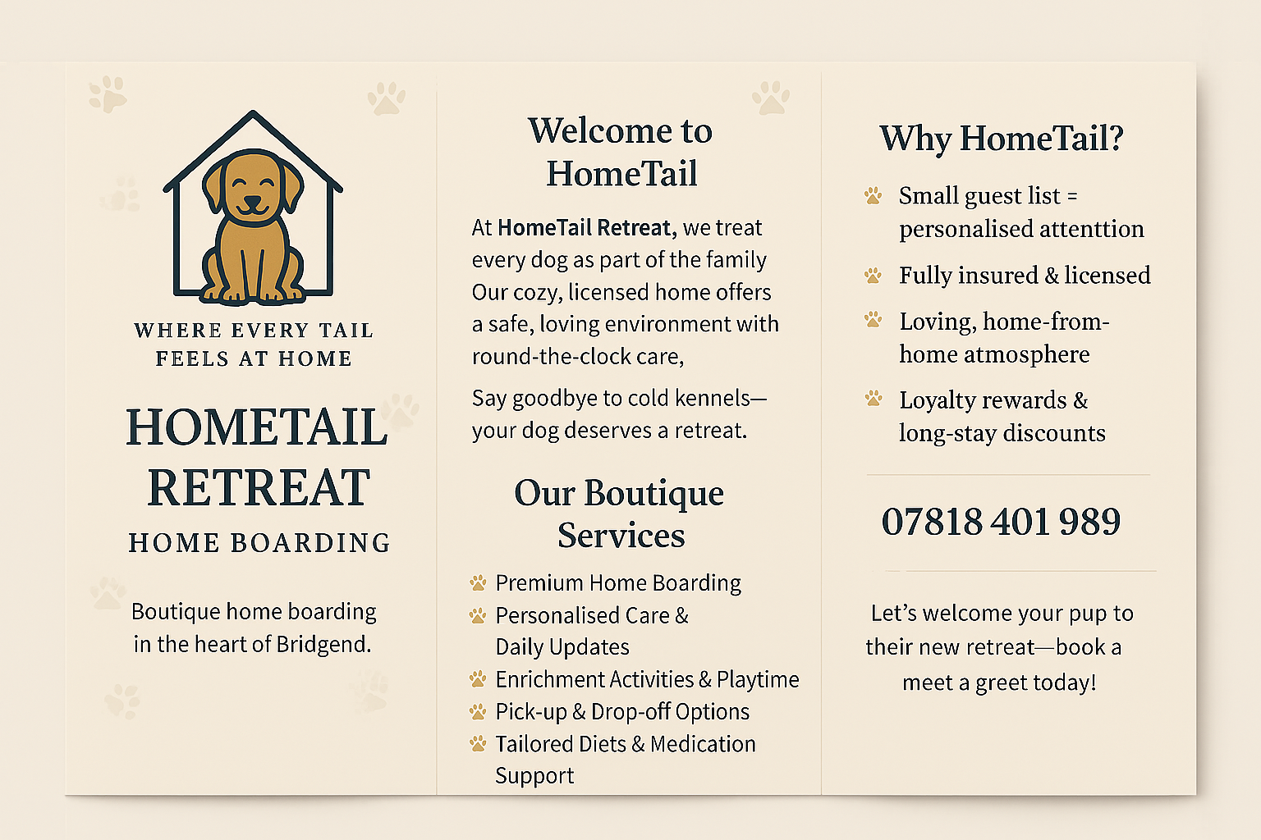

I am also going to introduce a Loyalty card and offer a discount for stays longer than 5 nights.
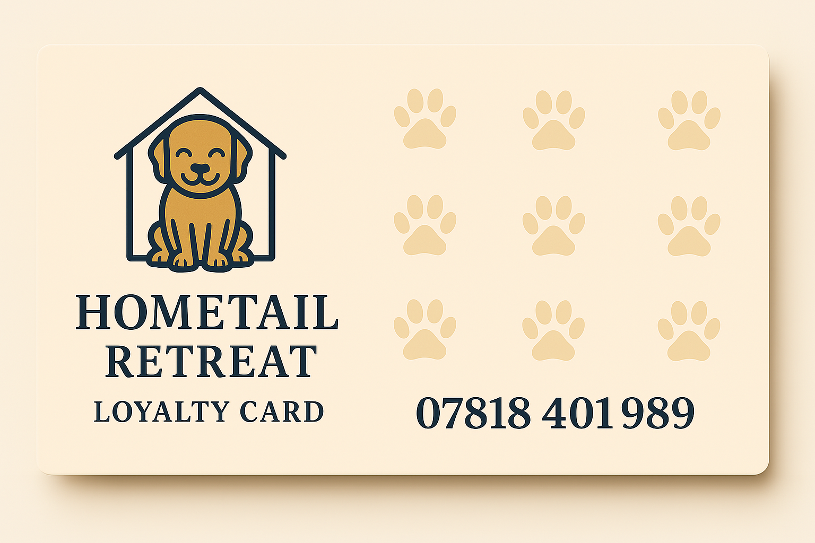

Pricing Strategy
To enable me to reach the price I am going to charge for a night's stay, I have used the Market-based price method. I have looked at various home boarding options within my area, as shown in the table below.
Competitor  Name | Nightly Rate  Daycare | Package Names | Add-Ons | Unique Features | Website
Hayley B | £35 Night  Daycare not available | None | Dog walking in your area | Nutrition and Behaviour Trained | No website
Joely M | £35 Night  Daycare £25 | None Works full-time | Daily Sitter Pick-Up/Drop-Off + £10 per day | Senior dog experience | No website
Talia A | £35 Night  Daycare £25 | None | No Collection option | None | No website
Claire H | £30 Night  Daycare £28 | None | Work on Thursday and Friday | None | No website
Jason D | £34 Night  Daycare £24 | None | Daily Sitter Pick-Up/Drop-Off + £5 per day | Pet Psychology Diploma and Dog First Aid | Yes
Rover (2019)

Pricing for HavenTail Retreat Dog Boarding
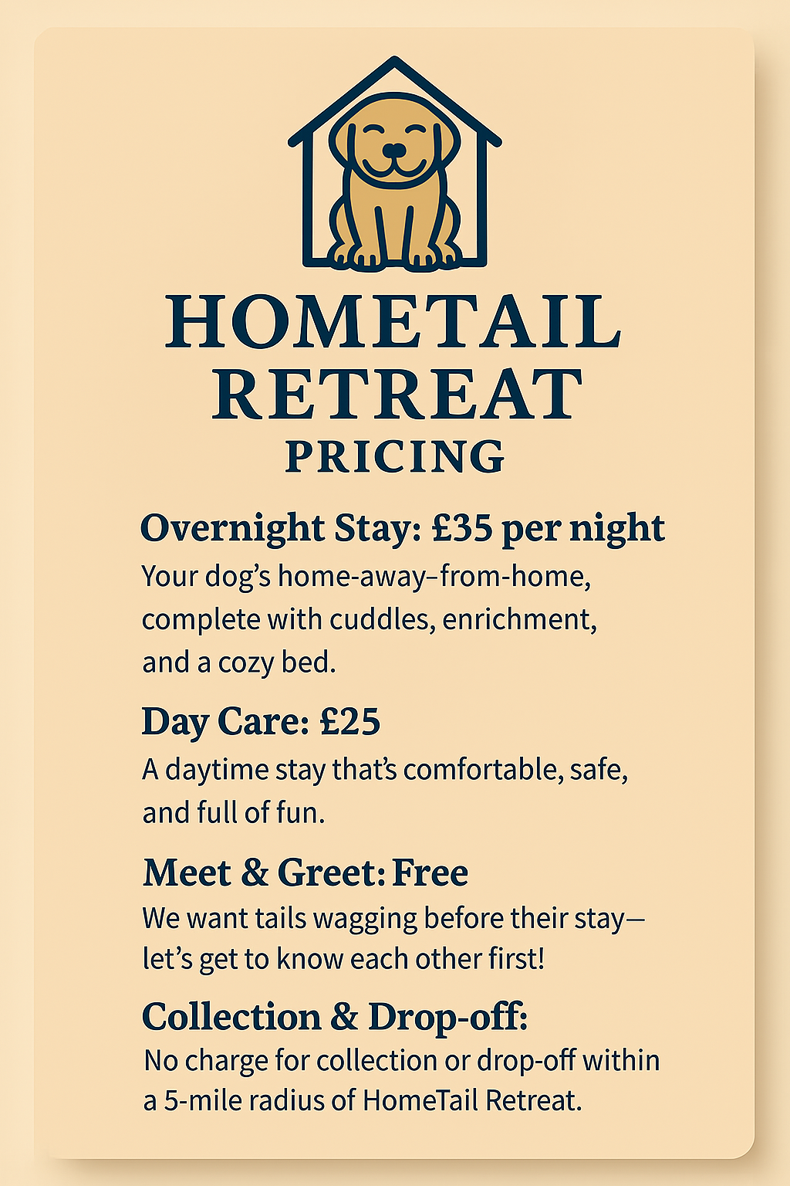

Income streams
Dog Home Boarding: Forecast income £4,725 as in the sales forecast and occupancy rate in the 12-month forecast.
Provide overnight home boarding in a homely environment. Projected revenue is based on occupancy, starting with low initial bookings to a constant mid-range capacity.
Dog Day care: Forecast £3,375 as in the sales forecast and occupancy rate in the 12-month forecast.
Includes daycare for busy professionals and people with commitments.

Sales Forecast for 12 months for HomeTail Retreat Dog Boarding
For the sales forecast, I have based the 12-month occupancy rate for home boarding rate at £35 for one night for 1 dog and day care for 1 dog at £25 per day. For the first year, I have based the occupancy rates on:
Month 1: 20%. Month 2: 23%. Month 3: 26%. Month 4: 29%. Month 5: 32%. Month 6: 35%. Month 7: 38%. Month 8: 41%. Month 9: 44%. Month 10: 47%. Month 11: 49%. Month 12: 50%.
- After the first year of the business, I would be looking to increase the occupancy rate to over 80% by growing brand recognition through partnerships and client referrals.

Budget and Timeline
Budget
All financial information regarding the setup of the business, monthly operational costs, profit sheet, and financial statement is included in the Financial Information section.
Timeline
Launch HomeTail Retreat Dog Boarding to offer premium overnight stays and achieve 50% occupancy. My mission will be to provide luxury pet care by the end of 12 months.
Build brand awareness in month 1 by distributing flyers locally and promoting myself through local dog groomers and veterinary practices. Use visual displays, which will be essential for attracting first-time customers, and can keep track of monthly bookings to check on progress.
Social media to build brand awareness and grow followers by 5 % in the first 3 months, increasing likes, comments, and shares of posts. This is essential for attracting first-time clients. Increase activity on posts to over 500 likes in the first 12 months.
Pricing and strategy. Launch seasonal promotions and loyalty cards to gain 10 new clients in the first 6 months. This will lead to repeat bookings and customer loyalty to be launched in month 2.

5. Operations

Location, Premises, Equipment
Location: The property is in Bridgend, South Wales, and has a calm, safe, and pet-friendly location that is perfect for a boutique dog care experience. Accessibility makes it easy to drop off and pick up pets, and no charge for pet collection within a 5-mile radius of HomeTail Retreat Dog Boarding.
Features of the premises: - A fenced-in outdoor play area - Interiors that are safe for dogs with gated areas.
Equipment: Beds, crates, and soft furniture - Food and water dishes, slow feeders, and toys. Tools for cleaning and personal care. Visual branding pieces, like signs and decorations in the reception area.

Production and Distribution Processes
Service Delivery: All services are on-site, and consistency, security, and quality are ensured. Bookings are made via an online system that lets guests make reservations and update details of pets and preferences.
Points of contact with clients: Initial meet and greet with follow-ups with thank-you notes, also loyalty cards to promote retention. Daily updates and feedback.
Distribution: No real product distribution as the location is based at the property in Bridgend.

People, Staff, Supplies
As I will be the owner and operator, I will run the business and oversee the daily operations and marketing. If demand grows, I will be looking to take on an extra staff member in the future. I have recently completed a Pet First Aid and CPR course and also obtained a Diploma in Dog Behaviour and Dog Grooming. I have attached a copy of my CV in Appendix 2.
Suppliers: Eco-friendly and, where available, organic products are searched for through local pet shops and online.

System and Procedures
Online booking system: Real-time booking to show availability and make reservations. Telephone bookings will also be available, as not everyone is technically versed.
Client Forms: Collect pet information and profiles, medical history, and emergency contact details.
Meet and Greet: This will enable both me and the pet owner to meet and discuss any questions they may have.
Vaccination & Health Check Compliance: Keep all records up to date and tracked by setting up reminders.

Health and Safety, Quality Control, Legal Compliance
Health and Safety: Use DEFRA-approved products to clean all areas. Dispose of waste with licensed providers. Pre-assessment of dogs and check for any signs of illness. Emergency contact details of the local vet.
Quality Control: Daily care checklist for routines for each pet. After each stay, ask the pet owner to fill in a short feedback form. Perform a daily cleanliness check of all bedding, safety gates, and outdoor areas.
Legal Compliance: I will be licensed by the local authority, and documents will be readily available for inspection. I will have public liability insurance in place at the start of the business and have put this in my cashflow forecast. I am fully aware of the GDPR policy in keeping all client information stored safely and kept for no longer than is necessary and only used for the specific purpose when given. I will also have an Enhanced DBS check at the start-up of the business.

6. Financial Information
Cashflow Forecast for 12 months for HomeTail Retreat Dog Boarding.
I am setting up the business to help me cover costs for day-to-day living expenses.
It will not be my main source of income.

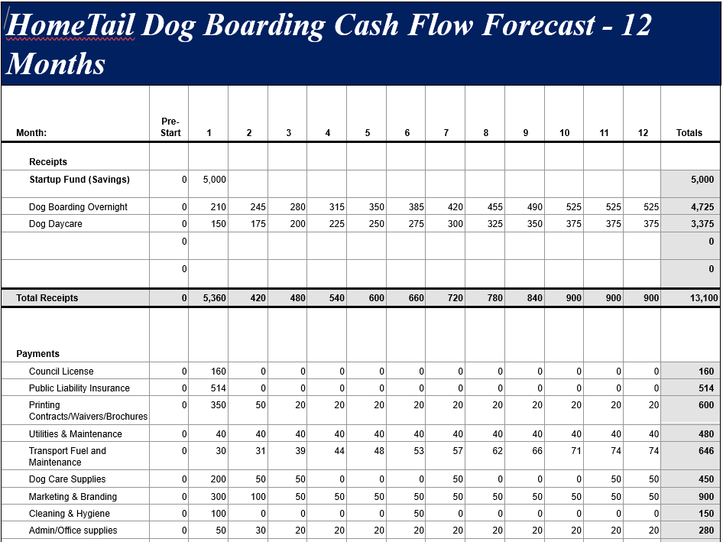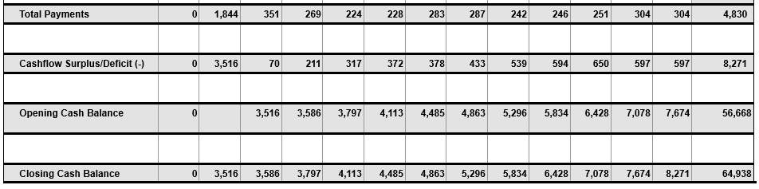

Set Up and Operational Costs
Set Up Costs
Category | Estimated Cost
Business Licensing/Public liability | £674
Business Preparation | £50
Equipment | £200
Branding and Materials | £350
Initial Supplies | £200
Training | £50
Transport set up | £50
Total | £1,574

Operational Costs/Monthly
Category |  | Estimated Cost
Utilities |  | £40
Cleaning & Hygiene Supplies |  | Bought in bulk at setup, so not needed until month 6
Consumables for Dogs |  | £50
Advertising & Promotion |  | £50
Fuel / Transport Costs |  | £31
Insurance |  | Paid for at setup, as it was cheaper
Software Subscriptions |  | £9.99
Waste Disposal Services |  | £0 Designated dog waste bins
Total | £ 180.99

Sources of Finance
To set up the business, I have savings of £5000 of my own money. The start-up money will be used to pay for important start-up costs like insurance, licensing, marketing, and branding. It will also cover basic supplies like cleaning supplies, dog crates, and bedding. By not borrowing any funds, I will have complete control over the business and what direction the business will follow. I am fully committed to its success. Using my funds allows me to start building a high-quality, boutique business from scratch, putting comfort, safety, and creating a homely atmosphere for every dog in my care.

Profit and Loss Statement 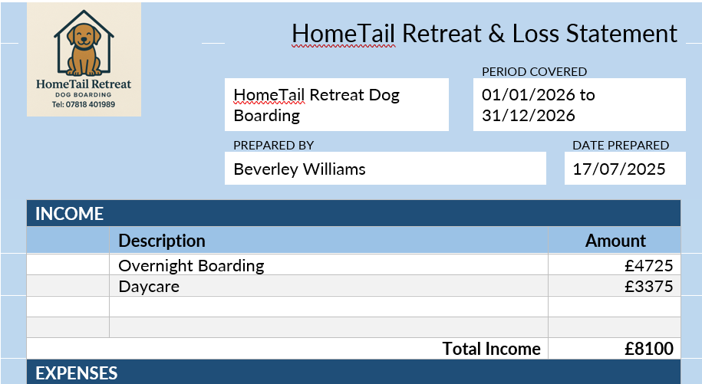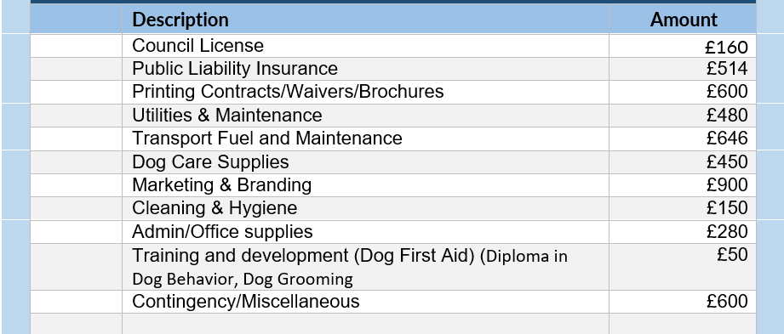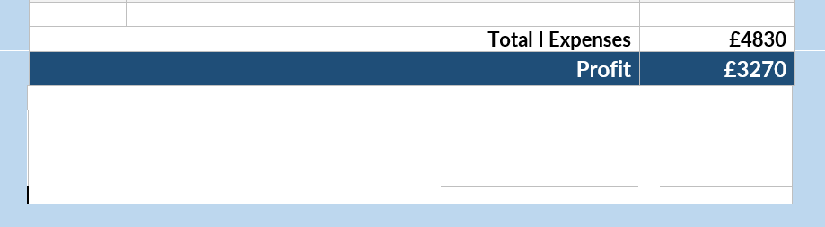

References
Aguilar, F. J. (1967). Scanning the business environment. Macmillan
Booms, B. H., & Bitner, M. J. (1981). Marketing strategies and organizational structures for service firms. In J. H. Donnelly & W. R. George (Eds.), Marketing of services (pp. 47–51). American Marketing Association.
Find Pet Boarding. (n.d.). Home boarding in Bridgend, South Wales. FindPetBoarding.com. https://www.findpetboarding.com/homeboarding/uk/wales/south_wales/bridgend/ [Accessed 26/07/2025]
Google. (n.d.). [Map of dog boarding facilities near Bridgend, Wales]. Google Maps. https://www.google.co.uk/maps/search/dog+boarding+near+me/@51.5128684,-3.5870488,14z [Accessed 26/07/2025]
Horizon Grand View Research. (2024). UK Pet Boarding Services Market Size & Outlook, 2030. Grandviewresearch.com. https://www.grandviewresearch.com/horizon/outlook/pet-boarding-services-market/uk [Accessed 26/07/2025]
Humphrey, A. (2005). SWOT Analysis for Management Consulting. SRI Alumni Newsletter. SRI International.
Martyn, M. (2023, February 16). All About Pet Ownership Statistics UK – Nation of Pet Lovers. World Animal Foundation. https://worldanimalfoundation.org/advocate/pet-ownership-statistics-uk/ [Accessed 26/07/2025]
Morris, M. J. (2008). Starting a successful business: start and grow your own company. Kogan Page.
PDSA. (2024). Pet Populations. Www.pdsa.org.uk. https://www.pdsa.org.uk/what-we-do/pdsa-animal-wellbeing-report/paw-report-2024/pet-populations [Accessed 26/07/2025]
Rover. (2019). Rover.com: Book Dog Boarding, Dog Walking & More. Rover.com. https://www.rover.com/ [Accessed 26/07/2025]

Appendix 1
🐾 Competitor Comparison Table – Bridgend Area
Competitor Name |  | Location from HomeTail Retreat | Servies Offered | Daily Rates | Media Presence | Reviews |  | Opening Hours
Sandy Lane |  | 0.8 miles | No information given | None given | None | None |  | None given
Pawesome Pals - Dog Walking & Pet Sitting |  | 0.4 miles | Pet Sitting and Dog Walking | Priced Individually | Instagram  Facebook | 5 Star |  | Mon-Friday 9-5 No weekend hours
Mutz N Strutz |  | 2 miles | Home Boarding  Dog training | None Given | Facebook  Instagram | 5 Star |  | Closed
Happy Pups Home Boarding | 2.8 miles |  | Home Boarding.  Daycare | From £30 nightly.  Daycare £25. Charge for taxi service | Facebook  Instagram  WhatsApp | 5 Star | 24 hours
Bark Buddy | 2.9 miles |  | Home Boarding.  Daycare | Nightly £34  Daycare £27 | Facebook  Instagram | 5 Star | 7 days  8-8
Google. (n.d.).

Appendix 2

Beverley Williams
Tel: 07818401989
Email: Skippy.77@hotmail.co.uk

Personal Profile
I am highly motivated and perform well working as part of a team or individually. I relate well with both customers and colleagues and thrive on working towards targets and deadlines. I am flexible in my approach to work and enjoy the challenge. I am quick to take on board any new procedures and implement them. I am an excellent team player with a can-do attitude. Some skills I have are Empathy: Demonstrating genuine care and understanding of customer needs. Adaptability: Being flexible and adjusting to different situations. Conflict Resolution: Calmly and effectively handle difficult situations. Attention to detail: Ensure accuracy in my work and attention to detail. Positive attitude: Create a welcoming environment for customers and colleagues. For the past 22 years, I have been employed by Lloyds Banking Group, and I finished with them on 19/09/2024.
I also have years of experience providing dog care, and I have always had dogs as pets growing up. I have also volunteered at my local Dogs Trust Centre.

Qualifications
Diploma in Dog Behaviour, Dog Grooming. CDP and IPHM Accredited from Lead Academy 17/07/2025
Pet First Aid and CPR International Open Academy 03/07/2025
Food Safety Level 3 HSC E-Learning 14/11/2024
ILM Level 4 Diploma in Leadership and Management, University of Wales Trinity St David. Started 01/10/2024 – 30/09/2025 Ongoing.
L4 Certificate of HE Applied Leadership and Management, University of Wales Trinity St David. Started 01/10/2024 – 30/09/2025 Ongoing
NVQ II Customer Service, University for Lloyds TSB 12/02/2004
BTEC Foundation Spreadsheets/Using Computers/Word Processing, Bridgend College 01/01/2002
NVQ II Hairdressing/Barbering, Afan College 01/05/1998
NVQ II Cooking for the Catering Industry, Bridgend College 01/05/1978

Employment History: Lloyds Banking Group
Customer Consultant. Data Subject Access Request/Call Requesting
December 2023 – 19th September 2024
Check DSAR requests from customers
Check support needs
Locate all calls the customer requested.
Listen to all calls to confirm the correct customer, and the calls are regarding their DSAR request.
Collate any letters that need to be sent to customers and send calls via disc or via email.
Outbound call customers to confirm the information that has been requested on the DSAR request.
Use Nitro Pro to edit documents.
Input data into various databases with the correct information regarding customers’ details.

Customer Consultant. Call Listening/Call Redaction/Transcribe Calls
February 2021 – December 2023
Listen to full calls that had potential fraud or martial disputes on them.
Any calls that had information not intended for that customer, I had to redact parts of the call.
Use Coral Video Studio to cut parts of the call.
Transcribe all calls that the customer had any fraud or martial dispute.
Use Nitro Pro to edit documents and attach transcripts and letters.
Input data into various databases with the correct information regarding customers’ details.

Bereavement Officer
December 2020 – February 2021
Check all details on requests that were received for validation.
Amend any accounts from sole to joint or close sole accounts.
Complete all account information regarding a notification of a deceased customer.
Arrange for any payments to be sent to Next of Kin via Chaps payment or Cheque.
Pay Funeral Charges if requested.
As well as working cases for the Next of Kin I also worked cases that would come in via a Solicitor.

Data Gather Complaints. Package Bank Accounts
December 2019 – December 2020
Gather screenshots from various databases regarding account complained about.
Worked CMC/Solicitor requests.
Check if customer had used any account benefits.
Update various databases with the outcome of my findings.

PPI Customer Service Advisor
April 2014 – December 2019
Logging all new PPI Complaints that came in, Business, CMC and Personal Customers.
Dealing with any queries received from Claims Management Companies.
Adhering to all banking guidelines and procedures ensuring the security of personal details.
Open incoming mail and scan and upload onto customer’s case.

Fos Relations Officer
April 2011 – April 2014
All cases that had been sent to FOS to review
Logging data onto cases to comply with our SLA agreements.
Logging Acceptance, Closures, Final Requests and Internal View on cases.
Project work
Maintained my 100% quality checks.

Seconded Team Coach
March 2009 – April 2011
Develop and coach the team to their full protentional.
Focus on the delivery of sales and service measures.
Ensure all regulatory standards are met when coaching.
Ensure all advisors have regular coaching interactions and feedback.
Update coaching plans and records/prep for coaching interactions.

Seconded Team Manager
February 2007 – March 2009
Develop and coach 10 team members to achieve and exceed targets. We achieved 122% of net sales in the month
Drive building the business with gross and net sales overachieving set targets.
Monitor and give timely feedback.
Manage sickness and attrition. My attrition was 0% during my secondment.

Telephone Banking Advisor
January 2001 – February 2007
Processing customers’ day-to-day banking requests and queries.
Meeting the needs of the customer by offering suitable products and services.
Providing first-class customer service.
Ensuring that sales are maintained
Deputize in the absence of Team Manager.

Personal Interests
I like gardening, DIY, and spending time walking my dog, as I love the outdoors.

