UNIVERSITY OF WALES
TRINITY SAINT DAVID

Topic: Personal Development Portfolio

Student: Hazra Bibi:
Student number: 2420438

Programme: CertHE Skills for the Workplace Health and Social Care

Module: Personal Development within Health and Social Care LCHS4008

Lecture: Dr Olubukola Adeghite

21/11/25

Contents
Task 1. A Strategy for My Future in Health and Social Services 3
Task 2. Academic Report on One Key Skill 5
Task 3. Reflective ERA Model 6
3.1. Experience 6
3.2. Reflection 7
3.3. Action 7
4. Conclusion 8
References: 9

Task 1. A Strategy for My Future in Health and Social Services
Health and social care careers involve intentional self-awareness, skill development, and alignment with national workforce standards, not just passion. I want to be a health care assistant in a residential or NHS setting, helping people with personal care, daily activities, and wellness. This action plan lists important employability abilities, assesses strengths and weaknesses, and creates a personal development plan (PDP) based on self-reflection and current research.
Effective communication comes first. Safe, compassionate practice relies on clear verbal and nonverbal communication to provide accurate information and create trust with service consumers. Recent study suggests that patient-centered communication enhances healthcare outcomes and patient satisfaction (Sharkiya, 2023). As Stock Controller, I explain complicated data across departments and to diverse audiences. Clarity, tone management, and active listening may be used in health and social care, especially when communicating with patients or multidisciplinary teams.
Second, caregiving requires structure and time management. Practitioners must professionally handle care plans, paperwork, and unforeseen priorities. The national evaluation of workforce statistics shows personnel shortages and significant turnover in adult social care, which requires resilience and self-management (Skills for Care, 2024). I've improved my capacity to focus, collaborate, and meet deadlines in my current position, which helps healthcare's organisational discipline.
Current literature emphasises collaboration as essential. Studies show that integrated interdisciplinary teams promote treatment continuity and staff well-being (Shi et al., 2025). I improved my teamwork and empathy by learning to share responsibilities, settle disagreement constructively, and adapt to different work styles in university. Teamwork improves handovers, communication, and service delivery in professional practice.
Additionally, sensitivity and professionalism underlie all interactions. To improve values-based recruitment and development in the industry, the national Care Workforce Pathway promotes confidentiality, decency, and respect (UK Government, 2025). Being patient, nonjudgmental, and accepting of variety fosters this mindset.
These qualities give a solid foundation, but I have many skill deficiencies that might limit my professional preparedness. Public speaking insecurity is the first. I'm good at one-on-one communication, but groups and reports make me nervous. Team briefings and patient updates are common in health and social care. The second gap is flexibility under duress, since patient crises and last-minute rota changes may disrupt consistency. The third is stress-management. Recently, workload and emotional labour have increased the danger of burnout and worker tiredness in the industry (Commons Library, 2024). Performance and well-being may suffer without effective coping skills. To fill these gaps, I have created the following personal development plan (PDP) with specific objectives, steps to take, and due dates (table 1).

Table 1. Personal Development Plan (Skills for Care, 2024)
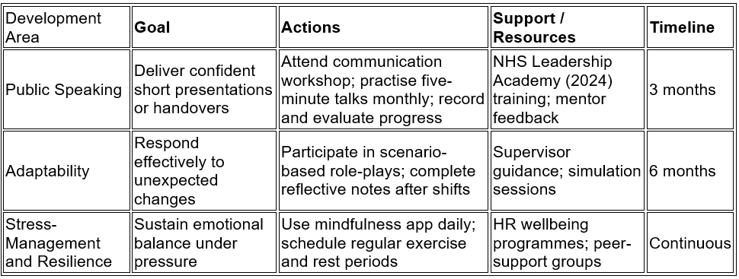

Specific and realistic actions. Professional communication feedback will be provided during NHS Leadership Academy seminars. My adaptability will improve with simulations, and my resilience with mindfulness and disciplined wellness routines. Their overall approach to employability advancement.
My growth strategy emphasises staff development and patient safety; continual learning enhances care outcomes (Health Foundation, 2024). My plan enhances my job and promotes sustainable, competent healthcare.
This approach includes interview preparation. Competence and thoughtfulness are shown by anticipating typical enquiries. In response to the question, “Tell me about a time you worked as part of a team,” I would mention a degree project where I organised research duties, delegated well, and managed scheduling difficulties. How do you handle stressful shifts? Mindfulness, organised planning, and end-of-day thoughts help me stay calm and avoid burnout. Why work in health and social care? Referring to the Care Quality Commission (2024) annual report's ethical framework, I want to help vulnerable individuals, promote dignity, and benefit society.
This personal action plan matches self-reflection with academic and industry evidence to prepare Health Care Assistants. Communication, organising, collaboration, and emotional resilience may help me provide person-centred, compassionate care and grow professionally. Through review and continual development, the Experience-Review-Action (ERA) reflective approach supports learning (University of Portsmouth, 2025). My employability grows with industry expectations and service customers with this systematic, evidence-based strategy.

Task 2. Academic Report on One Key Skill
Teamwork is still one of the most important skills for health and social care professionals to have, as it impacts the effectiveness of services and the results that patients get. Carers, nurses, managers, and allied health professionals all rely on one another and must work together every day in this industry. By minimising duplication and maximising safety, effective teamwork guarantees that the appropriate care is provided by the appropriate person at the appropriate time.
Teamwork boosts morale and the quality-of-care patients get, according to the research. Hospital readmissions are decreased, and continuity of treatment is enhanced by multidisciplinary teamwork, according to a systematic study (Shi et al., 2025). These results are in line with what the Health Foundation has long believed: that health and social care systems benefit from investments in team competency (Health Foundation, 2024). Thus, collaboration is more than just a social grace; it's a strategic tool that helps businesses achieve their quality, efficiency, and safety policy goals.
When looking at the workforce, cooperation is strongly related to employee happiness and retention. Job openings and employee turnover are still high in England, according to the most recent study from Skills for Care (2024), although retention rates are lower in companies that encourage teamwork and individual accountability. The Commons Library briefing also shows that stress-related absenteeism and burnout are problems in the adult social care sector, but that with the right kind of organised team support, these problems may be lessened (Commons Library, 2024).
Team leadership and safe practice are also emphasised at the NHS Leadership Academy. According to the NHS Leadership Academy (2024), the Healthcare Leadership Model highlights the importance of "Working with Others" and "Sharing the Vision" as fundamental behaviours that build inclusive teams that can address complicated patient demands. Within this structure, all professionals, regardless of rank, help foster an environment where everyone feels comfortable speaking their mind.
Cooperation is fortified even more by ethical behaviour. All interactions within the workforce should be based on compassion, decency, and respect, according to the UK Government’s Care Workforce Pathway (2025). By adhering to these guidelines, teams can be certain that their collaboration is value- and task-driven. Higher CQC ratings are associated with strong cooperation, according to the Care Quality Commission's annual state-of-care report (2024). This is especially true in cases when integrated teams communicate well and share responsibility.
There are still obstacles, even with these good ideas. According to Dawe (2024), ineffectiveness may be caused by a lack of communication, ambiguous boundaries, and friction within hierarchies. The situation is made worse by heavy workloads and staffing shortages, which results in uneven practice. Critical to resolving such problems is the development of skills in reflective learning and leadership. Practitioners may analyse behaviour, comprehend dynamics, and make modifications by developing a mentality of continuous assessment using structured reflection models like ERA (University of Portsmouth, 2025).
Taking these facts into account has helped me realise that emotional intelligence and personal initiative are the two most important qualities in a team member. The leadership qualities outlined by the Health Foundation (2024) are consistent with my work history; I often served as a liaison between departments, resolving minor disputes and clearing up confusion. I plan to use these lessons in health and social care by becoming an active participant in shared learning sessions, promoting constructive peer criticism, and communicating inclusively.
Caring, safe, and effective care is really a team effort. It is the meeting point for competence in one's field, accountability in one's ethical actions, and consideration for one's peers. Both the organization's success and the happiness of my coworkers and clients will benefit from my efforts to build trust, evaluate my own performance, and provide a helping hand to those around me.

Task 3. Reflective ERA Model
The Experience–Reflection–Action (ERA) approach organises professional learning analysis. Figure 1. It will help me evaluate my Component 1 presentation, learn from it, and plan my next steps.

Figure 1. Experience–Reflection–Action ERA (Health Foundation, 2024)
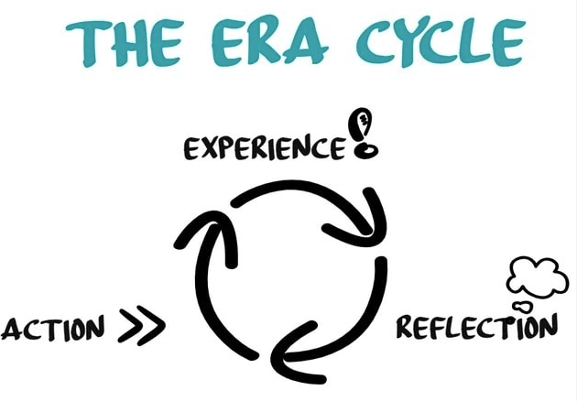

3.1. Experience
Presenting on self-awareness was enjoyable and challenging. I had good communication and planning but felt nervous while speaking, which was my personal growth plan weakness. My PowerPoint preparation helped me structure my thoughts rationally, and peer comments verified my clear and professional explanations. Nervousness slowed me and altered my posture. This showed how gradual exposure and practice build public-speaking confidence (Skills for Care, 2024).

3.2. Reflection
The lecture critically confirmed literature-based employability teachings. As Sharkiya (2023) said, communication builds comprehension; this reminded me to modify language and tone for varied audiences. To combat performance anxiety, the NHS Leadership Academy (2024) advises me to cultivate genuineness, which inspires confidence. Lifelong learning improves care safety, as the Health Foundation (2024) and my tutor agree.
In this encounter, teamwork was crucial. Previous peer talks imitated collaborative problem-solving despite the individual task. Shi et al. (2025) presented integrated care team dynamics. I improved my material by sharing ideas and seeing other viewpoints. As shown in our group rehearsals, the Care Quality Commission (2024) links collaborative learning to greater professional standards.
I realised my stress reaction was caused by perfectionism. Workload and self-pressure cause burnout, according to The Commons Library (2024). Accepting this relation helps me cope better. As recommended in my PDP, I shall practise mindfulness, exercise, and rest. According to the Skills for Care (2024) study, resilience training improves retention and wellness, highlighting the need of self-care.

3.3. Action
Systematically applying lessons gained is my goal. I will attend an NHS-approved communication training and rehearse small group presentations regularly, journaling my progress, following the Care Workforce Pathway's developmental recommendations (UK Government, 2025). Second, I will encourage colleagues to provide constructive criticism during peer observation. Dawe (2024) discovered that candid feedback fosters trust and collaborative effectiveness, supporting collaboration concepts.
After every big work activity, I will use the ERA phases to reflect on the event, analyse accomplishments and areas for growth, and create clear follow-up activities. The University of Portsmouth (2025) shows that systematic contemplation boosts confidence and critical thinking. Therefore, I shall turn contemplation from an academic necessity into a daily professional development habit.

4. Conclusion
Using the Experience-Review-Action (ERA) paradigm for reflection has helped me better grasp the interplay between professional development, evidence-based learning, and self-awareness. My presenting experience served as a reflection of my communication skills and areas in which I needed improvement; these are common experiences for health and social care professionals in their early careers. It was reaffirmed that competence and reflection, not natural ability, are how confidence grows (Sharkiya, 2023; NHS Leadership Academy, 2024; and others on patient-centered communication and genuine leadership). Based on what I've learnt, the bedrock of professional credibility is strong communication and collaboration bolstered by empathy, resilience, and ethical awareness.
I plan to transform introspection into long-term behavioural modification going forward. Following each significant undertaking, I will maintain my habit of doing a self-evaluation in accordance with the ERA framework in order to document my learnings, evaluate my progress, and set attainable objectives. According to Skills for Care (2024), persistence in this practice will boost my self-assurance, flexibility, and emotional intelligence. It is clear from this thought that compassionate care cannot exist without leadership, collaboration, and ongoing learning. Integrating reflective practice into my job every day will help me become a better practitioner who improves service quality and the health of my staff.

References:

Care Quality Commission (2024) The state of health care and adult social care in England 2023–24. London: CQC. Available at: https://assets.publishing.service.gov.uk/media/671b5ce3044f28e776c609dc/care-quality-commission-the-state-of-health-care-and-adult-social-care-in-england-2023-to-2024.pdf
(Accessed: 16/10/2025).

Commons Library (2024) Adult social care workforce in England. Research Briefing CBP-9615. Available at: https://researchbriefings.files.parliament.uk/documents/CBP-9615/CBP-9615.pdf (Accessed: 16/10/2025).

Health Foundation (2024) Building capability in health and social care teams. Available at: https://www.health.org.uk/publications/building-capability-in-health-and-social-care-teams
(Accessed: 19/10/2025).

NHS Leadership Academy (2024) Healthcare leadership model: supporting leadership development. Available at: https://www.leadershipacademy.nhs.uk/resources/healthcare-leadership-model (Accessed: 25/10/2025).

Sharkiya, S.H. (2023) ‘Quality communication can improve patient-centred health outcomes among older patients: a rapid review,’ BMC Health Services Research, 23: 886. Available at: https://doi.org/10.1186/s12913-023-09869-8 (Accessed: 25/10/2025).

Shi, Y. et al. (2025) ‘Effects of multidisciplinary teamwork in non-hospital settings: systematic review and meta-analysis,’ BMC Family Practice. Available at: https://pmc.ncbi.nlm.nih.gov/articles/PMC11998469/ (Accessed: 26/10/2025).

Skills for Care (2024) The state of the adult social care sector and workforce in England 2024. Leeds: Skills for Care. Available at: https://www.skillsforcare.org.uk/adult-social-care-workforce-data/workforce-intelligence/documents/state-of-the-adult-social-care-sector-and-workforce-in-england-2024.pdf (Accessed: 26/10/2025).

UK Government (2025) ‘Care workforce pathway for adult social care: overview.’ Available at: https://www.gov.uk/government/publications/care-workforce-pathway-for-adult-social-care/care-workforce-pathway-for-adult-social-care-overview (Accessed: 28/10/2025).

University of Portsmouth (2025) Using Gibbs and ERA reflective models. Available at: https://www.port.ac.uk/student-life/help-and-advice/study-skills/reflective-practice/using-gibbs-reflective-cycle (Accessed: 26/10/2025).

Dawe, J. (2024) ‘Learning from the multidisciplinary team: advancing patient outcomes through teamwork,’ Health Education Journal. Available at: https://doi.org/10.12968/hmed.2023.0387 (Accessed: 27/10/2025).

